Controlling Your Tongue

James 3:1-12

Online Sermon: http://www.mckeesfamily.com/?page_id=3567

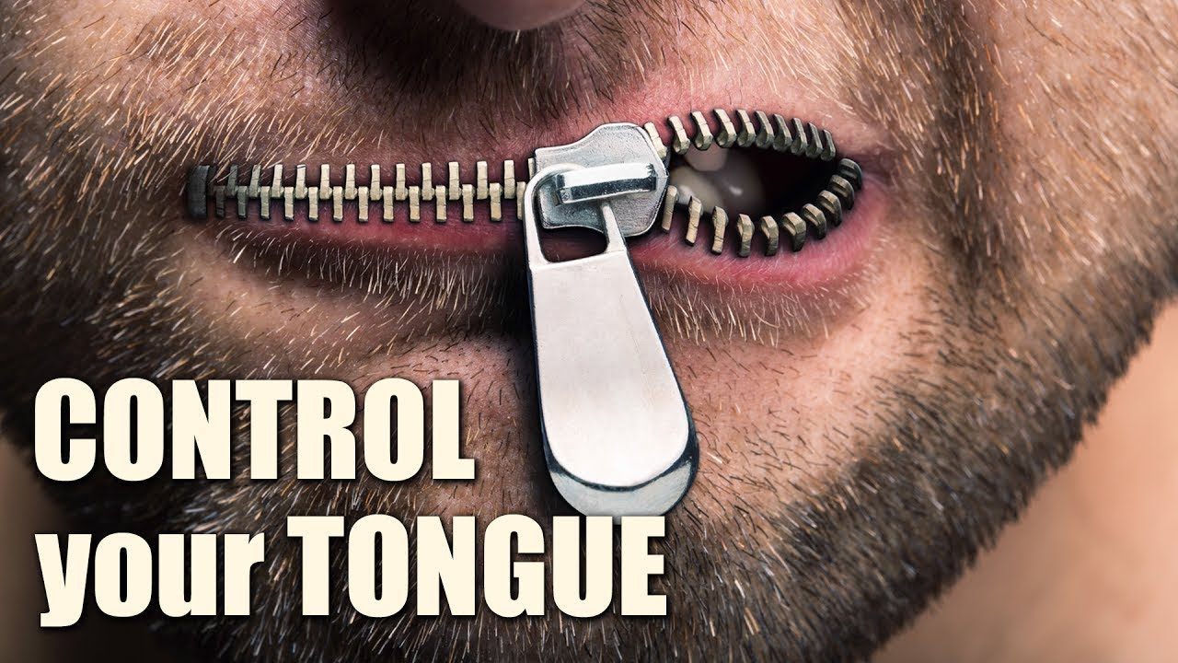
Dictionary.com defines “words” as a unit of language, consisting of one or more spoken sounds of their written representation, that functions as a principal carrier of meaning.” Words are the primary way in which we communicate our thoughts, emotions and desires to others and as such are incredibly powerful! For example, it was by God’s spoken word that all things came into existence (Genesis 1). The Bible is also filled with countless stories of speeches from heroes of the faith that inspire us with hope and assurance. Does not David’s words to Goliath, “you come to me with spear and javelin, but I come against you in the name of the Lord Almighty” (1 Samuel 17:45) increase our faith when threatened by formidable enemies? And surely when we face the darkest of valleys in life are not the words “the Lord is my shepherd, I lack nothing” or “He refreshes my soul” (Psalms 23) a source of great comfort? And are not Solomon’s words at the temple dedication that despite the “the heavens, the highest heaven, cannot contain God,” He chose to live in temple built by hands (1 Kings 8:24) humble and fill our hearts with incredible joy! And does not Peter and the other Apostle’s words to the Sanhedrin, “we must obey God rather than human beings” (Acts 5:29), inspire us to speak the word of God boldly to those who persecute us for introducing them to the light? And what about Peter’s words to Simon the sorcerer, “may your money perish with you because you thought that you could buy the gift of God with money” (Acts 8:20) not overwhelm our hearts with hope and joy that despite living in a fallen world of injustice Paul says, “it is by grace you have been saved, through faith not by works” (Ephesians 2:8-9)! And does not hearing Paul say that “the Spirit Himself intercedes for us through wordless groans” (Romans 8:26) make us feel our simple prayers have profound meaning and does not hearing him say “nothing can separate us from the love of God that is in Christ Jesus our Lord” (Romans 8:38-39) enable us to rejoice in all circumstances (1 Thessalonians 5:16-18) for He who “went to prepare a place for us” will one day return and take us home to eternally be with Him (John 14:3).


And yet while the words of the heroes of faith in the Bible inspire us to do good deeds and praise God the Father in heaven, do not the words of the villains of the Bible also provide a dire warning that our speech can also have severe consequences! Would not the Eve’s lie to the serpent, “you must not touch it (the tree of Good and Evil) or you will die” forever wring in her ears, especially during the pain of childbirth? Would not the Israelite people regret saying to Aaron “come, make us gods who will go before us” (Exodus 32) as three thousand of them were killed by the Levites? As the Israelite wandered 40 years in the wilderness would not the spies who said, “we can’t attack these people, they are stronger than we are” (Numbers 13:31) regret their foolish talk? And would not the commander of Sennacherib’s army regret saying, “who of all the gods of these countries has been able to save his hand from me, how then can the Lord deliver Jerusalem from my hand” (2 Kings 18:35) the night the angel of the Lord struck down 185,000 of his army (19:35)? Did not Job repent saying “let the Almighty answer me” (31:35) when he heard the words of God “brace yourself like a man; I will question you, and you shall answer me” (38:3)? Did not Judas hang himself (Matthew 7:5) out of “remorse” (27:3) for having said “what are you willing to give me if I deliver Him (Jesus) over to you” (Matthew 26:14)? As a blind Apostle Paul is led by the hand into Damascus did, he not regret making “murderous threats against the Lord’s disciples” (Acts 9)? And as the morning star burns forever in hell he may or may not regret but certainly will reflect on how his foolish were the words of his heart “I will raise my throne above the stars of God and sit enthroned on the mount of assembly” (Isaiah 14:13)! Since words have power to help, heal, hinder, hurt, harm, humiliate or build one another up in the faith; the remainder of this sermon is going to review James 3:1-12 and conclude that if one can control the tongue one can control any part of one’s life for Christ!


Words are so important that those who say them as part of their profession bear great responsibility to do so with fear and trembling. Since honor was often given to teachers and its gift was easy to counterfeit with eloquence and charisma, the church of James’ day was plagued with false teachers (e.g., 1 Tim. 1:7; Titus 1:11; 2 Pet. 2:1). So powerful and important are words that James warns those who want to be teachers of the word of God ought to do so with great care for they will be judged by God more strictly than others. False teachers, for example, “we are told in the book of Jude will get more hell in hell than non-teacher sinners.” We should also heed Jesus’ warning who said “if anyone causes one of these little ones – those who believe in Me – to stumble, it would be better for them to have a large millstone hung around their neck and to be drowned in the depths of the sea” (Matthew 18:6). Those who have the gift of teaching “bear an awesome responsibility for their exercise of that gift in nurturing people of the faith.” Not only will the teacher’s words be judged so will their attitudes and lifestyle. “To teach to satisfy our own ego needs” or in any manner that “misrepresents and distorts the Word of God” will not “go unnoticed by heaven” but recorded and that person will give an account before the judgment seat of Christ (2 Corinthians 5:10). This is one of the reasons why I as a pastor spend about 15 hours combing through God’s word and countless commentaries to ensure what I teach is right in God’s sight and then try to take time every day to repent of my sins so that my witness might match what I say at the pulpit! Even though James is primarily dealing with false teachers in today’s passage this warning applies to all Christians for Jesus said that “everyone will have to give an account on the day of judgement for every empty word spoken” (Matthew 12:36).

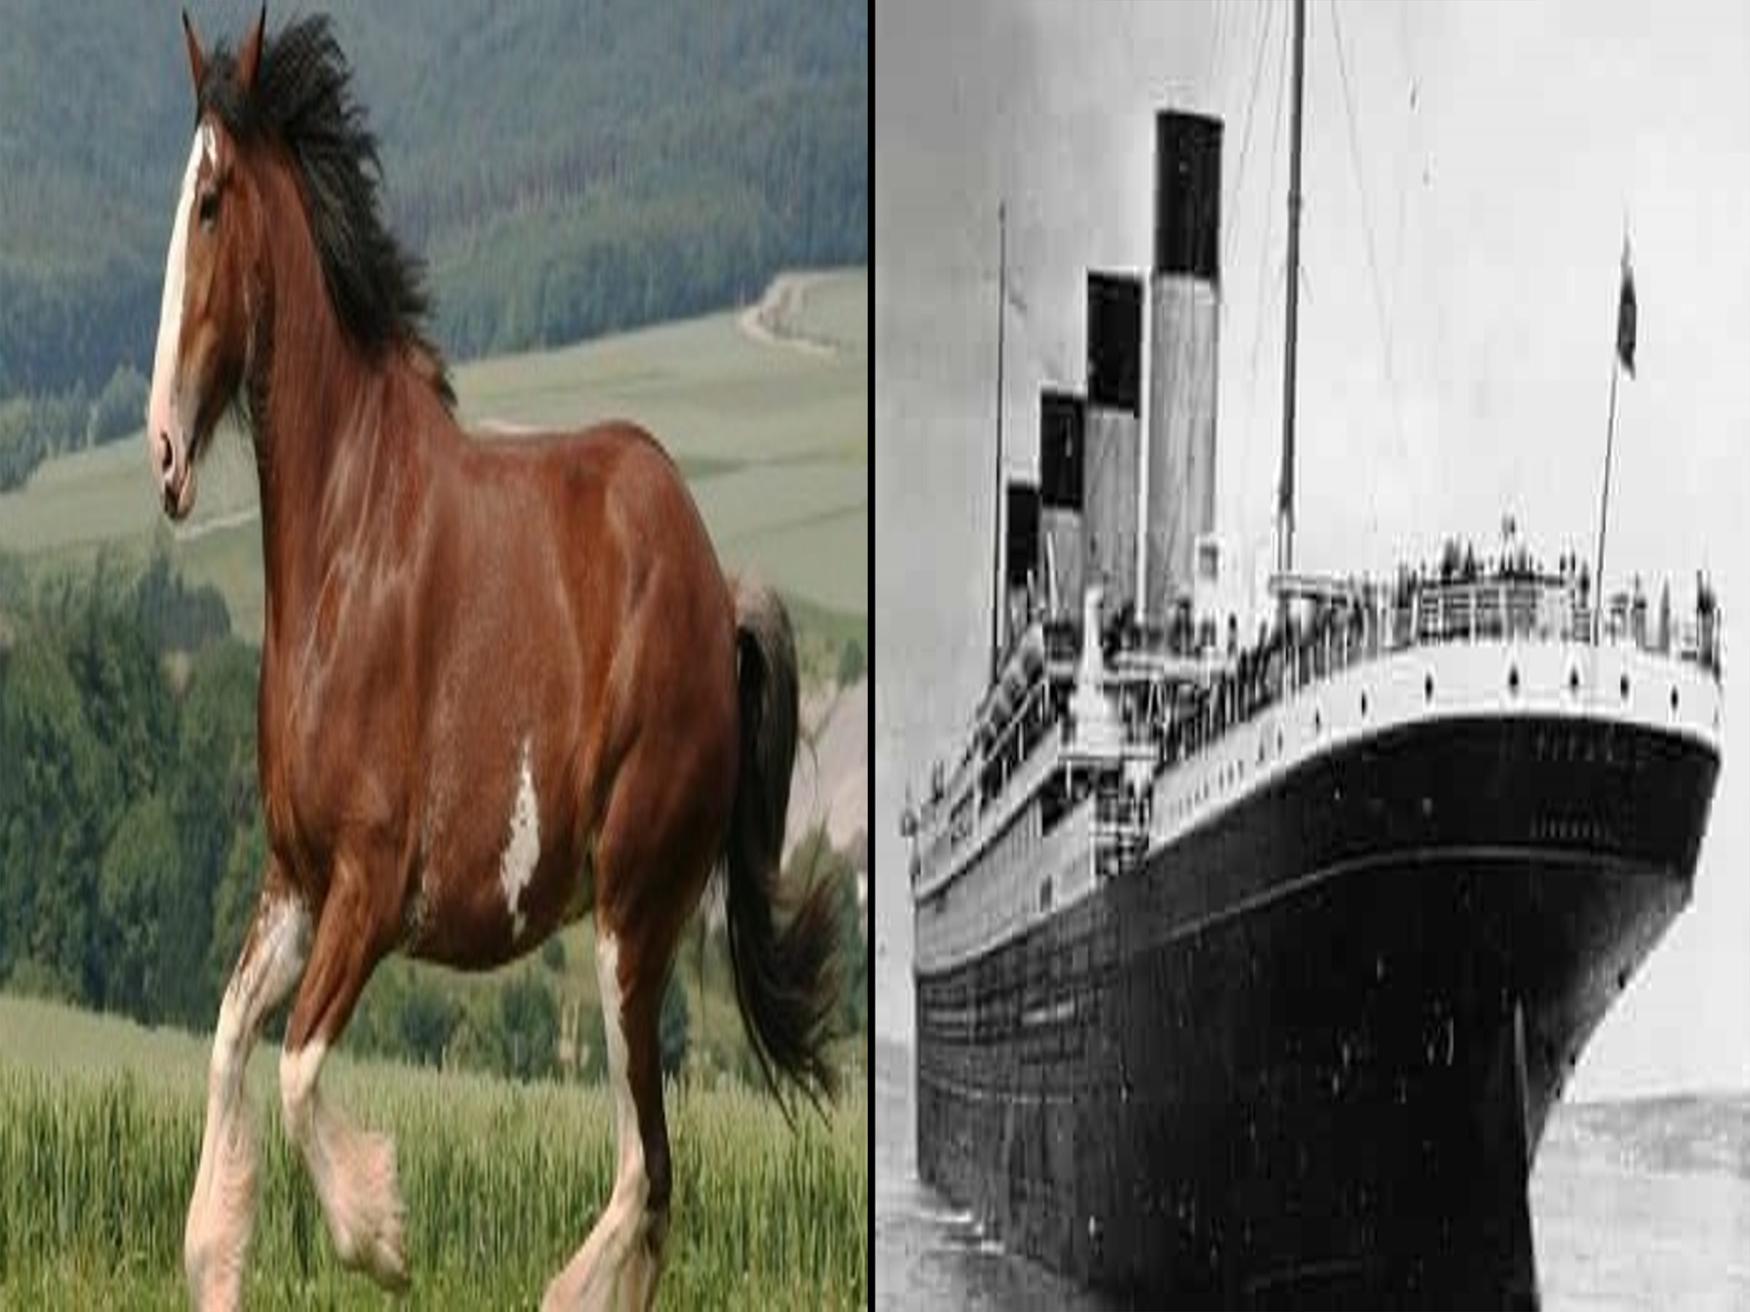
Even though we all stumble and fall short of the glory of God James promises that “anyone who is never at fault in what they say are perfect and able to keep their whole body in check” (verse 2)! James is not stating that sinlessness is achievable but merely that if one can tame the tongue then bridling the whole body will be easier in comparison. Since it seems very odd to us that such a small part of our body can guide and control the larger whole James gives several illustrations in everyday life where this is certainly the case. The first example he gives is horses. The average Clydesdale horse weighs between 1,800 to 2,000 pounds and can pull up to 8,000 pounds and yet a bit in their mouths is one of the primary means of controlling their behavior. Think about this for a second, a 200-pound person with a bridle and bit can control an animal that can pull about 40 times his/her weight! The second example James gives of a small object controlling a much larger one is a rudder on a ship. The Titanic weighed 52,310 tons and yet it was steered by a rudder that weighed just 0.2% of its weight (101 tons)! James is not saying that one can use the tongue to command the whole body to become spiritually mature but merely that “as the bit determines the direction of the horse and the rudder the ship, so can the tongue determine the destiny of a believer, if one cannot restrain the tongue then it is probable the rest of the body is likely to be uncontrolled and undisciplined also.” Or as we will see later in this passage the tongue is a spiritual barometer of the heart and as such only speaks from the fruit one is producing!

James warns the believer that while the tongue can boast in its power never forget that it is often the source of much sin in our lives. To illustrate this point James invites us to think about the devastating affects a small spark can have on a large forest. Let me give you a modern-day example:

“On October 8, 1871 Mrs. Olry’s cow kicked over the lantern at 8:30 p.m. and that led to the great Chicago fire where 100,000 people were homeless, 17,500 buildings were destroyed, 300 people died, and 40 million dollars’ worth of damage was done because the cow kicked over the lantern.”

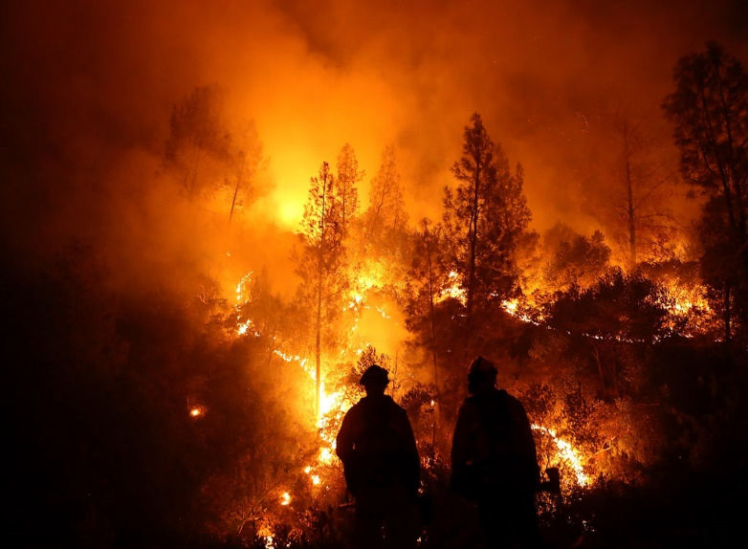
“How many churches have been ruined by gossip and slander! How many individuals have had their reputations ruined because of such talk! People who would never think about setting fire to their neighbor’s house can and do commit spiritual arson.” Many of us have started gossip fires without giving it a second thought of the potential damage, how disappointed God is with this sin, or the fact that those who gossip with us gossip about us! James warns “the tongue is a fire, a world of evil among the parts of the body. It corrupts the whole course of one’s life on fire and is itself set on fire by hell” (verse 6). “The flames of hate and prejudice, of jealousy, slander, and envy lick straight up from the lake of fire.” While James is primarily talking about false teachers in this verse, I believe he also had believers in mind for whom amongst us could ever say we are not influenced by the evil desires of our sinful nature? Like Apostle Paul do we not have to cry out to Abba Father to rescue, us the wretched, from the “evil we do not want to do but still do it” (Romans 7)? “Sticks and stones can break my bones, but words can never hurt me is profoundly false”! If we are to boast then let us be like apostle Paul and boast in the Lord (2 Corinthians 10:17)!

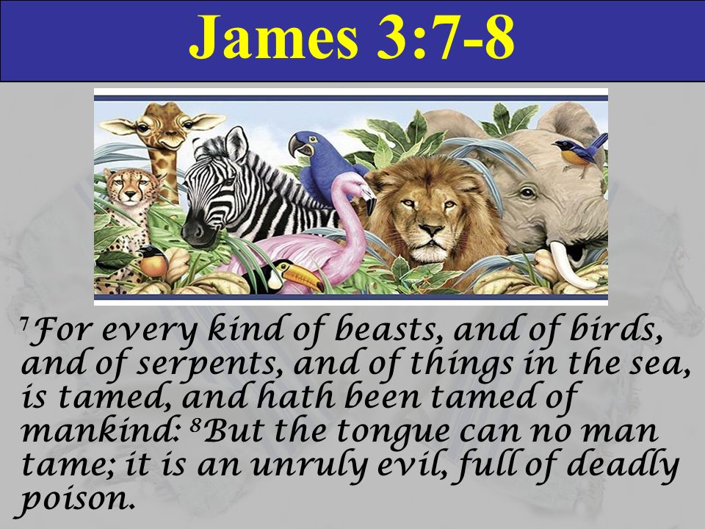
Even though we have learned how to tame the wildest of animals, reptiles, and sea creatures no human being can tame the tongue for it truly is a restless evil, and full of deadly poison (verses 7-8). What James is saying is that our odds of learning how to train an 8,000-pound elephant or a ferocious tiger is substantially better than taming the tongue which is zero percent! “The inability of the human race to tame the tongue is evidence of the irrational nature of its orientation and effort.” If the tongue is beyond taming, then why does Apostle Paul say that we are to let no unwholesome word proceed from our mouths lest we grieve the Holy Spirit of God (Ephesians 4:29-30)? If it is not humanly possible to stop from gossiping, slandering, blaspheming, profaning, complaining, and criticizing, then why even try to control one’s speech when in an “unguarded moment a critical, defamatory word slips out” and proves our tongues are “as sharp as a serpent’s, the poison of vipers on our lips (Psalms 140:3)? In response to these questions Augustine said, “James does not say that no-one can tame the tongue, but no-one from men (human beings), so that when it is tamed, we confess that this is brought about by the pity, the help, the grace of God.” Who will save us from our sinful natures, Christ who purchased our lives with His (1 Corinthians 6:20)! Like our salvation, taming the tongue is impossible by our own effort but by the grace and strength of God (Matthew 19:26) controlling the tongue is not just a possibility but an expectation of holiness. Due to our fallen nature still existing we of course cannot perfectly tame our tongue but certainly we can and must attempt through the power of the Spirit to take every thought and word captive so that our speech glorifies the Father in heaven (2 Corinthians 10:5)!

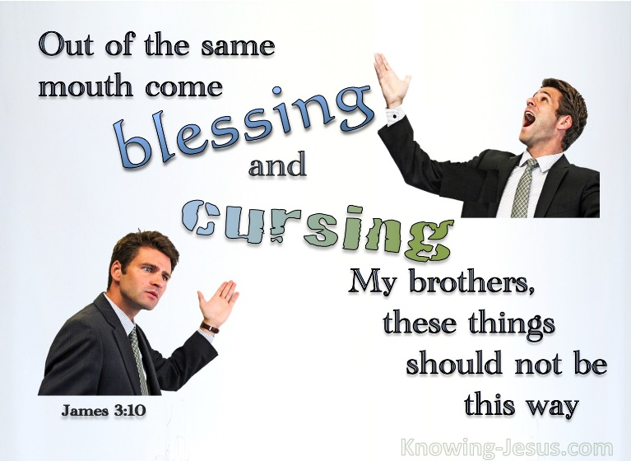
Above all James says do not use your tongue as an emblem of double mindedness. “With the tongue we praise our Lord and Father, and with it we curse human beings, who have been made in God’s likeness. Out of the same mouth come praise and cursing. My brothers and sisters, says James, this should not be (verses 10-11). “The problem is that both cursing and blessing are directed at the same object: God and a person-in-the-image-of-God” Cursing is especially heinous for in the Old Testament times it was often taken as a “desire that someone be cut off from God and experience eternal punishment!” I remember meeting a leader in the church, let us call him John, that I was quite impressed with. He read the Bible, he prayed passionately, and he was constantly doing good deeds. You could call him at three in the morning with a problem and he was quick to say, “if I can help in anyway, I will get out of bed right now and go and help you!” I looked up to him as a “spiritual giant” right up until the day I happened to look at some of his posts on Facebook. While about half of his messages were all about loving God and one another to my surprise and dare I say disappointment the other half were all about tearing down those he disliked! Like John in this story our witness to the world is negated by slander for Jesus said, “love your enemies, do good to those who hate you, bless those who curse you, pray for those who mistreat you” (Luke 6:27-28). Every time that we tear down, criticize, gossip and slander someone made in the image of God are we not dishonoring the One who, while we were His enemies, showed us love by atoning for our sins on the cross? What James is saying is that “acting against people who resemble God is the same as acting against God, who created those people.” If we are to genuinely love as Christ who died once and for all (Romans 6:14) then our love must not just be for those who love us but also anyone that we meet! For James to speak in love towards all others goes a long way towards taming the tongue!

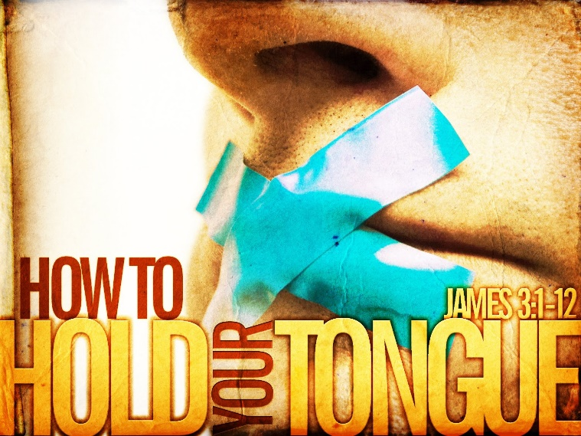
James finishes his teaching on taming the tongue with the profound truth that the tongue is a spiritual barometer. James asks, “can both fresh water and saltwater flow from the same spring? My bothers, and sisters, can a fig tree bear olives, or a grapevine bear figs? Neither can a salt spring produce fresh water” (verse 11-12). In other words, what James is saying is that by the words we express on our lips we will know the spiritual temperature of our hearts! If we gossip and slander others it is not just because they have done something to offend us but merely that “we have a wicked heart and they just gave us the opportunity to show how wicked it is by the words of hatred we use.” So, if we find our tongues always flapping and tearing down those made in the image of God what are we to do? First, ask God to examine your heart and show you any offensive thoughts, words, or deeds one is doing (Psalms 139:23-24). Second, confess your sins and He will not only forgive but cleanse your heart and make it as white as snow (1 John 1:9; Isaiah 1:18). And lastly, pray that God will keep watch and help you take captive every thought to make it obedient to Christ (Psalms 131, 141:3; 2 Corinthians 10:5). So, let us never stop inviting our Creator to renew our minds and transform our hearts so that every word we speak might express our love for Him and one another!

Let us pray,

I am Yours Lord, I gladly bow my knees and pray that You would teach me to love not only those who love me but my enemies as well. Search me O Lord and if you find any offensive thoughts within me then by Your grace and power may I ask and receive Your forgiveness and cleansing. Lord, please never stop taming my tongue and transforming my heart into your likeness! I love You and will always need You, my portion, my Lord, Savior and King!

Taken from the following website: https://www.dictionary.com/browse/word
Peter H. Davids, James, Understanding the Bible Commentary Series (Grand Rapids, MI: Baker Books, 2011), 80.
Anthony T. Evans, “‘The Poison of the Tongue,’” in Tony Evans Sermon Archive (Tony Evans, 1997), Jas 3:1–12.
David P. Nystrom, James, The NIV Application Commentary (Grand Rapids, MI: Zondervan Publishing House, 1997), 174.
Douglas J. Moo, James: An Introduction and Commentary, vol. 16, Tyndale New Testament Commentaries (Downers Grove, IL: InterVarsity Press, 1985), 124.
Roger Ellsworth, Opening up James, Opening Up Commentary (Leominster: Day One Publications, 2009), 105.
Roger Ellsworth, Opening up James, Opening Up Commentary (Leominster: Day One Publications, 2009), 105.
Anthony T. Evans, “‘The Poison of the Tongue,’” in Tony Evans Sermon Archive (Tony Evans, 1997), Jas 3:1–12.
David P. Nystrom, James, The NIV Application Commentary (Grand Rapids, MI: Zondervan Publishing House, 1997), 174.
Anthony T. Evans, “‘The Poison of the Tongue,’” in Tony Evans Sermon Archive (Tony Evans, 1997), Jas 3:1–12.
David P. Nystrom, James, The NIV Application Commentary (Grand Rapids, MI: Zondervan Publishing House, 1997), 175–176.
Taking from the following website: The Clydesdale Horse Breed: How Much Can They Pull? (horseracingsense.com)
Taken from the following website: Ship Specifications (titanicstory.com)
Douglas J. Moo, James: An Introduction and Commentary, vol. 16, Tyndale New Testament Commentaries (Downers Grove, IL: InterVarsity Press, 1985), 127.
Anthony T. Evans, “‘The Poison of the Tongue,’” in Tony Evans Sermon Archive (Tony Evans, 1997), Jas 3:1–12.
Roger Ellsworth, Opening up James, Opening Up Commentary (Leominster: Day One Publications, 2009), 111.
Anthony T. Evans, “‘The Poison of the Tongue,’” in Tony Evans Sermon Archive (Tony Evans, 1997), Jas 3:1–12.
Peter H. Davids, James, Understanding the Bible Commentary Series (Grand Rapids, MI: Baker Books, 2011), 83.
David P. Nystrom, James, The NIV Application Commentary (Grand Rapids, MI: Zondervan Publishing House, 1997), 178.
Peter H. Davids, James, Understanding the Bible Commentary Series (Grand Rapids, MI: Baker Books, 2011), 83.
David P. Nystrom, James, The NIV Application Commentary (Grand Rapids, MI: Zondervan Publishing House, 1997), 180.
Anthony T. Evans, “‘The Poison of the Tongue,’” in Tony Evans Sermon Archive (Tony Evans, 1997), Jas 3:1–12.
Roger Ellsworth, Opening up James, Opening Up Commentary (Leominster: Day One Publications, 2009), 111.
Douglas J. Moo, James: An Introduction and Commentary, vol. 16, Tyndale New Testament Commentaries (Downers Grove, IL: InterVarsity Press, 1985), 131.
Douglas J. Moo, The Letter of James, The Pillar New Testament Commentary (Grand Rapids, MI; Leicester, England: Eerdmans; Apollos, 2000), 162.
David P. Nystrom, James, The NIV Application Commentary (Grand Rapids, MI: Zondervan Publishing House, 1997), 180.
Peter H. Davids, James, Understanding the Bible Commentary Series (Grand Rapids, MI: Baker Books, 2011), 86.
Douglas J. Moo, James: An Introduction and Commentary, vol. 16, Tyndale New Testament Commentaries (Downers Grove, IL: InterVarsity Press, 1985), 133.
Anthony T. Evans, “‘The Poison of the Tongue,’” in Tony Evans Sermon Archive (Tony Evans, 1997), Jas 3:1–12.
Anthony T. Evans, “‘The Poison of the Tongue,’” in Tony Evans Sermon Archive (Tony Evans, 1997), Jas 3:1–12.

