**Light me Up!**

**Philippians 2:12-18**

Online Sermon: <http://www.mckeesfamily.com/?page_id=3567>

**“The Workout”**

Let me tell you a story of Tony Evan’s trip to the gym.

I was in the gym here at the church and a lady came in to work out and she had it going on. She was looking like somebody who wanted to work out. Everything about what she had on says, “I’m going at it.” You know she had on the work out attire, the headband around her head, wristbands around the wrist, water bottle on her side. She looked like she was there to work out. She loosens up, came in limbered up went down to touch toes and stretched and just impressive. She was obviously serious about working out, went and got on the bench, even had the breathing, just had it going on. Took off the dumbbells and did a couple of reps, put it down, took a towel, then says, “Well, you have a good day, I’m gone.” She looked good but she wasn’t there to work out. Now you would not have not known it by what she looked like or by the huffs and puffs she was taking but if you come and get on the bench three times and then you go home, you ain’t there to work out![1]

We came to church all dressed up in out finest of spiritual attire, Bible in hand, smiles of unconditional acceptance on our faces, ready not only to bow our heads to pray but to huff, puff and bellow out those traditional songs with whatever voices God gave us![2] And yet I cant help but wonder if we are sometimes like the lady in the gym, merely showing up but not ready to do what it takes to become strong. Surely we don’t want to be called “lukewarm Christians” or wander on the dark path so much that no one in the world knows we are God’s children! While our Savior is greatly pleased we the lost have been found, do we truly think He would say “good and faithful servant” to those who once bowed their knees but no longer seek or submit to His will? In verse twelve Paul says we are not to merely “show up” looking the part but are to “work out our salvation in fear and trembling!”

What does Paul mean by “workout your salvation”? How can salvation be “worked on” when by Paul’s own words, “it is by grace you have been saved, through faith – and it is not from yourselves, it is the gift of God – not by works, so that no one can boast” (Ephesians 2:8-9)? Paul is not suggesting some kind of “self-help” salvation in his letter to the church of Philippi,[3] as if one could ever add or take away anything from the atoning sacrifice of Christ, but that salvation has three different forms. In between the salvation past in which we were saved from the penalty of sin and the salvation future of glorification, is the ongoing salvation of sanctification.[4] When we pass from death to life, born of the Spirit and not the flesh (John 1:12-13), we are divinely enabled and expected to obey God’s commands (1 John 5:1-3) so that we A picture containing text
might become holy in His sight (1 Peter 1:16). We are not to strive for say 41 or even 63 percent righteousness[5] but are to keep our eyes fixed on the pioneer and perfector of our faith (Hebrews 12:1-2) by striving to walk perfectly in His footsteps. Even though we cannot attain sinlessness, through confession and based on the atoning sacrifice of Christ we can attain righteousness (1 John 1:9-10). To attain righteousness Paul says we are to “demolish arguments and every pretension that sets itself up against the knowledge of God, and take captive every thought to make it obedience to Christ (2 Corinthians 10:5)! “While we must not believe in salvation by works, we must most certainly believe in a salvation that works.”[6] James tells us that “faith by itself, if it is not accompanied by action, is dead” (2:16). To please God and to keep from being chameleons in this dark world that is not our home (Hebrews 13:14) we simply must display “evidence of Christ in our hearts”[7] by staying on the narrow path through our imitation of Jesus’ life. Since all believers start off as mere “babes in Christ” (1 Corinthians 3:1-3) and no one finishes their earthly life with the glory they will one day receive, we are to never stop striving to show God’s love, peace, holiness, goodness, and justice in our lives[8] while on this earth, even though it can only be fully attained upon the glorification of our bodies.

As we strive to become more like Jesus we are to do so with fear and trembling. When we hear this phrase we can’t help but think about how this Old Testament term was often used to signify being afraid of the mighty power of God’s wrath to correct His own.[9] While fear can be a powerful motivator to keep one on the narrow path, for Paul this phrase does not signify we should serve God with slavish terror, for the Spirit we have received does not make us 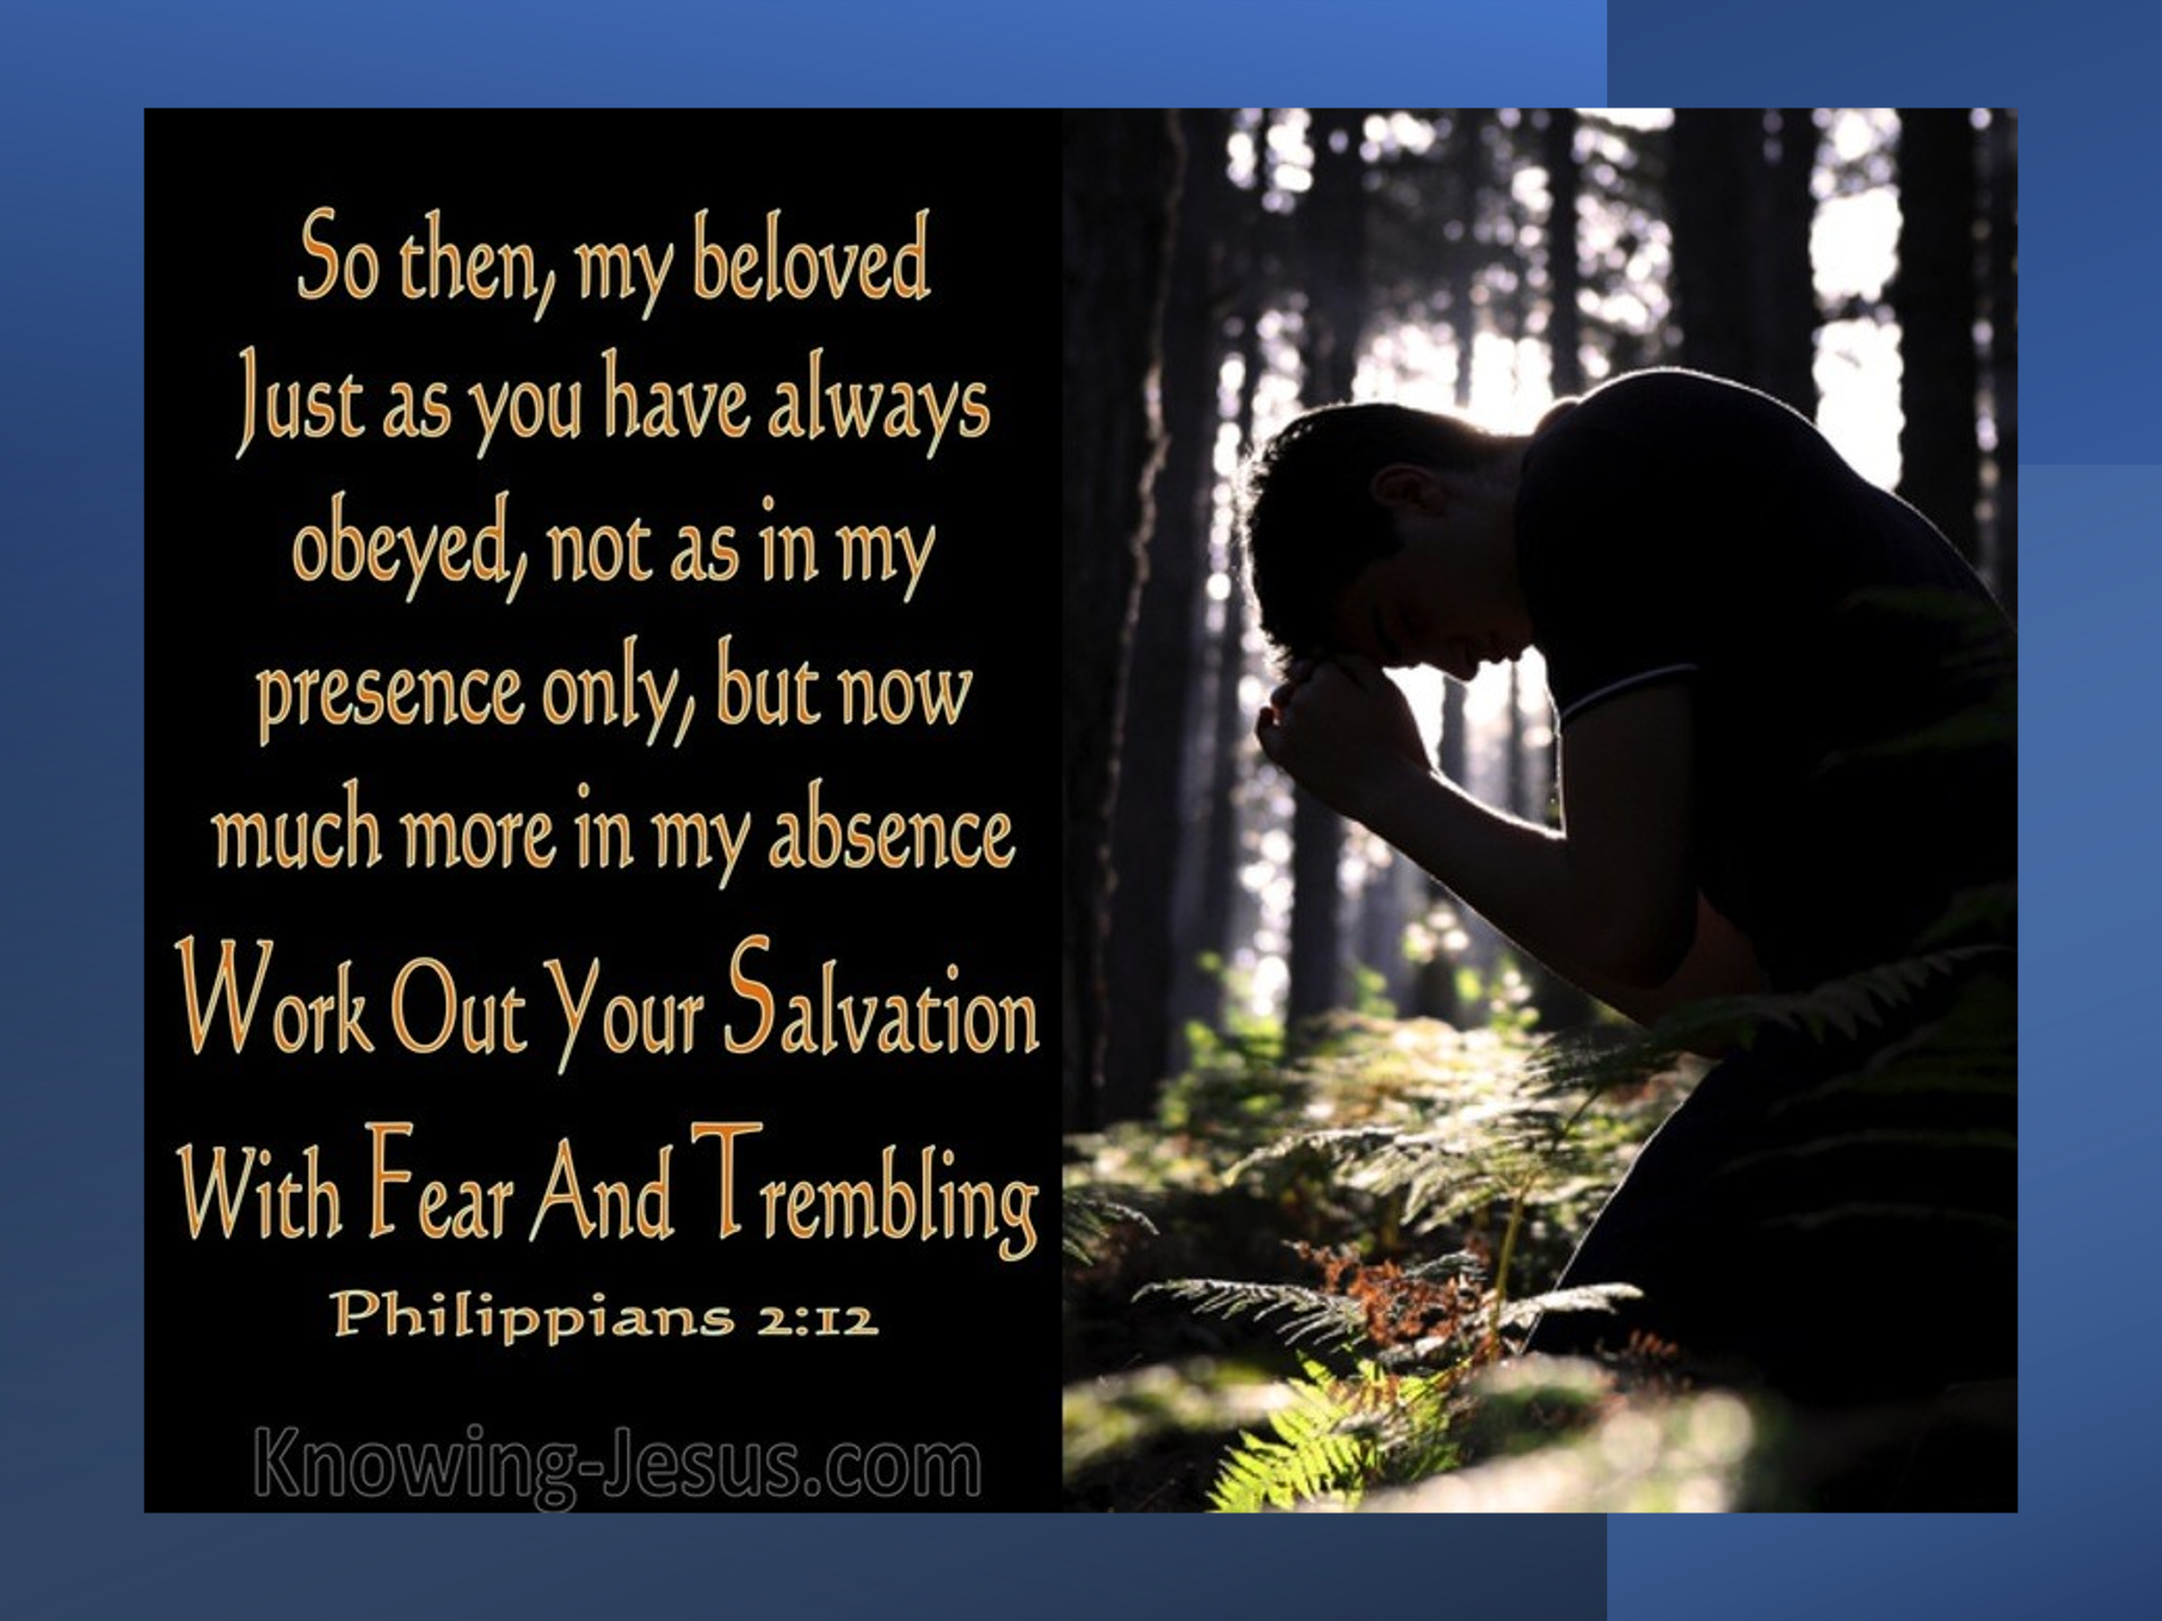slaves so that we live in fear (Romans 8:15),[10] but that we should serve Him with reverence, awe, an awareness of our weakness and our desperate need to receive His strength.[11] “Fear and trembling is an attitude that says that I want to honor God in my decision regardless of my circumstances that He might be glorified.”[12] Despite the trials, tribulations and persecutions that often come our way, we are to forever bow our knees in gratitude and faith that our Savior only does good to those who love Him (Romans 8:28). When we acknowledge His supremacy and right to rule over our lives[13] then even potentially life-threatening circumstances become a source of inexpressible joy for we believe beyond a doubt He will not only sustain us but increase our spiritual maturity if only we stayed bowed in faith one our knees (James 1:2-4)! While we are to be mindful that God disciplines those He loves (Hebrews 12:4-11), it is not fear but love, awe and a sense of overwhelming gratitude that Christ saved a wretch like me that spurs us on to do good deeds and constantly invites the Potter to never stop molding and reshaping these jars of clay into the ambassadors of light that we were meant to be (2 Corinthians 5:20)!

Lest we pridefully and foolishly think we can work out the sanctification of our salvation based on our efforts Paul says, “it is God who works in you, to will and act in order to fulfill His good purpose” (verse 13). “Apart from the work of God in his or her heart through Jesus Christ a person does not have free will where spiritual realities are concerned.”[14] Let me give you an illustration.

“It is as if a person were standing on the edge of a muddy pit with slippery sides. As long as he is on the edge he has free will; he can either stay on the bank or jump in. But if he decides to jump in, then his free will is lost as far as getting out of the pit is concerned. He has free will to walk around on the bottom or to sit down. He has free will to try to scramble up the side or to accept his plight philosophically. He has free will to cry for help or to be silent, to be angry or complacent. But he does not have free will to be again on the edge of the embankment.”[15]

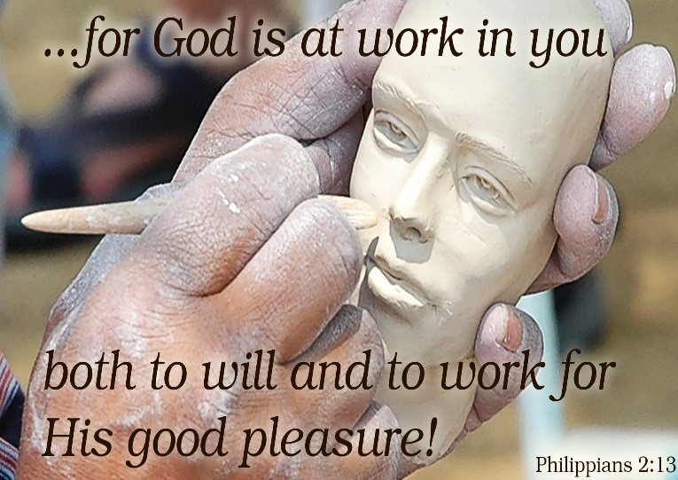This is what happened to Adam and Eve. They were permitted to pretty much do as they pleased right up until they disobeyed God and ate from the tree of knowledge of good and evil (Genesis 2:6-17). After they willfully jumped into the pit of sin, they lost the free will to choose God,[16] obey and draw nearer to Him. Everyone since Adam humanity shares in what is called the sinful nature and as such are incapable of being righteous or seeking God (Romans 3:10-11). It is only through our belief in the atoning sacrifice of Christ on the cross that we are born again and lifted by Christ out of the pit of slavery to sin (Romans 6:15-20). Sadly, though, even as redeemed masterpieces of God’s grace we still have the sinful nature and as such cannot attain holiness on our own! We have been empowered through His Spirit to become more like His Son Jesus![17] Praise be to God that “He works in us first to *will* and then to *act* out his good purpose.”[18] Without His help striving to be righteousness would be futile but through faith in His sovereignty over all things seen and unseen (Colossians 1:16), striving to be faithfully obedient and please God is attainable through the power of Jesus and the Spirit living within a person.[19]

**“Light me Up”**

 When we strive to work out our salvation, we must do so with the attitude of rejoicing so that “we might become blameless and pure, children of God without fault in a warped and crooked generation” (verse 14). Dressed in our finest of spiritual attire and Bible in hand is a bad witness when all we do is grumble and argue that God’s commands are unjust. When our motivation to become more like Jesus is based solely on fear of discipline, we sometimes obey grudgingly, not so much to please God but to avoid His wrath. Other times we are outright defiant and willfully break His commands and then try to argue with God as to why we were justified in doing so.[20] The reasons why we spend an “ornament amount of time arguing, grumbling, and complaining”[21] is that we love ourselves more than God and do not see how His commands benefit our lives. Having a form of “godliness” but denying its power (2 Timothy 3:5) is one of the main reasons the lost of this world call Christians hypocrites, for why would they ever “trade” in their pleasurable, broad sinful path for but a narrow one of pretense, grumbling and apparent misery? If we are to be Christ’s ambassadors without fault, then we must not just be motivated by fear of God’s wrath but also be so “head over heals” in love with Him that we rejoice to see His will done in our lives! We often fail to realize that whenever God is trying to develop us it is often in midst of trials, tribulations, and persecutions.[22] Despite these situations being “inconvenient” and incredible painful we are to rejoice and patiently wait for God’s intervention while we firmly stand on the Rock of our salvation (Psalms 18:2)! It is precisely in our suffering and pain and yet faithfully rejoicing that our witness of God’s goodness and love is unassailable for it points to our one heart’s desire and portion for living!

If we can obey God with thanksgiving in our hearts and out of a well-spring of love for Him, then Paul says we “will shine amongst the world like stars in the sky”! It is only when we become blameless, by this I don’t mean sinless, in the way we live our lives that the world is able to see the treasure and pearl we have inside (Matthew 13:44-46)![23] When we live the Gospel message and do good deeds Jesus says we are glorifying the Father in heaven (Matthew 5:16). So, despite the likelihood of becoming hard pressed on every side, perplexed, persecuted, and struck down (2 Corinthians 4:8-12) I say, “light me up!” Lord God in the face of the worldly depravity of pleasure, success, sex, 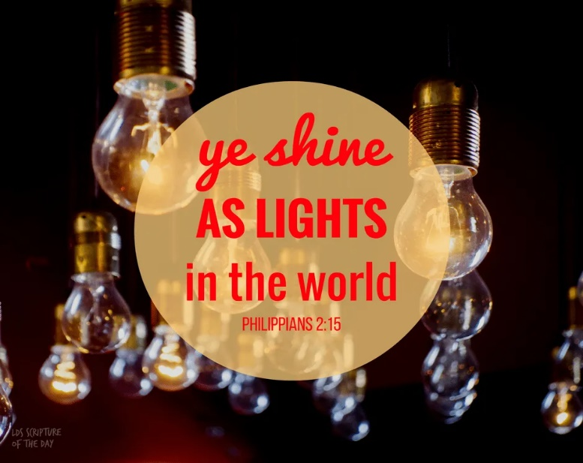money, and self-glorification,[24] may the refiners fire burn ever so brightly in my soul so that the world sees my obedience and Your seal within me and are drawn to Your glorious light! May I invite You to mold and reshape me into Your image daily. Discipline me if You must for I gladly acknowledge and rejoice in Your right to rule my life! May I not complain, grumble or seek to justify my sin but instead through Your grace and mercy may I always be open to repentance and forever allow You to plow furrows of righteousness in my soul! May you sweep my soul clean of unrighteousness, breaking down every pretension in my heart against You and build within me an ever-growing desire to love You and those around me. Lord I know I cannot live the life You expect of me but I rejoice that through the power of Your Spirit I can live in a manner that not only pleases You but one of a profound witness of Your grace and mercy to the world! May this be our prayer as we go out into the world and may we never stop asking God to “light me up!”

To keep our foolishness from becoming a pretense of holiness, Paul says we must “hold firmly to the word of life” (verse 16). Our witness to the world will be of little value if we do not live by the words of God that we speak![25] Because we live in a fallen world of many temptations and the view that truth is situationally dependent on each person, many of the paths we desire to take in life seem right but in fact are far from holy (Proverbs 14:12). We can only identify the darkness of our sin, our selfishness, pride, fear, and lust,[26] by relying on the Spirit of truth to make the words we read in God’s amazing love letter to come alive and transform our lives! There is no guarantee that memorizing the Bible will “make your life strong and healthy and fruitful.”[27] For example, the Pharisees memorized the Bible and yet at best looked beautiful on the outside but inside were whitewashed tombs full of dead man’s bones and all things unclean (Mathew 23:127)! “We need to think of the word of God as *fuel*, without which our lamp cannot shine, or as *food*, without which our souls cannot live, the point is the same: If we don’t soak in the fuel and eat the food, our light dims and our soul languishes.”[28] “In order not to be overwhelmed or snuffed out by the opposition of the world, the church needs “to maintain a grasp” on the word of life.”[29] The commands of the Bible were not just given so that our joy might be made complete for through the Spirit we come to know the truth and the truth sets us free (John 8:31-32, 15:11). As the Psalmist says, “blessed is the one who does not walk-in step with the wicked or stand in the way that sinners take or sit in the company of mockers, but whose delight is in the law of the Lord, and who meditates on it day and night” (1:2-3). Working out our salvation through sanctification is only possible when one daily invites God to transform one’s heart and mind with His truth (John 17:17; Romans 12:1-2).

**“Finishing Strong”**

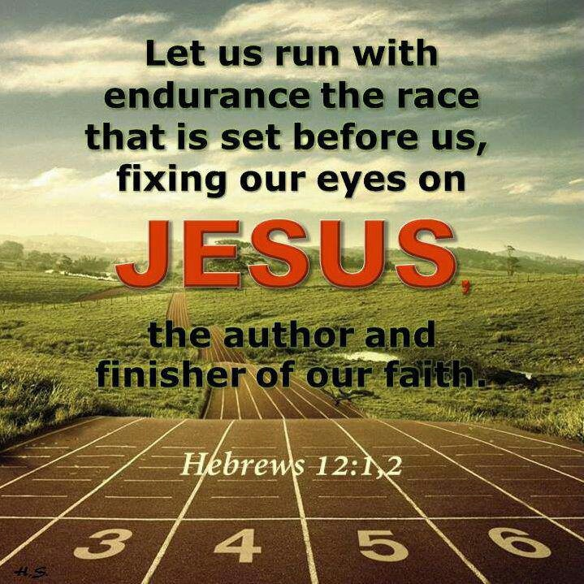 While we run the race to win the crowns of righteousness we can expect to go through many days of tribulations, persecutions and great suffering and pain. Sometimes the attack of the principalities and dark forces of this world (Ephesians 6:12) will take such a toll on our souls that yes like Paul we will feel like we are “being poured out like a drink offering on the sacrifice and service coming from our faith” (verse 11). And yet with the one life we must live surely, we can stand on the Rock of our Salvation, with an ever burning, non-quenchable, grace filled desire to please our Creator! With the belt of truth wrapped around our waist, the breastplate of righteousness in place, feet fitted with the readiness that comes from the Gospel of peace may we boldly raise the shield of faith, put on the helmet of salvation (Ephesians 6) and never stop crying out Abba Father mold me, shape me, discipline me if you must, but above all “light me up” with obedience to Your word so that my life might point away from me to You, my Cup and Portion forever. Though I have the “right to do anything” (1 Corinthians 6:12-20) I chose to read, meditate, and follow in Your footsteps all the days of my life! With the heartfelt desire to no longer be a “lukewarm Christian,” a pretender of righteousness, I gladly bow my knee to Your right to rule the life You have given me and purchased at the price of Your very life (1 Corinthians 6:19-20). So, Lord when I open Your holy word may You open my eyes so that I might see, my ears so that I might hear and my heart so that I might be daily transformed into Your likeness. Light me up Lord and no matter what the costs give me the hope, courage, and strength to go out into the world and tell them how utterly amazing the Treasure and Pearl within my heart truly is!

1. Tony Evans, [“(PART 7) ‘The Blessing of Spiritual Development,’”](https://ref.ly/logosres/tnyvnssrmnrchv?art=year.2005.1.7&off=9504&ctx=%E2%80%99re+working+it+out.%0a~I+was+in+the+gym+her) in *Tony Evans Sermon Archive* (Tony Evans, 2015), Php 2:12–18.
2. Tony Evans, [“(PART 7) ‘The Blessing of Spiritual Development,’”](https://ref.ly/logosres/tnyvnssrmnrchv?art=year.2005.1.7&off=10467&ctx=+there+to+work+out.+~See%2c+some+of+you+loo) in *Tony Evans Sermon Archive* (Tony Evans, 2015), Php 2:12–18.
3. James Montgomery Boice, [*Philippians: An Expositional Commentary*](https://ref.ly/logosres/boicecm71php?ref=Bible.Php2.12-13&off=3303&ctx=Working+It+Out%0a~Philippians+2%3a12+is+a+pro) (Grand Rapids, MI: Baker Books, 2000), 142.
4. Tony Evans, [“(PART 7) ‘The Blessing of Spiritual Development,’”](https://ref.ly/logosres/tnyvnssrmnrchv?art=year.2005.1.7&off=11524&ctx=ut+your+salvation.%E2%80%9D+~Salvation+comes+in+t) in *Tony Evans Sermon Archive* (Tony Evans, 2015), Php 2:12–18.
5. James Montgomery Boice, [*Philippians: An Expositional Commentary*](https://ref.ly/logosres/boicecm71php?ref=Bible.Php2.12-13&off=3466&ctx=+salvation.+This+is+~the+view+that+althou) (Grand Rapids, MI: Baker Books, 2000), 142.
6. Roger Ellsworth, [*Opening up Philippians*](https://ref.ly/logosres/openup71php?ref=Bible.Php2.12-13&off=1595&ctx=+had+done+inwardly.%0a~While+we+must+not+be), Opening Up Commentary (Leominster: Day One Publications, 2004), 43.
7. Gordon D. Fee, [*Paul’s Letter to the Philippians*](https://ref.ly/logosres/nicnt71php?ref=Bible.Php2.12&off=2234&ctx=tus+as+Lord+of+all.+~Thus+Paul+starts+on+), The New International Commentary on the New Testament (Grand Rapids, MI: Wm.B. Eerdmans Publishing Co., 1995), 233.
8. James Montgomery Boice, [*Philippians: An Expositional Commentary*](https://ref.ly/logosres/boicecm71php?ref=Bible.Php2.12-13&off=7617&ctx=miraculously+given.+~They+were+to+strive+) (Grand Rapids, MI: Baker Books, 2000), 144.
9. Gordon D. Fee, [*Paul’s Letter to the Philippians*](https://ref.ly/logosres/nicnt71php?ref=Bible.Php2.12&off=6448&ctx=gard+to+the+gospel.%0a~Finally%2c+they+are+to), The New International Commentary on the New Testament (Grand Rapids, MI: Wm.B. Eerdmans Publishing Co., 1995), 236.
10. F. F. Bruce, [*Philippians*](https://ref.ly/logosres/nibcnt71php?ref=Bible.Php2.12&off=1722&ctx=y+should+treat+this+~matter+is+shown+by+t), Understanding the Bible Commentary Series (Peabody, MA: Baker Books, 2011), 82.
11. Gordon D. Fee, [*Paul’s Letter to the Philippians*](https://ref.ly/logosres/nicnt71php?ref=Bible.Php2.12&off=6975&ctx=y+in+that+instance%2c+~its+being+closely+co), The New International Commentary on the New Testament (Grand Rapids, MI: Wm.B. Eerdmans Publishing Co., 1995), 236.
12. Tony Evans, [“(PART 7) ‘The Blessing of Spiritual Development,’”](https://ref.ly/logosres/tnyvnssrmnrchv?art=year.2005.1.7&off=7729&ctx=ring+and+trembling.+~Fear+and+trembling+i) in *Tony Evans Sermon Archive* (Tony Evans, 2015), Php 2:12–18.
13. Tony Evans, [“(PART 7) ‘The Blessing of Spiritual Development,’”](https://ref.ly/logosres/tnyvnssrmnrchv?art=year.2005.1.7&off=104&ctx=Evans%0aJuly+24%2c+2005%0a~We%E2%80%99ve+been+talking+a) in *Tony Evans Sermon Archive* (Tony Evans, 2015), Php 2:12–18.
14. James Montgomery Boice, [*Philippians: An Expositional Commentary*](https://ref.ly/logosres/boicecm71php?ref=Bible.Php2.12-13&off=8819&ctx=til+we+realize+that+~apart+from+the+work+) (Grand Rapids, MI: Baker Books, 2000), 144.
15. James Montgomery Boice, [*Philippians: An Expositional Commentary*](https://ref.ly/logosres/boicecm71php?ref=Bible.Php2.12-13&off=10119&ctx=ou+an+illustration.+~It+is+as+if+a+person) (Grand Rapids, MI: Baker Books, 2000), 144–145.
16. James Montgomery Boice, [*Philippians: An Expositional Commentary*](https://ref.ly/logosres/boicecm71php?ref=Bible.Php2.12-13&off=11109&ctx=fell+away+from+God.+~They+lost+the+free+w) (Grand Rapids, MI: Baker Books, 2000), 145.
17. Tony Evans, [“(PART 7) ‘The Blessing of Spiritual Development,’”](https://ref.ly/logosres/tnyvnssrmnrchv?art=year.2005.1.7&off=12689&ctx=s+good+pleasure.%E2%80%9D2%EF%BB%BF%0a~He+says%2c+%E2%80%9CI+want+you) in *Tony Evans Sermon Archive* (Tony Evans, 2015), Php 2:12–18.
18. James Montgomery Boice, [*Philippians: An Expositional Commentary*](https://ref.ly/logosres/boicecm71php?ref=Bible.Php2.12-13&off=8615&ctx=the+verse+says+that+~God+works+in+us+firs) (Grand Rapids, MI: Baker Books, 2000), 144.
19. James Montgomery Boice, [*Philippians: An Expositional Commentary*](https://ref.ly/logosres/boicecm71php?ref=Bible.Php2.12-13&off=13718&ctx=r+they+tell+us+that+~although+God+can+nev) (Grand Rapids, MI: Baker Books, 2000), 146.
20. Tony Evans, [“(PART 7) ‘The Blessing of Spiritual Development,’”](https://ref.ly/logosres/tnyvnssrmnrchv?art=year.2005.1.7&off=17774&ctx=%2c+that%E2%80%99s+grumbling.+~Disputing+means+inte) in *Tony Evans Sermon Archive* (Tony Evans, 2015), Php 2:12–18.
21. Tony Evans, [“(PART 7) ‘The Blessing of Spiritual Development,’”](https://ref.ly/logosres/tnyvnssrmnrchv?art=year.2005.1.7&off=19561&ctx=d+one+reason+alone.+~This+is+the+only+rea) in *Tony Evans Sermon Archive* (Tony Evans, 2015), Php 2:12–18.
22. Tony Evans, [“(PART 7) ‘The Blessing of Spiritual Development,’”](https://ref.ly/logosres/tnyvnssrmnrchv?art=year.2005.1.7&off=20950&ctx=+in+the+wilderness.+~Okay%2c+let+me+explain) in *Tony Evans Sermon Archive* (Tony Evans, 2015), Php 2:12–18.
23. Gordon D. Fee, [*Paul’s Letter to the Philippians*](https://ref.ly/logosres/nicnt71php?ref=Bible.Php2.15-16&off=127&ctx=+terms+of+concerns.+~As+in+the+prayer+rep), The New International Commentary on the New Testament (Grand Rapids, MI: Wm.B. Eerdmans Publishing Co., 1995), 244.
24. James Montgomery Boice, [*Philippians: An Expositional Commentary*](https://ref.ly/logosres/boicecm71php?ref=Bible.Php2.14-16&off=2950&ctx=e+a+contrast+to+it.%0a~The+world+has+its+go) (Grand Rapids, MI: Baker Books, 2000), 148.
25. F. F. Bruce, [*Philippians*](https://ref.ly/logosres/nibcnt71php?ref=Bible.Php2.16&off=140&ctx=s+the+word+of+life.+~They+are+to+present+), Understanding the Bible Commentary Series (Peabody, MA: Baker Books, 2011), 85.
26. John Piper, [*Sermons from John Piper (2000–2014)*](https://ref.ly/logosres/srmpiper2000?art=year.2010.2&off=4710&ctx=+Now+Paul+says+that+~Christians+shine+as+) (Minneapolis, MN: Desiring God, 2014).
27. John Piper, [*Sermons from John Piper (2000–2014)*](https://ref.ly/logosres/srmpiper2000?art=year.2010.2&off=1429&ctx=o+Promises+of+Power%0a~Hear+me+carefully.+I) (Minneapolis, MN: Desiring God, 2014).
28. John Piper, [*Sermons from John Piper (2000–2014)*](https://ref.ly/logosres/srmpiper2000?art=year.2010.2&off=6980&ctx=u+don%E2%80%99t%2c+you+won%E2%80%99t.+~So+whether+you+think) (Minneapolis, MN: Desiring God, 2014).
29. G. Walter Hansen, [*The Letter to the Philippians*](https://ref.ly/logosres/pntcphp?ref=Bible.Php2.16&off=1167&ctx=ain+at+a+place.%E2%80%9D356+~In+order+not+to+be+o), The Pillar New Testament Commentary (Grand Rapids, MI; Nottingham, England: William B. Eerdmans Publishing Company, 2009), 184.