**Can you Accept the Son on His Birthday?**

**Matthew 1:18-25**

Online Sermon: <http://www.mckeesfamily.com/?page_id=3567>

What was the best gift that you opened at Christmas? While many gifts that we receive quickly fade in importance over time others stand out as being special. One can easily forget or repackage and give away the ugly sweaters and ties, mugs, exercise bikes, outdated movies, socks, and anything to do with dieting but who could ever forget receiving mechanical toys, designer jeans and sneakers, wide screen televisions, smart watches, new cars, exotic vacations and expensive jewelry? While remembering opening these “special” gifts bring back fond memories nothing compares to the gift that humanity received over 2,000 years ago that once opened radically changed the very heart and soul of a person. God sent His Son Jesus to be born of a virgin, sharing both divine and human natures[1] He died for the sins of the world so that through belief in Him one can open God’s gift of salvation and be adopted as His children. The first part of this sermon is going to review Matthew 1:18-25 to explain how the first Christmas came about. This is a true story filled with miracles, traditions, an angelic dream, salvation, and faithful obedience to our Lord. The last part of this sermon is going to focus on four things one must do this Christmas to accept God’s gift of the Son.

**How the Birth of Jesus Came About**

**Joseph’s Dilemma (verses 18-19)**. Imagine how you would feel if your finance spent the last three months visiting her relatives and upon her return is found to be pregnant, despite the fact that you have never had sexual relations with her![2] It was not just the hurt and apparent betrayal Joseph had to deal with but a tough decision as to how to end their agreement to be married. To understand the “personal dilemma”[3] Mary’s pregnancy had for Joseph we need to first understand the culture of his day. There were two stages of marriage in ancient Judaism: betrothal and marriage.[4] Joseph and Mary were in the betrothal stage which lasted for one year Text
during which the girl would continue to live with her family.[5] This was not like today’s engagement for it was a legally binding contract that “gave the man legal rights over the young woman, and could only be dissolved by a formal process of divorce.[6] Despite the participants often being called “husband” and “wife,” [7] sexual relations with another person during the betrothal meant that one had committed adultery which was punishable by stoning to death![8] Mary’s pregnancy was a dilemma for Joseph who on the one hand wanted to obey the Mosaic Law and divorce Mary[9] but on the other hand did not want to subject her to public disgrace and the possibility of execution. In order to fulfill both the law and show compassion for Mary[10] Joseph decided to seek to legally annul his betrothal to Mary privately outside of the public court system by giving her a certificate of divorce (Deuteronomy 24:1-4).[11]

**The Angel’s Declaration (verses 20-23).** Before Joseph could privately divorce Mary an angel of the Lord appeared to him in a dream and told him the identity of the Father. The angel explained to Joseph that Mary had not been unfaithful to him for the child she was carrying was conceived by the Holy Spirit![12] This fulfilled the prophecy of Isaiah 7:14[13] that “the virgin will be with child and give birth to a Son, and 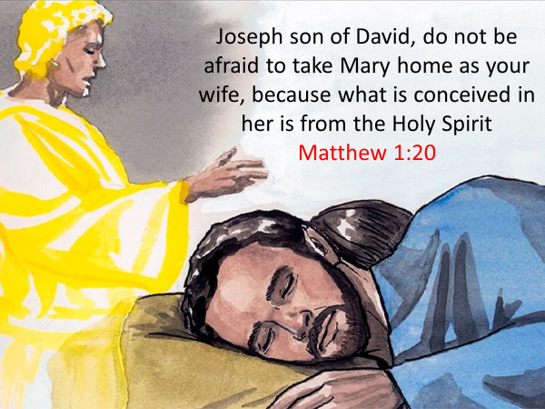they will call Him Immanuel.”[14] The “incarnation” was God’s Son becoming physically present in our world by taking human flesh and its nature.[15] Humanity has struggled to accept this miracle for centuries which is not surprising given that even Joseph needed an angel to convince him Mary was still a virgin! [16]  While the child would also be called “Wonderful Counselor, Mighty God, Everlasting Father, and Prince of Peace (Isaiah 9:6); [17] the angel told Joseph to name the baby Jesus “because He would save the people from their sins” (verse 21). “As fully God, Jesus was able to pay the eternal penalty for our sins (v. 21) for which finite humanity could not atone. As fully human He could be our adequate representative and substitutionary sacrifice.”[18] In naming Jesus Joseph accepted Him as his legal son, [19] which fulfilled prophecy that the Messiah would come from the line of David.[20] While the Jews thought Jesus came to liberate them from Roman opposition,[21] He actually came to release them from a far deadlier enemy the power of sin that had kept them in bondage and distant from His Father in heaven. The angel told Joseph to not fear public scrutiny and complete the “wedding stage of their marital relationship.”[22]

**Joseph’s Response (verses 24-25).** Dreams in Joseph’s day were taken very seriously by both Jews and Gentiles[23] for they were perceived to be a “medium of divine communication.”[24] Joseph faced a serious dilemma: would he divorce Mary privately to keep his honor in tact or would he proceed with the marriage and face public ridicule for the rest of his life for marrying an apparent adulterer? Since “Joseph valued commitment to God above his own honor,” when God revealed His will through the angel Joseph immediately believed and obeyed Him, “unbelievable as the truth would seem without a deep trust in the power of God!”[25] Even when Joseph married Mary Matthew tells us that Joseph chose to not have sexual relations with her until the birth of Jesus![26] The reason for abstaining was to fulfill Isaiah 7:14 that the mother of Immanuel would not only conceive but also bear a son as a virgin. This would not only have taken incredible self-control on Joseph’s part[27] but would have been costly for to wait until Jesus’ birth meant forgoing the opportunity to follow the Jewish tradition of having intercourse on the wedding night and publicly providing physical proof of Mary’s virginity![28] Joseph chose to obey God even though it meant he “would remain an object of shame in a society dominated by the value of honor.”[29]

**To Accept the Son one Must …**

**First Believe God Does Miracles.** To open God’s gracious gift like Joseph one must first believe God is sovereign and does miracles. “The Christian notion of a virginal conception was no more plausible in first-century Judaism than it is in the twentieth-century Western world, yet it has formed an integral part of Christian belief for two thousand years.”[30] Even though it took an angel to convince Joseph of the virgin birth Jesus tells us “blessed are those who have not seen and yet believe” (John 20:29) that Christ the Creator of all things seen and unseen (Colossians 1:16) can do anything! The Gospels are filled with stories of Jesus healing the sick, casting out evil spirits, walking on water, controlling nature, and even raising people from the dead. Just because an event cannot be proven based on sight, touch, hearing, smell, taste or proven scientifically does not mean the event did not occur. Luke for instance starts off his Gospel by declaring that he carefully investigated the miracles Jesus did and had many eyewitnesses that would collaborate their veracity. Despite this evidence, in the end miracles require faith. One simply cannot open God’s gift of the Son this Christmas without first believing that a sovereign God changes our existence in ways we cannot explain but still is true (John 8:31)!

**Through Jesus God is with Us**. The angel told Joseph that the people would call Jesus Immanuel which means “God with us” (verse 22). Imagine what it must have been like to be Adam and Eve and walk and talk with God in the Garden of Eden? Ever since the Fall sin has become a wedge between us and a holy God. While we were given glimpses of God through vision and dreams and even came near to Him during the times of the tabernacle and the temple, there were many restrictions 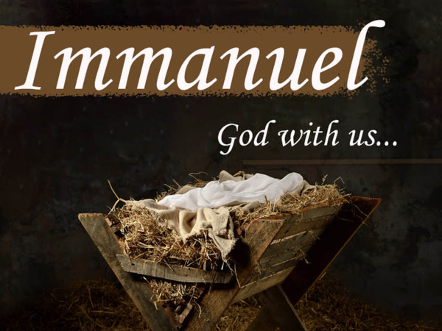on how sinful humanity could get close to God. Before the foundation of the world God chose to send His Son Jesus (Ephesians 1:4) to be born of a virgin and have face to face conversations with those who accepted and rejected His claims to be God. The moment the curtain was torn in two upon Christ’s death separation between God and humanity ended (Matthew 27:512). No longer would one have to go to a temple built by hands (Acts 17:24) to get close to God one simply needed to believe in His Son Jesus and His Spirit would live and commune with our spirit (Romans 8:16). Jesus came to tell the world that upon belief in Him one can boldly approach His Father’s throne of His grace (Hebrews 4:16)! To be close to God this Christmas then one simply must accept His Son by believing He is the way, truth, and life (John 24:6)!

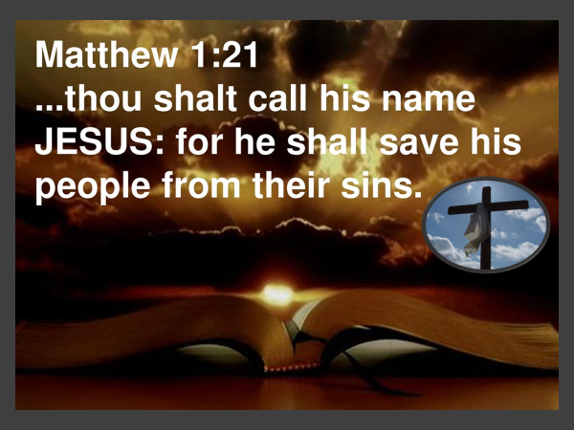**Believe in His Atonement.** The angel also told Joseph that the child was to be named “Jesus because He would save His people from their sins” (verse 21). Imagine how heart breaking it must have been for Jesus who had no sin (2 Corinthians 5:21) to live amongst humanity enslaved by sin (Romans 6:20)! Despite knowing what was right in God’s sight, humanity was incapable of following His laws (Romans 8:3) and therefore were deserving of God’s wrath. John 3:26 tells us that God did not send His Son Jesus to condemn the world but to show them the way they could be saved! Through the shedding of His blood on the cross Jesus atoned for our sins (Romans 3:21-31). Jesus is not just a prophet, priest, and king, He is the incarnate Son of God who had both a divine and human nature. He had to be divine to be sinless and human to be a representative substitute. Those who believe in Jesus’ atonement are born again (John 3:1-21) and receive a new heart (Ezekiel 36:26) that not only has been freed from the power of sin (Romans 6:7) but is also sealed with God’s very own Spirit that one has been eternally adopted into God’s family! To receive this gracious gift of salvation, one must believe in and accept Jesus as one’s redeemer and savior!

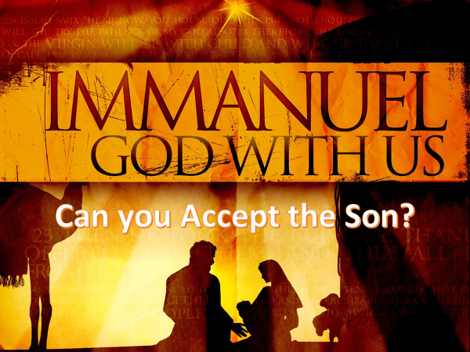**Be Willing to Obey.** Like Joseph you are facing a dilemma this Christmas. Joseph had to decide to either say YES to the angel’s request and face public humiliation or divorce Mary privately and keep his honor in the world’s eyes. Since Joseph valued commitment to God above his own honor, He obeyed and accepted Jesus as his son. If you want to come into God’s presence this Christmas, then you need to obey God’s call and accept His Son Jesus as your Savior. If you believe that Jesus died to atoned for your sins and you ask Him to be the Lord of your life then you will be born again of the Spirit and as one of God’s very own children. If you are already born again then I want to encourage you to do two things. First, tell as many as you can the reason why you have hope living in this fallen world (1 Peter 3:15). Tell the world about the Truth that set you free and God’s desire that none should perish (2 Peter 3:9). And second, approach God’s throne of grace and tell Him thank you for every spiritual blessing you have received in Christ, Jesus our Lord (Ephesians 1:3)!

1. Michael Green, [*The Message of Matthew: The Kingdom of Heaven*](https://ref.ly/logosres/bstus61mt?ref=Bible.Mt1.18-25&off=14313&ctx=he+person+of+Jesus.%0a~It+would+be+a+pity+i), The Bible Speaks Today (Leicester, England; Downers Grove, IL: InterVarsity Press, 2001), 64.
2. Michael J. Wilkins, [*Matthew*](https://ref.ly/logosres/nivac61mt?ref=Bible.Mt1.18-21&off=4141&ctx=he+extended+family.%0a~By+the+time+of+the+n), The NIV Application Commentary (Grand Rapids, MI: Zondervan Publishing House, 2004), 74.
3. Michael J. Wilkins, [*Matthew*](https://ref.ly/logosres/nivac61mt?ref=Bible.Mt1.18-21&off=5080&ctx=+and+Simeon+(2%3a25).%0a~But+at+this+point+Jo), The NIV Application Commentary (Grand Rapids, MI: Zondervan Publishing House, 2004), 75.
4. Michael J. Wilkins, [*Matthew*](https://ref.ly/logosres/nivac61mt?ref=Bible.Mt1.18-21&off=282&ctx=y+current+cultures.+~The+marriage+customs), The NIV Application Commentary (Grand Rapids, MI: Zondervan Publishing House, 2004), 73.
5. Michael Green, [*The Message of Matthew: The Kingdom of Heaven*](https://ref.ly/logosres/bstus61mt?ref=Bible.Mt1.18-25&off=5906&ctx=t+is+quite+natural.+~Betrothal%2c+the+pledg), The Bible Speaks Today (Leicester, England; Downers Grove, IL: InterVarsity Press, 2001), 61.
6. Michael J. Wilkins, [*Matthew*](https://ref.ly/logosres/nivac61mt?ref=Bible.Mt1.18-21&off=1501&ctx=icial+arrangements.+~In+a+formal+prenupti), The NIV Application Commentary (Grand Rapids, MI: Zondervan Publishing House, 2004), 73.
7. Michael J. Wilkins, [*Matthew*](https://ref.ly/logosres/nivac61mt?ref=Bible.Mt1.18-21&off=2273&ctx=p+(cf.+Gen.+24%3a53).%0a~Apparently+the+termi), The NIV Application Commentary (Grand Rapids, MI: Zondervan Publishing House, 2004), 74.
8. Michael J. Wilkins, [*Matthew*](https://ref.ly/logosres/nivac61mt?ref=Bible.Mt1.18-21&off=2569&ctx=Ketub.+9b%2c+12a)%2c+in+~Galilee+sexual+relat), The NIV Application Commentary (Grand Rapids, MI: Zondervan Publishing House, 2004), 74.
9. Craig Blomberg, [*Matthew*](https://ref.ly/logosres/nac22?ref=Bible.Mt1.18-19&off=2115&ctx=+unfaithful+to+him.+~He+is+called+a+%E2%80%9Crigh), vol. 22, The New American Commentary (Nashville: Broadman & Holman Publishers, 1992), 58.
10. D. A. Carson, [“The Gospels and Acts,”](https://ref.ly/logosres/nivzndrvnstbbl?ref=Bible.Mt1.19&off=29&ctx=ivorce+her+quietly.+~Jewish+tradition+req) in *NIV Biblical Theology Study Bible*, ed. D. A. Carson (Grand Rapids, MI: Zondervan, 2018), 1699.
11. D. A. Carson, [“Matthew,”](https://ref.ly/logosres/ebc08?ref=Bible.Mt1.19&off=1379&ctx=t+to+be+unfaithful.+~And+because+such+a+m) in *The Expositor’s Bible Commentary: Matthew, Mark, Luke*, ed. Frank E. Gaebelein, vol. 8 (Grand Rapids, MI: Zondervan Publishing House, 1984), 75.
12. James Montgomery Boice, [*The Gospel of Matthew*](https://ref.ly/logosres/boicecm61amt?ref=Bible.Mt1.18-25&off=3106&ctx=+pondering+this%2c+an+~angel+appeared+to+hi) (Grand Rapids, MI: Baker Books, 2001), 22.
13. While Isaiah 7:14 was literally fulfilled in the days of Ahaz, this prophecy took on typological significance for later generations according to Craig Evans.
14. James Montgomery Boice, [*The Gospel of Matthew*](https://ref.ly/logosres/boicecm61amt?ref=Bible.Mt1.18-25&off=1987&ctx=Testament+text+that+~Matthew+cites+as+a+p) (Grand Rapids, MI: Baker Books, 2001), 22.
15. Iain D. Campbell, [*Opening up Matthew*](https://ref.ly/logosres/openup61mt?ref=Bible.Mt1.18-25&off=687&ctx=+Matthew%E2%80%99s+account.+~The+incarnation+was+), Opening Up Commentary (Leominster: Day One Publications, 2008), 24–25.
16. D. A. Carson, [“The Gospels and Acts,”](https://ref.ly/logosres/nivzndrvnstbbl?ref=Bible.Mt1.20-21&off=8&ctx=is+fianc%C3%A9e.%0a1%3a20%E2%80%9321+~Not+surprisingly%2c+it) in *NIV Biblical Theology Study Bible*, ed. D. A. Carson (Grand Rapids, MI: Zondervan, 2018), 1699.
17. Michael J. Wilkins, [*Matthew*](https://ref.ly/logosres/nivac61mt?ref=Bible.Mt1.22-23&off=7789&ctx=ee+of+the+Gentiles%E2%80%9D+~(Isa.+9%3a1%E2%80%932)+with+a+), The NIV Application Commentary (Grand Rapids, MI: Zondervan Publishing House, 2004), 81.
18. Craig Blomberg, [*Matthew*](https://ref.ly/logosres/nac22?ref=Bible.Mt1.18-19&off=1254&ctx=duce+a+human+child.+~The+Christian+notion), vol. 22, The New American Commentary (Nashville: Broadman & Holman Publishers, 1992), 58.
19. Leon Morris, [*The Gospel according to Matthew*](https://ref.ly/logosres/pntcmatt?ref=Bible.Mt1.25&off=856&ctx=ng+the+child+Jesus.+~His+naming+of+the+ch), The Pillar New Testament Commentary (Grand Rapids, MI; Leicester, England: W.B. Eerdmans; Inter-Varsity Press, 1992), 32.
20. D. A. Carson, [“Matthew,”](https://ref.ly/logosres/ebc08?ref=Bible.Mt1.20&off=913&ctx=terature+(Bonnard).%0a~The+angel%E2%80%99s+opening+) in *The Expositor’s Bible Commentary: Matthew, Mark, Luke*, ed. Frank E. Gaebelein, vol. 8 (Grand Rapids, MI: Zondervan Publishing House, 1984), 75.
21. Craig A. Evans, [*The Bible Knowledge Background Commentary: Matthew–Luke*](https://ref.ly/logosres/bkbc61mt?ref=Bible.Mt1.21&off=70&ctx=their+sins+(v.+21).+~The+name+Jesus+means), ed. Craig A. Evans and Craig A. Bubeck, First Edition. (Colorado Springs, CO: David C Cook, 2003), 47.
22. Michael J. Wilkins, [*Matthew*](https://ref.ly/logosres/nivac61mt?ref=Bible.Mt1.18-21&off=9226&ctx=he+Davidic+Messiah.+~The+command+%E2%80%9Cdo+not+), The NIV Application Commentary (Grand Rapids, MI: Zondervan Publishing House, 2004), 77.
23. Craig A. Evans, [*The Bible Knowledge Background Commentary: Matthew–Luke*](https://ref.ly/logosres/bkbc61mt?ref=Bible.Mt1.20-21&off=286&ctx=s+of+saving+import.%0a~Dreams+were+taken+ve), ed. Craig A. Evans and Craig A. Bubeck, First Edition. (Colorado Springs, CO: David C Cook, 2003), 46.
24. Michael J. Wilkins, [*Matthew*](https://ref.ly/logosres/nivac61mt?ref=Bible.Mt1.18-21&off=8108&ctx=+25%3a31%2c+41%3b+26%3a53).%0a~Dreams+were+commonly), The NIV Application Commentary (Grand Rapids, MI: Zondervan Publishing House, 2004), 76.
25. Craig S. Keener, [*Matthew*](https://ref.ly/logosres/ivntcmat?ref=Bible.Mt1.18&off=17804&ctx=minimize+her+shame.%0a~Fourth%2c+Joseph+value), vol. 1, The IVP New Testament Commentary Series (Downers Grove, IL: InterVarsity Press, 1997), Mt 1:18.
26. Leon Morris, [*The Gospel according to Matthew*](https://ref.ly/logosres/pntcmatt?ref=Bible.Mt1.25&off=4&ctx=ry+as+his+wife.%0a25.+~But+though+he+marrie), The Pillar New Testament Commentary (Grand Rapids, MI; Leicester, England: W.B. Eerdmans; Inter-Varsity Press, 1992), 31–32.
27. Craig S. Keener, [*Matthew*](https://ref.ly/logosres/ivntcmat?ref=Bible.Mt1.18&off=10319&ctx=+in+this+narrative.+~First%2c+he+affirms%2c+a), vol. 1, The IVP New Testament Commentary Series (Downers Grove, IL: InterVarsity Press, 1997), Mt 1:18.
28. Craig S. Keener, [*Matthew*](https://ref.ly/logosres/ivntcmat?ref=Bible.Mt1.18&off=18524&ctx=o+begin+a+marriage!+~By+waiting+to+have+i), vol. 1, The IVP New Testament Commentary Series (Downers Grove, IL: InterVarsity Press, 1997), Mt 1:18.
29. Craig S. Keener, [*Matthew*](https://ref.ly/logosres/ivntcmat?ref=Bible.Mt1.18&off=18218&ctx=ey+are+the+father!)%0a~Joseph+trusted+God+e), vol. 1, The IVP New Testament Commentary Series (Downers Grove, IL: InterVarsity Press, 1997), Mt 1:18.
30. Craig Blomberg, [*Matthew*](https://ref.ly/logosres/nac22?ref=Bible.Mt1.18-19&off=1254&ctx=duce+a+human+child.+~The+Christian+notion), vol. 22, The New American Commentary (Nashville: Broadman & Holman Publishers, 1992), 58.