**The Key to Overcoming our Insecurities**

**Ephesians 1:11-14**

Online Sermon: <http://www.mckeesfamily.com/?page_id=3567>

The Oxford dictionary defines fear as “an unpleasant emotion caused by the belief that someone or something is dangerous, likely to cause pain, or a threat.”[1] Being “jars of clay” (2 Corinthians 4:7), that is with minds and bodies that are easily broken, it should not come as surprise that perceived or real threats to our well being provokes fear within our hearts. For example for some people their fears relate to animals such as spiders, dogs, insects; to others their fears relate to the natural environment such as heights, thunder, darkness; to others their fears relate to blood, injury, or medical issues such as broken bones, needles, incurable diseases; and to others their fears relate to specific situations such a public speaking, flying or driving.[2] While all of these items often make us so scared that they rob us of precious sleep, nothing drives us quicker into the fetal position, hugging our security blankets any faster than the threat or thought of our eventual death and what comes afterwards! One would think that those who believe in the way, truth and life would be exempt from this fear but with Jesus’ warning that some will merely think but are not in fact saved (Matthew 7:21-23), doubt and fear often reign supreme within their hearts as well. The following sermon is going to examine Ephesians 1:11-14 and in doing so show how knowing the works of the Holy Spirit is the key to knowing beyond a doubt that we are saved and are eternally safe in the hands of our Father!

**The Glorious Calling (11-12, 13b)**

The first work of the Holy Spirit is what theologians call “the effectual call.”[3] Without the Spirit’s conviction in relation to “sin, righteousness and judgment” (John 16:8-11),[4] people would not chose to believe in Christ’s atonement, nor make Him the lord of their lives![5] Since God’s eternal plan has been that none should perish (2 Peter 3:9), God has always provided a path for humanity to approach His holy throne. In the Old Testament Israel was chosen to be his portion[6] and light unto the nations (Psalms 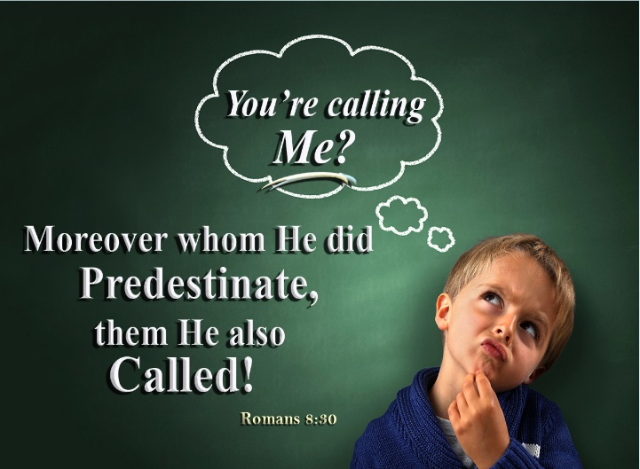33:12; Deuteronomy 4:20; Isaiah 49:6).[7] To keep from “downplaying of Israel’s salvation history in the course of his controversy with the Jewish opponents”[8] Paul stated it was God’s intention by predestination, [9] that the Jews were to be the first to hear (Romans 1:16, 2:9-10),[10] believe and claimed as God’s inheritance and possession in the Lord, Jesus Christ.[11] In verse 13a the “you also” refers to God’s portion also including the Gentile people of whom this letter was specifically addressed.[12] The Gentiles were no longer to “separated from Christ, strangers to the covenants of promise, without hope and without God in the world” (2:12),[13] but through faith in the atoning sacrifice of Christ were grafted into the vine as equal participants of the glorious, eternal inheritance as God’s portion (Romans 11:11-31).[14]

**One Church (13a)**

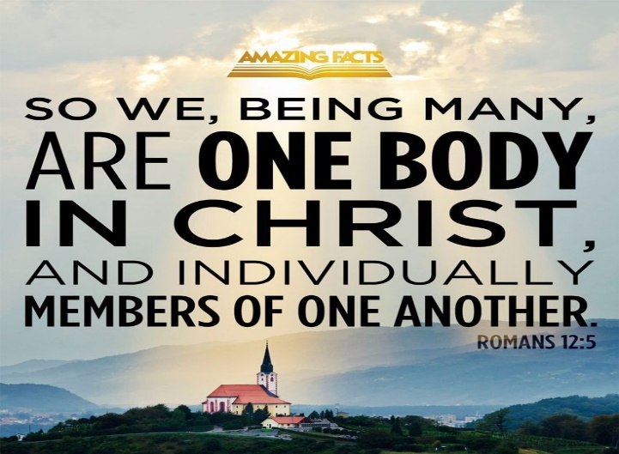 The second work of the Holy Spirit that Paul points out is the “making of a new people, the church” of both Jews and Gentiles.[15] Paul’s usage of the pronouns “we” and “you” is of great significance for both the people of his day, and us today.[16] Christ’s “once and for all” (Romans 6:10) atonement of sin for Paul meant the “barrier” or “dividing wall” of hostility[17] between the Greeks and Romans, rich and poor, slaves and free” has been torn down because all believers are one in Christ (Galatians 3:28-29)! Though differences of age, nationality, sex, wealth of public status might differ in the world’s eyes, for Paul this new church in Christ’s blood had no “first- or second-class citizens.”[18] While the “communication of the Gospel to the Gentiles was undertaken reluctantly” by the first Jewish believers,[19] upon witnessing that the “transforming knowledge” of the Gospel[20] led to the Gentiles being converted, as proven by the presence of the Holy Spirit, many churches formed and lived in harmony consisting of both Jews and Gentiles believers. Peace and unity were maintained in such diversified churches because they had a singular goal of becoming the praise of God’s glory[21] by bowing and submitting their will to the One who bought them at a price!

**Word and Spirit (13b)**

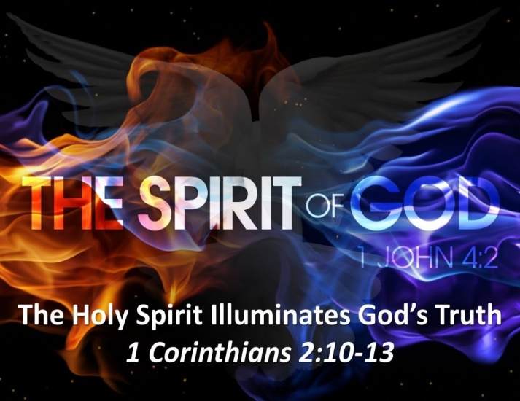The third work of the Holy Spirit that Paul points out is the illumination of God’s holy word. Like the Jews, the Gentiles have been received the “message of truth,”[22] “particularly as it is related to His saving purposes and humankind’s place in them.”[23] While all creation “testifies to God’s eternal power and divine nature,” (Romans 1:20) to truly believe in God Apostle Paul told the church of Rome the Gospel must first be preached[24] so that it is heard (Romans 10:14-15)! Even though beautiful are the feet that bring the Good News, just hearing is not enough to guarantee belief in the Son for until the Spirit illuminates spiritual truths in spiritual words[25] they will not penetrate the soul and spirit (Hebrews 4:12-13) but instead remain as words of mere foolishness (1 Corinthians 1:18) or worse yet offensive to those perishing in their sin. Revelation of God is not given without the Spirit’s aid for one to seek God that person must first be sought by Him![26] The Protestant Reformers such as Luther, Calvin and others strongly believed in the “work of the Holy Spirit in bringing men and women to faith and in leading and preserving them in that faith once they had believed**.”**[27]In today’s passage I can’t help but feel Apostle Paul’s overwhelming joy that many of the Jews and Gentiles who had heard the Gospel message believed and became God’s heirs and children forever!

**Marked with a Seal (13c)**

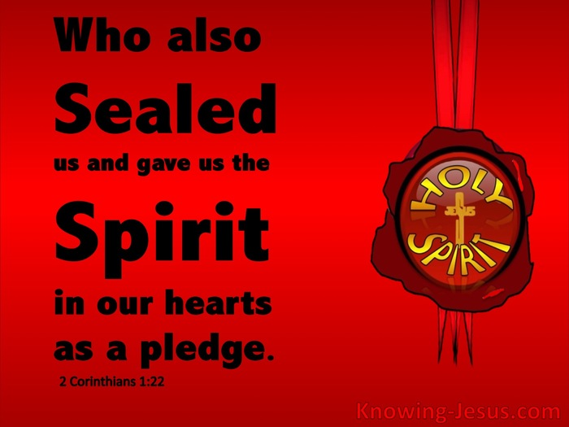The fourth work of the Holy Spirit is to seal or preserve[28] the believer until the day of redemption. A “seal” in Paul’s day was used “to authenticate as genuine (cf. Neh. 9:38), to render secure (cf. Matt. 27:66), and to denote ownership (cf. Rev. 7:3).”[29] While the Jews of the Old Testament saw circumcision as their seal, Paul stated that the Holy Spirit was the promised seal of one’s salvation in Christ (Romans 8:15-16; Galatians 4:6).[30] “Since God does all things for the praise of His glory, and since believing His Word magnifies that glory, therefore God takes decisive steps to secure for Himself the magnification of His glory forever: He *seals* the believer with the Holy Spirit, and *guarantees* that we will come to our inheritance praising His glory.”[31] John Piper rightly states the role of the Holy Spirit as a threefold seal: to secure faith and shuts out apostasy, to assure eternal sonship, and to be a sign that we as God’s own possession are divinely protected from evil forces.[32] The wording Paul uses in this passage are also reflective of baptism into which the believer baptized into the person of Christ is “placed under the Lord’s authority and protection.”[33] Paul’s primary point, however is “not the protection or eternal security of the believer, but rather the identification of who belongs to Christ.”[34] Praise be to God that a person does not have to live their live in fear wondering if one is saved or not, for by the fruits and the testimony of the Holy Spirit (Romans 8:15-17)[35] one is assured of one’s position before a holy God!

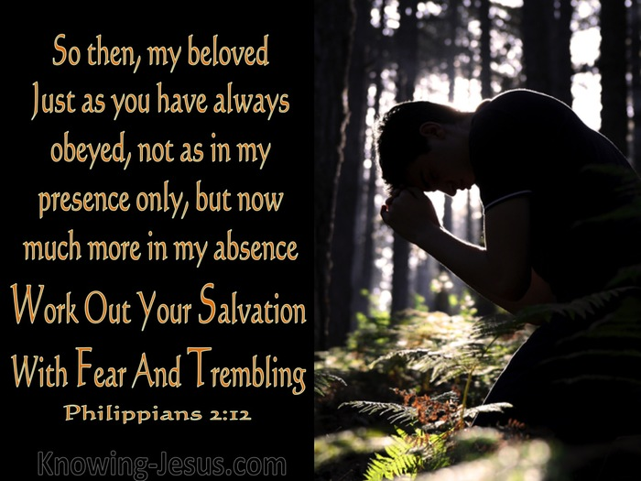Just because Christians have eternal security in the Spirit does not mean they will have an easy life, nor does it mean they can do anything they want upon their salvation. Having signed up for the most “dangerous mission in the world”[36] inevitably means one can expect to be persecuted (John 15:18-25) by those who think the cross is mere foolishness (1 Corinthians 1:18). Living in a fallen world where chance happens to everyone (Ecclesiastes 9:11) means hardships, trials and tribulations are going to be our constant companions (James 1:2-4). Peace is not attainable through a lack of difficulties but through faith that God will always do good to those who love Him (Romans 8:28). Also, eternal salvation in no way reduces our obligation to He who bought us at a price (1 Corinthians 6:20)! As those who are to work out their salvation with fear and trembling (Philippians 2:12), we must constantly be asking and open to having our minds renewed in truth that set us free (Romans 12:2). We are not to let our thoughts or actions merely happen but are to take every thought, word and deed captive for the Lord, Jesus Christ (2 Corinthians 10:5)! This does not mean salvation is by works (Ephesians 2:8) but that works, specifically the fruits of the Spirit, are proof that one is saved (James 2:14-25). With these overarching truths in mind let us now examine our glorious inheritance in our Lord.

**Glorious Inheritance (14)**

The final work of the Holy Spirit that Paul mentions in today’s passage is being a deposit guaranteeing our inheritance until the day of redemption. While the Gentiles have already inherited the promises to Abraham[37] and spiritual blessings through Christ (Ephesians 1:3),[38] the Spirit of God was given to believers as a deposit guaranteeing that more promises are yet to be received![39] While believers have been redeemed through belief in the atoning sacrifice in 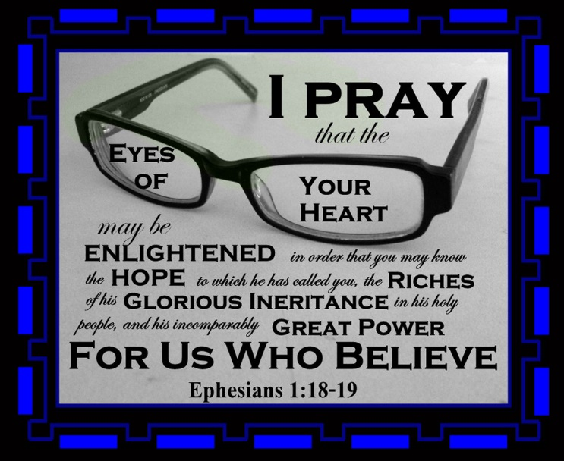Christ in the present, “complete or full” redemption will only happen in the future![40] The Holy Spirit is a “deposit” or “foretaste” [41] of the joyous life yet to come when believers will receive their “glorified bodies and stand before God without blemish!”[42] We as the “first fruits” of God’s glory (Romans 8:23)[43] eagerly await for Christ’s return so that we might go to our eternal home where there is no more sorrow, pain or death only praising our Lord all day long! The cure of fearing our animal, environment situations, medical issues, or negative situations in life is to be like Paul and remember though our troubles be many they are but “momentary” and insignificant in light of the guaranteed, eternal and glorious inheritance we are about to receive (2 Corinthians 4:17-18)!

**The Meaning of Life (12b, 14b)**

In conclusion eliminating fear is best accomplished by living according to the true meaning of life, to be the praise of God’s glory! [44] Since the goal of creation is “neither chaos nor disharmony but unity,”[45] God is “honored in the presence of human beings and angelic powers when men and women, redeemed from sin, live in accordance with His will and display family likeness which stamps them as His 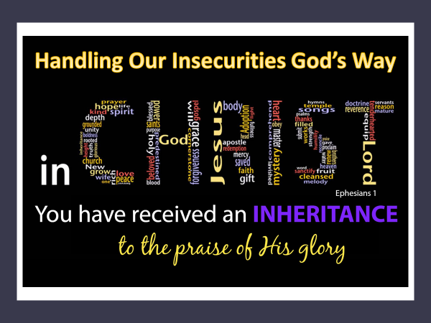children!”[46] We as the royal priests and Christ’s ambassadors then have a “high responsibility.” We are the “chosen instruments of God for the carrying out His purpose in the world”[47] and as such are not to take pride[48] in or hide[49] our spiritual blessings but share them with the world so that our thoughts, words and deeds might shine brightly and reveal to the lost the Father’s glory! Since all things are to be done “according to the good pleasure of His will,”[50] then the meaning of life is to know an obey God’s will in all that we do! Praise be to God that the Spirit believers have received is not one that enslaves us in fear but releases us to boldly live and proclaim the source of our eternal salvation to the world! Considering Paul’s teaching let us no longer loose sleep fearful of real and perceived threats but let us instead dream and live to be the praise of God’s glory! Amen!

1. Taken from the following website: <https://www.bing.com/search?q=fear+defined&form=ANNTH1&refig=cd13bea3788d4072a9216d710c972b52&sp=-1&ghc=1&pq=fear+defined&sc=8-12&qs=n&sk=&cvid=cd13bea3788d4072a9216d710c972b52>
2. Taken from the following website: <https://www.healthline.com/health/list-of-phobias>
3. James Montgomery Boice, [*Ephesians: An Expositional Commentary*](https://ref.ly/logosres/boicecm70eph?ref=Bible.Eph1.11-14&off=3058&ctx=pirit+and+his+work.%0a~The+first+work+of+th) (Grand Rapids, MI: Ministry Resources Library, 1988), 28.
4. James Montgomery Boice, [*Ephesians: An Expositional Commentary*](https://ref.ly/logosres/boicecm70eph?ref=Bible.Eph1.11-14&off=4325&ctx=Christ.+That+is+why+~Jesus+sent+the+Holy+) (Grand Rapids, MI: Ministry Resources Library, 1988), 28–29.
5. James Montgomery Boice, [*Ephesians: An Expositional Commentary*](https://ref.ly/logosres/boicecm70eph?ref=Bible.Eph1.11-14&off=3711) (Grand Rapids, MI: Ministry Resources Library, 1988), 28.
6. Peter Thomas O’Brien, [*The Letter to the Ephesians*](https://ref.ly/logosres/pntceph?ref=Bible.Eph1.11-12&off=1057&ctx=elic+beings%2c+but+the~+Lord+retains+Israel), The Pillar New Testament Commentary (Grand Rapids, MI: W.B. Eerdmans Publishing Co., 1999), 115.
7. Robert G. Bratcher and Eugene Albert Nida, [*A Handbook on Paul’s Letter to the Ephesians*](https://ref.ly/logosres/ubshbk70?ref=Bible.Eph1.11-12&off=1398&ctx=%E2%80%9Cto+choose+by+lot.%E2%80%9D+~The+idea+derives+fro), UBS Handbook Series (New York: United Bible Societies, 1993), 21.
8. John Muddiman, [*The Epistle to the Ephesians*](https://ref.ly/logosres/black70eph?ref=Bible.Eph1.11&off=2053&ctx=ed+by+the+desire+to+~correct+any+misunder), Black’s New Testament Commentary (London: Continuum, 2001), 77.
9. John Muddiman, [*The Epistle to the Ephesians*](https://ref.ly/logosres/black70eph?ref=Bible.Eph1.11&off=2386&ctx=n+(see+Rom.+9%3a4%E2%80%935).+~Thus%2c+%E2%80%98we%E2%80%99+(i.e.+Pau), Black’s New Testament Commentary (London: Continuum, 2001), 77.
10. Francis Foulkes, [*Ephesians: An Introduction and Commentary*](https://ref.ly/logosres/tntc70ephus?ref=Bible.Eph1.11-12&off=2473&ctx=ist+before+he+came.+~The+fact+that+the+Je), vol. 10, Tyndale New Testament Commentaries (Downers Grove, IL: InterVarsity Press, 1989), 63.
11. Douglas J. Moo, [“The Letters and Revelation,”](https://ref.ly/logosres/nivzndrvnstbbl?ref=Bible.Eph1.11&off=192&ctx=e+in+ch.+2.+chosen.+~Jewish+believers+in+) in *NIV Biblical Theology Study Bible*, ed. D. A. Carson (Grand Rapids, MI: Zondervan, 2018), 2118.
12. F. F. Bruce, [*The Epistles to the Colossians, to Philemon, and to the Ephesians*](https://ref.ly/logosres/nicnt72col?ref=Bible.Eph1.13&off=4&ctx=d+resurrection.%0a13++~But+God%E2%80%99s+portion+is), The New International Commentary on the New Testament (Grand Rapids, MI: Wm. B. Eerdmans Publishing Co., 1984), 264.
13. Peter Thomas O’Brien, [*The Letter to the Ephesians*](https://ref.ly/logosres/pntceph?ref=Bible.Eph1.14&off=4146&ctx=s+good+news+indeed.+~As+those+who+had+pre), The Pillar New Testament Commentary (Grand Rapids, MI: W.B. Eerdmans Publishing Co., 1999), 122.
14. Curtis Vaughan, [*Ephesians*](https://ref.ly/logosres/fsgc70eph?ref=Bible.Eph1.11&off=1368&ctx=+the+Promised+Land.+~Just+as+each+Israeli), Founders Study Guide Commentary (Cape Coral, FL: Founders Press, 2002), 27.
15. James Montgomery Boice, [*Ephesians: An Expositional Commentary*](https://ref.ly/logosres/boicecm70eph?ref=Bible.Eph1.11-14&off=7822&ctx=One+New+Man+of+Two%0a~The+third+work+of+the) (Grand Rapids, MI: Ministry Resources Library, 1988), 30.
16. James Montgomery Boice, [*Ephesians: An Expositional Commentary*](https://ref.ly/logosres/boicecm70eph?ref=Bible.Eph1.11-14&off=8679&ctx=aise+of+his+glory.%E2%80%9D%0a~This+was+an+importan) (Grand Rapids, MI: Ministry Resources Library, 1988), 30.
17. James Montgomery Boice, [*Ephesians: An Expositional Commentary*](https://ref.ly/logosres/boicecm70eph?ref=Bible.Eph1.11-14&off=9057&ctx=ew+breed+of+people%2c+~people+whose+lives+w) (Grand Rapids, MI: Ministry Resources Library, 1988), 30.
18. Peter Thomas O’Brien, [*The Letter to the Ephesians*](https://ref.ly/logosres/pntceph?ref=Bible.Eph1.13&off=3&ctx=+children%E2%80%99.%EF%BB%BF120%EF%BB%BF%0a13+~The+Lord%E2%80%99s+heritage+), The Pillar New Testament Commentary (Grand Rapids, MI: W.B. Eerdmans Publishing Co., 1999), 118.
19. F. F. Bruce, [*The Epistles to the Colossians, to Philemon, and to the Ephesians*](https://ref.ly/logosres/nicnt72col?ref=Bible.Eph1.13&off=658&ctx=of+God%E2%80%9D+(Rom.+1%3a1).+~The+communication+of), The New International Commentary on the New Testament (Grand Rapids, MI: Wm. B. Eerdmans Publishing Co., 1984), 264.
20. Francis Foulkes, [*Ephesians: An Introduction and Commentary*](https://ref.ly/logosres/tntc70ephus?ref=Bible.Eph1.13&off=686&ctx=+involves+for+them.%0a~The+Gentiles+had+com), vol. 10, Tyndale New Testament Commentaries (Downers Grove, IL: InterVarsity Press, 1989), 63–64.
21. James Montgomery Boice, [*Ephesians: An Expositional Commentary*](https://ref.ly/logosres/boicecm70eph?ref=Bible.Eph1.11-14&off=8255&ctx=s%E2%80%9D+in+verses+11%E2%80%9314%2c+~showing+that+the+ble) (Grand Rapids, MI: Ministry Resources Library, 1988), 30.
22. Arthur G. Patzia, [*Ephesians, Colossians, Philemon*](https://ref.ly/logosres/nibcnt70eph?ref=Bible.Eph1.13&off=182&ctx=r+coming+to+Christ%3a%0a~First%2c+they+heard+th), Understanding the Bible Commentary Series (Grand Rapids, MI: Baker Books, 2011), 157.
23. Peter Thomas O’Brien, [*The Letter to the Ephesians*](https://ref.ly/logosres/pntceph?ref=Bible.Eph1.13&off=2165&ctx=ems+to+be+intended.+~Here+in+Ephesians%2c+t), The Pillar New Testament Commentary (Grand Rapids, MI: W.B. Eerdmans Publishing Co., 1999), 119.
24. John Muddiman, [*The Epistle to the Ephesians*](https://ref.ly/logosres/black70eph?ref=Bible.Eph1.13&off=1693&ctx=pletely+different.+%E2%80%98~The+word+of+truth%E2%80%99+e), Black’s New Testament Commentary (London: Continuum, 2001), 78.
25. James Montgomery Boice, [*Ephesians: An Expositional Commentary*](https://ref.ly/logosres/boicecm70eph?ref=Bible.Eph1.11-14&off=11201&ctx=born+of+the+Spirit%E2%80%9D)~%2c+1+John+5%3a6+(%E2%80%9CThe+S) (Grand Rapids, MI: Ministry Resources Library, 1988), 31.
26. I believe this is a quote from A.W.Tozer.
27. James Montgomery Boice, [*Ephesians: An Expositional Commentary*](https://ref.ly/logosres/boicecm70eph?ref=Bible.Eph1.11-14&off=10684&ctx=art+from+Scripture.%0a~This+was+one+great+d) (Grand Rapids, MI: Ministry Resources Library, 1988), 31.
28. Douglas J. Moo, [“The Letters and Revelation,”](https://ref.ly/logosres/nivzndrvnstbbl?ref=Bible.Eph1.13&off=163&ctx=hip+and+protection.+~The+seal+used+to+mar) in *NIV Biblical Theology Study Bible*, ed. D. A. Carson (Grand Rapids, MI: Zondervan, 2018), 2118.
29. Curtis Vaughan, [*Ephesians*](https://ref.ly/logosres/fsgc70eph?ref=Bible.Eph1.13&off=1229&ctx=eal.+Believers+are+%E2%80%9C~sealed+with%E2%80%9D+the+Hol), Founders Study Guide Commentary (Cape Coral, FL: Founders Press, 2002), 28.
30. Francis Foulkes, [*Ephesians: An Introduction and Commentary*](https://ref.ly/logosres/tntc70ephus?ref=Bible.Eph1.13&off=2052&ctx=not+necessarily+so.+~The+Jews+thought+of+), vol. 10, Tyndale New Testament Commentaries (Downers Grove, IL: InterVarsity Press, 1989), 64.
31. John Piper, [*Sermons from John Piper (1980–1989)*](https://ref.ly/logosres/srmpiper1980?art=sermon.438&off=7883&ctx=t+you+would+expect.+~Since+God+does+all+t) (Minneapolis, MN: Desiring God, 2007).
32. John Piper, [*Sermons from John Piper (1980–1989)*](https://ref.ly/logosres/srmpiper1980?art=sermon.438&off=9721&ctx=ruth+is+the+same.%0a1.~+If+the+Spirit+seals) (Minneapolis, MN: Desiring God, 2007).
33. Arthur G. Patzia, [*Ephesians, Colossians, Philemon*](https://ref.ly/logosres/nibcnt70eph?ref=Bible.Eph1.13&off=5320&ctx=liever+with+a+seal.+~As+a+seal%2c+the+Spiri), Understanding the Bible Commentary Series (Grand Rapids, MI: Baker Books, 2011), 159.
34. Ben Witherington III, [*The Letters to Philemon, the Colossians, and the Ephesians : A Socio-Rhetorical Commentary on the Captivity Epistles*](https://ref.ly/logosres/sorhet78phm?ref=Bible.Eph1.12&off=1010&ctx=ership%2c+on+a+slave.+~The+point+is+not+the) (Grand Rapids, MI: Wm. B. Eerdmans Publishing Co., 2007), 237.
35. James Montgomery Boice, [*Ephesians: An Expositional Commentary*](https://ref.ly/logosres/boicecm70eph?ref=Bible.Eph1.11-14&off=13906&ctx=+the+Spirit%E2%80%99s+work.+~The+Holy+Spirit+veri) (Grand Rapids, MI: Ministry Resources Library, 1988), 32.
36. John Piper, [*Sermons from John Piper (1980–1989)*](https://ref.ly/logosres/srmpiper1980?art=sermon.438&off=1000&ctx=t+Dangerous+Mission%0a~So+let%E2%80%99s+make+sure+w) (Minneapolis, MN: Desiring God, 2007).
37. John Muddiman, [*The Epistle to the Ephesians*](https://ref.ly/logosres/black70eph?ref=Bible.Eph1.14&off=686&ctx=+future+completion.%0a~Paul+speaks+of+%E2%80%98inhe), Black’s New Testament Commentary (London: Continuum, 2001), 80.
38. F. F. Bruce, [*The Epistles to the Colossians, to Philemon, and to the Ephesians*](https://ref.ly/logosres/nicnt72col?ref=Bible.Eph1.14&off=1824&ctx=stry+of+the+Spirit.+~Redemption+is+alread), The New International Commentary on the New Testament (Grand Rapids, MI: Wm. B. Eerdmans Publishing Co., 1984), 266.
39. Arthur G. Patzia, [*Ephesians, Colossians, Philemon*](https://ref.ly/logosres/nibcnt70eph?ref=Bible.Eph1.14&off=7&ctx=+protection.%0a1%3a14+%2f+~In+addition+to+owner), Understanding the Bible Commentary Series (Grand Rapids, MI: Baker Books, 2011), 159.
40. Curtis Vaughan, [*Ephesians*](https://ref.ly/logosres/fsgc70eph?ref=Bible.Eph1.13&off=3558&ctx=ack+again%E2%80%9D+(p.+85).%0a~There+is%2c+of+course%2c), Founders Study Guide Commentary (Cape Coral, FL: Founders Press, 2002), 29.
41. Curtis Vaughan, [*Ephesians*](https://ref.ly/logosres/fsgc70eph?ref=Bible.Eph1.13&off=2779&ctx=e+use+of+this+word.+~The+earnest+was+itse), Founders Study Guide Commentary (Cape Coral, FL: Founders Press, 2002), 29.
42. Curtis Vaughan, [*Ephesians*](https://ref.ly/logosres/fsgc70eph?ref=Bible.Eph1.13&off=3993&ctx=93).+But+at+present+~our+redemption+is+in), Founders Study Guide Commentary (Cape Coral, FL: Founders Press, 2002), 29.
43. F. F. Bruce, [*The Epistles to the Colossians, to Philemon, and to the Ephesians*](https://ref.ly/logosres/nicnt72col?ref=Bible.Eph1.14&off=1034&ctx=s+%E2%80%9Cfirst+fruits%E2%80%9D%3a99+~in+Rom.+8%3a23+the+Spi), The New International Commentary on the New Testament (Grand Rapids, MI: Wm. B. Eerdmans Publishing Co., 1984), 266.
44. Francis Foulkes, [*Ephesians: An Introduction and Commentary*](https://ref.ly/logosres/tntc70ephus?ref=Bible.Eph1.11-12&off=1945&ctx=verywhere+at+work%E2%80%99.%0a~The+goal+of+this+his), vol. 10, Tyndale New Testament Commentaries (Downers Grove, IL: InterVarsity Press, 1989), 63.
45. R. C. Sproul, [*The Purpose of God: Ephesians*](https://ref.ly/logosres/purposegod?ref=Bible.Eph1.9-10&off=5395&ctx=er%2c+under+one+head.+~The+goal+of+creation) (Scotland: Christian Focus Publications, 1994), 30.
46. F. F. Bruce, [*The Epistles to the Colossians, to Philemon, and to the Ephesians*](https://ref.ly/logosres/nicnt72col?ref=Bible.Eph1.12&off=232&ctx=being+foreordained.+~God+is+honored+in+th), The New International Commentary on the New Testament (Grand Rapids, MI: Wm. B. Eerdmans Publishing Co., 1984), 264.
47. Curtis Vaughan, [*Ephesians*](https://ref.ly/logosres/fsgc70eph?ref=Bible.Eph1.13&off=5908&ctx=es+a+hostile+world.%0a~Finally%2c+our+respons), Founders Study Guide Commentary (Cape Coral, FL: Founders Press, 2002), 30.
48. Curtis Vaughan, [*Ephesians*](https://ref.ly/logosres/fsgc70eph?ref=Bible.Eph1.11&off=2876&ctx=is+glory%E2%80%9D+(vs.+12).+~God%E2%80%99s+intention+was+), Founders Study Guide Commentary (Cape Coral, FL: Founders Press, 2002), 27–28.
49. James Montgomery Boice, [*Ephesians: An Expositional Commentary*](https://ref.ly/logosres/boicecm70eph?ref=Bible.Eph1.11-14&off=7081&ctx=ise+of+this+glory.%E2%80%9D+~Sometimes+Christians) (Grand Rapids, MI: Ministry Resources Library, 1988), 29.
50. F. F. Bruce, [*The Epistles to the Colossians, to Philemon, and to the Ephesians*](https://ref.ly/logosres/nicnt72col?ref=Bible.Eph1.11&off=1191&ctx=nce+in+the+saints.%E2%80%9D%0a~The+idea+of+the+divi), The New International Commentary on the New Testament (Grand Rapids, MI: Wm. B. Eerdmans Publishing Co., 1984), 263.