**More than a Name**

**Colossians 1:15-20**

Online Sermon: <http://www.mckeesfamily.com/?page_id=3567>

A “name” is “a word or set of words by which a person, animal, place, or thing is known, addressed, or referred to.”[1] Upon birth the name Christians parents choose for their child often depends on its associated meaning. For example, Phoebe means “shining or pure light,” Naomi means “pleasant,” cherry means “fruit bearing,” Annette means “gracious or merciful,” and Christopher means “he who holds Christ in his heart.” Whether one chooses a name based on its associated meaning, after a relative, or simply because it sounds good, the result is the same, our names become associated with who we are as a person. Jesus has many names in the Bible to reflect the many facets of His person. He is called “Son of God,” “bread of life,” Alpha and Omega,” “Chief Cornerstone,” “Good Shepherd,” “King of Kings,” and so on to reflect His many divine attributes as our sovereign Creator. Even though the name “Jesus” is rich in Biblical meaning this does not mean that those who say His name know or believe in His identity. While it is a sin to say Jesus’ name in vain is it not equally or more grievous of a sin to relegate His name to a created being and to but one intermediary between us and God? What does Jesus’ name mean to you? The following sermon on Colossians 1:15-20 is going to examine Apostle Paul’s response to a heresy that broke out in Colossae concerning Christ’s identity in hope that we might come to associate the name “Jesus’” with His true identity: He is the image of the invisible God, firstborn and supreme over all creation, the head of the church and our Redeemer!

**Colossian Heresy**

While the “precise origin and philosophy of the false teachers” [2] in Colossae remains unclear, from Paul’s response[3] we can safely say at its core it related to the false belief that Christ being called the “first-born of all creation” suggested He was merely a created being.[4] This heresy was the beginning of second-century Gnosticism[5] and was championed by the Arians in the fourth century and still believed by the Jehovah Witnesses and others today. [6] The false teachers told the Colossians they “needed 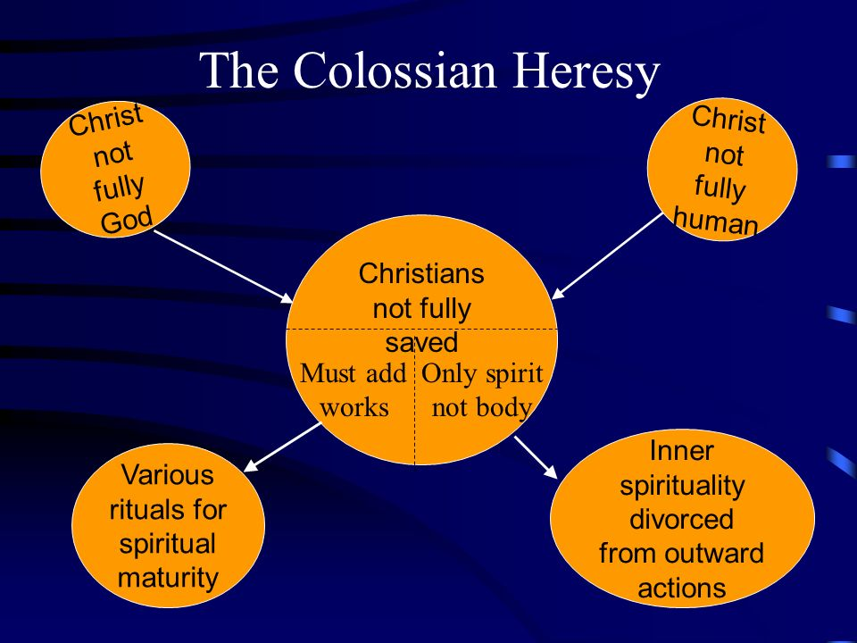something more than their relationship with Jesus” to bring them into the presence of God.[7] They believed the key to defeating the demons that ran rampant in their world[8] and the key to approaching God could only be found in receiving “special knowledge”[9] as obtained from legalism or mystical experiences. For example, to approach God they suggested one must first “appease or revere the elemental spirits of the universe” [10] by participating in “mystical rites that would transport them spiritually to a heavenly plane where they could worship God in the company of the hosts of heaven (Ezekiel 1:4-28; 1 Cor. 11:10; 2 Cor 12:1-5).”[11] Since to them Christ was not sufficient for one’s salvation, like the Judaizers[12] they suggested observing “ascetic practices and ritual observances; dietary restrictions (2:6), festival and Sabbath observance (2:16), self-abasement (2:18), taboos regarding what to handle, taste or touch (2:21), and quite possibly circumcision (2:11); [13] were the key to approaching a holy God. To counteract their arguments Paul masterfully stated Christ is sufficient for one’s salvation and approaching a holy God because 1) Jesus is the exact image of the invisible God, 2) firstborn and supreme over all creation, 3) head of the church and our 4) Redeemer.

1. **Christ is the Image of the Invisible God (15a, 19)**

To clarify Christ’s identity Apostle Paul begins with the bold statement that the “Son is the image of the invisible God” (15a) of which “God was pleased to have all His fulness dwell in Him” (19). While 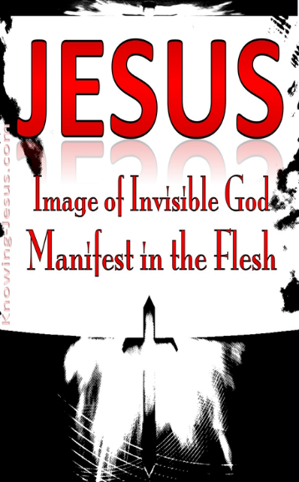Adam was created “according to the image” of God (Genesis 1:26-27),[14] Paul states Christ is the image (eikona) or the “exact and full representation of God in character.”[15] Since “fullness” for Paul is a “wide, far reaching, and all comprehending term” [16] this meant Christ was not a mere representation of God but contained all His attributes.[17] While us “mutable creatures by reason of our frailty as broken cisterns”[18] can not contain the fulness of God, He who is far more than Prophet, Priest and King,[19] the “Alpha and Omega,”[20] and “sinless lamb of the temple of heaven” (Revelation 21:22);[21] eternally has God’s nature (Hebrews 1:3) [22] because He is the second person of the Godhead! The closeness to God the Colossians sought then would not be found in the mere representation of the truth,[23] as found in legalism or mystical experiences, but in belief in a resurrected Lord or not all![24] The “indwelling of Christ in the Godhead”[25] for Paul is the only foundation by which sinners through grace and faith can be forgiven, born again, adopted and reconciled with a holy God! The purpose of Paul’s statements was to convince the Colossians if they wanted to know God then Christ must be pre-eminent in their thoughts,[26] not created beings on earth or in heaven! [27]

1. **Christ is Firstborn and Supreme Over all Creation (15b – 17)**

While the phrase “first-born over all creation” might sound like “Christ was part of creation and therefore not truly God,”[28] this phrase signifies Christ’s eternal pre-existence[29] as the “King Messiah,” [30] the divine heir of the Father[31] and agent and sustainer of all things seen and unseen (17). While God’s divine power and nature can be seen perceived in creation (Romans 1:20),[32] only Christ can claim the fullness of God’s nature and sovereignty as both the agent and goal of creation (Hebrews 1:2; 10:5–9; John 1:1–2; 8:58)![33] While the “Trinity was active in the work of creation” (Genesis 1) the “by Him” for Paul and other Biblical writers meant Christ was the agent not a recipient of God’s work of Creation as the false teachers of Colossae were suggesting![34] As the Alpha and Omega, Christ did not pre-exist in 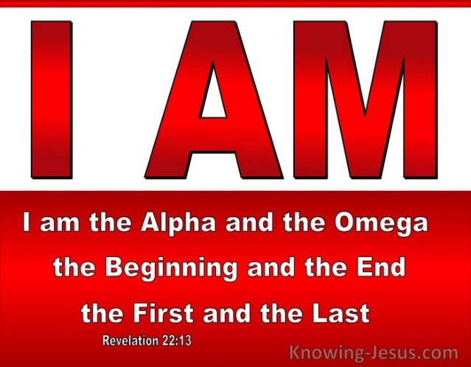human form but “emptied Himself” and became the incarnate, Son of God (Philippians 2:6–8).[35]Apostle Paul mentions the “all-encompassing”[36] work of Christ in Creation, His sovereignty over all things seen and unseen, specifically “thrones or powers or rulers or authorities;” to remind the Colossians that nothing rivals Christ[37] so their mystical experiences with “supernatural beings” [38] would not get them closer to God, only through His heir, Christ could salvation be obtained and the presence of God secured! Since it is through the “mediatorial world-rule of Christ that God’s eternal kingdom is finally to be established (1 Corinthians 15:24–28),”[39] the Colossians are to rejoice for those redeemed by Christ have “no ultimate terrors” [40] and therefore need not fear demons who are subject to Christ’s dominion and rule!

1. **Christ is the Head of the Church (18)**

Since Christ is the heir and sovereign Creator of all things seen and unseen Paul reminds the false teachers that this means Christ is also the head of the gathering of God’s people, the *ekklēsia* or the church.[41] Even though His “Lordship over fallen and rebellious creation (1 Cor. 15:25–28; Heb. 2:8)is yet to be manifested,”[42] Paul reminds the false teachers of Colossae that“there is 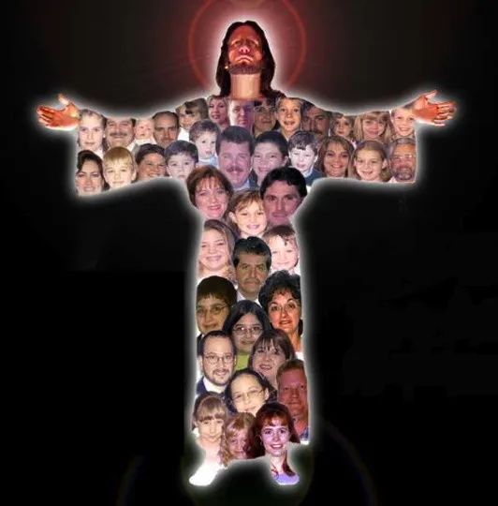nothing lacking in Christ because the fullness of deity, power and grace are His”[43] and as such Christ alone qualifies to be the “head” of the church. Christ’s authority over the church resides in what He has done for the church, i.e. atoning sacrifice,[44] and He exercises His authority by His Word and Spirit.[45] When Paul says “He is the head of the body, the church” (18), he is not referring to the Greek teachings of Plato, Stoics or Philo who believed the cosmos was filled and governed by “Wisdom” or “Logos,” as the head,[46] but the incarnate Christ, the founder of a “new order of resurrection,”[47] a “worldwide entity, embracing all who acknowledge Christ as Lord!”[48] At its “source” or “origin,”[49] the church is to be viewed as a living entity in which its head Christ “supplies life, exercises control and gives direction.”[50] Those who are baptized into Christ are the only members of the church for they alone are new creations and as such have “His risen life” [51] and every spiritual blessing eternally given to them (Ephesians 1:3).

1. **Christ is our Redeemer (20)**

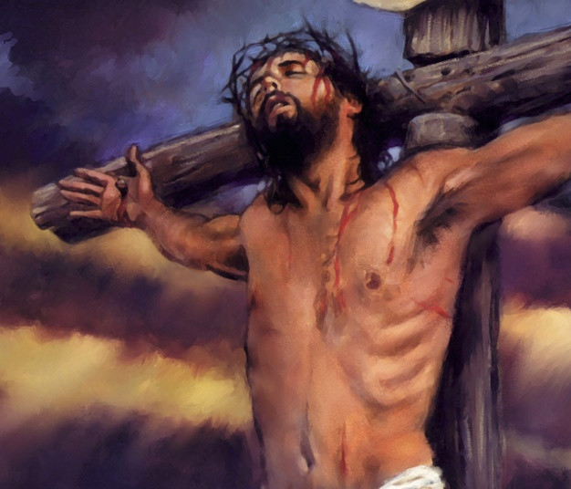 Paul finished his rebuttal to the Colossian heresy by stating that Christ’s supremacy can ultimately be seen in his role as Redeemer.[52] Even though in the Garden Adam had an “unbroken fellowship with God,”[53] after the Fall human nature became a “desert, empty, and void, and waste, inhabited only by the dragon of sin, and bittern of sorrow.”[54] Even though created by and for Him (16) and according to God’s image,[55] the bondage of sin created enmity and severed humanity’s relationship with the Creator.[56] Through faith in atonement of Christ[57] “sin’s curse and condemnation” were cancelled for He alone appeased God’s righteous wrath by paying the debt for our sin.[58] When Paul states “reconcile to Himself all things” (20) this does not mean that he was teaching universalism, the belief that none are condemned and one day all saved,[59] but as he points out later in 3:10-11 that the image of the Creator is renewed in those who put on the new nature through belief in His atonement.[60] “Nothing in heaven or on earth that God has appointed to be a part of the new creation in Christ will fail to be reconciled to Him.”[61] This also does not mean that the physical but spiritual consequences of the curse have been removed. So may we rejoice that when one’s “soul clasps the pierced feet of Jesus, and looks up into the face more marred than that of any man, even if one cannot understand all His works and offices, yet if one believes in Him, one will have reached the place wherein all fulness dwells, and of His fulness one shall receive.”[62]

**What Does the Name “Jesus” Mean to You?**

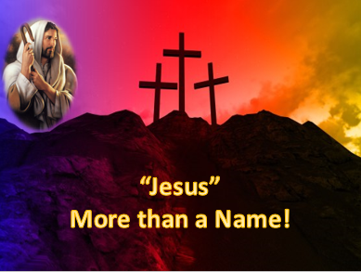A “name” is “a word or set of words by which a person, animal, place, or thing is known, addressed, or referred to.” For many in this world the name “Jesus” means nothing more than an easily pronounced curse word and yet for others His name represents a “good” but not sufficient person to give us salvation or access to a holy God. To combat such heresies Apostle Paul reminds us today that while Christ is the “first-born of all creation,” the “Son of God,” “Alpha and Omega,” and “King of Kings” is not the recipient but agent of creation, for He has eternally been the second person of the Godhead. Just because Christ chose to “empty” and humble Himself by becoming the Incarnate Christ does in no way reduce His pre-existent sovereignty over all things seen and unseen! As One who has purchased us at a price, He deserves more than our occasional thoughts or platitudes of endearment! As the One who appeased God’s righteous wrath against humanity, the Son of God alone has the right to be the Lord overall everyone and is the rightful head of the church. And finally, and with great rejoicing, Christ is our Redeemer. One simply cannot be reconciled and approach a holy God based on mystical experience or adherence to the Law but only based on faith in the atoning sacrifice of the Son. So, surely when you think about the name “Jesus” your mind hits a pinnacle of rejoicing for in Him us wretches have not only been set free from the bondage of sin but when we have faith and grace in Christ we are adopted and have become children of God!

1. https://www.bing.com/search?q=name+definition&form=ANNTH1&refig=2a05b454d9434b8f8f669ba88e96943e&sp=-1&ghc=2&pq=name+defin&sc=8-10&qs=n&sk=&cvid=2a05b454d9434b8f8f669ba88e96943e
2. Jason C. Kuo, [“Colossians, Letter to the,”](https://ref.ly/logosres/lbd?art=colossians.2c_letter_to_the.2c_introduction_to.colossians.2c_letter_to_the.2c_introduction_to.theological_emphases.false_teaching&off=825&ctx=+flesh%E2%80%9D+(2%3a23+ESV).%0a~The+precise+origin+a) ed. John D. Barry et al., *The Lexham Bible Dictionary* (Bellingham, WA: Lexham Press, 2016).
3. F. F. Bruce, [*The Epistles to the Colossians, to Philemon, and to the Ephesians*](https://ref.ly/logosres/nicnt72col?ref=Bible.Col1.19&off=2489&ctx=+mid-first+century.+~We+must+constantly+r), The New International Commentary on the New Testament (Grand Rapids, MI: Wm. B. Eerdmans Publishing Co., 1984), 73–74.
4. Douglas J. Moo, [*The Letters to the Colossians and to Philemon*](https://ref.ly/logosres/pntccolphm?ref=Bible.Col1.15&off=4497&ctx=+over+all+creation.+~Calling+Christ+%E2%80%9Cfirs), The Pillar New Testament Commentary (Grand Rapids, MI: William B. Eerdmans Pub. Co., 2008), 119.
5. Ian S McNaughton, [*Opening up Colossians and Philemon*](https://ref.ly/logosres/openup72col?ref=Page.p+11&off=199&ctx=iritual+it+was+not.+~It+is+generally+agre), Opening Up Commentary (Leominster: Day One Publications, 2006), 11.
6. Arthur G. Patzia, [*Ephesians, Colossians, Philemon*](https://ref.ly/logosres/nibcnt70eph?ref=Bible.Col1.15&off=1106&ctx=+the+created+order.+~Apparently+the+false), Understanding the Bible Commentary Series (Grand Rapids, MI: Baker Books, 2011), 30.
7. Max Anders, [*Galatians-Colossians*](https://ref.ly/logosres/hntc69ga?ref=Bible.Col1&off=37022&ctx=cy+of+Jesus+Christ.+~Heretics+told+believ), vol. 8, Holman New Testament Commentary (Nashville, TN: Broadman & Holman Publishers, 1999), 289.
8. William Barclay, [*The Letters to Philippians, Colossians, and Thessalonians*](https://ref.ly/logosres/ndsb71php?ref=Page.p+111&off=810&ctx=(1%3a16%2c+2%3a10%2c+2%3a15).+~The+ancient+world+be), 3rd ed. fully rev. and updated., The New Daily Study Bible (Louisville, KY; London: Westminster John Knox Press, 2003), 111.
9. Max Anders, [*Galatians-Colossians*](https://ref.ly/logosres/hntc69ga?ref=Bible.Col1&off=39965&ctx=et+hierarchicalism.+~Gnosticism+also+thou), vol. 8, Holman New Testament Commentary (Nashville, TN: Broadman & Holman Publishers, 1999), 289–290.
10. Mark Allen Powell, Introducing the New Testament: A Historical, Literary, and Theological Survey (Grand Rapids, MI: Baker Academic, 2009), 360.
11. Mark Allen Powell, Introducing the New Testament: A Historical, Literary, and Theological Survey (Grand Rapids, MI: Baker Academic, 2009), 360.
12. Max Anders, [*Galatians-Colossians*](https://ref.ly/logosres/hntc69ga?ref=Bible.Col1&off=39539&ctx=izers+in+Galatians.+~Judaizers+taught+tha), vol. 8, Holman New Testament Commentary (Nashville, TN: Broadman & Holman Publishers, 1999), 289.
13. Mark Allen Powell, Introducing the New Testament: A Historical, Literary, and Theological Survey (Grand Rapids, MI: Baker Academic, 2009), 360.
14. Charles H. Talbert, [*Ephesians and Colossians*](https://ref.ly/logosres/paideia70eph?ref=Bible.Col1.3-23&off=13657&ctx=lyn+2002%2c+36%2c+%2315).+~A+reference+to+Adam+), Paideia Commentaries on the New Testament (Grand Rapids, MI: Baker Academic, 2007), 187.
15. Ben Witherington III, [*The Letters to Philemon, the Colossians, and the Ephesians : A Socio-Rhetorical Commentary on the Captivity Epistles*](https://ref.ly/logosres/sorhet78phm?ref=Bible.Col1.15&off=73&ctx=+the+invisible+God.+~We+could+tease+this+) (Grand Rapids, MI: Wm. B. Eerdmans Publishing Co., 2007), 133.
16. C. H. Spurgeon, [“All Fulness in Christ,”](https://ref.ly/logosres/mtpserms17?ref=Page.p+123&off=102&ctx=rom+the+honeycomb.+%E2%80%9C~All+fulness%E2%80%9D+is+a+wi) in *The Metropolitan Tabernacle Pulpit Sermons*, vol. 17 (London: Passmore & Alabaster, 1871), 123.
17. C. H. Spurgeon, [“All Fulness in Christ,”](https://ref.ly/logosres/mtpserms17?ref=Page.p+123&off=3065&ctx=s+too+hard+for+him.+~Power%2c+wisdom%2c+truth) in *The Metropolitan Tabernacle Pulpit Sermons*, vol. 17 (London: Passmore & Alabaster, 1871), 123.
18. C. H. Spurgeon, [“All Fulness in Christ,”](https://ref.ly/logosres/mtpserms17?ref=Page.p+128&off=375&ctx=d+remain%2c+for+ever.+~Now+if+any+kind+of+f) in *The Metropolitan Tabernacle Pulpit Sermons*, vol. 17 (London: Passmore & Alabaster, 1871), 128.
19. C. H. Spurgeon, [“All Fulness in Christ,”](https://ref.ly/logosres/mtpserms17?ref=Page.p+128&off=3088&ctx=t+lay+hold+of+this.+~I+know+that+the+fuln) in *The Metropolitan Tabernacle Pulpit Sermons*, vol. 17 (London: Passmore & Alabaster, 1871), 128–129.
20. Ben Witherington III, [*The Letters to Philemon, the Colossians, and the Ephesians : A Socio-Rhetorical Commentary on the Captivity Epistles*](https://ref.ly/logosres/sorhet78phm?ref=Bible.Col1.15&off=1899&ctx=lped+create+it+all.+~He+is+the+one+that+J) (Grand Rapids, MI: Wm. B. Eerdmans Publishing Co., 2007), 134.
21. C. H. Spurgeon, [“All Fulness in Christ,”](https://ref.ly/logosres/mtpserms17?ref=Page.p+126&off=1314&ctx=s+power+they+reign.+~Those+snowy+robes+we) in *The Metropolitan Tabernacle Pulpit Sermons*, vol. 17 (London: Passmore & Alabaster, 1871), 126.
22. Ian S McNaughton, [*Opening up Colossians and Philemon*](https://ref.ly/logosres/openup72col?ref=Bible.Col1.15&off=37&ctx=st%E2%80%99s+person+(v.+15)%0a~Jesus+Christ+is+%E2%80%98the), Opening Up Commentary (Leominster: Day One Publications, 2006), 28.
23. C. H. Spurgeon, [“All Fulness in Christ,”](https://ref.ly/logosres/mtpserms17?ref=Page.p+122&off=2865&ctx=things.%E2%80%9D+Heb.+10%3a1.+~What+transport+is+th) in *The Metropolitan Tabernacle Pulpit Sermons*, vol. 17 (London: Passmore & Alabaster, 1871), 122.
24. Ben Witherington III, [*The Letters to Philemon, the Colossians, and the Ephesians : A Socio-Rhetorical Commentary on the Captivity Epistles*](https://ref.ly/logosres/sorhet78phm?ref=Bible.Col1.19&off=485&ctx=what+is+meant+here%3a+~the+fullness+of+God+) (Grand Rapids, MI: Wm. B. Eerdmans Publishing Co., 2007), 136.
25. David Brown, A. R. Fausset, and Robert Jamieson, [*A Commentary, Critical, Experimental, and Practical, on the Old and New Testaments: Acts–Revelation*](https://ref.ly/logosres/cmmntrycrtclexprmntlprctlvol6?ref=Bible.Col1.19&off=847&ctx=%5beskenosen%5d%3b+2%3a21).+~This+indwelling+Godh), vol. VI (London; Glasgow: William Collins, Sons, & Company, Limited, n.d.), 442.
26. Charles H. Talbert, [*Ephesians and Colossians*](https://ref.ly/logosres/paideia70eph?ref=Bible.Col1.3-23&off=20962&ctx=+(Martin+1974%2c+59).%0a~The+purpose+of+his+r), Paideia Commentaries on the New Testament (Grand Rapids, MI: Baker Academic, 2007), 190.
27. C. H. Spurgeon, [“All Fulness in Christ,”](https://ref.ly/logosres/mtpserms17?ref=Page.p+121&off=697&ctx=e+the+pre-eminence.+~We+would+seek+by+thi) in *The Metropolitan Tabernacle Pulpit Sermons*, vol. 17 (London: Passmore & Alabaster, 1871), 121.
28. John Piper, [*Sermons from John Piper (1980–1989)*](https://ref.ly/logosres/srmpiper1980?art=sermon.539&off=2764&ctx=ses+15%2c+20%2c+and+23.%0a~In+verse+15+it+may+s) (Minneapolis, MN: Desiring God, 2007).
29. Douglas J. Moo, [*The Letters to the Colossians and to Philemon*](https://ref.ly/logosres/pntccolphm?ref=Bible.Col1.17&off=732&ctx=hymn+as+a+whole.168%0a~The+claim+that+Chris), The Pillar New Testament Commentary (Grand Rapids, MI: William B. Eerdmans Pub. Co., 2008), 125.
30. Daniel M. Gurtner, [“Colossians,”](https://ref.ly/logosres/bkbc65ac?ref=Bible.Col1.15-20&off=1962&ctx=plies+it+to+Christ.+~Rabbis+understood+th) in *The Bible Knowledge Background Commentary: Acts–Philemon*, ed. Craig A. Evans and Craig A. Bubeck, First Edition. (Colorado Springs, CO: David C Cook, 2004), 595.
31. Ian S McNaughton, [*Opening up Colossians and Philemon*](https://ref.ly/logosres/openup72col?ref=Bible.Col1.15&off=253&ctx=o-eternal+with+him.+~The+Father+is+invisi), Opening Up Commentary (Leominster: Day One Publications, 2006), 28.
32. F. F. Bruce, [*The Epistles to the Colossians, to Philemon, and to the Ephesians*](https://ref.ly/logosres/nicnt72col?ref=Bible.Col1.15&off=1255&ctx=ather%E2%80%9D+(John+14%3a9).+~In+another+letter+Pa), The New International Commentary on the New Testament (Grand Rapids, MI: Wm. B. Eerdmans Publishing Co., 1984), 58.
33. Arthur G. Patzia, [*Ephesians, Colossians, Philemon*](https://ref.ly/logosres/nibcnt70eph?ref=Bible.Col1.16&off=344&ctx=he+action+intended%3a+~God+created+the+whol), Understanding the Bible Commentary Series (Grand Rapids, MI: Baker Books, 2011), 30.
34. John Piper, [*Sermons from John Piper (1980–1989)*](https://ref.ly/logosres/srmpiper1980?art=sermon.539&off=5152&ctx=the+previous+verse.+~Notice+how+Christ+%E2%80%9Ci) (Minneapolis, MN: Desiring God, 2007).
35. Ian S McNaughton, [*Opening up Colossians and Philemon*](https://ref.ly/logosres/openup72col?ref=Bible.Col1.17&off=396&ctx=+17%3a5%3b+2+Cor.+8%3a9).+~He+is+the+Alpha+and+), Opening Up Commentary (Leominster: Day One Publications, 2006), 29.
36. Ben Witherington III, [*The Letters to Philemon, the Colossians, and the Ephesians : A Socio-Rhetorical Commentary on the Captivity Epistles*](https://ref.ly/logosres/sorhet78phm?ref=Bible.Col1.16&off=164&ctx=+and+unseen+things.+~Nothing+at+all+was+c) (Grand Rapids, MI: Wm. B. Eerdmans Publishing Co., 2007), 134.
37. Douglas J. Moo, [*The Letters to the Colossians and to Philemon*](https://ref.ly/logosres/pntccolphm?ref=Bible.Col1.16&off=5505&ctx=+ancient+worldview.+~This+belief+was+appa), The Pillar New Testament Commentary (Grand Rapids, MI: William B. Eerdmans Pub. Co., 2008), 123.
38. Ben Witherington III, [*The Letters to Philemon, the Colossians, and the Ephesians : A Socio-Rhetorical Commentary on the Captivity Epistles*](https://ref.ly/logosres/sorhet78phm?ref=Bible.Col1.16&off=317&ctx=(v.+16c).+In+v.+16b+~Paul+enumerates+some) (Grand Rapids, MI: Wm. B. Eerdmans Publishing Co., 2007), 134.
39. F. F. Bruce, [*The Epistles to the Colossians, to Philemon, and to the Ephesians*](https://ref.ly/logosres/nicnt72col?ref=Bible.Col1.16&off=5892&ctx=ummed+up+in+Christ.+~Or%2c+as+Paul+had+put+), The New International Commentary on the New Testament (Grand Rapids, MI: Wm. B. Eerdmans Publishing Co., 1984), 65.
40. F. F. Bruce, [*The Epistles to the Colossians, to Philemon, and to the Ephesians*](https://ref.ly/logosres/nicnt72col?ref=Bible.Col1.16&off=2264&ctx=gospel+the+more.113+~For+those+who+have+b), The New International Commentary on the New Testament (Grand Rapids, MI: Wm. B. Eerdmans Publishing Co., 1984), 63.
41. David Brown, A. R. Fausset, and Robert Jamieson, [*A Commentary, Critical, Experimental, and Practical, on the Old and New Testaments: Acts–Revelation*](https://ref.ly/logosres/cmmntrycrtclexprmntlprctlvol6?ref=Bible.Col1.18&off=403&ctx=h.+1%3a22%3b+4%3a15%2c+16).+~The+One+who+is+Head+), vol. VI (London; Glasgow: William Collins, Sons, & Company, Limited, n.d.), 442.
42. Douglas J. Moo, [*The Letters to the Colossians and to Philemon*](https://ref.ly/logosres/pntccolphm?ref=Bible.Col1.18&off=8031&ctx=so+true+that+he+has+~yet+to+manifest+that), The Pillar New Testament Commentary (Grand Rapids, MI: William B. Eerdmans Pub. Co., 2008), 130.
43. Ian S McNaughton, [*Opening up Colossians and Philemon*](https://ref.ly/logosres/openup72col?ref=Bible.Col1.18-19&off=566&ctx=s%E2%80%99+in+Colosse+used.+~Paul+used+it+to+remi), Opening Up Commentary (Leominster: Day One Publications, 2006), 30.
44. David Brown, A. R. Fausset, and Robert Jamieson, [*A Commentary, Critical, Experimental, and Practical, on the Old and New Testaments: Acts–Revelation*](https://ref.ly/logosres/cmmntrycrtclexprmntlprctlvol6?ref=Bible.Col1.19&off=480&ctx=y+creature+(v.+15).+~For+two+reasons+Chri), vol. VI (London; Glasgow: William Collins, Sons, & Company, Limited, n.d.), 442.
45. Ian S McNaughton, [*Opening up Colossians and Philemon*](https://ref.ly/logosres/openup72col?ref=Bible.Col1.18-19&off=43&ctx=osition+(vv.+18%E2%80%9319)%0a~Christ+is+head+over+), Opening Up Commentary (Leominster: Day One Publications, 2006), 29–30.
46. Arthur G. Patzia, [*Ephesians, Colossians, Philemon*](https://ref.ly/logosres/nibcnt70eph?ref=Bible.Col1.18&off=836&ctx=of+the+cosmic+body.%0a~In+several+Greek+sou), Understanding the Bible Commentary Series (Grand Rapids, MI: Baker Books, 2011), 31–32.
47. Douglas J. Moo, [*The Letters to the Colossians and to Philemon*](https://ref.ly/logosres/pntccolphm?ref=Bible.Col1.18&off=6650&ctx=3%3b+Matt.+27%3a52%E2%80%9353).+~In+this+sense%2c+he+is), The Pillar New Testament Commentary (Grand Rapids, MI: William B. Eerdmans Pub. Co., 2008), 129.
48. Douglas J. Moo, [*The Letters to the Colossians and to Philemon*](https://ref.ly/logosres/pntccolphm?ref=Bible.Col1.18&off=2519&ctx=ians+and+Ephesians.+~The+ekkl%C4%93sia+is+no+l), The Pillar New Testament Commentary (Grand Rapids, MI: William B. Eerdmans Pub. Co., 2008), 127.
49. F. F. Bruce, [*The Epistles to the Colossians, to Philemon, and to the Ephesians*](https://ref.ly/logosres/nicnt72col?ref=Bible.Col1.18&off=4067&ctx=ist%E2%80%99s+head+is+God.%E2%80%9D+~In+these+three+claus), The New International Commentary on the New Testament (Grand Rapids, MI: Wm. B. Eerdmans Publishing Co., 1984), 68.
50. F. F. Bruce, [*The Epistles to the Colossians, to Philemon, and to the Ephesians*](https://ref.ly/logosres/nicnt72col?ref=Bible.Col1.18&off=4598&ctx=+the+church%E2%80%99s+lord.%0a~So+far+as+the+organi), The New International Commentary on the New Testament (Grand Rapids, MI: Wm. B. Eerdmans Publishing Co., 1984), 68.
51. F. F. Bruce, [*The Epistles to the Colossians, to Philemon, and to the Ephesians*](https://ref.ly/logosres/nicnt72col?ref=Bible.Col1.18&off=8729&ctx=ch%E2%80%99s+sinfulness.148%0a~The+conception+of+th), The New International Commentary on the New Testament (Grand Rapids, MI: Wm. B. Eerdmans Publishing Co., 1984), 71.
52. Douglas J. Moo, [*The Letters to the Colossians and to Philemon*](https://ref.ly/logosres/pntccolphm?ref=Bible.Col1.18&off=7430&ctx=or%3b+in+either+case%2c+~Christ%E2%80%99s+supremacy+i), The Pillar New Testament Commentary (Grand Rapids, MI: William B. Eerdmans Pub. Co., 2008), 130.
53. Ian S McNaughton, [*Opening up Colossians and Philemon*](https://ref.ly/logosres/openup72col?ref=Bible.Col1.20-23&off=42&ctx=passion+(vv.+20%E2%80%9323)%0a~Before+the+Fall%2c+God), Opening Up Commentary (Leominster: Day One Publications, 2006), 30.
54. C. H. Spurgeon, [“All Fulness in Christ,”](https://ref.ly/logosres/mtpserms17?ref=Page.p+122&off=1012&ctx=ure+it+if+we+could.+~In+these+respects+hu) in *The Metropolitan Tabernacle Pulpit Sermons*, vol. 17 (London: Passmore & Alabaster, 1871), 122.
55. Douglas J. Moo, [*The Letters to the Colossians and to Philemon*](https://ref.ly/logosres/pntccolphm?ref=Bible.Col1.20&off=1826&ctx=how+been+disrupted.+~Though+created+throu), The Pillar New Testament Commentary (Grand Rapids, MI: William B. Eerdmans Pub. Co., 2008), 134.
56. F. F. Bruce, [*The Epistles to the Colossians, to Philemon, and to the Ephesians*](https://ref.ly/logosres/nicnt72col?ref=Bible.Col1.20&off=825&ctx=from+their+Creator.+~In+Rom.+8%3a19%E2%80%9323+Paul), The New International Commentary on the New Testament (Grand Rapids, MI: Wm. B. Eerdmans Publishing Co., 1984), 74.
57. F. F. Bruce, [*The Epistles to the Colossians, to Philemon, and to the Ephesians*](https://ref.ly/logosres/nicnt72col?ref=Bible.Col1.20&off=2327&ctx=s%3b+and+as+for+Paul%2c+~he+thinks+rather+of+), The New International Commentary on the New Testament (Grand Rapids, MI: Wm. B. Eerdmans Publishing Co., 1984), 75.
58. Ian S McNaughton, [*Opening up Colossians and Philemon*](https://ref.ly/logosres/openup72col?ref=Bible.Col1.20-23&off=42&ctx=passion+(vv.+20%E2%80%9323)%0a~Before+the+Fall%2c+God), Opening Up Commentary (Leominster: Day One Publications, 2006), 30.
59. John Piper, [*Sermons from John Piper (1980–1989)*](https://ref.ly/logosres/srmpiper1980?art=sermon.539&off=2997&ctx=s+part+of+creation.%0a~In+verse+20+it+may+s) (Minneapolis, MN: Desiring God, 2007).
60. John Piper, [*Sermons from John Piper (1980–1989)*](https://ref.ly/logosres/srmpiper1980?art=sermon.539&off=6702&ctx=ion.%0aA+Clue+in+3%3a11%0a~Colossians+3%3a11+give) (Minneapolis, MN: Desiring God, 2007).
61. John Piper, [*Sermons from John Piper (1980–1989)*](https://ref.ly/logosres/srmpiper1980?art=sermon.539&off=9021&ctx=ver+all+the+church.+~Nothing+in+heaven+or) (Minneapolis, MN: Desiring God, 2007).
62. C. H. Spurgeon, [“All Fulness in Christ,”](https://ref.ly/logosres/mtpserms17?ref=Page.p+129&off=1003&ctx=rcession+for+them.%E2%80%9D+~I+desire+you+to+see+) in *The Metropolitan Tabernacle Pulpit Sermons*, vol. 17 (London: Passmore & Alabaster, 1871), 129.