**Under God’s Wings**

**Psalms 91**

Online Sermon: <http://www.mckeesfamily.com/?page_id=3567>

**“Whoever dwells in the shelter of the Most High will rest in the shadow of the Almighty”**

In the face of the “fleeting and frequently challenging nature of human existence,”[1] one fraught with difficulties, trials, temptations, war, pestilence, and injustice; [2] the Psalmist says to seek refuge under God’s wings and one can be assured of protection and rest![3] To read the promise that no harm will overtake you because God will command His angels to protect you has brought much joy and comfort to many afflicted hearts! For some Christians however this psalm is not a source of comfort but of despair. For those Christians who put their faith in God and seek refuge under His wings and yet continue to experience unspeakable turmoil and tribulation, the promise of God’s protection at best provokes confusion and at worst is seen as cruel to raise one’s hope only to later dash one’s expectations.[4] Did not God promise to “do good” and “give the desires of their hearts”[5] to those who love Him” (Romans 8:28; Psalms 37:4))? Surely, He who is indivisibly present and knows our every thought (Psalms 139) would be more than willing to help His own, especially when they ask for relief from suffering in His name (John 14:13)? Since every word of the Bible was inspired by the Spirit of truth (2 Peter 1:21; John 16:13) then it cannot be the promise but our interpretation that is flawed! The following sermon is going to examine Psalms 91 so that we might rejoice and find comfort in the truth that God offers divine protection to any Christian who seeks shelter under His wings!

**The Solemn Promise (1-2)**

In the first two verses with great resolve and passion the Psalmist outlines his central theme that he will always find shelter in the shadow of the Most High! [6] Not only does one find “food for one’s soul and spiritual refreshment”**[7]** under God’s wings but unspeakable peace that comes from knowing that despite sickness, evil and tribulations lurking around the corner**[8]** in the care of the Father one’s position is “unassailable, for He is our fortress and our refuge.” **[9]** For the Psalmist those who stay under God’s 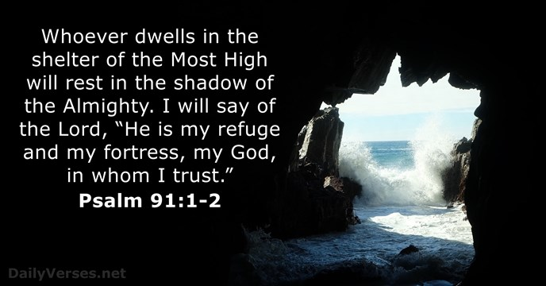wings are safe, no evil or harm can touch them for His power of protection has no boundaries and as such can be trusted to deflect any seen or unseen attack.***[10]*** Though many seek this inner sanctuary few Christians will find it because the promise of protection is not dependent on occasionally kneeling but continually residing and obeying His voice.[11] To have true fellowship with God means not just coming to Him when life difficulties threaten to crush one’s soul but in trust[12] to gladly submit to God’s rule over one’s every word, thought and deed! Those who choose to not treat God like an occasional resort but a constant abiding-place[13] will find perpetual solace[14] for under His wings in the cleft of the Rock of Ages[15] one finds a place of continual peace and security!

**Protection from Many Dangers (3-8)**

Now that the Psalmist has given the thematic guideline of his life, to abide and trust in God, in the next six verses he explains some of the dangers that God protects us from.[16] One of our worst fears is that of an attack from an unknown assailant. Since letting our light shine exposes the evil deeds of this world (John 3:20-21) we can expect many people to hate us, set traps and shoot devastating arrows of destruction our way (John 3:20-21, 15:18-19).[17] Whom amongst us has not been at minimum excluded from a group or being outright persecuted for righteousness sake (Matthew 5:11)? As A close up of an animal
Christians we are constantly in danger of attacks from, he who roars around like a lion seeking to devour us (1 Peter 5:8). Is it not the “terror or the night” that is most frightening? The darts of temptation of the wicked one[18] often arrive unannounced and are deadly for they entice the believer to give into the wicked desires present within their very hearts (James 1:14-15)! [19] And then there are the continual attacks on our temporal bodies that make feeling joy a real challenge! The Psalmist does not fear the arrows of affliction whether spiritual or temporal for he has faith[20] that under the wings of his covenant God,[21] who has full authority over everything,[22] he will not be allowed to be harmed. This does not mean that those who trust God never “feel” the arrows of affliction but merely that God will give them the strength to endure[23] until their inevitable, eternal deliverance![24]

**Invitation to be Under God’s Wings (9-10)**

It is at this point in the passage that the Psalmist stops to ask us if we in faith are willing to make God our refuge and dwelling place? While it is tempting to scream out “YES of course I want to abide under God’s wings,” the Psalmist is asking us to reflect on what living this statement would truly entail! In response to the Devil’s temptations that Jesus would turn stones to bread, throw Himself down so that the angels might lift Him up, or serve other gods (Matthew 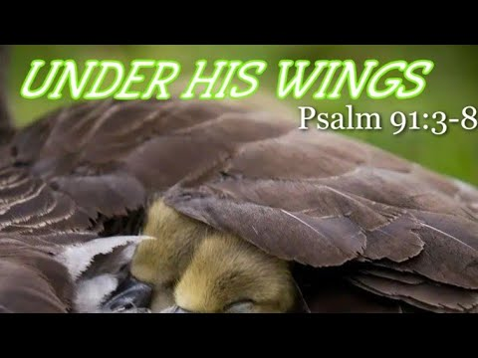4:1-11), Jesus made it clear that protection under God’s wings requires one to make Him the Lord of one’s life![25] This of course can only be accomplished by seeking first the kingdom of God (Matthew 6:33)! To do this one must become like Apostle Paul and be willing to give back to Christ the right to forge and choose one’s own path in life (1 Corinthians 10:23). Are you willing to give up control of an unknown future to the known God of Israel in every situation that you face in exchange for the strength to endure the fiery darts of persecution, sickness and those of Satan and his demons? Given the price to stay under the wings of God is strict obedience and submission to His will are you willing to traverse to such a safe, but demanding place?

**Receiving Miraculous Protection (11-13)**

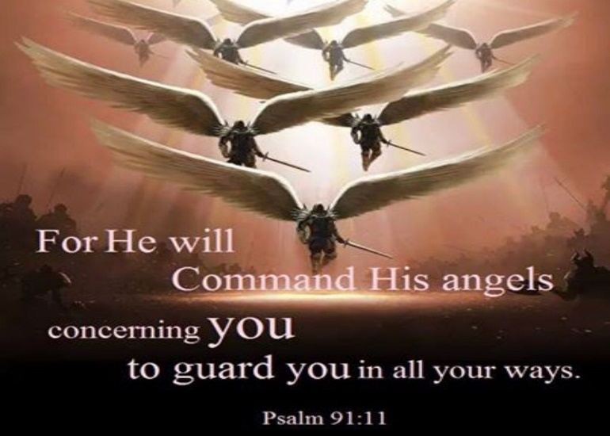 If you said YES to abiding in God’s presence by continually obeying His commands, then the next three verses contain a promise of how God will protect you. Those who take refuge in God will receive angelic protection![26] God has commanded those “unseen but swift and mighty messengers of heaven” [27] to carry such a person “in their arms like a child” [28] and to support them while walking amongst the fiery darts of tribulations.[29] While the Lord may permit many bad things to happen to His own, not a single dart is beyond God’s control, nor will it be allowed to penetrate and cause harm to one’s soul or standing before our holy God![30] If one’s focus is not on self but on faithfully serving God then this assurance should bring tears of joy, peace and great comfort! Instead of experiencing disaster or stumbling and succumbing to the temptation to sin, those under God’s wings are given victory over Satan and all his demons![31] Even though verses eleven and twelve focus on the angels being charged with the duty to lift believers out of danger,[32] verse thirteen concludes with the image of the believer as a victor[33] who will be given the power to tread upon the lion and the cobra, which represent actual and potential enemies and dangers.[34] In reading this one can’t help but remember Apostle John’s assurance to fear not for “the One who is in you is greater than the one in the world” (1 John 4:4)!

**Receiving Eternal Salvation (14-16)**

While the first two verses focused on the Psalmist’s personal declaration of faith and the next eleven on an invitation to join him under God’s wings, the final section is an “oracle spoken by God.” [35] God promises those who abide in His presence[36] to rescue, protect, answer their prayers, be present, honor, and give them a long life. Notice what God does not promise is the absence of tribulation![37] When we pray to God in the midst of the fiery darts of life’s difficulties He gives us what we truly need, an answer[38] that does not always include temporal escape but the ability to endure so that in our perseverance we might become more mature and draw nearer to Him (James 1:2-8). In verse fifteen God reminds us that He is indivisibly present, especially during our times of trouble! Even amidst the most heinous of diseases God is close, strengthening and encouraging us! God finishes with a promise that those who abide in Him will live a long, satisfying life. God is not saying one’s body will not die young but that abiding in Him is the key to living a “fulfilled” life,[39] one that does not fear divine retribution[40] but instead is filled with unspeakable joy that one has and will always be a living sacrifice that is honorable and a pleasing aroma for a holy God (Romans 12:1-2)!

**Conclusion**

In the face of the fleeting and frequently challenging nature of human existence it is reassuring and a source of great comfort to know that those who abide in God receive divine protection. If one thinks however that protection under God’s wings means the absence of tribulation, suffering and pain then one will be sadly disappointed for the moment one arrives one will realize this promise was never given and therefore will not be received! To continually abide in God’s presence will require submissions to His will which is continent upon whether one truly values God above everything else, including comfort to one’s physical well being. If one truly abides in His presence then seeking first the kingdom of God, regardless of the personal sacrifice, is never seen as a burden but an honor! It is by looking through a worldly lens that one comes to the false conclusion that God has broken His promises of protection. God promises to do good to those who love Him but if that good is unseen and not temporal but eternal, is it not still better than our definition of good that lasts but a fleeting moment? The Psalmist rightly promises that under God’s wings we will find protection for the only purpose of our lives that eternally matters is to offer ourselves as living sacrifices that are pleasing unto our Creator, Redeemer, and King!

1. Jamie A. Grant, [“Psalms 90–106,”](https://ref.ly/logosres/nivac19ps2?ref=Bible.Ps91&off=1877&ctx=h.+On+the+one+hand%2c+~it+is+important+to+b) in *Psalms*, ed. Terry Muck, vol. 2, The NIV Application Commentary (Grand Rapids, MI: Zondervan, 2018), 347.
2. C. H. Spurgeon, [“Under His Shadow,”](https://ref.ly/logosres/mtpserms57?ref=Page.p+434&off=1003&ctx=rity+can+we+desire%3f+~As+the+people+of+God) in *The Metropolitan Tabernacle Pulpit Sermons*, vol. 57 (London: Passmore & Alabaster, 1911), 434.
3. Jamie A. Grant, [“Psalms 90–106,”](https://ref.ly/logosres/nivac19ps2?ref=Bible.Ps91&off=23585&ctx=+preceding+stanzas.+~Anyone+reading+Psalm) in *Psalms*, ed. Terry Muck, vol. 2, The NIV Application Commentary (Grand Rapids, MI: Zondervan, 2018), 356.
4. Robert L. Jr. Hubbard and Robert K. Johnston, [“Foreword,”](https://ref.ly/logosres/bakerubot19ps?ref=Bible.Ps91.1-16&off=2011&ctx=sonal+confessions).%0a~For+certain+believer) in *Psalms*, ed. W. Ward Gasque, Robert L. Hubbard Jr., and Robert K. Johnston, Understanding the Bible Commentary Series (Grand Rapids, MI: Baker Books, 2012), 362.
5. C. H. Spurgeon, [“Under His Shadow,”](https://ref.ly/logosres/mtpserms57?ref=Page.p+436&off=2536&ctx=+her+where+she+sat.+~It+is+wonderful+how+) in *The Metropolitan Tabernacle Pulpit Sermons*, vol. 57 (London: Passmore & Alabaster, 1911), 436–437.
6. James Montgomery Boice, [*Psalms 42–106: An Expositional Commentary*](https://ref.ly/logosres/boicecm19bps?ref=Bible.Ps91&off=3677&ctx=rsonal+Faith+in+God%0a~The+first+verse+of+t) (Grand Rapids, MI: Baker Books, 2005), 747–748.
7. C. H. Spurgeon, [“Under His Shadow,”](https://ref.ly/logosres/mtpserms57?ref=Page.p+436&off=2178&ctx=ar+familiar+friend.+~Under+his+shadow+we+) in *The Metropolitan Tabernacle Pulpit Sermons*, vol. 57 (London: Passmore & Alabaster, 1911), 436.
8. C. H. Spurgeon, [“Under His Shadow,”](https://ref.ly/logosres/mtpserms57?ref=Page.p+438&off=400&ctx=n+their+warm+abode.+~When+we+are+very+sic) in *The Metropolitan Tabernacle Pulpit Sermons*, vol. 57 (London: Passmore & Alabaster, 1911), 438.
9. C. H. Spurgeon, [*The Treasury of David: Psalms 88-110*](https://ref.ly/logosres/treasdavd04?ref=Bible.Ps91.2&off=1162&ctx=otector+of+his+own.+~Let+us%2c+when+we+are+), vol. 4 (London; Edinburgh; New York: Marshall Brothers, n.d.), 89.
10. C. H. Spurgeon, [*The Treasury of David: Psalms 88-110*](https://ref.ly/logosres/treasdavd04?ref=Bible.Ps91.1&off=2357&ctx=sion+here+employed.+~Those+who+commune+wi), vol. 4 (London; Edinburgh; New York: Marshall Brothers, n.d.), 89.
11. C. H. Spurgeon, [“Under His Shadow,”](https://ref.ly/logosres/mtpserms57?ref=Page.p+436&off=1501&ctx=l+show+us+any+good%3f+~But+as+for+us%2c+O+Lor) in *The Metropolitan Tabernacle Pulpit Sermons*, vol. 57 (London: Passmore & Alabaster, 1911), 436.
12. C. H. Spurgeon, [“Under His Shadow,”](https://ref.ly/logosres/mtpserms57?ref=Page.p+440&off=1951&ctx=+we+must+trust+him.+~Come%2c+if+you+are+tro) in *The Metropolitan Tabernacle Pulpit Sermons*, vol. 57 (London: Passmore & Alabaster, 1911), 440.
13. C. H. Spurgeon, [“Under His Shadow,”](https://ref.ly/logosres/mtpserms57?ref=Page.p+434&off=0&ctx=w+of+the+Almighty.%E2%80%9D+~The+shadow+of+God+is) in *The Metropolitan Tabernacle Pulpit Sermons*, vol. 57 (London: Passmore & Alabaster, 1911), 434.
14. C. H. Spurgeon, [“Under His Shadow,”](https://ref.ly/logosres/mtpserms57?ref=Page.p+436&off=410&ctx=sing%2c+%E2%80%9CI+sat+down.%E2%80%9D%0a~Dear+friends%2c+is+Chr) in *The Metropolitan Tabernacle Pulpit Sermons*, vol. 57 (London: Passmore & Alabaster, 1911), 436.
15. C. H. Spurgeon, [“Under His Shadow,”](https://ref.ly/logosres/mtpserms57?ref=Page.p+434&off=1871&ctx=+our+Lord%E2%80%99s+shadow.+~He+was+at+the+first+) in *The Metropolitan Tabernacle Pulpit Sermons*, vol. 57 (London: Passmore & Alabaster, 1911), 434.
16. James Montgomery Boice, [*Psalms 42–106: An Expositional Commentary*](https://ref.ly/logosres/boicecm19bps?ref=Bible.Ps91&off=5691&ctx=st+in+God+Commended%0a~Having+stated+his+ow) (Grand Rapids, MI: Baker Books, 2005), 748.
17. C. H. Spurgeon, [“Under His Shadow,”](https://ref.ly/logosres/mtpserms57?ref=Page.p+438&off=2928&ctx=wer+to+do+anything%3f+~We+ought+to+be+as+ar) in *The Metropolitan Tabernacle Pulpit Sermons*, vol. 57 (London: Passmore & Alabaster, 1911), 438–439.
18. C. H. Spurgeon, [“Under His Shadow,”](https://ref.ly/logosres/mtpserms57?ref=Page.p+440&off=2292&ctx=uspect+the+fowler.+%E2%80%9C~Surely+in+vain+is+th) in *The Metropolitan Tabernacle Pulpit Sermons*, vol. 57 (London: Passmore & Alabaster, 1911), 440.
19. C. H. Spurgeon, [“Under His Shadow,”](https://ref.ly/logosres/mtpserms57?ref=Page.p+440&off=2796&ctx=noisome+pestilence.%0a~From+the+noisome+pes) in *The Metropolitan Tabernacle Pulpit Sermons*, vol. 57 (London: Passmore & Alabaster, 1911), 440.
20. Willem A. VanGemeren, [“Psalms,”](https://ref.ly/logosres/ebc05?ref=Bible.Ps91.3-4&off=678&ctx=+%E2%80%9Cfortress%E2%80%9D+(v.+2).+~Yahweh%E2%80%99s+care+is+bot) in *The Expositor’s Bible Commentary: Psalms, Proverbs, Ecclesiastes, Song of Songs*, ed. Frank E. Gaebelein, vol. 5 (Grand Rapids, MI: Zondervan Publishing House, 1991), 600.
21. Jamie A. Grant, [“Psalms 90–106,”](https://ref.ly/logosres/nivac19ps2?ref=Bible.Ps91.3-13&off=206&ctx=es+for+his+people.6%0a~Surely+he+will+save+) in *Psalms*, ed. Terry Muck, vol. 2, The NIV Application Commentary (Grand Rapids, MI: Zondervan, 2018), 349.
22. Willem A. VanGemeren, [“Psalms,”](https://ref.ly/logosres/ebc05?ref=Bible.Ps91.5-7&off=4&ctx=+to+his+people.%0a5%E2%80%937+~The+protection+of+Go) in *The Expositor’s Bible Commentary: Psalms, Proverbs, Ecclesiastes, Song of Songs*, ed. Frank E. Gaebelein, vol. 5 (Grand Rapids, MI: Zondervan Publishing House, 1991), 600.
23. C. H. Spurgeon, [“Under His Shadow,”](https://ref.ly/logosres/mtpserms57?ref=Page.p+441&off=1668&ctx=in+trusting+in+God.+~I+have+already+said+) in *The Metropolitan Tabernacle Pulpit Sermons*, vol. 57 (London: Passmore & Alabaster, 1911), 441.
24. James Montgomery Boice, [*Psalms 42–106: An Expositional Commentary*](https://ref.ly/logosres/boicecm19bps?ref=Bible.Ps91&off=6343&ctx=ease+or+pestilence.+~This+does+not+mean+t) (Grand Rapids, MI: Baker Books, 2005), 748–749.
25. Jamie A. Grant, [“Psalms 90–106,”](https://ref.ly/logosres/nivac19ps2?ref=Bible.Ps91&off=18122&ctx=+quite+appropriate.+~Clearly%2c+the+basic+m) in *Psalms*, ed. Terry Muck, vol. 2, The NIV Application Commentary (Grand Rapids, MI: Zondervan, 2018), 354.
26. Jamie A. Grant, [“Psalms 90–106,”](https://ref.ly/logosres/nivac19ps2?ref=Bible.Ps91.3-13&off=4141&ctx=mpassing+assurance.%0a~For+he+will+command+) in *Psalms*, ed. Terry Muck, vol. 2, The NIV Application Commentary (Grand Rapids, MI: Zondervan, 2018), 351.
27. C. H. Spurgeon, [“Under His Shadow,”](https://ref.ly/logosres/mtpserms57?ref=Page.p+441&off=2165&ctx=ot+against+a+stone.%0a~They+get+special+com) in *The Metropolitan Tabernacle Pulpit Sermons*, vol. 57 (London: Passmore & Alabaster, 1911), 441.
28. Robert G. Bratcher and William David Reyburn, [*A Translator’s Handbook on the Book of Psalms*](https://ref.ly/logosres/ubshbk19?ref=Bible.Ps91.11-12&off=1046&ctx=solicitude+of+God.%E2%80%9D+~The+angels+%E2%80%9Cwill+car), UBS Handbook Series (New York: United Bible Societies, 1991), 806.
29. Robert G. Bratcher and William David Reyburn, [*A Translator’s Handbook on the Book of Psalms*](https://ref.ly/logosres/ubshbk19?ref=Bible.Ps91.11-12&off=635&ctx=ot+very+convincing.%0a~It+is+not+easy+to+de), UBS Handbook Series (New York: United Bible Societies, 1991), 805–806.
30. Willem A. VanGemeren, [“Psalms,”](https://ref.ly/logosres/ebc05?ref=Bible.Ps91.11-13&off=920&ctx=od+19%3a4%3b+Isa+63%3a9).%0a~In+life+the+Lord+may) in *The Expositor’s Bible Commentary: Psalms, Proverbs, Ecclesiastes, Song of Songs*, ed. Frank E. Gaebelein, vol. 5 (Grand Rapids, MI: Zondervan Publishing House, 1991), 601.
31. C. H. Spurgeon, [“Under His Shadow,”](https://ref.ly/logosres/mtpserms57?ref=Page.p+441&off=3041&ctx=trample+under+feet.%0a~God+often+gives+vict) in *The Metropolitan Tabernacle Pulpit Sermons*, vol. 57 (London: Passmore & Alabaster, 1911), 441.
32. Willem A. VanGemeren, [“Psalms,”](https://ref.ly/logosres/ebc05?ref=Bible.Ps91.11-13&off=498&ctx=guard+you%2c%E2%80%9D+v.+11).+~The+Lord+charges+his) in *The Expositor’s Bible Commentary: Psalms, Proverbs, Ecclesiastes, Song of Songs*, ed. Frank E. Gaebelein, vol. 5 (Grand Rapids, MI: Zondervan Publishing House, 1991), 601.
33. Jamie A. Grant, [“Psalms 90–106,”](https://ref.ly/logosres/nivac19ps2?ref=Bible.Ps91.3-13&off=5437&ctx=status+as+observer%2c+~so+also+verse+13+con) in *Psalms*, ed. Terry Muck, vol. 2, The NIV Application Commentary (Grand Rapids, MI: Zondervan, 2018), 351.
34. Jamie A. Grant, [“Psalms 90–106,”](https://ref.ly/logosres/nivac19ps2?ref=Bible.Ps91.3-13&off=5907&ctx=f+Ps+74%3a14+above).+%E2%80%9C~The+lions+and+serpen) in *Psalms*, ed. Terry Muck, vol. 2, The NIV Application Commentary (Grand Rapids, MI: Zondervan, 2018), 352.
35. Jamie A. Grant, [“Psalms 90–106,”](https://ref.ly/logosres/nivac19ps2?ref=Bible.Ps91.13-16&off=44&ctx=otection+(91%3a13%E2%80%9316)%0a~The+final+stanza+of+) in *Psalms*, ed. Terry Muck, vol. 2, The NIV Application Commentary (Grand Rapids, MI: Zondervan, 2018), 352.
36. Willem A. VanGemeren, [“Psalms,”](https://ref.ly/logosres/ebc05?ref=Bible.Ps91.14-16&off=44&ctx=on+(91%3a14%E2%80%9316)%0a14%E2%80%9316+~The+Lord+announces+h) in *The Expositor’s Bible Commentary: Psalms, Proverbs, Ecclesiastes, Song of Songs*, ed. Frank E. Gaebelein, vol. 5 (Grand Rapids, MI: Zondervan Publishing House, 1991), 602.
37. James Montgomery Boice, [*Psalms 42–106: An Expositional Commentary*](https://ref.ly/logosres/boicecm19bps?ref=Bible.Ps91&off=16666&ctx=+acknowledging+that+~God+does+not+always+) (Grand Rapids, MI: Baker Books, 2005), 752.
38. James Montgomery Boice, [*Psalms 42–106: An Expositional Commentary*](https://ref.ly/logosres/boicecm19bps?ref=Bible.Ps91&off=16306&ctx=+and+protection.%0a2.+~An+answer+for+the+on) (Grand Rapids, MI: Baker Books, 2005), 752.
39. C. H. Spurgeon, [“Under His Shadow,”](https://ref.ly/logosres/mtpserms57?ref=Page.p+442&off=744&ctx=w+him+my+salvation.%0a~Now%2c+it+is+not+a+pro) in *The Metropolitan Tabernacle Pulpit Sermons*, vol. 57 (London: Passmore & Alabaster, 1911), 442.
40. Robert L. Jr. Hubbard and Robert K. Johnston, [“Foreword,”](https://ref.ly/logosres/bakerubot19ps?ref=Bible.Ps91.1-16&off=3099&ctx=n+interpretive+key.+~The+various+threats+) in *Psalms*, ed. W. Ward Gasque, Robert L. Hubbard Jr., and Robert K. Johnston, Understanding the Bible Commentary Series (Grand Rapids, MI: Baker Books, 2012), 362.