**Being a Good Dad**

**Psalms 127:1-4**

Online Sermon: <http://www.mckeesfamily.com/?page_id=3567>

One of the best and yet most terrifying experiences in my life was when I became a dad. From the moment I saw those two “pink lines” I knew I was over my head! I was not prepared to helplessly watch my wife struggle with wild food cravings, morning sickness, sore back, hips, and ankles! Even though I was not the one in pain and was supposed to be “calm” and strong I only vaguely remember the trip to the hospital! The wait was long, but once I saw our child come forth from the womb, I was very emotional. On the one hand I was overwhelmed with joy but on the other hand I was filled with anxiety for with such an incredible gift from God comes great responsibility! Would I make a good dad? Would I be able to work hard and provide our child with what was needed to “succeed” in life? Would I have the stamina to keep up with the pitter patter of little feet that would one day take me on unending events such as music lessons, sports, drama teams and the like? Would I be able to put away my selfish desires and place the needs of our child first? Then I got thinking about our child’s spiritual training. Would I be able to become a good role model and exemplify what it means to be a “living sacrifice” unto our God? Would I be able to remain calm and share God’s wisdom in the face of childish defiance? This sermon is going to propose the answer to all these questions is “YES” anyone can become a “good” dad if they are willing to build their family in God’s name!

**Unless the Lord Builds the House**

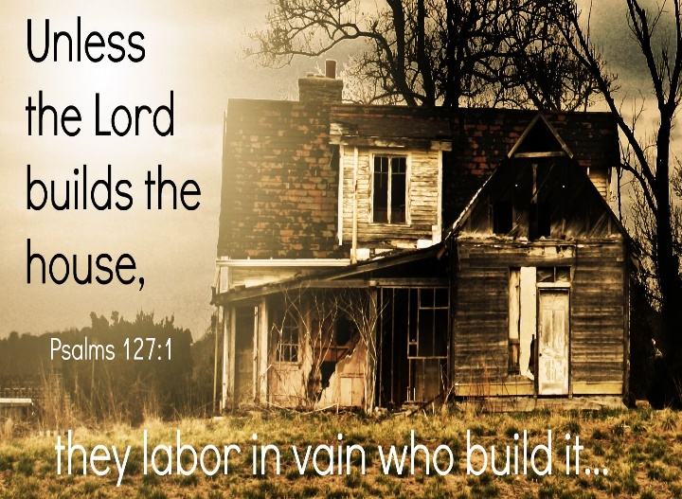Dad when it comes to building a really good family remember that while you are responsible for taking care of your children without knowing and embracing God’s plan for your family then all your efforts to raise them “right” will be mere vanity![1] Right after the flood scene in Genesis in chapter 11 we are told that the whole world had one language, settled in the plain of Shinar and sought to make their names great by building a tower up into the heavens. In response the Lord gave them many languages and scattered them all over the earth! The first reason why they failed was because they wanted to “make their names great” by establishing something a reputation that would outlive them.[2] Dad, while children can be a blessing in one’s old age (Psalms 127:5), your legacy through them is not permanent nor is it the primary goal in raising them. Scripture says to seek ye first the kingdom of God and that your light is to shine and point to God the Father in heaven (Matthew 5:16, 6:33). The second reason why the people building the tower failed is that it was not God’s plan for their lives.[3] Human wisdom is foolishness in God’s sight for His ways are always higher than our ways (1 Corinthians 3:19; Isaiah 55:8-9)! Dad the first step in raising your children well is to seek and embrace the Lord’s sovereign purpose and will[4] for both yourself and your children.

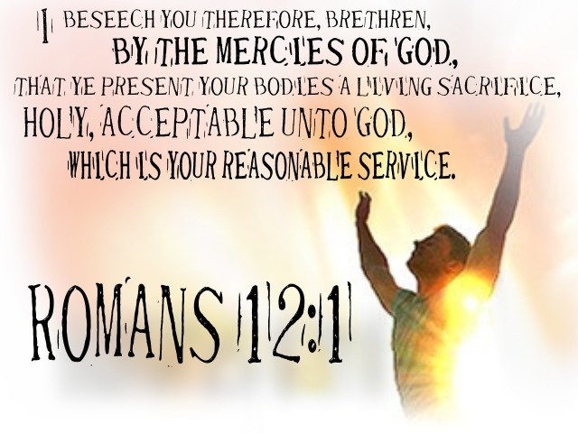Dad the second piece of advice I would like to give is to avoid the temptation to measure “fatherhood success” based on worldly acquisitions and accomplishments. Being a good Dad is not about providing our children with the most expensive house, car, clothes, and vacations; nor is it about trying to make them more rounded by enrolling them into countless sports, camps, dancing or musical classes. While there is nothing wrong with providing any of these items in moderation, it is more important that our children learn how to offer their bodies as living sacrifice unto their God (Romans 12:1-2)! Unless God is invited to build the family and “raise the poor out of the dust,”[5] our children will not know how to surrender their “rebellious, obstinate, self-centered ways”[6] to a God that truly loves and desires them to know Him. Instead of spending countless hours working so that we might afford “worldly stuff” that is here today and gone tomorrow (Matthew 6:19-20) we as dads need to take the time to read our Bible, pray and attend church so that our children might “see” how to honor God who has become our hearts desire and portion (Psalms 73:26)! Even though providing this kind of example will mean sacrificing many earthly possessions, living for God shows our children that every spiritual blessing in Christ Jesus (Ephesians 1:3) has infinitely more value than anything this world has to offer![7]

Dad the third piece of advice is to never stop showing your children how to learn more about God! While the fallen, depraved humanity cannot truly know the “Unknowable,” what we can learn and obey concerning God is significant and life changing. It is through knowledge that we learn what we can about God, and it is through faith in His son that we are saved. Moses told the Israelites to not only write the words of God in their hearts and minds but to take every opportunity to teach them to their children (Deuteronomy 11:18-21)! It is so easy today to get so consumed with building a “worldly” home filled with temporal riches and pleasures that we forget this world is not our home (Hebrews 11:13) but merely a stepping stone to an eternal paradise in God’s presence! Solomon who is said to have written Psalms 127, [8] in Ecclesiastes chapter 1 concluded that the product of his labor and toil under the sun, a kingdom of vast wealth and power, were meaningless for without God all life is vanity![9] It seems that every king in the Old Testament has an “annal” written of their accomplishments and yet their accomplishment were vanity for none were persevered! Apostle Paul told the church of Colossae that their labor was not in vain if they knew and strived towards doing the will of God the Father in heaven (3:23-24).[10] Our children will rebel against us from time to time but don’t loose heart dad for God does not determine our “fatherly” success based on how our children turn out but merely on our effort to show them how to have a genuine relationship with our God.

**Unless the Lord Watches over the City**

Now that you have invited the Lord to help build your family, Solomon’s next piece of advice is to ask the Lord for protection. Dad we all want our children to be safe from the many dangers of living in this fallen world. We rebuke and sometimes even discipline our children so that they might not take unnecessary risks or knowingly act in ways that give short term gains but long-term pain! While we try to build a family environment that is a fortress of security, this too is vanity because without God its foundation will crumble! [11] Unfortunately, we as the 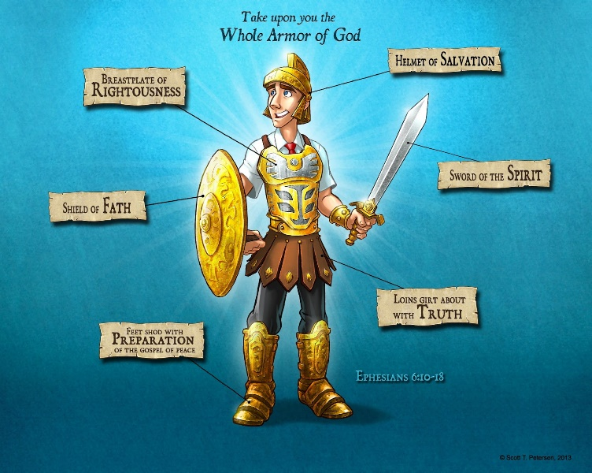watchmen of their fortresses[12] are simply incapable of protecting our children for often the battle is not against flesh and blood but against the spiritual forces of evil in this world (Ephesians 6:12). When it comes to battles with Satan and his demons we as fathers need to show them how to put on the armour of God (13-17) and to stand firm with the assurance that greater is He who is in them then he who is the world (1 John 4:4)! While any attempt to create a secure fortress for our children without God’s help “remains deceptive, delusional and ultimately unsuccessful,”[13] showing them how to stand on the rock of their Salvation is the key to them living in the only place they can that is unassailable (Psalms 62:2)!

**Vanity of Hard Work without the Lord**

 Solomon goes on and says that being a good dad is not a function of hard work and long hours but in taking time to be holy. While the Scripture is certainly not against hard work to provide for the necessities of life,[14] God certainly does not approve of anxious toil to attempt to build a good family through the accumulation of wealth and worldly experience! Rising early and going to bed late to chase after the wealth of this world[15] demonstrates to our children that we ourselves have not found the true value of every spiritual blessing offered to us in Christ Jesus our Lord. What our children need from their dads is not anxious care but to see their fathers rest and fed in the bosom of God in whom they have complete faith and trust![16] Taking time to rest, pray, read the Bible and meditate on God’s word shows our children that our and their true security comes not from human achievement[17] but from an utter dependence on God[18] to sustain and take care of not only our physical but more importantly our spiritual lives! Instead of using work as a crutch for our burdens[19] a good father casts them upon the Lord who alone can sustain him both this life and the next.

**Children are a Heritage from the Lord**

In conclusion the key to becoming a good dad is found in building up one’s family in the name of the Lord! Our children, who are fearfully and wonderfully made in the image of God, need their fathers to exemplify what it means to be a living sacrifice. Children are truly a blessing from our Creator[20] and as such we as dads have the honor and responsibility to show them that it is not the material things of life that are valuable but a close, personal relationship with our God! While we as dads do our absolute best to provide for and protect our children, we must acknowledge that our attempts to do so are pure vanity without God’s guidance and strength! While God values hard work above all He wants us dads to take time to be holy so that we might grow spiritually and become better examples of what it means to struggle and get nearer to God. Finally, dad while you are not responsible for the spiritual outcome of your children (that is their responsibility), you are going to be held accountable for how you have trained them in the ways of the Lord. So, dad write the laws of God upon your heart and take every opportunity to tell your children not only that you love them but how to have a close personal walk with God! Happy Father’s Day!

1. D. A. Carson, ed., [*NIV Biblical Theology Study Bible*](https://ref.ly/logosres/nivzndrvnstbbl?ref=Bible.Ps127&off=17&ctx=PSALM+127%0aPs+127+~Unless+the+Lord+Builds+) (Grand Rapids, MI: Zondervan, 2018), 1033.
2. John H. Walton, [*Genesis*](https://ref.ly/logosres/nivac01ge?ref=Bible.Ge11.1-9&off=8414&ctx=+quite+legitimately+~pursued.+In+the+Old+), The NIV Application Commentary (Grand Rapids, MI: Zondervan, 2001), 374.
3. John H. Walton, [*Genesis*](https://ref.ly/logosres/nivac01ge?ref=Bible.Ge11.1-9&off=9454&ctx=n+speech+forms.%0a(2)+~The+second+major+opt), The NIV Application Commentary (Grand Rapids, MI: Zondervan, 2001), 375.
4. Robert G. Bratcher and William David Reyburn, [*A Translator’s Handbook on the Book of Psalms*](https://ref.ly/logosres/ubshbk19?ref=Bible.Ps127.1&off=802&ctx=+is+worth+nothing.%E2%80%9D+~Human+labor+is+in+va), UBS Handbook Series (New York: United Bible Societies, 1991), 1073.
5. Matthew Henry, [*Matthew Henry’s Commentary on the Whole Bible: Complete and Unabridged in One Volume*](https://ref.ly/logosres/mhenry?ref=Bible.Ps127.1-5&off=1467&ctx=ing+all+is+nothing.+~Or%2c+rather%2c+it+is+to) (Peabody: Hendrickson, 1994), 933.
6. James Montgomery Boice, [*Psalms 107–150: An Expositional Commentary*](https://ref.ly/logosres/boicecm19cps?ref=Bible.Ps127&off=15459&ctx=s+outside+the+city.+~But+what+about+ourse) (Grand Rapids, MI: Baker Books, 2005), 1121.
7. James Montgomery Boice, [*Psalms 107–150: An Expositional Commentary*](https://ref.ly/logosres/boicecm19cps?ref=Bible.Ps127&off=15074) (Grand Rapids, MI: Baker Books, 2005), 1121–1122.
8. James Montgomery Boice, [*Psalms 107–150: An Expositional Commentary*](https://ref.ly/logosres/boicecm19cps?ref=Bible.Ps127&off=2387&ctx=alm+of+the+Vanities%0a~Psalm+127+is+said+to) (Grand Rapids, MI: Baker Books, 2005), 1117.
9. James Montgomery Boice, [*Psalms 107–150: An Expositional Commentary*](https://ref.ly/logosres/boicecm19cps?ref=Bible.Ps127&off=3163&ctx=n%E2%80%99s+other+writings%3f+~Solomon%E2%80%99s+best-known) (Grand Rapids, MI: Baker Books, 2005), 1117.
10. James Montgomery Boice, [*Psalms 107–150: An Expositional Commentary*](https://ref.ly/logosres/boicecm19cps?ref=Bible.Ps127&off=9146&ctx=ve+his+worker+rest.%0a~Paul+told+the+Coloss) (Grand Rapids, MI: Baker Books, 2005), 1119.
11. W. Dennis Tucker Jr., [“Psalms 107–150,”](https://ref.ly/logosres/nivac19ps2?ref=Bible.Ps127.1-2&off=2520&ctx=r+irreal+situation.+~The+image+shifts+fro) in *Psalms*, ed. Terry Muck, vol. 2, The NIV Application Commentary (Grand Rapids, MI: Zondervan, 2018), 791–792.
12. Robert G. Bratcher and William David Reyburn, [*A Translator’s Handbook on the Book of Psalms*](https://ref.ly/logosres/ubshbk19?ref=Bible.Ps127.1&off=893&ctx=n+purpose+and+will.%0a~In+the+same+way+the+), UBS Handbook Series (New York: United Bible Societies, 1991), 1073.
13. W. Dennis Tucker Jr., [“Psalms 107–150,”](https://ref.ly/logosres/nivac19ps2?ref=Bible.Ps127.1-2&off=3586&ctx=espective+contexts.+~In+Ecclesiastes+the+) in *Psalms*, ed. Terry Muck, vol. 2, The NIV Application Commentary (Grand Rapids, MI: Zondervan, 2018), 792.
14. Allen P. Ross, [“Psalms,”](https://ref.ly/logosres/bkc?ref=Bible.Ps127.1-2&off=586&ctx=ic+work+is+in+vain.%0a~The+toiling+(127%3a2)+) in *The Bible Knowledge Commentary: An Exposition of the Scriptures*, ed. J. F. Walvoord and R. B. Zuck, vol. 1 (Wheaton, IL: Victor Books, 1985), 885.
15. Matthew Henry, [*Matthew Henry’s Commentary on the Whole Bible: Complete and Unabridged in One Volume*](https://ref.ly/logosres/mhenry?ref=Bible.Ps127.1-5&off=2662&ctx=of+one+happy+turn%3a+%E2%80%9C~It+is+vain+for+you+t) (Peabody: Hendrickson, 1994), 933.
16. Robert G. Bratcher and William David Reyburn, [*A Translator’s Handbook on the Book of Psalms*](https://ref.ly/logosres/ubshbk19?ref=Bible.Ps127.2&off=1407&ctx=e+they+are+asleep.%E2%80%9D+~What+this+expressive), UBS Handbook Series (New York: United Bible Societies, 1991), 1073–1074.
17. Robert L. Jr. Hubbard and Robert K. Johnston, [“Foreword,”](https://ref.ly/logosres/bakerubot19ps?ref=Bible.Ps127.1-2&off=1202&ctx=t+encourages+one+to+~consider+the+relativ) in *Psalms*, ed. W. Ward Gasque, Robert L. Hubbard Jr., and Robert K. Johnston, Understanding the Bible Commentary Series (Grand Rapids, MI: Baker Books, 2012), 461.
18. Allen P. Ross, [“Psalms,”](https://ref.ly/logosres/bkc?ref=Bible.Ps127.1-2&off=421&ctx=n+vain+(cf.+128%3a2).+~The+point+is+that+wo) in *The Bible Knowledge Commentary: An Exposition of the Scriptures*, ed. J. F. Walvoord and R. B. Zuck, vol. 1 (Wheaton, IL: Victor Books, 1985), 885.
19. Matthew Henry, [*Matthew Henry’s Commentary on the Whole Bible: Complete and Unabridged in One Volume*](https://ref.ly/logosres/mhenry?ref=Bible.Ps127.1-5&off=3302&ctx=rkness%2c+Eccl.+5%3a17.+~They+are+continually) (Peabody: Hendrickson, 1994), 933.
20. D. A. Carson, ed., [*NIV Biblical Theology Study Bible*](https://ref.ly/logosres/nivzndrvnstbbl?ref=Bible.Ps127.3&off=6&ctx=+in+Gen+3%3a17.%0a127%3a3+~Children+are+a+bless) (Grand Rapids, MI: Zondervan, 2018), 1033.