**7 Characteristic of Motherhood**

**Various Scriptures**

Online Sermon: <http://www.mckeesfamily.com/?page_id=3567>

From the moment one finds out one is pregnant, life forever changes. Scripture states children are a gift from God that can simultaneously be a source of great joy and grief. It is far from easy bringing a child up in the ways of the Lord in a world that has embraced the god of self and as many paths as one can imagine! As you examine your own life only to find much sin you cannot help but wonder if you have what it takes to be a good mom in the eyes of Jesus? The answer of course is YES you can be a good mom because the Spirit of God who lives in you who will help you develop certain characteristics within yourself that are necessary to please the Father in how you raise your children. Today’s sermon is going to look at seven different moms in the Bible to find out what these characteristics are so that one day you will hear Jesus say well done with the gifts of life I entrusted you with, you have sacrificially loved and given your children every opportunity to know Me!

1. **“Patience” – Sarah**

The first characteristic of a good mom is patience. When Abram was 75[1] years old God called him to journey from Ur to the land of Canaan (Genesis 11:31). God promised to make Abram into a great nation (12:2). After 10 years had passed without having produced any children[2] Sarah attempted to build her family through her Egyptian slave Hagar who had a son with Abraham named Ishmael (16:1-4).[3] Some 15 years later[4] God told Abraham and Sarah that they would have a son and despite their laughter (17:17; 18:12) and Sarah’s womb being dead … it happened (21:1)! The day Isaac was born Sarah learned first-hand to be patient and wait on the Lord for what He promises happens![5] Mom when your children lie to your face, scream at their siblings, stay out many hours past their curfew, take unnecessary physical risks and chase after the ways of this world turn your heart and head upward and pray! Be patient and forebear the rebellion of your children lest you exasperate them (Ephesians 6:4) but also be willing to discipline them (Proverbs 13:24) when and as the Lord sees fit! And mom, always be ready to forgive your children as the Lord has forgiven you (Colossians 3:13)!

1. **“Endurance” - Haggar**

The second characteristic of a good mom is endurance. Sarah soon regretted her “attempt to implement the divine promise”[6] of Abraham becoming a great nation through her maidservant Hagar for the moment she got pregnant Hagar became arrogant. A deity had blessed her with Abraham’s heir living inside her womb! Sarai complained to Abraham and she got her authority back[7] to do whatever she pleased with her maidservant. Sarah mistreated Hagar and to keep Ishmael from sharing in Abraham’s inheritance she had both of them banned to the desert of Beersheba (Genesis 21:8-14).[8] Even though “God unequivocally identified Isaac as the heir of the Great Abrahamic promises” He told Hagar Ismael too would become a nation.[9] Mom children are not to be seen as “possessions” but as those who are fearfully and wonderfully knit within your womb (Psalms 139). While it is healthy to have joy in your children’s accomplishments do not forget that all good gifts in their lives comes from their Father in heaven (James 1:17). Hagar not only learned how to be a humble mom but, in the desert, she also learned how to endure great hardships (Genesis 21)! In the face of many trials and tribulations that often comes with child rearing, mom seek God who can always be found (Jeremiah 29:12-14) and stand firm in your desire to love and raise your children in the ways of the Lord!

1. **“No Favoritism” – Rebekah**

The third characteristic of a good mom is to not show favouritism for one child over another. In his old age Abraham decided that the “bearer of God’s Great Promise,” Isaac was not to intermarry with the Canaanites (Genesis 24:3)[10] but was to seek a wife amongst his own family.[11] A group of people standing next to a child
According to divine providence (24:11-21, 50-51) a woman who was both hospitable and hardworking,[12] Rebekah, said yes to being Isaac’s wife.[13] After 20 years of marriage[14] and intercessory prayer by Isaac (25:21) she had twin boys, Jacob and Esau. Isaac favored Esau and Rebekah Jacob which caused great strife and estrangement between the brothers for approximately 20 years![15] While it is often unwise to treat children with different needs the same, be very careful mom that you don’t favor one child over another simply due to his/her matching your personality better. Showing less love for one child can cut long-term wounds into their self-worth while showing favoritism can lead to spoiling and instill pride into his/her heart. To the best of your ability love your children equally and celebrate both their differences and similarities.

1. **“Sacrifice” – Jochebed**

The fourth characteristic of a good mom is the willingness to make sacrifices for her children. In the first part of Exodus we learn that Jacob’s descendants had prospered so much in Egypt that when a new Pharaoh came to power, who” no longer remembered Joseph’s legacy,” [16] he oppressed Israel and ordered all boys to be executed in the Nile River upon birth (Exodus 1). Upon the arrival of her third chid,[17] Moses, Jochebed hid him for three months but later had to place him in a papyrus basket and set him upon the Nile river. Pharaoh’s daughter found Moses, adopted him and unaware of her motherly status hired Jochebed to nurse and take care of him (2:1-10). In these ten short verses we learn of the incredible risk and sacrifice Jochebed made to keep her son A person standing next to a body of water
safe,[18] for if Pharaoh ever found out that she defied his orders she would certainly have been executed! To protect, shelter, encourage, nurture, and teach your children about God will require much personal sacrifice in one’s own appearance, interests, time, and money. Above all it is imperative that you become a living sacrifice (Romans 12:1-2) first to please God and second to be an example to your children of not sinlessness but through meditation and confession, and example of righteousness.

1. **“Obedience” – Samson’s Mother**

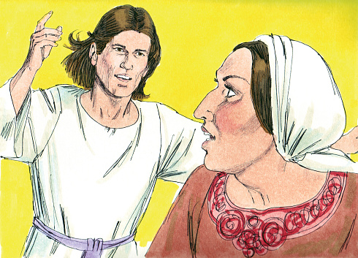The fifth characteristic of a good mom is the willingness to seek wisdom from the Lord. In Judges chapter 15 we are told that an angel of the Lord appeared to Manoah’s wife and told her that she was going to have a son who was to be dedicated to God with a Nazarite vow.[19] Not knowing exactly what this entailed[20] Manoah prayed and the angel told him and his wife that Samson was not to cut his hair, eat anything from a grapevine, drink fermented liquids or eat anything unclean (13:1-13). This Nazarite vow was not only imposed on Samson by divine meditation but also reinforced by his mother.[21] For example, when Samson wanted to marry a Philistine woman his mother rightly objected because she would lead him away from God. Samson should have listened to his mother’s advice for it was his fascination with foreign women that his hair got cut and his life ended.[22] Mom it is far from easy to live or to teach our children that we are not the master’s of our own destiny! God has a plan for you and for your children, the foundation of which is to seek and obey the will of the Lord. Take every opportunity to teach your children about the Lord, as you sit down, walk along the road, eat supper, play and all other times so that they might have every opportunity to know their Savior (Deuteronomy 6:4-9).

1. **“Faith” – Naomi**

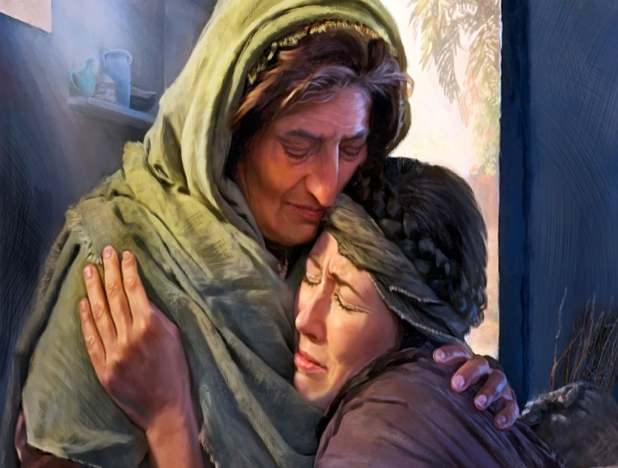The sixth characteristic of a good mom is to retain one’s faith in the darkest of times. Naomi’s life was a winding road of both blessings and tribulations. Due to a great famine in the land her family left Bethlehem-Judah to live in Moab.[23] If the famine was not difficult enough to endure her tribulations only deepened when her husband Elimelek and two sons Mahlon and Kilion die (Ruth 1:1-5)! Out of deep love for her daughters-in-law,[24] Orpah and Ruth, she urged them to not follow her to Judah to become foreigners in a strange land but return to Moab with the hope that the Lord would bless them with new husbands and with children.[25] While Orpah returned to her homeland Ruth made a solemn oath to God that she should not leave Naomi’s side (1:16-18).[26] The love Ruth had for Naomi was a testimony of how she saw Naomi as another mom. Life was hash so Naomi, whose name meant “pleasant” [27] had her name changed to “Mara” which meant “bitter.”[28] Upon finding out that Boaz was Ruth’s kinsmen redeemer with incredible faith Naomi blessed the Lord who in her mind was about to show both the living and dead great kindness![29] The story ends with Boaz marrying Ruth and her having a son (1:13-16). Mom, living in a fallen world means raising children will be far from easy. Like Naomi your family will experience times of great blessings and tribulations. When your faith waivers that God will do good to you (Romans 8:28), count your blessings to remember all the things He has done for you!

1. **“Enabled” - Mary**

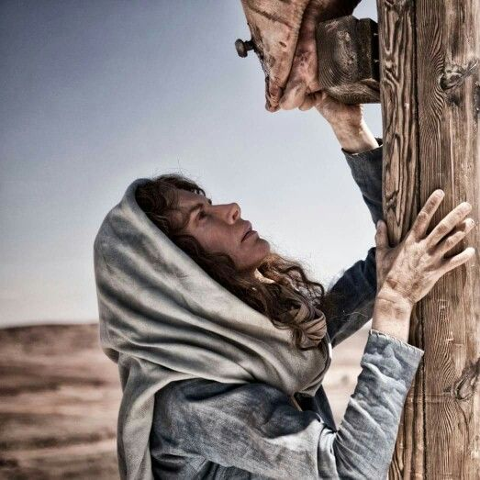The final characteristic of a good mom that I want to look at today is being enabled. The beginning of Matthew tells us that Mary was pledged to be married to Joseph when she became pregnant through the Holy Spirit (Matthew 1:18-19). This was unlikely the fairy tale marriage and start to a family that Mary dreamed of … it was far more! When the angel told Mary she had found favour with God and as such was to forever be called “the Mother of Immanuel who would save the people from their sins” (1:22; Luke 1:42), must have instilled great joy within her heart! As Jesus grew in wisdom and stature (Luke 2:52) and began His public ministry I can only imagine the mixed emotions Mary must have felt. The miracles her Son did would have instilled great pride and belief in His ministry while the constant death threats He received from the Jewish authorities must have produced many a sleepless night! And the tears of anguish Mary cried at the foot of the cross being soon be replaced by unspeakable joy of an empty tomb on Easter Morning … well that must have been quite an emotional, three-day roller-coaster ride! Mom, you too have been favoured by God. The same Spirit of God that raised Jesus from the dead (Romans 8:11) lives inside of you! God gave you your children as a gift but not without the divine ability to raise them. You too can grow in stature for if you ask the Lord for wisdom He who knit them in your womb and knows everything about them (Psalms 139) will grant your request (James 1:5-8)!

**Conclusion**

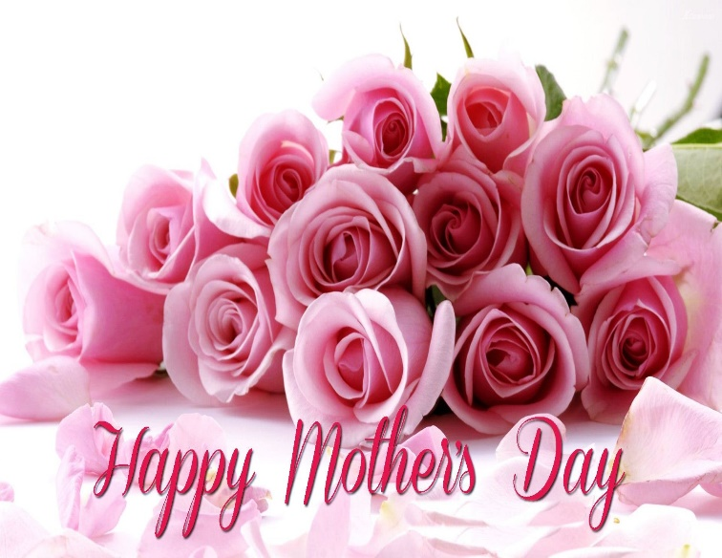 This sermon reviewed seven characteristics of a good mom. From Sarah one learns to be a good mom one must be patient as you teach your children about the Lord, forbearing often, discipling as God sees fit, and always ready to forgive upon confession. From Haggar one learns to be a good mom one must be humble and to ask God for the strength to endure the trials and tribulations that comes from raising children in a fallen world. From Rebekah one learns how important it is to love one’s children equally and to celebrate their difference and similarities. From Jochebed one learns to be a good mom one needs to be a good role model by being a living sacrifice unto the Lord. From Samson’s mother one learns how important it is to seek and obey the will of the Lord for each of your children. From Naomi one learns how important it is that your children see that you have faith in God in both the good and bad times. Mom none of these women mentioned were perfect for at times Sarah was jealous, Haggar arrogant and Rebekah favoured one child over the other. What made them good moms was not perfection but the desire to love and do their best to raise their children in the Lord. I want to leave you with this final note of praise: like Mary mom you have been divinely enabled by the Spirit of God to raise your children His way … so rejoice! Happy Mother’s Day.

1. John H. Walton, [*Genesis*](https://ref.ly/logosres/nivac01ge?ref=Bible.Ge11.27-30&off=660&ctx=en+the+two+notices.+~The+final+piece+of+i), The NIV Application Commentary (Grand Rapids, MI: Zondervan, 2001), 390.
2. Walter A. Elwell and Barry J. Beitzel, [“Sarah,”](https://ref.ly/logosres/bkrencbib?ref=Page.p+1905&off=0&ctx=h+was+still+barren.%0a~After+10+years+had+p) *Baker Encyclopedia of the Bible* (Grand Rapids, MI: Baker Book House, 1988), 1905.
3. John E. Hartley, [*Genesis*](https://ref.ly/logosres/bakerubot01ge?ref=Bible.Ge16.1-2&off=622&ctx=ss%2c+1985%5d%2c+p.+222).%0a~To+cope+with+the+sha), ed. W. Ward Gasque, Robert L. Hubbard Jr., and Robert K. Johnston, Understanding the Bible Commentary Series (Grand Rapids, MI: Baker Books, 2012), 164.
4. John E. Hartley, [*Genesis*](https://ref.ly/logosres/bakerubot01ge?ref=Bible.Ge21.2-7&off=9&ctx=16%3b+4%3a31).%0a21%3a2%E2%80%937+%2f+~When+Abraham+was+a+h), ed. W. Ward Gasque, Robert L. Hubbard Jr., and Robert K. Johnston, Understanding the Bible Commentary Series (Grand Rapids, MI: Baker Books, 2012), 198.
5. Martin H. Manser, [*Dictionary of Bible Themes: The Accessible and Comprehensive Tool for Topical Studies*](https://ref.ly/logosres/dicbblthemes?hw=patience&off=14&ctx=8318%0apatience%0a~The+quality+of+forbearance) (London: Martin Manser, 2009).
6. Ernst Axel Knauf, [“Hagar (Person),”](https://ref.ly/logosres/anch?ref=VolumePage.V+3%2c+p+18&off=4417&ctx=ES.+Genesis+16+is+a+~short+story+of+high+) ed. David Noel Freedman, *The Anchor Yale Bible Dictionary* (New York: Doubleday, 1992), 18.
7. William David Reyburn and Euan McG. Fry, [*A Handbook on Genesis*](https://ref.ly/logosres/ubshbk01?ref=Bible.Ge16.1&off=1529&ctx=+of+her+barrenness.%0a~She+had+an+Egyptian+), UBS Handbook Series (New York: United Bible Societies, 1998), 349.
8. William David Reyburn and Euan McG. Fry, [*A Handbook on Genesis*](https://ref.ly/logosres/ubshbk01?ref=Bible.Ge21.9-21&off=54&ctx=mael+Away+(21%3a9%E2%80%9321)%0a~In+this+section+Sara), UBS Handbook Series (New York: United Bible Societies, 1998), 466.
9. John E. Hartley, [*Genesis*](https://ref.ly/logosres/bakerubot01ge?ref=Bible.Ge21.12-13&off=283&ctx=+to+do+as+Sarah+had+~asked%2c+for+he+had+ap), ed. W. Ward Gasque, Robert L. Hubbard Jr., and Robert K. Johnston, Understanding the Bible Commentary Series (Grand Rapids, MI: Baker Books, 2012), 200.
10. Astrid Billes Beck, [“Rebekah (Person),”](https://ref.ly/logosres/anch?ref=VolumePage.V+5%2c+p+629&off=1698&ctx=ort-nosed+animal%E2%80%9D).%0a~The+story+of+Rebekah) ed. David Noel Freedman, *The Anchor Yale Bible Dictionary* (New York: Doubleday, 1992), 629.
11. John H. Walton, [*Genesis*](https://ref.ly/logosres/nivac01ge?ref=Bible.Ge24.1-9&off=216&ctx=him.+His+insistence+~that+Isaac%E2%80%99s+wife+be), The NIV Application Commentary (Grand Rapids, MI: Zondervan, 2001), 529.
12. D. A. Carson, ed., [*NIV Zondervan Study Bible: Built on the Truth of Scripture and Centered on the Gospel Message*](https://ref.ly/logosres/nivzndrvnstbbl?ref=Bible.Ge24.12-14&off=171&ctx=er+for+divine+help.+~He+seeks+a+woman+who) (Grand Rapids, MI: Zondervan, 2015), 64.
13. Astrid Billes Beck, [“Rebekah (Person),”](https://ref.ly/logosres/anch?ref=VolumePage.V+5%2c+p+629&off=4003&ctx=her+self-assurance.%0a~The+story+assumes+th) ed. David Noel Freedman, *The Anchor Yale Bible Dictionary* (New York: Doubleday, 1992), 629.
14. Astrid Billes Beck, [“Rebekah (Person),”](https://ref.ly/logosres/anch?ref=VolumePage.V+5%2c+p+630&off=148&ctx=his+mother%E2%80%99s+death.%0a~Rebekah+is+barren+fo) ed. David Noel Freedman, *The Anchor Yale Bible Dictionary* (New York: Doubleday, 1992), 630.
15. Stanley D. Walters, [“Jacob Narrative,”](https://ref.ly/logosres/anch?ref=VolumePage.V+3%2c+p+603&off=1928&ctx=egment+F+(29%3a1%E2%80%9330).+~Jacob%E2%80%99s+20-year+resi) ed. David Noel Freedman, *The Anchor Yale Bible Dictionary* (New York: Doubleday, 1992), 603.
16. James K. Bruckner, [*Exodus*](https://ref.ly/logosres/bakerubot02ex?ref=Bible.Ex1.1-22&off=387&ctx=acob.%E2%80%9D+(Gen.+50%3a24)%0a~The+first+chapter+of), ed. W. Ward Gasque, Robert L. Hubbard Jr., and Robert K. Johnston, Understanding the Bible Commentary Series (Grand Rapids, MI: Baker Books, 2012), 19.
17. R. Alan Cole, [*Exodus: An Introduction and Commentary*](https://ref.ly/logosres/totc02exus?ref=Bible.Ex2.2&off=15&ctx=old.%0a2.+Bore+a+son.+~The+story+does+not+s), vol. 2, Tyndale Old Testament Commentaries (Downers Grove, IL: InterVarsity Press, 1973), 63.
18. James K. Bruckner, [*Exodus*](https://ref.ly/logosres/bakerubot02ex?ref=Bible.Ex2.1-10&off=1037&ctx=nseful+and+poignant+~story+is+full+of+lit), ed. W. Ward Gasque, Robert L. Hubbard Jr., and Robert K. Johnston, Understanding the Bible Commentary Series (Grand Rapids, MI: Baker Books, 2012), 26.
19. James L. Crenshaw, [“Samson (Person),”](https://ref.ly/logosres/anch?ref=VolumePage.V+5%2c+p+950&off=5058&ctx=istic+framework+and+~two+themes%3a+Samson%E2%80%99s) ed. David Noel Freedman, *The Anchor Yale Bible Dictionary* (New York: Doubleday, 1992), 950.
20. Cheryl A. Brown, [“Judges,”](https://ref.ly/logosres/bakerubot06jos?ref=Bible.Jdg13.6-8&off=512&ctx=n+indication+of+his+~faith+and+piety.+He+) in *Joshua, Judges, Ruth*, ed. W. Ward Gasque, Robert L. Hubbard Jr., and Robert K. Johnston, Understanding the Bible Commentary Series (Grand Rapids, MI: Baker Books, 2012), 240.
21. James L. Crenshaw, [“Samson (Person),”](https://ref.ly/logosres/anch?ref=VolumePage.V+5%2c+p+950&off=5058&ctx=istic+framework+and+~two+themes%3a+Samson%E2%80%99s) ed. David Noel Freedman, *The Anchor Yale Bible Dictionary* (New York: Doubleday, 1992), 950.
22. James L. Crenshaw, [“Samson (Person),”](https://ref.ly/logosres/anch?ref=VolumePage.V+5%2c+p+950&off=5739&ctx=uandered+potential.+~The+mighty+Samson+fe) ed. David Noel Freedman, *The Anchor Yale Bible Dictionary* (New York: Doubleday, 1992), 950.
23. Kenneth A. Mathews, [“Naomi (Person),”](https://ref.ly/logosres/anch?ref=VolumePage.V+4%2c+p+1020&off=799&ctx=o%CA%BFo%CC%86m%C4%B1%CC%82+(%D7%A0%D6%B8%D7%A2%D6%B3%D7%9E%D6%B4%D7%99)%5d.+~The+wife+of+Elimelec) ed. David Noel Freedman, *The Anchor Yale Bible Dictionary* (New York: Doubleday, 1992), 1020.
24. Michael S. Moore, [“Ruth,”](https://ref.ly/logosres/bakerubot06jos?ref=Bible.Ru1.8&off=6&ctx=him-diviners.%0a1%3a8+%2f+~Naomi%E2%80%99s+concern+for+) in *Joshua, Judges, Ruth*, ed. W. Ward Gasque, Robert L. Hubbard Jr., and Robert K. Johnston, Understanding the Bible Commentary Series (Grand Rapids, MI: Baker Books, 2012), 316.
25. K. Lawson Younger Jr., [*Judges and Ruth*](https://ref.ly/logosres/nivac07jdg?ref=Bible.Ru1.6-19a&off=3772&ctx=our+mother%E2%80%99s+home.%E2%80%9D+~Having+come+to+Moab+), The NIV Application Commentary (Grand Rapids, MI: Zondervan, 2002), 420.
26. F. B. Huey Jr., [“Ruth,”](https://ref.ly/logosres/ebc03?ref=Bible.Ru1.16-17&off=673&ctx=ate+her+from+Naomi.+~She+swore+a+solemn+c) in *The Expositor’s Bible Commentary: Deuteronomy, Joshua, Judges, Ruth, 1 & 2 Samuel*, ed. Frank E. Gaebelein, vol. 3 (Grand Rapids, MI: Zondervan Publishing House, 1992), 524.
27. Kenneth A. Mathews, [“Naomi (Person),”](https://ref.ly/logosres/anch?ref=VolumePage.V+4%2c+p+1020&off=2593&ctx=Ruth%E2%80%99s+and+Naomi%E2%80%99s.%0a~The+name+%E2%80%9CNaomi%E2%80%9D+is+) ed. David Noel Freedman, *The Anchor Yale Bible Dictionary* (New York: Doubleday, 1992), 1020.
28. Arthur E. Cundall and Leon Morris, [*Judges and Ruth: An Introduction and Commentary*](https://ref.ly/logosres/totc07jdgus?ref=Bible.Ru1.20&off=4&ctx=on+appropriate.%0a20.+~Naomi+puts+stress+on), vol. 7, Tyndale Old Testament Commentaries (Downers Grove, IL: InterVarsity Press, 1968), 253.
29. Arthur E. Cundall and Leon Morris, [*Judges and Ruth: An Introduction and Commentary*](https://ref.ly/logosres/totc07jdgus?ref=Bible.Ru2.20&off=668&ctx=8%2c+where+see+note).+~There+is+a+strong+se), vol. 7, Tyndale Old Testament Commentaries (Downers Grove, IL: InterVarsity Press, 1968), 271.