**How to Tell them About Jesus**

**Matthew 28:19, Acts 16:16-40**

Online Sermon: <http://www.mckeesfamily.com/?page_id=3567>

I was watching the news this morning and in bold, highlighted colors the worldwide meter of COVID-19 cases has now hit over 2.1 million with about 150 thousand deaths![1] The world is frantically seeking to develop a vaccine and a cure for this deadly disease. Canada for example has devoted 275 million[2] and United States 1.25 billion[3] to do research on this disease! If you developed a cure for this disease would you not share it with the world? Would you not go on every news station, travel across the globe and Facebook everyone how to be saved from this deadly disease? Absolutely, yes! Let me tell you a statistic about a disease far more deadly than COVID-19. Approximately 2/3rds or over 5 billion people of this world are not Christian[4] and face an eternity in hell where excruciating pain never ceases due to a disease called sin. The Good News is that while everyone is affected by this disease the cure is known and available to all who will believe in Jesus Christ! Since we as Christians have the cure[5] why do we devote a mere 1 percent of our tithe to evangelism? There are many reasons the chief of which is that this world is skeptical and dare I say hostile to believing in a single God, especially when that god is not self! The following sermon is going to review how Paul and Silas were able to effectively evangelise to the hostile people of their time in hope that we might learn and apply their proven techniques to evangelising the unsaved of our generation.

**Effective Evangelism Starts with Prayer and Action**

The story begins by telling us that one day when Paul and Silas were on their way to the Jewish place of prayer, which was located at outside the city gate at the river (verse 13),[6] they met a slave girl who made a lot of money for her owners by predicting the future.[7] She was possessed by a spirit of Pythona, [8] a Greek god of prophecy.[9] While this seems odd to our western culture, in antiquity demon possession happened frequently. [10] Once the demon A group of people standing in a room
recognized the divine source of Paul and Silas’ ministry was none other than Jesus Christ[11] it got the girl to shout that these men were from the Most High God and that they were about to tell everyone how to be saved (verse 17). Since salvation “was the object of vows and prayers to many gods in the Greco-Roman world,” [12] the demon was likely trying to get the focus from the missionaries teaching diverted away from Christ and onto any other god. She kept this up for many days until Paul got frustrated with her and “in the name of Jesus Christ” commanded the demon to leave the slave girl. We are told that she was immediately freed from the demon but are left to wonder if she became a believer[13] or not. [14]

 From the first part of this story one learns that effective evangelism begins with prayer and action. Prayer is not only powerful and effective for our physical and spiritual well being (James 5:16) but is also the backbone of evangelism. Not only will the Holy Spirit give you the words to say (Matthew 10:19) but will also open the door of a person’s heart to be receptive to the Good News.[15] Our role is to plant and water the seeds (1 Corinthians 3) and to pray that the Spirit would quicken their hearts and upon belief covert them into born-again believers. While the first step in evangelism is prayer let us not forget the second step is … to GO! In the Great Commission Christ commands us to GO and make disciples of all nations (Matthew 28:19). With Spirit-led boldness,[16] like Paul and Silas we are to leave the comfort of our church and go out into our communities and preach what this world must do to be saved. While this will be uncomfortable and invite much criticism, surely the comfort that we have received (2 Corinthians 1:3-4) and the prospect of them spending an eternity in hell (2 Thessalonians 1:5-9) is enough motivation to provoke us into fulfilling our role as Christ’s ambassadors (2 Corinthians 5:20) and planting seeds of righteousness in God’s kingdom. While not everyone is called to be an evangelist all are called to give the reason why they have hope in Jesus Christ as their Lord (1 Peter 3:15).

**Effective Evangelism Invites Persecution**

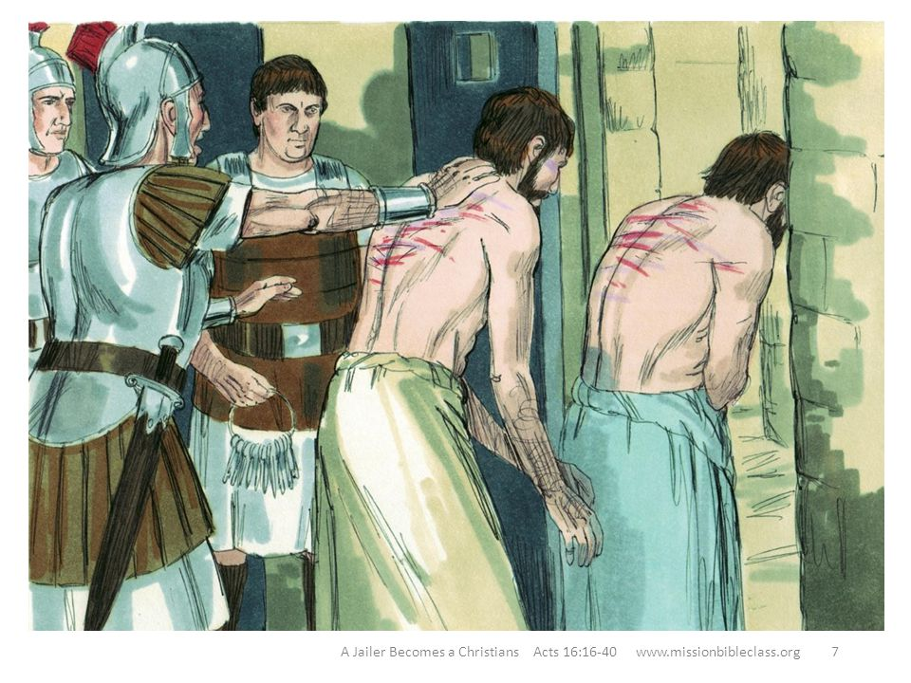 Once the owners realized the slave girl could no longer predict the future and therefore their hope of making money was gone, they dragged Paul and Silas into the marketplace to face the authorities (verse 19). Appealing to “xenophobia and anti-Semitism of the people,”[17] the owners accused the missionaries of stirring up and threatening the social cohesion of the city.[18] Ignoring the obvious economic and self-serving reasons for the owners complaint,[19] without legal or social merit[20] the magistrates of the city shamefully had Paul and Silas publicly beaten and thrown into prison.[21] Despite Judaism being a legal religion of the Roman empire[22] this incident and others proved that the Jewish people were merely tolerated but generally disliked and persecuted.[23] Ironically at this point in the story the authorities had no idea the Paul and Silas were actually Roman citizens and as such the city, which was mostly retired Roman soldiers,[24] would have strongly disapproved of illegally beating and imprisoning their own countrymen!

 From this part of the story we learn that effective evangelism invites persecution! Jesus warned us that since we do not imitate the sins of this world nor is our eternal destination theirs, expect the unbelievers of this world to hate not only the Gospel message but us personally (John 15:18-25)! The more our words and deeds reflect God’s righteousness the more our light will shine and expose not only their evil but also the eternal hell they have invited into their lives (John 3:19-21)! While our physical lives are unlikely to be in jeopardy while proclaiming the Good News, never underestimate the anguish and pain of being economically and socially sanctioned for having spoken the words of Jesus! The more we speak the truth concerning Christ the greater the likelihood that our minds will come to bear the marks of persecution of our Lord! [25] When this happens, we are not to be discouraged[26] for often our witness in prosecution softens the hardest of hearts! The light truly shines brightest in the darkest places!

**Effective Evangelism Rejoices and Provides Clarity in Persecution**

Imagine what it must have been like for Paul and Silas in that prison. After having been severely flogged with rods (verse 22), the jailer took them to the maximum security “inner cell” of the prison and fastened their feet into stocks.[27] As if the floggings were not painful enough, these stocks “forced the legs apart in such a way as to cause the utmost discomfort and cramping pain.”[28] How did they react to the humiliation, injustice and pain[29] that was so 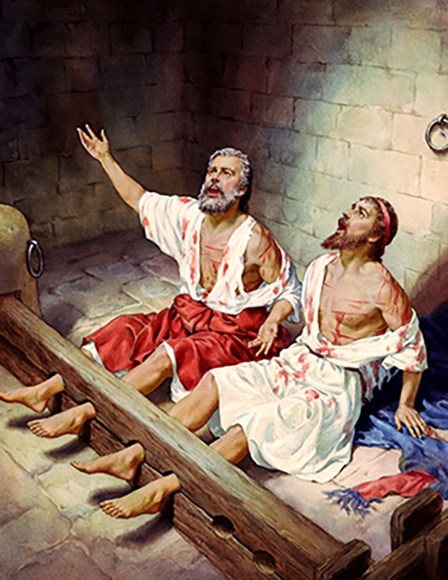intense they could not sleep? [30] Amongst their pain they broke out in prayer and singing that God invited them into this wonderful opportunity.[31] At about midnight there was a violent earthquake and the prison doors flew open and everyone’s chains came loose (verse 26). Seeing the prison doors open, being an honorable retired Roman soldier,[32] the jailer drew his sword to kill himself rather than allow Rome to humiliate, torture and publicly execute him. [33] Paul told him to not harm himself for all prisoners were still present and accounted for (verse 28). The jailer immediately asked, “sirs what must I do to be saved” to which Paul said, “believe in Jesus” (verse 31). The jailer invited Paul and Silas into his home and that night and his entire household got saved and were baptized (verse 34)!

From this part of the story we learn that effective evangelism rejoices and seeks to clearly proclaim the Good News in all circumstances. When God opens the door of a person’s heart to plant and water the seeds of righteousness be ready to drop everything and serve! Like Paul and Silas even during persecution we are to rejoice (Philippians 4:4)[34] and sing songs of praise for in doing so we focus on glorious eternal realities instead of gloomy temporary ones. As their prayers and songs rang throughout the corridors of the prison their voices boldly and truthfully proclaimed the word of God![35] Often the words best spoken are those that are sacrificially lived! So when God asks you to serve even if there is a personal sacrifice to make do so with thanksgiving and rejoice that this wretch that was once lost but found has been given the opportunity to plant and water the seeds of righteousness in another person’s heart. And when it comes to proclaiming the Good News present the Gospel message with simplicity and clarity. Like Paul simply tell the world they must believe in Jesus to be saved.[36] Explain that belief in the Lord Jesus Christ means as your Sin-bearer, as your Deliverer you vow to make Him the Lord of everything you do in life![37]

**Effective Evangelism Means Clearing the Path**

The story finishes by telling us that the next morning the magistrates ordered the jailer to release Paul and Silas from prison. Though no reason is given for their about-face it is likely that the earthquake was to the magistrates like an omen and warning of divine retribution from the missionaries foreign God.[38] Paul demanded the magistrates publicly admit their mistake by escorting both of them out of prison (verse 37). Paul insisted that he be given a public apology[39] so that the magistrate’s false imprisonment might not negatively affect the church’s ability to spread the Gospel message. [40] Upon hearing that Paul and Silas were both Roman citizens out of fear of possible consequences that they themselves having broken Roman laws, [41] the magistrates went to the prison to appease and escort these missionaries of the Most High God out of prison and out of their city. How I absolutely love a story with a divine, happy ending!

I want to finish this sermon with one final thought from Charles Spurgeon. The law told the Jews to keep their roads well cared for and unobstructed. Debris was to be removed from the roads, bridges kept in good shape and signs were to be setup to mark the way to their cities of refuge so that when a person sought safety it would be found.[42] The person who is born again does not demand the best seat in service, i.e. one free of effort or persecution,[43] but merely the opportunity to be the hands and feet of Jesus. As those purchased at a price it is our duty and privilege to be invited to tell others how they can be saved with clarity. Clearing debris from the mission field means humbly praying that the Hoy Spirit might quicken the hearts of the mission field and give one the words and courage to boldly speak the Gospel truth to the skeptical and often hostile believers of this age. While inevitably evangelism will invite persecution, with thanksgiving and rejoicing may we as Christ’s ambassadors always be willing to drop everything to tell this world God has the cure for their disease, sin, belief in His Son Jesus Christ! If you had the cure for COVID-19 you would certainly share it so why not share the cure for the disease sin that is killing over 5 billing of this world!

1. Taken from the following website: <https://www.worldometers.info/coronavirus/>
2. Taken from the following website: <https://sciencebusiness.net/news/canada-pledges-c275m-coronavirus-rd-adding-global-funding-rush>
3. Taken from the following website: <https://www.sciencemag.org/news/2020/03/massive-us-coronavirus-stimulus-includes-research-dollars-and-some-aid-universities>
4. Taken from the following website: <https://www.pewresearch.org/fact-tank/2017/04/05/christians-remain-worlds-largest-religious-group-but-they-are-declining-in-europe/>
5. I am not saying that once born again the person longer sins but does so. What I am saying is that Christ’s blood covers the believer’s sins and seals them to spend an eternity in heaven with Him.
6. Richard N. Longenecker, [“The Acts of the Apostles,”](https://ref.ly/logosres/ebc09?ref=Bible.Ac16.13&off=6&ctx=ia+(16%3a13%E2%80%9315)%0a13+In+~Jewish+law%2c+a+congre) in *The Expositor’s Bible Commentary: John and Acts*, ed. Frank E. Gaebelein, vol. 9 (Grand Rapids, MI: Zondervan Publishing House, 1981), 460.
7. David J. Williams, [*Acts*](https://ref.ly/logosres/nibcnt65ac?ref=Bible.Ac16.16-17&off=2712&ctx=+it+up+in+this+way.+~But+Luke+himself+had), Understanding the Bible Commentary Series (Grand Rapids, MI: Baker Books, 2011), 286.
8. James Montgomery Boice, [*Acts: An Expositional Commentary*](https://ref.ly/logosres/boicecm65ac?ref=Bible.Ac16.16-40&off=3042&ctx=he+Greek+text+says.+~It+actually+says%2c+%E2%80%9CS) (Grand Rapids, MI: Baker Books, 1997), 278.
9. David G. Peterson, [*The Acts of the Apostles*](https://ref.ly/logosres/pntcacts?ref=Bible.Ac16.16-24&off=379&ctx=to+someone+else.%E2%80%9952+~There+is+no+indicati), The Pillar New Testament Commentary (Grand Rapids, MI; Nottingham, England: William B. Eerdmans Publishing Company, 2009), 462.
10. James Montgomery Boice, [*Acts: An Expositional Commentary*](https://ref.ly/logosres/boicecm65ac?ref=Bible.Ac16.16-40&off=1986&ctx=e+of+the+Slave+Girl%0a~Because+of+our+parti) (Grand Rapids, MI: Baker Books, 1997), 278.
11. Ajith Fernando, [*Acts*](https://ref.ly/logosres/nivac65ac?ref=Bible.Ac16.16-24&off=170&ctx=its+in+Jesus%E2%80%99+life.+~The+spirits+seem+to+), The NIV Application Commentary (Grand Rapids, MI: Zondervan Publishing House, 1998), 444.
12. David G. Peterson, [*The Acts of the Apostles*](https://ref.ly/logosres/pntcacts?ref=Bible.Ac16.16-17&off=2478&ctx=is+own+pantheon%E2%80%99.60+~Salvation+in+materia), The Pillar New Testament Commentary (Grand Rapids, MI; Nottingham, England: William B. Eerdmans Publishing Company, 2009), 464.
13. James Montgomery Boice, [*Acts: An Expositional Commentary*](https://ref.ly/logosres/boicecm65ac?ref=Bible.Ac16.16-40&off=8044&ctx=sued+such+commands!+~The+girl+was+deliver) (Grand Rapids, MI: Baker Books, 1997), 280.
14. David G. Peterson, [*The Acts of the Apostles*](https://ref.ly/logosres/pntcacts?ref=Bible.Ac16.16-24&off=379&ctx=to+someone+else.%E2%80%9952+~There+is+no+indicati), The Pillar New Testament Commentary (Grand Rapids, MI; Nottingham, England: William B. Eerdmans Publishing Company, 2009), 462.
15. Ajith Fernando, [*Acts*](https://ref.ly/logosres/nivac65ac?ref=Bible.Ac16.11-40&off=16607&ctx=ruth+of+the+gospel.+~But+ultimately+it+is), The NIV Application Commentary (Grand Rapids, MI: Zondervan Publishing House, 1998), 448.
16. Ajith Fernando, [*Acts*](https://ref.ly/logosres/nivac65ac?ref=Bible.Ac16.11-40&off=16146&ctx=les+right+away.%0a(2)+~Note+the+interplay+b), The NIV Application Commentary (Grand Rapids, MI: Zondervan Publishing House, 1998), 447–448.
17. David G. Peterson, [*The Acts of the Apostles*](https://ref.ly/logosres/pntcacts?ref=Bible.Ac16.19-21&off=1781&ctx=opular+(crowds)%E2%80%99.67+~They+used+labelling+), The Pillar New Testament Commentary (Grand Rapids, MI; Nottingham, England: William B. Eerdmans Publishing Company, 2009), 465–466.
18. James Montgomery Boice, [*Acts: An Expositional Commentary*](https://ref.ly/logosres/boicecm65ac?ref=Bible.Ac16.16-40&off=10639&ctx=to+say+in+essence%2c+%E2%80%9C~These+men+are+Jews+a) (Grand Rapids, MI: Baker Books, 1997), 281.
19. David G. Peterson, [*The Acts of the Apostles*](https://ref.ly/logosres/pntcacts?ref=Bible.Ac16.16-24&off=826&ctx=+prison+(16%3a16%E2%80%9324).+~The+charge+ignores+t), The Pillar New Testament Commentary (Grand Rapids, MI; Nottingham, England: William B. Eerdmans Publishing Company, 2009), 462.
20. Ajith Fernando, [*Acts*](https://ref.ly/logosres/nivac65ac?ref=Bible.Ac16.16-24&off=2246&ctx=t+midnight+(v.+25).+~The+treatment+Paul+a), The NIV Application Commentary (Grand Rapids, MI: Zondervan Publishing House, 1998), 445.
21. C. H. Spurgeon, [“Conversion and Character,”](https://ref.ly/logosres/mtpserms59?ref=Page.p+445&off=2068&ctx=came+in+Paul%E2%80%99s+way.+~It+was+a+sad+rufflin) in *The Metropolitan Tabernacle Pulpit Sermons*, vol. 59 (London: Passmore & Alabaster, 1913), 445–446.
22. David G. Peterson, [*The Acts of the Apostles*](https://ref.ly/logosres/pntcacts?ref=Bible.Ac16.19-21&off=2228&ctx=sting+social+order.+~Judaism%2c+however%2c+wa), The Pillar New Testament Commentary (Grand Rapids, MI; Nottingham, England: William B. Eerdmans Publishing Company, 2009), 466.
23. David J. Williams, [*Acts*](https://ref.ly/logosres/nibcnt65ac?ref=Bible.Ac16.20-21&off=2350&ctx=two+men+being+Jews.+~Though+imperial+poli), Understanding the Bible Commentary Series (Grand Rapids, MI: Baker Books, 2011), 287.
24. James Montgomery Boice, [*Acts: An Expositional Commentary*](https://ref.ly/logosres/boicecm65ac?ref=Bible.Ac16.16-40&off=9398&ctx=atriotic+community.+~Philippi+had+been+se) (Grand Rapids, MI: Baker Books, 1997), 280.
25. C. H. Spurgeon, [“Conversion and Character,”](https://ref.ly/logosres/mtpserms59?ref=Page.p+446&off=1565&ctx=treets+of+Philippi.+~God+knows+where+it+i) in *The Metropolitan Tabernacle Pulpit Sermons*, vol. 59 (London: Passmore & Alabaster, 1913), 446.
26. C. H. Spurgeon, [“Conversion and Character,”](https://ref.ly/logosres/mtpserms59?ref=Page.p+446&off=617&ctx=ts+of+Jesus+Christ%2c+~never+be+discouraged) in *The Metropolitan Tabernacle Pulpit Sermons*, vol. 59 (London: Passmore & Alabaster, 1913), 446.
27. Ajith Fernando, [*Acts*](https://ref.ly/logosres/nivac65ac?ref=Bible.Ac16.16-24&off=1841&ctx=t+a+trial%E2%80%9D+(v.+37).+~They+were+sent+to+th), The NIV Application Commentary (Grand Rapids, MI: Zondervan Publishing House, 1998), 445.
28. F. F. Bruce, [*The Book of the Acts*](https://ref.ly/logosres/nicnt65ac?ref=Bible.Ac16.23-24&off=200&ctx=part+of+the+prison.+~These+stocks+had+mor), The New International Commentary on the New Testament (Grand Rapids, MI: Wm. B. Eerdmans Publishing Co., 1988), 315.
29. Ajith Fernando, [*Acts*](https://ref.ly/logosres/nivac65ac?ref=Bible.Ac16.11-40&off=20842&ctx=Songs+in+the+night.+~The+emotions+of+Paul), The NIV Application Commentary (Grand Rapids, MI: Zondervan Publishing House, 1998), 449.
30. David J. Williams, [*Acts*](https://ref.ly/logosres/nibcnt65ac?ref=Bible.Ac16.22-24&off=1502&ctx=arper+perspective).+~As+an+additional+tor), Understanding the Bible Commentary Series (Grand Rapids, MI: Baker Books, 2011), 288.
31. James Montgomery Boice, [*Acts: An Expositional Commentary*](https://ref.ly/logosres/boicecm65ac?ref=Bible.Ac16.16-40&off=13233&ctx=t+from+the+beating.%0a~We+would+have+said%2c+) (Grand Rapids, MI: Baker Books, 1997), 281.
32. F. F. Bruce, [*The Book of the Acts*](https://ref.ly/logosres/nicnt65ac?ref=Bible.Ac16.27&off=266&ctx=tunity+and+escaped.+~For+a+man+brought+up), The New International Commentary on the New Testament (Grand Rapids, MI: Wm. B. Eerdmans Publishing Co., 1988), 317.
33. James Montgomery Boice, [*Acts: An Expositional Commentary*](https://ref.ly/logosres/boicecm65ac?ref=Bible.Ac16.16-40&off=13679&ctx=ners+were+all+gone.+~He+was+ready+to+kill) (Grand Rapids, MI: Baker Books, 1997), 282.
34. James Montgomery Boice, [*Acts: An Expositional Commentary*](https://ref.ly/logosres/boicecm65ac?ref=Bible.Ac16.16-40&off=12576&ctx=rison+that+evening%2c+~%E2%80%9CRejoice+in+the+Lord) (Grand Rapids, MI: Baker Books, 1997), 281.
35. C. H. Spurgeon, [“Conversion and Character,”](https://ref.ly/logosres/mtpserms59?ref=Page.p+452&off=579&ctx=+had+reassured+him.+~Their+voices+had+bee) in *The Metropolitan Tabernacle Pulpit Sermons*, vol. 59 (London: Passmore & Alabaster, 1913), 452.
36. R. A. Torrey, [*Revival Addresses*](https://ref.ly/logosres/revivaddr?ref=Page.p+130&off=669&ctx=words+of+the+text%2c+%E2%80%9C~Believe+on+the+Lord+) (Chicago; New York: Fleming H. Revell Company, 1903), 130.
37. R. A. Torrey, [*Revival Addresses*](https://ref.ly/logosres/revivaddr?ref=Page.p+134&off=688&ctx=%2c+to+sum+it+all+up%2c+~to+believe+on+the+Lo) (Chicago; New York: Fleming H. Revell Company, 1903), 134.
38. David G. Peterson, [*The Acts of the Apostles*](https://ref.ly/logosres/pntcacts?ref=Bible.Ac16.35-36&off=382&ctx=ts+and+punishments.+~No+reason+is+given+f), The Pillar New Testament Commentary (Grand Rapids, MI; Nottingham, England: William B. Eerdmans Publishing Company, 2009), 471.
39. Ajith Fernando, [*Acts*](https://ref.ly/logosres/nivac65ac?ref=Bible.Ac16.35-40&off=509&ctx=the+magistrates.%E2%80%9D16+~Therefore+they+insis), The NIV Application Commentary (Grand Rapids, MI: Zondervan Publishing House, 1998), 446.
40. David J. Williams, [*Acts*](https://ref.ly/logosres/nibcnt65ac?ref=Bible.Ac16.36-37&off=1047&ctx=f+outraged+justice%3b+~it+was+important+tha), Understanding the Bible Commentary Series (Grand Rapids, MI: Baker Books, 2011), 291.
41. David G. Peterson, [*The Acts of the Apostles*](https://ref.ly/logosres/pntcacts?ref=Bible.Ac16.37&off=209&ctx=ated+accordingly.95+~They+had+been+public), The Pillar New Testament Commentary (Grand Rapids, MI; Nottingham, England: William B. Eerdmans Publishing Company, 2009), 472.
42. James Montgomery Boice, [*Acts: An Expositional Commentary*](https://ref.ly/logosres/boicecm65ac?ref=Bible.Ac16.16-40&off=17135&ctx=run+to+and+be+safe.+~Spurgeon+indicated+h) (Grand Rapids, MI: Baker Books, 1997), 283.
43. C. H. Spurgeon, [“Conversion and Character,”](https://ref.ly/logosres/mtpserms59?ref=Page.p+453&off=2666&ctx=them+with+gladness.+~The+man+who+is+reall) in *The Metropolitan Tabernacle Pulpit Sermons*, vol. 59 (London: Passmore & Alabaster, 1913), 453.