**Our Refuge**

**Psalms 46:1-3**

Online Sermon: <http://www.mckeesfamily.com/?page_id=3567>

**“If, indeed the Lord be our refuge and strength, we are entitled to seek after a spirit which shall bear us above the dreads of common men.”[1]**

When the tides of tribulations come roaring into one’s life and “our men lose their hope of a future and purpose, you’ll surely watch them die a slow death in front of you.”[2] While humanity has always been worried about the ways in which this world might end such as global warming, asteroid hitting the earth, engineered diseases, nuclear war, overpopulation or robot takeovers; nothing instills fear into the heart as quick as having to “live” with an inescapable threat to one’s own personal livelihood, mind or body! When the “worldly” solutions of money, fame, power and the creativity of one’s mind fail to provide the means of escape, where can one go to find refuge for one’s soul? During the dark and dangerous periods of the Reformation Martin Luther found in Psalms 46 the answer to this question … refuge is found in the Lord![3] “A sense of nearness and graciousness of God is the antidote to fear,”[4] for in His sovereignty He promises to not only do good to those who love Him (Romans 8:28) but to grant them strength, endurance and peace that surpasses all understanding! While non-believers might not see the logic of having faith in One who cannot be seen, though saints might get perplexed (2 Corinthians 4:8-12)[5] they need not fear any peril because they can always run to their ever present Father to find divine protection, strength and refuge![6] The following sermon is going to focus first on the false refuge of the things of this world and finish with what refuge in God looks like.

**False Refuge in the Things of this World**

For many people in this world security against the unknown comes from acquiring an abundance of earthly stuff. To insure against tribulation many people acquire fat bank accounts, lush stock portfolios and all sorts of other tangible assets. Others find security in obtaining specialized skill sets or personal 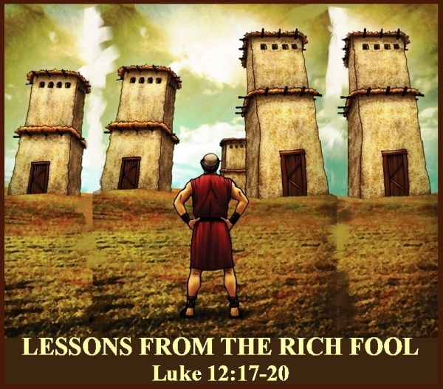talents that are in high demand[7] and yet others find security in family, friends or business connections.[8] And when in need some will even find their security in their ability to “break down, divide, destroy, disintegrate” [9] or steal the assets of others. The Bible says that only a fool would seek such earthly things as security for an unknown future because they are only temporary and are unable to protect oneself from the greatest tribulations of life (Matthew 6:19-21). No amount of money, specialized training, or privileged relationships can ensure one against heartbreak, failure, sin, disease or worldly disasters[10] such as the Coronus virus the world is facing right now! In a parable of the rich fool Jesus stated that finding security in earthly possessions is vanity because upon death no one takes their earthly riches with them nor do they provide any help when facing God’s judgement (Luke 12:13-21)!

**True Refuge is Found in God**

We will never know what true strength and peace is until we believe in and trust that our God oversees everything, and can do anything![11] Luther stated the reason he sang Psalms 46 when facing tribulations was “because God is with us and powerfully and miraculously preserves and defends His church and His word against fanatical spirits, against the gates of hell, against the implacable hatred of Satan, and against all assaults of the world, the flesh and sin.”[12] True peace of mind does not arise from one’s own personal self-sufficiency,[13] but is freely granted to God’s children when they draw nearer to His presence (James 4:8).[14] While it is true that God is indivisible present everywhere always (Psalms 139), we as His children are not always willing to listen, see or obey Him. “God’s word and ordinances are rivers and streams with which God makes His saints glad in dark cloudy days” [15] and the gentle whisper of His voice can calm the fiercest storms of fear raging in one’s heart! If only we would be still (verse 10),[16] pray, learn from and obey God we would no longer store treasures up on earth[17] as insurance but instead rejoice for we would have faith beyond any doubt that our future is known and secured by Christ Jesus our Lord!

**True Refuge in God Eliminates Fear**

It is one thing to confess or know that God is our refuge it is quite another “to bring our hearts to feel that confessed security is monumental!”[18] Fear is often the companion of uncertainty but even more so when the magnitude of one’s calamities threatens one’s very own life. In today’s passage the Psalmist states that “even if human existence would be threatened with dissolution”[19] by the return of precreation[20] chaotic waters that topple the mountains into the heart of the sea,[21] believers will fear not because our God would still be sovereign! When we allow memories of past deliverances and “immediate enjoyment of divine help”[22] to flood into our souls, fear is swallowed up solely by faith in our Creator.[23] This kind of unshakeable faith is attainable for any believer who not only remembers who God is, our sovereign Creator, but who God is to us, our refuge and strength.[24] Praise be to God that no calamity will separate us from the love of God[25] that says “I have always known you (Psalms 139) and will never allow you to experience trials without My peace (Philippians 4:7). No matter what happens My children are joint heirs with Christ[26] and will spend eternity with Me in paradise (John 3:16).” Because God is present as the refuge of His people, it is unreasonable for His children to fear anything![27]

**True Refuge in God Readies Oneself for Satan’s Attacks**

“If you become fearless through the presence of God, that courage will be tried.”[28] Masquerading as an angel of light (2 Corinthians 11:14) Satan is more than capable of promoting doubt and fear into our hearts. To the 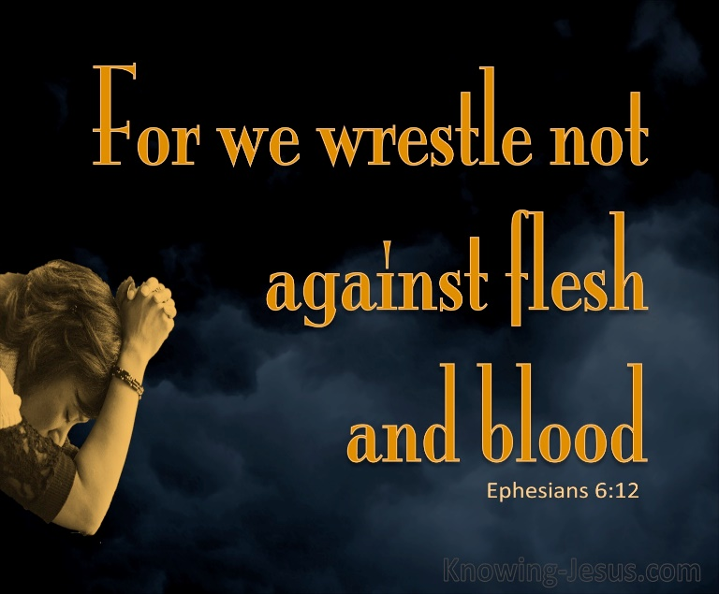church of Ephesus Apostle Paul wrote that what we as Christians wrestle against the most is not people trying to harm us but with the spiritual forces of evil in this dark world (6:12). Even though the Devil has lost the battle for our eternal destination (John 3:16) he is more than willing to instill terror into the hearts of those believers who are weak in their faith.[29] Though the Devil prowls around like a lion looking to devour us we are to fear no evil for when we sit down in the middle of the storm and are still**[30]** in the presence of He who is greater than the Devil and millions of demons**[31]** we can hear God’s powerful voice say “you are secure in the palm of My hand and beneath My wings.” Despite Satan’s attacks of terror upon our minds we can continue to feel peace that surpasses all understanding because our portion (Psalms 16:5) is God whose plans to do good for us (Romans 8:28) is founded on the unmoveable Rock of our salvation. Ironically it is precisely in trails and tribulations that “believers find new grace”[32] and become even more certain of the truth that since God is for them so who can be against them (Romans 8:31)? May during our storms we strap on the armour of God (Ephesians 6:10-17) and cry out “the Lord liveth and blessed by my Rock (Psalms 18:46)! [33]

**A Great Harvest of Hurting Sheep**

In 2 Kings 6:8-23 we are told a beautiful story about how Elisha shared his unwavering faith in God with his servant. In this passage we are told that the king of Aram was trying to war against Israel but each time he made a battle plan with his officers when it came time to fight Israel had moved and successfully evaded his armies (8-10)! Furious with the situation the king of Aram summoned his officers and demanded to know who was the traitor to which they replied that somehow the 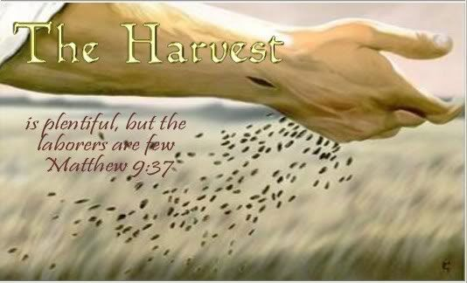prophet Elisha knew every word of the king’s plans despite them being spoken in the privacy of his bedroom (11-12). Once the king found out Elisha was in Dothan, he sent a strong force of horses and chariots and surrounded the city (13-14). When Elisha’s servant got up and looked out his window terror filled his soul and I can only imagine with great quivering in his voice asked Elisha what shall we do (15)? Elisha prayed to God that his servant’s eyes might be open and once granted he was able to see the hills full of horses and chariots of fire of the Lord’s army (16-17). That day the Lord blinded king Aram’s army and both Elisha and his servant were delivered from any harm (18-23)!

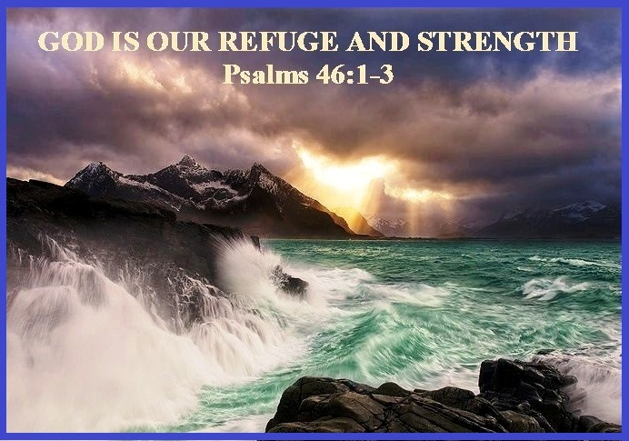 I tell you this story to remind both you and me there exists a great harvest of hurting sheep in this world! An estimated 2/3rd of the world are unsaved and about 1.6 billion people have not heard about Jesus.[34] Despite this truth only 1 % of Christian income is spent reaching unbelievers.[35] Part of the problem lies in that fact that a staggering 51 % of churchgoers don’t know the Great Commission and 25 % know it but not what it means![36] When earthly solutions of money, fame, power and the creativity of their minds fail to deliver this world from tribulations terror fills their souls! The more distraught the situation the more the world will look to the fearless of the Christians and want to know to whom their peace is found! What an amazing time to be alive for during this pandemic the whole world seeks to find security. In response to the crowds gathering to hear or to receive His touch Jesus stated, “the harvest is plentiful, but the labourers are few” (Matthew 9:36-37).[37] No longer able to stand on earthly means of escape this world is desperately looking for a Deliverer. In the comfort that you have received tell the whole world the reason why you have hope … my Jesus who is my portion and the rock of my salvation, wants you to enter into His divine fellowship of security and peace! Let’s obey the Great Commission and go out into this world and baptize them in the name of the Father, Son and Holy Spirit and teach them all about Jesus! I want to leave you with this final quote from John Piper:

**“I want to live my life in this age of massive misery and lostness so that when I die, I can look up from my bed, not with any pretense of perfection, not with any illusions of my indispensability, but with faith and hope in Jesus my Savior, and say, “I have glorified you, Father, on earth, having accomplished the work you gave me to do.”**[38]

1. C. H. Spurgeon, [“Earthquake, but Not Heartquake,”](https://ref.ly/logosres/mtpserms33?ref=Page.p+121&off=706&ctx=ll+who+rest+in+God.+~If%2c+indeed+the+Lord+) in *The Metropolitan Tabernacle Pulpit Sermons*, vol. 33 (London: Passmore & Alabaster, 1887), 121.
2. Author is Nan Jones, taken from the book *Poems about Life*.
3. James Montgomery Boice, [*Psalms 42–106: An Expositional Commentary*](https://ref.ly/logosres/boicecm19bps?ref=Bible.Ps46&off=1340&ctx=orite+was+Psalm+46.+~It+is+said+of+Luther) (Grand Rapids, MI: Baker Books, 2005), 388.
4. C. H. Spurgeon, [“Earthquake, but Not Heartquake,”](https://ref.ly/logosres/mtpserms33?ref=Page.p+126&off=392&ctx=r+you+to+be+afraid.+~A+sense+of+the+nearn) in *The Metropolitan Tabernacle Pulpit Sermons*, vol. 33 (London: Passmore & Alabaster, 1887), 126.
5. C. H. Spurgeon, [“Earthquake, but Not Heartquake,”](https://ref.ly/logosres/mtpserms33?ref=Page.p+126&off=2814&ctx=ed+by+his+presence.+~We+are+perplexed%2c+bu) in *The Metropolitan Tabernacle Pulpit Sermons*, vol. 33 (London: Passmore & Alabaster, 1887), 126.
6. Willem A. VanGemeren, [“Psalms,”](https://ref.ly/logosres/ebc05?ref=Bible.Ps46.1&off=1004&ctx=%3a8%2c+10%3b+Exod+3%3a12).%0a~This+great+God+is+%E2%80%9Ce) in *The Expositor’s Bible Commentary: Psalms, Proverbs, Ecclesiastes, Song of Songs*, ed. Frank E. Gaebelein, vol. 5 (Grand Rapids, MI: Zondervan Publishing House, 1991), 351.
7. James Montgomery Boice, [*Psalms 42–106: An Expositional Commentary*](https://ref.ly/logosres/boicecm19bps?ref=Bible.Ps46&off=3272&ctx=ster+in+this+world.%0a~Other+people+think+t) (Grand Rapids, MI: Baker Books, 2005), 388.
8. James Montgomery Boice, [*Psalms 42–106: An Expositional Commentary*](https://ref.ly/logosres/boicecm19bps?ref=Bible.Ps46&off=3151) (Grand Rapids, MI: Baker Books, 2005), 388.
9. C. H. Spurgeon, [“Earthquake, but Not Heartquake,”](https://ref.ly/logosres/mtpserms33?ref=Page.p+130&off=2375&ctx=+French+Revolution.+~To+break+down%2c+divid) in *The Metropolitan Tabernacle Pulpit Sermons*, vol. 33 (London: Passmore & Alabaster, 1887), 130.
10. James Montgomery Boice, [*Psalms 42–106: An Expositional Commentary*](https://ref.ly/logosres/boicecm19bps?ref=Bible.Ps46&off=2708&ctx=+comparable+refuge.%0a~Some+people+think+th) (Grand Rapids, MI: Baker Books, 2005), 388.
11. C. H. Spurgeon, [“Earthquake, but Not Heartquake,”](https://ref.ly/logosres/mtpserms33?ref=Page.p+123&off=315&ctx=od+is+our+strength.+~We+never+know+what+s) in *The Metropolitan Tabernacle Pulpit Sermons*, vol. 33 (London: Passmore & Alabaster, 1887), 123.
12. James Montgomery Boice, [*Psalms 42–106: An Expositional Commentary*](https://ref.ly/logosres/boicecm19bps?ref=Bible.Ps46&off=1851&ctx=rtress+Is+Our+God.%E2%80%9D%0a~Luther+said%2c+%E2%80%9CWe+sin) (Grand Rapids, MI: Baker Books, 2005), 388.
13. C. H. Spurgeon, [“Earthquake, but Not Heartquake,”](https://ref.ly/logosres/mtpserms33?ref=Page.p+122&off=2887&ctx=h+a+truer+reliance.+~Though+the+earth+be+) in *The Metropolitan Tabernacle Pulpit Sermons*, vol. 33 (London: Passmore & Alabaster, 1887), 122–123.
14. C. H. Spurgeon, [“Earthquake, but Not Heartquake,”](https://ref.ly/logosres/mtpserms33?ref=Page.p+128&off=1190&ctx=er+means+of+escape.+~Presence+of+mind+is+) in *The Metropolitan Tabernacle Pulpit Sermons*, vol. 33 (London: Passmore & Alabaster, 1887), 128.
15. Matthew Henry, [*Matthew Henry’s Commentary on the Whole Bible: Complete and Unabridged in One Volume*](https://ref.ly/logosres/mhenry?ref=Bible.Ps46.1-5&off=4711&ctx=he+city+of+our+God.+~God%E2%80%99s+word+and+ordin) (Peabody: Hendrickson, 1994), 809.
16. John Piper, [*Sermons from John Piper (1990–1999)*](https://ref.ly/logosres/srmpiper1990?art=sermon.778&off=7739&ctx=rry+fill+our+minds.%0a~Psalm+46%3a10+says%2c+%E2%80%9CB) (Minneapolis, MN: Desiring God, 2007).
17. Matthew Henry, [*Matthew Henry’s Commentary on the Whole Bible: Complete and Unabridged in One Volume*](https://ref.ly/logosres/mhenry?ref=Bible.Ps46.1-5&off=2994&ctx=ell+for+the+church.+~See+Ps.+93%3a4.+If+the) (Peabody: Hendrickson, 1994), 809.
18. Robert L. Jr. Hubbard and Robert K. Johnston, [“Foreword,”](https://ref.ly/logosres/bakerubot19ps?ref=Bible.Ps46.1-3&off=506&ctx=to+bestow+blessing.%0a~It+is+one+thing+to+c) in *Psalms*, ed. W. Ward Gasque, Robert L. Hubbard Jr., and Robert K. Johnston, Understanding the Bible Commentary Series (Grand Rapids, MI: Baker Books, 2012), 209.
19. Gerald H. Wilson, [*Psalms*](https://ref.ly/logosres/nivac19ps01?ref=Bible.Ps46.1-3&off=1325&ctx=ablished+boundaries.~+Similarly+here+in+P), vol. 1, The NIV Application Commentary (Grand Rapids, MI: Zondervan, 2002), 716.
20. Robert G. Bratcher and William David Reyburn, [*A Translator’s Handbook on the Book of Psalms*](https://ref.ly/logosres/ubshbk19?ref=Bible.Ps46.1-3&off=593&ctx=used+also+in+22%3a19.%0a~All+of+the+catastrop), UBS Handbook Series (New York: United Bible Societies, 1991), 431.
21. James Montgomery Boice, [*Psalms 42–106: An Expositional Commentary*](https://ref.ly/logosres/boicecm19bps?ref=Bible.Ps46&off=4571&ctx=t+help+in+trouble.%E2%80%9D%0a~God+is+our+help+even) (Grand Rapids, MI: Baker Books, 2005), 389.
22. C. H. Spurgeon, [“Earthquake, but Not Heartquake,”](https://ref.ly/logosres/mtpserms33?ref=Page.p+126&off=70&ctx=%3f+How+dare+we+fear%3f%0a~Once+more%2c+dear+frie) in *The Metropolitan Tabernacle Pulpit Sermons*, vol. 33 (London: Passmore & Alabaster, 1887), 126.
23. Robert L. Jr. Hubbard and Robert K. Johnston, [“Foreword,”](https://ref.ly/logosres/bakerubot19ps?ref=Bible.Ps46.1-3&off=717&ctx=rity+is+monumental.+~This+is+the+case+esp) in *Psalms*, ed. W. Ward Gasque, Robert L. Hubbard Jr., and Robert K. Johnston, Understanding the Bible Commentary Series (Grand Rapids, MI: Baker Books, 2012), 209.
24. C. H. Spurgeon, [“Earthquake, but Not Heartquake,”](https://ref.ly/logosres/mtpserms33?ref=Page.p+123&off=1071&ctx=rings+are+in+thee.%E2%80%9D%0a~This+confidence+is+g) in *The Metropolitan Tabernacle Pulpit Sermons*, vol. 33 (London: Passmore & Alabaster, 1887), 123.
25. C. H. Spurgeon, [“Earthquake, but Not Heartquake,”](https://ref.ly/logosres/mtpserms33?ref=Page.p+127&off=831&ctx=+of+his+confidence.+~No+calamity+will+cha) in *The Metropolitan Tabernacle Pulpit Sermons*, vol. 33 (London: Passmore & Alabaster, 1887), 127.
26. C. H. Spurgeon, [“Earthquake, but Not Heartquake,”](https://ref.ly/logosres/mtpserms33?ref=Page.p+123&off=1745&ctx=monopolize+the+sun.+~And+shall+not+the+Ch) in *The Metropolitan Tabernacle Pulpit Sermons*, vol. 33 (London: Passmore & Alabaster, 1887), 123.
27. C. H. Spurgeon, [“Earthquake, but Not Heartquake,”](https://ref.ly/logosres/mtpserms33?ref=Page.p+127&off=564&ctx=+will+not+we+fear.%E2%80%9D+~Because+God+is+prese) in *The Metropolitan Tabernacle Pulpit Sermons*, vol. 33 (London: Passmore & Alabaster, 1887), 127.
28. C. H. Spurgeon, [“Earthquake, but Not Heartquake,”](https://ref.ly/logosres/mtpserms33?ref=Page.p+129&off=1694&ctx=ss+will+be+exposed.+~If+you+become+fearle) in *The Metropolitan Tabernacle Pulpit Sermons*, vol. 33 (London: Passmore & Alabaster, 1887), 129.
29. C. H. Spurgeon, [“Earthquake, but Not Heartquake,”](https://ref.ly/logosres/mtpserms33?ref=Page.p+128&off=830&ctx=t+which+is+foolish.+~Men+when+they+are+fr) in *The Metropolitan Tabernacle Pulpit Sermons*, vol. 33 (London: Passmore & Alabaster, 1887), 128.
30. James Montgomery Boice, [*Psalms 42–106: An Expositional Commentary*](https://ref.ly/logosres/boicecm19bps?ref=Bible.Ps46&off=5605&ctx=+is+not+shaken.%E2%80%9D%EF%BB%BF3%EF%BB%BF+~She+added+that+the+t) (Grand Rapids, MI: Baker Books, 2005), 389.
31. James Montgomery Boice, [*Psalms 42–106: An Expositional Commentary*](https://ref.ly/logosres/boicecm19bps?ref=Bible.Ps46&off=5605&ctx=+is+not+shaken.%E2%80%9D%EF%BB%BF3%EF%BB%BF+~She+added+that+the+t) (Grand Rapids, MI: Baker Books, 2005), 389.
32. C. H. Spurgeon, [“Earthquake, but Not Heartquake,”](https://ref.ly/logosres/mtpserms33?ref=Page.p+129&off=2129&ctx=ped+from+under+you.+~Suppose+that+the+Lor) in *The Metropolitan Tabernacle Pulpit Sermons*, vol. 33 (London: Passmore & Alabaster, 1887), 129.
33. C. H. Spurgeon, [“Earthquake, but Not Heartquake,”](https://ref.ly/logosres/mtpserms33?ref=Page.p+131&off=1746&ctx=ce%2c+I+said+to+him%2c+%E2%80%9C~And+is+God+dead%3f+Do+) in *The Metropolitan Tabernacle Pulpit Sermons*, vol. 33 (London: Passmore & Alabaster, 1887), 131.
34. Taken from the following website: <https://www1.cbn.com/ChurchWatch/archive/2008/09/10/23rds-of-the-worlds-people-dont-know-jesus-praying-through>
35. John Piper, [*Sermons from John Piper (1990–1999)*](https://ref.ly/logosres/srmpiper1990?art=sermon.778&off=4035&ctx=hese+people+are+in.+~Less+than+1%25+of+the+) (Minneapolis, MN: Desiring God, 2007).
36. Taken from the following website: <https://www.barna.com/research/half-churchgoers-not-heard-great-commission/>
37. John Piper, [*Sermons from John Piper (1990–1999)*](https://ref.ly/logosres/srmpiper1990?art=sermon.778&off=120&ctx=nd+Success%0aPsalm+46%0a~Almost+everywhere+Je) (Minneapolis, MN: Desiring God, 2007).
38. John Piper, [*Sermons from John Piper (1990–1999)*](https://ref.ly/logosres/srmpiper1990?art=sermon.778&off=4845&ctx=I+want+to+say+too.%E2%80%9D+~I+want+to+live+my+li) (Minneapolis, MN: Desiring God, 2007).