**Good News from Coronavirus Outbreak**

**Hebrews 10 :19-25**

Online Sermon: <http://www.mckeesfamily.com/?page_id=3567>

As the Coronavirus reeks havoc across this world one can’t help but wonder how we might give hope and peace in this time of crises. Those who used to think that the preventative measures such as social distancing, washing one’s hands frequently, avoiding touching one’s eyes, nose, mouth and the outright quarantine of entire cities were measures of the paranoid; as the cases and deaths rise the skeptical have changed their mind … this virus is deadly. Not only does it bring the possibility of death with it but also the likelihood of many people being laid off from work. While fear is the natural response to our dire circumstances surely we who have not been given a spirit of fear (2 Timothy 1:7) would take this opportunity to let our light shine so that others might feel our God-given peace that surpasses all understanding (Philippians 4:7)! To be a light and offer this world peace of mind there are three things we must do: 1) draw nearer to God to learn love and peace from the Master, 2) hold onto and share the hope we have in our Lord Jesus Christ and 3) look for ways to spur one another onto good deeds!

**Draw Nearer to God to Learn Love and Peace from the Master (19-22)**

 To contain the coronavirus China issued one of the largest quarantine in human history,[1] locking down an estimated 50 million people![2] Imagine being quarantined since January and not being allowed to even go outside![3] As much as one loves one’s family would not the isolation reek havoc on one’s mind? Would you not spend at least some of your free time daydreaming about fast food, movies, park walks, vacation trips, snowmobiling or stuffing your face at family or social gatherings? And should you or a loved one get the virus would not thoughts of death ravage your mind? Praise be we as God’s children have the cure for fear and that is faith! This world needs to know that the moment Jesus says “be gone” this virus will cease to exist! So, shouting this Biblical truth from the mountaintop is all it will take to dispel the world’s fear of this virus? For a few yes but for many others unless the messenger has faith that goes beyond the superficial and becomes the kind of faith that living for God permeates their every thought, word and deed;[4] the message as glorious as it is will fail to cut through their fear. If we truly love God and those who are suffering, then we as Christians must take immediate action and ask the Father to help us to become living sacrifices of His word (Romans 12:1-2)!

This brings me to the first of Paul’s exhortations in today’s passage and that is to draw nearer to God. Even though James tells us “to consider it pure joy, my brothers and sisters, whenever you face trials of many kinds” (1:2) this kind of peace is not humanly attainable but given to those who are born again and have received every spiritual blessing[5] in Christ Jesus their Lord (Ephesians 1:3)! One of the greatest of these blessings is the privilege to boldly come into the presence of our Father to receive mercy and grace (Hebrews 4:14-16). In the Old Testament times only the high priest once a year on the Day of Atonement could enter the presence of God inside of the holy of holies.[6] It was through the blood of the Lamb that was slain on the cross that the veil of the temple was torn in two signifying access to the Father is now “wide open” [7] to every member of the community of faith (Ephesians 2:18; 3:12).[8] In the presence of the Father we not only learn about absolute holiness but also, in the depths of His love, mercy and omnipotence (no limits to God’s power), peace that quenches all fear of any virus or tribulation threatening our lives!

Apostle Paul states this “new and living way” that our great priest[9] Christ has opened for us (John 14:6) [10] is one that requires us to boldly approach God with “sincere hearts and full assurance that faith brings” (verse 22). We are not to approach God’s throne cherishing sin in our hearts (Psalms 66:18) or with an attitude of indifference to His righteous commands but with a genuine thirst to be molded and reshaped into His image (Isaiah 64:8) so that we might become the saints that we were created to be (1 Corinthians 1:2)! May our prayers in front of the Father reflect a genuine desire to imitate His Son and to do His will. Like Apostle Paul baptism needs to not only be a symbol of salvation of a regenerate heart[11] but also the death of the old self (Romans 6:1-5) with all its carnality and self-glorification! When this happens prayer ceases to be about what “I” can receive and more about what can “I” do to please Abba, my Father (Romans 8:15)! It is only when the interior life of a person[12] obeys the laws that God has written upon their hearts (Hebrews 10:16) that their light shines so brightly that this skeptical world no longer sees “self” but instead the love of the Father who offers to melt away their fear in His loving arms (Matthew 5:16)!

**Sharing the Hope we Have in our Lord Jesus Christ (23)**

This brings me to the second of Paul’s exhortations in today’s passage and that is to “let us hold unswervingly to the hope we profess, for He who promised is faithful.” So that our faith might be genuine and our lives right in God’s sight may we “hold to, keep or retain” the teaching and traditions of our faith[13] as depicted and grounded in the person and work of Jesus Christ our Lord (1 Corinthians 11:2, 15:2).[14] “What justifies our attempts at faithfulness is God’s faithfulness: He who promised is faithful (Hebrews 11:11)” [15] to forgive our confessed sins (1 John 1:9), to draw nearer to us as we draw nearer to Him (James 4:8) and to guard our hearts and minds with His love and power! As His ambassadors (2 Corinthians 5:20), royal priests (1 Peter 2:9) and companions (Hebrews 3:14)[16] Apostle Peter says we are to always be “ready to give an answer to everyone who asks” the source of our hope (1 Peter 3:15)! More than ever this world needs us Christians to stand firmly on the rock of our salvation (1 Corinthians 3:11) and cry out “let me show you the amazing treasure or pearl (Matthew 13:44-46) that I have found for He alone is the reason I fear not any virus or tribulation that comes my way!”

**Spurring one Another onto Good Deeds (24-25)**

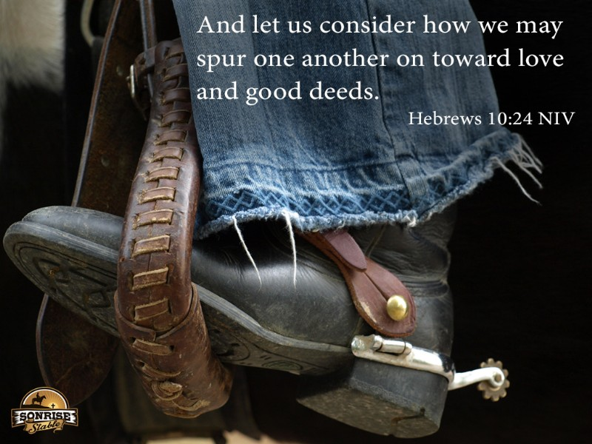This brings me to the last of Paul’s exhortations in today’s passage and that is to consider how we may encourage and spur one another toward love and good deeds. We are not to live our lives in a vacuum but as active members of a worshipping community. Since continually standing firm on the rock of our salvation is far from easy, then may we “notice, consider or pay special attention”[17] to the needs of our immediate Christian community, the local church to which we belong.[18] Even though we as the church submit for the Lord’s sake to the government’s request to not meet publicly (1 Peter 2:13-17), let us briefly consider some of the ways we can support our church family.

1. **Talk to one Another**. While the virus cannot spread through the telephone lines our words of encouragement, joy and peace certainly can! Fellowship is not just spending time physically together but also being emotionally connected to one another. Let’s get into the habit of calling or emailing one another so that we might share in each other’s burdens and uplift one another to the Lord!
2. **Pray for One Another**. I did not place prayer first not because I believe it is secondary in importance but to emphasize that while we talk with one another we ought to seek out the needs of our brothers and sisters so that we might take them to the Lord in prayer. Especially pray that the members of our church might be protected from the fiery darts of Satan who is always trying to fill our hearts with fear and doubt. Remember James says prayer of a righteous person is truly powerful and effective (5:16)!
3. **Do Good Deeds**. Paul says we are to spur one another on toward love and good deeds which comes in a variety of forms. For example, when you are going to pick up supplies for yourself offer to do so for someone else. If able donate food to the local food bank for the homeless and poor of this world for they need our help! If someone is in a financial crisis due to being laid off work provide what you can and let the deacons and pastor know so that we might try and secure additional funds.

This list is not intended to be exhaustive but to spur us the church onto looking for ways to love and support each other in this time of crises. May we show our love for one another by doing good deeds and pointing the world to God the Father in heaven who promises to always do good to those who love Him (Romans 8:28)!

**Conclusion**

As the Coronavirus reeks havoc across the world there is much we can do as Christians. We who have not been given a spirit of fear need to tell the world why we have peace and hope in this time of crises. The truth is that our God is sovereign and the moment He says “be gone” this virus will be eliminated! But until our faith goes from being superficial to sacrificial our Good News will not be accepted, nor will it dispel their fears. So, if we truly want to help this terrified world let’s approach God’s throne of grace and have Him reshape us into His image so that as saints we might point to Abba, our Father. Once our teachings and traditions of faith are grounded in the person and work of Jesus Christ may we go out into the world and point to the incredible Treasure and Pearl we found! Finally, during this crisis let’s not forget our church family. Though we do not meet physically together may we continually support our church family by talking to each other, praying for one another and spurring one another onto doing good deeds. I want to close with this final thought: while this virus will not be forgotten neither will our God who will eliminate it!

1. Taken from the following website: <https://www.businessinsider.com/quarantine-history-following-china-wuhan-coronavirus-lockdowns-2020-1>
2. Taken from the following website: <https://www.vox.com/2020/1/28/21083742/coronavirus-quarantine-wuhan-china-photos>
3. Taken from the following website: <https://www.thejakartapost.com/news/2020/03/04/the-impatience-of-being-idle-chinas-factory-workers-chafe-under-quarantine.html>
4. George Guthrie, [*Hebrews*](https://ref.ly/logosres/nivac79heb?ref=Bible.Heb10.19-25&off=17264&ctx=he+end+of+the+book.%0a~With+10%3a19%E2%80%9325%2c+there), The NIV Application Commentary (Grand Rapids, MI: Zondervan Publishing House, 1998), 347.
5. Leon Morris, [“Hebrews,”](https://ref.ly/logosres/ebc12?ref=Bible.Heb10.19-25&off=600&ctx=one+for+his+people.+~On+the+basis+of+Chri) in *The Expositor’s Bible Commentary: Hebrews through Revelation*, ed. Frank E. Gaebelein, vol. 12 (Grand Rapids, MI: Zondervan Publishing House, 1981), 103.
6. F. F. Bruce, [*The Epistle to the Hebrews*](https://ref.ly/logosres/nicnt79heb?ref=Bible.Heb10.22&off=68&ctx=ar+to+God%2c+that+is.+~No+longer+is+the+pri), Rev. ed., The New International Commentary on the New Testament (Grand Rapids, MI: Wm. B. Eerdmans Publishing Co., 1990), 253–254.
7. F. F. Bruce, [*The Epistle to the Hebrews*](https://ref.ly/logosres/nicnt79heb?ref=Bible.Heb10.20&off=1150&ctx=s+also+probably+the+~inner+veil%2c%EF%BB%BF88%EF%BB%BF+and+), Rev. ed., The New International Commentary on the New Testament (Grand Rapids, MI: Wm. B. Eerdmans Publishing Co., 1990), 251.
8. Donald A. Hagner, [*Hebrews*](https://ref.ly/logosres/nibcnt79heb?ref=Bible.Heb10.19-21&off=765&ctx=ce+(or+%E2%80%9Cboldness%E2%80%9D).+~What+had+previously+), Understanding the Bible Commentary Series (Grand Rapids, MI: Baker Books, 2011), 163–164.
9. Peter T. O’Brien, [*The Letter to the Hebrews*](https://ref.ly/logosres/pntcheb?ref=Bible.Heb10.21&off=259&ctx=r+the+house+of+God.+~The+reminder+to+the+), The Pillar New Testament Commentary (Grand Rapids, MI; Nottingham, England: William B. Eerdmans Publishing Company, 2010), 365.
10. Donald A. Hagner, [*Hebrews*](https://ref.ly/logosres/nibcnt79heb?ref=Bible.Heb10.19-21&off=1297&ctx=n+disclosed%E2%80%9D+(9%3a8).+~But+now+it+is+eviden), Understanding the Bible Commentary Series (Grand Rapids, MI: Baker Books, 2011), 164.
11. F. F. Bruce, [*The Epistle to the Hebrews*](https://ref.ly/logosres/nicnt79heb?ref=Bible.Heb10.22&off=3068&ctx=oly+of+holies.%EF%BB%BF105%EF%BB%BF+~But+the+present+real), Rev. ed., The New International Commentary on the New Testament (Grand Rapids, MI: Wm. B. Eerdmans Publishing Co., 1990), 255.
12. George Guthrie, [*Hebrews*](https://ref.ly/logosres/nivac79heb?ref=Bible.Heb10.19-22&off=4682&ctx=aw+near+to+God.+(a)+~We+must+come+%E2%80%9Cwith+a), The NIV Application Commentary (Grand Rapids, MI: Zondervan Publishing House, 1998), 343.
13. George Guthrie, [*Hebrews*](https://ref.ly/logosres/nivac79heb?ref=Bible.Heb10.23&off=325&ctx=as+an+ongoing+call.+~An+ancient+author+va), The NIV Application Commentary (Grand Rapids, MI: Zondervan Publishing House, 1998), 344.
14. George Guthrie, [*Hebrews*](https://ref.ly/logosres/nivac79heb?ref=Bible.Heb10.23&off=1392&ctx=er+is+challenged+to+~hold+onto+the+Christ), The NIV Application Commentary (Grand Rapids, MI: Zondervan Publishing House, 1998), 344.
15. Donald A. Hagner, [*Hebrews*](https://ref.ly/logosres/nibcnt79heb?ref=Bible.Heb10.23&off=535&ctx=ded+in+that+belief.+~This+is+the+faith+th), Understanding the Bible Commentary Series (Grand Rapids, MI: Baker Books, 2011), 165.
16. F. F. Bruce, [*The Epistle to the Hebrews*](https://ref.ly/logosres/nicnt79heb?ref=Bible.Heb10.23&off=207&ctx=asized%3a+it+is+only+%E2%80%9C~if+we+maintain+our+c), Rev. ed., The New International Commentary on the New Testament (Grand Rapids, MI: Wm. B. Eerdmans Publishing Co., 1990), 256.
17. George Guthrie, [*Hebrews*](https://ref.ly/logosres/nivac79heb?ref=Bible.Heb10.24-25&off=260&ctx=tually+and+morally.+~The+word+translated+), The NIV Application Commentary (Grand Rapids, MI: Zondervan Publishing House, 1998), 345.
18. George Guthrie, [*Hebrews*](https://ref.ly/logosres/nivac79heb?ref=Bible.Heb10.24-25&off=963&ctx=e+past+(Heb.+6%3a10).+~The+need+to+be+chall), The NIV Application Commentary (Grand Rapids, MI: Zondervan Publishing House, 1998), 345.