**My Deliverer**

**Psalms 18:29, 2 Chronicles 32**

Online Sermon: <http://www.mckeesfamily.com/?page_id=3567>

**“With your help I can advance against a troop; with my God I can scale a wall”**

What our minds know as sweet doctrine our hearts have yet to be fully experienced.[1] Even though we know that we are not to worry about our lives, what we shall wear as clothes, eat or drink; most Christians are consumed with the unending dangers that Tomorrow might bring! Fear of the unknown is somewhat understandable because our memories of the pain and aguish of past trials and tribulations have proven that by chance crushing burdens are truly “lurking” around the next corner. These burdens come in many forms such as personal attacks from enemies, financial insolvency, marital disagreements, death of loved ones or physical diseases but the most difficult burden Christians face is the constant assault on their holiness by the spiritual forces of evil of this dark world (Ephesians 6:2)! The yoke of these burdens often feels like unsurmountable walls that will forever keep us stuck in our tribulations to drown in our fear and despair. If you are feeling like the wall of life has taken away your hope and joy, then keep reading for the key to scaling life’s most difficult walls is to be found and secured in faith in our Lord Jesus Christ!

**Conquering One Troop**

 Enemies … most don’t want them and yet they spring forth like bad weeds in a garden! Even though we are created in the image of God each one of us have our own unique nuances. Our identities are forged not just in our experiences but with other factors such as our family, culture, religion, workplace environment, social status and by the characteristics of our peer groups. While the world says uniqueness is to be tolerated and celebrated, practically this is not usually the case. Differences often repulse people, especially when one has wronged another! Having enemies is inevitable especially if one is a Christian because the Light that shines in us exposes the evil deeds of others and testifies that they are not right with God (John 3:20, 15:18-25)! When people revolt against us, who can do us serious physical, financial, spiritual or psychological harm; terror and desperation often flood into our souls. Since we have not been given a Spirit of fear (2 Timothy 1:7), the Psalmist rightly reminds us that we are to have faith that God can help us advance against the “one troop” that is seeking our demise. To understand this phrase better let’s turn to the story of what Hezekiah did when the far more powerful king of Assyria threatened to defeat his kingdom.

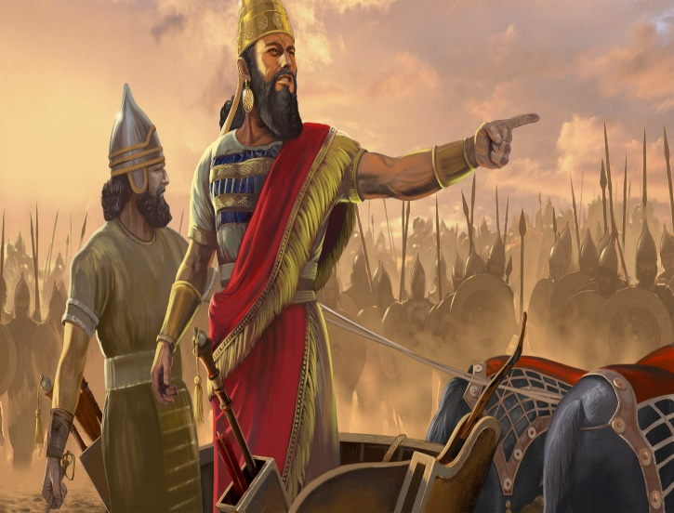 Even though Hezekiah did “what was good and right and faithful before the Lord his God” (31:20), we are told that the vastly more powerful king of Assyria, Sennacherib, invaded and laid siege to the fortified cities of Judah (32:1). Despite blocking the streams that flowed through the land, making repairs, building an additional wall, and forging numerous weapons and shields (32:2-5); Jerusalem’s military officers still needed words of hope from their king because Assyria had a vast and superior army (32:6-7). Hezekiah’s military was scared for very good reasons. First, according to the Assyrian annals Sennacherib had just swept through Judah and ransacked forty-six towns and villages, taking more than 200,000 captives.[2] And second, while he was attacking Lachish, Sennacherib sent officers to tell Hezekiah and the people that their confidence in God saving them was foolish for other nations prayed to their gods and yet they were easily defeated (32:9-17). Even though Hezekiah had paid tribute to the Assyrian king earlier (2 Kings 18:14) this foreigner was now outside their walls calling out his threats in Hebrew to instill fear in the hearts of those stationed on the wall (32:18) with the frightening message: surrender and live or fight and die (2 Kings 18:32)!

Imagine for a moment that you were on the wall of Jerusalem that fateful night! As you look out upon the vast Assyrian army you know that you are supposed to be brave and confident in the Lord and yet you find yourself trembling in fear. You reason to yourself that this is understandable considering that you had just spent the last several days wondering what happened to your relatives and friends who lived in the conquered cities of Judah? Are they dead or have they been taken captive? As you again look out at the vast army your heart breaks for you can’t help but feel overwhelmed with the thought of loosing everything and living your retirement years as a slave or worse yet having your wife or children killed … how could you ever live with such a horror? Facing Assyria, you think aren’t your fears more of a reality check than fantasies of an overactive imagination? You conclude that it is inevitable, Jerusalem is about to fall as easily as the other fortified cities of Judah!

Even though Jerusalem was powerless to resist such a formidable enemy, to God Assyria’s threat to His people represented nothing more than a mere troop to One who is omnipotent![3] Scripture states that King Hezekiah and the prophet Isaiah cried out to God and the Lord sent an angel who “annihilated” all the fighting men, commanders and officers of the Assyrian army that were threatening them (32:20-21)! In today’s passage king David had a similar experience for God easily delivered him from the hands of King Saul and his armies! Moses cried out to God and He drowned the Egyptian army in the sea (Exodus 14)! Even the might and power of all of Rome and the Jewish Sanhedrin that put Christ on the cross were nothing but a mere troop to Jesus who dealt a deathblow to them and Satan through His atonement and resurrection![4] And when it comes to physical ailments remember Jesus opened the ears of the deaf, caused the blind to see, healed the diseases of the people and even raised people from the dead and in doing so proved they are but one troop easily conquered by Him with but a single command! No enemy, no financial difficulty, no marital disagreement, virus or disease is anything but a mere single troop to Christ who is sovereign over all things seen and unseen (Colossians 1:16)! Jesus truly does good to those who love Him (Romans 8:28) and cry out in faith, not fear, to be delivered!

**Scaling the Wall**

The most difficult burden Christians face is the constant assault on their holiness by the spiritual forces of evil of this dark world (Ephesians 6:2)! Apostle Peter tells us to “be alert and of sober mind for our enemy the devil prowls around like a roaring lion looking for someone to devoir (1 Peter 5:8)! The devil who was created as an angel of light, sealed with perfection, filled of wisdom and beauty (Ezekiel 28:12) is a master deceiver (Revelation 12:9) of whose attacks no human strength could ever prevail.[5] Knowing the evil desires of our hearts (James A person standing in front of a building
1:14) and how easily our minds succumb to fear he raises his bow and constantly shoots his fiery darts (Ephesians 6:16) of temptation and fear of the worst possible future into our minds. So powerful are his deceptions that Scripture states he took humanity captive as his slaves, powerless to ever escape (Romans 6:20).[6] Sin created an impenetrable wall between us and our holy God that by human effort alone cannot be scaled or torn down!

While in our own strength we cannot scale the walls of Satan’s attacks, with Jesus our comforter and the Spirit of truth as our guide we are untouchable, firmly secured in an eternal foundation of victory over sin and death! When Jesus Christ died on the cross to atone for humanity, He leaped over all the walls of sin that was imprisoning us and stood there with the keys of hell and death in His very hands (Revelation 1:18), forever securing for us an opportunity to become heirs and children of His Father (John 1:12)! From Apostle Paul we learn that the true battleground for a Christian is in the mind (Romans 7) for it is there that one learns that the walls Satan places in our lives are not impenetrable as he would have us believe but can be easily leaped over when our allegiance is with the One who bought and secured our freedom (1 Corinthians 6:18-20)! We have divine power through the Holy Spirit living inside of us that in faith we can break down any stronghold of sin that Satan places in our minds and take every thought obedient to Christ (2 Corinthians 10:5). This does not mean that faith diminishes our difficulties but instead increases our strength in Jesus to overcome every fiery dart and wall of sin Satan places in the way of drawing nearer to our Saviour![7]

**Conclusion**

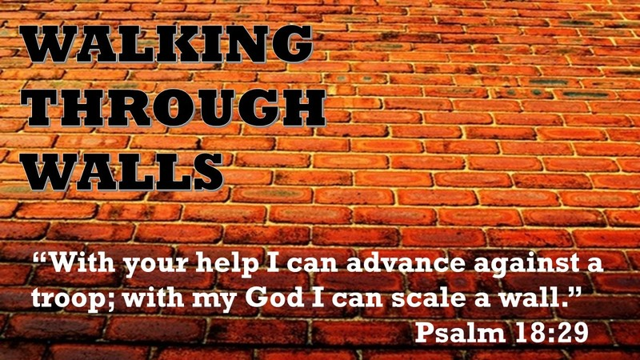**“With your help I can advance against a troop; with my God I can scale a wall” (Psalms 18:29)!** May our minds come to know this phrase by King David as sweet doctrine, but more importantly may our hearts fully experience this to be true! For this to happen one must in faith give one’s allegiance to Jesus to secure victory over the prince of this world. There will always be a new enemy, financial difficulty, marital issue, virus or disease lurking around the corner wanting to fill our hearts with fear. When this happens may we not see the yoke of these fiery darts from Satan as unsurmountable but as a single troop or puny wall that with faith in Christ can be easy defeated or scaled. In conclusion lets put our faith today into practice. I know that the coronavirus COVID-19 has placed into many a heart incredible fear. While there is much that we do not know about the virus what we do know matters. Our God who sent His Son to die on the cross to break our bondage of sin is and always will be omnipotent! So let us take every precaution to be safe and good stewards of the life God has given us but lets not live our lives in fear but in faith that God always does good to those who love Him and with a single word can eradicate this disease forever!

1. C. H. Spurgeon, [“One Trophy for Two Exploits,”](https://ref.ly/logosres/mtpserms49?ref=Page.p+133&off=935&ctx=which+David+passed.%0a~My+dear+brethren%2c+we) in *The Metropolitan Tabernacle Pulpit Sermons*, vol. 49 (London: Passmore & Alabaster, 1903), 133.
2. Andrew E. Hill, [*1 & 2 Chronicles*](https://ref.ly/logosres/nivac13ch?ref=Bible.2Ch32.9-19&off=405&ctx=+2+Kings+18%3a13%E2%80%9316).+~The+Assyrian+annals+), The NIV Application Commentary (Grand Rapids, MI: Zondervan, 2003), 593.
3. C. H. Spurgeon, [“One Trophy for Two Exploits,”](https://ref.ly/logosres/mtpserms49?ref=Page.p+135&off=1684&ctx=+enemies+of+Christ.+~It+will+often+be+of+) in *The Metropolitan Tabernacle Pulpit Sermons*, vol. 49 (London: Passmore & Alabaster, 1903), 135.
4. C. H. Spurgeon, [“One Trophy for Two Exploits,”](https://ref.ly/logosres/mtpserms49?ref=Page.p+136&off=1190&ctx=ound+for+him+a+way.+~They+imagined%2c+when+) in *The Metropolitan Tabernacle Pulpit Sermons*, vol. 49 (London: Passmore & Alabaster, 1903), 136.
5. C. H. Spurgeon, [“One Trophy for Two Exploits,”](https://ref.ly/logosres/mtpserms49?ref=Page.p+135&off=2148&ctx=ighty+they+are%2c+and+~how+powerless+all+hu) in *The Metropolitan Tabernacle Pulpit Sermons*, vol. 49 (London: Passmore & Alabaster, 1903), 135.
6. C. H. Spurgeon, [“One Trophy for Two Exploits,”](https://ref.ly/logosres/mtpserms49?ref=Page.p+138&off=1503&ctx=+for+a+few+minutes.+~The+people+of+the+Lo) in *The Metropolitan Tabernacle Pulpit Sermons*, vol. 49 (London: Passmore & Alabaster, 1903), 138.
7. C. H. Spurgeon, [“One Trophy for Two Exploits,”](https://ref.ly/logosres/mtpserms49?ref=Page.p+141&off=2385&ctx=es+the+believer+do%3f+~There+is+a+troop%2c%E2%80%94we) in *The Metropolitan Tabernacle Pulpit Sermons*, vol. 49 (London: Passmore & Alabaster, 1903), 141.