**Shall we Continue to Sin?**

**Romans 6:1-14**

Online Sermon: <http://www.mckeesfamily.com/?page_id=3567>

The essence of our salvation lies in both grace and faith. Grace means we did not get what we deserve, condemnation and death, because a sinless Christ got what He did not deserve, God’s righteous wrath! He who holds the “keys of heaven, earth and hell”[1] died once and for all and in doing so “His grace delivered us not merely from punishment but from sin’s power.”[2] In his letter to the church of Rome Apostle Paul states that the law was brought in so that trespass might increase, when sin increases, grace increases even more (Romans 5:20). While it would be “foolish” to place oneself under the works of the law (Galatians 3) does this mean that Paul is suggesting that the believer is now free to go on sinning so that grace might increase and further display the glory of God? Also, if the law and its righteous decrees are not to be followed what then is to be the Christian’s benchmark on how to live a holy life, pleasing unto God? In Romans 6:1-14 Paul states the answer to these questions are to be found in knowing what it means to have union with Christ in His death, resurrection and walk.

**Not Under the Law**

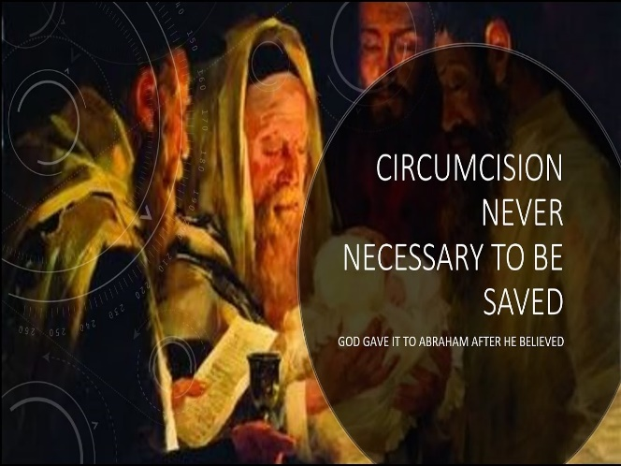 Imagine for a moment what it must have been like to be a Gentile believer during the time of Apostle Paul. How would one feel hearing Paul and Barnabas at Syrian Antioch argued with the “Judaizers” [3] over their teaching that grace and faith were not enough to become saved, one must also be “circumcised according to the custom taught by Moses” (Acts 15:1)? Wouldn’t one be worried that if this one command could be added what would stop some of those Pharisee believers (15:5) from enforcing the full 613 commands of the Old Testament? What a glorious day it would have been for the Gentiles to hear the results of the Jerusalem council that only required them to follow four commands: “to abstain from food sacrificed to idols, from blood, from the meat of strangled animals and from sexual immorality” (15:29). Any Gentile that tried to place themselves back under the works of the Law for Paul was cursed for it was by faith that Abraham was credited as righteous in God’s sight (Galatians 3:6) long before he was circumcised and under the law (Romans 4:11).

**License to Sin?**

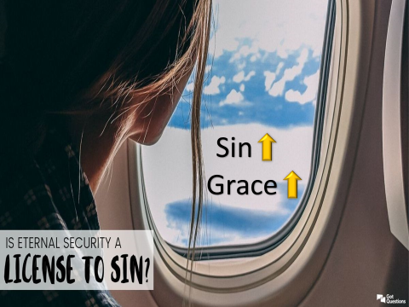 This brings us to the crux and main question Apostle Paul is trying to answer in today’s passage: “**What shall we say, then? Shall we go on sinning so that grace may increase (6:1)”?** While union with sinful Adam brought us condemnation and death, union with a sinless, resurrected Christ brings us justification to be eternally adopted into God’s family (1 Corinthians 15:21). God does not reckon us “righteous” or acceptable as a member of His family based on our deeds (Titus 3:5) but on Christ’s (Romans 5:18)[4] who has never sinned and fallen short of His glory! Critics, who considered Paul to be an antinomian (3:8; Acts 2:21), [5] feared that his view of grace would lead to rampant sin and an utter disregard for holiness! After all, if the basis of our forgiveness, salvation and acceptance into God’s family is solely based on the deeds of Christ then why not indulge in the short term pleasures of sin and in doing so let the grace of God shine even brighter? To keep Christians from distorting grace and making it a license to sin, Paul reminded believers that their union with Christ in death and resurrection means they are obligated to walk as He did!

**Union with Christ in His Death (verses 6:2-3, 6-7)**

**2By no means! We are those who have died to sin; how can we live in it any longer? 3Or don’t you know that all of us who were baptized into Christ Jesus were baptized into His death? 6For we know that our old self was crucified with Him so that the body ruled by sin might be done away with, that we should no longer be slaves to sin—7because anyone who has died has been set free from sin.**

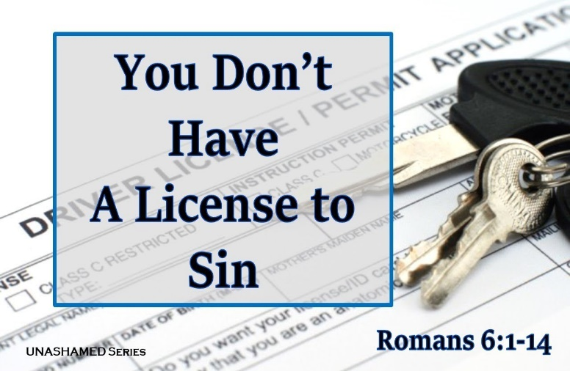 Grace is not a license to sin because of our union with Christ in His death.[6] “When Christ died, believers in some crucial sense died in and with Him.”[7] Even though baptism is not the means of obtaining union with Christ[8] it symbolically attests to our “old self” being crucified on the cross with Jesus.[9] Those who are united with Christ are no longer condemned[10] and have been freed from the entanglement and power of sin. [11] Even though the old self has been crucified it is a “slow and agonizing death”[12] that leaves the believer open to being influenced by their old nature. While it is possible for believers to still sin[13] they are to rejoice that in their union with Christ in His death the claim of sin to rule over our lives has been eternally broken.[14] Since those who are part of this new creation order (2 Corinthians 5:17)[15] have died to sin they are not to go on living in it[16] because the “I” of the life of Adam no lives inside the believer, [17] only Christ (Galatians 2:20)! The reason why we do not sin so that grace might increase is because when Christ died, we died and therefore are not justified to continue living sinful lives.[18]

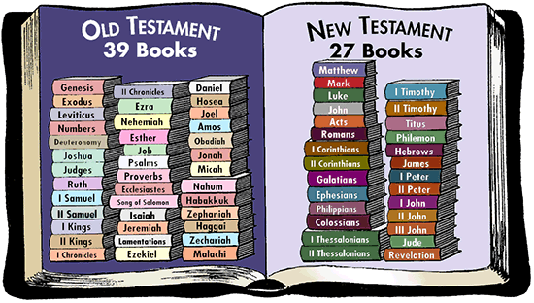 This still leaves us with a perplexing question to answer: did Apostle Paul define the sin based on just the four prohibitions of the Jerusalem council or did his definition of sin also encompass both Old and New Testament commands? To answer this question, one must first understand that the council chose the four abstinences not to be a “cannon” of commands for the Gentiles[19] but for the sake of promoting commonality and Jewish-Gentile fellowship.[20] The Jews would not associate with anyone who willingly ate food sacrificed to idols, consumed blood, ate meat of strangled animals or were sexually immoral. To promote the union of both Jews and Gentiles for Apostle Paul his cannon of laws included the four recommended by the council but also those mentioned in Christ’s teachings. While it might appear that Paul’s statement that a Christian “died to the law” (Romans 7:4) suggests he “threw out” all Old Testament commands, similar to Christ Paul upheld the authority of the OT right down to the “least stroke of the pen!”[21] Even though Christ fulfilled the law and removed the need to make sacrifices this did not mean for Paul that the law was sinful (Romans 7:7) but when its intent was internalized and obeyed[22] made external restriction to the OT laws theoretically unnecessary.[23]

**Union with Christ in His Resurrection (verses 6:4-5, 9-11)**

**We were therefore buried with Him through baptism into death in order that, just as Christ was raised from the dead through the glory of the Father, we too may live a new life. 5For if we have been united with Him in a death like His, we will certainly also be united with Him in a resurrection like His. 9For we know that since Christ was raised from the dead, He cannot die again; death no longer has mastery over Him. 10The death He died, He died to sin once for all; but the life He lives, He lives to God. 11In the same way, count yourselves dead to sin but alive to God in Christ Jesus**

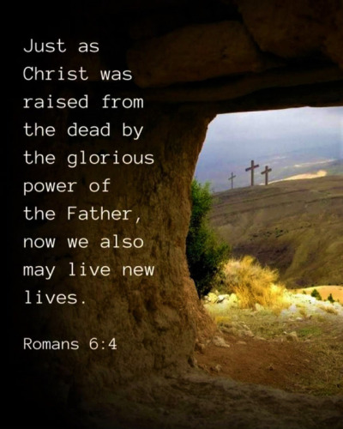 Grace is not a license to sin also because of our union with Christ in His resurrection.[24] On the third day Christ, who did not live for self but to do the will of God the Father,[25] in His sinlessness[26] He rose from the dead and forever conquered the grave and the mastery of sin and death.[27] In doing so Christ paid our debt and provided the means in which those who believe in Him might have new life in Him.[28] Those who participate in Christ’s resurrection[29] are born of the Spirit and now have God’s assistance to grow into the likeness of His Son.[30] Since our old lives have been crucified with Christ[31] Paul states the believer is not to continue to live as if nothing happened[32] but is to obey the intent of the law not to secure the salvation they already have but so that their deeds might reflect thanksgiving for grace and point the world to God the Father in heaven. [33] Surely, He who died once and for all[34] has the right and expectation that believers would be holy as God is holy?

**Walking with Christ (verses 12-14)**

**12Therefore do not let sin reign in your mortal body so that you obey its evil desires. 13Do not offer any part of yourself to sin as an instrument of wickedness, but rather offer yourselves to God as those who have been brought from death to life; and offer every part of yourself to Him as an instrument of righteousness. 14For sin shall no longer be your master, because you are not under the law, but under grace.**

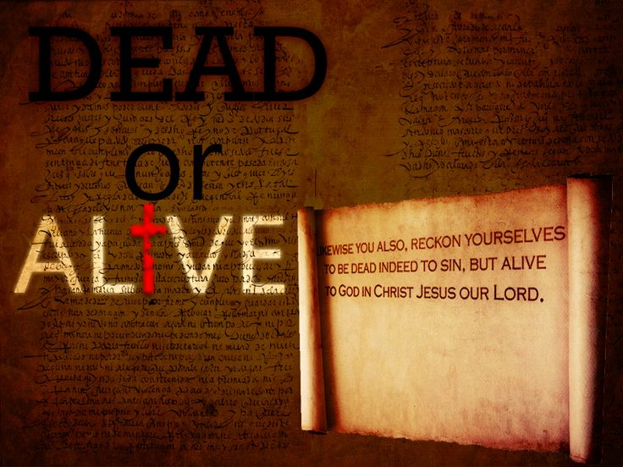 Paul finished this section of his letter by concluding that grace is not a license to sin but the means of justification and sanctification! Even believers are still “diseased, irritable, excitable, and inclined to self-assertion and demoniacal self-distraction,”[35] this does not mean that sin has mastery or is to be the lord of the believer’s life.[36] The death and resurrection of Christ has broken the power of sin[37] and as such has freed the believer to choose which master, Satan or God that they want to serve (Matthew 6:24).[38] Even though “sin wants to capture and rule over” the believer,[39] through the power of the Spirit one can chose to surrender one’s mind, heart, body and soul[40] to faithfully obey one’s Creator! While the law demanded righteousness but could not produce it, grace removes condemnation and He who is for (Romans 8:31), faithful (2 Corinthians 1:18) and has freed us (Galatians 5:1)[41] has enables us to be holy as He is holy. Considering Paul’s teachings will you continue in sin or will you resist the passions and “subtle suggestions of evil,” [42] embrace faithful obedience and draw nearer to God so that He might draw hearer to you? Will you choose to live your life dead to sin and alive in Christ?

1. C. H. Spurgeon, [“Death and Life in Christ,”](https://ref.ly/logosres/mtpserms09?ref=Page.p+197&off=896&ctx=+very+day+he+lives.+~There+at+his+Father%E2%80%99) in *The Metropolitan Tabernacle Pulpit Sermons*, vol. 9 (London: Passmore & Alabaster, 1863), 197.
2. Craig S. Keener, [*Romans*](https://ref.ly/logosres/newcovcomm66ro?ref=Bible.Ro6.1-11&off=762&ctx=e+opposite+is+true%3a+~grace+delivers+not+m), New Covenant Commentary Series (Eugene, OR: Cascade Books, 2009), 79.
3. Richard N. Longenecker, [“The Acts of the Apostles,”](https://ref.ly/logosres/ebc09?ref=Bible.Ac15.1&off=2&ctx=+Antioch+(15%3a1%E2%80%934)%0a1+~The+immediate+occasi) in *The Expositor’s Bible Commentary: John and Acts*, ed. Frank E. Gaebelein, vol. 9 (Grand Rapids, MI: Zondervan Publishing House, 1981), 442.
4. John Piper, [*Sermons from John Piper (2000–2014)*](https://ref.ly/logosres/srmpiper2000?art=sermon.27&off=3989&ctx=+our+justification.+~God+reckons+us+right) (Minneapolis, MN: Desiring God, 2014).
5. Craig S. Keener, [*Romans*](https://ref.ly/logosres/newcovcomm66ro?ref=Bible.Ro6.1-11&off=217&ctx=th+Adam+in+5%3a12%E2%80%9321.+~Paul%E2%80%99s+detractors%2c+w), New Covenant Commentary Series (Eugene, OR: Cascade Books, 2009), 79.
6. Everett F. Harrison, [“Romans,”](https://ref.ly/logosres/ebc10?ref=Bible.Ro6.1-4&off=2416&ctx=+dependence+on+him.+~Union+with+Christ+me) in *The Expositor’s Bible Commentary: Romans through Galatians*, ed. Frank E. Gaebelein, vol. 10 (Grand Rapids, MI: Zondervan Publishing House, 1976), 69.
7. John Piper, [*Sermons from John Piper (2000–2014)*](https://ref.ly/logosres/srmpiper2000?art=sermon.27&off=10469&ctx=+in+three+steps.%0a1.+~When+Christ+died%2c+be) (Minneapolis, MN: Desiring God, 2014).
8. Everett F. Harrison, [“Romans,”](https://ref.ly/logosres/ebc10?ref=Bible.Ro6.1-4&off=2728&ctx=ptism+(Luke+12%3a50).%0a~Paul+uses+baptism+to) in *The Expositor’s Bible Commentary: Romans through Galatians*, ed. Frank E. Gaebelein, vol. 10 (Grand Rapids, MI: Zondervan Publishing House, 1976), 69.
9. Everett F. Harrison, [“Romans,”](https://ref.ly/logosres/ebc10?ref=Bible.Ro6.5-7&off=2816&ctx=+and+as+he+sees+it.%0a~But+what+was+it+that) 70.
10. C. H. Spurgeon, [“Death and Life in Christ,”](https://ref.ly/logosres/mtpserms09?ref=Page.p+199&off=1031&ctx=s+Christ+our+Lord.%E2%80%9D%0a~Well%2c+then%2c+it+seems) in *The Metropolitan Tabernacle Pulpit Sermons*, vol. 9 (London: Passmore & Alabaster, 1863), 199.
11. Everett F. Harrison, [“Romans,”](https://ref.ly/logosres/ebc10?ref=Bible.Ro6.5-7&off=5195&ctx=settles+all+claims.+~Our+union+with+Chris) in *The Expositor’s Bible Commentary: Romans through Galatians*, ed. Frank E. Gaebelein, vol. 10 (Grand Rapids, MI: Zondervan Publishing House, 1976), 70.
12. James R. Edwards, [*Romans*](https://ref.ly/logosres/nibcnt66ro?ref=Bible.Ro6.5-7&off=1660&ctx=+on+sin.+In+verse+2+~the+believer+%E2%80%9Cdied%E2%80%9D+), Understanding the Bible Commentary Series (Grand Rapids, MI: Baker Books, 2011), 162.
13. Everett F. Harrison, [“Romans,”](https://ref.ly/logosres/ebc10?ref=Bible.Ro6.1-4&off=1576&ctx=gically+impossible.+~What+he+does+present) in *The Expositor’s Bible Commentary: Romans through Galatians*, ed. Frank E. Gaebelein, vol. 10 (Grand Rapids, MI: Zondervan Publishing House, 1976), 68.
14. James R. Edwards, [*Romans*](https://ref.ly/logosres/nibcnt66ro?ref=Bible.Ro6.2&off=2534&ctx=llude+to+Mark+3%3a27.+~Since+Christ+has+bro), Understanding the Bible Commentary Series (Grand Rapids, MI: Baker Books, 2011), 159.
15. Everett F. Harrison, [“Romans,”](https://ref.ly/logosres/ebc10?ref=Bible.Ro6.5-7&off=3330&ctx=y+of+sin+and+death.+~For+the+Christian%2c+t) in *The Expositor’s Bible Commentary: Romans through Galatians*, ed. Frank E. Gaebelein, vol. 10 (Grand Rapids, MI: Zondervan Publishing House, 1976), 70.
16. John Piper, [*Sermons from John Piper (2000–2014)*](https://ref.ly/logosres/srmpiper2000?art=sermon.27&off=9406&ctx=ase%3f%0a%E2%80%A2+Answer%3a+No!%0a%E2%80%A2~+Reason%3a+Because+if+) (Minneapolis, MN: Desiring God, 2014).
17. Everett F. Harrison, [“Romans,”](https://ref.ly/logosres/ebc10?ref=Bible.Ro6.1-4&off=2973&ctx=e+baptismal+waters.+~The+importance+of+bu) in *The Expositor’s Bible Commentary: Romans through Galatians*, ed. Frank E. Gaebelein, vol. 10 (Grand Rapids, MI: Zondervan Publishing House, 1976), 69.
18. John Piper, [*Sermons from John Piper (2000–2014)*](https://ref.ly/logosres/srmpiper2000?art=sermon.27&off=11206&ctx=alid+for+us+in+him.+~When+he+died%2c+we+die) (Minneapolis, MN: Desiring God, 2014).
19. Richard N. Longenecker, [“The Acts of the Apostles,”](https://ref.ly/logosres/ebc09?ref=Bible.Ac15.20-21&off=955&ctx=acceptable+to+Paul.+~But+in+reality+they+) in *The Expositor’s Bible Commentary: John and Acts*, ed. Frank E. Gaebelein, vol. 9 (Grand Rapids, MI: Zondervan Publishing House, 1981), 448.
20. Richard N. Longenecker, [“The Acts of the Apostles,”](https://ref.ly/logosres/ebc09?ref=Bible.Ac15.20-21&off=1740&ctx=+Jerusalem+Council.+~The+first+had+to+do+) in *The Expositor’s Bible Commentary: John and Acts*, ed. Frank E. Gaebelein, vol. 9 (Grand Rapids, MI: Zondervan Publishing House, 1981), 448.
21. D. A. Carson, [“Matthew,”](https://ref.ly/logosres/ebc08?ref=Bible.Mt5.18&off=909&ctx=(Lachs%2c+pp.+106%E2%80%938).+~In+any+event+Jesus+h) in *The Expositor’s Bible Commentary: Matthew, Mark, Luke*, ed. Frank E. Gaebelein, vol. 8 (Grand Rapids, MI: Zondervan Publishing House, 1984), 145.
22. Michael J. Wilkins, [*Matthew*](https://ref.ly/logosres/nivac61mt?ref=Bible.Mt5.17&off=2185&ctx=48)%2c+indicates+that+~Jesus+not+only+fulfi), The NIV Application Commentary (Grand Rapids, MI: Zondervan Publishing House, 2004), 228–229.
23. Robert H. Mounce, [*Matthew*](https://ref.ly/logosres/nibcnt61mt?ref=Bible.Mt5.17-20&off=3135&ctx=+the+nature+of+God.+~As+created+beings%2c+w), Understanding the Bible Commentary Series (Grand Rapids, MI: Baker Books, 2011), 44.
24. Craig S. Keener, [*Romans*](https://ref.ly/logosres/newcovcomm66ro?ref=Bible.Ro6.1-11&off=4630&ctx=of+death+(5%3a12%E2%80%9321).+~Thus%2c+because+believ), New Covenant Commentary Series (Eugene, OR: Cascade Books, 2009), 81.
25. C. H. Spurgeon, [“Death and Life in Christ,”](https://ref.ly/logosres/mtpserms09?ref=Page.p+196&off=1294&ctx=+it+all+could+mean.+~But+the+third+day+co) in *The Metropolitan Tabernacle Pulpit Sermons*, vol. 9 (London: Passmore & Alabaster, 1863), 196.
26. James R. Edwards, [*Romans*](https://ref.ly/logosres/nibcnt66ro?ref=Bible.Ro6.8-11&off=1929&ctx=to+the+eternal+God.+~Because+he+lived+for), Understanding the Bible Commentary Series (Grand Rapids, MI: Baker Books, 2011), 164.
27. James R. Edwards, [*Romans*](https://ref.ly/logosres/nibcnt66ro?ref=Bible.Ro6.3-4&off=2193&ctx=+the+fact+of+death.+~Baptism+denotes+the+), Understanding the Bible Commentary Series (Grand Rapids, MI: Baker Books, 2011), 160.
28. Craig S. Keener, [*Romans*](https://ref.ly/logosres/newcovcomm66ro?ref=Bible.Ro6.1-11&off=2877&ctx=tion+of+conversion.+~The+divine+side+of+c), New Covenant Commentary Series (Eugene, OR: Cascade Books, 2009), 80.
29. F. F. Bruce, [*Romans: An Introduction and Commentary*](https://ref.ly/logosres/tntc66rous?ref=Bible.Ro6.3-14&off=1627&ctx=d%3f+This%2c+says+Paul.+~Their+former+existen), vol. 6, Tyndale New Testament Commentaries (Downers Grove, IL: InterVarsity Press, 1985), 140–141.
30. James R. Edwards, [*Romans*](https://ref.ly/logosres/nibcnt66ro?ref=Bible.Ro6.8-11&off=1929&ctx=to+the+eternal+God.+~Because+he+lived+for), Understanding the Bible Commentary Series (Grand Rapids, MI: Baker Books, 2011), 164.
31. R. C. Sproul, [*The Gospel of God: An Exposition of Romans*](https://ref.ly/logosres/gospelgod?ref=Bible.Ro6.4&off=261&ctx=e+was+raised+again.+~Our+old+lives+have+b) (Great Britain: Christian Focus Publications, 1994), 111.
32. R. C. Sproul, [*The Gospel of God: An Exposition of Romans*](https://ref.ly/logosres/gospelgod?ref=Bible.Ro6.5&off=250&ctx=h+his+resurrection%3f+~How+can+we+identify+) (Great Britain: Christian Focus Publications, 1994), 111–112.
33. C. H. Spurgeon, [“Death and Life in Christ,”](https://ref.ly/logosres/mtpserms09?ref=Page.p+197&off=261&ctx=l+of+thy+salvation.+~Believe+that+Jesus+o) in *The Metropolitan Tabernacle Pulpit Sermons*, vol. 9 (London: Passmore & Alabaster, 1863), 197.
34. James R. Edwards, [*Romans*](https://ref.ly/logosres/nibcnt66ro?ref=Bible.Ro6.8-11&off=1659&ctx=ry+over+him+(v.+9).+~The+death+and+resurr), Understanding the Bible Commentary Series (Grand Rapids, MI: Baker Books, 2011), 163.
35. John Peter Lange et al., [*A Commentary on the Holy Scriptures: Romans*](https://ref.ly/logosres/lange66ro?ref=Bible.Ro6.12&off=5577&ctx=ject+to+the+spirit%2c+~since+they+are+disea) (Bellingham, WA: Logos Bible Software, 2008), 210.
36. James R. Edwards, [*Romans*](https://ref.ly/logosres/nibcnt66ro?ref=Bible.Ro6.12-14&off=2896&ctx=r+be+Christ%E2%80%99s+lord%2c+~and+sin+will+no+long), Understanding the Bible Commentary Series (Grand Rapids, MI: Baker Books, 2011), 165.
37. James R. Edwards, [*Romans*](https://ref.ly/logosres/nibcnt66ro?ref=Bible.Ro6.12-14&off=10&ctx=t+Jesus.%E2%80%9D%0a6%3a12%E2%80%9314+%2f+~We+now+encounter+the), Understanding the Bible Commentary Series (Grand Rapids, MI: Baker Books, 2011), 164.
38. James R. Edwards, [*Romans*](https://ref.ly/logosres/nibcnt66ro?ref=Bible.Ro6.12-14&off=2436&ctx=ludes+Paul+(v.+14).+~Since+believers+stan), Understanding the Bible Commentary Series (Grand Rapids, MI: Baker Books, 2011), 165.
39. R. C. Sproul, [*The Gospel of God: An Exposition of Romans*](https://ref.ly/logosres/gospelgod?ref=Bible.Ro6.12&off=504&ctx=es+ruled+our+souls.+~Sin+was+the+monarch+) (Great Britain: Christian Focus Publications, 1994), 114.
40. R. C. Sproul, [*The Gospel of God: An Exposition of Romans*](https://ref.ly/logosres/gospelgod?ref=Bible.Ro6.13&off=940&ctx=hat+does+that+mean%3f+~It+means+that+as+a+C) (Great Britain: Christian Focus Publications, 1994), 115.
41. James R. Edwards, [*Romans*](https://ref.ly/logosres/nibcnt66ro?ref=Bible.Ro6.12-14&off=3526&ctx=relude+(Gal.+3%3a24).+~The+law+demands+righ), Understanding the Bible Commentary Series (Grand Rapids, MI: Baker Books, 2011), 165.
42. Everett F. Harrison, [“Romans,”](https://ref.ly/logosres/ebc10?ref=Bible.Ro6.11-14&off=2106&ctx=+has+been+reigning.+~The+believer+must+do) in *The Expositor’s Bible Commentary: Romans through Galatians*, ed. Frank E. Gaebelein, vol. 10 (Grand Rapids, MI: Zondervan Publishing House, 1976), 71.