**The Music of Ministry**

**1 Corinthians 12:12-31**

Online Sermon: <http://www.mckeesfamily.com/?page_id=3567>

While most Christians rightly point to a lack of attendees, financial resources or society’s increased immorality as reasons for the decline of church influence; how would one’s perspective change if one were to judge those contained within its own walls? For instance, is it reasonable for a church to expect to be a light unto this world when many of its members do not know of and do not believe that God has given them any spiritual gifts?[1] Will not the church continue to remain on the fringes of society and be perceived as one “voice” amongst many as long as her words remain unaccompanied by the demonstration of the Spirit’s power (1 Corinthians 2:4)? With only one in five people attending church in North America[2] and 65 to 94[3] percent of teens leaving church because they never established a personal relationship with God, one would think that every single Christian would want to know and use their spiritual gifts to plant seeds of righteousness before these people perish! This sermon is going to focus on how to overcome the reasons why Christians choose to ignore their gifting by examining five simple steps to get them to use their spiritual gifts: overcoming fear by faith, acquiring some passion, be willing to feel some pain, acknowledging one’s limits and working together within the body of Christ.

**Step 1: Overcoming Fear Through Faith**

The fear of trying something new is scary and keeps many people in a vice that stops them from growing, evolving and progressing in life.[4] Our first experiences are scary because of the unknown elements they contain and the higher probability of failure. Remember how scary it was to ride a bike, go on a date or work at a job for the very first time? If the unknowns of these “firsts” were not scary enough were not our minds also racing with probabilities of being hurt by scraping our knees, being romantically rejected or fired due to poor performance? Overcoming our fears takes courage and commitment! I am 51 years old and I am in the process of learning how to play the guitar. This is a little scary for I have zero musical background and am incapable of singing a single note! My apprehension does not stem just from a “fear of looking bad” but also of wasting many hours on an endeavor that in the end might not be successful. Even though the music theory comes easy for me, the constant misplaced fingers and buzzing of chords only reinforces my fear that I am wasting my time! And yet I press on for I truly want to know if I can learn enough to play beautiful music for my Lord, Saviour and King!

If you think learning to ride a bike, going on a first date or starting a new job was scary, how much more frightening is it to try a role inside of God’s church? I don’t know about you but to be asked to do miracles greater than Jesus did (John 14:12) while wrestling against the spiritual forces of this world (Ephesians 6:12) is a BIG ask especially in light of the testimonies of Christians whom tried to serve and were either unappreciated or downright failed to make any noticeable impact! To overcome the fear of failure one must have faith that giving oneself fully to work of God will not be in vain (1 Corinthians 15:58) because He who is responsible for the harvest (1 Corinthians 3:7) will reap it in His due time! Also, the fear of trying new roles in the church is greatly diminished when one accepts the fact that failure is not a reflection of one’s character but merely that one has not yet found out what one’s spiritual gifts are and the divine role assigned to him/her. As His hands and feet, we are to have faith that any church whose members use their spiritual gifts will have light that shines far beyond their walls!

**Step 2: Acquiring Some Passion**

One of the primary reasons that today’s churches have so little influence on society is due to her members being carnal and lukewarm! It is nearly impossible to get passionate about serving in God’s kingdom with one or both of one’s feet firmly planted on the broad paths of this world! Apostle Paul tells us that considering Christ’s atoning sacrifice for us we are to no longer to live for ourselves but are to fulfill the role of His ambassadors (2 Corinthians 2:14-21). Should not those who have been bought at a price (1 Corinthians 6:20) be willing to make serving God their top priority or has the Greatest Command to love Him first (Matthew 22:37-40) not penetrated our stone hearts? It is only when the church members see God alone as their portion (Psalms 16:5) that they will begin to have passion to serve! Spiritual gifts are not to be a burden but a great privilege that God would choose to work through such great sinners (Romans 3:23) as us! Without faith it is impossible to please God (Hebrews 11:6), without passion faith is dead and useless (James 2:17)! So, let us run the race of life not to please ourselves but to use our gifts to serve God and one another!

**Step 3: Be Willing to Feel Some Pain**

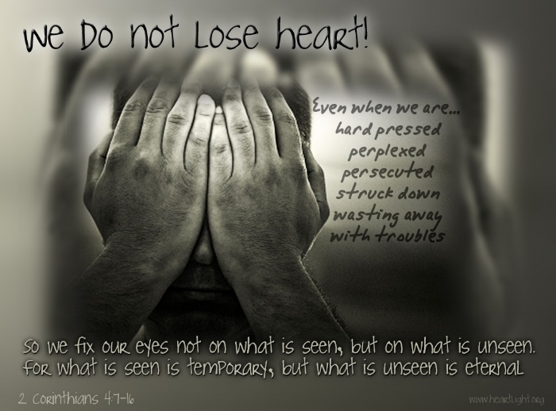 Those whom wish to not feel pain in life will not last long in ministry! It did not take me long to realize how painful it was to use the soft ends of my fingers to press down on the hard, steel strings of a guitar! Those who choose to put their finger on the pulse of their gifting can expect to be attacked ferociously by he who “prowls around like a roaring lion looking for someone to devour” (1 Peter 5:8). The Devil pays little attention to the carnal, lukewarm Christian but will send many enemies to attack anyone whose service points to God the Father in heaven (Matthew 5:15). While many Christians quit ministry due to conflict with people both inside and outside of the church, just as many quit because their lack of spiritual fruit gave Satan a foothold into their minds to convince them they were either worthless or should attend to their own pleasure rather than serve others. To keep the battlefield of the mind from becoming too painful Apostle Paul tells us to take every thought captive by surrendering it to Christ (2 Corinthians 10:5). The key to being able to serve a long time in ministry is remembering that while these fragile jars of clay (2 Corinthians 4:7) feel pain and are easily broken, by keeping our eyes fixed on what is unseen our joy and passion will be renewed daily (2 Corinthians 4:16-18) by He whom is greater than any adversary we will face (1 John 4:4)!

**Step 4: Acknowledging one’s Limits**

One of the things that I struggle with in learning to play the guitar is using the fingers on my left hand. To make chords with my non-predominant hand takes a lot of practice! For instance, to make a G Major chord I have to place my middle finger on the top string to make a G note, my index finger on the second string to make a B note, my ring finger on the fifth string to make a D note and my pinky finger on sixth string to make another G note. To get all these fingers on the right frets and strings takes repetition which hopefully will lead to muscle A person holding a guitar
memory, that is making the chord without thinking. Once the chord is formed my right hand strums the strings in succession from the top to the bottom. What would it be like if I decided to only use the index finger on my left hand to make and play the chord? I would have to make each note with my index finger as fast as my right hand strummed the strings which is often less than a second! It would be nearly impossible to play with a single finger on the left hand while maintaining the rhythm and keeping in time, especially considering how quickly the index finger would become too tired to move at such speeds. Why would anyone ever want to unnecessarily exclude their other fingers and make chord playing virtually impossible?

One of the things that Christians struggle with is knowing their limits when serving in God’s kingdom. In his letter to the church of Corinth Apostle Paul had much to say about spiritual gifting (1 Corinthians 12). Upon conversion the Spirit of God gives each new believer at least one spiritual gift (verse 4). Whatever gifts one has received are to be used to perform a divine role and in doing so strive to build up the body of Christ (verse 7). No one has been given all the spiritual gifts and therefore no one single person is to perform all the roles inside of the church (verses 7-11). When a single person does all roles in the church they fail because kingdom work can only be accomplished with spiritual gifting (Matthew 19:26)! One of the reasons why the church is not having influence on its members or society is due to the “voices” speaking are not empowered by the Spirit to do so. If a person has a role he/she is doing but does not have the spiritual gifts to perform said role then the church is better off to have that person hand off this role to those who are gifted.

**Step 5: Working Together as one Body**

What would a church look like if all its members knew and used their spiritual gifts? The church is the body of Christ and as such has been divinely constructed so that each of its members are interdependent upon one another (verse 12). If I want to successfully play a G Major chord, then all my fingers on my left hand must do their part. The same is true inside of the church. If we are to fulfill our roles as lights unto the nations, then each member must see how their refusal to know and use their spiritual gifts dramatically affects the health and witness 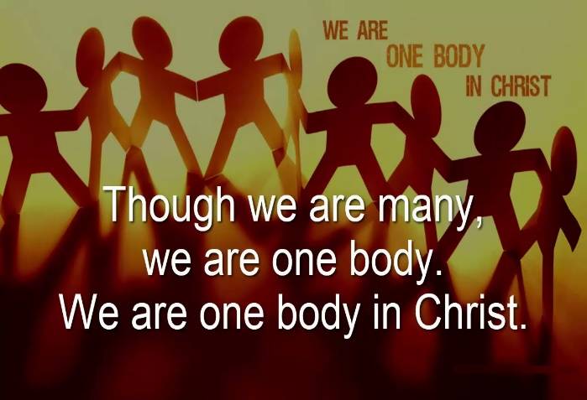of the church. The cure for the few doing all the work inside the church and getting burned out is to have all members fulfill their roles and in doing so lighten everyone’s load. Remember, God has placed some to be apostles, some to be prophets, some to be teachers, some to perform miracles, some to heal others and some to speak in tongues (verses 27-31). God did not give one person all the spiritual gifts because He wants the body to be interdependent upon each other. Like the guitar chord that is best played when all fingers are used in unison, so too must the church find a way to get all of her members to use their spiritual gifts to play and live out the Gospel message of reconciliation that is being offered to this world!

**The Music of Ministry**

 When a church decides to know and use their spiritual gifts to build each other up in the faith they go from being carnal and lukewarm to the very hands and feet of Christ! I purchased a guitar with a high resale value just in case God tells me that I have no gifting in this area. If I never learn to play the guitar that is ok for it will not be taken as a personal failure but as God saying NO, your gifts lie elsewhere! What a shame it is that so few people inside of the church experiment and look for their spiritual gifting. To be given the power and gifting to do miracles greater than Christ ever did while on this earth is an honor that I do not take for granite. While I may never play beautiful music on my guitar, every time I preach a sermon, teach a Sunday School class, pray for and counsel the people of the church and perform weddings and funerals I play ministry music to my Lord, Savior and King! While ministry can be frustrating and difficult, I stand firm in my desire to serve in whatever way God asks of me! The only thing that holds you back from playing beautiful music to God as well is the wisdom, courage and desire to know and use whatever gifts God has given you!

1. Taken from the following website: <https://www.barna.com/research/survey-describes-the-spiritual-gifts-that-christians-say-they-have/>
2. Reginald W. Bibby, *Beyond the Gods and Back: Religion’s Demise and Rise and Why it Matters* (Lethbridge, AB: Project Canada Books, 2011), 5, 44.
3. Timothy P. Jones, ed., Perspectives on Family Ministry: 3 Views (Nashville, TN: B & H Publishing Group, 2009), 102.
4. Quote partially taken from Mandy Hale.