**Samson’s Strength**

**Judges 15:1-20**

Online Sermon: <http://www.mckeesfamily.com/?page_id=3567>

Whom amongst us has not heard of the great strength of Samson? Was not slaying 1,000 Philistines with nothing but a jawbone of a donkey and tearing apart a lion and bringing down a temple building with nothing but his mere hands not impressive? One can’t help but dream what it must have been like to have been given supernatural strength and assigned the role of fighting to free God’s people from those whom subjugated them for over 40 years! While it is very tempting to place Samson on a pedestal so high that it overshadows our own “trivial” callings, one must not forget he was not chosen because of his holiness but so that in his weakness God’s power over His enemies might be made known. This sermon is going to examine Samson’s encounter with the Philistines and conclude that his physical strength was also accompanied by great weaknesses of sin in form of being unequally yoked, seeking vengeance for personal gain and forgetting the power of God whom granted him his victories.

**Samson Biography**

Samson, whose name *šemeš* (Judges 13:24) meant “little sun,” [1] most likely lived near the end of the 11th century BC. [2] His father was Manoah from the tribe of Dan.[3] While his mother’s name is not known, like her predecessor Sarah she received a divine visitor[4] whom despite her being barren[5] was told she would have a son. Samson was to be raised as a Nazarite with rules such as not drinking wine, cutting one’s hair or coming into contact with the dead (Numbers 6:1-21).[6] 1200 years after the Conquest the Philistine and Amorites forced part of the tribe of Dan to migrate (Judges 18) with the remainder staying and accepting them as their rulers.[7] Samson was chosen by God to be one of the last judges during a period when “spiritual confusion, moral depravity and political fragmentation” [8] of God’s people was predominant. Despite having been chosen as a judge and blessed with supernatural strength,[9] Samson “erotic liaisons with foreign women eventually led to his enslavement and death by his own hands.[10] While Samson will forever be differentiated from Israel’s other judges due to his supernatural strength, he will also be known not as a ruler or organizer of people but an “individualistic hero”[11] whom did not seem to care much about “God, family or nation” [12] and yet despite his various sins, God chose him to smite the Philistines with a mighty blow!

**Do not be Unequally Yoked (verses 1-5)**

The first “act” of Judges 15 takes place during the time of the wheat harvest. Samson took a young goat as a present for his wife which was the customary gift for consummating a “visiting” marriage[13] and a decent token gift of reconciliation for having promptly left her because she had betrayed his trust by sharing the meaning of his riddle. [14] The father of the bride immediately forbid Samson to come near her[15] for he had given her away to one of his companions.[16] The father then attempted to pacify Samson’s anger by stating he had abandoned his wife and seemed to hate her so the marriage was null and void and he tried to appease him by offering him his more attractive, younger daughter.[17] Unimpressed with the alternative marriage, which was unlawful for an Israelite to accept (Leviticus 18:18),[18] Samson decided to vent his anger on the Philistines. Knowing that it was the dry season when the grain was gathered in heaps and in a most combustible state,[19] Samson chose to get his revenge[20] by tying together in pairs 100 jackals[21] with lit torches attached to their tails and unleashing them in the nearby Philistine fields. The result was that their crops, grapevines and olive trees where consumed by fire,[22] a blow he knew would cripple their economy![23]

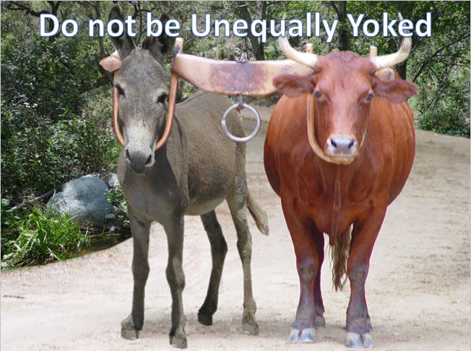From this act of revenge, we learn a lot about Samson’s character and the dangers of marrying unbelievers. First, the cruelty to animals displayed in Samson’s revenge was hideous and cannot be condoned, especially in the light the beginning and future peace between all of creation.[24] Second, despite being against his parent’s wishes (Judges 14) [25] and God’s command to not marry foreigners (Deuteronomy 7:3); Samson chose not once but twice (see Delilah – chapter 16) to have relations with foreign women whom in the end not only led to his captivity and losing his eyesight but also in him losing his life at his own hands![26] While Christians are not under the cultural laws of the Old Testament, we are to obey the intent of this law which was to not be unequally yoked with unbelievers as verified in 2 Corinthians 6:4-18! Christians are not to be united with unbelievers because their wickedness and love of this world will inevitably lead one astray because one is trying to please both God and one’s mate. Since righteousness and wickedness have nothing to do with each other, neither should Christians be united unto those whose allegiance is to this world.

**Seeking Vengeance for Personal Gain (verses 6-11)**

The second act of Judges 15 focuses on “eye for eye” retribution. Even though Samson’s claim of innocence[27] and presumed right to seek vengeance in the face of “subtlety and malice” 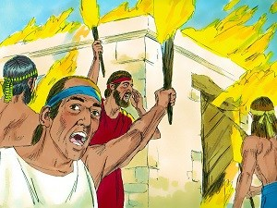of having his bride wrongfully given away was justified in his eyes,[28] the Philistines don’t see it that way. They chose to avenge themselves not by directly attacking Samson but in act that was both “cowardly and unjust”[29] they decided it would be easier[30] “to get even” by burning to death Samson’s wife and her father! The cruel act of cowardice provoked Samson’s utter contempt[31] and motivated by personal revenge[32] he “attacked them viciously” (verse 8) and promised to continue to do so until he felt satisfied that he got his revenge. The Philistines camped at the high land of Judah (Lehi) [33] and when the people of Judah asked why they had come to fight them they responded, “to do to him as he did to us” (verse 9). Seeing that continued domination and peace with their rulers the Philistines was in jeopardy,[34] 3,000 men from Judah met with Samson and demanded the reason for his attacks on their rulers. In his defense Samson stated, “I merely did to them what they did to me” (verse 11)!

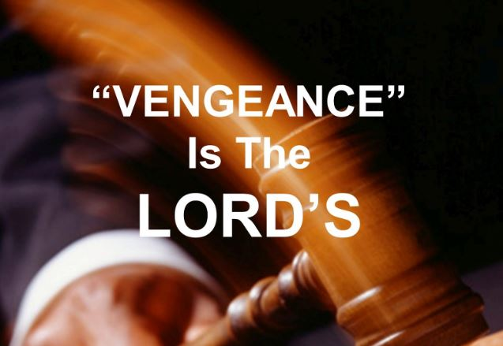From act two we learn that revenge rarely leads to justice but merely hurts the pride and traps the recipients in a never-ending cycle of violence. Even though Samson’s retribution fulfilled his “higher calling”[35] to weaken the Philistines[36] this did not justify his selfish motives to appease his wrath and satisfy his pride.[37] While any act of violence can be justified by an “eye for an eye” mentality, rarely does such acts lead to justice because those who have planks in their eyes (Matthew 7:3-5) cannot see into the hearts of others and truly understand their motives (1 Corinthians 2:10-16). Does not vengeance rightly belong (Romans 12:19) to the Judge of the living and the dead (2 Timothy 4:1)? And when it comes to our attitude towards the “perpetrators” of life are we not only instructed to avoid doing evil unto others but to do good and love those who mistreat us (Mathew 5:38-48)? And while the world thinks such absorption of wrongs done against oneself is a sign of weakness[38] does it not show strength and faith to trust one’s Creator to not only judge rightly but to protect one from the perpetrator’s attempt to tarnish one’s “reputation”? When wronged I say trust in the Lord and He will make it right!

**Forgetting the Power of God (verses 12-20)**

The final act of Judges 15 focuses on the Spirit of the Lord giving Samson a great victory over the Philistines. Not impressed with Samson’s form of retributive justice the “cowardly unthankful wretches,” [39] the Judahites were so satisfied with the “status quo”[40] that they rejected their opportunity to rally with their hero and strike a blow against the enemy. Instead they “bowed to the Philistine wishes” and asked Samson to allow them to bind him with rope and hand him over for certain death![41] Not wishing to fight his own countrymen[42] Samson agreed to be bound as long as they agreed to not kill him themselves. In the face of the Judahite betrayal and the Philistine shouts of victory,[43] the Spirit of God came powerfully upon Samson and his ropes became like “charred flax” (verse 14) and dropped from his hands. Samson then picked up a fresh jawbone of a donkey and with it miraculously slayed[44] a thousand Philistines! Being physically and emotionally drained[45] and feeling like he was about to perish from dehydration, Samson cried out to God to not let him die and fall into the hands of the uncircumcised Philistines. Even though Samson displayed little concern for the fate of his people or that God got the glory for the victory, [46] God still granted Samson’s wish and opened up a hollow place and filled it with water.

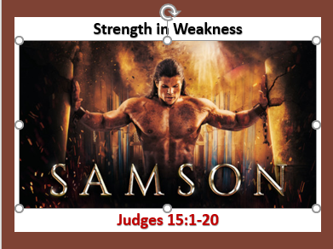From this final act we learn how easily we as Christians can be overwhelmed by trials and tribulations! Why would one who had just been granted the power to slay one thousand men with a mere jawbone of a donkey ever think God would let him die of thirst? Charles Spurgeon read Judges 15 and concluded that “it is very usual for God’s people, when they have enjoyed a great deliverance, to find a little trouble too much for them.”[47] Apostle James states that trials and tribulations in life help us to mature in the faith when we persevere, seek His wisdom and never waiver (James 1:1-8) in our belief that God is sovereign (1 Timothy 6:15) and will do good to those who love Him (Romans 8:28). Whether these afflictions happen by chance (Ecclesiastes 9:11) or of our own doing, they are blessings when they become a catalyst that “brings unthankful people to God.”[48] Instead of murmuring in the dark, deserts of life, one is to count one’s blessings and recount all the times in one’s life God has miraculously saved these fragile jars of clay that while fearfully and wonderfully made (Psalms 139) still are wretches that offer dirty rags of righteousness (Isaiah 64:6)! So, when you feel overwhelmed by life’s most difficult moments remember this simple truth: those who rely on God will find that in their weakest moments they are truly strong **IF** they choose to rely ona firm foundation of love and trust in their Lord, Savior and King!

1. James L. Crenshaw, [“Samson (Person),”](https://ref.ly/logosres/anch?ref=VolumePage.V+5%2c+p+950&off=4133&ctx=h+by+his+own+hands.%0a~The+name+Samson+appe) ed. David Noel Freedman, *The Anchor Yale Bible Dictionary* (New York: Doubleday, 1992), 950.
2. Jay Todd, [“Samson the Judge,”](https://ref.ly/logosres/lbd?hw=Samson+the+Judge&off=98&ctx=udges+(Judg+13%E2%80%9316).+~A+Nazirite+who+posse) ed. John D. Barry et al., *The Lexham Bible Dictionary* (Bellingham, WA: Lexham Press, 2016).
3. Walter A. Elwell and Barry J. Beitzel, [“Samson,”](https://ref.ly/logosres/bkrencbib?ref=Page.p+1889&off=1683&ctx=Samson.+~Manoah%E2%80%99s+son%2c+from+Dan%E2%80%99s+tribe.+) *Baker Encyclopedia of the Bible* (Grand Rapids, MI: Baker Book House, 1988), 1889.
4. James L. Crenshaw, [“Samson (Person),”](https://ref.ly/logosres/anch?ref=VolumePage.V+5%2c+p+952&off=2229&ctx=+of+these+subplots.%0a~Like+her+predecessor) 952.
5. Walter A. Elwell and Barry J. Beitzel, [“Samson,”](https://ref.ly/logosres/bkrencbib?ref=Page.p+1889&off=1683&ctx=Samson.+~Manoah%E2%80%99s+son%2c+from+Dan%E2%80%99s+tribe.+) 1889.
6. Tremper Longman III, Peter Enns, and Mark Strauss, eds., [*The Baker Illustrated Bible Dictionary*](https://ref.ly/logosres/bakerillbbldctnry?ref=Page.p+1471&off=1874&ctx=pecial+holy+status.+~Numbers+6%3a1%E2%80%9321+descr) (Grand Rapids, MI: Baker Books, 2013), 1471.
7. A. E. Cundall, [“Samson,”](https://ref.ly/logosres/nbd?ref=Page.p+1053&off=3329&ctx=elite+hill-country.+~Shamgar%E2%80%99s+exploit+pr) ed. D. R. W. Wood et al., *New Bible Dictionary* (Leicester, England; Downers Grove, IL: InterVarsity Press, 1996), 1053.
8. Tremper Longman III, Peter Enns, and Mark Strauss, eds., [*The Baker Illustrated Bible Dictionary*](https://ref.ly/logosres/bakerillbbldctnry?ref=Page.p+1471&off=1331&ctx=found+in+1+Samuel).+~The+period+of+judges), 1471.
9. Jay Todd, [“Samson the Judge,”](https://ref.ly/logosres/lbd?art=samson.biblical_account.samson.e2.80.99s_birth&off=625&ctx=r+womb+(Judg+13%3a4).%0a~After+his+birth%2c+Sam) ed. John D. Barry et al., *The Lexham Bible Dictionary* (Bellingham, WA: Lexham Press, 2016).
10. James L. Crenshaw, [“Samson (Person),”](https://ref.ly/logosres/anch?ref=VolumePage.V+5%2c+p+950&off=4029&ctx=of+the+Danite+clan.+~Samson%E2%80%99s+erotic+liai) 950.
11. Allen C. Myers, [*The Eerdmans Bible Dictionary*](https://ref.ly/logosres/eerdbibdct?ref=Page.p+908&off=5077&ctx=judges%2c+a+ruler+and+~organizer+of+people+) (Grand Rapids, MI: Eerdmans, 1987), 908.
12. Tremper Longman III, Peter Enns, and Mark Strauss, eds., [*The Baker Illustrated Bible Dictionary*](https://ref.ly/logosres/bakerillbbldctnry?ref=Page.p+1471&off=1564&ctx=+Samson+did+nothing+~except+to+satisfy+hi),1471.
13. Herbert Wolf, [“Judges,”](https://ref.ly/logosres/ebc03?ref=Bible.Jdg15.1-2&off=540&ctx=sehold+would+cause.%0a~If+this+was+a+%E2%80%9Cvisit) in *The Expositor’s Bible Commentary: Deuteronomy, Joshua, Judges, Ruth, 1 & 2 Samuel*, ed. Frank E. Gaebelein, vol. 3 (Grand Rapids, MI: Zondervan Publishing House, 1992), 470.
14. Arthur E. Cundall and Leon Morris, [*Judges and Ruth: An Introduction and Commentary*](https://ref.ly/logosres/totc07jdgus?ref=Bible.Jdg15.1&off=528&ctx=by+this+time+and+he+~made+the+journey+to+), vol. 7, Tyndale Old Testament Commentaries (Downers Grove, IL: InterVarsity Press, 1968), 162.
15. Matthew Henry, [*Matthew Henry’s Commentary on the Whole Bible: Complete and Unabridged in One Volume*](https://ref.ly/logosres/mhenry?ref=Bible.Jdg15.1-8&off=965&ctx=or+peace%E2%80%99+sake.%0aII.+~The+repulse+he+met+w) (Peabody: Hendrickson, 1994), 359.
16. Allen C. Myers, 908.
17. Matthew Henry, [*Matthew Henry’s Commentary on the Whole Bible: Complete and Unabridged in One Volume*](https://ref.ly/logosres/mhenry?ref=Bible.Jdg15.1-8&off=1734&ctx=s+designed+ill.%E2%80%9D+2.+~He+endeavours+to+pac) , 359.
18. Robert Jamieson, A. R. Fausset, and David Brown, [*Commentary Critical and Explanatory on the Whole Bible*](https://ref.ly/logosres/jfbcomm?ref=Bible.Jdg15.2&off=158&ctx=usal+of+admittance.+~The+proposal+he+made), vol. 1 (Oak Harbor, WA: Logos Research Systems, Inc., 1997), 168.
19. Robert Jamieson, A. R. Fausset, and David Brown, [*Commentary Critical and Explanatory on the Whole Bible*](https://ref.ly/logosres/jfbcomm?ref=Bible.Jdg15.1&off=153&ctx=red+into+heaps%2c+and+~lying+on+the+field+o), 168.
20. F. Duane Lindsey, [“Judges,”](https://ref.ly/logosres/bkc?ref=Bible.Jdg15.6-8&off=8&ctx=15%3a6%E2%80%938.+~When+the+Philistines+learned+tha) in *The Bible Knowledge Commentary: An Exposition of the Scriptures*, ed. J. F. Walvoord and R. B. Zuck, vol. 1 (Wheaton, IL: Victor Books, 1985), 406.
21. Arthur E. Cundall and Leon Morris, [*Judges and Ruth: An Introduction and Commentary*](https://ref.ly/logosres/totc07jdgus?ref=Bible.Jdg15.3-6&off=674&ctx=mission+of+the+story~.+In+all+probability), vol. 7, Tyndale Old Testament Commentaries (Downers Grove, IL: InterVarsity Press, 1968), 162.
22. Herbert Wolf, [“Judges,”](https://ref.ly/logosres/ebc03?ref=Bible.Jdg15.3-6&off=1115&ctx=in+such+quantities.+~The+fire+spread+with) 470.
23. Daniel Isaac Block, [*Judges, Ruth*](https://ref.ly/logosres/nac06?ref=Bible.Jdg15.4-5&off=266&ctx=the+wheat+harvest.%E2%80%9D+~Philistia+was+grain+), vol. 6, The New American Commentary (Nashville: Broadman & Holman Publishers, 1999), 441.
24. Arthur E. Cundall and Leon Morris, [*Judges and Ruth: An Introduction and Commentary*](https://ref.ly/logosres/totc07jdgus?ref=Bible.Jdg15.3-6&off=1364&ctx=ess+them+so+sorely.+~But+such+wanton+crue), 163.
25. Tremper Longman III, Peter Enns, and Mark Strauss, eds., [*The Baker Illustrated Bible Dictionary*](https://ref.ly/logosres/bakerillbbldctnry?ref=Page.p+1471&off=2199&ctx=e+a+good+Israelite.+~Against+his+parents%E2%80%99), 1471.
26. James L. Crenshaw, [“Samson (Person),”](https://ref.ly/logosres/anch?ref=VolumePage.V+5%2c+p+950&off=5690&ctx=+rhetoric+unit+in+a+~suspense-filled+tale) 950.
27. Herbert Wolf, [“Judges,”](https://ref.ly/logosres/ebc03?ref=Bible.Jdg15.3-6&off=4&ctx=cted+the+offer.%0a3%E2%80%936+~Samson%E2%80%99s+claim+of+in) 470.
28. Matthew Henry, [*Matthew Henry’s Commentary on the Whole Bible: Complete and Unabridged in One Volume*](https://ref.ly/logosres/mhenry?ref=Bible.Jdg15.1-8&off=4238&ctx=s+his+incendiaries.+~They+had+injured+Sam) 360.
29. John Peter Lange et al., [*A Commentary on the Holy Scriptures: Judges*](https://ref.ly/logosres/lange07jdg?ref=Bible.Jdg15.6&off=117&ctx=asion+of+his+wrath.+~They+determine+to+av) (Bellingham, WA: Logos Bible Software, 2008), 205.
30. Arthur E. Cundall and Leon Morris, [*Judges and Ruth: An Introduction and Commentary*](https://ref.ly/logosres/totc07jdgus?ref=Bible.Jdg15.3-6&off=2009&ctx=us+consequences.+It+~was+easier+for+the+P), vol. 7, Tyndale Old Testament Commentaries (Downers Grove, IL: InterVarsity Press, 1968), 163.
31. John Peter Lange et al., [*A Commentary on the Holy Scriptures: Judges*](https://ref.ly/logosres/lange07jdg?ref=Bible.Jdg15.7&off=49&ctx=em%2c+If+ye+act+thus.+~This+cruel+cowardice), 205.
32. F. Duane Lindsey, [“Judges,”](https://ref.ly/logosres/bkc?ref=Bible.Jdg15.6-8&off=189&ctx=Timnite+household).+~Motivated+again+by+p) 406.
33. Robert Jamieson, A. R. Fausset, and David Brown, [*Commentary Critical and Explanatory on the Whole Bible*](https://ref.ly/logosres/jfbcomm?ref=Bible.Jdg15.9&off=3&ctx=the+Philistines.%0a9.+~Then+the+Philistines), 168.
34. Herbert Wolf, [“Judges,”](https://ref.ly/logosres/ebc03?ref=Bible.Jdg15.9-13&off=373&ctx=tradite+him+(v.11).+~Their+action+betrays) 472.
35. Daniel Isaac Block, [*Judges, Ruth*](https://ref.ly/logosres/nac06?ref=Bible.Jdg15.4-5&off=1677&ctx=e+Israelite+troops.+~Samson+is+a+man+with), 441.
36. Tremper Longman III, Peter Enns, and Mark Strauss, eds., [*The Baker Illustrated Bible Dictionary*](https://ref.ly/logosres/bakerillbbldctnry?ref=Page.p+1471&off=2794&ctx=ing+their+property.+~Samson+was+doing+thi), 1471.
37. James L. Crenshaw, [“Samson (Person),”](https://ref.ly/logosres/anch?ref=VolumePage.V+5%2c+p+951&off=1836&ctx=+two+eyes%E2%80%9D+(16%3a28).+~The+narrative+emphas), 951.
38. Arthur E. Cundall and Leon Morris, [*Judges and Ruth: An Introduction and Commentary*](https://ref.ly/logosres/totc07jdgus?ref=Bible.Jdg15.7&off=333&ctx=at+have+gone+on+for+~generations.+At+some), 163.
39. Matthew Henry, [*Matthew Henry’s Commentary on the Whole Bible: Complete and Unabridged in One Volume*](https://ref.ly/logosres/mhenry?ref=Bible.Jdg15.9-17&off=2949&ctx=dy+to+stone+him.+2.+~They+begged+of+him+t) 360.
40. F. Duane Lindsey, [“Judges,”](https://ref.ly/logosres/bkc?ref=Bible.Jdg15.9-14&off=266&ctx=to+the+Philistines.+~Apparently+satisfied) 406.
41. Herbert Wolf, [“Judges,”](https://ref.ly/logosres/ebc03?ref=Bible.Jdg15.9-13&off=552&ctx=+an+opportunity+for+~them+to+rally+around) 472.
42. Ibid.
43. Daniel Isaac Block, [*Judges, Ruth*](https://ref.ly/logosres/nac06?ref=Bible.Jdg15.12a&off=373&ctx=low+Israelite%3a+they+~have+come+to+tie+him), 444.
44. Robert Jamieson, A. R. Fausset, and David Brown, [*Commentary Critical and Explanatory on the Whole Bible*](https://ref.ly/logosres/jfbcomm?ref=Bible.Jdg15.16&off=101&ctx=lain+a+thousand+men%E2%80%94~The+inadequacy+of+th), 169.
45. Herbert Wolf, [“Judges,”](https://ref.ly/logosres/ebc03?ref=Bible.Jdg15.18-19&off=326&ctx=like+Elijah%2c+Samson+~was+physically+and+e) 473.
46. Daniel Isaac Block, [*Judges, Ruth*](https://ref.ly/logosres/nac06?ref=Bible.Jdg15.18&off=2268&ctx=his+manner+of+life.+~Far+from+displaying+), 447.
47. C. H. Spurgeon, [*Morning and Evening: Daily Readings*](https://ref.ly/logosres/morneve?ref=DayOfYear.Jan+21+PM&off=612&ctx=lly+been+delivered.+~It+is+very+usual+for) (London: Passmore & Alabaster, 1896).
48. Matthew Henry, [*Matthew Henry’s Commentary on the Whole Bible: Complete and Unabridged in One Volume*](https://ref.ly/logosres/mhenry?ref=Bible.Jdg15.18-20&off=1821&ctx=with+their+prayers.+~Afflictions+are+ofte) 361.