**Making Every Path Straight!**

**Luke 3:4=6**

Online Sermon: <http://www.mckeesfamily.com/?page_id=3567>

How should one respond to the voice calling in the wildernesses to “make our paths straight”? When John the Baptist originally spoke these words, many people chose to repent and be baptised so that their hearts would be ready to meet their Lord, Saviour and King! Despite having been commanded by Jesus Himself to make our paths straight so that we might be found faithful and wise upon His return, to our shame our response has been an occasional “hot flash” of drawing close to Him but for the most part has been an attitude of indifference! It is not that Christians today don’t want a close personal relationship with their Savior, they certainly do, but living in a world where change and fast pace seem to be the only constants, they have inadvertently made self rather than Christ the ruler of their hearts! This sermon is about hearing the voice calling in the wildernesses of our hearts to embrace the only change that matters, to become more like Jesus!

**Seeing in the Wilderness (Luke 3:4)**

**As it is written in the book of the words of Isaiah the prophet: “A voice of one calling in the wilderness, ‘Prepare the way for the Lord, make straight paths for Him.**

The “ambassador” of the King, John the Baptist’s message some two thousand years ago was spoken in the Desert of Judea (Matthew 3:1), a “barren and rugged land west of the Dead Sea.”[1] While his clothes were made from Camel’s hair, his belt made of leather and his diet of locusts and wild honey (Matthew 3:4) were not impressive by ancient standards, his message was so provocative that it was perceived either as an attack on the Jerusalem establishment (Matthew 3:7) and other powerful social groups (Luke 3:10-14)[2] or an outright fulfillment of Isaiah 40:2 … the emissary of the Messiah had arrived! Like an OT emissary to a king whom was sent to cleanup the environment where he was to visit, John was sent to warn the people that they needed to clean their hearts to meet their Master or face the wrath of God for being faithless (Matthew 3:7)[3] ones merely concerned with an external appearance of holiness.[4] For the people to be ready to meet Jesus John taught that they needed a radical change[5] that can only come from a contrite (Isaiah 57:14-17)[6] and repentant heart! The mountains, valleys and crooked places of their hearts that were keeping them from fully submitting to the authority of God must be repented of and in their place put a genuine desire to love Him and one another (Matthew 22:37-49; Luke 3:10-14)![7]

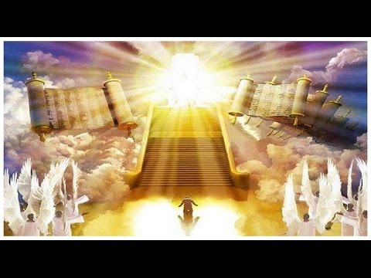While the Messiah has already arrived and atoned for the sins of humanity this does not negate His message and urgency for Christians today to make their paths straight. In Matthew 24 Jesus told us to keep watch for we do not know the day or hour that He will return. Then in chapter 25 Jesus warned that those who are unsaved upon His return will be excluded from the marriage feast (1-13), thrown outside into the darkness (14-30), and will suffer the fate of the devil and angels (31-46).[8] And just because believers are justified by faith in Christ this does not mean that they will be exempt from judgement for their deeds as well (Romans 14:19, 12; 1 Corinthians 3:12-15; 2 Corinthians 11:15).[9] He who has entrusted and given us life expects in return not mere “moments” of hot and mostly cold indifference to His existence but allegiance in the form of undying love and commitment to His commands (James 1:22) and will for our very lives (Hebrews 13:20-21)! This sermon is going to outline four steps to preparing one’s heart to please Jesus both now and upon His return: 1) “dig up” one’s pride and carnal passions, 2) straighten one’s ways through confession, 3) fill one’s calendar with service to God, and 4) smooth out the “rough patches” of life by continually focussing and submitting to the pioneer and perfector of our faith, Jesus.

**“Dig up” Pride and Carnal Passions (“Every Mountain and Hill made Low” – verse 5b)**

 Before one will ever be willing to live by the Spirit one must fulfill Christ’s command to deny (Mark 8:34) and have self crucified with Christ (Galatians 2:20). One of the main reasons why Christians are “cold” or “indifferent” to their Creator is due to pride. Pride is a sin of the attitude of the heart that says “I” am the master of my destiny and as such I am the “best” one to seek and establish my future![10] These “mountain peaks” of arrogance and haughty eyes (Proverbs 21:4) “removes God as the center of one’s life and exalts self, attributing to self the honor due God.”[11] Is not God’s word to be a “lamp unto our feet” (Psalms 119:105)? Are not Christians told to “trust in the Lord with all our heart and lean not on your own understanding” (Proverbs 3:5-6)? Surely, He who had bought us at a price (1 Corinthians 6:20) has more than paid the price for our allegiance, devotion and undying love to make Him alone the center of our lives! We must never forget that while we are the “creator” of temporal things, Jesus alone is the eternal Creator and ruler of all things both seen and unseen (Colossians 1:16). Until one’s goals and dreams are crucified on the cross one’s cold attitude towards God will remain and be subject to present and future judgment!

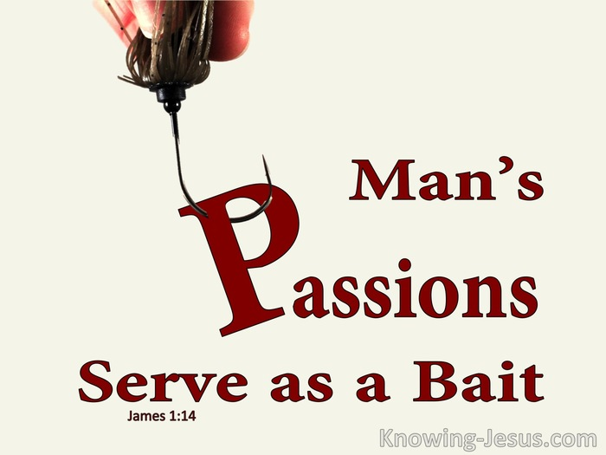The other fundamental reason Christians are “cold” is due to loving the things of this world more than they do God or other people. While there is nothing wrong with celebrating the fact that one was fearfully and wonderfully made (Psalms 139:14) a little lower than the angels (Psalms 8:5), it is wrong to be preoccupied with acquiring more “stuff” to satisfy the evil desires of one’s heart (James 1:14)! Our passions often serve as bait. Way too many Christians are so busy working towards fulfilling their own goals that there simply is no time left to read the Bible, go to church, pray or feed the poor. To deny oneself, take up one’s cross and follow Jesus is a price very few Christians are willing to pay because that would require kingdom goals to always trump their own personal agendas! How have you responded to Jesus’ command to give up the lust of the eyes, flesh and pride of life (1 John 2:15-17)? Are you like carnal Christians who are willing to spend countless hours working to afford the “finer” stuff in life and yet when God comes asking you to abide in His will you tell Him “go away I have no time?” Do you love others better than yourself (Philippians 2:3) not just with mere words but are willing to walk a mile in their shoes and if necessary, give them whatever money or time they need to get through their rough patches? Until our attitude changes to such that nothing on earth or in heaven we desire but God (Psalms 73:25-26), our relationship with Him will remain shallow and sinful in His sight!

**Straightening through Confession (“The Crooked ways Shall Become Straight,” verse 5C)**

To get rid of pride and carnal passions one must first confess them as sins! Confession is not just a simple prayer of “forgive me Father for I have sinned” but to be true repentance must go beyond words spoken and become a complete “change of one’s mindset.”[12] Instead of being indifferent to how our carnal passions affect our relationship with God we must allow Scripture to judge our words, thoughts and deeds so deeply[13] that we are inwardly convicted to see how grievous our “planks” of sin (Matthew 7:5) are to a holy God! Living in a world that suggests there are many paths that lead to happiness and the “heaven of choice,” it can be difficult to keep one’s focus on the truth that the path to God is narrow (Matthew 7:3) and defined by Him alone! Since our best wisdom is foolishness in God’s sight (1 Corinthians 1:25), if we truly want to leave behind the “old self” our prayers must be like Kind David’s: “search me, God and know my heart; test me and know my anxious thoughts, see if there is any offensive way in me, and lead me in the way of everlasting” (Psalms 139:23-24). Those who pray this prayer with a contrite heart and genuine desire to become more like Jesus will have their crooked ways made straight by their Lord, Saviour and King!

**Fill one’s Calendar with Service to God (“Every Valley Shall be Filled in”, verse 5a)**

One of the best litmus tests of repentance is to look at one’s calendar. A truly repentant heart will be in hot pursuit and will have a single-minded vision of being an apprentice in the kingdom of the living God.[14] Such a person will have their calendar full of dates for spending time serving God and helping others for two main reasons. First, the power to change one’s evil desires is not within one’s grasp but can be obtained through the power of the Holy Spirit (1 John 4:4). Without spending time with our Creator, the repentant soul will become hungry and thirsty again and will be open to the Devil making a new stronghold within their heart (Matthew 12:43-45). Second, a truly repentant heart that places God and others above their own self-interests will have a calendar full of kingdom service. Since no one hears the “whole counsel of God in isolation”[15] we need others not only for supportive, Spirit led advice but to function as one body of Christ. God’s loving presence is meant to “extend through others to me and from me to others.”[16] A truly repentant heart has their calendar marked with ample time slots to love both God and others, leaving just enough time to take care of the necessities of life!

**Smooth out the Rough Patches with Jesus (“the rough ways smooth”, verse 5d)**

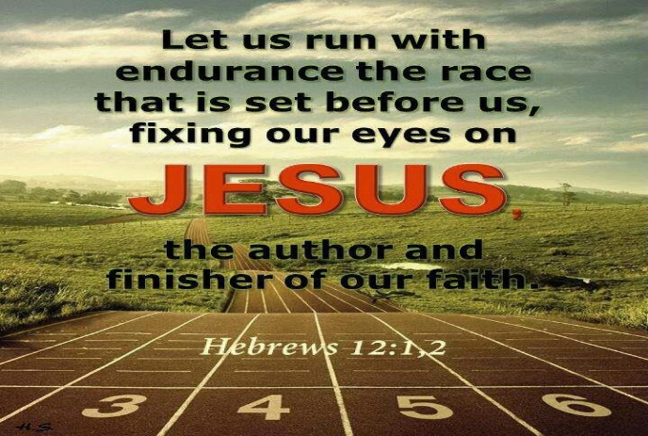Now that one’s calendar is filled with events that demonstrate love for God and others the last step is to stay on course by keeping one’s eyes fixed on the pioneer and perfector of one’s faith (Hebrews 12:2). How many New Year’s resolutions have people made and then break soon afterwards? How many times have we as Christians slotted out more time for loving God and others only to later find that our intent was not carried out? Since the “flesh often wants what is contrary to the spirit,”[17] renovation of the heart is not a one-time experience but a lifetime of sanctification through the grace of the Lord, Jesus Christ. When the sensations, desires and emotions of the old self rear their ugly head one must be ready to surrender one’s evil inclinations over to Christ to be crucified. To stay on the path of loving God and one another then is not just a function of effort but is mostly accomplish through continual prayer to the Holy Spirit to sanctify one’s inner being by transforming one’s thoughts, feelings, body, social context and soul. While the rough or sinful patches of life cannot be eliminated, for all sin and fall short of God’s glory (Romans 3:23), by keeping one’s eyes fixed on Christ’s example of what it means to be holy one can faithfully run the endurance race of life and become more like Him!

**Conclusion**

How should one respond to the voice calling in the wildernesses to “make our paths straight”? To be found faithful both now and upon Jesus’ return there is much that one can do to have more “hot flashes” of drawing close to God. While indifference towards God can be “comfortable” because it leaves the appearance of “self” being in charge, such an attitude needs to be confessed as sinful or risk the wrath of God! This of course can be avoided by taking four steps to make your paths straight towards Jesus. First, the desire to put self first must be crucified and replaced with a love for God and one another. Second, instead of being indifferent to our carnal passions they need to be confessed and through the power of the Spirit turned away from by seeing them not as pleasurable but sinful in God’s sight. Third, once ones’ house is put in order one needs to fill one’s calendar with events that spend time with serving God and loving others. And last, to keep on the narrow path one must continuously pray for forgiveness and the power to keep one’s eyes fixed on Christ. If one can follow these four steps, then one will be found to be faithful both now and when Jesus comes again!

1. Louis A. Barbieri, Jr., [“Matthew,”](https://ref.ly/logosres/bkc?ref=Bible.Mt3.1-2&off=113&ctx=ife.+Matthew+picked+~up+the+story+with+th) in *The Bible Knowledge Commentary: An Exposition of the Scriptures*, ed. J. F. Walvoord and R. B. Zuck, vol. 2 (Wheaton, IL: Victor Books, 1985), 24.
2. Paul W. Hollenbach, [“John the Baptist,”](https://ref.ly/logosres/anch?ref=VolumePage.V+3%2c+p+893&off=1567&ctx=.+(1)+His+Audience.+~If+John+was+an+alien) ed. David Noel Freedman, *The Anchor Yale Bible Dictionary* (New York: Doubleday, 1992), 893.
3. Paul W. Hollenbach, [“John the Baptist,”](https://ref.ly/logosres/anch?ref=VolumePage.V+3%2c+p+893&off=2691&ctx=%3a17%E2%80%9318%3b+Luke+3%3a19).+~Considering+the+OT+p) ed. David Noel Freedman, *The Anchor Yale Bible Dictionary* (New York: Doubleday, 1992), 893.
4. Iain D. Campbell, [*Opening up Matthew*](https://ref.ly/logosres/openup61mt?ref=Bible.Mt3.1-12&off=1004&ctx=itans+of+Judaism%E2%80%99.1+~Many%2c+but+not+all%2c+w), Opening Up Commentary (Leominster: Day One Publications, 2008), 31.
5. Darrell L. Bock, [*Luke*](https://ref.ly/logosres/nivac63lu?ref=Bible.Lk3.1-22&off=4318&ctx=+Baptist%E2%80%99s+remarks.+~A+certain+type+of+he), The NIV Application Commentary (Grand Rapids, MI: Zondervan Publishing House, 1996), 108.
6. Darrell L. Bock, [*Luke*](https://ref.ly/logosres/nivac63lu?ref=Bible.Lk3.1-22&off=5760&ctx=o+note+his+arrival.+~Among+the+evidences+), The NIV Application Commentary (Grand Rapids, MI: Zondervan Publishing House, 1996), 108.
7. Paul W. Hollenbach, [“John the Baptist,”](https://ref.ly/logosres/anch?ref=VolumePage.V+3%2c+p+893&off=2838&ctx=aelites+(Matt+3%3a7).+~Only+if+they+repente) ed. David Noel Freedman, *The Anchor Yale Bible Dictionary* (New York: Doubleday, 1992), 893.
8. Robert H. Mounce, [*Matthew*](https://ref.ly/logosres/nibcnt61mt?ref=Bible.Mt25.1-46&off=212&ctx=oughout+chapter+25.+~Like+the+foolish+you), Understanding the Bible Commentary Series (Grand Rapids, MI: Baker Books, 2011), 232.
9. James M. Scott, [*2 Corinthians*](https://ref.ly/logosres/nibcnt68co2?ref=Bible.2Co5.10&off=116&ctx=tological+judgment.+~The+we+all+includes+), Understanding the Bible Commentary Series (Grand Rapids, MI: Baker Books, 2011), 116.
10. Walter A. Elwell and Barry J. Beitzel, [“Pride,”](https://ref.ly/logosres/bkrencbib?ref=Page.p+1752&off=2983&ctx=1%3b+13%3a4%3b+Col+2%3a18).%0a~Pride+is+basically+a) *Baker Encyclopedia of the Bible* (Grand Rapids, MI: Baker Book House, 1988), 1752.
11. Tremper Longman III, Peter Enns, and Mark Strauss, eds., [*The Baker Illustrated Bible Dictionary*](https://ref.ly/logosres/bakerillbbldctnry?hw=Pride&off=6&ctx=PRIDE+~Human+pride+removes+God+from+the+c) (Grand Rapids, MI: Baker Books, 2013), 1355.
12. Darrell L. Bock, [*Luke*](https://ref.ly/logosres/nivac63lu?ref=Bible.Lk3.1-22&off=8322&ctx=el+(Luke+24%3a43%E2%80%9347).%0a~John+preaches+in+the), The NIV Application Commentary (Grand Rapids, MI: Zondervan Publishing House, 1996), 109.
13. W. E. Vine, Merrill F. Unger, and William White Jr., [*Vine’s Complete Expository Dictionary of Old and New Testament Words*](https://ref.ly/logosres/tn-vines?ref=GreekStrongs.3670&off=310&ctx=d+of%2c+the+result+of+~inward+conviction%2c%E2%80%9D+) (Nashville, TN: T. Nelson, 1996), 120.
14. Dallas Willard. 2002. *Renovation of the Heart: Putting on the Character of Christ* (Colorado Springs, CO: NavPress), 42.
15. Foster, Richard J. 1998. *Celebration of Discipline: The Path to Spiritual Growth* (New

    York, NY: HarperSanFranscisco), 179.
16. Dallas Willard, 187.
17. Dallas Willard, 36.