**Seeing a Reflection!**

**1 Corinthians 13:8-12**

Online Sermon: <http://www.mckeesfamily.com/?page_id=3567>

Like the church of Corinth many Christians today covet having superior knowledge … but is this too lofty or the wrong goal to obtain? Is not our perceived “superior” knowledge of self, creation, and God a source of many of the fights amongst fellow Christians? These fights of course are foolish for how can “I” know with certainty that “MY” hours of meditation and referencing the very best commentaries has led to an interpretation that is not tainted by “MY” sin? And how does one know the truth one has “received from the Spirit” has been understood correctly or truly came from Him? Is it possible for anyone to search the unsearchable or know the unknowable? And even if one truly knows more about God than others, does this mean one has a right to fight or “disassociate” from them, especially considering that knowledge without love is useless (13:1-3)? This sermon is going to explore the answers to these questions and what Paul meant when he said that while we see as a reflection in a mirror, we will one day know fully when we see God face to face!

**Knowing as a Child**

Speaking to the church of Corinth whom coveted[1] and probably thought their knowledge was “complete” (6:12; 8:1, 4; 10:1-4) and not partial (13:10),[2] Paul reminded them that their thoughts and reasoning were imperfect and mere childlike.[3] Since maturity is defined as “attaining the whole measure of the fullness of Christ” (Ephesians 4:13) such a state will not exist until Christ returns![4] Even though in Christ we partake in the Divine nature (2 Peter 1:4) and have been given the fullness in Christ (Colossians 2:9),[5] this does not mean that believers have become omnipotent. If we no longer believe that our wisdom is mere foolishness in God’s sight (1 Corinthians 1:25) then we run the risk of letting our child like immaturity rear its ugly head and in turn be like Job and must brace ourselves and explain to God, the mysteries of the universe (Job 38-41)! It truly is childish to boast in our knowledge of ourselves, creation or God when we only see dimly as those with imperfect knowledge![6]

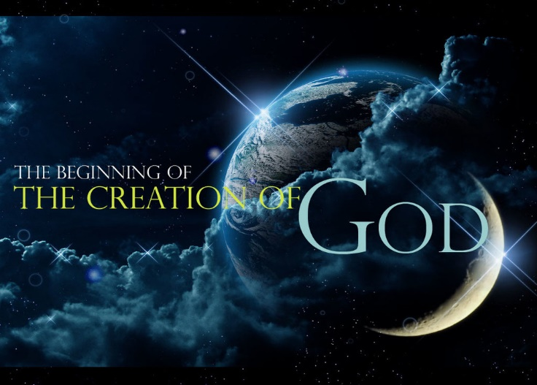 **Imperfect Knowledge of Ourselves**. Do we fully understand the human body with its 30 to 40 trillion cells?[7] Have we figured out why we have fingerprints, have an appendix, a dominant hand, yawn, have blood types, dream, have viruses in our bodies, are weaker than other primates and have laughter that is contagious?[8] And when it comes to the human soul isn’t our knowledge far from perfect? For instance, while the human soul can be described as a “spirit” who truly knows what this is and whom amongst us can without doubt declare whether the spirit resides in the brain, heart, blood or another part of our bodies?[9] And when it comes to our standing before a holy God are we certain that we have become the living stones and sacrifices (1 Peter 2:5) pleasing to He who bought us at a price (1 Corinthians 6:20)? While our standing in relation to salvation is perfected by our faith in Jesus Christ, will not our flattering image of our own holiness shatter at the judgement seat of Christ (2 Corinthians 5:10)? How could anyone say they have “found” and known their true self considering all these uncertainties?

**Imperfect Knowledge of Creation**. Whom amongst us truly understands what God has created all around us? Whom of us can say what is dark matter or dark energy, whether our solar system is normal, what makes supermassive black holes, if there are parallel universes, what happens inside a black hole, do naked singularities exist and what truly is gravity?[10] With only about 1/3 of the insect[11] and plant and animal species of the oceans known,[12] how could one ever say I have this universe figured out? If we should be so foolish to say we know everything about this universe then whom of us could ever stand when God asks us to explain its mysteries? And of the all the things unseen above, below and all around us whom of us can truly say?[13] Of the few unseen things such as angels, demons, heaven and even Jesus Himself; is it not only through the “telescope of faith”[14] that we have such “knowledge” and can accept these things?

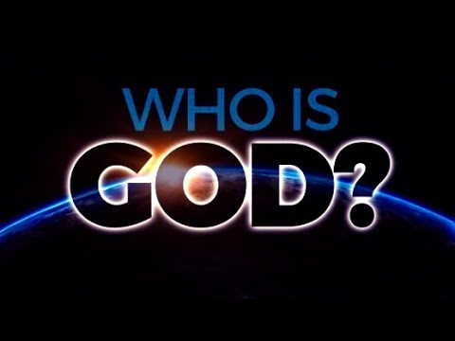**Imperfect Knowledge of God**. And finally, “how astonishingly little do we know about God!”[15] Who can truly comprehend God being indivisibly present on His throne (Revelation 4:20), in the church (Matthew 18:20) in the believer's heart (Galatians 2:20) and everywhere else both seen and unseen (Psalms 139:7-11; Jeremiah 23:23-24)? Surely He who numbers and names the stars in the sky (Psalms 147:4, Isaiah 40:26) counts every hair on a person's head (Matthew 10:30), knows every thought (1 Chronicles 28:9), every secret (Hebrews 4:12-13, Psalms 44:20-21) and word a person will or ever has spoken (Psalms 139:4) is beyond our understanding? And whom amongst us can truly comprehend His holiness (Psalms 99:9; 1 Peter 1:15; Isaiah 57:15), His self-existence being eternal (Revelation 22:13; John 17:5) or His ability to do anything (Job 42:2; Romans 1:20; Matthew 19:26) consistent within His own nature (Titus 1:2; James 1:13; 2 Timothy 2:13)? Since God is not exactly like anything or anyone created, describing the ineffable is in a sense truly beyond both thought and language.[16] While we know some things about God’s attributes more is unknown and left to faith than known by the intellect, for from all eternity to all eternity the depths of God's wisdom and knowledge are beyond measure, limit or comprehension (Romans 11:33-34).

**The Vanity of Knowledge**

**Love never fails. But where there are prophecies, they will cease; where there are tongues, they will be stilled; where there is knowledge, it will pass away. 9For we know in part and we prophesy in part, 10but when completeness comes, what is in part disappears.**

Since our knowledge of self, creation and God are not only limited but will one day pass away; Paul told the church of Corinth that they should not covet knowledge and tongues but love.[17] If one’s relationship with a fellow believer is soured by another person’s opposing points of view[18] concerning God then one’s “perceived” superior knowledge has become the product of pride and utter vanity! Is it not prideful to think God speaks to and has only given you alone the ability to fathom all the mysteries of the universe? It is not the seeking of knowledge that Paul is objecting too (Romans 10:14; 1 Corinthians 12:8) but the conceit to believe that we are no longer a child and as such our knowledge is now complete![19] Do we not know that “our spiritual manhood in heaven will discard many things” [20] we think we know the moment we see God face to face? When we walk the streets of gold and hear from the very mouth of Christ the explanations for all the trials and injustices[21] we have seen or experienced in our lifetimes will we not be awestruck not only of our former ignorance but also of the infinite wisdom and knowledge of our Savior and King? And when it comes to pride in self will this not melt away at the judgment seat of Christ (2 Corinthians 5:10) when the “blackness of our hearts” is revealed and we have no recourse but to cry out Abba, Father (Romans 8:15) have mercy on me for I am truly vile (Job 40:4)?[22] Knowledge puffs up but love truly lasts forever!

**Lessons to Learn by Looking into the Mirror**

**Lesson #1: Gratitude**. Even though Corinth was famous for its bronze metal that when buffed and shined would act like a mirror, [23] the image viewed in this mirror was dark and unclear[24] in comparison to looking directly at the person. In a similar way our knowledge of ourselves, creation and God has been flawed by seeing things through the eyes of those who live in a fallen world. Even though we must wait until we get into heaven to receive our eschatological knowledge that is promised to be full,[25] we should rejoice and be thankful for the knowledge God has currently given to us![26] For what we know about God even though incomplete is enough to point us to the path of salvation! Praise be that we know that as masterpieces of His grace (Ephesians 2:10) God wishes none of us to perish (2 Peter 3:9) but instead has provided through faith in the atoning sacrifice of Christ (John 3:16) the only path (John 14:6) to be adopted as His children (John 1:12)! While we don’t know exactly how the old self is transformed into the new, we should be overwhelmed with joy that looking through the telescope of faith is all that is needed to receive the glorious inheritance (Ephesians 1:18) in heaven offered to those He calls His own!

**Lesson #2: Humility and Forbearance**. Surely two Christians grouping in the darkness of this fallen world can agree to forbear and always love one another? We are not to amass knowledge of ourselves, creation and God so that we might arrogantly point out our “perceived” superior connection to and understanding of all things seen and unseen. How many times has today’s born again “Pharisees” tried to force the “letter” of their law upon another while withholding grace? How many times has brotherly and sisterly love been destroyed by intolerance to opposing points of view, especially when it comes to the interpretation of Scripture? Are not Christ’s ambassadors and royal priests called to “soften the asperity of their debates”[27] and forebear with differing points of views by humbly accepting the truth that they too are childlike and currently see only in part? Remember the Spirit gave various gifts to all members of the body to have them build one another up in the faith (1 Corinthians 12), not become angry with and separate from the body in which Christ died for (Ephesians 5:25) and is the chief cornerstone (Ephesians 2:20)! Instead of separating from those having differing points of view we are to in gentleness and humility “make every effort to keep the unity of the Spirit through the bond of peace” (Ephesians 4:2).

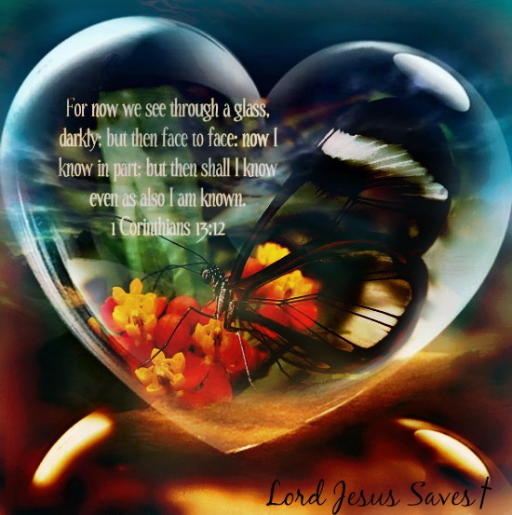**Lesson #3: Faith in God**. And lastly, we learn that we are to lean not unto our own understanding but trust in the wisdom of God (Proverbs 3:5-6)![28] While “we do not yet perceive how He will make all those dark dispensations, trials and afflictions that come upon His people to sub-serve His glory and their happiness”[29] the circumstances appointed to us will in heaven be understood as His great acts of mercy and kindness. To one day find out why a loved one died at a young age, or why we suffered so long with that painful disease, or why we lost our job, or why God allowed wars, earthquakes or famines, or why we were created ugly or not overly smart; will be a day of great rejoicing! And while we are unlikely to understand everything concerning God’s providence (for that would imply we have become omnipotent like God), [30] will not our salvation be enough to fulfill our heart’s desire? Death will no longer be seen as a sorrowful end of life but a journey through the gate of endless joy that we in our childlike state dreaded to enter![31] So, lets look forward to that glorious day when “everything that exalted itself against the knowledge of God will be casted down and replaced with true knowledge and obedience to Christ (2 Corinthians 10:5)!

1. Matthew Henry, [*Matthew Henry’s Commentary on the Whole Bible: Complete and Unabridged in One Volume*](https://ref.ly/logosres/mhenry?ref=Bible.1Co13.8-13&off=12&ctx=Verses+8%E2%80%9313%0a~Here+the+apostle+goes+on+to+) (Peabody: Hendrickson, 1994), 2269.
2. Roy E. Ciampa and Brian S. Rosner, [*The First Letter to the Corinthians*](https://ref.ly/logosres/pntccor1?ref=Bible.1Co13.9&off=155&ctx=fts+in+v.+8.+For+we+~know+in+part+and+we+), The Pillar New Testament Commentary (Grand Rapids, MI; Cambridge, U.K.: William B. Eerdmans Publishing Company, 2010), 656.
3. Leon Morris, [*1 Corinthians: An Introduction and Commentary*](https://ref.ly/logosres/tntc67co1us?ref=Bible.1Co13.11&off=4&ctx=%3b+see+on+v.+8).%0a11.+~The+contrast+between), vol. 7, Tyndale New Testament Commentaries (Downers Grove, IL: InterVarsity Press, 1985), 180.
4. David K. Lowery, [“1 Corinthians,”](https://ref.ly/logosres/bkc?ref=Bible.1Co13.11&off=362&ctx=+Corinthians+13%3a10.+~In+the+Ephesians+pas) in *The Bible Knowledge Commentary: An Exposition of the Scriptures*, ed. J. F. Walvoord and R. B. Zuck, vol. 2 (Wheaton, IL: Victor Books, 1985), 536.
5. Norman L. Geisler, [“Colossians,”](https://ref.ly/logosres/bkc?ref=Bible.Col2.10&off=6&ctx=2%3a10.+~Not+only+is+all+the+%E2%80%9Cfullness%E2%80%9D+(pl) in *The Bible Knowledge Commentary: An Exposition of the Scriptures*, ed. J. F. Walvoord and R. B. Zuck, vol. 2 (Wheaton, IL: Victor Books, 1985), 677.
6. C. H. Spurgeon, [“Now, and Then,”](https://ref.ly/logosres/mtpserms17?ref=Page.p+417&off=2362&ctx=read+out+before+us.+~Our+Lord+Jesus+is%2c+a) in *The Metropolitan Tabernacle Pulpit Sermons*, vol. 17 (London: Passmore & Alabaster, 1871), 417.
7. Taken from the following website: <https://www.medicalnewstoday.com/articles/318342.php>
8. Taken from the following website: <https://www.rd.com/health/wellness/human-body-mysteries/>
9. John Wesley, [*Sermons, on Several Occasions*](https://ref.ly/logosres/wslyserm?art=serm069&off=13996&ctx=matter+of+fact.%0a13.+~Well%3b+but+if+we+know) (Oak Harbor, WA: Logos Research Systems, Inc., 1999).
10. Taken from the following website: <https://www.livescience.com/34052-unsolved-mysteries-physics.html>
11. Taken from the following website: <https://www.si.edu/spotlight/buginfo/bugnos>
12. Taken from the following website: <https://www.usnews.com/news/articles/2012/11/15/two-thirds-of-ocean-life-remains-undiscovered->
13. John Wesley, [*Sermons, on Several Occasions*](https://ref.ly/logosres/wslyserm?art=serm069&off=1948&ctx=ably+in+this+world%3a+~But+of+innumerable+t) (Oak Harbor, WA: Logos Research Systems, Inc., 1999).
14. C. H. Spurgeon, [“Now, and Then,”](https://ref.ly/logosres/mtpserms17?ref=Page.p+417&off=2362&ctx=read+out+before+us.+~Our+Lord+Jesus+is%2c+a), 417.
15. John Wesley, [*Sermons, on Several Occasions*](https://ref.ly/logosres/wslyserm?art=serm069&off=2609&ctx=wn+ignorance!%0aI.+1.+~To+begin+with+the+gr) (Oak Harbor, WA: Logos Research Systems, Inc., 1999).
16. A. W. Tozer, The Knowledge of the Holy.
17. Marion L. Soards, [*1 Corinthians*](https://ref.ly/logosres/nibcnt67co1?ref=Bible.1Co13.8-10&off=440&ctx=+a+contrast+between+~love+and+prophecies%2c), Understanding the Bible Commentary Series (Grand Rapids, MI: Baker Books, 2011), 274.
18. C. K. Barrett, [*The First Epistle to the Corinthians*](https://ref.ly/logosres/black67co1?ref=Bible.1Co13.8-11&off=517&ctx=ove+never+fails.+If+~my+relationship+with), Black’s New Testament Commentary (London: Continuum, 1968), 305.
19. C. H. Spurgeon, [“Now, and Then,”](https://ref.ly/logosres/mtpserms17?ref=Page.p+410&off=2951&ctx=h+a+glass%2c+darkly.%E2%80%9D+~Thank+God+we+do+know) 410–411.
20. Ibid.
21. John Wesley, [*Sermons, on Several Occasions*](https://ref.ly/logosres/wslyserm?art=serm069&off=22944&ctx=articular+families.+~We+cannot+at+all+com) (Oak Harbor, WA: Logos Research Systems, Inc., 1999).
22. C. H. Spurgeon, [“Now, and Then,”](https://ref.ly/logosres/mtpserms17?ref=Page.p+412&off=374&ctx=ven+than+we+do+now.+~There+we+shall+see%2c+) i412.
23. Leon Morris, [*1 Corinthians: An Introduction and Commentary*](https://ref.ly/logosres/tntc67co1us?ref=Bible.1Co13.12&off=324&ctx=erfect+in+contrast.+~Our+knowledge+of+God), 180.
24. David K. Lowery, [“1 Corinthians,”](https://ref.ly/logosres/bkc?ref=Bible.1Co13.12&off=7&ctx=13%3a12.+~A+city+like+Corinth%2c+famous+for+i) 536.
25. Marion L. Soards, [*1 Corinthians*](https://ref.ly/logosres/nibcnt67co1?ref=Bible.1Co13.11-12&off=898&ctx=n+earlier+chapters.+~Current+knowledge+is), 275.
26. C. H. Spurgeon, [“Now, and Then,”](https://ref.ly/logosres/mtpserms17?ref=Page.p+418&off=2252&ctx=ion+before+I+close.+~Methinks+there+is+an) 418.
27. C. H. Spurgeon, [“Now, and Then,”](https://ref.ly/logosres/mtpserms17?ref=Page.p+419&off=522&ctx=+may+be+but+a+step.%0a~Another+lesson+is+th) 419.
28. John Wesley, [*Sermons, on Several Occasions*](https://ref.ly/logosres/wslyserm?art=serm069&off=30135&ctx=hence+we+may+learn%2c+~Secondly%2c+a+lesson+o) (Oak Harbor, WA: Logos Research Systems, Inc., 1999).
29. C. H. Spurgeon, [“Now, and Then,”](https://ref.ly/logosres/mtpserms17?ref=Page.p+414&off=552&ctx=entre+of+his+love.%E2%80%9D+~We+do+not+yet+percei) 414.
30. Ibid., 415.
31. Ibid., 419.