**Twelve Ordinary Men**

Online Sermon: <http://www.mckeesfamily.com/?page_id=3567>

Today we are going to continue the sermon series on the Twelve Apostles by examining the life of Nathanael. Before I begin, I want to acknowledge that the book “Twelve Ordinary Men” by John MacArthur was used as the foundation for this sermon series. Imagine spending your whole life combing through the Mosaic Law and the Prophets to learn as much as you can about the coming of the Messiah and then one day your friend boldly declares He has arrived! How would you react? You would think that Nathanael would have been overwhelmed with joy, drop everything and run to the feet of his Master! And yet we find in John 1:43-51 that his initial reaction was one of skepticism. As soon as Phillip said Jesus was from Nazareth Nathanael’s prejudice kicked in and he found himself dismissing any chance that the Messiah had come because His home town had a reputation of being unrefined, uneducated, evil, corrupt, and full of sinful people! And yet after just hearing a few words from Jesus his prejudices melted away and he cried out “Rabbi you are the Son of God” (verse 49). In examining the life of Nathanael, we are going to learn how those who genuinely seek God will see their prejudice and skepticism give way to truth and faith in their Master.

**Background on Nathanael**

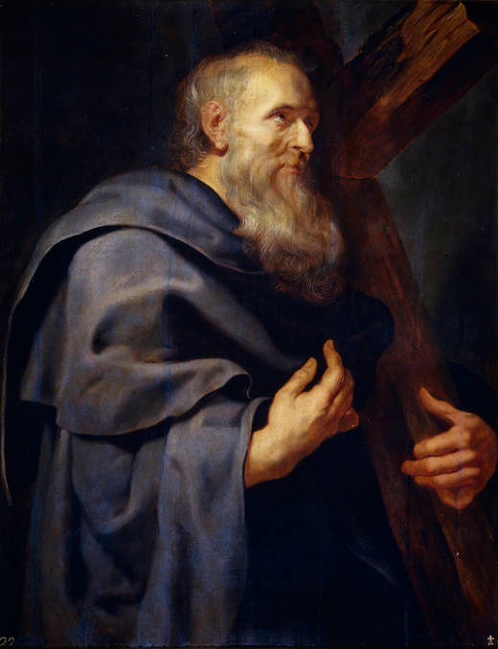What little that can be known about Nathanael comes mostly from the Gospel of John.[1] Nathanael is a Greek name that means “God has given” and his Jewish surname Bartholomeaw means “son of Tomai.”[2] While Nathanael’s genealogy is not given anywhere in the Bible or historically, some scholars suggest that Maach, wife of King David, was daughter of King Talmai of Geshur (2 Samuel 3:3) which would mean that Nathanel was of Davidic descent.[3] Nathanael’s home town was Cana of Galilee (John 21:2).[4] According to John MacArthur, Nathanael was most likely a professional fisherman along with Phillip, Thomas,[5] and the other four apostles Peter, Andrew, James and John (John 21, Mark 1:21, 29; Luke 5:10) who were fishing partners.[6] Even though the name “Nathanael” has been identified as “Bartholomew” since the 9th century, [7] some scholars have suggested he could have been either James the Son of Alphaeus, Matthew, Simon the Cananaean[8] or not even a disciple![9] Nathanael’s name is listed in sixth place in each of the lists of Apostles (Matthew 10:2-4; Mark 3:16-18; Luke 6:12-15)[10] as his surname Bartholomew. His itinerant ministry ranged from Anatolia to Parthia, Egypt and India; each with its own tradition on how he was martyred.[11]

**Love of Scripture**

**43The next day Jesus decided to leave for Galilee. Finding Philip, He said to him, “Follow me.” 44Philip, like Andrew and Peter, was from the town of Bethsaida. 45Philip found Nathanael and told him, “We have found the One Moses wrote about in the Law, and about whom the prophets also wrote—Jesus of Nazareth, the son of Joseph.”**

By mentioning that Jesus was the one whom Moses and prophets wrote about Phillip knew this would peak Nathanael’s interest whom was an ardent student of the Old Testament.[12] To hear that the heart of the Old Testament had been finally fulfilled in Jesus would have been profound for any Jewish person to hear, especially for one whom meditated on Scripture[13] all those days sitting under the fig tree outside his home![14] From Nathanael we learn that while truth is not easily found those who genuinely seek will find God who is always near (James 4:8). Had Nathanael not read about the prophesied virgin birth (Isaiah 7:14) or the Messiah coming from a lowly place like Bethlehem (Micah 5:2) or having no beauty of majesty (Isaiah 53:2); he most likely would not have gone to meet one whom did not fulfill Jewish expectations that the Messiah would be a Jewish King whom would conquer Rome. Even though the religious establishment of Nathanael’s day was “dominated by hypocrisy and false piety”[15] this did not deter him from recognizing and accepting the truth concerning Jesus! As one without guile or deceit, Nathanael truly was a “symbol of the pious Israelite whom Christ came”![16]

**Prejudice and Skepticism**

**46“Nazareth! Can anything good come from there?” Nathanael asked. “Come and see,” said Philip.**

A picture containing book, text

Description generated with very high confidence The moment Phillip said Jesus was from Nazareth Nathanael became skeptical that He was the Messiah! Since “Nazareth was not mentioned in the Old Testament, the Talmud, Midrash or contemporary pagan writings,”[17] why would the Messiah be born in such an insignificant place?[18] Not even the people in the synagogues of Capernaum (John 6:42) or Nazareth itself (Mark 6:1-6) believed that was possible![19] Nathanael probably wondered why would God’s own Son and Savior of humanity choose to take up residence at an “uncultured place, full of evil, corrupt, and sinful people”?[20] His disdain for Nazareth was either due to civil rivalry with his home town Cana[21] or was due to his misconception that anything familiar or close to home could not house such a great honor![22] To have him cured of his “human blindness,” Philip chose not to try and win over his friend by argument but instead took Him to see Jesus.[23]

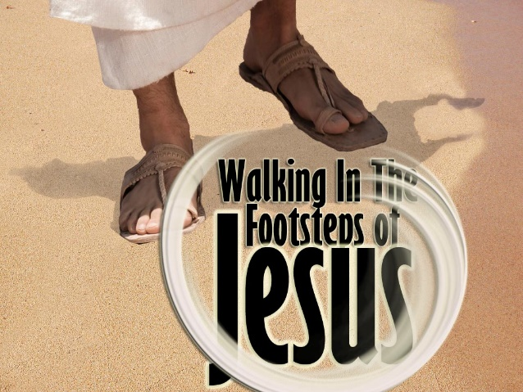We can learn a lot from how Phillip handled Nathanael whom was skeptical of the truth. We live in a fallen world in which the “ruler of the kingdom of the air” (Ephesians 2:2) has been given the freedom to poison the hearts and minds of humanity. Satan roars like a lion, seeking to devour the testimony of creation (Romans 1:20), God’s word (2 Timothy 3:16) and the Spirit’s call (John 16:13). Living in a world where truth is relational to “self” and is in a constant flux of change as circumstances change, it should come as no surprise that Jesus’ statement “I am the way, truth and life” (John 14:6) is perceived by many in this world as being mere foolishness (1 Corinthians 1:18)! We can learn a lot from Phillip on how to deal with the skeptical people of this world. First, he told Nathanael about Jesus. Likewise, if we do not boldly preach to the lost of this world then how will they ever know the truth (Romans 10:14)? And second, Philip was a follower of Jesus. Once a skeptic knows the Good News show them the power of the Gospel message by walking in the footsteps of Christ (2 Peter 2:21)! It is only when someone sees the glorious riches (Ephesians 3:16-19) you have that they will be willing to give up the broad path of sin (Matthew 7:13) to embrace a loving God whom has a place for them in His kingdom (2 Peter 3:8-10)!

**Cured of Human Blindness**

**47When Jesus saw Nathanael approaching, He said of him, “Here truly is an Israelite in whom there is no deceit.” 48“How do you know me?” Nathanael asked. Jesus answered, “I saw you while you were still under the fig tree before Philip called you.” 49Then Nathanael declared, “Rabbi, you are the Son of God; you are the king of Israel.”**

When Jesus saw Nathanael approaching Him, He said Nathanael was a person without deceit.[24] Even though Nathanael was tainted by prejudice and sin, Jesus saw into his heart and found there to be no hypocrisy but only a genuine love to see the Messiah.[25] Unlike the scathing rebuke the scribes and Pharisees would get from Jesus (Matthew 23:13-33), Nathan received high praise for Jesus saw him as a true Israelite descendant (Romans 9:6-7), not circumcised merely outwardly but of the heart (Romans 2:28-29)![26] Nathanael asked Jesus how He knew him? Jesus said “I saw you under the fig tree” which was either a reference to Hosea 9:10[27] or more likely a reference to one of Nathanael’s times of prayer, meditation or study at his home town.[28] Jesus’ supernatural knowledge of Nathanael[29] broke his skepticism and cured his human blindness as can be seen in his profound Christological statement “Rabbi, you are the Son of God and king of Israel” (John 1:49; Psalms 2:6-7)![30]

**50Jesus said, “You believe because I told you I saw you under the fig tree. You will see greater things than that.” 51He then added, “Very truly I tell you, you will see ‘heaven open, and the angels of God ascending and descending on’ the Son of Man.”**

Jesus acknowledged Nathanael’s faith based on His omnipotent knowledge of his private, devotional life[31] and then told him he was about to witness far more and greater miracles. As an example of what was to come Jesus quoted Genesis 28:10-17 in which Jacob had a dream of a ladder that was set up on earth, reached all the way to heaven and had angels ascending and descending on it.[32] If Jacob whom was filled with guile and forced from his home for having lied to his father and swindled his brother was “eligible to receive a vision from God, would not Nathanael be even more worthy of such a blessing?[33] Yes Nathanael would get to see that Jesus was the ladder by which the “realities of heaven will be brought down to earth” (John 3:13),[34] that would forever help him overcome “his disdain for the familiar and commonplace.”[35] He was about witness first hand evidence that Jesus was far more than a person from Nazareth or the son of Joseph (1:45) the carpenter (Mark 6:3), he was the Son of Man (1:51) whom would pay for the sins of the world (1 Peter 3:18) and in doing so become the only path to God the Father in heaven (John 14:6)!

 I want to finish this sermon by saying “blessed are those how have not seen and yet believe” (John 20:29b). While you cannot literally take a skeptic to the feet of Jesus, you can introduce them to the life saving grace of Christ by telling them about all the miracles God has done for you! First, point them to the intricacies of creation that clearly demonstrate His eternal power and divine nature (Romans 1:20). Though Jesus all things were created and are held together (Colossians 1:16). Second, tell them of all the miracles you and others have received from God (Matthew 11:4-6). We all know of or have first hand experience of physical, emotional or spiritual miracles. For example, tell them of the time when God sent you money when you had none, sent advice from a friend that helped you in a rough patch in your marriage or the time when He wrapped His arms around you when a loved one unexpectedly passed away. And most importantly, tell them about the miracle of your salvation. Tell them how you felt when Christ forgave you of a lifetime of rejecting Him and you were born again not of flesh and blood but of the Spirit of God (John 1:13)! Remember, it only took one miracle to convince Nathanael … maybe that is all it will take to convince your skeptical friend, colleague, or family member to embrace God’s gift of salvation!

1. JoAnn Ford Watson, [“Philip (Person),”](https://ref.ly/logosres/anch?ref=biblio.at%3dPhilip%2520(Person)%7Cau%3dWatson%2c%2520JoAnn%2520Ford%7Ced%3dFreedman%2c%2520David%2520Noel&off=153&ctx=+3:18+%3d+Luke+6:14).+~More+is+known+of+him) ed. David Noel Freedman, *The Anchor Yale Bible Dictionary* (New York: Doubleday, 1992), 311.
2. John F. MacArthur Jr., [*Twelve Ordinary Men: How the Master Shaped His Disciples for Greatness, and What He Wants to Do with You*](https://ref.ly/logosres/12ordmen?ref=Page.p+119&off=627&ctx=r+in+his+own+right.%0a~Philip+is+a+Greek+na) (Nashville, TN: W Pub. Group, 2002), 119.
3. W. Brian Shelton, [*Quest for the Historical Apostles: Tracing Their Lives and Legacies*](https://ref.ly/logosres/qsthstrclpstls?ref=Page.p+160&off=1559&ctx=ouble+names+exist.3+~Some+scholars+have+s) (Grand Rapids, MI: Baker Academic: A Division of Baker Publishing Group, 2018), 160.
4. Walter A. Elwell and Barry J. Beitzel, [“Nathanael,”](https://ref.ly/logosres/bkrencbib?ref=Page.p+1526&off=2090&ctx=Nathanael.+~Jew+from+Cana+of+Galilee+whom) *Baker Encyclopedia of the Bible* (Grand Rapids, MI: Baker Book House, 1988), 1526.
5. Ibid.
6. Walter A. Elwell and Barry J. Beitzel, [“Peter, The Apostle,”](https://ref.ly/logosres/bkrencbib?ref=biblio.at%3dPeter%2c%2520The%2520Apostle%7Cpg%3d1659%E2%80%931667%7Cvo%3d2&off=1690&ctx=His+Background.+~As+previously+stated%2c+Pe) 1659.
7. Michael J. Wilkins, [“Bartholomew (Person),”](https://ref.ly/logosres/anch?ref=VolumePage.V+1%2c+p+615&off=835&ctx=Gk+OT+and+Josephus.%0a~From+the+9th+century) ed. David Noel Freedman, *The Anchor Yale Bible Dictionary* (New York: Doubleday, 1992), 615.
8. Walter A. Elwell and Barry J. Beitzel, [“Nathanael,”](https://ref.ly/logosres/bkrencbib?ref=Page.p+1526&off=3539&ctx=n+the+early+church.%0a~Two+less+plausible+i) *Baker Encyclopedia of the Bible,* 1526.
9. Barclay Moon Newman and Eugene Albert Nida, [*A Handbook on the Gospel of John*](https://ref.ly/logosres/ubshbk64?ref=Bible.Jn1.45&off=10&ctx=John+1%3a45%0a~Nathanael+(mentioned+only+here), UBS Handbook Series (New York: United Bible Societies, 1993), 47–48.
10. Walter A. Elwell and Barry J. Beitzel, 1675.
11. W. Brian Shelton, [*Quest for the Historical Apostles: Tracing Their Lives and Legacies*](https://ref.ly/logosres/qsthstrclpstls?ref=Page.p+163&off=1624&ctx=in+other+locations.+~The+geographical+ran) (Grand Rapids, MI: Baker Academic: A Division of Baker Publishing Group, 2018), 163.
12. Merrill C. Tenney, [“John,”](https://ref.ly/logosres/ebc09?ref=Bible.Jn1.43-45&off=977&ctx=and+seems+fanciful.%0a~Nathanael+seems+to+h) in *The Expositor’s Bible Commentary: John and Acts*, ed. Frank E. Gaebelein, vol. 9 (Grand Rapids, MI: Zondervan Publishing House, 1981), 41.
13. W. Brian Shelton, [*Quest for the Historical Apostles: Tracing Their Lives and Legacies*](https://ref.ly/logosres/qsthstrclpstls?ref=Page.p+161&off=207&ctx=+the+Prophets+wrote%E2%80%94~Jesus+of+Nazareth%2c+t), 161.
14. Raymond F. Collins, [“Nathanael (Person),”](https://ref.ly/logosres/anch?ref=VolumePage.V+4%2c+p+1030&off=4371&ctx=hilip%E2%80%99s+invitation.+~In+rabbinic+traditio) ed. David Noel Freedman, *The Anchor Yale Bible Dictionary* (New York: Doubleday, 1992), 1030.
15. John F. MacArthur Jr., [*Twelve Ordinary Men: How the Master Shaped His Disciples for Greatness, and What He Wants to Do with You*](https://ref.ly/logosres/12ordmen?ref=Page.p+137&off=1966&ctx=ense+they+were+very+~different+from+the+r), 137.
16. Walter A. Elwell and Barry J. Beitzel, [“Nathanael,”](https://ref.ly/logosres/bkrencbib?ref=Page.p+1526&off=4970&ctx=acob%E2%80%99s+experiences.+~Nathanael+is+thus+a+) *Baker Encyclopedia of the Bible*, 1526–1527.
17. George R. Beasley-Murray, [*John*](https://ref.ly/logosres/wbc36?ref=Bible.Jn1.43-46&off=595&ctx=m+pens+of+apostles.+~Nathanael%E2%80%99s+expostul), vol. 36, Word Biblical Commentary (Dallas: Word, Incorporated, 2002), 27.
18. Leon Morris, 145.
19. J. Ramsey Michaels, [*John*](https://ref.ly/logosres/nibcnt64jn?ref=Bible.Jn1.35-51&off=6869&ctx=y-splendored+thing.%0a~Nathanael%E2%80%99s+attitude), Understanding the Bible Commentary Series (Grand Rapids, MI: Baker Books, 2011), 40.
20. John F. MacArthur Jr., [*Twelve Ordinary Men: How the Master Shaped His Disciples for Greatness, and What He Wants to Do with You*](https://ref.ly/logosres/12ordmen?ref=Page.p+140&off=405&ctx=lace+like+Nazareth.+~It+was+an+uncultured), 140.
21. Ibid., 139.
22. J. Ramsey Michaels, [*John*](https://ref.ly/logosres/nibcnt64jn?ref=Bible.Jn1.35-51&off=6237&ctx=+of+Joseph+(v.+45).+~Nathanael%E2%80%99s+answer+r), Understanding the Bible Commentary Series, 39.
23. Leon Morris, 145.
24. J. Ramsey Michaels, 40.
25. John F. MacArthur Jr., [*Twelve Ordinary Men: How the Master Shaped His Disciples for Greatness, and What He Wants to Do with You*](https://ref.ly/logosres/12ordmen?ref=Page.p+142&off=1800&ctx=inly%2c+he+was+human.+~He+had+sinful+faults), 142–143.
26. John F. MacArthur Jr., [*Twelve Ordinary Men: How the Master Shaped His Disciples for Greatness, and What He Wants to Do with You*](https://ref.ly/logosres/12ordmen?ref=Page.p+143&off=764&ctx=+however%2c+was+real.%0a~In+Romans+9%3a6%E2%80%937%2c+the), 2002), 143.
27. J. Ramsey Michaels, 41.
28. Leon Morris, 146.
29. J. Ramsey Michaels, 42.
30. Raymond F. Collins, [“Nathanael (Person),”](https://ref.ly/logosres/anch?ref=VolumePage.V+4%2c+p+1030&off=5086&ctx=ss+their+faith+in+a+~profound+christologi) 1030.
31. John F. MacArthur Jr., [*Twelve Ordinary Men: How the Master Shaped His Disciples for Greatness, and What He Wants to Do with You*](https://ref.ly/logosres/12ordmen?ref=Page.p+146&off=627&ctx=came+from+Nazareth%2c+~His+omniscience%2c+His), 146.
32. Ibid., 147.
33. Merrill C. Tenney, [“John,”](https://ref.ly/logosres/ebc09?ref=Bible.Jn1.47-51&off=124&ctx=hel+(Gen+28%3a10%E2%80%9317).+~Jacob+was+filled+wit) in *The Expositor’s Bible Commentary: John and Acts*, 41.
34. Leon Morris, 149.
35. J. Ramsey Michaels, 42.