**God’s Word is Truth!**

**Psalms 119:1-8**

Online Sermon: <http://www.mckeesfamily.com/?page_id=3567>

Blessed are those who believe so strongly in God’s word being true that they are not only willing to meditate day and night on His statues but are also willing to become living sacrifices by walking in accordance with its precepts! Last week we put the Bible through rigorous tests and learned that due to its multiple sources, textual agreement, eye witness testimony and predictive accuracy; one can safely conclude that God’s love letter is “absolutely” true. And yet living an age when people no longer put up with sound doctrine (2 Timothy 4:3-4), pastors and teachers of God’s word are finding that more and more Christians are “ignoring” or “tearing out” sections of Scripture! It seems like any verse that either points to the way a person lives as being sinful or “counter-cultural” has become too vile for some Christian’s spiritual diets! The first part of this sermon is going to answer the question: are Christians to obey every single command that God has given them?, and the second part of the sermon is going to discuss the dangers of allowing the culture to influence our interpretation of God’s word.

**Obeying Every Single Command?**

**Illustration**. For this sermon I asked for an adult to volunteer for a skit (thankfully many in congregation love to participate in illustrations). I brought to the church a mattress, quilts and a pillow. The volunteer was given a night gown to wear, a hat and were instructed to crawl into bed. I was dressed up with a wig, beard and a cane to signify an “older,” “wise” father (I am not really that wise but am working on it!). The person in the bed was instructed that while they were an adult, taking the lowly position of a child was a great honor (Matthew 18:3-5) for in their “no holds back” questioning of God’s word they will find the truth! I also took several helium balloons. I instructed my wilful volunteer that to sound like a child he/she must inhale some helium before asking advice from me, the older, “wise” father! I added this part to the sermon to keep the attention of the children present whom were under the age of 11. The goal of this skit is to ask questions from the perspective of an innocent child that most adults are thinking about but are to afraid to ask! While the children might not understand all the answers given, I hope the adults will be convicted enough to continue this crucial conversation at home!

**Question 1: Does God want me to obey every single command in the Bible?**

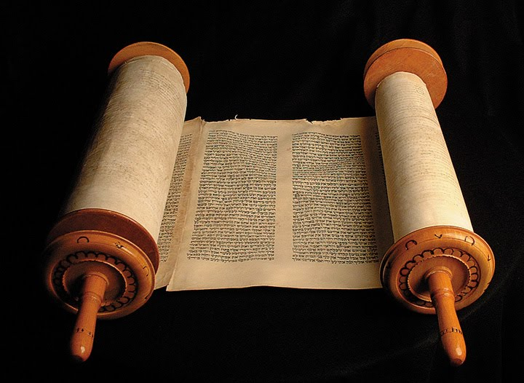 Son, that is a good but difficult question to answer. Let me first start by saying that there are many commands in the Bible, especially the Old Testament, that you are not asked to obey. We as born-again believers are no longer under the Older Mosaic Covenant and as such are not bound to obey the “letter” of its laws. In his letter to the church of Rome Paul wrote that since no one could follow the law in its entirety, the law only points out a person’s sin whose wages is death. (Romans 6:23). Christ bore the punishment for our sins upon the cross (Isaiah 53) so that we might be forgiven and need not to offer any more sacrifices (Hebrews 10:18). Christ fulfilled the Old Testament law and ushered in a new stage in God’s plan of salvation[1] which was based not on works but on faith in a risen Savior! Those choose to put themselves back under the Mosaic Law are “foolish” for to do so would mean that Christ’s death meant nothing (Galatians 3:1)![2]

**Question 2: Does this mean that I don’t have to obey any of the Old Testament laws?**

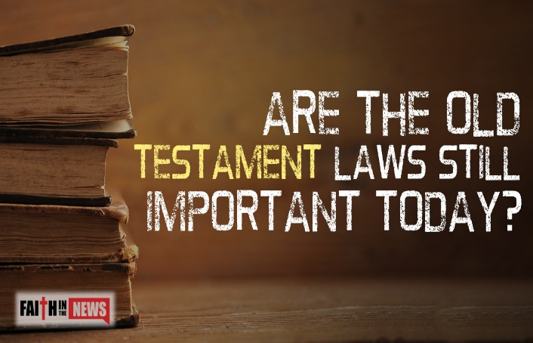 My child, at the council of Jerusalem, it was decided that the only things Christians should obey from the Old Testament is to “abstain from food polluted by idols, from sexual immorality, from the meat of strangled animals and from blood” (Acts 15:20). The moment Peter was commanded in his vision to get up kill and eat four-footed animals, as well as birds and reptiles that were according to the Old Testament “unclean,” (Acts 10:15) meant that the dietary laws were no longer to be obeyed.[3] This means that eating rabbits, pigs, bears, boars or catfish, shark, swordfish, crab, lobster, and shrimp is no longer forbidden by the Bible.[4] Also at this council it was decided that while physical circumcision was no longer required (1 Corinthians 7:19-20), Christians were to have their hearts circumcised by the Spirit (Galatians 2:29) and as such would no longer see the commands as burdensome but instruction on holy living (1 John 5:2).

**Question 3: Does this mean that out of the roughly 613 commands of the Old Testament there are only four that a Christian must follow?**

Son, while Christians are not required to follow the ceremonial and civil laws this does not mean that that Old Testament laws have been abolished. In the Sermon on the Mount Jesus said that He did not come to abolish the Law or the Prophets but to fulfill them (Matthew 5:17-20). While this might appear to be a contradiction to the prior answer it is the “letter” of the law and not the “intent” that is has been fulfilled and changed. Jesus came to actualize the Scripture and take us to a deeper understanding of why the commands were given.[5] Jesus gave us some examples of this deeper meaning during the Sermon on the Mount. For instance, the deeper meaning or intent of the commandment “do not murder” was to teach humanity it was wrong to be angry, hate or hold grudges against one other (5:21-26). The deeper meaning or intent of the commandment “do not commit adultery” was to keep the marriage bed pure by forbidding lustfully looking upon others (5:27-30). While Christians are no longer required to follow the ceremonial and civil laws, they are still required to follow the intent of these laws: to be set apart as distinct (Matthew 5:16) and separate from the world (1 John 2:15) for God. When it comes to the moral laws of the Old Testament, they are to be obeyed in their entirety.

**Question 4: Are we to obey every single command of the New Testament?**

Very good question my son and for the most part the answer is yes! There are some verses in the New Testament that scholars suggest no longer need to be obeyed because the culture they addressed no longer exists. For example, when Paul said, “women should remain silent in the churches” (1 Corinthians 14:24) many scholars believe that he only said this due to the lack of education of the women of his time period and so that the Corinthians would not be discredited in the eyes of the Greek culture whom felt that a virtuous woman should remain 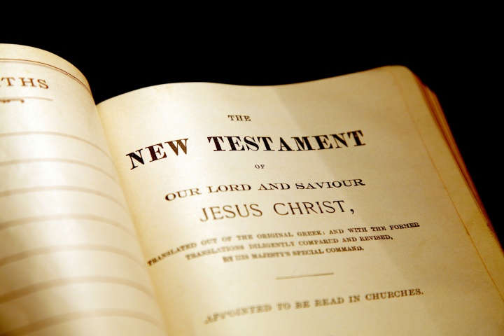silent in public.[6] Paul promoted the rights of women during his time period as demonstrated in his selection of various women to aid him in his ministry.[7] Another example of NT cultural laws are those relating to slavery. Paul’s commandment for slaves to obey their masters (whom in turn were to submit to the authority of Christ) is no longer in effect due to the abolishment of slavery in this part of the world. Paul’s suggestion to Philemon to grant freedom to his slave was not only counter cultural but clearly demonstrated his disapproval of this societal norm. There are very few commands in the New Testament that could be deemed culturally specific and when in doubt ask the Spirit and He will point them out to you (John 16:13).

**Cultural Influences**

**Question 5: Do most Christians accept and obey the Bible?**

While most Christians say they believe the Bible is 100% true and therefore should be obeyed in its entirety, there are many topics in the Bible that have become at best “debatable” and for some outright rejected. For example, since approximately 80 % of unmarried evangelical young adults have had sex;[8] sex before marriage is now a controversial topic within our churches. Since more and more countries have legalized and are promoting same-sex marriage, it is now “taboo” to share what the Bible says on this topic. Since almost one in two Christians will get divorced in their lifetime most pastors dare not even mention what the Bible says about this topic lest they be ushered the door.[9] Since one in four women will get an abortion in their lifetime, preaching the sanctity of life is now a controversial topic for a lot of Christians.[10] Due to the influence of this “ME” generation that believes in no restrictions, some Christians now reject any notion that spiritual gifting assigns divine roles within the church while others outright reject the necessity to ask for forgiveness of sins once one becomes a believer!

**Question 6: Does the culture we live in affect our interpretation of God’s word?**

The answer to this question is the main reason why we are having this discussion. The culture in which we live has a dramatic affect on how we interpret Scripture. The more society moves away from and outright rejects God’s word as being true, the more Christians will “tear out” pages of Scripture to make it more palatable to their culture. The more Christians participate in the sins of their culture the less likely God’s word will have an authoritative position in their lives! How hard would it have been to be Noah (Genesis 7), Lot (Genesis 19) or Moses (Exodus 32) to remain faithful and obedient to God while everyone else was feasting on their sinful desires or their hearts (James 1:14-15)? Instead of accepting the “foolishness” of this world (1 Corinthians 3:19) we as Christians should bow our knees and unquestionably accept the authority of God’s word to teach us how to live holy lives (2 Timothy 3:16)! To do this we must reject any temptation to interpret God’s word through “worldly eyes” but instead through the eyes of the Holy Spirit whose timeless truths never change (John 16:13).

**Question 7: What can one do to keep one’s ways pure?**

To finish off today’s discussion I want to give you one final piece of advice: “watch and pray so that you will not fall into temptation for the spirit is willing, but the flesh is weak” (Matthew 26:41). Hide the word of God in your heart so that you might not sin against Him (Psalms 119:9-16) and through prayer and thanksgiving draw nearer to Him and He will draw nearer to you (James 4:8). In the end one must choose what will be the compass for living one’s life. If you allow your culture to dictate your beliefs, then while that broad path will be pleasurable it will not lead you closer to God. If you accept and allow His word to be the authority in your life, then you will be blessed and will one day hear the words “good and faithful servant.” The choice is yours to make: to whom do you want to be your master?

1. L. Ann Jervis, [*Galatians*](https://ref.ly/logosres/nibcnt69gal?ref=Bible.Ga3.1-2&off=4252&ctx=t+they+received+the+~Spirit+at+the+beginn), Understanding the Bible Commentary Series (Grand Rapids, MI: Baker Book, 2011), 79.
2. James Montgomery Boice, [“Galatians,”](https://ref.ly/logosres/ebc10?ref=Bible.Ga3.1&off=800&ctx=im+6:9%3b+Titus+3:3).+~This+term+was+clearl) in *The Expositor’s Bible Commentary: Romans through Galatians*, ed. Frank E. Gaebelein, vol. 10 (Grand Rapids, MI: Zondervan Publishing House, 1976), 453.
3. David J. Williams, [*Acts*](https://ref.ly/logosres/nibcnt65ac?ref=Bible.Ac10.9-16&off=3100&ctx=ke+(cf.+Jonah+3:1).%0a~But+what+did+it+mean), Understanding the Bible Commentary Series (Grand Rapids, MI: Baker Books, 2011), 188.
4. Taken from the following website: <http://www.uncleanfoodsdietarylaws.com/clean_unclean_food_list.html>
5. Michael J. Wilkins, [*Matthew*](https://ref.ly/logosres/nivac61mt?ref=Bible.Mt5.17&off=2496&ctx=t+meaning+in+Jesus.+~Jesus+has+come+to+ac), The NIV Application Commentary (Grand Rapids, MI: Zondervan Publishing House, 2004), 229.
6. Leon Morris, [*1 Corinthians: An Introduction and Commentary*](https://ref.ly/logosres/tntc67co1us?ref=Bible.1Co14.34-35&off=163&ctx=Christian+practice.+~For+women+to+take+on), vol. 7, Tyndale New Testament Commentaries (Downers Grove, IL: InterVarsity Press, 1985), 193.
7. Taken from the following website: <http://enrichmentjournal.ag.org/200102/082_paul.cfm>
8. Taken from the following website: <https://www.christianpost.com/news/are-most-single-christians-in-america-having-sex.html>
9. Taken from the following website: <https://www.focusonthefamily.com/about/focus-findings/marriage/divorce-rate-in-the-church-as-high-as-the-world>
10. Taken from the following website: <https://www.washingtonpost.com/news/to-your-health/wp/2017/10/19/u-s-abortion-rate-fell-25-percent-from-2008-to-2014-one-in-four-women-have-an-abortion/?noredirect=on&utm_term=.5e174320c537>