**Talebearer!**

**Leviticus 19:16**

Online Sermon: <http://www.mckeesfamily.com/?page_id=3567>

 The human brain only weighs about three pounds of soft, gooshy like tissue and yet it houses more than 1.1 trillion cells.[1] This organ of the body is truly remarkable for it “controls all the functions of the body, interprets information from the outside world, and embodies the essence of the mind and soul.”[2] Even though the brain cannot perform calculations as fast as the K computer by Fujitsu, which is four times faster and can hold 10 times more data than our brains, the human brain is still impressive due to its efficiency of consuming less juice than what is needed to dim a lightbulb and nicely fitting within our tiny heads![3] And unlike the K computer, our brains are capable of managing a wide range of emotions such as anger, fear, disgust, sadness, happiness, surprise, love and is the source of our creativity and artistic expressions. Upon examining the human brain how could one not agree with king David that “we are fearfully and wonderfully made” (Psalms 139:14)!

With such an amazing gift you would think that humanity would use it to praise God the Father in heaven (1 Peter 1:3-12) and yet out of the between 10,000 to 60,000 thoughts we humans have per day, research shows that about 80% of our thoughts are negative and 95% are a mere repetition from one day to the next.[4] While we are all created in the image of God and descendants of Adam and Eve (Genesis 1-2), this does not mean that we see nor appreciate the miracle of human life all around us! Ever since Cain became jealous and killed his brother Abel humanity has had a love/hate relationship with one another. Even though it is only 1 % of people who commit violent physical crimes,[5] whom amongst us has not verbally assaulted another? While God gave us the freedom to think as we please (1 Corinthians 6:12) this does not mean that our tongues are to be a consuming fire that praises God while we curse humanity whom was made in His image (James 3:6-10)! Living in a world where the average person checks their cell phone once every 12 minutes,[6] talebearing and gossiping have become modern day weapons that cut just as deep as any knife! This sermon is going to review the definition of talebearing, when it is a sin and how to deal with those who spread lies about you.

**Talebearing and Slander Defined**

Slander is defined as “evil, malicious talk or lies intended to defame or destroy another person’s reputation” [7] and talebearing is defined as “idle, often sensational and groundless talk about others.”[8] In the Bible it includes **whispering** (Romans 1:29), **backbiting** (Romans 1:30; 2 Corinthians 12:20), **evil surmising** (1 Timothy 1:4), **babbling** (Ecclesiastes 10:11), **tattling** (1 Timothy 5:13), **evil speaking** (Psalms 41:5; 109:20), **defaming** (Jeremiah 20:10), **bearing false witness** (Exodus 20:16; Deuteronomy 5:20; Luke 3:14), **judging charitably** (James 4:11-12), **raising false reports** (Exodus 23:1) and **repeating matters** (Proverbs 17:9).[9] Since one cannot know the thoughts, motives and deeds of another, rarely does an exchange of “secret” information[10] or “talebearing” concerning another (especially when not present) not misrepresent and therefore also constitute slanderous talk. With approximately 80 % of the conversations people have every day are made up of gossip,[11] one can’t help but wonder when the sharing of information concerning another is a sin and when it is not?

**When is Talebearing a Sin?**

Let’s start with the obvious: using our minds to think and speak slanderous talk is an abomination unto God (Proverbs 6:16, 19), especially when it comes from evil intent (Matthew 15:19; Luke 6:45) and hatred for another person (Psalms 41:7; Psalms 109:3). In Mark 14:53-65 we are told of when Jesus was taken before the Sanhedrin. The hearing took place in the middle of the night which not only suggests the priests were under time constraints but also that the court proceedings represented nothing more than “kangaroo justice from a lynch mob.”[12] “With all the chief priests and the whole of the Sanhedrin looking for evidence against Jesus” (verse 55) it is not surprising that many “stood up and gave false testimony” (verse 57). These God-fearing Jews were so consumed with hatred for Jesus that they were willing to lie to secure His fate on the cross! Many times, we are like the Sanhedrin, a lynch mob perverting justice! With pride in our own holiness and anger in our eyes, our lying tongues spread false reports about another with the intent of destroying their reputation. Bearing false witness is a direct violation of the Ten Commandments (Exodus 20:16)[13] and as such is a sin that God hates seeing a person commit (Proverbs 6:16; Leviticus 19:16)!

Despite most Christians knowing that slander is a sin it has become the “weapon of choice” in most church confrontations! While almost all Christians can safely say they do not hate another person to the extent they are willing to do them bodily harm, most feel they are more than justified in expressing their hostility towards another through “character assassination.” A “cardinal vice of intolerance”[14] of the differentiated others within the church has blinded many self-righteous Christians and has left these “agents of reconciliation”[15] impotent and accomplices of further violence. To justify their aggressive and often false testimonies they tend to “demonize” the other to make their false testimonies more palatable. What a shame it is that Christ’s hospital for wounded souls would be filled with those who would try and win the “political battle for supremacy” by tearing down others rather than becoming a servant to all by forgiving, loving and building them up in the faith! Since hatred is part of the sinful nature (Galatians 5:20),[16] make every effort to see others as Christ saw on them cross so that one might not be tempted to go through a dreadful season (Ecclesiastes 3:8) of tearing down God’s children!

While most Christians would agree that slander is a sin, is it also a sin to think and use our minds to repeat negative things about a person to defend our own reputation? Genesis 3 tells us the story of the first-time humanity was caught in a sin. Eve and Adam both broke God’s command to not eat from the Tree of Knowledge of Good and Evil. Instead of accepting responsibility for the sin, Adam chose to try and exonerate himself by obliquely suggesting God lacked good judgement in making Eve who had deceived him.[17] In response God rightfully cursed Adam, Eve, the Serpent and all of humanity for their sins (3:13-19). Trying to destroy another person’s reputation to defame their witness is a sin for three reasons. First, in Matthew 7:3-5 Jesus states one is not to judge a brother or sister until one has confessed the “planks in one’s own eyes.” Second, in Matthew 5:38-48 Jesus sates instead of an “eye for an eye, tooth for a tooth” mentality one should not resist an evil person but instead love and pray for them. And third, despite how good one’s sources rarely are the “negative things” one speaks about the other person the truth and therefore repeating them equates to outright slander!

When quarrels and fights become as normal and frequent as praying and worshipping, such a church will soon close their doors! Our insatiable desire for retribution can keep even the best of Christians caught forever in a cycle of violence.

In January 2006, Australian scientists discovered the cause of a mysterious disease that had killed thousands of Tasmanian devils on the island state of Tasmania, off the coast of Australia. The scientists initially believed the deaths were caused by a virus; however, their research ultimately uncovered a rare, fatal cancer. They named it Devil Facial Tumor Disease, or DFTD. What is strange, according to cytogeneticist Anne-Marie Pearse, is that the abnormalities in the chromosomes of the cancer cells were the same in every tumor. That means the disease began in the mouth of a single sick devil. The ferocious little animal facilitated the spread of DFTD by biting its neighbors when squabbling for food, which, according to Pearse, is a natural behavior of Tasmanian devils. “Devils jaw-wrestle and bite each other a lot, usually in the face and around the mouth, and bits of tumor break off one devil and stick in the wounds of another,” Pearse said. Over the course of several years, infected devils continued to inflict deadly wounds with their mouths. Consequently, DFTD spread at an alarming rate, ultimately wiping out over 40 percent of the devil population. A similar fate threatens the church if its members persist in the devilish behavior of wounding their neighbors with their mouths.

Sam O’Neal,[18]

Retribution is the biting cancer that is responsible for many church splits, decline and eventual dissolution! If our churches are to survive this “ME” generation then we need to teach the members of the church how we as a body of Christ are interdependent and as such are to love, support and build each other up in the faith (Romans 12:3-8)!

Three preachers were on a fishing trip, they weren’t catching many fish, so one preacher said he thought it would be nice if they confessed their biggest sins to each other and then prayed for each other. They all agreed. The first preacher said that his biggest sin was that he liked to sit at the beach now and then and watch pretty women stroll by. The second preacher confessed that his biggest sin was going to the racetrack every so often and putting a small bet on a horse.

Turning to the third preacher, they asked, “Brother, what is your biggest sin?” With a grin, he said, “My biggest sin is gossiping.””

**Van Morris, Mount Washington, Kentucky**[19]

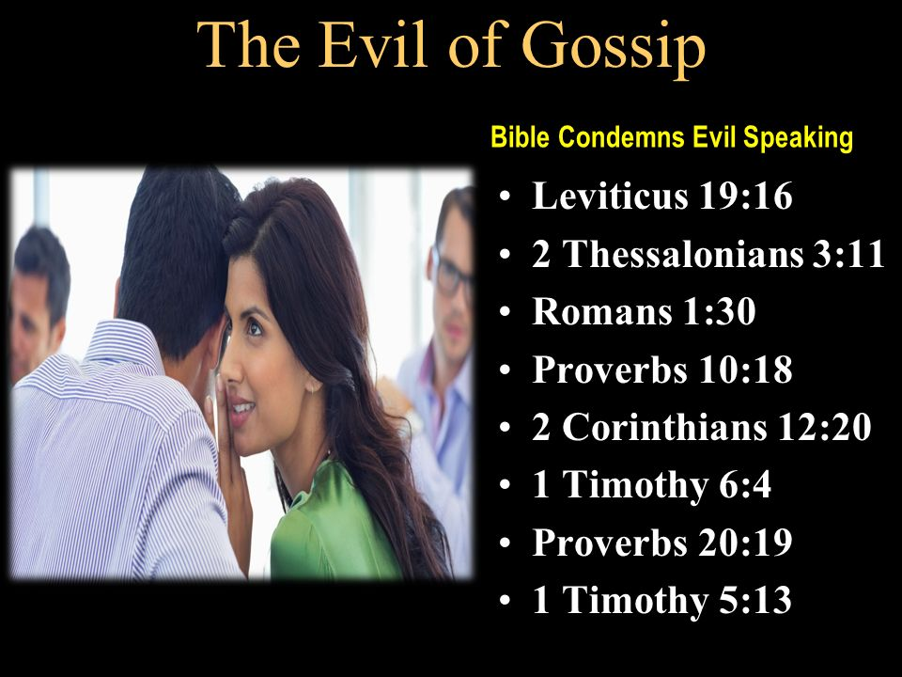While slander is unquestionably a sin what about using our minds to think and spread sensational and groundless talk about others? In Paul’s letter to Timothy he warns him of the young widows and their tendency to spread nonsense and controversial words (1 Timothy 6:4) about others inside the church (5:13).[20] Whether their intent was malicious or not their “gossip” or meddling in other people’s affairs had the tragic effect of not only wasting time but disrupting peace within the body of Christ.[21] Gossip is not only a sin (Proverbs 18:8; Leviticus 19:18; Romans 1:29-30; 2 Corinthians 12:20) because the “facts” spread are “absurd in comparison to the truth” [22] and therefore slanderous, but also because it betrays confidence in relationships (Proverbs 11:13, 20:19) and stirs up conflict in the church which God finds detestable in His sight (Proverbs 6:19)! As ones whom will give an account for every word spoken (Matthew 12:36-37) the “prudent hold their tongues” (Proverbs 10:10; Psalms 141:3), speaking only those words that edify and build up the body of Christ!

**How to Deal with Slander**

I want to finish this sermon by giving some practical advice on what to do when you are a victim of slander or gossip. First, let me say that my heart goes out to you for deceitful words of another easily break these “jars of clay” (2 Corinthians 4:7). While there are no steadfast list of rules on how to handle a slanderer, I find the following seven steps to be Biblical and helpful.

1. In the face of lying lips and deceitful tongues pray to the Lord for protection (Psalms 64:1-4; Psalms 31:14-20) and council (Psalms 120:1-2; Psalms 119:23).
2. Through meditation and prayer (Psalms 1:2) invite God to examine one’s own heart (Psalms 139:23) and confess (1 John 1:9) whatever words the perpetrator says that truthfully point out your sin.
3. In the face of slander and gossip pray that God would enable one to continue to love and not hate that person (Matthew 5:38-48; James 3:9-10).
4. If the words are minor overlook them (Colossians 3:13) and outright avoid foolish and stupid arguments that are intended to produce quarrels (2 Timothy 2:23-26).
5. If possible, go to the person and point out their fault one on one and if they wont listen take one or two others along and if they still wont listen tell it to the church (Matthew 18:15-19).
6. Watch and pray that God will enable you to live “such good lives” that even though they accuse you of doing wrong they might see your good deeds and glorify God (1 Peter 2:12, 15, 3:9) and feel shame for having wrongly accused you (Romans 12:20-21).
7. If the person is persecuting you because of your witness of Christ, then rejoice and thank God for great is your reward in heaven (Matthew 5:11-12; Acts 5:41).

While this list is far from complete, I want to leave you with one final thought: our minds were not fearfully and wonderfully made to slander and gossip about another but to build them up in the faith as one body of Christ!

1. Taken from the following website: <https://www.rickhanson.net/your-wonderful-brain/>
2. Taken from the following website: <https://mayfieldclinic.com/pe-anatbrain.htm>
3. Taken from the following website: <https://www.scientificamerican.com/article/computers-vs-brains/>
4. Taken from the following website: <https://faithhopeandpsychology.wordpress.com/2012/03/02/80-of-thoughts-are-negative-95-are-repetitive/>
5. Taken from the following website: <https://www.ncbi.nlm.nih.gov/pmc/articles/PMC3969807/>
6. Taken from the following website: <https://nypost.com/2017/11/08/americans-check-their-phones-80-times-a-day-study/>
7. Tremper Longman III, Peter Enns, and Mark Strauss, eds., [*The Baker Illustrated Bible Dictionary*](https://ref.ly/logosres/bakerillbbldctnry?hw=Slander&off=8&ctx=SLANDER+~Evil%2c+malicious+talk+or+lies+int) (Grand Rapids, MI: Baker Books, 2013), 1551.
8. Taken from the following website: <https://www.thefreedictionary.com/talebearing>
9. R.A. Torrey, [*The New Topical Text Book: A Scriptural Text Book for the Use of Ministers, Teachers, and All Christian Workers*](https://ref.ly/logosres/torreys?hw=Slander&off=13&ctx=Slander%0a1.+An~+abomination+to+God.+Pr+6:1) (Oak Harbor, WA: Logos Bible Software, 2001).
10. P. Ellingworth, [“Talebearing, Slander,”](https://ref.ly/logosres/nbd?ref=biblio.at%3dTalebearing%2c%2520Slander%7Cau%3dEllingworth%2c%2520P.%7Ced%3dWood%2c%2520D.%2520R.%2520W.%3bMarshall%2c%2520I.%2520H.%3bMillard%2c%2520A.%2520R.%3bPacker%2c%2520J.%2520I.%3bWiseman%2c%2520D.%2520J.&off=22&ctx=LEBEARING%2c+SLANDER.+~These+words+translat) ed. D. R. W. Wood et al., *New Bible Dictionary* (Leicester, England; Downers Grove, IL: InterVarsity Press, 1996), 1150.
11. Taken from the following website: <https://www.nydailynews.com/life-style/health/gossip-80-percent-conversations-experts-article-1.403005>
12. David E. Garland, [*Mark*](https://ref.ly/logosres/nivac62mk?ref=Bible.Mk14.53-65&off=649&ctx=under+rabbinic+law.+~A+hearing+in+the+mid), The NIV Application Commentary (Grand Rapids, MI: Zondervan Publishing House, 1996), 559.
13. Allen P. Ross, [“Proverbs,”](https://ref.ly/logosres/ebc05?ref=Bible.Pr6.17-19&off=2518&ctx=n+to+all+concerned.%0a~The+sixth+abominatio) in *The Expositor’s Bible Commentary: Psalms, Proverbs, Ecclesiastes, Song of Songs*, ed. Frank E. Gaebelein, vol. 5 (Grand Rapids, MI: Zondervan Publishing House, 1991), 935.
14. Miroslav Volf, *Exclusion and Embrace: A Theological Exploration of Identity, Otherness, and Reconciliation (*Nashville: Abingdon Press, 1996), 73.
15. Ibid., 36.
16. K. S. Ellis, [“Hatred,”](https://ref.ly/logosres/ndbt?ref=biblio.at%3dHatred%7Cau%3dEllis%2c%2520K.%2520S.&off=110&ctx=+(in+EDBT%2c+p.+326).+~This+is+a+fair+asses) ed. T. Desmond Alexander and Brian S. Rosner, *New Dictionary of Biblical Theology* (Downers Grove, IL: InterVarsity Press, 2000), 535.
17. John E. Hartley, [*Genesis*](https://ref.ly/logosres/bakerubot01ge?ref=Bible.Ge3.8-13&off=917&ctx=he+restricted+tree.+~Before+admitting+thi), ed. W. Ward Gasque, Robert L. Hubbard Jr., and Robert K. Johnston, Understanding the Bible Commentary Series (Grand Rapids, MI: Baker Books, 2012), 68.
18. Craig Brian Larson and Phyllis Ten Elshof, [*1001 Illustrations That Connect*](https://ref.ly/logosres/1001illconct?ref=Page.p+154&off=1785&ctx=ILLUSTRATION+270%0a~BITING+CANCER%0a%0aTopics:+) (Grand Rapids, MI: Zondervan Publishing House, 2008), 154–155.
19. Craig Brian Larson and Phyllis Ten Elshof, [*1001 Illustrations That Connect*](https://ref.ly/logosres/1001illconct?ref=Page.p+220&off=580&ctx=ILLUSTRATION+390%0a~YOUR+BIGGEST+SIN%0a%0aTopic) (Grand Rapids, MI: Zondervan Publishing House, 2008), 220.
20. Gordon D. Fee, [*1 and 2 Timothy, Titus*](https://ref.ly/logosres/nibcnt75ti?ref=Bible.1Ti5.13&off=1215&ctx=ouse+to+house%E2%80%9D+that+~they+are+involved+in), Understanding the Bible Commentary Series (Grand Rapids, MI: Baker Books, 2011), 122.
21. Gordon D. Fee, [*1 and 2 Timothy, Titus*](https://ref.ly/logosres/nibcnt75ti?ref=Bible.1Ti5.13&off=742&ctx=+others+as+well%2c+or+~whether+perhaps+it+i), Understanding the Bible Commentary Series (Grand Rapids, MI: Baker Books, 2011), 122.
22. Gordon D. Fee, [*1 and 2 Timothy, Titus*](https://ref.ly/logosres/nibcnt75ti?ref=Bible.1Ti5.13&off=1215&ctx=ouse+to+house%E2%80%9D+that+~they+are+involved+in), Understanding the Bible Commentary Series (Grand Rapids, MI: Baker Books, 2011), 122.