**God’s Word is Truth!**

**Psalms 119:1-8**

Online Sermon: <http://www.mckeesfamily.com/?page_id=3567>

Blessed are those who believe so strongly in God’s word being the truth that they are not only willing to meditate day and night on His statues but are also willing to become living sacrifices by walking in accordance to its precepts! Does this sound like the average church attendee? Living in a culture that has relegated truth to being nothing more than mere perceptions, created and deconstructed from one mind to the next; the truth concerning God has become lost in a sea of never-ending interpretations and outright modifications. To make Scripture more palatable to our spiritual digestive system most Christians either choose to interpret God’s word through “worldly eyes” or “tear out” the parts of God’s word that says the way they are living is a sin! We should not be surprised when some Christians reject parts of God’s word for, we are living in the predicted age when people no longer put up with sound doctrine (2 Timothy 4:3-4)! More than ever the church needs apologetics to preach and teach that all of Scripture has and always will be God-breathed and therefore true (2 Timothy 3:16)! The first part of this sermon series is going to discuss why God’s word is absolute truth and the second part is going to give a warning to those who chose to “tear out” commands they refuse to obey!

**Part 1: Absolute Truth**

Is the Bible absolute truth? While the Bible answers some of life’s foundational questions such as who created the universe? why am I here? and what will happen to me when I die? this does not mean that the Bible is accepted as truth for most people. Those who outright reject the Bible as being absolute truth do so for a variety of reasons:

1. **Oral Tradition**. The Bible is a collection of writings that span over 3,500 years.[1] If one believes the Pentateuch was written by Moses, critics argue that his knowledge of events way before his time must have been received by oral tradition and as such would not be accurate.
2. **Sin of the Writers**. Since the Bible is written by human authors whom all sin (Romans 3:23). Who is to say their sin did not taint what they wrote?
3. **Contradictions**. There are contradictions in the Bible so how can it represent truth when it contradicts itself?
4. **No Original Manuscripts**. Since there are no original manuscripts then how can one be certain the word of God accurately represents the events it describes?
5. **Translations**. The Bible has been translated so many times over the centuries how can one know with certainty it has not been altered to fit modern times?

To prove that the Bible is 100 % truth to the critics of this world lets put the Bible to the test by

1) determining if there are multiple voices and textual agreement of the sources of the Bible and 2) close proximity of time in which these sources are written to the actual events, and 3) the predictability of events.

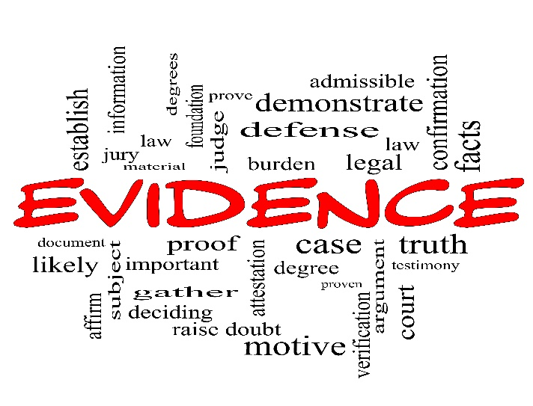When we receive a document claiming to know what happened in the past it must first pass rigorous tests to prove its claim for authenticity. Often, we view history as being the exact representation of an event written down to be forever preserved in time. This certainly is not the case. Ever have two people experience the exact same event and come out with completely different details? Or have an event occur but only parts are remembered? Ever hear someone falsify details of an event for their own selfish reasons? Unless we can time travel back in time and see the entire event for ourselves then how can we know for certain any historical document is true?

History truthfully is merely the reconstruction of an event based on those details that have the highest probability of occurrence.

1. The probabilities are increased when the evidence is collected from more than one reliable source. When multiple sources give the exact same details, this increases the probability that they in fact occurred.
2. Also, those sources that were written closest to the event are deemed more credible because the longer times goes on before one writes the more that is forgotten.

These two criteria: agreement between multiple sources and proximity of time that the event occurred and when it was written; is the criteria historians use to prove a manuscript authentic or a fake.

**Multiple Sources**

The Bible has multiple sources each of which contain text in agreement with our written Bible today.

1. **Papyri**. Manufactured in Egypt as far back as the 4th century BC, the Egyptians took the papyri plant and made sheets to write on. They took the inner pith and overlapped it, then soaked and pounded the plant material into sheets. The sheets are then pressured dried. Paper was not invented until about 100 BC and not in wide circulation until much later. The oldest source comes from writing done on the Papyri plant in the 2nd Century. We have 86 pieces of Papryi plant with either a single or multiple verses written on them. As you can see, one of the negative things about this form of writing is that the plant material degrades over time making it very hard to read something written almost 2000 years ago.
2. **Leather**. Obviously taken from animal skins and was called Uncials. It is much easier to read these documents because they tend to stand the test of time better. We have approximately 274 of these sources.
3. **Minuscules**. Were written in cursive or long hand writing. They are called minuscule because they only contain a very small part of the overall text of the body in which they represent. For instance, the above minuscule is from the book of James but is a single verse 4:15. We have 2795 of these.
4. **Lectionaries**. These were worship guides that contained passages of Scripture. We have 2209 of these.
5. **Full Manuscripts**. Full manuscript of the New Testament. The Vaticanus was written in the 4th Century. There were two others: the Sinaiticus written in the 4th century as well and the Alexadrinus written in the 5th century.

According to the authors of God’s Not Dead there are over 20,000 manuscripts that make up the base of the Bible. Substantial evidence but is it enough to say it is reliable? Ancient historical books such as Plato, Caesar, Pliny, Euripes, Tacitus, Herodutus have 20 sources or less! Only Sophocles has 193 and Aristotle has 49. In other words, the evidence from a source perspective is OVERWHELMING!

**Textual Consistency**

Many will attack the credibility of the Bible on the bases of textual discrepancies. Several such instances:

1. the number of arms-bearing men in Judah and Israel (cf. 2 Samuel 24:9 **(800,000 men)** to 1 Chronicles 21:5 **(1,100,00 men)**
2. the number of Syrian charioteers slain by David (cf. 2 Samuel 10:18 **(700)** to 1 Chronicles 19:18 **(7000)**
3. Number of stalls Solomon had 1 Kings 4:26 **(40,00)** and 2 Chronicles 9:25 **(4000)**
4. the number of baths in the "molten sea" (cf. 1 Kings 7:23,26 **(2000)** to 2 Chronicles 4:5 **(3000)**

There were also date discrepancies: such as when was Jesus born 4 BC (Matthew 2:1) or 6 AD (Luke 2:14). Secular Web gives 101 inconsistencies but when I looked up debate.org I found 101 of them answered with logical reasons. For instance, the arms-bearing men in Judah and Israel could be explained by stating Samuel only included men ready for battle whereas the Chronicler might have included all men who were of age to fight weather they were ready or not.

The author’s of God’s not Dead cited 40 lines of Scripture that are in doubt but none of them affect our doctrine. The Bible is not meant to be purely a historical document or even a scientific one. Most universities no longer make the claim that the Bible is inerrant due to the above discrepancies. It is meant to be a love letter from God to us. When it comes to our Baptist denomination: the following is held as true: Scripture is infallible in matters of faith and practice. Even with the 40 variations the Bible is still 98 % accurate by secular thinking. My personal stance is the Bible is inerrant when one gives leeway for the culture in which various writings were written.

**Textual Consistency**

The Bible translations range from word for word for those who want a literal translation, to thought for thought to a complete paraphrase of the original text. All these translations merely exist to make the word of God easier to understand. The Bible was written predominately in three languages: Hebrew, Greek an Aramaic. It was written by many authors and over centuries of time. So, for us today to read the original text in say either Hebrew, mostly the OT, Aramaic or Greek, the NT; would be very difficult because we would have to learn these languages and the dialect in which they were written. Words today have different 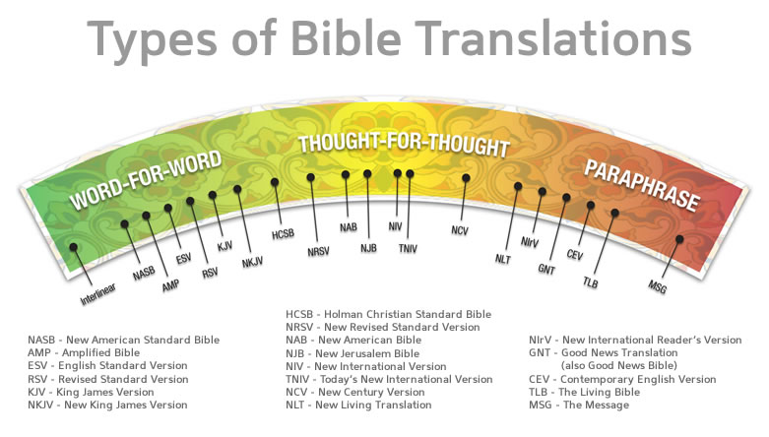meanings than they did in the past. Today we speak with many culturally specific nuances: for example, know anyone who speaks chiac? This is a language mixed heavily in French with English words. Very hard to understand. Can you imagine someone reading Chiac 500 years from now? What would they understand? It would have to be translated into modern language to be understood.

This is what the translators of the Bible have done. The Bible has been translated not to synthesize writings with modern day culture, but to make it understandable. If anyone was to change the details of the Bible in a translation, they would be immediately challenged by our Hebrew, Greek and Aramaic scholars who have access to the original languages and know the nuances of said texts. If found to be a false translation, then they would deem it as such, and it would be thrown out as being illegitimate.

**Close Proximity**

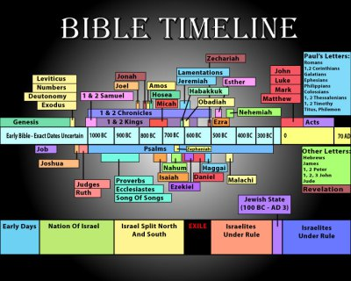**Theory**: Documents that are written much later after an event has occurred are less likely to contain all the details of the event and are more prone to including factual errors. The question is: how long after the events occurred was the Bible written? This is a complicated question. First, lets look at the books of the Bible. Let’s look at both Testaments and the evidence.

**Old Testament (OT).** The most difficult criticism to handle comes from the writing of the Pentateuch – Genesis, Exodus, Leviticus, Numbers and Deuteronomy. If Moses was the author of the Pentateuch, which I believe he was, then it would have been written around 1300 Bce. In other words, Moses wrote about events that happened millenniums or thousands of years before his time. Does this mean it fails the test of having been written close in time to the events it describes? The answer is no because the question is flawed. The way in which people communicated history before writing was through what is called oral tradition. People would memorize mass details of events and pass those details down from one generation to the next. The atheists at this point of course would object. Anytime you tell a secret from one person to the next the details get distorted. Also, time tends to make us forget many details and specifics of events. The problem with this kind of thinking is that it projects our modern ability to remember onto a past culture. Historians have found that oral tradition is remarkably accurate. In ancient times people were able to pass down information impeccably because they learned how to memorize and recite massive amounts of information. We today have lost this ability because writing is assumed to be a superior form of communication. Atheists have to be very careful to not throw out oral tradition because a lot of our history before writing comes to us in this form. So if they throw out the OT because the sources are written extremely late after they occurred then a lot of history has no evidence as well. Surprisingly, the Pentateuch was almost unanimously considered divine and accurate at the time of its writing and the Old Testament was accepted as God’s word by 90 AD whereas the New Testament took much longer.

**New Testament (NT).** Most of the books were written within 70 years after Jesus’ death. This means there would be many eye witnesses alive that could refute the NT if it contained false data. This of course does not mean the NT was not contested. It took over 200 years for the early Christians to agree on the 27 books that should be included in the NT Cannon of Scripture. Right after Jesus’ returned to heaven many authors wrote books and claimed that they represented the life of Jesus. Many tried to taint the reputation of Christ by ascribing to Him false beliefs. For instance, Gnosticism that was predominant in Paul’s time, was written down in a book called the Gospel of Thomas. Most of this book agrees with Scriptures but some of it is radically different. Gnostics believed that each of us has a divine spark within us and when we receive the secret knowledge of the Gnostics the spark can be freed to return to God as part of Him. In response to so many radical beliefs being attributed to Christ believers decided to canonize their beliefs according to the following criteria: the writing must be part of Jesus’ teachings, the writing must come from a primary witness such as an apostle, and the teachings must be proven as acceptable to the churches whom agreed they were authentic. Remarkably these criteria are the same that people use today to evaluate the authenticity of historical documents. How does the NT compare to other documents? For example, Homer’s Iliad was written approximately 500 years after the events it wrote happened. Conversely, one NT piece – John 18 – is dated within 25 years of the events of Christ.

**Predictability of Events**

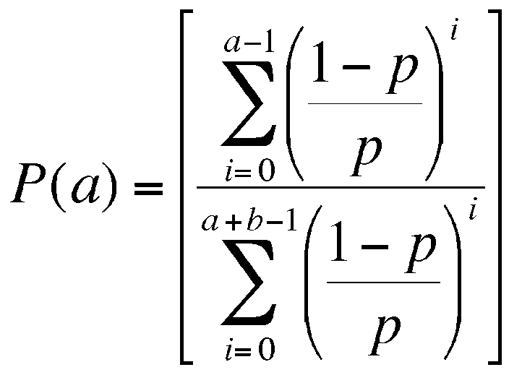The Bible is far from just a historical document; it is a supernatural one as well. The atheists ask: how do you know that the writers of Bible who had sin in their lives not taint the very words they wrote? Peter answered this question in 2 Peter 1:21: “For prophecy never had its origin in the human will, but prophets, though human, spoke from God as they were carried along by the Holy Spirit.” This does not mean that the writers were mere stenographers. After all, we only have to look at the books of the Bible to find many different styles of writing were employed. While the writers had freedom in linguistic style, they did not have freedom to alter the message from God! 2 Timothy 3:16-17 states “All Scripture is inspired by God and profitable for teaching, for reproof, for correction, for training in righteousness so that the man of God may be adequate, equipped for every good work.” Amen

The Bible stands so much taller than any other writing because of the inspiration of God who gave us predictions that are 100 accurate of events. According to The Encyclopedia of Biblical Prophecy there are 1,239 prophecies in the OT and 578 prophecies in the NT. While our time does not permit us to review all the prophecies that were have been fulfilled, I do want to focus on those pertaining to our Lord Jesus Christ. For instance, Isaiah 7:14 states the Messiah would be a virgin, Micah 5:2 states the Messiah would be born in Bethlehem, Zechariah 11:12-13 states the Messiah would be betrayed for 30 shekels of silver and Psalms 22:12-18 describes the death of the Messiah. Jesus fulfilled all of these prophecies and over 300 more! Let’s look at the probability of a person meeting just 8 of the prophecies attributed to the Messiah: The number is 1 in 100 quadrillion! These events were predicted hundreds of years before they occurred! To fulfill all 300 prophecies is a statistical impossibility. There has not been a single prophecy in all the Bible that has been proven to be false! No other book can even come close to making such a statement. **Obviously, the Bible is a supernatural document!**

**Part 1: Obedience**

If we truly believe that God’s word is 100 % accurate and absolute truth, then why are we not willing to become living sacrifices by meditating and obeying every single word? Let’s look at what the Psalmist says about God’s word in chapter 119:1-9:

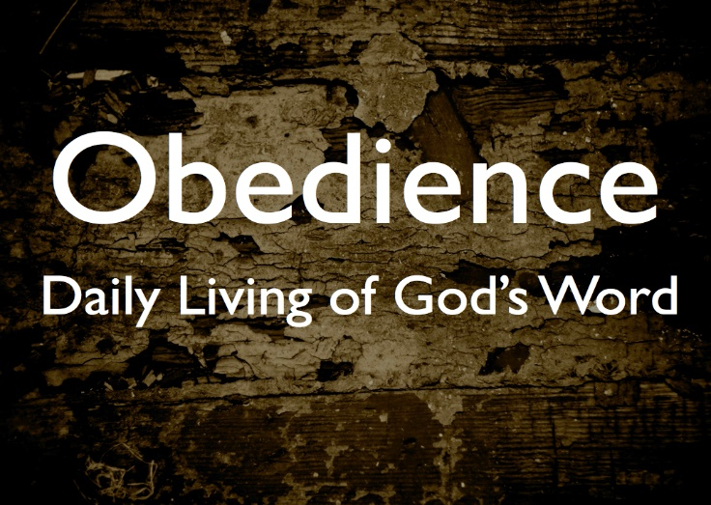**1Blessed are those whose ways are blameless, who walk according to the law of the Lord. 2Blessed are those who keep his statutes and seek him with all their heart — 3they do no wrong but follow his ways. 4You have laid down precepts that are to be fully obeyed. 5Oh, that my ways were steadfast in obeying your decrees! 6Then I would not be put to shame when I consider all your commands. 7I will praise you with an upright heart as I learn your righteous laws. 8I will obey your decrees; do not utterly forsake me.**

God’s word is like a treasure or a pearl (Matthew 13:44-45) to the Psalmist, for contained within its pages is the “complete and perfect expression of the will of God!”[2] The Psalmist does not look at the Bible through worldly glasses only to tear out anything that does not conform to his sinful desires, but instead chooses to see and obey the entirety of God’s laws so that he might become blameless in God’s sight![3] While the Psalmist is fully aware that he cannot become sinless, his desire to be a person of integrity through submission and obedience,[4] never waivers for he truly wants to praise God with an upright heart! Like the Psalmist do we believe that God’s word is absolute truth?

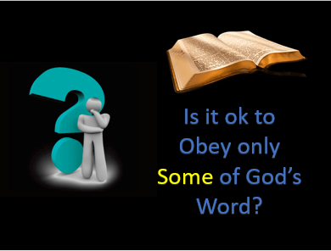 I want to finish the first part of this series with a challenge. Having 22 stanzas of eight verses each,[5] Psalms 119 is one of the longest chapters in the entire Bible.[6] In this acrostic poem one hears the words of the psalmist whose absolute devotion to God can be found in his recitation and obedience.[7] At least 171 out of the 176 verses in Psalms 119 explicitly refers to “the precepts, word, laws, commandants, or degrees of God” from one central theme: the key to happiness can be found in knowing and conforming to the laws of God![8] I want to challenge you this week to read this chapter at least once a day. Each time you read the chapter make a mental note of the absolute trust the Psalmist has in every single word that came from God and then ask yourself these questions: have I rejected some of God’s word and if so, why is my view of Scripture so much lower than that of the Psalmist? Also play close attention to what extent has your culture influenced your perception of God’s word as the key to be blessed in His eyes. The answers to these questions will lay the foundation for the next part of this sermon series that is going to talk about all the pages we have ripped out of Scripture.

1. Taken from the following website: <https://www.biblica.com/resources/bible-faqs/when-was-the-bible-written/>
2. Robert G. Bratcher and William David Reyburn, [*A Translator’s Handbook on the Book of Psalms*](https://ref.ly/logosres/ubshbk19?ref=Bible.Ps119.1-3&off=395&ctx=or%2c+manner+of+life.+~The+word+blameless+(), UBS Handbook Series (New York: United Bible Societies, 1991), 998.
3. Matthew Henry, [*Matthew Henry’s Commentary on the Whole Bible: Complete and Unabridged in One Volume*](https://ref.ly/logosres/mhenry?ref=Bible.Ps119.1-3&off=780&ctx=+of+the+Lord%2c+v.+1.+~God%E2%80%99s+word+is+a+law+) (Peabody: Hendrickson, 1994), 914.
4. Willem A. VanGemeren, [“Psalms,”](https://ref.ly/logosres/ebc05?ref=Bible.Ps119.1-8&off=35&ctx=rophe+(119:1%E2%80%938)%0a1%E2%80%938+~The+blessing+of+God+) in *The Expositor’s Bible Commentary: Psalms, Proverbs, Ecclesiastes, Song of Songs*, ed. Frank E. Gaebelein, vol. 5 (Grand Rapids, MI: Zondervan Publishing House, 1991), 738–739.
5. Willem A. VanGemeren, [“Psalms,”](https://ref.ly/logosres/ebc05?ref=Bible.Ps119&off=44&ctx=d%E2%80%99s+Law+in+Distress%0a~The+longest+psalm+in) in *The Expositor’s Bible Commentary: Psalms, Proverbs, Ecclesiastes, Song of Songs*, ed. Frank E. Gaebelein, vol. 5 (Grand Rapids, MI: Zondervan Publishing House, 1991), 736.
6. D. A. Carson, ed., [*NIV Zondervan Study Bible: Built on the Truth of Scripture and Centered on the Gospel Message*](https://ref.ly/logosres/nivzndrvnstbbl?ref=Bible.Ps119&off=114&ctx=n+permeates+Ps+119.+~Almost+every+verse+o) (Grand Rapids, MI: Zondervan, 2015), 1147.
7. Willem A. VanGemeren, [“Psalms,”](https://ref.ly/logosres/ebc05?ref=Bible.Ps119&off=369&ctx=oppression+of+evil.+~He+has+been+surround) in *The Expositor’s Bible Commentary: Psalms, Proverbs, Ecclesiastes, Song of Songs*, ed. Frank E. Gaebelein, vol. 5 (Grand Rapids, MI: Zondervan Publishing House, 1991), 736.
8. James Montgomery Boice, [*Psalms 107–150: An Expositional Commentary*](https://ref.ly/logosres/boicecm19cps?ref=Bible.Ps119&off=4469&ctx=32+mean+God%E2%80%99s+Word.+~Whatever+the+case%2c+a) (Grand Rapids, MI: Baker Books, 2005), 971.