**A Gift for the Dogs**

**Matthew 15:21-28**

Online Sermon: <http://www.mckeesfamily.com/?page_id=3567>

Merry Christmas! O how this phrase rolls off our tongues this time of year! Just hearing the word “Christmas” can instill in our mind wonderful thoughts of turkey, ham, potato, dressing, cranberry, eggnog and all you can eat puddings, doughnuts, fruitcakes, pumpkin, mince, apple, cherry and lemon pies! It is not just the food we eat that makes Christmas joyous but also the heart-felt hugs and sharing of life’s stories with family and friends that brings a smile to our faces and warms the cackles of our hearts! Despite the positive thoughts there are also negative ones that we have at Christmas as well. What also comes to our minds is the hustle and bustle of trying to “fit” everyone into our visitation schedule, the insufferable car jambs and the never-ending search to find the “right” gifts while we tolerate the pushy and down right rude shoppers in our way! And still for others this season Christmas promotes feelings of inadequacy and injustice amongst the poor of our world.

As I describe these mixed feelings relating to this time of year and I can’t help but wonder if the word “Christmas” has become a “worldly” buzzword that rolls off our tongues, devoid of its true meaning! We casually say “merry Christmas” to those that we meet but rarely are we thinking about nor do we promote Christ laying in a manger. We spend countless hours trying to find the best gifts money can buy in hopes of impressing our family and friends and yet we leave at the foot of the cross nothing more than platitudes of indifference as we hurry by to visit elsewhere! Does not our Creator and Savior deserve our very best gift? While in His sovereignty Jesus needs nothing from us, the gift He wants is our love and allegiance. This first of a four-part sermon series is going to review the story of the Canaanite woman and in doing so reveal the first step in reclaiming the true meaning of Christmas is to remember and share the gift us “dogs” got from Jesus that first Christmas!

**Knowing our Status and Mission**

**21Leaving that place, Jesus withdrew to the region of Tyre and Sidon. 22A Canaanite woman from that vicinity came to Him, crying out, “Lord, Son of David, have mercy on me! My daughter is demon-possessed and suffering terribly.”**

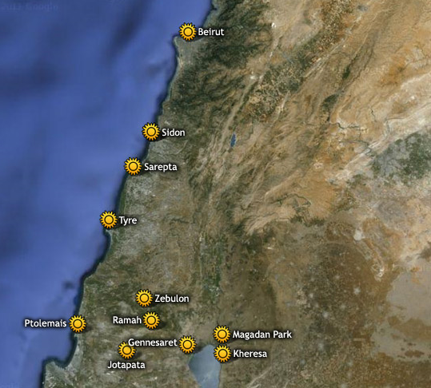 When Jesus left the Jewish region of Gennesaret (14:34)[1] He traveled between thirty to fifty miles to the region of Tyre and Sidon.[2] While some believe Jesus was merely seeking a retreat from the pressures of controversy with the Scribes and Pharisees[3] and the draining effect of ministering to large crowds,”[4] the length of this journey (perhaps months) [5] more likely points to Jesus’ motive was to evangelise the Gentiles. Shortly after Jesus gets to the border of Tyre and Sidon[6] a Canaanite woman from the region went out and met Him where He was ministering[7] and asked Him to heal her daughter who was demon possessed and suffering greatly! This was a remarkable request considering she was part of a race that goes back to 3000 BC[8] who were “sworn enemies of Israel,” [9] full of idolatry,[10] unclean and therefore presumed by Jews and most Gentiles to be outside of Messianic blessings![11] The significance of these first two verses is that they represent the “beginning of the end of all barriers to whom the Gospel message would be preached.”[12]

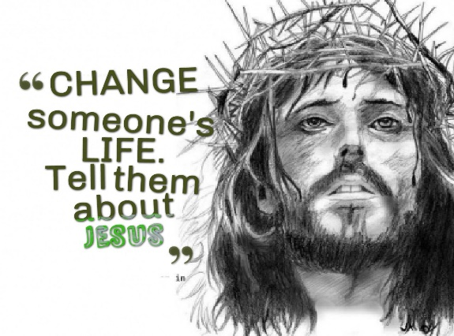This brings me to my first point: to effectively promote Christ lying in a manger we must be willing to go and tell the world that the mercy we have received has been offered to them as well, regardless of whom they are (Matthew 28:16-20)! It simply is not enough to merely give Jesus platitudes or symbols of allegiance by attending a church service or two at Christmas. Jesus wants our hearts to remember and offer the comfort that we have received (2 Corinthians 1:3-5) when we went from being Gentiles outside of the promise with no hope (Ephesians 2:12-13) to being grafted into His family (Romans 11:11-24)! We must not only be ready to give the reasons why we have hope in Christ (1 Peter 3:15) we must GO and make disciples of all nations when ever and where ever asked! The unbelievers in this world are entangled by sin (Hebrews 12:1, 2 Peter 2:20) and are suffering greatly! They desperately need Christians to see the image of God in them (Genesis 1:27) and care enough to point them to His mercy, even though they do not deserve it any more than we did (Ephesians 2:8-9)! We need an attitude adjustment, one that goes from being indifferent to Christmas to one that is so overwhelmed with the mercy we have received that we compelled to share Christ with the world!

 This brings me to my second point: a world that is suffering needs to know Jesus! For the one in ten teenagers and young adults that have depression in Canada,[13] the 80 percent of this world living on less than $10 a day,[14] the 24 people per minute that are victims of rape or physical violence,[15] the 125,000 Canadians that just filed for bankruptcy,[16] and for the 1.7 million people in the United States that just got diagnosed with cancer; in the midst of their suffering they need to know there is hope! The need to know that the Great Physician, Jesus who is sovereign over all things seen and unseen (Colossians 1:16) can heal their broken minds, bodies and souls! Instead of ignoring their cries for mercy this Christmas, by continuing to “walk on the other side of their street,” we need to be Good Samaritans by first feeding, clothing and comforting them (James 2:14-18) and then by telling them that they too can join the kingdom of God (John 3:16) and someday get to go to heaven where there is no more sorrow, death, pain or injustice (Revelation 21:1-8)! Until that day Jesus will send a Comforter to teach them the truth concerning God (John 14:26) and will give them living waters (John 4:4-26) that will flow inside and in turn give them unspeakable joy (1 Peter 1:8)!

**Relying on God for a Harvest**

**23Jesus did not answer a word. So, His disciples came to Him and urged Him, “Send her away, for she keeps crying out after us.” 24He answered, “I was sent only to the lost sheep of Israel.” 25The woman came and knelt before Him. “Lord, help me!” she said.**

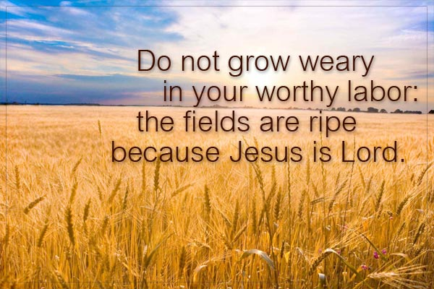 My third point is that in proclaiming the true meaning of Christmas we are to rely on God for the harvest. In response to Jesus’ initial silence, the disciples[17] request to quickly send her away[18] because she was a nuisance[19] and an ancient enemy undeserving of grace[20] and Jesus’ statement that He only came for the lost sheep of Israel; the Canaanite woman knelt and claimed Jesus to be her Lord. When we sheep proclaim Christ amongst the wolves of this world (Matthew 10:16) we are to be ready to be persecuted for righteousness sake (Matthew 5:10)! If having our words fall upon the grounds of indifference was not hurtful enough, we be must be prepared to hear and witness the hatred (John 15:18-25) that many of this world have towards the Light because it exposes their evil deeds (John 3:20). We must also be ready when planting seeds of righteousness to only hear “silence” as to when and if they will bear fruit! In face of the inevitable hardships of sharing the Good News at Christmas, we are to remain steadfast in our faith that the Lord of all will ripen the fields in His time and manner!

**Having the Faith of a “Dog”**

**26He replied, “It is not right to take the children’s bread and toss it to the dogs.” 27“Yes it is, Lord,” she said. “Even the dogs eat the crumbs that fall from their master’s table.”**

My fourth point is that to be effective in telling others about the true meaning of Christmas we must have faith that they can be saved! With compassion in His eyes that would have “robbed His words of all insult and bitterness,” [21] Jesus asked the Canaanite woman if it was right to take the covenantal blessings of God’s children and give them to the infidel, Gentile dogs?[22] While she agreed with Jesus that the children of Israel have priority[23] and therefore should be fed first,[24] surely a sovereign God has a crumb left over for those whom have a recognized place in His house[25] and under His care?[26] In believing that Jesus was the Lord of both His own and the other sheep (John 10:16), she passed Jesus’ test of her faith![27] Like the Canaanite woman when we go out into this world to proclaim the Good News we must have faith that the Master has barred no one from entrance into His kingdom. Even though there is no one righteous (Romans 3:10-18) anyone can receive a crumb of the bread of life (John 6:35) from the Master’s table and be saved!

**Expect a Miracle at Christmas**

**28Then Jesus said to her, “Woman, you have great faith! Your request is granted.” And her daughter was healed at that moment.**

The final point is to expect a miracle at Christmas! Due to her “indomitable persistence springing from an unconquerable hope”[28] and faith in Jesus,[29] the Canaanite woman’s request was granted, and her daughter was healed! To keep the phrase “Merry Christmas” from becoming a buzzword that rolls off our tongues, devoid of its true meaning; we as Christians must learn to bow our knees to our Lord and prepare for Him the very best gift we have to offer, our A sunset over a body of water
allegiance! While the food and visitation of the season are to be sought after so are the unbelieving souls that suffer without knowing their Savior! While sharing this message will often be met with indifference or hostility, we must have faith that those who take a crumb from the Master’s table will be miraculously and eternally changed! So, I start off this Christmas series with a plea that we might get our attitudes adjusted to be submissive to Jesus as Lord and in doing so share the comfort we have received to all who ask why we have hope!

1. Michael J. Wilkins, [*Matthew*](https://ref.ly/logosres/nivac61mt?ref=Bible.Mt15.21&off=44&ctx=le+regions+(15:21).+~Jesus+may+have+staye), The NIV Application Commentary (Grand Rapids, MI: Zondervan Publishing House, 2004), 538.
2. Barclay Moon Newman and Philip C. Stine, [*A Handbook on the Gospel of Matthew*](https://ref.ly/logosres/ubshbk61?ref=Bible.Mt15.21&off=575&ctx=sus+landed+(14:34).%0a~Tyre+and+Sidon+were+), UBS Handbook Series (New York: United Bible Societies, 1992), 492.
3. Leon Morris, [*The Gospel according to Matthew*](https://ref.ly/logosres/pntcmatt?ref=Bible.Mt15.21&off=85&ctx=m+where+he+made+his+~exit.+Perhaps+he+had), The Pillar New Testament Commentary (Grand Rapids, MI; Leicester, England: W.B. Eerdmans; Inter-Varsity Press, 1992), 401.
4. R. T. France, [*Matthew: An Introduction and Commentary*](https://ref.ly/logosres/tntc61mtus?ref=Bible.Mt15.21-22&off=46&ctx=wals%E2%80%99%2c+see+on+4:12.+~This+brief+visit+to+), vol. 1, Tyndale New Testament Commentaries (Downers Grove, IL: InterVarsity Press, 1985), 249.
5. James Montgomery Boice, [*The Gospel of Matthew*](https://ref.ly/logosres/boicecm61amt?ref=Bible.Mt15.21-39&off=2420&ctx=fied+in+detail%2c+but+~Tyre+was+about+twent) (Grand Rapids, MI: Baker Books, 2001), 288.
6. D. A. Carson, [“Matthew,”](https://ref.ly/logosres/ebc08?ref=Bible.Mt15.21&off=432&ctx=s+us+to+ask+whether+~Jesus+actually+enter) in *The Expositor’s Bible Commentary: Matthew, Mark, Luke*, ed. Frank E. Gaebelein, vol. 8 (Grand Rapids, MI: Zondervan Publishing House, 1984), 354.
7. Robert H. Mounce, [*Matthew*](https://ref.ly/logosres/nibcnt61mt?ref=Bible.Mt15.22&off=14&ctx=hore.%0a15:22+%2f+Came:+~Gk.+exelthousa+does+), Understanding the Bible Commentary Series (Grand Rapids, MI: Baker Books, 2011), 155.
8. Leon Morris, [*The Gospel according to Matthew*](https://ref.ly/logosres/pntcmatt?ref=Bible.Mt15.22&off=139&ctx=s+about+to+narrate.+~She+was+a+Canaanite%EF%BB%BF), 401.
9. John Nolland, [*The Gospel of Matthew: A Commentary on the Greek Text*](https://ref.ly/logosres/nigtcmt?ref=Bible.Mt15.22&off=210&ctx=ced+later+in+7:26).+~The+choice+of+%E2%80%98Canaa), New International Greek Testament Commentary (Grand Rapids, MI; Carlisle: W.B. Eerdmans; Paternoster Press, 2005), 631–632.
10. Craig S. Keener, [*Matthew*](https://ref.ly/logosres/ivntcmat?ref=Bible.Mt15.21&off=714&ctx=ent+Canaanites%2c+the+~bitter+biblical+enem), vol. 1, The IVP New Testament Commentary Series (Downers Grove, IL: InterVarsity Press, 1997), Mt 15:21.
11. Craig A. Evans, [*The Bible Knowledge Background Commentary: Matthew–Luke*](https://ref.ly/logosres/bkbc61mt?ref=Bible.Mt15.22&off=642&ctx=lical+associations.+~This+is+a+person+tha), ed. Craig A. Evans and Craig A. Bubeck, First Edition. (Colorado Springs, CO: David C Cook, 2003), 309.
12. James Montgomery Boice, [*The Gospel of Matthew*](https://ref.ly/logosres/boicecm61amt?ref=Bible.Mt15.21-39&off=3138&ctx=ithout+meaning%2c+and+~William+Barclay+is+c) 288.
13. Taken from the following website: <https://www.cbc.ca/news/health/depression-suicidal-thoughts-1.3940621>
14. Taken from the following website: <http://www.globalissues.org/article/26/poverty-facts-and-stats>
15. Taken from the following website: <https://www.thehotline.org/resources/statistics/>
16. Taken from the following website: <https://bankruptcy-canada.com/bankruptcy/bankruptcy-canada-statistics/>
17. The commentaries do not agree as to whether the disciples wanted Jesus to grant her request and heal the woman’s daughter. I believe in the context of the verse that either they wanted a quick healing to get rid of her or just wanted Jesus to send her away. The commentaries provide evidence for both possibilities.
18. Robert H. Mounce, [*Matthew*](https://ref.ly/logosres/nibcnt61mt?ref=Bible.Mt15.21-28&off=1132&ctx=s+does+not+respond.+~The+disciples+come+t), 152.
19. Leon Morris, [*The Gospel according to Matthew*](https://ref.ly/logosres/pntcmatt?ref=Bible.Mt15.23&off=296&ctx=no+reason+for+this.+~His+disciples+appare), 402.
20. D. A. Carson, [“The Gospels and Acts,”](https://ref.ly/logosres/nivzndrvnstbbl?ref=Bible.Mt15.23&off=6&ctx=+for+healing.%0a15:23+~The+disciples+reflec) 1962.
21. James Montgomery Boice, [*The Gospel of Matthew*](https://ref.ly/logosres/boicecm61amt?ref=Bible.Mt15.21-39&off=7198&ctx=a+disarming+smile.%E2%80%A6+~We+can+be+quite+sure) 289.
22. Ibid.
23. John Nolland, [*The Gospel of Matthew: A Commentary on the Greek Text*](https://ref.ly/logosres/nigtcmt?ref=Bible.Mt15.26&off=1248&ctx=+and+the+transition+~to+v.+27+easier+if+t), 634.
24. D. A. Carson, [“Matthew,”](https://ref.ly/logosres/ebc08?ref=Bible.Mt15.26&off=345&ctx=+(rightly+Bonnard).+~The+question+is+one+) 355.
25. Leon Morris, [*The Gospel according to Matthew*](https://ref.ly/logosres/pntcmatt?ref=Bible.Mt15.27&off=593&ctx=is+spread%2c+and+that+~the+dogs+eat+what+fa), 405.
26. Michael J. Wilkins, [*Matthew*](https://ref.ly/logosres/nivac61mt?ref=Bible.Mt15.22-28&off=3736&ctx=rsists.+In+a+sense%2c+~Jesus+is+testing+her), 540.
27. James Montgomery Boice, [*The Gospel of Matthew*](https://ref.ly/logosres/boicecm61amt?ref=Bible.Mt15.21-39&off=4966&ctx=%E2%80%99s+telling+her+that+~his+commission+reach) 289.
28. Robert H. Mounce, [*Matthew*](https://ref.ly/logosres/nibcnt61mt?ref=Bible.Mt15.21-28&off=3557&ctx=aughter+was+healed.+~The+persistence+of+t), 153.
29. Leon Morris, [*The Gospel according to Matthew*](https://ref.ly/logosres/pntcmatt?ref=Bible.Mt15.28&off=711&ctx=is+interesting+that+~Jesus+does+not+comme), 405–406.