**The Meaning of Life**

**Ecclesiastes 1:1-11, Matthew 21:18-27**

Online Sermon: <http://www.mckeesfamily.com/?page_id=3567>

“Mother Teresa was born in 1910 in Skopje, the capital of the Republic of Macedonia. Little is known about her early life, but at a young age, she felt a calling to be a nun and serve through helping the poor. At the age of 18, she was given permission to join a group of nuns in Ireland. After a few months of training, with the Sisters of Loreto, she was then given permission to travel to India. On her arrival in India, she began by working as a teacher; however, the widespread poverty of Calcutta made a deep impression on her, and this led to her starting a new order called “The Missionaries of Charity”. The primary objective of this mission was to look after people, who nobody else was prepared to look after. Mother Teresa felt that serving others was a fundamental principle of the teachings of Jesus Christ. She often mentioned the saying of Jesus, “Whatever you do to the least of my brethren, you do it to me.”

She experienced two particularly traumatic periods in Calcutta. The first was the Bengal famine of 1943 and the second was the Hindu/Muslim violence in 1946, before the partition of India. In 1948, she left the convent to live full-time among the poorest of Calcutta. She chose to wear a white Indian sari, with a blue border, out of respect for the traditional Indian dress. For many years, Mother Teresa and a small band of fellow nuns survived on minimal income and food, often having to beg for funds. But, slowly her efforts with the poorest were noted and appreciated by the local community and Indian politicians.

In 1952, she opened her first home for the dying, which allowed people to die with dignity. Mother Teresa often spent time with those who were dying. Some have criticized the lack of proper medical attention, and their refusal to give painkillers. Others say that it afforded many neglected people the opportunity to die knowing that someone cared. Her work spread around the world. By 2013, there were 700 missions operating in over 130 countries. The scope of their work also expanded to include orphanages and hospices for those with terminal illnesses.

Mother Teresa became known as a great saint and received the following awards: The first Pope John XXIII Peace Prize. (1971), Kennedy Prize (1971), The Nehru Prize –“for the promotion of international peace and understanding”(1972), Albert Schweitzer International Prize (1975), The Nobel Peace Prize (1979), the States Presidential Medal of Freedom (1985), Congressional Gold Medal (1994), U Thant Peace Award (1994) and Honorary citizenship of the United States (November 16, 1996).”[1]

**The Desire to Have one’s Life Matter**

Does hearing of someone who started out with nothing and yet accomplishing so much inspire you to work even harder so that your life might have “meaning”? That of course depends on how one defines the “meaning” of life! Even if our hard work would lead to becoming the richest, most famous and powerful of the land would our lives have any significance? After all, when the sun raises and sets from one generation to the next can anyone truly say they have made any lasting difference? While the next generation might remember the modern successes stories of Arianna Huffington, Bill Gates, George Steinbrenner, Walt Disney, Steve Jobs and Milton Hershey; how long before someone comes up with a newer and more glamorous invention that relegates their accomplishments to mere footnotes in history? So, if our “success treasures” are here today and gone tomorrow, does this mean that searching for any meaning in life is pure vanity? To answer this question, I will start out by examining Ecclesiastes 1:1-11 and conclude that all things under the sun are truly vanity. The second part of this sermon is going to examine Matthew 21:18-22 and conclude the meaning of life is found above the sun, bearing fruit for God who lives in heaven.

**Everything Under the Sun is Meaningless (Ecclesiastes 1:1-11)**

For most people meaning in life is derived from earthly accomplishments. We tend to see those who are the best badminton, football, soccer, tennis players or the best looking, most rich or famous as having lived a “valuable” or “meaningful” life. Being the best is not just a buzzword for our society but the core and essence of much of our motivation. Since 1955 the Guinness World Records books have sold over 141 million copies in over 20 languages.[2] Every year countless people attempt to set new records in hopes of their name being written in this book and will do anything to retain their standing. For example, in 1967 Donald Campbell died while trying to get his speed boat to travel more than 300 mph in order to break his own world record![3] While many are not motivated to break a world record, most are willing to put in countless hours to be ranked in the upper echelon of society so that they might see their life as having meaning. Let’s turn to the Bible and see what God says about deriving the meaning of life from temporal accomplishments.

**The words of the Teacher, a son of David, king in Jerusalem: 2“Meaningless! Meaningless!” says the Teacher. “Utterly meaningless! Everything is meaningless.” 3What do people gain from all their labors at which they toil under the sun? 4Generations come and generations go, but the earth remains forever. 5The sun rises and the sun sets, and hurries back to where it rises. 6The wind blows to the south and turns to the north; round and round it goes, ever returning on its course. 7All streams flow into the sea, yet the sea is never full. To the place the streams come from, there they return again. 8All things are wearisome, more than one can say. The eye never has enough of seeing, nor the ear its fill of hearing. 9What has been will be again, what has been done will be done again; there is nothing new under the sun. 10Is there anything of which one can say, “Look! This is something new”? It was here already, long ago; it was here before our time. 11No one remembers the former generations, and even those yet to come will not be remembered by those who follow them.**

**Ecclesiastes 1:1-11, NIV**

 I want you to use your imagination for just a moment. Imagine Solomon[4] sitting under a tree, laying on his bed or sitting on his throne contemplating the meaning of life. Solomon had accomplished much in life. Not only was he famous for being the son of David and king of Israel but was also known as the one who built a glorious temple unto God! Solomon was also known for his wisdom. When God appeared to Solomon in a dream and said, “ask for whatever you want Me to give you,” Solomon asked for a wise and discerning heart (1 Kings 3:1-15)! Despite his outstanding accomplishments this wise king began to question whether the value of his life was dependent upon what he had accomplished. Would the core or essence of his being be known throughout future generations? How would being a great king, temple builder and wise person tell future generations his likes and dislikes, worries and times of rejoicing, his favorite colors or foods that he liked to eat? For that matter how long would the temple last and would Israel remember when he dedicated it to the Lord?

Solomon wondered what do people truly “gain from all their labors at which they toil under the sun?” (verse 3). “Birth and death are two ends of a spectrum of life. Man has no control over either.”[5] If the physical body is destined to return to the dust in which it was formed would not our accomplishments also fade with the passage of time? The meaning of life is not found in being successful at sowing a reaping for three reasons. First, no matter how much effort we put into sowing and reaping our “success” is not guaranteed because we do not fully understand, nor do we control the universe that is around us.[6] And second, the endless cyclical nature of this world means that no person can “break out of this temporal circle into a state that leads somewhere.”[7] The wind will continue to blow (verse 6) and the streams flow into the sea (verse 7) from one generation to the next regardless of what we do![8] We cannot control the laws of nature, only God can! And third, our efforts to extend our “fifteen minutes of fame”[9] is merely an exercise in futility[10] for there is nothing new under the sun, all things are merely a variant of the past which remain unchanging over time![11] After giving this evidence much consideration Solomon concluded the following:

**Point 1: Everything done “under the sun” is utterly meaningless (verse 2)!**

**Life’s Meaning is Found in Producing Fruit in Accordance with God’s Will**

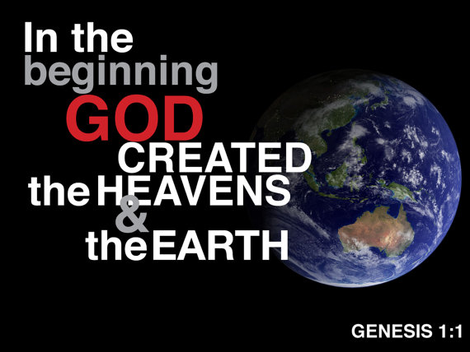 If everything done under the sun is utter vanity, then what is the meaning of life? By the end of Ecclesiastes Solomon tells us the meaning of life can only be found above the sun. While the physical body is destined to return to the dust in which it was formed, the soul returns to God who created it (12:7)! Humanity was created in the image of God (Genesis 1:27) and bought by the blood of Christ (1 Corinthians 6:20) for the express purpose of redemption and reconciliation with a holy God (2 Corinthians 5:17-20). Our value is firmly rooted in the love of Christ who died (John 3:16) and set us free from the bondage of sin (Romans 6:22). The meaning of life is not found in satisfying our worldly desires and passions to accumulate treasures on this earth that are here today and gone tomorrow (Matthew 6:20-21) but in living our lives in accordance with the will of Jesus (Matthew 6:33) who controls all things seen and unseen (Colossians 1:16)! How important is it that we bear fruit while on this earth? To answer this question let’s examine the Parable of the Fig Tree (Matthew 21:18-22)

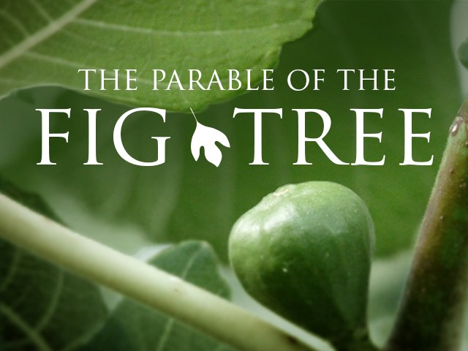In this parable we are told that when Jesus was on His way back to the city, He became hungry (verse 18). Along the roadside[12] He saw a fig tree that had green leaves but no fruit. This was unusual for even though it not the season for the fig tree to bear fruit (Mark 11:13)[13] the green leaves advertised that at minimum it had green figs that were edible.[14]  In response to finding the tree barren Jesus says “may you never bear fruit again” and the tree withered and died (verse 19). Since the disciples were amazed the fig tree died immediately after Jesus’ command (verse 20), He reminded them that the authority that had been given to Him over heaven and earth had been given to them as well.[15] In the last section of this parable Jesus taught the disciples the importance of trusting in Him.[16] If they had faith and did not doubt, they could ask that a mountain to cast itself into the sea and it would be done (verse 21). Jesus finished this parable by promising His disciples that when they believe anything that they asked for in prayer would be granted (verse 22).

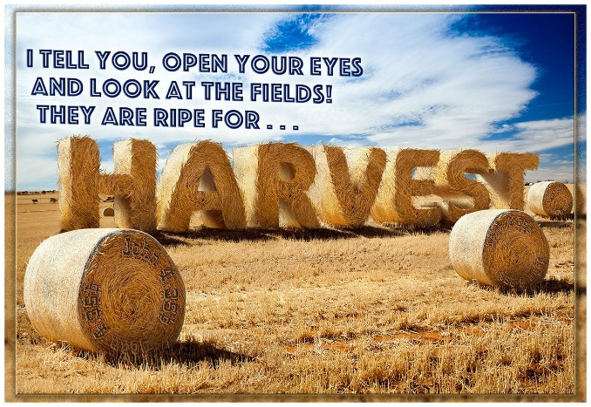In this parable Israel, whom was often compared to a fig tree or vine in the Old Testament,[17] was warned that while their form of religion (2 Timothy 2:5) as represented by the “green leaves” of the temple, Torah and status as “God’s chosen people” gave the appearance of fruit, they were barren and as such would soon fall under His judgement.[18] This parable represents a stern warning to the modern day Christian as well: God’s creatures must produce that for which they were created or risk falling under His judgement![19] While singing, reading the Bible and praying only on Sunday morning might give the appearance of the green leaves of righteousness, this will not fool God who can look beyond the intellect and peer into the soul (Psalms 139)! For our lives to have meaning we must go beyond merely listening to the word of God (James 1:22-25) while chasing after the evil desires of our own hearts (James 1:14), we must surrender that which is not our own (1 Corinthians 6:19-20) and with all our heart, mind, soul and strength obey His word and will for our lives! Let’s not forget that the fields are truly ripe (John 4:35), and our lifetime is the season to bear much fruit!

**Conclusion**

Life has meaning when one accomplishes that which God has created one to do! The meaning of Mother Theresa’s life is not to be found in her earthly titles but in her never-ending obedience to God’s call to feed and take care of the poor of India! While life has no meaning under the sun, there is great meaning in serving the Creator of all things seen and unseen. What keeps us from living fruitful lives is our reluctance to trust that God can and will do more than we can ask or imagine! We invite God into moments of our lives so that we might have an appearance of holiness and still chase after the evil desires of our hearts! As those who were purchased at the price of His Son’s life, God demands that we surrender that which is not our own and embrace the calling He created us to accomplish. While the earth and heaven will pass away, we can be rest assured that anything we do in the name and will of Jesus will last for an eternity!

1. Based on the book Mother Teresa and taken from the following website: <https://www.biographyonline.net/nobelprize/mother_teresa.html>
2. Taken from the following website: <http://www.guinnessworldrecords.com/news/press-release/2018/4/ninety-guinness-world-records-attempts-at-the-2018-virgin-money-london-marathon-521802>.
3. Taken from the following website: <https://www.bbc.com/news/uk-scotland-glasgow-west-45068703>
4. I do believe that verse one is an indication that king Solomon wrote the book of Ecclesiastes. There are many commentators whom believe the authorship is unknown and as such refer to the writer as either being the Pastor/Teacher or Qohelet.
5. Jim Winter, [*Opening up Ecclesiastes*](https://ref.ly/logosres/openup21ec?ref=Bible.Ec3.2-3&off=25&ctx=and+death+(vv.+2%E2%80%933)%0a~The+issue+is+both+pa), Opening Up Commentary (Leominster: Day One Publications, 2005), 51.
6. Iain Provan, [*Ecclesiastes, Song of Songs*](https://ref.ly/logosres/nivac21ec?ref=Bible.Ec1.1-11&off=9067&ctx=empts+to+manipulate+~the+world+through+ou), The NIV Application Commentary (Grand Rapids, MI: Zondervan, 2001), 52.
7. J. Stafford Wright, [“Ecclesiastes,”](https://ref.ly/logosres/ebc05?ref=Bible.Ec1.4-11&off=1175&ctx=htly+maintains+that+~meaning+and+security) in *The Expositor’s Bible Commentary: Psalms, Proverbs, Ecclesiastes, Song of Songs*, ed. Frank E. Gaebelein, vol. 5 (Grand Rapids, MI: Zondervan Publishing House, 1991), 1153.
8. Michael A. Eaton, [*Ecclesiastes: An Introduction and Commentary*](https://ref.ly/logosres/totc21ecus?ref=Bible.Ec1.9-10&off=6&ctx=isfied+(rsv).%0a9%E2%80%9310.+~These+verses+amplify), vol. 18, Tyndale Old Testament Commentaries (Downers Grove, IL: InterVarsity Press, 1983), 71.
9. Jim Winter, 54–55.
10. Elizabeth Huwiler, [“Ecclesiastes,”](https://ref.ly/logosres/bakerubot20pr?ref=biblio.at%3dEcclesiastes%7Cau%3dHuwiler%2c%2520Elizabeth&off=48146&ctx=%0a1:2+%2f+Meaningless:+~The+Hb.+word+hebel+i) in *Proverbs, Ecclesiastes, Song of Songs*, ed. W. Ward Gasque, Robert L. Hubbard Jr., and Robert K. Johnston, Understanding the Bible Commentary Series (Grand Rapids, MI: Baker Books, 2012), 181.
11. J. Stafford Wright, [“Ecclesiastes,”](https://ref.ly/logosres/ebc05?ref=Bible.Ec1.4-11&off=1784&ctx=all+in+vain+(v.+8).+~Every+generation+loo) in *The Expositor’s Bible Commentary: Psalms, Proverbs, Ecclesiastes, Song of Songs*, ed. Frank E. Gaebelein, vol. 5 (Grand Rapids, MI: Zondervan Publishing House, 1991), 1154.
12. Leon Morris, [*The Gospel according to Matthew*](https://ref.ly/logosres/pntcmatt?ref=Bible.Mt21.19&off=202&ctx=nnecessary+details%3b+~that+it+was+by+the+r), The Pillar New Testament Commentary (Grand Rapids, MI; Leicester, England: W.B. Eerdmans; Inter-Varsity Press, 1992), 530.
13. D. A. Carson, [“The Gospels and Acts,”](https://ref.ly/logosres/nivzndrvnstbbl?ref=Bible.Mt21.18-22&off=131&ctx=o+fruit.+Mark+11:13+~explains+that+%E2%80%9Cit+wa) in *NIV Zondervan Study Bible: Built on the Truth of Scripture and Centered on the Gospel Message*, ed. D. A. Carson (Grand Rapids, MI: Zondervan, 2015), 1975.
14. James Montgomery Boice, [*The Gospel of Matthew*](https://ref.ly/logosres/boicecm61bmt?ref=Bible.Mt21.18-27&off=2921&ctx=on+Without+Practice%0a~I+know+nothing+about) (Grand Rapids, MI: Baker Books, 2001), 450.
15. James Montgomery Boice, 455.
16. Leon Morris, 531.
17. James Montgomery Boice, 448–449.
18. D. A. Carson, 445.
19. Michael J. Wilkins, [*Matthew*](https://ref.ly/logosres/nivac61mt?ref=Bible.Mt21.18-22&off=1561&ctx=en+more+(21:20%E2%80%9321).+~Jesus%E2%80%99+cursing+the+f), The NIV Application Commentary (Grand Rapids, MI: Zondervan Publishing House, 2004), 694.