**Was Jesus a Revolutionary?**

**John 2:13-22**

Online Sermon: <http://www.mckeesfamily.com/?page_id=3567>

A picture containing outdoor, sky

Description generated with very high confidence One of the first courses that I took at Seminary was Christian history. I frankly was not looking forward to the course, for history was not a topic I particularly liked in High School. As the professor began to tell us the story of the first Crusade I soon realized how gifted he was in making history come alive! In 1098 the task was to get to Antioch of which there were two routes: around the mountains or through the Syrian Gates. Most of the Crusaders took the safe route and went around the mountains and in doing so drew out the Arab army. Once this happened the rest of the Crusaders went through the Syrian Gate which was not guarded because the Arabs thought no one in their right mind would go through this indefensible area. They in turn found little resistance and easily conquered the city. After the Crusaders defeated the Arabs they retreated to the desert but later returned and surrounded the city. With no way to escape and cut off from the supplies of their Norman ships, a long-term siege meant certain defeat for the Crusaders. It was at this moment that one of the chaplains, a monk named Peter Bartholomew said he saw a vision of a lance that pierced Jesus side being buried right beneath their feat. Since Antioch had seen many wars the chance of finding a lance was almost certain and once found Peter declared this relic was a sign from Christ of a guaranteed victory. Without fear and full of passion they stormed out of the gates of the city and caught the Arabs off guard and defeated them.

**“We are Going to Change the World”**

A close up of a person wearing a hat

Description generated with very high confidenceA person wearing a suit and tie smiling at the camera

Description generated with very high confidenceA close up of a person

Description generated with very high confidenceRevolutions fire the imagination filling people with a vivid picture of a utopian future full of laughter, justice and abundance. On August 28, 1963 Martin Luther King, Jr. delivered the “I have a dream” speech that inspired America to see a future of racial and economic equality and justice for all people, regardless of their skin color! Nelson Mandela, a South African revolutionary became a symbol of strength and hope as he kept the vision of abolishing institutionalized racial segregation in the foremost of the people’s minds. By humbly helping the poorest of the poor in the slums of Calcutta, Mother Teresa challenged people all over the world to see value in all human life. Not all revolutionaries are non-violent, nor do they paint a picture of social justice. For example, in his vision to conquer the world Genghis Khan A person wearing a uniform

Description generated with very high confidenceA person posing for the camera

Description generated with very high confidencebrutally killed about 11 percent of the world’s population in his lifetime. With the vison of instilling a purely agrarian communist society, Pol Pot killed about one-fifth of Cambodia’s population in just four years. Having blamed the loss of World War I and the economic downfall of Germany on the Jews, Hitler rallied his nation to slaughter over six million of them between 1941 and 1945.

**Was Jesus a Revolutionary?**

 The secular world does not have a monopoly when it comes to people that dream big and inspire others to seek an alternative future! The call for societal change has echoed from the sanctuaries of the churches, synagogues and mosques of major religions during one time or another.[1] While their calls to change were often like Martin Luther King Jr., Nelson Mandela or Mother Theresa’s non-violence and peaceful protests; others see change only possible by destroying the “present systems of social order and government.”[2] So, this brings me to the main question to be answered in today’s sermon: was Jesus a revolutionary and if so was He looking for change through peaceful or violent means? To answer this question, I am first going to look at a group named the Zealots and clear up some misconceptions concerning what kind of change Jesus came to this earth to instill. Second, while Jesus had zeal for His Father’s house, His cleansing of the temple was not a violent revolution to abolish Jewish customs but to fulfill them. And lastly, I am going to finish by explaining that the revolt that Jesus wanted was one of allegiance to His Father and as such His teachings were viewed dangerous enough to get Him crucified and yet ironically it was through this act and His resurrection that this event would forever changed the world!

**Association with the Zealots?**

A close up of a persons face

Description generated with high confidence Since Jesus proclaimed the kingdom of God was at hand and had at least one disciple that formerly belonged to a group called the Zealots, He was sometimes associated with this radical, violent group. “Zealot” was a name given to a group of the late Second Temple period and in the Bible referred those whom had a “jealous desire to protect one’s self, group, space or time against any violations” of “God’s right to exclusive allegiance from Israel.”[3] After having read of stories of zealous vengeance in the Old Testament such as Simeon and Levi killing the men of Shechem for the rape of their sister Dinah (Genesis 34:1-31), Elijah killing the prophets of Baal (1 Kings 18:36-40; 19:10-18) and king Josiah rooting out idolatry in the land (2 Kings 22:1-23:30); this group felt that zeal for God meant taking justice into their own hands.[4] Many members of this group carried swords or daggers and became known as the “Sicarii” which meant “cut-throats or assassins.”[5] In Jesus’ day the main goal of the Zealots was to always be ready to overthrow Rome through violence. They started a political-religious revolt that led to the Jewish war against Rome in A.D. 66 and the subsequent destruction of Jerusalem by the Roman general Titus in A.D. 70.[6]

A group of people standing in front of a crowd

Description generated with very high confidenceWhile there were elements of Jesus’ teachings that appealed to a violent group called the Zealots this does not mean that Jesus advocated violence as the means to obtain change.[7] For example, in Matthew 5:39 Jesus said to “not resist an evil person, if anyone slaps you on the right cheek, turn to them the other cheek also.” In Matthew 5:44 Jesus said to “love your enemies and pray for those who persecute you.” In Matthew 5:9 Jesus said, “blessed are the peacemakers for they will be called children of God.” Not only did His teachings advocate non-violence but so did His actions. After having performed the miracle of feeding the five thousand, Jesus withdrew to the mountain so that the people could not force Him to become a king who would overthrow Rome (John 6:14-15). When Jesus was arrested in the Garden of Gethsemane He healed the servant of the high priest and told Peter to “put his sword back in its place for all who draw the sword die by the sword” (Matthew 26:52). Jesus then said that at anytime He could call to the Father and have twelve legions of angels come and fight for Him but refused to do so because violence was not the way the kingdom of God was to be ushered in! Even in the face of such evidence then how does one explain Jesus’ zeal for and cleansing of the Temple?

**Zeal for His Father’s House**

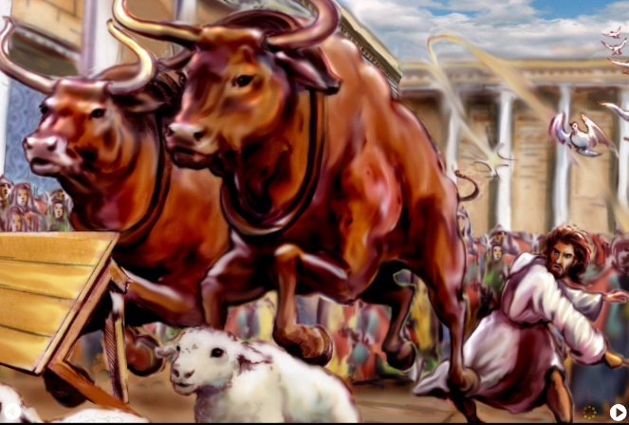 Other than the healing of a man with a shriveled hand on the Sabbath (Mark 3:1-6), the only other time that Jesus demonstrated anger was in the story of the temple cleansing and the focus of today’s sermon as found in John 2:13-20. The story begins by telling us that Jesus went to Jerusalem to attend the annual feast of the Jewish Passover (verse 13).[8] Entering into the court of the Gentiles,[9] Jesus found money changers exchanging Roman coins for Tyrian coinage[10] so that they might pay the temple tax and buy the sacrificial animals to be used for their offerings. Money exchange and the selling of animals was permitted in the temple court as a convenience to the pilgrims.[11] Jesus however viewed this trade as an act of desecration.[12] Since weapons were not permitted in the temple,[13] Jesus made a whip out of cords or rushes[14] and with it drove out the animals and then overturned the moneychanger’s tables and scattered their coins.[15] While driving them out Jesus told them that His Father’s house was not to be one of trade (allusion to Zechariah 14:29-1).[16] Verse seventeen says that later the disciples remembered the Messianic prophesy of Psalms 69:9 the that says “zeal for Your house will consume me.” [17]

 Does this passage prove that Jesus was a violent revolutionary like that of the Zealots? No, for a variety of reasons. First, Jesus was not condemning the merchants for dishonest business practices but for being in the temple area and thus interfering with the Gentile’s opportunity to pray![18] His objection was not against “those engaged in or leading worship, but against those detracting from it!”[19] Second, while it was convenient to set up the market in the temple[20] it was not appropriate because God’s house was to be one of prayer (Isaiah 56:7),not a commercial venture.[21] Third, while Jesus’ actions might appear to be similar to a Zealot, they differed for no where it is written that Jesus hurt, killed or tried to lead an insurrection against the Jewish people in the temple.[22] While the cleansing could have been seen as a prophetic gesture pointing to the end of the temple, Jewish sacrificial system[23] and any barrier to the true worship of God;[24] this would be accomplished not through killing those of either the Romans or Jewish institutions but through convincing all people to be a light unto the nations (Matthew 5:14-16) by loving God and one another (Matthew 22:37-40)!

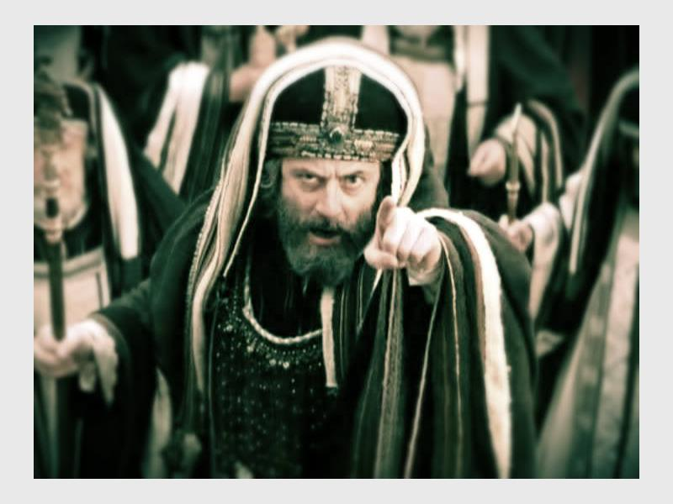The best evidence that Jesus was not a Zealot can be found in His response to the Jews who asked Him to prove His authority (verse 18) of what He did and His implied claim of being the Messiah.[25] Jesus answered them with a parabolic riddle[26] “destroy this temple and I will raise it again in three days” (verse 19). In response the Jews told Jesus what he suggested was impossible, for no one could rebuild a temple that took Herod forty-six years to construct and was yet to be finished.[27] The Jews and the even the disciples did not realize that Jesus was predicting His death and resurrection.[28] After “three days and nights in the heart of the earth” (Matthew 12:40)[29] the Jerusalem temple would now give way to whom it always pointed to, the Son of God![30] Jesus was not a violent revolutionary that came to condemn an institution or even the world, but through His substitutionary sacrifice to save it (John 3:17). O the irony that in demanding Jesus’ death the Jews offered the “one sacrifice that can truly expediate sin” [31] and in doing so eliminated the need for a temple built by hands! [32]

**Revolution of the Heart**

 While Jesus certainly was not a Zealot, the impact He has had on His creation has far reaching, eternal implications! To be a Gentile in the temple court, always looking in but never permitted to get close to the presence of God (Acts 21:27-32), must have been truly heart-breaking. In His death the curtain of the holy of holies was torn in two (Matthew 27:51) signifying that no longer would humanity have any obstacles to getting close to God because those who are born again have His Spirit living inside of them (Acts 2:38)! Jesus’ announcement of the kingdom of God whose entrance was not based on social, political or genealogical status, or even that of good works (Ephesians 2:8-9) resonated in the hearts of those who were enslaved not only by people but also to the evil desires in their own hearts (James 1:14)! While some followed Jesus merely to be recipients of His miracles, others sold everything they had to obtain the pearl and treasure in the field (Matthew 13:44-46). Was Jesus a revolutionary … no, He was and is far more than that, He is the Lamb of God that was slain before the foundation of the world (Revelation 13:8) and I and others have given our full allegiance to Him because He alone is our Creator, Redeemer and King (Isaiah 47:4, Revelation 17:14)! No one has ever changed this world nearly as much as Jesus for no one except Him can claim that all things were created by and for Him (Colossians 3:16)! Filling our hearts with a utopian, eternal future in heaven that is filled with laughter, justice and especially His presence has inspired many to say, “take my life and let it be yours, let me serve in your kingdom!”

1. James Montgomery Boice, [*The Gospel of John: An Expositional Commentary*](https://ref.ly/logosres/boicecm64ajn?ref=Bible.Jn2.12-17&off=975) (Grand Rapids, MI: Baker Books, 2005), 168.
2. James Montgomery Boice, 169.
3. David Rhoads, [“Zealots,”](https://ref.ly/logosres/anch?ref=biblio.at%3dZealots%7Cau%3dRhoads%2c%2520David%7Ced%3dFreedman%2c%2520David%2520Noel&off=989&ctx=The+Concept+of+Zeal%0a~During+this+two-cent) ed. David Noel Freedman, *The Anchor Yale Bible Dictionary* (New York: Doubleday, 1992), 1044.
4. Ibid.
5. James Montgomery Boice, 169.
6. Ibid.
7. Ibid.
8. Merrill C. Tenney, [“John,”](https://ref.ly/logosres/ebc09?ref=Bible.Jn2.13-14&off=6&ctx=ple+(2:13%E2%80%9322)%0a13%E2%80%9314+~About+the+time+of+th) in *The Expositor’s Bible Commentary: John and Acts*, ed. Frank E. Gaebelein, vol. 9 (Grand Rapids, MI: Zondervan Publishing House, 1981), 44.
9. Leon Morris, [*The Gospel according to John*](https://ref.ly/logosres/nicnt64jn?ref=Bible.Jn2.14&off=3&ctx=fice+of+Jesus.62%0a14+~The+%E2%80%9Ctemple%E2%80%9D+signifi), The New International Commentary on the New Testament (Grand Rapids, MI: Wm. B. Eerdmans Publishing Co., 1995), 169–170.
10. George R. Beasley-Murray, [*John*](https://ref.ly/logosres/wbc36?ref=Bible.Jn2.13-22&off=2653&ctx=+as+in+vv+19%E2%80%9320.%0ac.+~Money+changers+were+), vol. 36, Word Biblical Commentary (Dallas: Word, Incorporated, 2002), 38.
11. Merrill C. Tenney, 44.
12. George R. Beasley-Murray, 39.
13. Barclay Moon Newman and Eugene Albert Nida, [*A Handbook on the Gospel of John*](https://ref.ly/logosres/ubshbk64?ref=Bible.Jn2.15&off=505&ctx=ng+in+this+context.+~No+weapons+of+any+so), UBS Handbook Series (New York: United Bible Societies, 1993), 66.
14. Leon Morris, 171.
15. J. Ramsey Michaels, [*John*](https://ref.ly/logosres/nibcnt64jn?ref=Bible.Jn2.13-25&off=1252&ctx=e+temple+cleansing.+~Fashioning+a+cat-o%E2%80%99-), Understanding the Bible Commentary Series (Grand Rapids, MI: Baker Books, 2011), 50.
16. Andrew T. Lincoln, [*The Gospel according to Saint John*](https://ref.ly/logosres/black64jn?ref=Bible.Jn2.16&off=86&ctx=ve+to+this+account.+~Whereas+the+Synoptic), Black’s New Testament Commentary (London: Continuum, 2005), 138.
17. Leon Morris, 172.
18. D. A. Carson, [“The Gospels and Acts,”](https://ref.ly/logosres/nivzndrvnstbbl?ref=Bible.Jn2.15-16&off=8&ctx=e+service).%0a2:15%E2%80%9316+~Jesus+is+not+condemn) in *NIV Zondervan Study Bible: Built on the Truth of Scripture and Centered on the Gospel Message*, ed. D. A. Carson (Grand Rapids, MI: Zondervan, 2015), 2150–2151.
19. George R. Beasley-Murray, 39.
20. Leon Morris, 172.
21. Merrill C. Tenney, 44.
22. James Montgomery Boice, 170.
23. Andrew T. Lincoln, 138.
24. George R. Beasley-Murray, 39.
25. Leon Morris, 173.
26. George R. Beasley-Murray, 40.
27. J. Ramsey Michaels, 54.
28. Leon Morris, 178.
29. Ibid.
30. Andrew T. Lincoln, 140–141.
31. Leon Morris, 175.
32. Leon Morris, 178.