**Needing an Attitude Adjustment?**

**Philippians 4:8-9**

Online Sermon: <http://www.mckeesfamily.com/?page_id=3567>

A close up of a sign

Description generated with very high confidence The moment you said I believe in Jesus (John 3:16) and asked Him to be the Lord of your life (Romans 10:9) a radical transformation occurred … you became a new creation (2 Corinthians 5:17), born again, not of flesh and blood (John 1:13) but of water and the Spirit (John 3:5-8)! You have been adopted into God’s family as heirs (Romans 8:16-17) with a glorious inheritance to be received partly now but fully in His presence (Ephesians 1:15-23). As one of His children He expects you to become holy as He is holy (1 Peter 1:16). While that might seem impossible (Hebrews 11:6) for those who start off as mere babes in Christ (1 Corinthians 3:1), the chains of sin that so easily entangled you (Hebrews 12:1-2) have been broken by the Spirit who is far more powerful than your unbridled passions and the Prince of the air (Ephesians 2:2) who enslaved you (1 John 4). While God has enabled and expects you to live the rest of your life obeying Him (1 Peter 4:2-5), He has given you free will (1 Corinthians 6:12) and as such there will always be a struggle within you between your old nature of sin and your new nature (Romans 7) of Christlikeness (2 Corinthians 3:18). However, being bought at a price (1 Corinthians 6:20) you are expected through the power of the Spirit to put off evil desires (Colossians 3:5) and to run the race to please God and one day receive crowns of righteousness (1 Corinthians 9:24-27). Do you disagree with all the above?

**Problem: You are What you Think**

Since most Christians would wholeheartedly agree that their earthly goal is to be transformed into Christlikeness through strict obedience to His will, then why do so many choose to glorify the old self and obey the Prince of this world? I believe it is because we often forget spiritual battles are not against flesh and blood but against established strongholds of evil desires in our minds (2 Corinthians 10:3-5). Even though everyone born again has overcome the world and therefore has the power of the Spirit to obey God (1 John 5:3), this does not mean that the old self no longer has evil desires that flood our minds (James 1:14)! And while an evil thought entering a person’s mind in not necessarily a sin, entering a fantasy world that honors the ways of the Price of this world certain is … for as you think you will become (Proverbs 23:7)![1] To win the battlefield of the mind Paul says we must not merely let our thoughts happen but take each one of them captive to obey Christ (2 Corinthians 10:3-5). And with these thoughts of holiness we are to live our lives walking in the steps of Christ!

**Taking our Thoughts Captive to Obey Christ**

**8Finally, brothers and sisters, whatever is true, whatever is noble, whatever is right, whatever is pure, whatever is lovely, whatever is admirable—if anything is excellent or praiseworthy—think about such things.**

**Philippians 4:8, NIV**

Paul wrapped up his directive to the church of Philippi by first telling them to train their minds to think and reflect about virtues that come from God.[2] For Paul, to obtain the mindset of Jesus Christ (Philippians 2:5) is not only attainable but, as good food is necessary for bodily health, so are holy thoughts necessary for mental and spiritual health.[3] While many of the virtues Paul talked about overlapped with those of the Greco-Roman world[4] and other moral philosophers of 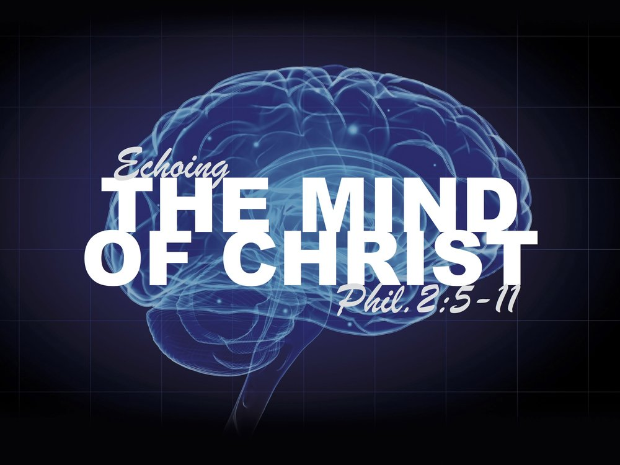his day,[5] Paul chose these virtues, gave them a new sense of meaning[6] and in doing so painted a “stark antitheses between the mind of Christ and the mind of the world” (Philippians 1:27-30).[7] By thinking about whatever is true, noble, right, pure, lovely, admirable, excellent or praiseworthy, one will be drawn into the presence of God and as such enabled to live out[8] and act on the “basis of the fruit of what the Spirit is producing in the believers.”[9] Let’s look at each of these eight virtues in more detail.

**Think Truthful Thoughts**. While “truth” could be defined in relation to a “warning against indulgence in mental fantasies or baseless slanders,” [10] or a reference to what is authentic reliable and real[11] or a reference to what is “sincere in thought, attitude or action”[12] as the Greeks have defined it; Paul sees the term “truth” as being grounded in God’s holy Word.[13] He who created and sustains all things seen and unseen (Colossians 1:16) alone gets to decide what is true or not. The truth that sets a person free (John 8:31-32) “has its focus in God (Romans 1:18) and the gospel of Christ” (Romans 15:8; 2 Corinthians 4:2; 11:10; Galatians 2:5).[14] It is though meditating on His word day and night (Psalms 1:2) that one’s eyes are open to see and confess the planks in one’s eyes so that one might stay on (Matthew 7:5-5) the narrow path, walking in the footsteps of one’s Master (Psalms 119:133)!

A picture containing object, clock

Description generated with high confidence **Think Noble Thoughts**. “Honest,” “honorable,” “worthy,” “deserving respect,” [15] dignity of moral excellence”[16]and “awe-inspiring”[17] are adjectives that are synonymous and good descriptors of being “noble.” The word “noble” in Hellenistic Greek referred not only to those things that had “fine personal qualities and high moral principles,” [18] but specifically to those things that had an “aura of the sublime, majestic or sacred.”[19] Noble for Paul most likely refers to the sacred things such as the temple, Law or Sabbath[20] but also refers to the characteristic traits of those who are living holy lives. For example, the only other time Paul uses the term “noble” is in describing the characteristics of deacons (1 Timothy 3:8) and older men (Titus 2:2).[21] If we are to be a light unto the world then our character must be distinct from all that is “vulgar and profane.” [22] By keeping our eyes fixed on the pioneer and perfector of our faith (Hebrews 12:2) our words, thoughts and deeds will reflect the mind of Christ and point people to the glory of God the Father in heaven (1 Peter 2:12)!

**Thinking Righteous Thoughts**. Living in a fallen world what is “right” or “just” depends on whose eyes one is looking through! For Paul anything that “conforms to God’s standards and is worthy of His approval,”[23] is both “right” and “just.”[24] Only the Creator and sustainer of all life (Colossians 1:16), the sinless (1 Peter 2:22) Lamb who was slain (Revelation 5:12), is faultless in defining what is right and just. Even though there is “no one righteous, not even one” (Romans 3:10), those who “live by faith” (Romans 1:17; Galatians 3:11) [25] are “right” A close up of a piece of paper

Description generated with very high confidenceand “just” in the eyes of God’s through the redemptive work of Christ (John 1:12)![26] To live a holy life, one is not to seek council (Palms 1:1) and follow the ways of this world but are to submit to the commands of God’s word[27] and those given by His Spirit! This submission is to be an ongoing occurrence so that our minds might be renewed daily in knowledge of and adherence to His perfect and pleasing will (Romans 12:2).

A close up of a device

Description generated with high confidence**Thinking Pure Thoughts**. While the word “pure” “originally signified the awe-inspiring holiness of the gods and their realm,” [28] for Paul this term referred to “anything that is free from the taint of sin.”[29] Purity is mentioned throughout the New Testament. In Titus 2:5 the “younger women” are instructed to be “self-controlled and pure,” in James 3:17 we are told that “wisdom that comes from heaven first of all is pure” and in 1 Peter 3:2 we are told that those who have “hope in Christ are to purify themselves, just as He is pure.”[30] “Purity” in the Bible in Ephesians 5:3 is also described as the absence of sexual immorality, greed or any other sin that makes one impure.[31] “Purity” is not just an individual’s responsibility but that of the body of Christ as well. Paul’s statement in 1 Timothy 5:22, that he wanted to present the church to Christ as a pure virgin (2 Corinthians 11:2), [32] meant that the members were to have “pure motives, acting with transparency and integrity and not with guile”.[33] If one desires to be pure then one must be constantly thinking about and examining one’s heart (2 Corinthians 13:5) by asking God to reveal sin to be confessed and avoided in the future (Palms 139:23-24).

**Thinking Lovely and Admirable Thoughts**. “Lovely” or “admirable” are similar virtues[34] that refer to a Christian’s lifestyle being maintained in holiness so that their light might shine and be a beacon of hope to those lost in sin. Activities that make “believers attractive and winsome, such as generosity, kindness, compassion and willingness to forgive”[35] are to be sought and lived so that nothing bad might be found within a person’s life to taint their witness concerning a holy God![36] It is not that we are to strive to be well-spoken of [37] so that we might brag about how “attractive” or “good” we are to society but are to strive for a “good reputation and good name” [38] so that the purity of our lives might point to the power of the Gospel message! Seeing a genuine, God-fearing Christian who has the “eyes of Christ” soon turns the heads of the people of this world who usually only see the darkness of this world! To share the “pearl” or “treasure in the field” (Matthew 13:44-46) to those who have many gods but only allegiance to “self” is an honor that must be done with integrity, or it will not be heard or accepted!

**Walking in the Steps of Jesus Christ**

**Whatever you have learned or received or heard from me, or seen in me—put it into practice. And the God of peace will be with you.**

**Philippians 4:9, NV**

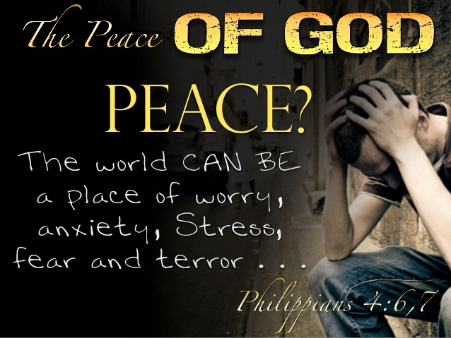 Paul finished this section of his letter by telling the Philippians to put into practice what they have learned, received, or seen in him.[39] While this at first glance “appears to be the height of presumption and egotism on Paul’s part,” [40] in light of 1 Corinthians 11:1 we come to understand Paul is saying to only emulate him to the extent that he himself has put into practice the mind of Christ.**[41]** Even though Scripture says you will become what you think (Proverbs 23:7),[42] for Paul this does not negate the need to make every effort to put into practice noble, true, right, pure lovely and admirable thoughts![43] To help them obtain the “mindset and pattern of Christ,”[44] Paul prays that the God of peace be with them and in turn sanctify (1 Thessalonians 5:23)[45] and guard their hearts and minds in Christ (Philippians 4:7). In a world filled with worry, anxiety, stress, fear and terror who would not want to receive the peace of God that surpasses all understanding?

**Conclusion**

I do believe that most Christians including myself need an attitude adjustment. The battleground is truly in the mind and for most of us our thoughts still reflect our love to gratify the old self who obeyed the Price of this world. If we want to be like Jesus, then we need to no longer merely let our thoughts happen but take each of them captive to obey Christ. By thinking about whatever is true, noble, right, pure, lovely, admirable, excellent or praiseworthy one will be drawn into the presence of God and as such enabled to think with the mind of Christ. Paul’s prayer for the church of Philippi was that the God of peace might be with and empower them to put into practice the above virtues and in doing so walk in the footsteps of Christ. I want to leave you with this final question to ponder: what greater incentives do we need to put Paul’s words into action than that of helping others to see the Gospel message through how we live our lives and us in turn to receiving the peace of God? [46]

1. Roger Ellsworth, [*Opening up Philippians*](https://ref.ly/logosres/openup71php?ref=Bible.Php4.8&off=36&ctx=right+things+(v.+8)%0a~The+book+of+Proverbs), Opening Up Commentary (Leominster: Day One Publications, 2004), 84.
2. G. Walter Hansen, [*The Letter to the Philippians*](https://ref.ly/logosres/pntcphp?ref=Bible.Php4.8&off=2&ctx=entire+discourse.%0a8+~Finally%2c+Paul+wraps+), The Pillar New Testament Commentary (Grand Rapids, MI; Nottingham, England: William B. Eerdmans Publishing Company, 2009), 295.
3. F. F. Bruce, [*Philippians*](https://ref.ly/logosres/nibcnt71php?ref=Bible.Php4.8&off=173&ctx=+character+to+life.+~As+good+food+is+nece), Understanding the Bible Commentary Series (Peabody, MA: Baker Books, 2011), 145.
4. Ben Witherington III, [*Paul’s Letter to the Philippians: A Socio-Rhetorical Commentary*](https://ref.ly/logosres/sorhet71php?ref=Page.p+250&off=380&ctx=uly+Christian+life.+~It+is+a+mistake+to+s) (Grand Rapids, MI; Cambridge, U.K.: William B. Eerdmans Company, 2011), 250.
5. I-Jin Loh and Eugene Albert Nida, [*A Handbook on Paul’s Letter to the Philippians*](https://ref.ly/logosres/ubshbk71?ref=Bible.Php4.8&off=110&ctx=n+lists+of+virtues.+~The+teaching+device+), UBS Handbook Series (New York: United Bible Societies, 1995), 132.
6. Ben Witherington III, 250.
7. Markus Bockmuehl, [*The Epistle to the Philippians*](https://ref.ly/logosres/black71php?ref=Bible.Php4.8&off=2330&ctx=atedly+stressed+the+~stark+antithesis+bet), Black’s New Testament Commentary (London: Continuum, 1997), 250.
8. I-Jin Loh and Eugene Albert Nida, 132.
9. Ben Witherington III, 251.
10. F. F. Bruce, 145.
11. Ben Witherington III, 255.
12. I-Jin Loh and Eugene Albert Nida, 133–134.
13. Roger Ellsworth, 85.
14. Markus Bockmuehl, 251.
15. I-Jin Loh and Eugene Albert Nida, 134.
16. Roger Ellsworth, 85.
17. Ben Witherington III, 255–256.
18. Catherine Soanes and Angus Stevenson, eds., [*Concise Oxford English Dictionary*](https://ref.ly/logosres/coed11?hw=Noble&off=95&ctx=+the+aristocracy.%0a2+~having+fine+personal) (Oxford: Oxford University Press, 2004).
19. Markus Bockmuehl, 252.
20. Daniel M. Gurtner, 586.
21. G. Walter Hansen, 296.
22. Markus Bockmuehl, 252.
23. Homer A. Kent Jr., [“Philippians,”](https://ref.ly/logosres/ebc11?ref=Bible.Php4.8&off=941&ctx=+worthy+of+respect.+~%E2%80%9CRight%E2%80%9D+(dikaia)+ref) in *The Expositor’s Bible Commentary: Ephesians through Philemon*, ed. Frank E. Gaebelein, vol. 11 (Grand Rapids, MI: Zondervan Publishing House, 1981), 152.
24. Roger Ellsworth, 85.
25. Markus Bockmuehl, 252.
26. G. Walter Hansen, 297.
27. John Peter Lange et al., [*A Commentary on the Holy Scriptures: Philippians*](https://ref.ly/logosres/lange71php?ref=Bible.Php4.8&off=1797&ctx=ct%2c+veneration.%E2%80%94H.%5d%E2%80%94~Whatsoever+things+ar) (Bellingham, WA: Logos Bible Software, 2008), 70.
28. G. Walter Hansen, 298.
29. Roger Ellsworth, 85.
30. G. Walter Hansen, [*The Letter to the Philippians*](https://ref.ly/logosres/pntcphp?ref=Bible.Php4.8&off=7945&ctx=al+significance.110+~Paul+desires+to+pres), The Pillar New Testament Commentary (Grand Rapids, MI; Nottingham, England: William B. Eerdmans Publishing Company, 2009), 298.
31. F. F. Bruce, 146.
32. Ibid.
33. Ben Witherington III, 256.
34. Daniel M. Gurtner, 586.
35. Roger Ellsworth, [*Opening up Philippians*](https://ref.ly/logosres/openup71php?ref=Bible.Php4.8&off=523&ctx=the+taint+of+sin%3b%0a%E2%80%A2+~THE+LOVELY%E2%80%94those+vir), Opening Up Commentary (Leominster: Day One Publications, 2004), 85.
36. I-Jin Loh and Eugene Albert Nida, 134.
37. Markus Bockmuehl, 253.
38. Roger Ellsworth, 85.
39. G. Walter Hansen, 300.
40. Ralph P. Martin, 179.
41. G. Walter Hansen, 301–302.
42. Ben Witherington III, 258.
43. F. F. Bruce, 146.
44. Ben Witherington III, 259.
45. G. Walter Hansen, 303.
46. Ralph P. Martin, 179–180.