**Standing Firm**

**1 Corinthians 10:1-13**

Online Sermon: <http://www.mckeesfamily.com/?page_id=3567>

Are you confident that you are standing firm in your relationship with the Lord Jesus Christ? Standing on the foundation of God’s deliverance, sustenance and divine presence has led many Christians to conclude that they are unshakeable in their faith. Surely those who stand on the practice of Lord’s Supper, prayer, reading the Bible and are experiencing God’s blessings in their lives will not be so entangled by sin that God will give them His wrath? In 1 Corinthians 10:1-13 Paul gave a dire warning to the church of Corinth and to us today: if you think you are standing firm be careful that you don’t fall. In other words, if you think that being a pastor, deacon or prominent member of the church or an elderly person with vast spiritual experience is insurance against loosing favor with God then think again! The first part of this sermon will review the analogy Paul draws between Israel and Corinth to show that the moment those who stand on the mountains of God’s blessings forget who got and keeps them there will fall because closeness to God is a product of His power, not ours! The second part of this sermon focuses on Paul’s warning that He who did not spare His chosen nation His wrath for having disobeyed Him, will not spare wrath against those of this final age! The last part of this sermon will focus on Paul’s assurance that those who rely on the power of Christ are standing on unshakeable ground for He will not permit them to be tempted beyond what they can bear or endure!

**The Blessed can Fall from Grace**

**For I do not want you to be ignorant of the fact, brothers and sisters, that our ancestors were all under the cloud and that they all passed through the sea. 2They were all baptized into Moses in the cloud and in the sea. 3They all ate the same spiritual food 4and drank the same spiritual drink; for they drank from the spiritual rock that accompanied them, and that rock was Christ. 5Nevertheless, God was not pleased with most of them; their bodies were scattered in the wilderness (verses 1-5, NIV)**

By using the phrases “brothers and sisters” and “our ancestors,” Paul invited the Corinthians to see “themselves in light of a new identity formed through their adoption into the covenant people of God.”[1] Christ destroyed the hostility and barrier between both Jew and Gentile and reconciled them both into one church through the cross (Ephesians 2:14). This A close up of a sign

Description generated with very high confidencemeans that both Jew and Gentile believers at Corinth[2] shared the same spiritual descendants.[3] Paul stated he did not want the Gentile believers to be ignorant of the fact that the promise made to Abraham that he “would be heir to the world” and a “father of many nations” was not fulfilled by following the law but through faith (Romans 4:16-17).[4] Abraham is the father of both Jewish and Gentile Christians in virtue of their faith in God.[5] Having established common ancestry Paul masterfully invited “ALL” Corinthians to see the Exodus events of God’s chosen people as “authoritative ethical instructions,” a warning that “even on top of a mountain of God’s blessings anyone can fall![6]

In verses 1b to verse five Paul draws an analogy between the blessings of the Israelite people in the Exodus and that of the church of Corinth and in doing so “invited” them to no longer be ignorant or “clueless”[7] of the lessons they might learn from their “forefathers.”[8] In these few verses Paul outlined five advantages enjoyed by Israel that are also enjoyed by the church of Corinth.[9]

* 1. **Guidance and Protection**. **For I do not want you to be ignorant of the fact, brothers and sisters, that our ancestors were all under the cloud and that they all passed through the sea** (verse 1).Paul’s reference to the “cloud” and “through the sea” refer to the story of God delivering Israel from Egypt in Exodus 13-14.[10] For our liberated forefathers the pillar of cloud not only served as a theophanic guide (Exodus 13:21) as they travelled in the wilderness[11] but also as supernatural protection for the people as they crossed the Red Sea and were delivered from extermination by the Egyptian army (Exodus 14:19-20)! Likewise, did not the Corinthians also experience God’s guidance (Luke 1:70), protection (1 Peter 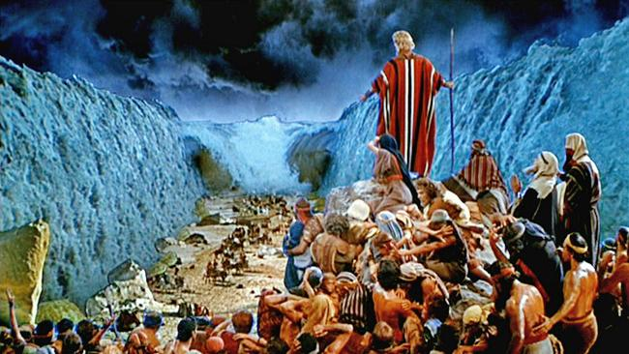1:5)[12] and deliverance from being under the law that only brought death (Romans 7:10)? [13] Those who were “held in slavery by their fear of death” (Hebrews 2:14-15) were freed by Him who gave Himself for humanity’s sins so that they might no longer be slaves to the present evil age (Galatians 1:4). The Devil who roars and seeks to destroy us (1 Peter 5:8) we should not fear because greater is He who is in us than he who is in the world (1 John 4:4)! And when it comes to God’s presence we truly have been blessed beyond measure. While there has never been a place where humanity could go where God is not (Psalms 139), having the Holy Spirit living inside of us is an honor because He offers to commune with our spirit whenever sought (Romans 8:16).

**A picture containing man, person

Description generated with very high confidence3. Baptism.** **They were all baptized into Moses in the cloud and in the sea** (verse 2). For a modern-day Christian to read “baptized into Moses” can be somewhat disturbing[14] for there is no Jewish parallel given for such a baptism.[15] Understanding the deliverance of Israel from Egypt in “explicitly anachronistic terms” [16] Paul formulated this phrase to “make the metaphorical parallel to baptism into Christ as clear as possible.” [17]  Being baptized into Moses means that upon their deliverance from the Egypt, our forefathers were “initiated and inaugurated under God” [18] as a nation whom would be required to follow His laws and covenant[19] as presented by Moses, God’s entrusted servant. Likewise, the Corinthians have been delivered from their enslavement to sin and have been “baptized into the body of Christ (1 Corinthians 12:13) of which He is the Head (Ephesians 1:22) and in whom they trusted (Matthew 12:21; Ephesians 1:12).[20] Just as the people were expected to obey the laws of Moses, the Corinthians are expected to obey the laws of Christ.[21] Being in a covenant with God is a blessing for it means we have been adopted into God’s family (Ephesians 1:5) and now have all the spiritual blessings and rights as heirs (Galatians 4:7)!

**A picture containing cup, table, coffee, indoor

Description generated with very high confidence4-5. Spiritual Food and Drink. They all ate the same spiritual food 4and drank the same spiritual drink; for they drank from the spiritual rock that accompanied them, and that rock was Christ** (verse 4).When Paul prefixed food and drink with the term “spiritual” he did not mean that he saw them as immaterial[22] but that the source of the manna and water provided to the children of Israel were objects of grace[23] miraculously provided by God.[24] For Paul the manna and water the Israelites received was to be an analogy pointing to the Lord’s supper.[25] Manna typified a type of Christ crucified,[26] bread that came down from heaven that once eaten would lead to eternal life (John 6:31-34).[27] When Paul said the water the Israelites drank was from the spiritual rock that was Christ it is difficult to interpret what he meant, either through allegory, analogy or metaphorically.[28] Since Moses got water from the rock at the beginning and end of the wilderness wanderings (Exodus 17:1-7; Numbers 20:2-13),[29] a Jewish exegetical tradition developed in which a supernatural rock the size of a large round vessel surging and gurgling with water travelled with the Israelite people.[30] This rock typifies the preexistent “wisdom of God”or Christ.[31] Christ then was the source of the supernatural water for both our forefathers and for the church of Corinth (John 4:10–14).[32] For Paul, the elements of the Lord’s Supper are to be seen as food and drink of the Spirit, blessings given to both our forefathers and the Corinthians! [33]

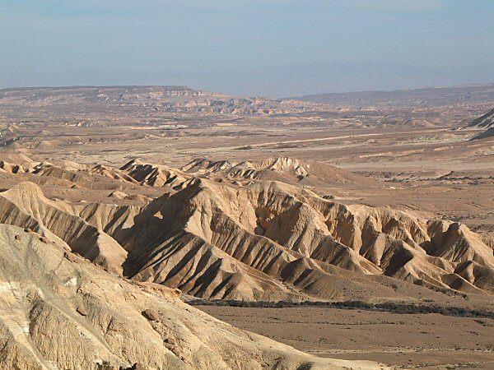**Nevertheless, God was not pleased with most of them; their bodies were scattered in the wilderness** (verse 5). Even after having received God’s blessings of His presence, protection, baptism and the Lord’s supper; most of our forefathers chose to sin against God and as a result were scattered in the wilderness. For Paul the wilderness journey of our forefathers is to be a warning[34] that “great initial spiritual blessings are not guarantee of continuing divine favor” [35]… anyone can fall short of the glory of God!

**Those who Fall Risk Receiving God’s Wrath**

**6Now these things occurred as examples to keep us from setting our hearts on evil things as they did. 7Do not be idolaters, as some of them were; as it is written: “The people sat down to eat and drink and got up to indulge in revelry.” b 8We should not commit sexual immorality, as some of them did—and in one day twenty-three thousand of them died. 9We should not test Christ, d as some of them did—and were killed by snakes. 10And do not grumble, as some of them did—and were killed by the destroying angel.**

**A close up of an animal

Description generated with high confidence**Paul warns the Corinthians that even though by God’s grace they were not disciplined every time they sinned did not mean that God does not punish those He loves when they set their hearts on doing evil in His sight! Paul lists four major sins[36] that led to Israel perishing in the wilderness.

1. **Idolatry**. **Do not be idolaters, as some of them were; as it is written: The people sat down to eat and drink and got up to indulge in revelry**. Using a direct quote from Exodus 32:6[37] Paul references one of the most notorious moments of sin in the history of Israel, worshipping the golden calf.[38] Despite all the blessings they had received, instead of obeying God they chose to create an idol and give credit to many “gods” for delivering them from Egypt.[39] Paul mentioned the golden calf not only to warn both the Corinthians[40] and us today that God punishes those who worship creation rather than the Creator (Romans 1:25). While we cannot imagine how anyone would be so foolish to practice idolatry, is not anything except God that our hearts cling to and rely upon an idol? [41] Or do we foolishly think that our golden calf of lust for money, fame and power is less heinous to God than theirs was? God is still a jealous God and as such demands no other gods but Him!
2. A person lying on a bed

   Description generated with high confidence **Sexual Immorality**. **We should not commit sexual immorality, as some of them did—and in one day twenty-three thousand of them died.** Here Paul is referring to the event in Numbers 25:1-9, when after having had sexual relations with the Moabite women,[42] some of the Israelite men went to the sacrificial rites and *then* partook of meat that had been offered to the Moabite gods and *then bowed themselves down* to these gods.”[43] In response to their participation in gross sexual immorality[44] they received punishment from God in the form of a plague in which twenty-four thousand Israelites perished![45] Paul mentioned this incident to remind the Corinthians to stay away from fornication, for many of them liked to frequent a temple dedicated to Venus which had a thousand priestesses, all common prostitutes.[46] We too are warned by God to flee from sexual immorality which are sins against one’s own body (1 Corinthians 6:18). God will not overlook our lust for the flesh anymore than He did Israel!
3. **Testing God**. **We should not test Christ, as some of them did—and were killed by snakes.** Here Paul is referring to the time when the Israelites complained that God brought them out of Egypt to the wilderness to eat detestable mannan and to die of thirst (Numbers 21:4-9).[47] For not having faith in God’s plan and provision[48] God sent venomous snakes 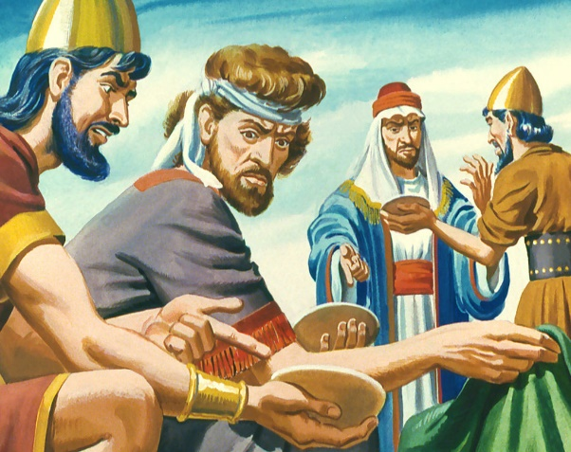amongst them and many Israelites died.[49] Paul most likely mentioned this incident for they were struggling with the Christ’s plan on how they were to get to heaven (1 Corinthians 1:18-3:20)![50] Every time that we look for a way out of trials and tribulations instead of persevering and maturing in the faith (James 1:1-4) are we not just as guilty as our forefathers for testing God? Will not the same God that punished Israel for testing Him punish us as well?
4. A picture containing person

   Description generated with high confidence **Grumbling Against God**. **And do not grumble, as some of them did—and were killed by the destroying angel.** Here Paul is referring to a passage in Numbers 16:41-49 in which Israel spoke rebelliously against God’s appointed leaders Moses and Aaron and as a result many were swallowed up by the earth, burned to death or died by a plague. What sparked this rebellion was Moses’ request that Israel make tassels on their garments to remind them to obey all of God’s commands.[51] Is this not a warning for us today? Will those who have overcome the world through belief in Christ be held accountable for obeying His commands that are no longer a burden to follow (1 John 5:3-5)? When one refuses to obey God one’s foundation and favor with God is far from secure!

**Overcoming Temptation and Standing Firm**

**These things happened to them as examples and were written down as warnings for us, on whom the culmination of the ages has come. 12So, if you think you are standing firm, be careful that you don’t fall! 13No temptation has overtaken you except what is common to mankind. And God is faithful; he will not let you be tempted beyond what you can bear. But when you are tempted, he will also provide a way out so that you can endure it.**

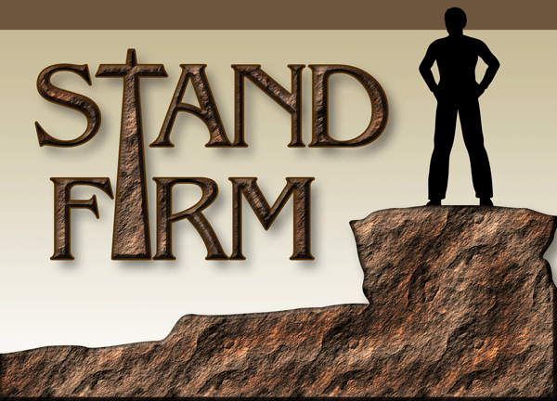Lest we missed the point Paul finished by summarizing the main theme of 1 Corinthians 10:1-13 as being “if you think you stand firm, be careful that you don’t fall.” After having read this passage one can’t help but wonder: if those who had God’s protection, presence, baptism and Lord’s Supper succumbed to idolatry, sexual immorality, testing and grumbling against God; what hope did the Corinthian or today’s Christians have that holiness can be maintained? Paul addressed this question by first ensuring us that our temptations are common to others who have successfully preserved and not sinned.[52] Paul implores us to not be disillusioned[53] into thinking that this means we can remain faithful by trusting in the false securities of our own strengths, abilities or desires.[54] The key to standing firm is to trust in God’s faithfulness[55] to not allow us to be tempted beyond what we can bear and to either provide a means to escape or the strength to endure and not sin. The problem is that most Christians are not looking for a way out by resting on God’s promise of escape or endurance but in way to indulge in the sinful desires of their hearts![56] I want to leave you with this final quote:

**“We live indeed in a tempting world, where we are compassed about with snares. Every place, condition, relation, employment, and enjoyment, abounds with them; yet what comfort may we fetch from such a passage.”[57]**

1. Roy E. Ciampa and Brian S. Rosner, [*The First Letter to the Corinthians*](https://ref.ly/logosres/pntccor1?ref=Bible.1Co10.1-2&off=791&ctx=d+at+their+pride.%0a%E2%80%A6+~brothers+and+sisters), The Pillar New Testament Commentary (Grand Rapids, MI; Cambridge, U.K.: William B. Eerdmans Publishing Company, 2010), 445–446.
2. C. K. Barrett, [*The First Epistle to the Corinthians*](https://ref.ly/logosres/black67co1?ref=Bible.1Co10.1&off=338&ctx=ed+through+the+sea.+~It+is+evident+that+P), Black’s New Testament Commentary (London: Continuum, 1968), 220.
3. Lee Martin McDonald, [“1 Corinthians,”](https://ref.ly/logosres/bkbc65ac?ref=Bible.1Co10.1b-2&off=141&ctx=oud+and+in+the+sea.+~Paul+makes+sure+that) in *The Bible Knowledge Background Commentary: Acts–Philemon*, ed. Craig A. Evans and Craig A. Bubeck, First Edition. (Colorado Springs, CO: David C Cook, 2004), 311.
4. James R. Edwards, [*Romans*](https://ref.ly/logosres/nibcnt66ro?ref=Bible.Ro4.1-12&off=617&ctx=n+is+that+of+3:28%2c+%E2%80%9C~For+we+maintain+that), Understanding the Bible Commentary Series (Grand Rapids, MI: Baker Books, 2011), 111.
5. C. K. Barrett, 91.
6. Alan F. Johnson, [*1 Corinthians*](https://ref.ly/logosres/ivnt1co?ref=Bible.1Co10.1-13&off=1321&ctx=8%3b+Bockmuehl+2000).+~It+is+clear+in+the+c), vol. 7, The IVP New Testament Commentary Series (Downers Grove, IL: InterVarsity Press, 2004), 154.
7. Marion L. Soards, [*1 Corinthians*](https://ref.ly/logosres/nibcnt67co1?ref=Bible.1Co10.1&off=251&ctx=they+were+ignorant.+~The+word+%E2%80%9Cignorant%E2%80%9D+), Understanding the Bible Commentary Series (Grand Rapids, MI: Baker Books, 2011), 200.
8. Roy E. Ciampa and Brian S. Rosner, 445.
9. David K. Lowery, [“1 Corinthians,”](https://ref.ly/logosres/bkc?ref=Bible.1Co9.26-27&off=2374&ctx=f+their+advantages.%0a~Five+advantages+were) in *The Bible Knowledge Commentary: An Exposition of the Scriptures*, ed. J. F. Walvoord and R. B. Zuck, vol. 2 (Wheaton, IL: Victor Books, 1985), 525.
10. Marion L. Soards, 200.
11. Roy E. Ciampa and Brian S. Rosner, 447.
12. David K. Lowery, 525.
13. Ibid.
14. Leon Morris, [*1 Corinthians: An Introduction and Commentary*](https://ref.ly/logosres/tntc67co1us?ref=Bible.1Co10.2&off=373&ctx=llowers+of+Moses%E2%80%99).+~It+is+startling+for+), vol. 7, Tyndale New Testament Commentaries (Downers Grove, IL: InterVarsity Press, 1985), 139.
15. C. K. Barrett, 221.
16. Marion L. Soards, 200.
17. Roy E. Ciampa and Brian S. Rosner, 447–448.
18. W. Harold Mare, [“1 Corinthians,”](https://ref.ly/logosres/ebc10?ref=Bible.1Co10.1-5&off=964&ctx=hrough+the+Red+Sea.%0a~That+%E2%80%9Cthey+were+all+) in *The Expositor’s Bible Commentary: Romans through Galatians*, ed. Frank E. Gaebelein, vol. 10 (Grand Rapids, MI: Zondervan Publishing House, 1976), 249.
19. Matthew Henry, [*Matthew Henry’s Commentary on the Whole Bible: Complete and Unabridged in One Volume*](https://ref.ly/logosres/mhenry?ref=Bible.1Co10.1-5&off=1999&ctx=nts+like+ours.+(1.)+~They+were+all+baptiz) (Peabody: Hendrickson, 1994), 2261.
20. David K. Lowery, 526.
21. Roy E. Ciampa and Brian S. Rosner, 447–448.
22. Roy E. Ciampa and Brian S. Rosner, 448.
23. W. Harold Mare, [“1 Corinthians,”](https://ref.ly/logosres/ebc10?ref=Bible.1Co10.1-5&off=1669&ctx=ion+and+leadership.%0a~That+the+food+and+dr) in *The Expositor’s Bible Commentary: Romans through Galatians*, ed. Frank E. Gaebelein, vol. 10 (Grand Rapids, MI: Zondervan Publishing House, 1976), 249.
24. Roy E. Ciampa and Brian S. Rosner, 448.
25. Ibid.
26. Matthew Henry, 2261.
27. Ibid.
28. Alan F. Johnson, 157.
29. Leon Morris, 140.
30. Lee Martin McDonald, 311–312.
31. Alan F. Johnson, 158.
32. David K. Lowery, 526.
33. Roy E. Ciampa and Brian S. Rosner, 449.
34. Leon Morris, [*1 Corinthians: An Introduction and Commentary*](https://ref.ly/logosres/tntc67co1us?ref=Bible.1Co10.1&off=3&ctx=try+brings+ruin.%0a1.+~For+ties+this+sectio), vol. 7, Tyndale New Testament Commentaries (Downers Grove, IL: InterVarsity Press, 1985), 139.
35. Alan F. Johnson, 155.
36. Alan F. Johnson, 158.
37. Marion L. Soards, 202.
38. Roy E. Ciampa and Brian S. Rosner, 455.
39. Ibidl
40. C. K. Barrett, 225.
41. Roy E. Ciampa and Brian S. Rosner, 458–459.
42. Marion L. Soards,.
43. Roy E. Ciampa and Brian S. Rosner, 460.
44. Ibid., 459.
45. Leon Morris, 141.
46. Matthew Henry, 2261.
47. David K. Lowery, 527.
48. Ibid.
49. Leon Morris, 141.
50. David K. Lowery, 527.
51. Matthew Henry, 2262.
52. Roy E. Ciampa and Brian S. Rosner, 468.
53. C. K. Barrett, 227.
54. C. K. Barrett, 229.
55. Ibid.
56. David K. Lowery, 527.
57. Matthew Henry, 2262.