**Seeking a Better Portrait**

**Acts 17:24-28**

Online Sermon: <http://www.mckeesfamily.com/?page_id=3567>

We have been created in the image of God and given specific spiritual gifts to become and serve as the person God has designed us to be! While we know this to be true, many Christians either do not know or do not appreciate the portrait God has assigned to them because they are too busy envying the worldly portraits of others. When depression sets in because expectations are not met, many Christians become willing to do anything it takes to obtain the optimal portrait; including seeking the advice from the world and sinning against God. While everyone since Adam was created with a marred image of God, we as Christians are not meant to look and act like this world who have painted themselves with the green of envy, blue of dissatisfaction and black of sin! If this describes you then please do not loose hope for those who choose to confess and rely on the red blood of Christ for redemption will have their sins cleansed as white as snow and will feel inexpressible joy as they seek and find the glorious portrait God created them to have!

**ILLUSTRATION**

Supplies: To do this illustration you will need bristol boards, paint brushes, five colors of paint, blind folds and a silly, painters outfit.

The goal of this illustration is to teach how important it is to seek, find and embrace the portrait that God has for one’s life. To help get volunteers the pastor should dress up in a very silly painter’s outfit. To start off ask for children to volunteer for the blind portrait painting challenge. The paint used in this challenge has be water based so that no staining of clothes happens. Since the challenge is quite difficult and to encourage intergenerational relationship building, have each child choose an adult partner. The “team” of two are then to choose which of them will be the guide and which one will be the painter. The guide’s job is to be the “eyes” of their partner who is to be blindfolded while painting. Each team can choose either one or several of the five different colors: green, blue, black, red or white to paint something that makes them happy. The contestants will be given five minutes to complete their painting. Upon completion each of the paintings will be held up to the congregation and they will get a chance to guess what the painting represents. Those of whose painting are correctly identified will get a nicer gift than those whose paintings cannot be identified.

**PAINTING OUR PORTRAIT**

A sign on a pole

Description generated with very high confidence To a certain extent everyone gets to decide what kind of portrait they want to paint of themselves. There are some things in life that are beyond our control such as height, skin, hair and eye color that are generally inherited from our parents. Danny DeVito can’t do much about his height of under five feet tall. And while you can dye your hair the new hair that grows out will always revert to its original color. Like genetics many of our experiences are beyond our control for they tend to happen by chance (Ecclesiastes 9:11) and are a by-product of living in a fallen world. For example: when, living during a world war or a time of peace, and where, living in a poor country like Hatti or a rich country like Canada; has a dramatic affect what portrait one can paint! While many things are beyond our control having the ability to make our own choices means we have the freedom to paint much of what goes onto our canvass of life!

To create the best life portrait possible, one should seek and follow the advice of our Creator! Listen to what Paul has to say about God our Creator:

**24“The God who made the world and everything in it is the Lord of heaven and earth and does not live in temples built by human hands. 25And He is not served by human hands, as if He needed anything. Rather, He Himself gives everyone life and breath and everything else. 26From one man He made all the nations, that they should inhabit the whole earth; and He marked out their appointed times in history and the boundaries of their lands. 27God did this so that they would seek Him and perhaps reach out for Him and find Him, though He is not far from any one of us. 28‘For in Him we live and move and have our being.’ r As some of your own poets have said, ‘We are His offspring.’**

**Acts 17:24-28, NIV**

As the offspring of He who is the life and breath of all things created both seen and unseen, we are to seek the advice on how to live our lives from our Creator. With the A picture containing person, ground

Description generated with high confidencespiritual gifts we have received we are to fulfill the divine role assigned to each of us. This is accomplished by allowing our footsteps in life to be guided by God’s holy word (Psalms 119:133) and by keeping in step with the Holy Spirit (Galatians 5:25). Those who have faith in the atoning sacrifice of Christ (John 3:16) will not only know the truth and be set free (John 8:31-32) from the bondage of sin (Romans 8:19-22) but will also be born again (Galatians 3:26) and will feel inexpressible joy (1 Peter 1:8-9) of realizing the glorious riches of their inheritance in Christ (Ephesians 1:7)! Even though we know all of this to be true the follow section will explain how people tend to use the green, blue and black colors to paint with and in doing so create a worldly portrait of a life full of sadness and sin.

**Green = Envying Another Image**

 While everyone is offered the opportunity to have God paint their portrait, many people find obedience to God offensive, so they paint by examining what seems to make the people of this world happy. Selling “happiness” to consumers in Canada is a 10-billion-dollar industry[1] in which coveting what others have tends to be the primary drive for consumer spending. Constantly seeing advertisements of people drinking and enjoying a party, sailing on a yacht, driving a fancy sports car, being adored by crowds of cheering fans or lying on the beach retired at age 55; it is no wonder so many people are enticed to covet the worldly things of life! It is easy to sell the broad path that allows one to create a portrait without restrictions or accountability to people who have already rejected their Creator! To be told one can climb any mountain, achieve any goal resonates strongly with this individualistic, consumer-based society.

**Blue = Dissatisfaction from Unmet Expectations**

 Just because one chases after the things of this world does not mean that one can paint a happy portrait for one’s life. First, due to a lack of ability or the right circumstances most people will not become rich, famous or powerful! While you might want to be a brain surgeon, model or famous singer; if you lack the intellect, looks or vocal abilities then these dreams are not going to be realized. While you might want to be rich if you live in the slums of Hatti then this dream is less likely to be realized than if you were born into a rich family. Second, even if you are successful based on worldly standards, your happiness is unlikely to last because you will always covet someone else’s portrait that is better than yours! People who chase after the things of this world tend to be blue with dissatisfaction because their cravings are insatiable! And the third reason that one cannot always paint a happy portrait is because one’s soul that was created by God to have a relationship with Him cannot feel true joy without His presence in one’s life.

**Black = Seeking Advice from the World and Sinning Against God**

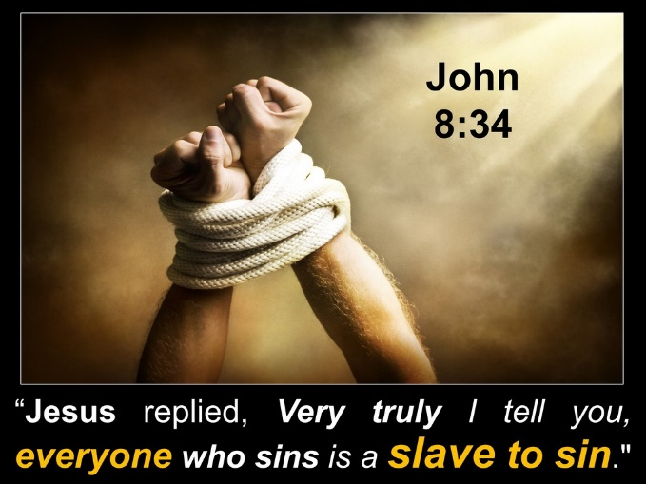 In the illustration the person doing the painting was blindfolded to point out that due to our sinful nature inherited from Adam we are blind to the things of God. It is a sin to ask the world instead of our Creator for advice on how to live our lives. The lust of the flesh and eyes and the pride of life prove that the love of God is not in that person (1 John 2:15-17). Coveting what others have not only breaks one of the Ten Commandments (Exodus 20:17) but also enslaves the person to sin! Those who feel dissatisfaction from unmet expectations are often willing to sin even more if it means increasing the likelihood of obtaining a better worldly portrait! When sin is left unchallenged in a person’s life it soon is no longer is a source of temporary happiness but becomes a habit and then part of that person’s very character. When this happens, that person becomes a slave (Romans 6:20, John 8:34) to a worldly portrait that cannot bring joy but only sorrow that comes from being so distant from one’s Creator!

**Red = Blood of Christ**

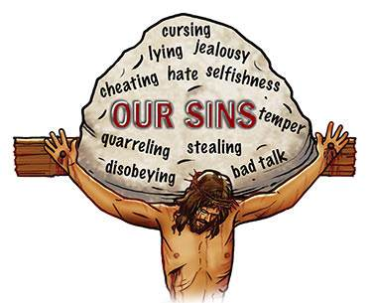 The red paint in the illustration represents the blood of Christ as being the only way for humanity to become free from the bondage of sin! Apostle Paul tells us that each person is a prisoner of the law of sin that has us so firmly in its grips that none, but our Lord Jesus Christ can free us (Romans 7:21-24). Since all have sinned (Romans 3:23) and the wages of that sin is death (Romans 6:23), someone had to die for humanity having broken God’s laws! Only the sinless Lamb of God, Jesus, who was both human and God, would atone and appease God’s righteous wrath against humanity (Hebrews 10:11-14). Those who have belief in the atoning sacrifice of Christ are born again and adopted into God’s family (John 1:12). Praise be to God, Christ’s blood breaks the bondage of sin, and empowers us through His Spirit to obey His commands (1 John 5:2-4) and embrace the portrait that God has assigned to us!

**White = Erasing and Making a New Portrait**

**A picture containing baseball, person, bat, holding

Description generated with very high confidence** I want to finish this sermon by encouraging you as Christians to erase and make new portraits. While you are no longer under the bondage of sin and its consequences, spiritual death; this does not mean that you are sinless! Those who claim the blood of Christ automatically means they are “without sin deceive themselves and the truth is not in them” (1 John 1:9)! To be freed from the consequences of sin, death is not to be a license to sin (Romans 6:1-4) but the opportunity to erase the sinful parts of one’s portrait! When a person confesses their sins, God is faithful and just to not only forgive them but to erase their sins as white as snow (Isaiah 1:18)! While the world does not forget the bad that we do in life, through confession God does! With your portrait clean you are freed to embrace your spiritual gifts and accomplish the divine tasks God has assigned to you! I want to leave you with this parting note: while much of your portrait might already be painted there is still time to embrace God’s will and allow Him to be the guide in painting His portrait for you!

1. Taken from the following website: <https://www.statista.com/topics/1837/advertising-in-canada/>