**The Way, Truth and Life**

**John 14:6**

Online Sermon: <http://www.mckeesfamily.com/?page_id=3567>

Can you imagine what it must have been like to be one of the disciples and hear the final words of Christ? After having witnessed Jesus walk on water, heal the sick and bring the dead back to life the disciples were unlikely ready to hear what Jesus was about to do next! On His way to Jerusalem Jesus told the disciples that he was about to be delivered to the chief priests and teachers of the law who would condemn and hand Him over to the Gentiles to be mocked, flogged and crucified on a cross (Matthew 20:17-19). After the Lord’s Supper Jesus told the disciples that once He was raised from the dead He would remain with them but a short time and would then return to the right hand of God the Father in heaven (John 14:1-4). Peter’s response to Jesus’ predicted departure, wanting to die to return with Him or Philip’s response of wanting to see God the Father immediately; are responses we can understand and even emphasize with. However, it is Thomas’ response “we don’t know where you are going, so how can we know the way (14:5)?” has puzzled humanity for generations! In today’s sermon we are going to explore what Jesus meant when He told Thomas: “I am the way, truth and life (14:6)!”

**Created by God**

A picture containing tree, water, colorful, outdoor

Description generated with very high confidence Before one can fully understand Jesus’ response to Thomas one must first understand the origins of humanity. As diamonds can contain much value in a small space[1] so do human beings. When David considered the heavens, moon and stars of this vast universe he could not help but wonder why God would declare that humanity was created a little lower than the angels (Psalms 8:2). While it is true that having two arms, legs, eyes, and between 30 and 40 trillion cells and bacteria[2] is impressive, what are we in comparison to this vast universe that is billions of light years in diameter?[3] The answer to this question is found in Scripture that says our value comes from having been fearfully and wonderfully made (Psalms 139:14) in the image of God (Genesis 1:27). He whom all the world is His (Psalms 50:12) did not create humanity because He needed us (Acts 17:25) but out of love. We were made in the likeness of God so that we might have a relationship with Him. In the Garden of Eden God entered a covenant with humanity in which had we not disobeyed God we would have remained there until this very day!

**The Great Fall**

A person posing for a picture

Description generated with very high confidence Instead of remaining faithful to God and enjoying paradise, humanity chose to sin against God. Even in the Garden where we walked and talked with Him (Genesis 3:8), we did not trust that God would provide us with the absolute best life to live. So, we cheated on God and gave into our evil desire (James 1:14) to become a divine being, knowing both good and evil (Genesis 3:4).[4] While Satan was correct when he said “our eyes would be opened,” he neglected to tell us that we would be cut off from God (Genesis 3:24) and enslaved to our sin (Romans 6:20). He also neglected to tell us that we would love evil far more than good! Instead of repenting and obtaining mercy we chose to continue to cheat on God by using wood (Jeremiah 10:8), silver and gold (Psalms 115:4) to make and worship creation rather than our Creator (Romans 1:25). With the lust of the flesh, lust of the eyes and the pride of life (1 John 2:16) firmly entrenched in our desires, we refused to believe it worthwhile to retain the knowledge of God, so we traded in His image to become gossipers, slanderers, God-haters, insolent, arrogant and boastful people (Romans 1:28-32). Even though we felt temporary pleasure from gratifying the fleeting sinful pleasures of sin (Hebrews 11:25), being separated from God left our souls dead (Romans 3:23) and constantly searching for the inexpressible joy that can only be found in the embrace of our Creator (1 Peter 1:8-9)!

**Futile Attempts to Reach God**

We tried to talk with God but our attempts to reach Him were futile for our love and entanglement of sin (Hebrews 12:1) were way too strong. Even though we knew what we must do to be holy (Romans 7:12), we were not able to be righteous (Romans 3:9-20) for whom amongst us could ever stop sinning (1 John 1:9-10)? Even if we could top sinning, which one of us could ever atone for the sins that we have already done? While God wishes that none should perish (2 Peter 3:9), His everlasting mercy cannot give way to His avenging justice;[5] the wages of sin can be nothing less than death (Romans 6:23)! Let me tell you a quick story of from my childhood.

A picture containing indoor, scene, ground, pier

Description generated with high confidenceI remember the very first time I went to a summer camp. As a young boy I had never stayed away from home any more than a single night. One day at church there was an announcement that the church was willing to sponsor children to go to Camp Wildwood. My parents asked me if I wanted to go and at first, I said NO. After much coaxing and prodding and with the promise that I could return whenever I wanted, with great reservations I finally said YES. I remember the trip from Hillsborough to the camp at McKees Mills seemed like it would take forever! When I arrived, my parents had to coax me to stay for I was incredibly shy and did not make friends easily. The mere though of being in a cabin with boys I did not know, being asked to participate in sporting events, singing, swimming or eating food with others; absolutely petrified me! The only thing that got me through that week was that I knew I could call at any time and my parents would come and get me. Knowing my way home helped me to endure and bare the loneliness of being separated from my parents!

Like me at camp, the disciples could only bear being separated from the Master if they knew how they could one day go and be with Him. So, Jesus told them the key to knowing and being with God the Father was not through our efforts to follow the law that was powerless because it was weakened by the flesh (Romans 8:3) but though belief in He who was the way, truth and life (John 14:6).

**Jesus is the Way**

With their depraved minds (Romans 1:28) humanity has created many gods and paths to their preferred paradise. For Gnostics the material world is evil and it is only by obtaining secret knowledge of the universe that one can release the divine spark from within and become god. For the Hindus Brahman is manifested in many gods and goddesses and can only be obtained in reincarnation until enlightenment is obtained. For Islam submitting to the will of Allah as demonstrated in faith, prayer, alms, pilgrimage and fasting will gain one entrance into Paradise. For Jehovah Witnesses while salvation was made possible through the death of Jesus, only those 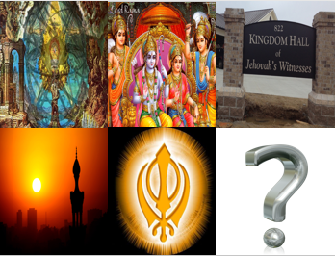who learn and obey Jehovah’s requirements, a mere 144,000, will participate in His kingdom while the rest will be annihilated. For the Sikhs they believe that a person will be reincarnated until they overcome self by realigning to the will of God and once this is accomplished will merge with Him.[6] Being in contact with so many divergent beliefs has left postmoderns to come to the belief that either God does not exist, a singular path to Him cannot be known or any and all paths will lead to His presence.[7]

A picture containing person, sign

Description generated with high confidenceIn John 14:6 Jesus says none of the above paths are correct for there is only one way to know God the Father in heaven and that is through His Son. “The way” supposes a path from humanities enslavement and death to sin which has led to a total isolation from God, to having a relationship with the Father as His child.[8] Humanity has broken the Covenant with God and since we cannot pay the price for our sins anymore than we can by our own efforts be released from the power and guilt of sin, we need a Mediator between us and God.[9] This Mediator is Jesus Christ. He who had no sin took upon our sin (2 Corinthians 5:21) and died on the cross (1 Peter 2:24) for everyone, including His enemies (Romans 5:10). Now “when the sin of God’s people was moved from them to Christ, the wrath of God went where the sin went, and it fell upon Christ, until he said, “My God, my God, why hast thou forsaken me.”[10] This does not mean that all of humanity was instantly reconciled unto God. Only those who have faith in Jesus’ atoning sacrifice and make Him the Lord of their lives are saved (1 Timothy 2:5) and have been adopted as God’s children. Even though people often claim there are many paths to heaven that is simply not true for no other foundation than the one laid by Jesus Christ will remove the guilt of sin and allow one to have a relationship with God the Father in heaven (1 Corinthians 3:11; 1 Timothy 2:5).[11]

**Jesus is the Truth**

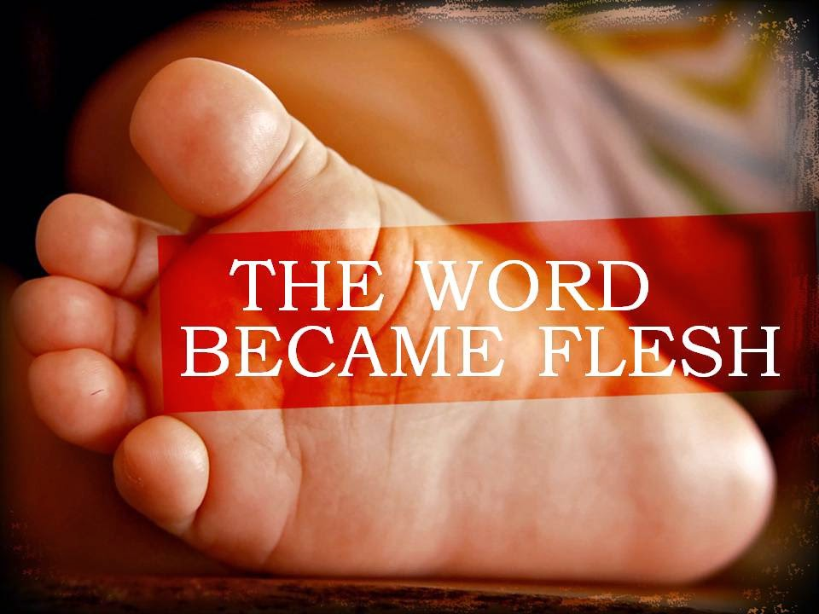 Even though Jesus being our Mediator is often viewed as an exclusive and highly offensive statement to our postmodern culture, [12] Jesus being the only way is the truth for only He “has an intimate knowledge of God unmarred by sin.”[13] When we want an answer to a tough math question we ask a mathematician to get the right answer. Doesn’t it make since then to ask God’s own Son how we are to know His Father? We could ask another human being, but their sin would mar the answer and we would not get the absolute truth concerning God. When Jesus told the disciples that he was soon going to heaven Phillip went to the expert, Jesus and requested that He reveal the truth concerning God the Father before His departure (John 14:8). In response to this request Jesus did not say that He came to reveal or point to the truth concerning the Father but instead said that since He and the Father are one (John 10:30), not only was He the truth but anyone who had seen Him also has seen the Father (John 14:9).[14] Jesus’ mission was to bear witness to the truth concerning God (John 18:37) for He alone is God’s self-disclosure as the Word made flesh (John 1:14) and is the true God and source of eternal life (1 John 5:20). “Jesus’ life, death and resurrection embody not only point to the truth concerning God[15] but also represents the only way to have a relationship with Him.[16]

**Jesus is the Life**

Jesus final claim is to be life for all those who believe in Him. A. W. Pink wrote:

A picture containing sky, person, outdoor, flying

Description generated with very high confidence“The whole Bible bears solemn witness to the fact that the natural man is spiritually lifeless. He walks according to the course of this world; he has no love for the things of God. The fear of God is not upon him, nor has he any concern for His glory. *Self* is the center and circumference of his existence. He is alive to the things of the world but is *dead* to heavenly things. The one who is out of Christ exists, but he has no spiritual life. When the prodigal son returned from the *far* country the father said, ‘This, my son, was *dead,* and is alive again; he was lost, and is found’ (Luke 15:24).”[17]

Jesus did not come to condemn this world but to offer us life (John 3:17-18). Jesus came to offer us a solution to a human problem, sin, that had no human solution.[18] He rose from the dead so that in turn by belief in His atoning sacrifice we might have life and have it abundantly. As Christians we know where Christ has gone, and we certainly know the way, but do we truly know not that even in our brokenness we can cry out Abba Father and those with a pure heart will not only hear God’s voice but will also receive help by Him? While we were the ones who drove the nails in Jesus’ hands and feet by our sin, praise be to God that we are also the recipients of grace through our one and only Mediator, Jesus Christ! So, this Easter we remember and celebrate Jesus’ words “I am the way, and the truth and the life.”

1. C. H. Spurgeon, [“The Way,”](https://ref.ly/logosres/mtpserms16?ref=biblio.at%3dThe%2520Way%7Cpg%3d409%E2%80%93420&off=232&ctx=e+smallest+compass.+~Diamonds+have+much+v) in *The Metropolitan Tabernacle Pulpit Sermons*, vol. 16 (London: Passmore & Alabaster, 1870), 409.
2. Taken from the following website: <https://news.nationalgeographic.com/2016/01/160111-microbiome-estimate-count-ratio-human-health-science/>
3. Taken from the following website: <https://www.space.com/24073-how-big-is-the-universe.html>
4. John E. Hartley, [*Genesis*](https://ref.ly/logosres/bakerubot01ge?ref=Bible.Ge3.1-5&off=3480&ctx=+would+bring+death.%0a~The+serpent+then+ass), ed. W. Ward Gasque, Robert L. Hubbard Jr., and Robert K. Johnston, Understanding the Bible Commentary Series (Grand Rapids, MI: Baker Books, 2012), 66.
5. C. H. Spurgeon, [“The Way,”](https://ref.ly/logosres/mtpserms16?ref=biblio.at%3dThe%2520Way%7Cpg%3d409%E2%80%93420&off=2996&ctx=lt+of+sin%2c+for+that+~mercy+is+blocked+up+) in *The Metropolitan Tabernacle Pulpit Sermons*, vol. 16 (London: Passmore & Alabaster, 1870), 410.
6. Taken from the following website: <http://www.religionfacts.com/>
7. Wells, David F. *The Courage to Be Protestant: Truth-Lovers, Marketers, and Emgergents in the Postmodern World*. Grand Rapids, MI: Willian B. Eerdmans Publishing Company, 2008.
8. James Montgomery Boice, [*The Gospel of John: An Expositional Commentary*](https://ref.ly/logosres/boicecm64djn?ref=Bible.Jn14.5-6&off=6914&ctx=+taken+in+its+turn.+~The+first+to+be+cons) (Grand Rapids, MI: Baker Books, 2005), 1077.
9. C. H. Spurgeon, [“The Way,”](https://ref.ly/logosres/mtpserms16?ref=biblio.at%3dThe%2520Way%7Cpg%3d409%E2%80%93420&off=10829&ctx=+out+of+an+unclean%3f+~Man%2c+thy+sinfulness+) in *The Metropolitan Tabernacle Pulpit Sermons*, vol. 16 (London: Passmore & Alabaster, 1870), 412.
10. C. H. Spurgeon, [“The Way,”](https://ref.ly/logosres/mtpserms16?ref=biblio.at%3dThe%2520Way%7Cpg%3d409%E2%80%93420&off=6911&ctx=h+causes+the+wrath.+~Remove+the+cause%2c+yo) in *The Metropolitan Tabernacle Pulpit Sermons*, vol. 16 (London: Passmore & Alabaster, 1870), 411.
11. James Montgomery Boice, [*The Gospel of John: An Expositional Commentary*](https://ref.ly/logosres/boicecm64djn?ref=Bible.Jn14.6&off=1672&ctx=n+apart+from+Jesus.%0a~Many+verses+teach+it) (Grand Rapids, MI: Baker Books, 2005), 1082.
12. James Montgomery Boice, [*The Gospel of John: An Expositional Commentary*](https://ref.ly/logosres/boicecm64djn?ref=Bible.Jn14.5-6&off=3346&ctx=through+me%E2%80%9D+(14:6).%0a~At+the+same+time%2c+we) (Grand Rapids, MI: Baker Books, 2005), 1076.
13. Merrill C. Tenney, [“John,”](https://ref.ly/logosres/ebc09?ref=Bible.Jn14.6&off=523&ctx=the+master+of+life.+~He+is+the+way+to+the) in *The Expositor’s Bible Commentary: John and Acts*, ed. Frank E. Gaebelein, vol. 9 (Grand Rapids, MI: Zondervan Publishing House, 1981), 144.
14. James Montgomery Boice, [*The Gospel of John: An Expositional Commentary*](https://ref.ly/logosres/boicecm64djn?ref=Bible.Jn14.5-6&off=10359&ctx=es+all+other+truth.+~He+did+not+say%2c+%E2%80%9CI+h) (Grand Rapids, MI: Baker Books, 2005), 1079.
15. Andrew T. Lincoln, [*The Gospel according to Saint John*](https://ref.ly/logosres/black64jn?ref=Bible.Jn14.5-6&off=1001&ctx=sion+in+13:36%E2%80%9314:4%2c+~Jesus%E2%80%99+claim+to+be+t), Black’s New Testament Commentary (London: Continuum, 2005), 390.
16. D. A. Carson, [*The Gospel according to John*](https://ref.ly/logosres/pntcjohn?ref=Bible.Jn14.6&off=473&ctx=dination.+Still%2c+if+~Thomas%E2%80%99+question+and), The Pillar New Testament Commentary (Leicester, England; Grand Rapids, MI: Inter-Varsity Press; W.B. Eerdmans, 1991), 491.
17. Arthur W. Pink, Exposition of the Gospel of John, vol. 2, page 356.
18. Willard, Dallas. 2002. *Renovation of the Heart: Putting on the Character of Christ*. Colorado Springs, CO: NavPress, page 20.