**Handling Bad Situations God’s Way**

**Matthew 26:46-56**

Online Sermon: <http://www.mckeesfamily.com/?page_id=3567>

Living in a fallen world means going through hardships in life is unavoidable. Who has not had an unexpected expense occur so large that they thought this might be the one that drives them in bankruptcy? Who has not had a heated fight with their spouse or child so intense that they thought they might never return home after their brisk departure? Who has not had a physical ailment serious enough to make one wonder if one was going to live or die? Who has not had a friend or colleague stab them in the back to try to destroy their reputation? Since many hardships are unavoidable, we are left with the challenge of how to make the “best” out of bad situations. While the world defines “best” as any choice that benefits “self” the most, God defines “best” as any choice that is made by seeking and obeying His will. Even though we know that perseverance leads to spiritual growth, it is not always easy to have faith and stay on God’s course. Whether we choose to follow the ways of this world or God matters for choice is not only where sin dwells but also where Christian maturity begins. In today’s sermon I am going to review Judas’, the large crowd’s, Peter’s, the disciples’ and Jesus’ response to His arrest in the Garden of Gethsemane to emphasize both the wrong and right way to handle difficult situations.

**47While he was still speaking, Judas, one of the Twelve, arrived. With him was a large crowd armed with swords and clubs, sent from the chief priests and the elders of the people. 48Now the betrayer had arranged a signal with them: “The one I kiss is the man; arrest him.” 49Going at once to Jesus, Judas said, “Greetings, Rabbi!” and kissed Him.**

**Matthew 26:47-49, NIV**

**What is in it for me?**

A picture containing person, indoor, food, table

Description generated with very high confidenceThe last time that we saw Judas was in the upper room during the Last Supper.[1] During the meal Jesus told the disciples that one of the twelve who dipped his bread in the bowl with Him would betray Him. One by one they said to Jesus “surely you don’t mean me?” (Mark 14:17-20). Jesus remained silent for each of their questions, all except Judas in which He said, “you have said so” (Matthew 26:25) … in other words, you are the betrayer. One can only imagine how Judas must have felt. As one of the twelve disciples chosen by Jesus Himself (Luke 6:12-16), surely, he was secure in his position in God’s kingdom? Had he not shown commitment to Jesus by giving up everything to follow Him (Matthew 19:27)? Was he not numbered amongst the twelve disciples that Jesus told to go to the lost sheep of Israel, heal the sick, cleanse the leapers and cast out demons (Matthew 10:5-8)? To his horror Jesus’ earlier words:

**21“Not everyone who says to me, ‘Lord, Lord,’ will enter the kingdom of heaven, but only the one who does the will of my Father who is in heaven. 22Many will say to me on that day, ‘Lord, Lord, did we not prophesy in your name and in your name drive out demons and in your name perform many miracles?’ 23Then I will tell them plainly, ‘I never knew you. Away from me, you evildoers!’ (Matthew 7:21-23)**

were meant for him! Even though he said “Lord, Lord” and did miracles, he was not part of Jesus’ family! One can only imagine the hurt and pain Judas felt in that very moment, for He knew the words of Christ “you have said so” echoed in his heart the truth … he had never truly given his allegiance over to Jesus!

A yellow sign with black text

Description generated with very high confidence Judas faced a very bad situation! Can you imagine being told you are not saved and worse yet that “it would have been better for you if you had not been born” (Matthew 26:24)? How did Judas respond to knowing the truth that he was the betrayer? He could have asked Jesus to forgive his wicked heart and pledge his allegiance to Him that very moment (1 Corinthians 12:23). After all, Jesus forgave and let into the kingdom the tax collectors and prostitutes (Luke 5:29-31), so why not him? Instead of choosing the righteous path, Judas departed from Jesus and the others during the Last Supper so that he could privately make the necessary arrangements to betray Him (cf. John 13:26–30).[2] Why did he do it? Was it out of jealousy? Was it out of disappointment that Jesus was not going to be the expected Messiah who was to conquer Rome? Was it due to resentment that he had wasted three years of his life and now the Messiah would be soon dead? While we do not know exactly why Judas chose to betray Jesus; his fee of 30 shekels of silver clearly outlined one of his main reasons![3] He who had given up everything to serve in the kingdom of God wanted to be paid!

From Judas’ example we learn the wrong way to handle financial difficulties. Most people have gone through financial difficulties in their lifetime. Unexpected expenses occur such as roof leaks, appliances breaking, major car repairs, losing one’s job, expensive medications can be a source of great stress; especially when one has been living from pay check to pay check! From Judas we learn that our motives and the way get our money matters. With Peter’s words “we have left everything to follow you, what then will there be for us?” (Matthew 19:27) echoing in his heart, Judas made the fateful decision that 30 shekels of silver was worth more to him now than it was to have faith in Jesus and one day receive the honor A picture containing floor, indoor, table, sitting

Description generated with very high confidenceof sitting on one of the twelve thrones judging Israel! Because we do not have faith that God loves us enough to not give us stones when we ask for bread (Matthew 7:9-11), we are often like Judas and try to fix our financial problems by whatever means necessary. This of course only proves that the treasures we seek are earthly (Matthew 6:19-21) and that we do not understand Jesus’s words: “is not life more than food, and the body more than clothes” (Matthew 6:25)?

**Following the Crowd**

**A group of people standing in front of a crowd

Description generated with very high confidence** The chief priests and elders liked Judas’ betrayal plan so much that they immediately sent (Luke 22:52) Roman soldiers and temple guards (John 18:3) to the Garden of Gethsemane to arrest Jesus.[4] Since the authorities feared how those who had seen Jesus perform many miracles might respond, they loved the idea of arresting Jesus when the only ones around Him were His disciples.[5] Since there were a lot of pilgrims present for the Passover[6] and it was a dark night,[7] upon their arrival Judas immediately identified Jesus by going up to Him and saying “greetings Rabbi” and then by kissing Him. “Rabbi” was a “studied insult” [8] for by greeting his teacher before greeting the other disciples symbolize equality with Jesus.[9] While the kiss was not an unusual form of greeting between a disciple and Rabbi,[10] it was an elaborate show of affection on the outside[11] that was particularly heinous considering Judas’ motivation was one of manipulation of his friends and enemies to advance his own goals.[12]

A herd of sheep standing on top of a grass covered field

Description generated with very high confidence From the arrest of Jesus, we learn that following the ways of this world is not the right way to handle a bad situation. Judas knew the chief priests and elders hated Jesus, so he decided to join and help them find a way to kill Him. When faced with difficult situations we must remember to not seek the council of this world (Psalms 1:1-6) and in turn become part of their “mob,” like Judas had. The world will always encourage us to make choices that gratifies the lust of the flesh, the lust of the eyes and the pride of life (1 John 2:15-17). Making these kinds of choices reflect our heart’s desire is not to serve God but ourselves. Even when the “mob” is led by religious leaders, such as the chief priests and elders in this passage, one should only follow them when their motives come from God and are not self-serving. Remember God put the leaders in their position of authority, so we should obey them (1 Peter 2:13-17) but not when they are breaking God’s laws.

**52“Put your sword back in its place,” Jesus said to him, “for all who draw the sword will die by the sword. 53Do you think I cannot call on my Father, and he will at once put at my disposal more than twelve legions of angels? 54But how then would the Scriptures be fulfilled that say it must happen in this way?” 55In that hour Jesus said to the crowd, “Am I leading a rebellion, that you have come out with swords and clubs to capture me? Every day I sat in the temple courts teaching, and you did not arrest me. 56But this has all taken place that the writings of the prophets might be fulfilled.” Then all the disciples deserted Him and fled.**

**Matthew 26:52-56, NIV**

**Getting Vengeance**

 It is not just from Judas that we learn of the wrong way to handle bad situations but also from Peter.[13] Upon awakening suddenly, Peter saw the arresting party move toward Jesus.[14] In response to the threat Peter drew out his sword and cut off the right ear of Malchus (John 18:10), the servant of the high priest.[15] From Peter’s point of view it was imperative that the Master escape from this mob.[16] Even though Peter showed great courage in the face of overwhelming odds, Jesus healed the servant’s ear (Luke 22:51) and then proceeded to tell Peter why his actions were wrong.[17] First, Peter’s use of the sword was dangerous for those who “draw the sword will die by the sword” (verse 52). Second, it was foolish to think Jesus was defenseless when He had at His disposal more than twelve legions or 72,000 angels that would fight for Him if asked.[18] Jesus was not leading a rebellion and as such the Jewish leaders had plenty of opportunities in the temple courts to arrest Him. And lastly, it was a sin to not fulfill Scripture[19] that clearly said Jesus would face the Passion of the cross without resistance (Isaiah 53:7; Psalms 22:16-18).[20]

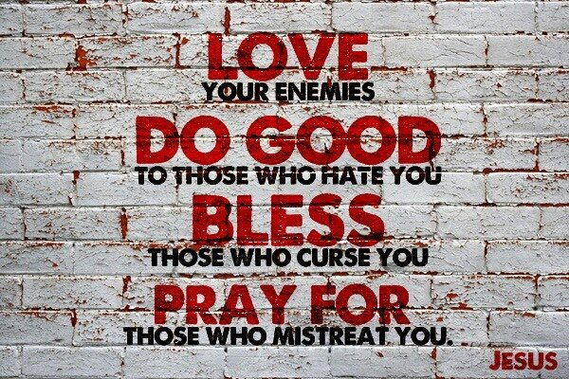 From Peter we learn that retribution is not the way God wants us to handle unjust situations. “The way of the world is to assert its will on others through human power, even violence, and the way of the world is to retaliate against violence with violence.” [21] The world tells us to “beat down” those who attack you so viciously that not only will they not be able to get back up but will also think twice about trying to hurt you again in the future. When someone wrongs us, there is always the temptation to “demonize” the perpetrator so that our vicious attacks might somehow feel justified. Paul tells us “do not repay evil with evil but instead to be careful to do right in everyone’s eyes” (Romans 12:17). James tells us that we are not to curse human beings because they have been made in the image of God (3:9-10). We are not to fight with the same weapons of this world but are to use the divine power given to us to demolish the strongholds of unjust attitudes (2 Cor. 10:4–5).[22] And when we are in doubt of how to handle injustice, ask God for wisdom and always be ready to love your enemies through your good deeds (Romans 12:20-21)!

**Running Away**

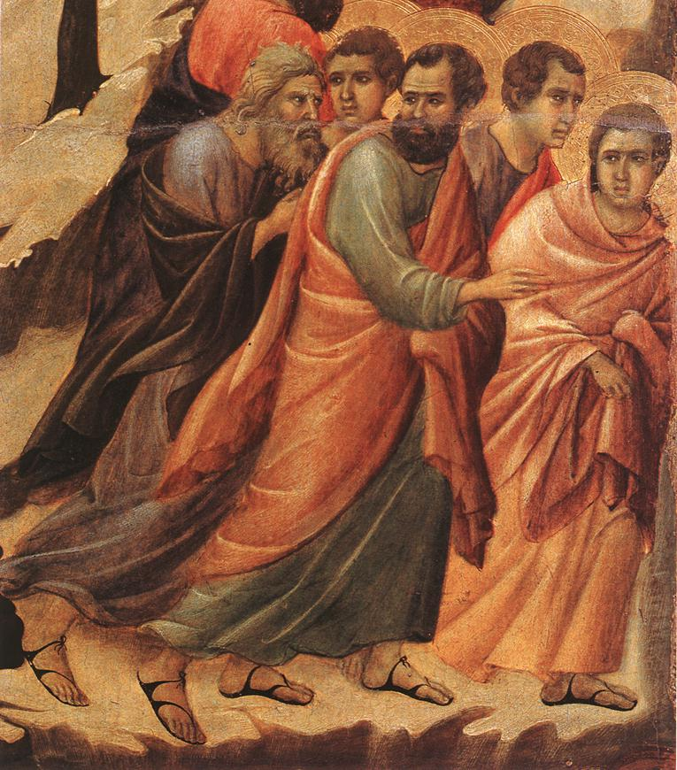SincePeter’s impetuous action of wielding the sword and cutting off the ear of the high priest’s servant made the disciples vulnerable to arrest, today’s passage finishes by telling us that all the disciples fled the scene.[23] Those who were unable to stay awake while Jesus prayed were now fleeing instead of standing by their Master.[24] Jesus had predicted their cowardice earlier (26:31-34) [25] and their fleeing was fulfillment of Zechariah who predicted that once the Shephard was struck the sheep would run away (13:7).[26] Martyrdom without resistance was simply a price the disciples were not yet ready to pay.[27] It was only through the divine grace of having received the Holy Spirit that these disciples who were timid like hares in the garden became brave like lions in later ministries.[28] Whether in front of the Sanhedrin (Acts 4:1-22) or in the face of death, for the rest of their lives no one could stop the disciples from spreading the Gospel message![29]

A person walking down a dirt road

Description generated with high confidence When faced with difficult situations in life there is always the temptation to run away. Who of us wants to face the possibility of bankruptcy? Who of us wants to stand tall and love our enemies that are trying to destroy us? Who of us wants to suffer a physical ailment so severe that it threatens our very lives? Under intense hardship our sinful nature looks for any means to escape. The problem we face is that not all methods of escape are acceptable to God. For example, while stealing from others or using violence against them might alleviate financial difficulties or presumably correct injustices, this kind of behavior is worldly and as such is a sin against God. Also, if one was to always run away from one’s circumstances then how would one’s faith increase? James tells us that it is through the testing of our faith and perseverance that we are made spiritually mature and complete (1:2-4). We should only take a path of escape from our difficulties when that path comes from God.

**Seeking God’s Will**

A picture containing person, man, looking, indoor

Description generated with very high confidence Jesus’ response to Judas’ greeting and kiss was “do what you came for, friend.” How did Jesus know exactly what was to be done when Judas betrayed Him? First, Scripture says even before the foundation of this world Jesus knew He was going to die for the sins of this world (Revelation 13:8). And secondly, before Judas arrived Jesus had just finished praying and asking God the Father what His will was for this situation. Jesus did not ask His Father because He did not know His will but to provide us an example of how we are to handle difficult situations. Like Jesus we are to seek and know God’s will through prayer and fasting in all matters. So, when faced with difficult situations don’t be like Judas who defiantly opposed God, like the crowds that blindly followed others, Peter who chose to meet violence with violence or the disciples who chose to run away. Instead through prayer and fasting seek and obey God’s will and He will give you the strength to endure and/or escape any situation and may everything we do as Christians be for the honor and glory of God the Father in heaven!

1. James Montgomery Boice, [*The Gospel of Matthew*](https://ref.ly/logosres/boicecm61bmt?ref=Bible.Mt26.47-56&off=2002&ctx=y+Was+Judas+Needed%3f%0a~The+last+we+saw+Juda) (Grand Rapids, MI: Baker Books, 2001), 574.
2. Michael J. Wilkins, [*Matthew*](https://ref.ly/logosres/nivac61mt?ref=Bible.Mt26.47&off=42&ctx=mple+troop+(26:47).+~Judas+left+Jesus+and), The NIV Application Commentary (Grand Rapids, MI: Zondervan Publishing House, 2004), 857–858.
3. James Montgomery Boice, [*The Gospel of Matthew*](https://ref.ly/logosres/boicecm61bmt?ref=Bible.Mt26.47-56&off=6297&ctx=ntic+evil+activity.%0a~Why+did+he+do+it%3f+Mi) (Grand Rapids, MI: Baker Books, 2001), 575.
4. Robert H. Mounce, [*Matthew*](https://ref.ly/logosres/nibcnt61mt?ref=Bible.Mt26.47-56&off=115&ctx=h+swords+and+clubs.+~The+mob+(which+inclu), Understanding the Bible Commentary Series (Grand Rapids, MI: Baker Books, 2011), 244.
5. Leon Morris, [*The Gospel according to Matthew*](https://ref.ly/logosres/pntcmatt?ref=Bible.Mt26.55&off=1168&ctx=en+him+at+any+time.+~They+had+not+done+so), The Pillar New Testament Commentary (Grand Rapids, MI; Leicester, England: W.B. Eerdmans; Inter-Varsity Press, 1992), 677.
6. Barclay Moon Newman and Philip C. Stine, [*A Handbook on the Gospel of Matthew*](https://ref.ly/logosres/ubshbk61?ref=Bible.Mt26.48&off=715&ctx=+its+use+at+12:38).+~The+city+of+Jerusale), UBS Handbook Series (New York: United Bible Societies, 1992), 820.
7. D. A. Carson, [“Matthew,”](https://ref.ly/logosres/ebc08?ref=Bible.Mt26.48-50&off=6&ctx=m+(Mt+27:19).%0a48%E2%80%9350+~The+need+for+pointin) in *The Expositor’s Bible Commentary: Matthew, Mark, Luke*, ed. Frank E. Gaebelein, vol. 8 (Grand Rapids, MI: Zondervan Publishing House, 1984), 546.
8. Robert H. Mounce, [*Matthew*](https://ref.ly/logosres/nibcnt61mt?ref=Bible.Mt26.47-56&off=977&ctx=+they+should+seize%2c+~but+it+was+also+a+%E2%80%9Cs), Understanding the Bible Commentary Series (Grand Rapids, MI: Baker Books, 2011), 245.
9. Leon Morris, 674.
10. Leon Morris, 673.
11. Robert H. Mounce, 244–245.
12. Craig S. Keener, [*Matthew*](https://ref.ly/logosres/ivntcmat?ref=Bible.Mt26.47&off=1181&ctx=7%3b+t.+H%CC%A3agiga+2:1).+~That+Judas+should+be), vol. 1, The IVP New Testament Commentary Series (Downers Grove, IL: InterVarsity Press, 1997), Mt 26:47.
13. James Montgomery Boice, [*The Gospel of Matthew*](https://ref.ly/logosres/boicecm61bmt?ref=Bible.Mt26.47-56&off=7303&ctx=s+Attack+on+Malchus%0a~It+is+not+only+from+) (Grand Rapids, MI: Baker Books, 2001), 575.
14. James Montgomery Boice, 576.
15. Craig A. Evans, 490.
16. Leon Morris, 675.
17. D. A. Carson, 547.
18. Robert H. Mounce, 245.
19. Leon Morris, 676.
20. D. A. Carson, 547.
21. Michael J. Wilkins, [*Matthew*](https://ref.ly/logosres/nivac61mt?ref=Bible.Mt26.51-54&off=633&ctx=the+sword%E2%80%9D+(26:52).+~The+way+of+the+world), The NIV Application Commentary (Grand Rapids, MI: Zondervan Publishing House, 2004), 859.
22. James Montgomery Boice, 578.
23. Michael J. Wilkins, [*Matthew*](https://ref.ly/logosres/nivac61mt?ref=Bible.Mt26.56b&off=38&ctx=don+Jesus+(26:56b).+~Peter%E2%80%99s+impetuosity+), The NIV Application Commentary (Grand Rapids, MI: Zondervan Publishing House, 2004), 860.
24. James Montgomery Boice, 579.
25. Michael J. Wilkins, 861.
26. James Montgomery Boice, 579.
27. Craig S. Keener, Mt 26:50.
28. C. H. Spurgeon, [*Morning and Evening: Daily Readings*](https://ref.ly/logosres/morneve?ref=DayOfYear.Mar+27+AM&off=1367&ctx=+the+Lord+wills+it.+~These+very+apostles+) (London: Passmore & Alabaster, 1896).
29. James Montgomery Boice, 579.