**Don’t Take the Bait**

**James 4:1-3**

Online Sermon: <http://www.mckeesfamily.com/?page_id=3567>

Whom amongst us does not know that we are one body of Christ, instructed to love, support and build each other up in the faith? And yet whom amongst us does not have one or several other Christians that have offended us? Looking back, their offenses did not start out heinous but by the time we were done “demonizing” these “perpetrators” our “flesh wounds” soon became firmly entrenched into our souls! The closer the relationship and the deeper the love we once had for the person, the deeper our current “indifference” or dare I say “hatred” we have towards that person. If only our love for ourselves and our pride was not so strong, maybe we could have respected and made room in our lives for the differences of others! Offense is a tool that Satan has been using since the beginning of time to destroy not only our relationships with each other but also our witness of “love” to this world. In this sermon I am going to review the book ***Bait of Satan*** by John Bevere and in doing so challenge each of you to go to the foot of the cross and with the forgiveness you have received offer it to all those “perpetrators” that have offended you!

**Offense is Affecting the Church**

A picture containing clipart

Description generated with high confidenceThe modern-day church is facing both internal and external threats that has led many to question its long-term survival. For example, the Postmodern belief that truth is a highly individualistic creation of one’s own mind, makes it very difficult to teach the Bible is the absolute truth.[1] Religious syncretism has obscured the truth so dramatically that the monotheistic belief in a single God is considered bigotry by most of this world. Due to the highly publicized fall of various religious leaders and institutions, confidence in the morality of the church has dropped nearly 20% over the last few decades.[2] Church attendance in Canada over the last 70 years has been in a steady decline from 67% in 1945 to 13% in 2015,[3] while atheism during the same time period has more than doubled.[4] To make matters worse the next generation the baby boomers are 50% less likely to attend church than their predecessors.[5]

A person wearing glasses and smiling at the camera

Description generated with very high confidenceWhile these numbers are serious threats, nothing reduces church attendance any faster than when members of the church start feeling they have been mistreated and misjudged by one another and therefore are justified to “demonize” and fight against their alleged “perpetrators.” When members stop serving by considering others better than themselves (Philippians 2:3) but instead feel entitled to their “acquired” positions of authority, the split and eventual dissolution of that church is not far away![6] After all, how many people in the church have stepped down from positions of service because they were offended by another member? How many people do you know that profess to be Christians and yet will not step a foot into the church because the politics are far too fierce? Is it possible for the wretched, miserable, poor, blind and naked (Revelations 3:14-20) people of the church to avoid offense and fulfil God’s command to love Him and one another? To answer this question let’s first look at how offense occurs in the first place.

**External and Internal Influences – The Foundation of the Cycle of Violence**

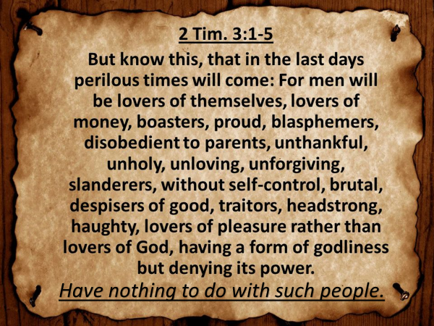 Given the selfishness of our culture, many Christians believe we are living in the end times.[7] While Paul tells us to have nothing to do with such people, whom amongst us truly can say we have not to some extent emulated some worldly characteristics? Do we not think about making money way too often? Have we not been abusive to our friends, family, colleagues and even from time to time church members? Do we not have people we refuse to forgive? Whom amongst us has not restricted the rights and freedoms of others when it benefited our own self-interest? As Christians we know we are not to emulate the sinful ways of this world (1 John 2:15) and yet we often find our hearts left unexamined and unrepentant are easily hardened by the deceitfulness of sin (Hebrews 3:13).

A person with a sunset in the background

Description generated with very high confidenceSince the flesh desires what is contrary to the Spirit and the Spirit desires what is contrary to the flesh; every Christian has an ongoing war inside of them (Galatians 5:17) in which the flesh, i.e. our sinful nature, often wins (Romans 7:18-20). Those who sow to please their flesh will reap destruction (Galatians 6:8). Since sin hinders our ability to hear God’s voice[8] and seek His wisdom, too often Christians get their council from this world who tells them it is “ok” to “beat down” anyone who might jeopardize the selfish desires of their hearts! While we should celebrate and make room for the differences of others, I believe we are living in the predicted age when many will be offended, betray and hate others (Matthew 24:10-13) because they are lawless and have allowed their love grow cold for one another.[9] If only we would anoint our eyes with salve (Revelation 3:18), we might come to know our true condition[10] … we have broken the command to love one another!

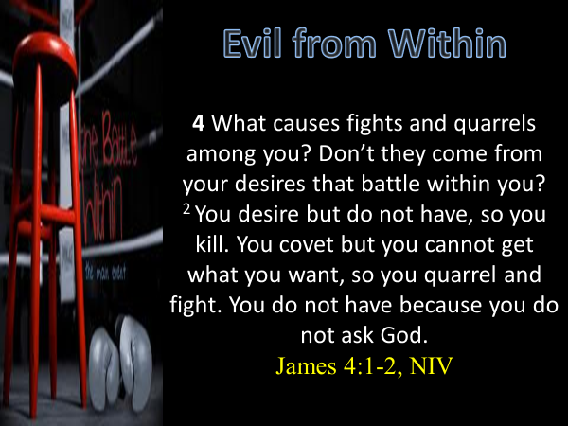Being influenced by the selfishness of this world and the internal desires of the flesh lays the foundation to fight to gratify the evil desires of our hearts. James tells us coveting what others have is the source of fights and quarrels in the church (4:1-2). The seeds of these fights can be found in those who respond to the differences of others by forbearing them while at the same time keeping a record of all the wrongs they have ever done! Each time a wrong occurs forbearance becomes more difficult because it puts one more cut onto one’s soul. Eventually the wounds are unbearable, and the person starts to demonize the other, covet and do heinous things against that person. In return the alleged perpetrator retaliates, and cycle of violence is unending. This begs the question; how does one avoid being offended when the other person has treated them with indifference or worst yet injustice?

**Not Getting Offended in the Face of Injustice - Joseph**

A group of people around each other

Description generated with high confidence To answer this question let’s look at Joseph (Genesis 37). Joseph was the offspring of Jacob and Rachel. We are told in Scripture that Jacob favored Joseph due to his being born late in Jacob’s life and as a result made him a coat of many colors. When his brothers saw that their father favored him over the rest of them, they hated Joseph and could not speak a kind word to him. To make matters even worse Joseph told his brothers he had a dream in which one day he would rule over them. This created jealousy in their hearts that intensified their hatred to the extent that they could tolerate him no longer! They plotted to kill him, throw him into a cistern and cover up their actions by saying that ferocious animals had devoured him. Reuben interjected and convinced the brothers to not kill Joseph with the intent of freeing him later from the cistern. When the other brothers saw Midianite, merchants come their way they decided it would be better to sell Joseph for twenty shekels of silver rather than get blood on their hands without being paid.

A group of people riding on the back of a horse

Description generated with high confidence What the brothers did to Joseph went beyond cruel. By selling Joseph to Potiphar, an officer of Pharaoh and the captain of the guard, they completely stripped Joseph of his identity. Not only would he not receive his father’s name and any part of his inheritance; both he, his future wife and any children would automatically be slaves as well![11] For ten long years he served Potiphar, not once hearing from his family and with the knowledge that his father was grieving over his apparent death. To make matters worse, due to Potiphar’s wife accusing him of trying to sleep with her, Joseph was thrown into Pharaoh’s prison (Genesis 39). With his feet bruised with shackles and his neck put in irons (Psalms 105:18), Joseph was given nothing more than bread and water to live on (1 Kings 22:27)! How would you feel if you were Joseph? Would you not feel justified to at the very least demonize your brothers, and more likely while in prison spend every waking moment plotting your revenge? And yet the next time Joseph met his brothers, even though he was second in command of Egypt and could have exacted his revenge, he not only forgave them but convinced Pharaoh to give his family Goshen, the choicest of Egyptian lands (Genesis 46-47)!

**Breaking the Cycle of Offense**

A sign on the side of a building

Description generated with very high confidence **How to Avoid Offense**. Because Joseph’s foundation was to trust God to take care of him he did not get offended by his brother’s actions. “A person who is not stabilized or founded in the revealed Word of God is a prime candidate to be moved along by the storm of offense.”[12] To keep from being offended our council and foundation of our beliefs must not come from this world but from God. Those who have one foot in God’s and one foot in Satan’s kingdom leave the door open for offense. When one is governed by one’s emotions and intellect, the opinions and statements against others are taken as absolute truth that varies based on whom one gets one’s council. When a person asks God for wisdom either through prayer or by meditating on His word, offense does not occur because our chief Cornerstone (Ephesians 2:19-22) would never tell us to be indifferent or hate but to love that person! Instead Jesus gives us the courage to go to our brother or sister when wronged (Matthew 18:15-20) and clearly see the situation from their point of view, so that us “living stones” might be able to forgive and make room for one another as one spiritual household (1 Peter 2:5). One can tell that Joseph did not get offended by his brother’s actions because he did not keep records of their wrongs (1 Corinthians 13:6)!

A close up of a person

Description generated with high confidence **How to Overcome Offense**. How does one overcome offense in the face of the hands of injustice? This is far from easy but can be accomplished. Even though His own rejected Him, His disciples deserted Him, and the Roman government system failed Him; while on the cross Jesus looked upon His enemies and said “forgive them they know not what they do” (Luke 23:34). Reflect for a moment on all the sins that you have done in your lifetime. Even as Christians are not our sins the reason why Jesus died on the cross? He had every reason to hate us and leave us under the curse of spiritual death and yet while we were still His enemies Christ died so that we might have a chance to be reconciled unto Him! Should we not follow Christ’s example and show grace, mercy and forgiveness to others (2 Corinthians 1:3-7)? Letting go of offense is a matter of trust. Do you trust God enough to handle your unjust situation in a way that is fair and equitable to both parties or do you feel you are the better judge?

1. Grenz, Stanley J. *A Primer on Postmodernism*. Grand Rapids, MI: Willian B. Eerdmans Publishing Company, 1996, 43.
2. Ibid., 27.
3. Taken from the following website: <http://www.intrust.org/Magazine/Issues/New-Year-2016/Religious-affiliation-and-attendance-in-Canada>
4. Reginald Bibby, *Resilient Gods, Being Pro-Religious, Low Religious or no Religious in Canada*, 2017, 80.
5. Ibid., 20 (hopefully the older baby boomers get the more they start attending church).
6. Taken from the following website: <https://thomrainer.com/2015/03/nine-thoughts-church-splits/>.
7. John Bevere, Bait of Satan: Living Free from the Deadly Trap of Offense, Charisma House Book Group, 2004, 6.
8. John Bevere, 8.
9. Ibid., 12.
10. Ibid., 11.
11. John Bevere, 24.
12. John Bevere, 70.