**Let there be Light**

**Genesis 1:1-5**

Online Sermon: <http://www.mckeesfamily.com/?page_id=3567>

**In the beginning God created the heavens and the earth. 2Now the earth was formless and empty, darkness was over the surface of the deep, and the Spirit of God was hovering over the waters. 3And God said, “Let there be light,” and there was light. 4God saw that the light was good, and he separated the light from the darkness. 5God called the light “day,” and the darkness he called “night.” And there was evening, and there was morning—the first day.**

**Genesis 1:1-5, NIV**

Light and darkness is contrasted all throughout Scripture. In Genesis these terms refer to the light of day and the darkness of night but in the New Testament these terms refer to the spiritual darkness that comes from being in a fallen state of deprivation and separation from God (Romans 3:23, 6:23) versus having the spiritual light that comes from being born of the Spirit (John 3:5-8) and adopted as His children (John 1:12). For many spiritual light and darkness are not easy terms to understand. For example, since God is pure light and in Him there is no darkness (1 John 1:5) does this mean that those who are born again no longer have the darkness of sin inside of them? Since we know this is not true of anyone (1 John 1:8-9) then how can a person say that they are truly born again? And since the cross is foolishness to those perishing in their sins (1 Corinthians 1:18) then how can the Spirit of God hover over and convict anyone to be born again when God cannot look on sin (Habakkuk 1:13)? In today’s sermon I am going to answer these questions by drawing an analogy between what we do know physical darkness and light to what we struggle to understand, spiritual darkness and light.

**God Created the Heavens and the Earth**

Before we get into the analogy I want to first turn your attention to the very first statement in Genesis: “in the beginning God created the heavens and the earth.” While this statement seems straightforward it is the subject of great debate in philosophy, theology and metaphysics.[1] While these debates are beyond the scope or intent of this sermon there are a few points that I would like to make. First, while Genesis 1:1 could refer to an extended period of time prior to the seven days of creation,[2] the seven words A picture containing animal, invertebrate

Description generated with very high confidenceof this verse were most likely intended to be not only a literary introduction to the Creation story[3] but also an anticipation of the end of the universe[4] when the new heavens and earth will come (Isaiah 65:17; 66:22).[5] Until God spoke nothing existed but Him.[6] Since something cannot be created out of nothing,[7] Creation of all things between the heavens and the earth, which encompasses the entire universe,[8] is to be seen as a divine activity[9] in which all things seen and unseen owe their existence to Elohim.[10] While the Creation story is not intended to prove or disprove scientific theories, given amble evidence of miracles in the Bible one can say with confidence that Genesis accurately teaches the origin[11] of “matter, life, values, evil, grace, the family, nations, and other things—in a way that unites us all.”[12]

**Illustration – The Darkness and the Light**

 To help us better understand how much physical darkness and light affect our ability to function, I did the following illustration at church. I first constructed a cave out of some two by fours, plastic and a tarp. I placed a giant stuffed spider on the outside roof of the cave and spider web all throughout the inside to make it a little scary. I then took a black marker and wrote on the inside roof of the cave the following phrases from Genesis 1:3-5: “formless and empty darkness,” “Spirit of God was hovering,” “Let there be Light,” and “Separating the light from the darkness.” I then asked if any children wanted to volunteer. They got to choose one adult to accompany them so that they might enter and feel safer in the cave. I gave each child a glow stick. Once inside the cave the adult and child were to look for one of the above phrases and were permitted to use the glow stick if they wanted too. It was hard to find the phrases that were written in black on a blue background and even more difficult to interpret them for many words were written backwards. To make it more exciting those who participated and did not find a phrase a small prize, those who found a phrase with using the glow stick got a bigger prize and those who found a phrase without using the glowstick got the biggest prize. To make sure everyone got a turn each team was given a maximum of two minutes in the cave.

**Physical and Spiritual Darkness and Light**

A picture containing dark

Description generated with very high confidence While the illustration was a lot of fun its intent was to create what is called an analogy. An analogy is the comparison of two things for clarification. Jesus often used something in the physical world which was easy to understand to explain something in the spiritual world that was difficult to understand. For example, Jesus used the process of physically sowing seeds to help His audience understand why the same Gospel message was received by some and rejected by others. Jesus used the process of making bread to help His audience understand that the kingdom of God would exert its influence from within a person and in turn the born-again believer’s faith and deeds would influence the world. Jesus used the process of separating physical wheat from tares to help explain how God at the final judgment is going to separate His own from non-believers so that some will go to heaven and the others burned in hell (Matthew 13). In today’s sermon I am going to use the darkness and light of illustration of the cave to help explain what the Bible means by spiritual darkness and light.

**Formless and Empty Darkness**

A close up of a person wearing a hat

Description generated with high confidence Being in a physical cave of darkness can teach us a lot about spiritual darkness. Once the team got into the cave they immediately lit their glow stick for without it they could not find or read the phrases that they were looking for. In verse two we are told the “earth was formless and empty.” “The evil that involves mankind is the product of our own choice, expressed as a rebellion against God, and it has affected us so totally that there is now nothing we can do to restore ourselves or regain that position of privilege and responsibility that we lost by rebellion.”[13] Even though creation declares the glory of God (Psalms 19:1-2), His eternal power and divine nature (Romans 1:20); knowledge of God alone cannot save a person. The soul without light is one that is spiritually dead, sinful and utterly barren of any fruit.[14] Within an unregenerate soul exists the forces of chaos[15] for until the soul finds its Creator he/she will forever be looking for but never finding the truth (2 Timothy 3:7). While living without boundaries[16] can bring short term happiness, if a soul rejects the Truth that will set it free (John 8:32), he/she cannot be released from the from the bondage of sin that will inevitably bring eternal, spiritual death (Romans 6)!

**Spirit of God was Hovering**

[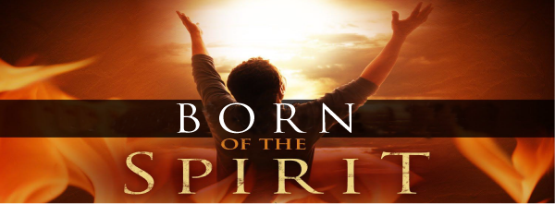](https://www.google.ca/url?sa=i&rct=j&q=&esrc=s&source=images&cd=&cad=rja&uact=8&ved=2ahUKEwiWhJ78u4XaAhVD54MKHeJyBF8QjRx6BAgAEAU&url=http://www.taurangaelim.nz/audio-born-of-the-spirit/&psig=AOvVaw0IzMDwEKErJQZyl8eyagXJ&ust=1521998365561900) The act of shaping and forming the world began with the Spirit of God hovering over the waters.[17] In a similar manner the act of the “second creation,” i.e. being born again, can only be initiated and accomplished through the power of the Spirit. While no one can know where the Spirit comes or goes (John 3:8), the coming of the Day of the Lord (Joel 2:28-29), the conception of Jesus (Matthew 1:18), the Day of Pentecost (Acts 2:1-4) are just a few examples of the Spirit’s creative and redemptive activity.[18] In the illustration each team in the cave soon realized they needed to use the glow stick or they would never be able to see the phrases. In a similar manner the Gospel message cannot be “seen” or understood until first the Spirit of God gives the person enough light to perceive and then to either accept or reject the truth concerning God. The Spirit does not need to participate in the darkness of a person to reveal to them light. Since God does not want anyone to perish (2 Peter 3:9), we can be assured that everyone will be given enough light to make this choice!

**Let there be Light**

[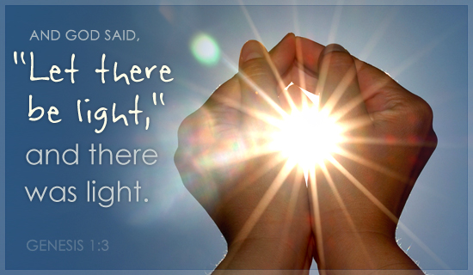](https://www.google.ca/url?sa=i&rct=j&q=&esrc=s&source=images&cd=&cad=rja&uact=8&ved=2ahUKEwjFiZzGzYXaAhWJxYMKHYcMBhwQjRx6BAgAEAU&url=http://www.chronozoom.com/regyoo/RegYoo/506ad1d0-1088-4a88-918a-9b563384538f&psig=AOvVaw1ljmdV1eFdvc4bjpLJyqxX&ust=1522003070617066) In the illustration the moment the person chose to use the glow stick the darkness had to give into the presence of light. In a similar manner the moment that God said “let there be light” there was light! The moment that a person asks for forgiveness of sins, believes in the atoning death of Christ and makes Him the lord of their lives (Romans 10:9), they go through the second creation and are born again, not of flesh and blood (John 1:13) that is corrupted and perishable (1 Corinthians 15:50) but that born of water and the Spirit as an eternal child of God (John 3:5). While how beautiful are the feet that bring the Good News (Romans 10:14), planting and watering the seeds of righteousness cannot bear fruit without the Spirit’s power to raise the soul from dead to life (1 Corinthians 3:6)! God can look upon a person born again even though their old self still sins (1 John 1:9-10) because of His seal is on their heart (Ephesians 1:13) and Jesus has paid the price for their sins (John 3:16).

**Separating the Light from the Darkness**

[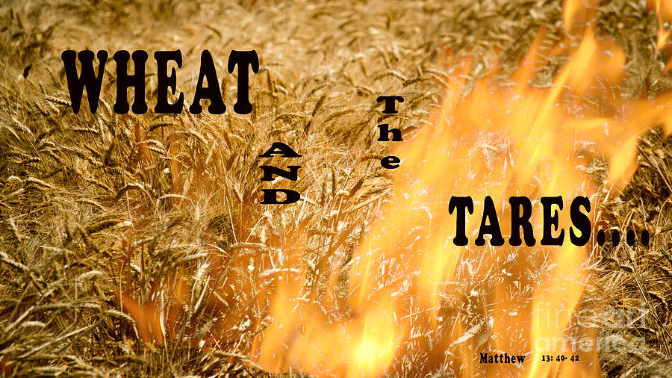](https://www.google.ca/url?sa=i&rct=j&q=&esrc=s&source=images&cd=&cad=rja&uact=8&ved=2ahUKEwiJhvrS0YXaAhUM7YMKHc6oDHkQjRx6BAgAEAU&url=https://fineartamerica.com/featured/wheat-and-the-tares-beverly-guilliams.html&psig=AOvVaw181XZkHyyDBtg6buDwd-aN&ust=1522004177926744) The purpose of this sermon was not just to clear up some misconceptions concerning spiritual darkness and light but was also to finish with a warning that the day is coming when God will separate the wheat from the tares (Matthew 13:24-30). In the creation story God separated the darkness and called it “night” from the light that He called “day.” The day is coming when God will separate those whose names are in the Book of Life from those He never knew (Revelation 20:15). On that day, while all will bow their knees to the Creator (Philippians 2:9-11) only the wheat will go and be with Him in paradise. Those who never knew God (Matthew 7:21-23) will be gathered together and placed in fiery furnace where there will forever be weeping and gnashing of teeth (Matthew 13:50). Now that you know this to be true I pray the Spirit of God will reveal Himself to you and you will chose to bow your knee to Him and have your soul hear God say “let there be light.”

1. John H. Walton, [*Genesis*](https://ref.ly/logosres/nivac01ge?ref=Bible.Ge1.1&off=46&ctx=)%0aIn+the+beginning.+~It+sounds+so+simple%2c), The NIV Application Commentary (Grand Rapids, MI: Zondervan, 2001), 67.
2. John H. Walton, [*Genesis*](https://ref.ly/logosres/nivac01ge?ref=Bible.Ge1.1&off=3910&ctx=his+initial+period.+~Sailhamer+is+incline), The NIV Application Commentary (Grand Rapids, MI: Zondervan, 2001), 69.
3. John H. Walton, 70.
4. K. A. Mathews, [*Genesis 1-11:26*](https://ref.ly/logosres/nac01a?ref=Bible.Ge1.1&off=90&ctx=1:1+%E2%80%9C~In+the+beginning%E2%80%9D+(be%CC%86re%CC%84%CA%BEs%CC%8Ci%CC%82t)+ma), vol. 1A, The New American Commentary (Nashville: Broadman & Holman Publishers, 1996), 126.
5. D. A. Carson, ed., [*NIV Zondervan Study Bible: Built on the Truth of Scripture and Centered on the Gospel Message*](https://ref.ly/logosres/nivzndrvnstbbl?ref=Bible.Ge1.1&off=849&ctx=+and+the+new+earth.+~Isaiah+repeatedly+st) (Grand Rapids, MI: Zondervan, 2015), 25.
6. Derek Kidner, [*Genesis: An Introduction and Commentary*](https://ref.ly/logosres/totc01geus?ref=Bible.Ge1.1&off=1253&ctx=iliar+translation%2c+%E2%80%98~In+the+beginning+God), vol. 1, Tyndale Old Testament Commentaries (Downers Grove, IL: InterVarsity Press, 1967), 48.
7. Matthew Henry, [*Matthew Henry’s Commentary on the Whole Bible: Complete and Unabridged in One Volume*](https://ref.ly/logosres/mhenry?ref=Bible.Ge1.1-2&off=4068&ctx=ade+out+of+nothing.+~By+the+ordinary+powe) (Peabody: Hendrickson, 1994), 3.
8. John E. Hartley, [*Genesis*](https://ref.ly/logosres/bakerubot01ge?ref=Bible.Ge1.1&off=835&ctx=is+never+mentioned.+~The+terms+%E2%80%9Cthe+heave), ed. W. Ward Gasque, Robert L. Hubbard Jr., and Robert K. Johnston, Understanding the Bible Commentary Series (Grand Rapids, MI: Baker Books, 2012), 43.
9. John H. Walton, 70.
10. John H. Sailhamer, [“Genesis,”](https://ref.ly/logosres/ebc02?ref=Bible.Ge1.1&off=2379&ctx=of+1:1+(see+Notes)%2c+~the+narrative+states) in *The Expositor’s Bible Commentary: Genesis, Exodus, Leviticus, Numbers*, ed. Frank E. Gaebelein, vol. 2 (Grand Rapids, MI: Zondervan Publishing House, 1990), 20.
11. James Montgomery Boice, [*Genesis: An Expositional Commentary*](https://ref.ly/logosres/boicecm01agn?ref=Bible.Ge1.1&off=4301) (Grand Rapids, MI: Baker Books, 1998), 15.
12. James Montgomery Boice, 16.
13. James Montgomery Boice, 18.
14. C. H. Spurgeon, [“Light, Natural and Spiritual,”](https://ref.ly/logosres/mtpserms11?ref=biblio.at%3dLight%2c%2520Natural%2520and%2520Spiritual%7Cpg%3d637%E2%80%93648&off=1495&ctx=+disorder.+There+is+~no+thought+of+faith%2c) in *The Metropolitan Tabernacle Pulpit Sermons*, vol. 11 (London: Passmore & Alabaster, 1865), 637.
15. John H. Walton, 72.
16. John H. Walton, 73.
17. C. H. Spurgeon, [“Light, Natural and Spiritual,”](https://ref.ly/logosres/mtpserms11?ref=biblio.at%3dLight%2c%2520Natural%2520and%2520Spiritual%7Cpg%3d637%E2%80%93648&off=2886&ctx=n+with+the+formation~+and+shaping+of+the+) in *The Metropolitan Tabernacle Pulpit Sermons*, vol. 11 (London: Passmore & Alabaster, 1865), 637–638.
18. D. A. Carson, ed., [*NIV Zondervan Study Bible: Built on the Truth of Scripture and Centered on the Gospel Message*](https://ref.ly/logosres/nivzndrvnstbbl?ref=Bible.Ge1.2&off=1770&ctx=Acts+2:1%E2%80%934%2c+16%E2%80%9321).+~Although+the+term+%E2%80%9CH) (Grand Rapids, MI: Zondervan, 2015), 26.