**Divine Healing**

**Luke 7:22; Isaiah 61:1-3; Luke 5:27-32**

Online Sermon: <http://www.mckeesfamily.com/?page_id=3567>

Where can one look for healing of the body, mind and soul when all human attempts at healing have failed? While we would all like to stay forever on the mountain top of pleasure, living in this fallen world inevitably means also walking in the valleys of incredible pain. Who can stand the pain when our bones become sore vexed and our flesh begins to fail? When sleep is the only escape from the very pain that keeps one awake all hours of the night, how can one be content and not seek any means of escape? When one feels like they are trapped at the bottom of a lake of loneliness and utter despair, where any happiness is internally viewed as a sin because pain has become one’s only faithful friend, how can one ever expect to escape when one’s own mind is a prison of relentless darkness from within? Knowing that no human can light the way in our dark, bottomless pit of despair how can one not be utterly crushed when all hope is cut away from one’s mind? And who can stand the searing pain of knowing that despite our sincere efforts to strive against it and repeated confessions to God that the indwelling of a sin has become not only a habit but part of one’s very character? After all, how could a holy God ever accept what appears to others as intentional, outright defiance against one’s own Creator? This sermon is all about giving hope to those whose broken body, mind and soul have no human physician that can heal them. My goal is to remind you that when you cry out “Jesus Help Me,” He who created you can also heal you, especially when all hope is gone!

A picture containing person

Description generated with very high confidence**Living in a Fallen World**

Adam and Eve’s disobedience brought tragic spiritual, physical and social deprivation to this world.[1] “Although the image of God in man survives (Genesis 9:6), reason has lost its soundness (2 Corinthians 4:4), the will no longer is free to choose God and the good (John 8:34), and sinners are spiritually blind (1 Corinthians 2:14) and dead (Ephesians 2:1, 5).”[2] Due to sin, even the rest of God’s creation has been brought under a curse.[3] Since the earth has been subjected to frustration and is currently under a bondage of decay (Romans 8:20-22), blessings and curses are not always the product of obedience or disobedience but can also be the product of mere chance (Ecclesiastes 9:11). While an individual’s disobedience has a direct negative impact on the health of the soul, the body is destined to decay over time and to eventually return to the dust in which it came the moment God commands it to do so! Given that one cannot stop sinning while living in a world under a curse, it should not come as a surprise that we are not immune to sin or its consequences of pain in our bodies, minds and souls!

**Healing of our Body**

A person looking at the camera

Description generated with high confidence The consequences of living in a fallen world are often realized when the body gets hurt. From the first time we skinned our knee, bumped our head or went to the dentist we soon learned that our bodies feel pain when broken. While I wished this list represented the most pain one would ever feel, there are diseases that cause far more excruciating pain than words would ever do justice to describe. For example, 19 % of men and 9 % percent of women[4] will get kidney stones which are often described as being more painful than giving birth.[5] While almost everyone gets lower back pain at least once in their lifetime, this single leading cause of disability worldwide leaves one in ten in chronic pain for their entire lives![6] One in two Canadians will develop cancer in their lifetimes and experience the pain of not only having their cells mutate but also the pain of drug therapy![7] While the doctors can treat, cure and remove the pain of these diseases some of the time; most patients must live with chronic pain and others face imminent death. When doctors cannot heal to whom do we turn?

**22So he replied to the messengers, “Go back and report to John what you have seen and heard: The blind receive sight, the lame walk, those who have leprosy are cleansed, the deaf hear, the dead are raised, and the good news is proclaimed to the poor.**

**Luke 7:21-22, NIV**

A picture containing farm machine

Description generated with high confidenceDue to his denunciation of Herod Antipas for his marriage to his brother Phillip’s wife, John was thrown into prison (Matthew 6:14-29).[8] To make matters worse this was not just any prison but the fortress of Machaerus near the Dead Sea! This was where Herod punished the worst offenders. It was halfway underground and was desperately hot. Even though having been born into a priestly family (Luke 1:5), having the Spirit of God living inside oneself since birth (Luke 1:15-17) and being the forerunner of the coming of the Messiah (Isaiah 40:3-5; Malachi 3:1) were truly joyful events, lying in a prison fortress in great anguish and pain soon resulted in John doubting whether Jesus was truly the Messiah (Matthew 1:2-6)![9] In response to his doubts Jesus tells both John and us that His healing of those who were blind, lame, deaf, having leprosy and had even died was ample proof of His identity!

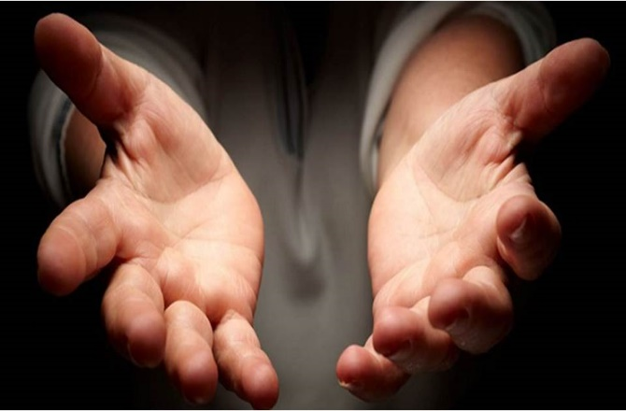Like John, when waves of pain come rushing in they can quickly drown every blessing that one has. Upon receiving the news that your pain is chronic and most likely will end your life can crush hope in even the most mature of Christian. When the doctors cannot heal you turn to He who knit you in your mother’s womb (Psalms 139:13), for the Great Physician has command over all diseases. When hope is but a distant memory, remember all the stories in the Bible of Jesus’ miracles. Did Jesus not heal the one born blind (John 9:1-12), the woman subject to bleeding for twelve years (Mark 5:25-34), the paralyzed man (Matthew 9:1-8), the 38-year invalid (John 5:1-15), the man with leprosy (Mark 1:40-45) and even raised Lazarus back to life (John 11:38-44)? And even when Jesus chooses to not heal while one remains on the face of this earth, He will give you the strength to not only persevere but have a powerful testimony to others that great faith can be experienced in utter weakness and in this weakness you are strong!

**Healing of our Mind**

A picture containing sky

Description generated with very high confidenceThe consequences of living in a fallen world are often felt when the mind gets broken. While this world is full of many pleasurable experiences to be had, there are also tribulations that can fracture the mind. If the peer pressure of being in school was not scary enough, one in four students will be bullied in their lifetime.[10] If this was not difficult enough to endure, as we grow up 4 in 10 Canadians will go through at least one divorce in this lifetime and all of us will experience grief of losing a loved one. These difficulties in life have a dramatic effect upon our minds. Anxiety disorders are the most common mental illness in the U.S. affecting 18% of its population over the age of 18 every year.[11] Often associated with anxiety, some 350 million people worldwide also suffer from depression[12] of which according to the World Health Organization approximately 800,000 of them will commit suicide every year.[13] A study of students from 70 colleges and universities across the U.S. found that more than 50% of those surveyed thought about suicide at least once in their lifetime.[14] When the psychologists and drugs of this world cannot help repair the diseases of the mind surely there is a better option than suicide to relieve the pain!

**The Spirit of the Sovereign Lord is on me, because the Lord has anointed me to proclaim good news to the poor. He has sent me to bind up the brokenhearted, to proclaim freedom for the captives and release from darkness for the prisoners**

**Isaiah 61:1, NIV**

Two people standing in front of a crowd

Description generated with very high confidence When Jesus stood in the temple and read from the book of Isaiah He claimed He had not only been commissioned, consecrated and authorized to proclaim the good news but to also bind/heal the brokenhearted![15] Since all things in heaven and earth, visible or invisible were created by Him and for Him (Colossians 1:16), why should we ever doubt that He alone can heal the mind? Was it not Jesus who healed the man whose mind was possessed by a legion of demons (Mark 5:1-20)? Was it not Jesus who restored the broken mind of the Samaritan woman who was an outcast of society (John 4:7-26)? And was it not Jesus who healed Peter’s feelings of utter despair for having denied Jesus three times? When it feels like the weight of the world is crushing our minds, Christ alone is the one who can comfort by breaking the chains of fear that have imprisoned our minds. Healing is best found by reading and obeying God’s word so that our minds can be renewed (Romans 12:1-2) with the unspeakable joy that can only be given by our Savior who lived, bled and died for us (1 Peter 1:8)!

**Healing of the Soul**

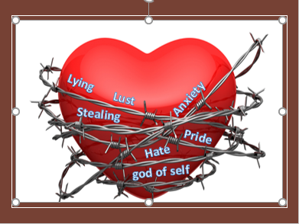The final consequence of living in a fallen world that I am going to look at is how sin affects the soul. We all sin and fall short of the glory of God (Romans 3:23). Did you know that for every ten minutes a person is talking they lie at least once and for the entire day they lie about 100 times?[16] Did you know that the average unmarried, male thinks about sex about 19 times a day and female about 10?[17] Did you know that even though we are to feel unspeakable joy of serving in God’s kingdom, the average person has 40,000 negative thoughts a day?[18] Did you know that one in six people will steal something in their lifetime?[19] Did you know that even though 77% of the people feel that society’s morality is going downhill, 57% of Christians read their bible only four times a year and only 26% read it daily?[20] And while I looked but could not find a statistic, how many Christians do you think are breaking the first commandment (Exodus 20:3), to not have other gods in their lives?

**30But the Pharisees and the teachers of the law who belonged to their sect complained to his disciples, “Why do you eat and drink with tax collectors and sinners?” 31Jesus answered them, “It is not the healthy who need a doctor, but the sick. 32I have not come to call the righteous, but sinners to repentance.”**

**Luke 5:30-32, NIV**

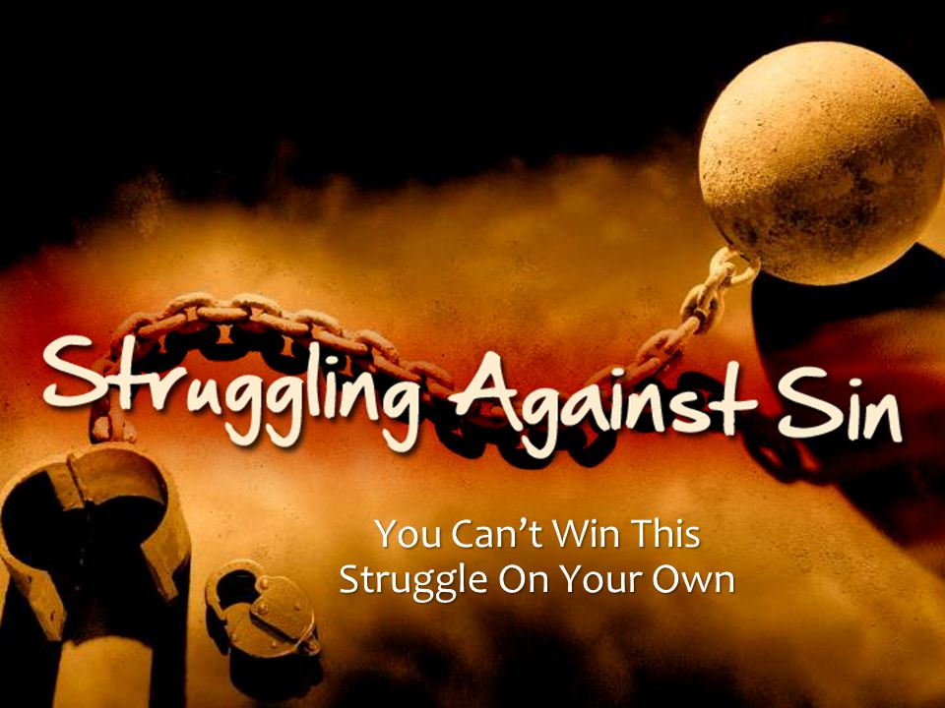Sin drives a wedge between us and God for He whose image you were made in commands you to be holy like He is holy (1 Peter 1:16). The essence of who we are, our souls, comes from God (Ecclesiastes 12:7) and as such must be fed by the Bread of life (John 6) to be healthy! We all (1 John 1:10) have evil desires in our hearts (James 1:14) that drag us away from God. While we know we ought to do good, i.e. obey God’s commands, that is what we do least often; and while we know we should avoid sinning that is what we do most often (Romans 7:8-24). Since God knew we would never be able to win this battle and stop sinning, He sent His Son Jesus to atone for our sins and give us the power to be holy! When the Pharisees asked Jesus “why do you drink with tax collectors and sinners?” I am so glad Jesus responded by saying that He came to heal us sinners so that we might be delivered from the wages of sin, death!

***Final Thought: Where can one look for healing of the body, mind and soul when all human attempts have failed? When all else fails and life’s tribulations are crushing one’s body, mind and soul turn to the Great Physician for He who knit you in your mother’s womb can make you whole again!***

1. Walter A. Elwell, [*Evangelical Dictionary of Theology: Second Edition*](https://ref.ly/logosres/evdicttheo?ref=Page.p+434&off=5277&ctx=+of+the+Human+Race.+~The+fall+denotes+Ada) (Grand Rapids, MI: Baker Academic, 2001), 434–435.
2. Ibid., 436.
3. Leon Morris, [*The Epistle to the Romans*](https://ref.ly/logosres/pntcrom?ref=Bible.Ro8.21&off=542&ctx=+this+as+permanent.+~Creation+will+in+due), The Pillar New Testament Commentary (Grand Rapids, MI; Leicester, England: W.B. Eerdmans; Inter-Varsity Press, 1988), 322.
4. Taken from the following website: <https://www.kidney.org/atoz/content/kidneystones>
5. Taken from the following website: <https://www.prevention.com/health/top-painful-medical-conditions>
6. Taken from the following website: <https://www.acatoday.org/Patients/Health-Wellness-Information/Back-Pain-Facts-and-Statistics>
7. Taken from the following website: <http://www.cancer.ca/en/cancer-information/cancer-101/cancer-statistics-at-a-glance/?region=on>
8. Walter A. Elwell, [*Evangelical Dictionary of Theology: Second Edition*](https://ref.ly/logosres/evdicttheo?ref=Page.p+636&off=1439&ctx=+his+manifestation.%0a~John%E2%80%99s+denunciation+) (Grand Rapids, MI: Baker Academic, 2001), 636.
9. Paul W. Hollenbach, [“John the Baptist,”](https://ref.ly/logosres/anch?ref=biblio.at%3dJohn%2520the%2520Baptist%7Cau%3dHollenbach%2c%2520Paul%2520W.%7Ced%3dFreedman%2c%2520David%2520Noel&off=15588&ctx=+highly+(11:11).%0a5.+~While+John+was+in+pr) ed. David Noel Freedman, *The Anchor Yale Bible Dictionary* (New York: Doubleday, 1992), 889.
10. Taken from the following website: <https://www.thetoptens.com/hardest-things-life/>
11. Taken from the following website: <https://adaa.org/about-adaa/press-room/facts-statistics>
12. Taken from the following website: <https://www.healthline.com/health/depression/facts-statistics-infographic#2>
13. Taken from the following website: <https://www.livescience.com/44615-suicide-help.html>
14. Taken from the following website: <http://abcnews.go.com/Health/DepressionNews/50-college-students-felt-suicidal/story?id=5603837>
15. John Goldingay, [*Isaiah*](https://ref.ly/logosres/bakerubot23is?ref=Bible.Is61.1-9&off=1079&ctx=ch+other+in+the+ot.+~Anointing+suggests+c), ed. W. Ward Gasque, Robert L. Hubbard Jr., and Robert K. Johnston, Understanding the Bible Commentary Series (Grand Rapids, MI: Baker Books, 2012), 346.
16. Taken from the following website: <https://www.reference.com/world-view/many-times-day-average-person-lie-47b13ac29354113c>
17. Takenf from the following website: <http://www.bbc.com/future/story/20140617-how-often-do-men-think-about-sex>
18. Taken from the following website: <http://business.financialpost.com/entrepreneur/three-techniques-to-manage-40000-negative-thoughts>
19. Taken from the following website: <http://time.com/4069935/thief-study/>
20. Taken from the following website: <https://religionnews.com/2013/04/04/poll-americans-love-the-bible-but-dont-read-it-much/>