**LIFE UNDER CONSTRUCTION**

**Matthew 7:24-27**

Online Sermon: <http://www.mckeesfamily.com/?page_id=3567>

**ILLUSTRATION**

This illustration focuses on my lack of carpentry skills. The first thing I did was I dressed up in an outrageous outfit. I had coveralls, a wig and a pencil by my ear to make myself appear like a “crazy carpenter.” When I started the skit, there was also on the overhead screen a picture of a crazy carpenter to help emphasize this theme. I then announced to the church that I was about to build for them a new bookshelf. I took out the instruction manual from the box. As I attempted to read it I complained profusely that while it was written in English it read awkward as if it was translated from a foreign language like Hebrew, Greek or Aramaic. I then made all sorts of puzzling faces. I commented that I needed to seek advice from another person on what I should do with these instructions. I then played a video clip of another me saying that real men don’t read instructions so I threw them away and laughed … I can build this bookshelf myself, who needs help?

Now came the time to begin construction. I poured the contents of the box out on a table where all could see. I then took two pieces of board, aligned up their edges and took a small hammer and nail and proceeded to attach one board to the other. As I was pounding in that first nail I grumbled about how awkward holding the boards together was and the length of time it was taking to get that small nail driven into place. I then looked intently up at the congregation as if I had an awesome idea and proceeded to ask it I could have a volunteer. I ended up choosing a known carpenter from the congregation to help me. I told him I did not want his advice just his hand to hold the boards together. I then told him the last nail took way too long to drive in so this time I was going to use a sledge hammer and a much longer nail for stability. I then awkwardly pounded in a nail in each of the corners of all four boards to make a box shaped outline of a bookshelf.

Now came the time to make the inner shelf. I took out a board and had a very puzzling look upon my face. I asked the carpenter if this board would fit inside the box to make a shelf? He recommended measuring it but I told him that would take way too long. So, I used my feet to measure the length of the box. I measured the length of the box at three and a half of my feet and proceeded to use a circular saw to cut the board accordingly. The carpenter of course just shook his head. I then placed the board into the box and found the best it would fit was on a steep angle. I looked puzzled but said it would do. I then complained that nailing in of the spikes took way too long. So, I took out my drill bit and just below the wood of the shelf I screwed in some rather long screws for the wood to sit on.

Now came the time to make a backing on the shelf. I showed the shelf to the congregation and tested its sturdiness. I concluded it was way too flimsy! So, I took a piece of pressed board that was slightly too big for the back of the box and proceeded to attach it into place. I again complained that the small nails, large spikes and the screws took way too long so I used duct tape and wrapped it around the box to hold the back into place.

The last thing I did was to try and sell the book shelf. I talked about the bookshelf and said many impressive comments about the carpentry work. I asked the congregation if anyone wanted to purchase this rare, one of a kind work of art? I tried to auction it off but no takers. So, to prove to them it’s worth I tried to place several books on the shelf. Of course, with each attempt the books just fell of the shelf and onto the floor. I told the congregation I was really puzzled for I had taken a long time to build this wonderful shelf, what went wrong? I then told them that if it could not be used as a shelf then maybe a chair. So, I sat down on the shelf and it collapsed. I got up and finished the skit by asking them: would you let me build your house?

**CRAZY CARPENTER OR BUILDING GOD’S WAY?**

**24“Therefore everyone who hears these words of mine and puts them into practice is like a wise man who built his house on the rock. 25The rain came down, the streams rose, and the winds blew and beat against that house; yet it did not fall, because it had its foundation on the rock. 26But everyone who hears these words of mine and does not put them into practice is like a foolish man who built his house on sand. 27The rain came down, the streams rose, and the winds blew and beat against that house, and it fell with a great crash.”**

While this skit was humorous and entertaining it also contains a profound message! In the above passage Jesus tells us a parable about the wise and foolish builder. The wise builder hears and lives by God’s words so that when the tribulations of life inevitably come they stand firm in His loving presence. The foolish man chooses to reject God’s word but instead builds their lives on the shifting sands of culture. While there is more freedom and often less effort in choosing one’s own path in life, when the rains of tribulations come that man finds his house crumbles because God is not with Him. The crazy carpenter skit was based on this parable. In today’s sermon, I am going to explain the symbolism contained in the skit, for many of the actions, words and carpentry deeds clearly reflect how foolish we are to try and build anything on the foundation of our own efforts!

**LIFE’S INSTRUCTION MANUAL**

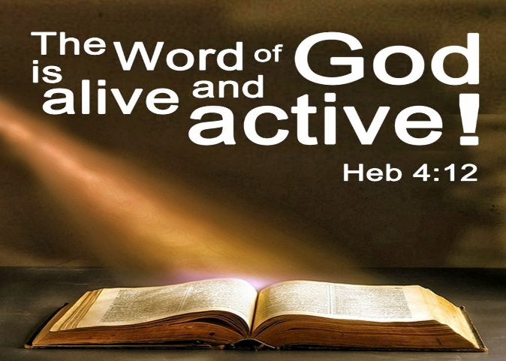 At the first of the skit I took out the instruction manual from the box and attempted to understand how to build the bookshelf. Even though I knew that following the instructions would lead to building the perfect bookcase, I chose to throw them out. The instructions in this skit symbolize God’s holy word. I remember when my son, David was born. Even though he was almost 11 pounds upon birth, I could not help but marvel at how small he was. Then I got to thinking, I am his dad and what do I know about child rearing? I felt like asking the doctor: does he come with an instruction manual? Being a pastor, I know the answer to this question is yes, he certainly does! God’s holy word is alive and active (Hebrews 4:12), a love letter from God telling us exactly what we must do to live good and holy lives! While holding David in my arms would I ever dream of being like the crazy carpenter in this skit and throw out the instruction manual? While none of us would ever dream doing so, we often ignore God’s word to our own peril for a variety of reasons!

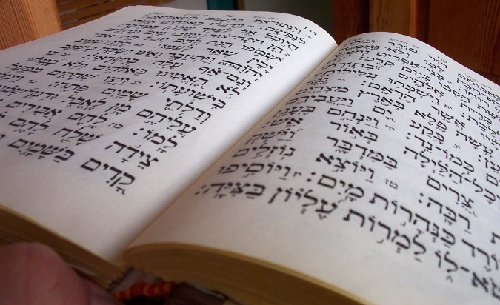 One of the reasons we do not read and live God’s word is that Bible translations contain words that are difficult to understand. After having examined the instruction manual for the book shelf I concluded that it must have been translated for it was for the most part incomprehensible. While the wording was clearly in English; the diagrams, symbols and words given were foreign to this accountant/pastor. The Bible for the most part was written in Hebrew (Old Testament), Koine Greek and Aramaic (New Testament). If you have ever tried to translate from one language to another you know how difficult this can be for often local phrases from one dialect cannot be easily transcribed into another. For example, when the British say “it’s monkeys outside” or “dog’s diner,” you must know their dialect to know that this means “it’s very cold outside” or “your nicely dressed.”[1] The meaning of words changes over time as well. For example, originally the word “awful” was synonymous with the word “awesome” and both meant “reverential or respectful fear.”[2] To fully understand the words of the Bible you need to know the dialect of many different cultures from many different time periods. To avoid imposing a modern meaning onto the ancient words of the Bible and therefore ending up with an incorrect interpretation, one must take the time to study the grammatical syntax of God’s word with tools such as lexicons and concordances over a time of many cultures.[3] While one could rely on a translation, they don’t all have the same words or underlying meanings.

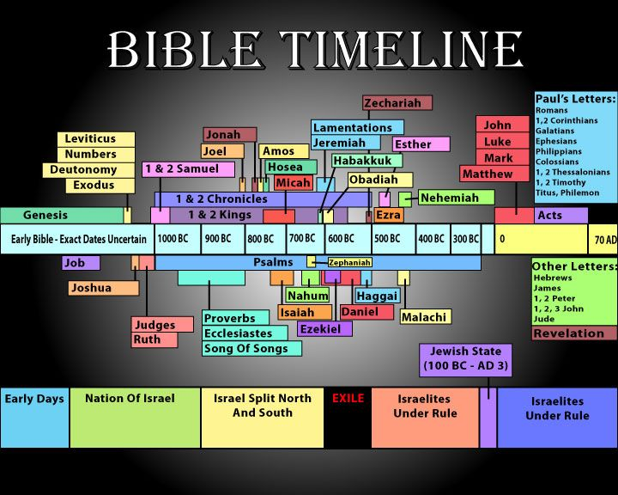 Not only does one need to know the meaning of various ancient words, one must also know the cultures and the circumstances of the readers in which the words were intended for! Even though history is often a hypothetical, imaginative reconstruction of events based on probabilities;[4] modern advances in lexicography and archaeology[5] allow the modern interpreter access to ancient worldviews, geographic, economic, political, social patterns of behavior and religious practices that influenced the perceptive and mindset of both the author and reader as they interacted with the text.[6] If Job is considered the oldest book of the Bible then one would have to know the various cultures of each book of the Bible for a time period of about 7,000 years! Wow, it is no wonder so many Christians find understanding God’s instruction manual to be a momentous task!

The good news is that to help us understand the various linguistic and cultural differences we have the ultimate guide living inside of us … the Holy Spirit. Through the outpouring of the Spirit by Jesus that Scripture was formed as the “divinely inspired linguistic medium” of God’s revelation.[7] It is only through the illumination, admonition and consolation of the Spirit that the we are led into all truth.[8] The Spirit who inspired the words of Scripture and knows the mind of God because He is God (1 Corinthians 2:11-13), is more than able to translate Scripture into words that we can understand regardless of our intellectual capabilities. This of course, does not absolve us from our responsibility to meditate on God’s word day and night (Psalms 1:2). As we allow His word to interfere/guide our personal decision making, we are to have faith that His way not only leads to living a holy life but also one that can stand with unspeakable joy in the face of the harshest of life’s tribulations.

**SEEKING ADVICE**

 After having thrown out the instruction manual I then proceeded to seek advice on how to build the shelf from a trusted source. You think building a shelf can be complicated, what about making the right choices in life? While God has given us the right to do anything that we want, Apostle Paul states there are many choices that are neither beneficial or constructive (1 Corinthians 10:23-24). While most would accept this statement as being fundamentally true, being near to so many different cultures makes it difficult to know which choice is the right one! So, we ask advice from others. Unfortunately, the advice we seek often comes from the wicked, sinners and mockers of this world (Psalms 1:1). Does not the Bible clearly teach that the world’s wisdom is foolishness in God’s sight (1 Corinthians 3:19)? Remember the show *Who Wants to be a Millionaire*? Seeking the advice from the world is like calling a friend only to find out they don’t have the right answer! And if we are not satisfied with worldly advice then, like I did in the skit, we simply make life choices on our own; as if we know better than God how to find unspeakable joy!

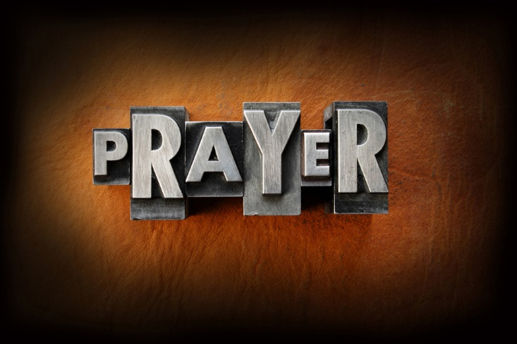 When we face any life choice should we not seek advice from God? James tells us that when we lack the wisdom to make the right choices in life we should pray to God and have faith that He will give us the right choice to make every single time (James 1:5-6). Prayer is to be our lifeline, as natural as breathing for it is the central avenue which God uses to transform us![9] Who better to instruct us how to feel unspeakable joy (1 Peter 1:8) in His kingdom than God Himself. So important is prayer that Paul told the church of Thessalonica to pray without ceasing (1 Thessalonians 5:17). So, why don’t we as Christians bathe every decision in prayer? For the same reason that I went from a hammer, to a sledge hammer, to a drill and then duct tape … we either feel that we have a better way of doing things or are simply too impatient to wait for an answer from God. Think about all the bad decisions we as Christians have made in our lives. Now think about how much grief we could have avoided if we only had sought, waited for an answer and then took God’s advice. O the blessings we have missed on and the grief that we have poured out on our own heads!

**TAKING THE TIME**

 From the beginning of the skit to the end I grumbled that it was taking way too much time to construct the shelf. I grumbled that it took too long to figure out the instructions, and way too long to pound in nails or drill in screws. The longer it took the more frustrated I became. While I wanted to build a great bookshelf, I did not want to spend anytime doing so. The same is true when it comes to spiritual maturity. While most of Christians want to finish their lives as mature as Peter, James and John; most are not willing to pay the price! With 21 % of Christians praying only once a week, 23 % rarely ever praying,[10] and only 19 % reading their Bible daily;[11] how can the modern-day church honestly say they are taking time to be holy? While being born again is a great first step in becoming more like Jesus, spiritual formation takes a lifetime of surrendering one’s heart over to Christ! Each day according to apostle Paul we need to pray and read the Bible so that we might continue to surrender our desires to conform to the patterns of this world (Romans 12:1-2). Offering our bodies and minds as living sacrifices means taking the time to replace old sinful habits with the spiritual disciplines of prayer, meditation, fasting, simplicity, solitude and service!

**WHOSE HOUSE ARE YOU BUILDING?**

Living in a fallen world where chance happens to everyone, life can be very complicated and far from easy! While we have the right to make any choices we want in life we are painfully aware that not all choices will lead to happiness. Constantly being bombarded by conflicting advice from people of diverse cultures provides little clarity as to which choices in life might be beneficial and lead to holy living. Praise be to God that He has provided us with an instruction manual on how to build our “house”/lives! While the Bible can be difficult to understand the meaning of its words and the various cultures of its intended readers, the Holy Spirit who lives inside of us translates His divine words into a language that each of us can fully understand. So, we are left without any excuse for not making the right choices in life! The question I want to leave you with is this: whose house are you building, your own that is destined to crash like my bookshelf or are you truly building your home in His kingdom that will last for an eternity?

1. Taken from the following website: <https://www.pinterest.com/explore/british-slang/>
2. Taken from the following website: <http://mentalfloss.com/article/61876/11-words-meanings-have-changed-drastically-over-time>
3. William W. Klein, Craig L. Blomberg and Robert L. Hubbard, Jr. *Introduction to Biblical Interpretation* (Nashville, TN: Thomas Nelson Inc., 1993), 256.
4. N.T. Wright. *Jesus and the Victory of God: Christian Origins and the Question of God* (Vol. 2. Minneapolis: Fortress Press, 1996), 8.
5. Russell Spittler. "Scripture and the Theological Enterprise: View from a Big Canoe," in the Use of the Bible in Theology/Evangelical Options. Ed. R. K. Johnson (Atlanta, GA: John Knox, 1985), 75.
6. Klein et al., 229.
7. Torrance, Thomas F. *Reality & Evangelical Theology: The Realism of Christian Revelation* (Eugene, OR: Wipf and Stock Publishers, 1982), 93.
8. Barth, Karl. *Evangelical Theology: An Introduction*. (Grand Rapids, MI: William B. Eerdmans Publishing Company, 1963), 57.
9. Richard Foster, 1998. Celebration of Discipline: The Path to Spiritual Growth (New

   York, NY: HarperSanFranscisco), 33.
10. Taken from the following website: <http://www.pewresearch.org/fact-tank/2016/05/04/5-facts-about-prayer/>
11. Taken from the following website: <http://www.christianitytoday.com/news/2012/september/80-of-churchgoers-dont-read-bible-daily-lifeway-survey.html>