**ATTRIBUTES OF GOD**

**PART3: GRACE AND OMNIPRESENCE**

Online Sermon: <http://www.mckeesfamily.com/?page_id=3567>

What God has revealed about Himself is called His attributes. In last week’s sermon, we reviewed just two of these attributes: justice and mercy. By justice I mean that God giving humanity a lifetime to change their evil ways does not violate His unchanging desire to hold people accountable in this lifetime or the next. While forgiveness without consequences might appear to violate justice, it does not because Christ paid the price for our sins, once and for all. By mercy I mean that God is actively compassionate. Our high priest Jesus is sympathetic towards our suffering for He has not forgotten the agony He endured on the cross! While God may not remove suffering, He mercifully provides the means for us to endure it and mature in the faith. This week’s sermon is going to focus on two more attributes of God: grace and omnipresence.

**ATTRIBUTE 6: GOD’S GRACE**

**“For us who stand under the disapproval of God, who by sin lie under sentence of God’s eternal, everlasting displeasure and banishment, grace is an incomprehensibly immense and overwhelming plenitude of kindness and goodness. If we could only remember it, we wouldn’t have to be played with and entertained so much. If we could only remember the grace of God toward us who have nothing but demerit, we would be overwhelmed by this incomprehensibly immense attribute, so vast, so huge, that nobody can ever grasp it or hope to understand it.”[1]**

 Even though the definition of grace is like the definition of mercy they are not the same. The heart of the “concept of mercy is the love of God, which is freely manifested in His gracious saving acts on behalf of those to whom he has pledged himself in covenant relationship.”[2] Suffering can either be due to discipline for having sinned or could be the by-product of chance that happens to everyone (Ecclesiastes 9:11). Last week we learned that mercy is when God looks upon the suffering of those living in a fallen world and has active compassion towards them by either changing their situation or providing the means to endure it. The heart of grace on the other hand is “the dimension of divine activity that enables God to confront human indifference and rebellion with an inexhaustible capacity to forgive and to bless.”[3] Grace is “God’s goodness confronting human demerit”[4] wherein God looks upon the sins of humanity that deserves death (Romans 6:23) and yet is still willing to provide the means to be forgiven and have one’s relationship with Him restored.

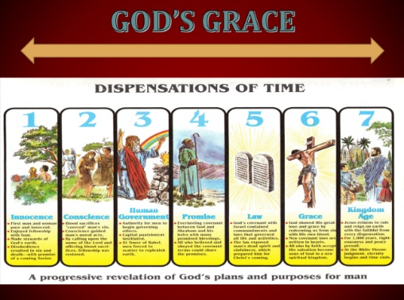Christ is the channel through which grace flows.[5] Grace did not come from when Christ was born in a manger (Luke 2:1-7), when He was baptized (Matthew 3:13-17), when He died on the cross (Luke 23:44-46) or even when He rose again (Luke 24:1-9) and went to the Father’s right hand in glory (Psalms 110:1). The plan of salvation was not conceived at any of these times but was laid before the foundation of this world (Revelation 13:8). While God progressively revealed His plans and purpose for humanity over approximately seven dispensations of time that does not negate the fact that God’s plan from eternity past was to manifest His grace through the birth, death and resurrection of Jesus Christ. “If God had not operated in grace He would have swept the human race away. He would have crushed Adam and Eve under His heel in awful judgment, for they had it coming.”[6] As it is every single person who has lived or ever will live, no matter how evil or good; has been given grace in the form of a lifetime of chances to embrace salvation through belief in the atoning sacrifice of Jesus Christ!

It was a hundred years before the Church ever began to try to explain the atonement.[7] While I can somewhat understand that Christ voluntarily took on the righteous wrath of God that was due to the wages of our sins, how can anyone truly understand what this means? The intensity and severity of God’s wrath knows no one except the Son. Like Job, I cannot “brace myself like a man” and answer God’s questions when it comes to His splendor and wonder

(Job 38). When I come to the foot of the cross I can’t help but kneel in wonder, humbly acknowledging that I see dimly now, for creation cannot touch the untouchable or know the unknowable! God is wholly other and as such while I know of His plan of atonement, I will not see it clearly until Christ returns and reveals it to me. I often feel like a two-year-old child asking my father a question that I could never understand the answer until I grow up! How I look forward to the day when I receive my spiritual body and come to rest in His presence so that I might know what cannot be known now!

While we wait to meet God face to face what we can know now about atonement can have a profound affect on one’s life. I want to invite you to see yourself as the prodigal son. Unwilling to have faith in God that He will provide eternal crowns and blessings to those who follow His will and commands, we have chosen to believe that we are masters of our own destinies capable of doing a better job than God at providing for our hearts desires. Like the prodigal son we waste our riches, i.e. a lifetime of opportunities to serve God and one another, on the prostitutes of money, fame and power. God was right to be angry with our squandering away of His blessings, we deserve to die. “Praise be to God that the prodigal son is the human race that went out to the pigsty in Adam but came back in Jesus!”[8] If you yield to Jesus and come home, then all the overwhelming, incomprehensible plentitude of goodness and kindness in the great illimitable reaches of God’s nature are on your side. Even justice is on the side of the returning sinner: “He is faithful and just to forgive us our sins” (1 John 1:9). All the infinite attributes of God rejoice together when a man believes in the grace of God and returns home.[9]

**ATTRIBUTE 7: GOD’S OMNIPRESENCE**

**Whither shall I go from thy spirit? or whither shall I flee from thy presence? If I ascend up into heaven, thou art there: if I make my bed in hell, behold, thou art there. If I take the wings of the morning, and dwell in the uttermost parts of the sea; Even there shall thy hand lead me, and thy right hand shall hold me.**

**Psalm 139:7–10**

 God is indivisibly present everywhere always. If you send up the furious question, “Oh God, where art Thou?” the answer comes back, “I am where you are; I am here; I am next to you; I am close to everywhere.” That’s what the Bible says.[10] If there were any borders to God, i.e. any place where God is not, then God would not be infinite. God is equally close to all parts of this vast universe for He does not occupy space like you and I do but instead swallows up space. Is it not humbling to know that it is vanity to try and be the first to get to another planet such as Mars, knowing full well that God is already there? If you go to the heavens, hell or the depths of the sea, God is present! God fills heaven and earth just as the ocean fills a bucket which has been submerged in it a mile down. The bucket is full of the ocean, but the ocean surrounds the bucket in all directions.[11] This means that while God fills the heavens and the earth they in turn cannot contain God (2 Chronicles 2:6). Given God’s omnipresence is infinite then why do we say that God often seems to be so distant from us? How can God be indivisibly present and yet so very far away?

We are shut off from God—not because God is spatially far from us, not because He is remote like a far galaxy or star, but because there is a dissimilarity in nature.[12] When we think of spiritual things we tend to use temporal concepts. For instance, when we think about putting distance between ourselves and our enemies we tend to think the further away our enemies are from us the better off we will be. You can have two of God’s creation in the same place such as a tree and a person, and have little communication happen because their natures are so different. In a similar manner when we sense that God is remote is because there is a dissimilarity between 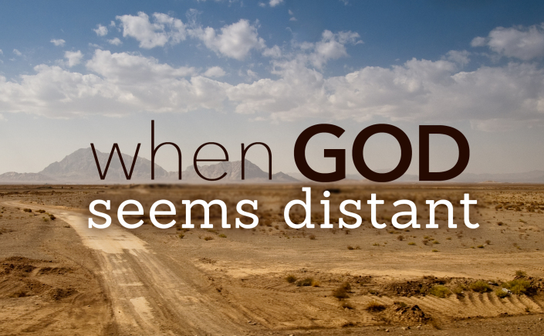moral characters.[13] While humanity was created in the image (Genesis 1:27) or likeness of God (James 3:9), once sin entered this world through Adam and Eve humanity became unlike God is His moral nature. The moral incompatibility between humanity who fulfills the desires of the flesh and mind (Ephesians 2:1-3) has led to our being alienated from a Holy God. So, when one says “God seems so distant from me” is not to be taken as God is physically far away but as acknowledgement that my sin has driven a wedge between me and God because how can holiness have anything to do with iniquity?

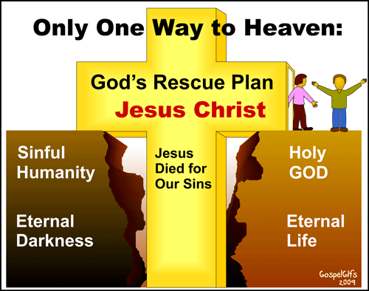 Since God’s and our natures are so dissimilar does this means that one’s filthy rags of iniquity will forever keep one from communicating with our Creator? Praise be to God the answer is NO! The dissimilarity between God’s and our nature can be reconciled through the One who is both God and man.[14] Jesus came down and became flesh and became both God and man, sin excepted, in order that by His death He might remove everything out of the way so that man could come back.[15] We are told in Scripture that “God reconciled the world to Himself in Christ, not counting people’s sins against them” (2 Corinthians 5:19). This does not mean that God overlooks sin but that He provides a path through faith in the atoning sacrifice of His Son, Jesus for the sinner to come home and partake of the divine nature (2 Peter 1:4) though the Holy Spirit. With a deposit of His own nature in the believer, similarity exists between both natures and therefore the ability to once again communicate with God.

 Since Christians have received this deposit of God’s divine nature, the Holy Spirit, then why do so many of us still feel distant from our Creator? When a person becomes born again they receive the provision of grace through our Lord Jesus Christ that enables them to forgo the wages of sin, spiritual death (Romans 5:17). They become born again of water and the Spirit (John 3:5), the deposit guaranteeing eternal acceptance into God’s family (2 Corinthians 1:22). The more a person sins the more the grace of Christ increases and covers those sins (Romans 6:1). This does not mean that once a person is born again they are free do live their lives in any manner they desire. God does not want His children to continue living like pagans (1 Peter 4:3) but to consider themselves dead to sin and slaves of righteousness (Romans 6:18). While a Christian does not loose their salvation when they sin they do loose the ability to communicate with a holy God. When God feels distance from us it is because we have allowed our moral character to be flawed by the evil desires of our hearts (James 1:14). The only way to restored commune with God is to confess one’s sins and return to being righteous in God’s sight (1 John 1:9).

**CONCLUSION**

Today’s sermon focused on two of God’s attributes: grace and omnipresence. By grace I mean that while God should eternally disapprove and condemn all of humanity, His providing the means to know Him through the atoning death of His Son Jesus is evidence of the incomprehensible, immense and overwhelming goodness of our God! While we cannot comprehend the atonement of Christ, His grace should compel us to not squander our lives but to take every opportunity to serve our Creator. By omnipresence I mean that God is indivisible present everywhere at all times. If one goes to the heavens, hell or the depths of the sea, God is there. When God seems distant from us it is not because He spatially distant but that sin has crept into our lives and made our moral character dissimilar to that of His. Praise be that through confession we become right with God and able to once again communicate with Him. Next week we are going to look at the final two of God’s attributes covered in this series: holiness and perfection.

1. A. W. Tozer and David E. Fessenden, [*The Attributes of God: A Jouney into the Father’s Heart*](https://ref.ly/logosres/attrgod1;ref=Page.p_104;off=1884;ctx=od._Grace_abounded!_~For_us_who_stand_und), vol. 1 (Camp Hill, PA: WingSpread, 2003–), 105.
2. Walter A. Elwell and Barry J. Beitzel, [“Mercy,”](https://ref.ly/logosres/bkrencbib;ref=biblio.at$3DMercy$7Cpg$3D1440$E2$80$931441$7Cvo$3D2;off=1004;ctx=At_the_heart_of_the_~concept_of_mercy_is_) *Baker Encyclopedia of the Bible* (Grand Rapids, MI: Baker Book House, 1988), 1440.
3. Gilbert Bilezikian, [“Grace,”](https://ref.ly/logosres/bkrencbib;ref=biblio.at$3DGrace$7Cau$3DBilezikian,$2520Gilbert$7Cpg$3D899$E2$80$93900$7Cvo$3D1;off=582;ctx=te_of_God$E2$80$99s_nature._~Grace_is_the_dimensi) *Baker Encyclopedia of the Bible* (Grand Rapids, MI: Baker Book House, 1988), 898.
4. A. W. Tozer and David E. Fessenden, [*The Attributes of God: A Jouney into the Father’s Heart*](https://ref.ly/logosres/attrgod1;ref=Page.p_98;off=683;ctx=lt,_whereas_grace_is~_God$E2$80$99s_goodness_conf), vol. 1 (Camp Hill, PA: WingSpread, 2003–), 98.
5. A. W. Tozer and David E. Fessenden, [*The Attributes of God: A Jouney into the Father’s Heart*](https://ref.ly/logosres/attrgod1;ref=Page.p_99;off=916;ctx=hrist$E2$80$9D_(John_1:17)._~Christ_is_the_channe), vol. 1 (Camp Hill, PA: WingSpread, 2003–), 99.
6. A. W. Tozer and David E. Fessenden, [*The Attributes of God: A Jouney into the Father’s Heart*](https://ref.ly/logosres/attrgod1;ref=Page.p_102;off=630;ctx=from_the_beginning._~If_God_had_not_opera), vol. 1 (Camp Hill, PA: WingSpread, 2003–), 102.
7. A. W. Tozer and David E. Fessenden, [*The Attributes of God: A Jouney into the Father’s Heart*](https://ref.ly/logosres/attrgod1;ref=Page.p_111;off=1111;ctx=let$E2$80$99s_just_believe._~It_was_a_hundred_yea), vol. 1 (Camp Hill, PA: WingSpread, 2003–), 111.
8. A. W. Tozer and David E. Fessenden, [*The Attributes of God: A Jouney into the Father’s Heart*](https://ref.ly/logosres/attrgod1;ref=Page.p_114;off=194;ctx=lider_nor_a_sinner._~The_prodigal_son_is_), vol. 1 (Camp Hill, PA: WingSpread, 2003–), 114.
9. A. W. Tozer and David E. Fessenden, [*The Attributes of God: A Jouney into the Father’s Heart*](https://ref.ly/logosres/attrgod1;ref=Page.p_115;off=549;ctx=well_not_have_died._~But_if_you_yield_to_), vol. 1 (Camp Hill, PA: WingSpread, 2003–), 115.
10. A. W. Tozer and David E. Fessenden, [*The Attributes of God: A Jouney into the Father’s Heart*](https://ref.ly/logosres/attrgod1;ref=Page.p_118;off=1060;ctx=herever_you_may_be._~And_if_you_send_up_t), vol. 1 (Camp Hill, PA: WingSpread, 2003–), 118.
11. A. W. Tozer and David E. Fessenden, [*The Attributes of God: A Jouney into the Father’s Heart*](https://ref.ly/logosres/attrgod1;ref=Page.p_119;off=1223;ctx=earth._But_actually_~God_fills_heaven_and), vol. 1 (Camp Hill, PA: WingSpread, 2003–), 119.
12. A. W. Tozer and David E. Fessenden, [*The Attributes of God: A Jouney into the Father’s Heart*](https://ref.ly/logosres/attrgod1;ref=Page.p_121;off=428;ctx=_the_same_time.$0ABut_~we_are_shut_off_from), vol. 1 (Camp Hill, PA: WingSpread, 2003–), 121.
13. A. W. Tozer and David E. Fessenden, [*The Attributes of God: A Jouney into the Father’s Heart*](https://ref.ly/logosres/attrgod1;ref=Page.p_123;off=129;ctx=an_He_is_right_now.$0A~The_reason_we_sense_), vol. 1 (Camp Hill, PA: WingSpread, 2003–), 123.
14. A. W. Tozer and David E. Fessenden, [*The Attributes of God: A Jouney into the Father’s Heart*](https://ref.ly/logosres/attrgod1;ref=Page.p_129;off=1090;ctx=n_of_the_Dissimilar$0A~The_dissimilarity_ca), vol. 1 (Camp Hill, PA: WingSpread, 2003–), 129.
15. A. W. Tozer and David E. Fessenden, [*The Attributes of God: A Jouney into the Father’s Heart*](https://ref.ly/logosres/attrgod1;ref=Page.p_131;off=1156;ctx=did_He_do_about_it$3F_~He_came_down_and_bec), vol. 1 (Camp Hill, PA: WingSpread, 2003–), 131.