**ATTRIBUTES OF GOD**

**PART1: INFINITE, IMMENSE, GOOD**

Online Sermon: <http://www.mckeesfamily.com/?page_id=3567>

**“Lord how great is our dilemma, in thy presence silence best becomes us but love inflames our hearts and constrains us to speak. Were we to hold our peace the stones would cry out, yet if we speak what shall we say? Teach us to know that we cannot know for the things of God knoweth no man but the Spirit of God. Let faith support us where reason fails and we shall think because we believe not in order that we may believe.”**

**A.W. Tozer, The Knowledge of the Holy**

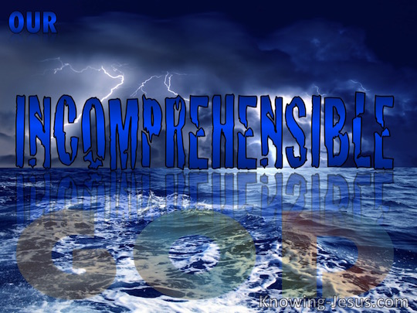 To touch the untouchable, know the unknowable, comprehend the uncomprehend able is dare we say a task that is truly beyond human ability. Since God is not exactly like anything or anyone created, describing the ineffable is in a sense truly beyond both thought and language. Any description of God by using what we already know, i.e. what has been created, never really describes God and runs the risk of making God in our image and not the other way around. This does not mean that we who are created in the likeness and image of God are unable to know anything about Him. 1 Corinthians 2:11 states the Spirit who knows all things about God has inspired the writers of Scripture to convey the attributes of God by using “like” terms so that we might receive a minimal understanding of our Creator. While these comparisons are not to be taken as literal and exact representations of God, Paul says they are valuable for they remain an act of self-disclosure by His Spirit. “That God can be known by the soul in tender personal experience while remaining infinitely aloof from the curious eyes of reason constitutes a paradox best described as darkness to the intellect but sunshine to the heart” (Frederick W. Favour). Deep calleth unto deep and though polluted and landlocked by the Fallen nature, the soul senses its origin and longs to return to its Creator.

The yearning of the soul compels us to ask the question: what is God like? If we mean in Himself then there can be no answer but if one means what has God disclosed about Himself that inspired reason can comprehend then there is much that can be known. For the soul that truly thirsts for God what a joy it is to sit and listen to His Spirit reveal the truth concerning Him! Those things that have been revealed and are true of God we call His attributes (not to be confused with traits or characteristics for these terms relate only to creation). While many theologians try to number His attributes, the goal of this series is not to correctly identify an exact list that cannot be known but instead to invite you to learn the truth that God revealed 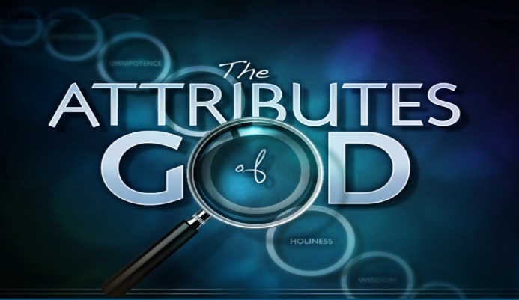concerning Himself for just ten of His attributes. These attributes have been revealed through nature, Scripture and through the Holy Spirit. As you read this series I want to encourage you to learn more about these attributes through prayer, meditation and the reading of God’s holy word. After all, to think correctly concerning God requires one to bask in His revelation concerning Himself. This series will be broken up into four sermons the first of which will focus on God’s attributes of infinity, immensity and goodness.

**ATTRIBUTE 1: INFINITY**

**“God is infinite! That’s the hardest thought I will ask you to grasp. You cannot understand what infinite means, but don’t let it bother you—I don’t understand it and I’m trying to explain it! “Infinite” means so much that nobody can grasp it, but reason nevertheless kneels and acknowledges that God is infinite. We mean by infinite that God knows no limits, no bounds and no end. What God is, He is without boundaries. All that God is, He is without bounds or limits.”[1]**

**A.W. Tozer**

God is so much more than the one that Christians often make up from their own imaginations. The god that the human mind often conjures up is often one that is loving, kind and supportive. One that does not believe in justice if we do something wrong but does so when others offend us. The kind of god that one can call upon as a personal best friend that never questions, or limits our words, thoughts or deeds but instead is always approving of any path one chooses in life. Like the boy in the picture many want to create a god that will allow one’s imagination to create and recreate a world that bows to our will! This of course is not the “infinite, perfect, all-knowing, all-wise, all-loving, infinitely boundless, perfect God”[2] that Created and holds all things together (Colossians 1:16). A god made up from one’s imagination is no better than those who from their stiff necked (Acts 7:51) attitude refused to retain the knowledge of God as their Creator (Romans 1:28) and ended up worshipping idols of god and silver (Psalms 115:4) that are truly worthless!

****For God to be truly God and not the byproduct of one’s imagination then He must be first and foremost described as “infinite.” Infinite, boundless or unlimited are words that are very difficult to define. This is partially due to the fact these words are often used incorrectly in our human language. For instance, while some might say they have unlimited wealth this is certainly not true for even the richest man in the world Bill Gates has a defined pool of material possessions. And even when people say they have boundless energy they still must sleep sometime to refuel for the next day! Tozer correctly points out that infinite, boundless or unlimited are words that “do not describe space or time or matter or motion or energy; these words do not apply to creatures or sand or stars or anything that can be measured.”[3] “God doesn’t *extend* into space; God *contains* space,”[4] His knowledge and power have no limitations. Only He who laid the foundations of this universe (Job 38) and knit us in our mother’s womb (Psalms 139:13), can lay claim to being without any boundaries, limitations, beginning or ending!



Our attitude towards God must be changed for salvation can never be “an insurance policy from hell,” [5] but as a gateway into a relationship with He who is all that our hearts truly desire. He who took pleasure in creating the heavens and the earth (Genesis 1:4, 10, 12) took pleasure in the perfection of His work. Praise God for His mighty heavens and His surpassing greatness (Psalms 150) for He not only delights in His work creating but also in His work of redeeming! Through our belief in the atoning sacrifice of His Son Jesus (John 3:16), we are invited to feel the “joy without end” of being part of the Trinity.[6] Salvation is so much more than just an insurance policy from hell, it is the means in which we are invited to be one with God (John 17:20-21). The same God who paints the sky, makes the trees grow, changes the seasons and clothes the flowers of the fields with splendor and wonder (Matthew 6:28); wants us to sing for joy that He who was slain (Revelation 5:9-11) has provided us the means necessary for our redemption and entrance into His kingdom and presence!

**ATTRIBUTE 2: IMMENSITY**

**“God is above all things, beneath all things, outside of all things and inside of all things. God is above, but He’s not pushed up. He’s beneath, but He’s not pressed down. He’s outside, but He’s not excluded. He’s inside, but He’s not confined. God is above all things presiding, beneath all things sustaining, outside of all things embracing and inside of all things filling. That is the immanence of God.”[7]**

**A.W. Tozer**

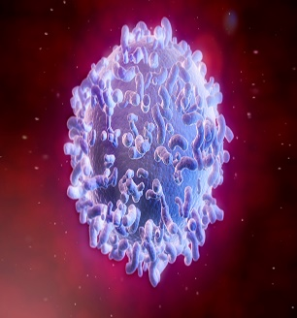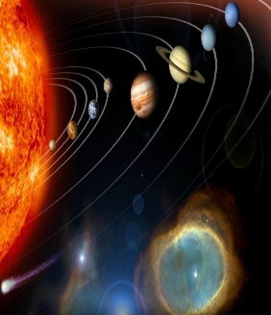The great French philosopher and mystic mathematician, Pascal, said this: “We are halfway between immensity and that which is infinitesimally small.” [8] On the one hand this universe is truly vast and beyond our imaginations. For example, the distance planets are from one another is almost beyond our comprehension. While our minds might comprehend the earth’s, moon being 250,000 miles away or the sun being 93 million miles away from the earth; -how does one comprehend one of the furthest galaxies MACS0647-JD being approximately 13.3 billion light years away from us?[9] On the other hand parts of this universe are also infinitesimally small. While the five vital organs and 206 bones of the human body can be easily comprehended, who truly comprehend the body having 37.2 trillion cells[10] or capillaries that are 50 times thinner than a single strand of a baby’s hair?[11] Such thinking of course puts things in perspective for we truly are between being both infinitely large and small at the same time!

Then there is God who is both immanent and immense. With immanent I mean that God is indivisibly present at all places, always. He is above all things, beneath all things, outside all things and inside all things. This should bring us great joy for God never truly comes to us when we pray, for He is always with us! Whether we go to the heavens or the depths, God always knows our thoughts and is willing to help us, especially in the darkness times of our lives (Psalms 139). With immense I mean that God is bigger than the entire universe. Moving throughout this vast universe of billion and trillions of light years, so big that our whole solar system must look like a mere grain of sand, we find it is God alone who stretches out the heavens like a curtain, layeth the beams in His chambers in the waters, maketh clouds His chariots and walketh upon the wings of the wind (Psalms 104:1-3)![12] What a great source of comfort it is to know that in comparison to God this universe is tiny and fully controlled by His sovereignty.

Of all the things in the universe that one could desire nothing fully satisfies the soul except being in the presence of He who created and sustains our very lives. Tozer rightly states that the greatest calamity of the human soul is to be created in the image (Genesis 1:27) or likeness of God (James 3:19), crowned with honor and glory (Psalms 8:5) and yet still reject one’s own Creator. Can you imagine spending an entire eternity with a soul that yearns for God, hungry but cannot be fed, thirsty but cannot drink; to live without God who is truly bigger than all things seen and unseen is a hell that not even Lazarus can provide any relief (Luke 16:24).[13] Even if one gains all the riches this universe has to offer that will be little relief for our souls will forever remain restless, broken and enslaved to our own passions (James 1:13-15). Praise be to God that those who embrace salvation can forever be hid with Christ in God (Colossians 3:3), our source of true happiness and rest!

**ATTRIBUTE 3: GOODNESS**

**God is kindhearted, gracious, good-natured and benevolent in intention.[14] God is not only infinitely good, He is perfectly good.[15] The goodness of God is the only valid reason for existence, the only reason underlying all things.[16] If a man will not take God’s goodness, then he must have God’s severity toward all who continue in moral revolt against the throne of God and in rebellion against the virtuous laws of God.[17]**

**A.W. Tozer**



O to taste and see that the Lord is good (Psalms 36:7). Christianity at any given time is strong or weak depending upon her concept of God.[18] This is especially true in relation to our concept of who God is in His goodness. He is the one who created the heavens and the earth that are necessary for life to exist! As we search the millions of planets around us and yet time and time again do not find one comparable to this earth that can sustain our lives, we are reminded that our habitat did not just happen but was the grand design of He who truly gives good gifts unto us His children (Matthew 7:11). And even when the pen of nature writes without too much clarity, the Word of God is very, very clear: God is good![19] God who created all things seen and unseen (Colossians 1:16), parted the Red Sea (Exodus 14:21), gave the blind their sight (Mark 8:22-25, Luke 18:35-43, John 9) and sent His son to die on the cross so that we might be able to have a relationship with Him (John 3:16), is good! God who does not change (Malachi 3:6), will continue to do good unto those who love Him (Romans 8:28)! Praise be that there will never be a time when God is not kind-hearted, gracious, good-natured and benevolent in His intentions towards us!

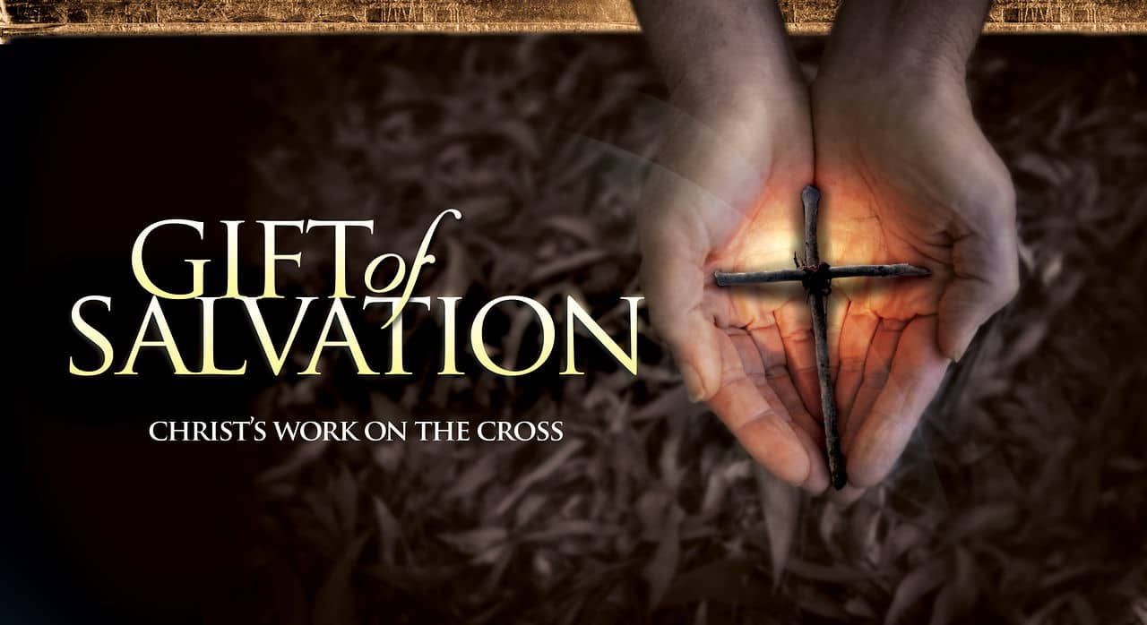 Nowhere can God’s goodness be seen more acutely than in our gift of salvation.[20] We have all sinned and fallen short of the glory of God (Romans 3:23). Being under the power of sin means that there is no one righteous, no one who understands or seeks God. Based on our own merits Scripture states we all have become worthless, not a single soul doing good (Romans 3). Does not the Fallen deserve condemnation and death for having offered Him mere filthy rags of service (Isaiah 64:6)? If God had acted according to His justice alone He would have pulled out the stopper and flushed us all down to hell![21] While God has every right to give us what we deserve He does not wish anyone should perish (2 Peter 3:9). Out of His grace, mercy and loving kindness, He offers to adopt as children those who have faith in the atoning death of His son. Imagine for a moment what it will be like to be in the presence of God, shouting glory, glory to the Lamb that was slain (Revelation 5:12)! Living in His presence and not the hell we deserve, will we not see our salvation as anything but the goodness of our Creator?



Just because God is abounding in love does not mean we as Christians are justified to continue to sin. To taste salvation that is unmerited yet graciously received only to continue to live like the pagans (1 Peter 4:3), is truly an injustice that can only be handled by Him who disciplines those He loves (Hebrews 12:6). At this point one could object and say if apostle Paul could not do what was right because the law was weakened by the sinful nature (Romans 7) then what hope do we have to live holy lives? This is where God’s goodness comes in for nothing is too hard for God! Jesus Christ is called our sympathetic high priest. He got this title because He was tempted in everyway that we are and yet did not sin (Hebrews 2:17-18). When we are tempted by the evil desires in our hearts (James 1:14) we can boldly approach His throne, cry out and He will not only give us grace and mercy but also a path to endure the temptation without sinning. And even if we do sin our sympathetic, high priest Jesus is faithful to cleanse us from unrighteousness upon our repentance (1 John 1:9). While God does not want to discipline us, He will if it is the only way to keep us on the right path.

**CONCLUSION**

While comprehending the ineffable is a task being human ability, through the Spirit of God our souls who yearn for God can come to know Him. What God has revealed concerning Himself is called His attributes. In today’s sermon, we looked at just three of these attributes. First, God is infinite and by this, I mean that He is without limits, boundaries, beginning or ending. He who laid the foundations of this universe is not limited to time, matter, motion or energy. Second, God is immanent and by this, I mean He is above all things, beneath all things, outside all things and inside all things. God is indivisibly present everywhere and infinitely larger than this entire universe. Third, God is good and by this, I mean kind-hearted, gracious, good natured and benevolent in his intention. While the Fallen deserve Hell, God’s goodness can be found in His offering of salvation to all who believe in the atoning sacrifice of His Son! Next week’s sermon is going to focus on two more attributes of God: justice and mercy.

1. A. W. Tozer and David E. Fessenden, [*The Attributes of God: A Jouney into the Father’s Heart*](https://ref.ly/logosres/attrgod1;ref=Page.p_4;off=238;ctx=t_of_God_in_Christ.$0A~God_is_infinite!_Tha), vol. 1 (Camp Hill, PA: WingSpread, 2003–), 4.
2. A. W. Tozer and David E. Fessenden, [*The Attributes of God: A Jouney into the Father’s Heart*](https://ref.ly/logosres/attrgod1;ref=Page.p_7;off=1104;ctx=s_not_the_true_God._~He$E2$80$99s_not_the_infinit), vol. 1 (Camp Hill, PA: WingSpread, 2003–), 7.
3. A. W. Tozer and David E. Fessenden, [*The Attributes of God: A Jouney into the Father’s Heart*](https://ref.ly/logosres/attrgod1;ref=Page.p_4;off=1382;ctx=e_anything_but_God._~They_do_not_describe), vol. 1 (Camp Hill, PA: WingSpread, 2003–), 4–5.
4. A. W. Tozer and David E. Fessenden, [*The Attributes of God: A Jouney into the Father’s Heart*](https://ref.ly/logosres/attrgod1;ref=Page.p_5;off=1179;ctx=lized_he_meant_that_~God_doesn$E2$80$99t_extend_i), vol. 1 (Camp Hill, PA: WingSpread, 2003–), 5.
5. A. W. Tozer and David E. Fessenden, [*The Attributes of God: A Jouney into the Father’s Heart*](https://ref.ly/logosres/attrgod1;ref=Page.p_3;off=810;ctx=ve_and_can_desire.$E2$80$9D_~The_Church_will_come), vol. 1 (Camp Hill, PA: WingSpread, 2003–), 3.
6. A. W. Tozer and David E. Fessenden, [*The Attributes of God: A Jouney into the Father’s Heart*](https://ref.ly/logosres/attrgod1;ref=Page.p_2;off=261;ctx=and_golden_streets._~Lady_Julian_saw_that), vol. 1 (Camp Hill, PA: WingSpread, 2003–), 2.
7. A. W. Tozer and David E. Fessenden, [*The Attributes of God: A Jouney into the Father’s Heart*](https://ref.ly/logosres/attrgod1;ref=Page.p_22;off=555;ctx=._He_is_right_here.$0A~God_is_above_all_thi), vol. 1 (Camp Hill, PA: WingSpread, 2003–), 22.
8. A. W. Tozer and David E. Fessenden, [*The Attributes of God: A Jouney into the Father’s Heart*](https://ref.ly/logosres/attrgod1;ref=Page.p_20;off=1178;ctx=_all_that_is_made.$E2$80$9D$0A~The_great_French_phi), vol. 1 (Camp Hill, PA: WingSpread, 2003–), 20.
9. Source found on the following website: http://www.space.com/18502-farthest-galaxy-discovery-hubble-photos.html
10. Taken from the following website: <http://www.smithsonianmag.com/smart-news/there-are-372-trillion-cells-in-your-body-4941473/>
11. Taken from the following website: https://www.kidsdiscover.com/quick-reads/human-bodys-smallest-parts/
12. A. W. Tozer and David E. Fessenden, [*The Attributes of God: A Jouney into the Father’s Heart*](https://ref.ly/logosres/attrgod1;ref=Page.p_25;off=322;ctx=_the_great_God,_the_~Shepherd_of_the_univ), vol. 1 (Camp Hill, PA: WingSpread, 2003–), 25.
13. A. W. Tozer and David E. Fessenden, [*The Attributes of God: A Jouney into the Father’s Heart*](https://ref.ly/logosres/attrgod1;ref=Page.p_33;off=1186;ctx=_$E2$80$9CEver_me_wanteth.$E2$80$9D$0A~This_is_the_greatest), vol. 1 (Camp Hill, PA: WingSpread, 2003–), 33.
14. A. W. Tozer and David E. Fessenden, [*The Attributes of God: A Jouney into the Father’s Heart*](https://ref.ly/logosres/attrgod1;ref=Page.p_42;off=874;ctx=What_$E2$80$9CGood$E2$80$9D_Means$0A~God_is_kindhearted,_gr), vol. 1 (Camp Hill, PA: WingSpread, 2003–), 42.
15. A. W. Tozer and David E. Fessenden, [*The Attributes of God: A Jouney into the Father’s Heart*](https://ref.ly/logosres/attrgod1;ref=Page.p_43;off=794;ctx=e_is_infinitely_so.$0A~God_is_not_only_infi), vol. 1 (Camp Hill, PA: WingSpread, 2003–), 43.
16. A. W. Tozer and David E. Fessenden, [*The Attributes of God: A Jouney into the Father’s Heart*](https://ref.ly/logosres/attrgod1;ref=Page.p_45;off=791;ctx=r_Reason_for_Living$0A~The_goodness_of_God_), vol. 1 (Camp Hill, PA: WingSpread, 2003–), 45.
17. A. W. Tozer and David E. Fessenden, [*The Attributes of God: A Jouney into the Father’s Heart*](https://ref.ly/logosres/attrgod1;ref=Page.p_48;off=1227;ctx=heaven_or_to_hell.$E2$80$9D_~If_a_man_will_not_ta), vol. 1 (Camp Hill, PA: WingSpread, 2003–), 48.
18. A. W. Tozer and David E. Fessenden, [*The Attributes of God: A Jouney into the Father’s Heart*](https://ref.ly/logosres/attrgod1;ref=Page.p_41;off=0;ctx=t_carry_redemption.$0A~Christianity_at_any_), vol. 1 (Camp Hill, PA: WingSpread, 2003–), 41.
19. A. W. Tozer and David E. Fessenden, [*The Attributes of God: A Jouney into the Father’s Heart*](https://ref.ly/logosres/attrgod1;ref=Page.p_42;off=399;ctx=9:1)._But_while_the_~pen_of_nature_writes), vol. 1 (Camp Hill, PA: WingSpread, 2003–), 42.
20. A. W. Tozer and David E. Fessenden, [*The Attributes of God: A Jouney into the Father’s Heart*](https://ref.ly/logosres/attrgod1;ref=Page.p_47;off=156;ctx=_if_they_were_here.$0A~Nobody_ever_got_anyt), vol. 1 (Camp Hill, PA: WingSpread, 2003–), 47.
21. A. W. Tozer and David E. Fessenden, [*The Attributes of God: A Jouney into the Father’s Heart*](https://ref.ly/logosres/attrgod1;ref=Page.p_47;off=1197;ctx=_deserved_hell,_and_~if_God_had_acted_acc), vol. 1 (Camp Hill, PA: WingSpread, 2003–), 47.