**HOW TO PRAY**

Online Sermon: <http://www.mckeesfamily.com/?page_id=3567>

**Matthew 6:7-15**

We are told in 1 Thessalonians 5:16-18 to pray without ceasing, to be in commune with God from one moment to the next. While we understand the importance of praying as Christians, do we truly understand the way in which God wants us to talk to Him? God is our sovereign Creator and as such expects us to approach His throne with boldness but also with reverence. Jesus tells us that using “Christianese” terms, the theological words of the vain glory-seeking Pharisees, or using the vein repetitions and babbling of the pagans; are not appropriate ways to communicate with a holy God! In Matthew 6:9-13 Jesus gives us a model as to how we are to pray in six petitions: the first three focus on God’s name, kingdom and will and the last three focus on our physical and spiritual needs, forgiveness of sins and aid in spiritual battles. To begin this sermon lets first look at two things to avoid when praying to God.

**THINGS TO AVOID WHEN PRAYING**

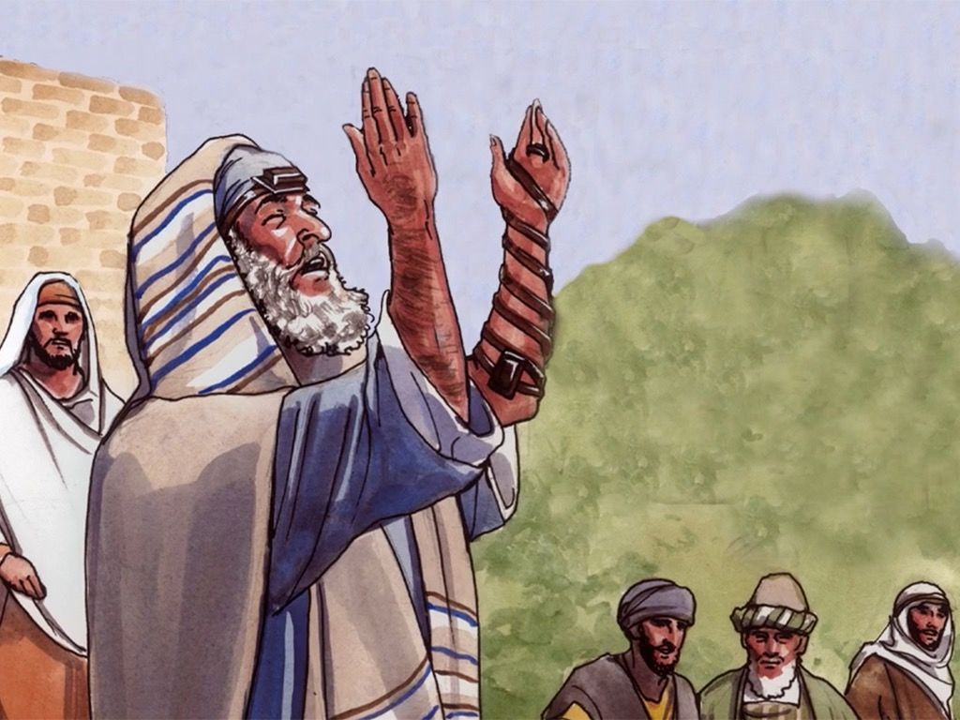 For the most part it is the attitude of the heart that truly matters as to whether one’s prayer is acceptable to God or not. In addressing the Jewish people who prayed three times a day: morning, afternoon, and evening; Jesus tells them to avoid two attitudes of the heart that are offensive to God. First, “prayer can be perverted from a true act of piety into an act of hypocrisy when the external act masks an inner corrupt motive.”[1] When the set time came to pray the Jewish people had a choice to make: where should I pray? For those who chose to discretely “go into a room, close the door and pray to the Father who is unseen” (6:6) Jesus praises them but for those who chose to “pray standing in the Synagogues and on the street corners” (6:5), Jesus condemns them. It was not the choice of the place that was wrong, for public prayer is far from a sin, but the attitude of the heart. God simply rejects prayer when one’s inner motive is self-seeking praise from ongoing watchers but welcomes prayer when one’s only desire is to have an intimate communion with one’s Creator!

The second attitude of the heart to avoid when praying is vain repetition or babbling. In Jesus’ day, Gentiles or pagans would repeat a list of divine names of their gods in hopes of manipulating them into giving them their heart’s desires.[2] Since many believed the longer the prayer the greater the probability of being heard, repetition was used as the means of lengthening their requests. For example, from morning until noon the pagan prophets repeated the words “O Baal, answer us” (1 Kings 18:26) in hopes of forcing Baal to set fire to the alter. Jesus is not saying that long prayers are a sin, for in Luke 6:12 Jesus Himself prayed all night, but instead is saying that vainly repeating words in an attempt to force God to bow to your will is a sin. Since the Father already knows what we need (verse 8), “prayer is much about changing *us*, our character, our will, and our values, even while we seek for God’s response.”[3] In answering prayers, God does not promise to give you your heart’s desire but does promise to do good to those who love Him (Romans 8:28)!

**HOW TO PRAY**

 Now that we know that we are to avoid praying for human praise and are not to use vain repetition, Jesus gives us a model of how to pray. Even though many people call this model “The Lord’s Prayer” it should be called “The Disciple’s Prayer”[4] because the sinless Lamb of God, Jesus would never have prayed for the forgiveness of sins.[5] The shorter version of this prayer found in Luke 11:2-4 was a response to the disciple’s request for Jesus to teach them how to pray as John had taught his disciples.[6] This prayer is not intended to be memorized and repeated without thought, but instead as a model of how one is to address a holy God. Since this model does not contain prayer for our brothers or sisters (James 5:16, Ephesians 6:18) or for our enemies (Matthew 5:44) it is not intended to be a complete model of prayer but merely how to properly address God and make requests of Him. The remainder of this sermon will explore the following six petitions of this model prayer: honoring God’s name, focusing on God’s kingdom, seeking God’s will, our physical and spiritual needs, forgiveness of sins, and our aid in spiritual battles.

**HONOURING GOD’S NAME**

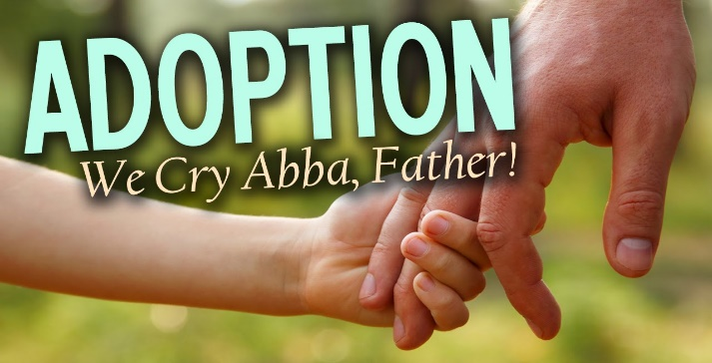 Before petitioning God to provide for one’s needs one should first acknowledge His glorious name. While there are many names for God such as Elohim, the creator of heaven and earth (Genesis 1:1), El Elyon, the Most High God (Genesis 14:18-19), Jehovah, I am who I am (Exodus 3:14), or Adonai, the Lord; Jesus invites us to call God, “Father.” The term “Father” or “Abba” is a name often “used by children for their earthly fathers that denotes warmth and intimacy in the security of a loving father’s care.”[7] In Romans 8:15 Paul tells us that the moment that we receive the Spirit we are adopted and get to cry out “Abba Father.” Addressing God as “Father” is our way of acknowledging His everlasting love and sovereign care for us. Even though not a single Israelite in the Old Testament ever directly addressed God as Father,Jesus invites us to address God with the same term “Father” that Jesus used in His prayers (Matthew 11:25; 26:39, 42; Mark 14:36; Luke 23:34; John 14:11; 12:27; 17:1, 5, 11, 24, 25).[8]

While we get to intimately call God “Father” we must not forget His name is also hollowed. The purpose of acknowledging God’s name as hollowed or holy is that God might be sanctified or set apart amongst us and treated with the highest honor possible.[9] After all He is the one who knit us in our mother’s womb (Psalms 139:13), spoke the words “let there be light” (Genesis 1:3) and marked off the dimensions of the earth separating the land from the sea (Job 38). God has always existed and as our Creator and has every right to ask us to not make Him one god amongst many in our lives (Exodus 20:3) but instead to hold Him in the highest honor in our words, thoughts and deeds by submitting to His power and authority over all things seen and unseen. Like Moses, when we approach God we are to honor, glorify and exalt Him not by taking off our sandals but by allowing Him to circumcise our hearts with His righteous ways.

**FOCUSING ON GOD’S KINGDOM**

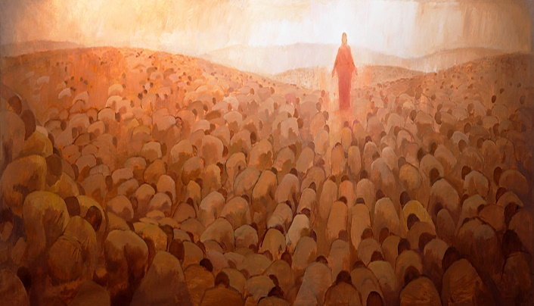 The second petition is an urgent request that God will fully establish His kingdom here on earth. The Israelites waited for centuries for God to inaugurate the kingdom in which His rule would reign supreme. While His kingdom has been established through the life and ministry of Jesus Christ, the Anointed One; “it awaits the second advent to be complete and final” (1 Corinthians 15:28).[10] As Christians we are to look forward to the day when God’s sovereign rule will be fully realized in our hearts. This will be the day when the duplicity of our flesh and stony hearts will have sin cut out of them by the Potter and reshaped back into His glorious image. Having removed the evil desires of their hearts (Revelation 11:15) will leave all nations free to bow and confess that Jesus is Lord (Philippians 2:10-11). That my friends will be a glorious day! In the meantime, let’s keep our eyes fixed on Jesus, the pioneer and perfecter of our faith (Hebrews 12:2).

**SEEKING GOD’S WILL**

In this petition, Jesus explains that focusing on the kingdom of God is accomplished by seeking His will in all matters. “Wherever the kingdom of heaven exerts its presence, God’s will is experienced. God reigns in heaven absolutely, which means that all of heaven experiences His perfect will.”[11] Jesus wants us to pray that the earth will experience this same rule of God. Like Jesus, may we freely submit to the will of the Father in everything that we do! And even when we wish the cup of suffering for His name’s sake might be passed from us, may we with courage and faith cry out to our glorious Father, “may your will be done!” We are not to be passive observers but active participants[12] whose obedient and repentant lives point to the present and future consummation of His kingdom. While perfect obedience must await the King’s arrival,[13] may we strive to have all our words, thoughts and deeds reflect His hollowed name, kingdom and will! And when we fail as sinners always do, may we through His grace repent and continue to run the race ever before us!

**ASKING GOD TO PROVIDE FOR OUR PHYSICAL/SPIRITUAL NEEDS**

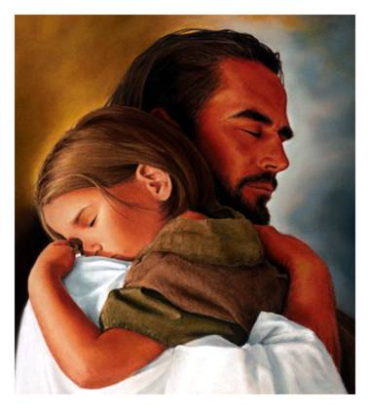 The second half of the prayer focuses on asking God to provide for the personal needs of the worshiper. The fourth petition, is to ask God to provide for our physical sustenance. “Give us our daily bread” is not a command, for creation never has the right to command the Creator, but a request that God would provide for the present day’s physical and spiritual needs.[14] While we are in some respects responsible to provide for ourselves, we are not to be anxious about what we shall eat or wear (Matthew 6:34) for God promises to provide these things to those who seek first His kingdom. While “daily food” is a reference to Israel’s reliance on God for manna in the desert (Exodus 16) this can also be a reference to our spiritual sustenance. When it comes to spiritual needs who is more qualified to provide than the Spirit who knows all things about God and in our weakness, can intercede for us with wordless groans (Romans 8:26). When God gives us our daily bread we are to thank Him “from whom these and all other good gifts come” (James 1:17). God truly does good to those who love Him (Romans 8:28)!

**ASKING GOD FOR FORGIVENESS**

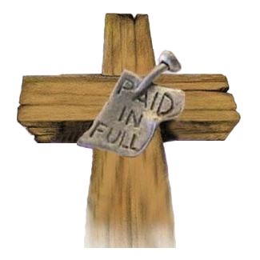 The fifth petition is to ask for forgiveness of sins. The word “debt” or opheilema that Matthew uses is the same as “sin” or hamartia that Luke uses in his version of the Lord’s prayer. “Sin creates an obligation or “debt” to God that we cannot possibly repay.”[15] The wages of sin, death, can only be cancelled or pardoned based on the substitutionary death of Jesus Christ.[16] Those who have received forgiveness of sins are to be so filled with gratitude that they will eagerly forgive others. Jesus warns us in verses 14-15 that if we do not forgive and cancel the debts of others when they repent then God will not forgive and cancel our debts when we repent. It is not that forgiving others is a condition of being forgiven but that forgiveness is not to be a one-way process. Since we and others sin daily, Jesus is telling us to forgive and ask for forgiveness each day so that nothing will hinder our fellowship with a holy God![17]

 This is arguably the most difficult of the six petitions because it is often nearly impossible for the mind to cancel the debts of those who have offended us. In our minds those who have been bent on harming us and destroying our reputations have much to pay for! It is so much easier to avoid the person and gossip about them than it is to face them and work things out in accordance with Matthew 18:15-20. Even though Jesus commands us to love our enemies, our love tends to be withheld from those who intentionally harm us. And even when the “perpetrator” comes back and asks to be forgiven we tend to withhold our love until they “pay the price” for having sinned against us. We simply demand our pound of flesh. In this fifth petition Jesus teaches us that our love for those created in His image must be unconditional and we are to forgive them when they repent or God will not forgive us when we repent, nor will He cancel our debts. Those who have been forgiven much are asked to forgive much as well.

**ASKING GOD FOR AID IN SPIRITUAL BATTLES**

 The final petition is for God to help us not fall into temptation but to be delivered from the evil one. Since God does not tempt us to do evil (James 1:13) and the fact that the word “peirasmos” can either mean “temptation” or “testing” (Matthew 4:1-11), the phrase “lead us not into temptation” should be translated to mean that we should pray to God for either relief from testing (Exodus 16:4; Deuteronomy 18:6, 1 Peter 1:7) or pray that our testing does not lead to temptation.[18] Trials are only a source of great joy and increase in faith when they are persevered though the power of the Spirit! The second phrase “deliver us from the evil one” is a request that God would protect and deliver us from the spiritual battles that one inevitably faces. May we pray every day to be victorious over the “the powers of this dark world and against the spiritual forces of evil in the heavenly realms” (Ephesians 6:12)!

**CONCLUSION**

The commonly used doxology for the “Disciples Prayer” is fitting way to conclude this prayer: “for thine is the kingdom, and the power, and the glory for ever and ever amen.” Even though this phrase was not included in the oldest MSS (in Luke as in Matthew), it is unlikely that any first-century person would have repeated this prayer without using this phrase.[19] It is fitting that this prayer that started out glorifying God the Father, His kingdom and His will concludes by giving Him all the honor and glory. This prayer is an example of how we as Christians can boldly but humbly approach a holy God and ask Him to provide for daily needs: physical and spiritual bread, forgiveness of sins and divine deliverance from the evil one. Praise be to God that He loves us unconditionally and has provided us with the means to have a healthy relationship with Him!

1. Michael J. Wilkins, [*Matthew*](https://ref.ly/logosres/nivac61mt;ref=Bible.Mt6.5-6;off=112;ctx=be_perverted_from_a_~true_act_of_piety_in), The NIV Application Commentary (Grand Rapids, MI: Zondervan Publishing House, 2004), 273.
2. D. A. Carson, [“The Gospels and Acts,”](https://ref.ly/logosres/nivzndrvnstbbl;ref=Bible.Mt6.7;off=242;ctx=biage._like_pagans._~They_used_long_lists) in *NIV Zondervan Study Bible: Built on the Truth of Scripture and Centered on the Gospel Message*, ed. D. A. Carson (Grand Rapids, MI: Zondervan, 2015), 1940.
3. Michael J. Wilkins, [*Matthew*](https://ref.ly/logosres/nivac61mt;ref=Bible.Mt6.7-8;off=1449;ctx=rden_(Matt._26:44)._~Prayer_is_much_about), The NIV Application Commentary (Grand Rapids, MI: Zondervan Publishing House, 2004), 274.
4. Michael J. Wilkins, [*Matthew*](https://ref.ly/logosres/nivac61mt;ref=Bible.Mt6.9-13;off=123;ctx=ciples_should_pray._~While_it_is_commonly), The NIV Application Commentary (Grand Rapids, MI: Zondervan Publishing House, 2004), 274.
5. James Montgomery Boice, [*The Gospel of Matthew*](https://ref.ly/logosres/boicecm61amt;ref=Bible.Mt6.1-18;off=7989;ctx=yer$E2$80$9D_is_in_John_17.$0A~I_have_called_this_a) (Grand Rapids, MI: Baker Books, 2001), 98.
6. Robert H. Mounce, [*Matthew*](https://ref.ly/logosres/nibcnt61mt;ref=Bible.Mt6.9-10;off=236;ctx=s$E2$80$99_request_to_teach_~them_to_pray_as_John), Understanding the Bible Commentary Series (Grand Rapids, MI: Baker Books, 2011), 55.
7. Michael J. Wilkins, [*Matthew*](https://ref.ly/logosres/nivac61mt;ref=Bible.Mt6.9;off=117;ctx=$E2$80$9D_is_$E2$80$9CAbba,$E2$80$9D_a_name_~used_by_children_for), The NIV Application Commentary (Grand Rapids, MI: Zondervan Publishing House, 2004), 275.
8. James Montgomery Boice, [*The Gospel of Matthew*](https://ref.ly/logosres/boicecm61amt;ref=Bible.Mt6.1-18;off=9662) (Grand Rapids, MI: Baker Books, 2001), 98.
9. Michael J. Wilkins, [*Matthew*](https://ref.ly/logosres/nivac61mt;ref=Bible.Mt6.9;off=1362;ctx=the_person)_is_that_~God_might_be_$E2$80$9Csancti), The NIV Application Commentary (Grand Rapids, MI: Zondervan Publishing House, 2004), 276.
10. Robert H. Mounce, [*Matthew*](https://ref.ly/logosres/nibcnt61mt;ref=Bible.Mt6.9-10;off=2155;ctx=tion_is_followed_by_~an_urgent_request_th), Understanding the Bible Commentary Series (Grand Rapids, MI: Baker Books, 2011), 56.
11. Michael J. Wilkins, [*Matthew*](https://ref.ly/logosres/nivac61mt;ref=Bible.Mt6.10;off=1372;ctx=preceding_petition._~Wherever_the_kingdom), The NIV Application Commentary (Grand Rapids, MI: Zondervan Publishing House, 2004), 277.
12. Leon Morris, [*The Gospel according to Matthew*](https://ref.ly/logosres/pntcmatt;ref=Bible.Mt6.10;off=1379;ctx=at_he_does_himself._~It_points_to_no_pass), The Pillar New Testament Commentary (Grand Rapids, MI; Leicester, England: W.B. Eerdmans; Inter-Varsity Press, 1992), 145.
13. Robert H. Mounce, [*Matthew*](https://ref.ly/logosres/nibcnt61mt;ref=Bible.Mt6.9-10;off=2828;ctx=r_his_will_is_done._~Perfect_obedience_to), Understanding the Bible Commentary Series (Grand Rapids, MI: Baker Books, 2011), 56.
14. Michael J. Wilkins, [*Matthew*](https://ref.ly/logosres/nivac61mt;ref=Bible.Mt6.11;off=191;ctx=art-whole_figure_of_~speech_for_$E2$80$9Cfood$E2$80$9D_(4), The NIV Application Commentary (Grand Rapids, MI: Zondervan Publishing House, 2004), 278.
15. Michael J. Wilkins, [*Matthew*](https://ref.ly/logosres/nivac61mt;ref=Bible.Mt6.12;off=332;ctx=e_obedience_to_God._~Sin_creates_an_oblig), The NIV Application Commentary (Grand Rapids, MI: Zondervan Publishing House, 2004), 279.
16. James Montgomery Boice, [*The Gospel of Matthew*](https://ref.ly/logosres/boicecm61amt;ref=Bible.Mt6.1-18;off=14272;ctx=e_sinful_creatures._~Hence,_we_also_need_) (Grand Rapids, MI: Baker Books, 2001), 100.
17. D. A. Carson, [“The Gospels and Acts,”](https://ref.ly/logosres/nivzndrvnstbbl;ref=Bible.Mt6.12;off=27;ctx=rgive_us_our_debts._~Means_not_that_we_lo) in *NIV Zondervan Study Bible: Built on the Truth of Scripture and Centered on the Gospel Message*, ed. D. A. Carson (Grand Rapids, MI: Zondervan, 2015), 1941.
18. Michael J. Wilkins, [*Matthew*](https://ref.ly/logosres/nivac61mt;ref=Bible.Mt6.13;off=362;ctx=11$3B_James_1:12$E2$80$9313),_~this_petition_indica), The NIV Application Commentary (Grand Rapids, MI: Zondervan Publishing House, 2004), 279.
19. Leon Morris, [*The Gospel according to Matthew*](https://ref.ly/logosres/pntcmatt;ref=Bible.Mt6.13;off=2689;ctx=er_and_ever._Amen.$E2$80$9D_~This_is_lacking_in_t), The Pillar New Testament Commentary (Grand Rapids, MI; Leicester, England: W.B. Eerdmans; Inter-Varsity Press, 1992), 149.