**REPENTANCE SERIES**

Online Sermon: <http://www.mckeesfamily.com/?page_id=3567>

We started off this series by talking sin and the character of God. When we sin, we become distant from God because He is pure light and there is no darkness in Him at all. We learned that repentance is the mechanism that God has given us to be forgiven and have our relationship restored with Him. Since we are ambassadors and royal priests who have the gift of the Holy Spirit, then why are we not able to continually repent and thus maintain our close relationship with God? To begin to answer this question, last week we explored seven myths concerning repentance. It is a myth that motivations such as sorrow, preservation, penance, reformation, self-deception, selective and no consequence; lead to repentance. This week’s sermon will explain ten of the most common impediments to repentance and then finish off by describing seven key motivating factors of a truly repentant heart.

.

**PART 3: MOTIVATION TO REPENT**

**IMPEDIMENTS TO REPENTANCE**

**Psalm 51:1-4**

Before I describe seven Godly motivators that lead to repentance I first want to describe some of the reasons as to why we do not repent. In his book *The Doctrine of Repentance*, Thomas Watson lists ten impediments of repentance.

1. **Blessings = no Need to Repent**

**17You say, ‘I am rich; I have acquired wealth and do not need a thing.’ But you do not realize that you are wretched, pitiful, poor, blind and naked. Revelation 3:19, NIV**

When Christians are blessed they often foolishly assume that there must be no sin in their lives and therefore no need to repent. For example, Jesus told the church of Laodicea that their blessings did not excuse the fact that they were wretched, poor, blind and naked and in need of repentance. Like the people of Laodicea, when we are lukewarm in our attitude towards sin, God will spit us out of His mouth (3:16).

1. **Repentance is Easy**

Many Christians believe repentance is easy, just bow your head and give God a quick prayer of confession. Repenting and having sin removed from one’s life is far from easy! When sins become habits, they tend to become part of our character. These strongholds of sin are not easily torn down!

1. **God’s Mercy = no Need to Repent**

**16But for that very reason I was shown mercy so that in me, the worst of sinners, Christ Jesus might display his immense patience as an example for those who would believe in Him and receive eternal life. 1 Timothy 1:16, NIV**

Even though Paul was the “chief of all sinners,” God chose to show him mercy. Likewise, God often shows us mercy as well but that does not mean that we are to roll like pigs in the muck of our sin! Do not forget, God also knows how to discipline those He loves (Hebrews 12:6)!

1. **Too Lazy to Change**

Often Christians do not repent because they are lazy. While it is only through the power of the Holy Spirit that one can truly repent and change, God still wants us to put daily effort into having our minds transformed (Romans 12:2).

1. **Sin is Pleasurable**

James says that we are tempted by the evil desires in our hearts (1:14). “The sinner thinks there is danger in sin, but there is delight, and danger doth not so terrify him, as the delight bewitcheth him.”[1] How can one repent when one does not grieve but rejoice in one’s sin?

1. **Repentance will Remove One’s Joy**

This is the belief that following God’s commands leads to stifling the joy out of one’s life. Since God demands a contrite heart for repentance to occur (Isaiah 57:15), we often think this means there will be no joy living a repentant life. Repentance takes away the joy of sin yes, but also replaces it with unspeakable joy of being closer to God!

1. **Sins are too Evil to be Forgiven**

Often, we believe that our sins are so evil that God would never forgive us! Like Judah, we often feel like our sin is so evil that we cannot be forgiven and therefore cannot escape God’s wrath. Do not forget that God’s anger is not so hot that His mercy cannot cool it, nor is there any sin that the blood of Christ cannot cleanse!

1. **There is no Punishment**

To the other extreme, we often think that God’s mercy is always given and His discipline always forgotten. While God often gives us space and time to repent, do not take His mercy and compassion for granite. “The longer God’s arrow is drawing, the deeper it wounds.”[2]

1. **Fear of Reproach**

This is the belief that if I repent then others might notice my sin and call me a hypocrite. Since we do not belong to this world, Jesus told Christians to be ready to be persecuted for righteousness sake (John 15:18-19). Nothing invites the scorn of this world quicker than a repentance person clarifying their sin. Instead of seeing worldly persecution as a bad thing, Jesus tells us to view ourselves as blessed for having gotten on the right track (Matthew 5:10).

1. **Love of this World**

Coveting the things of this world makes it impossible to grieve for one’s sins. Often, we would rather put “gold in our bags rather than put tears in God’s bottle.”[3] The thorns of this world choke out the word of God in our lives.

These are just some of the more common reasons as to why Christians do not repent. These reasons of course are nothing more than excuses to not obey God.

**SEVEN KEY MOTIVATORS FOR REPENTANCE**

The motivation of our hearts makes all the difference as to whether one gets forgiven. Last week we learned that King Saul’s motivation to repent, having his reputation restored as a God-fearing leader, was rejected by God while King David’s rending of his heart and pleading for mercy was accepted. The way in which we approach a holy God matters. But how does one acquire such motivation? It is easy to be motivated based on self-centered gains like Saul but how does one focus on the offense of the sin to the extent that one becomes like David and offer a contrite and broken heart? In his book, *Repentance: The First Word of the Gospel*, Richard Owen Robert’s outlines seven key ways to acquire a broken, repentant heart by focusing on: God’s sovereign rights as creator, God’s person, God’s love, body and blood of Christ, God’s warnings and God’s aspirations for us.

**GOD’S SOVERIGN RIGHTS AS CREATOR**

It is against God our Creator that we have sinned! We live in a society that is preoccupied with rights. Frequently we hear people say things like “I have the right to an education,” “I have the right to my own opinion,” “I have the right to be free,” “I have the right to decide what happens to my body” and so on. Our so-called rights have expanded to such an extent that we often come to feel like we have the right to do almost anything! But what about God’s rights as our Creator? He who created us in His image (Genesis 1:27) or likeness (James 3:9) has every right to limit our freedom. To be close to God He expects us to be holy as He is holy (1 Peter 1:16). This means that we do not have the right to: seek other gods, create an image of Him, break the Sabbath, misuse the Lord’s name, murder, commit adultery, steal, bear false witness or covet what others have (Exodus 20). Demanding the right to sin will not please nor will it bring us closer to a holy God. A repentant heart is one that begins everyday with the motivation to please God who is the Creator and sustainer of one’s life!

**GOD’S PERSON**

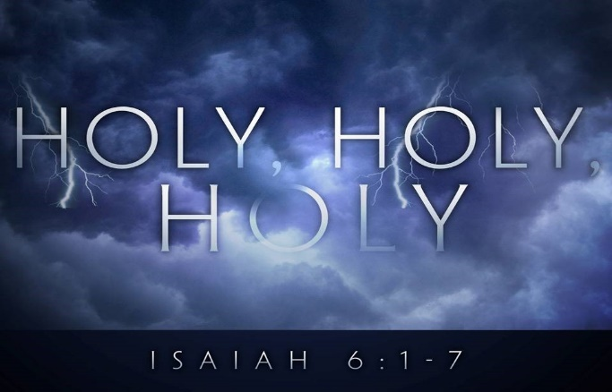 Having the right view of God’s person is a powerful motivator to repent. “When Nathan confronted David concerning his sin, a major thrust of his accusation against the king was that he despised the Lord” (2 Samuel 12:9).[4] An essential part of God’s attributes as outlined in Scripture is His holiness. In Isaiah’s vision the seraphim called out to one another: “holy, holy, holy is the Lord Almighty; the whole earth is full of His glory (6:3). There is no one like He who is pure light (1 John 1:5) whose Son Jesus lived amongst us and yet never sinned (1 Peter 2:22)! God hates iniquity (Psalms 5:5) and when we stubbornly refuse to repent we store up His wrath against us (Romans 2:5). If fear cannot get you to repent then stop for a moment and think about the love Jesus Christ demonstrated for you and me on the cross. If we could only see every sin that we do as being another spike driven in the hands and feet of our Savior, would we not want to repent and stop sinning? Viewing God as both judge and Christ as our sympathetic high priest are powerful motivators to repentance!

**GOD’S WORD**

Wanting to be obedient to God’s word is a powerful motivator to repent. David viewed God’s law as being perfect, pure, true and when followed capable of restoring the soul (Psalms 19:7-11). For one who viewed Scripture as being more valuable than gold and sweeter than honey, one can only imagine the shame David felt when Nathan asked him “why have you despised the word of the Lord by doing evil in His sight” (2 Samuel 12:9)? Like David we are fully aware that all sin goes against God’s word. David was horrified and his heart immediately broke upon being reminded that he sinned against the very law that he was meditating on day and night (Psalms 119:97)! Knowing the law, even loving it, is no substitute for keeping the law.[5] Knowledge of the law only leads to holiness when we allow the law to change our thoughts, words and deeds. Having the laws of God written on our hearts is a powerful motivator to live a repentant lifestyle.

**GOD’S LOVE**

The love of God is a powerful motivator to repent and stay on the path of righteousness. While fear of God is the beginning of wisdom (Proverbs 9:10) it is does not produce lasting change until one truly loves God with all of one’s heart. Our love for God must go way beyond a temporary emotional experience. When David sinned God did not remove His love from the king. You see God’s love is not based on a person’s conduct for it was then He would love absolutely no one (all have sinned – Romans 3:23). As it is God loves us even when we are His enemies (Romans 5:10). Our souls that have been created by Him and for Him (Colossians 1:16) crave to be near to our Creator. After having sinned David stated “when I kept silent about my sin, my body wasted away through my groaning all day long” (Psalms 32:3). Often it is the crushing burden of sin and remembering the love of Christ who died for our sins that motivates us to repent and have our relationship restored with our loving God!

**BODY AND BLOOD OF CHRIST**

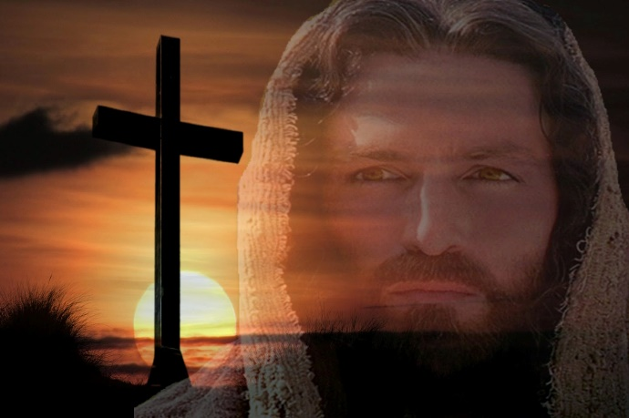One can think of no better motivator to crush the pride of one’s sin than the cross of Jesus Christ! The root of all sin is pride. We think we can do anything we want and God does not notice or care. At the foot of the cross we come to understand that this is certainly not true for our sin cost Christ His very life. The wrath of God that rightly was meant for us was fully placed on Christ (Isaiah 53:5-6) and by His atoning death and resurrection we have been freed from the bondage of sin (1 Peter 2:24). Considering this, Paul urges us to put off the former, old self that is being corrupted by its deceitful desires (Ephesians 4:22). Like Paul, this means that “I” must be crucified with Christ so that “I” might no longer live but only Christ in me (Galatians 2:20). Knowing that Jesus died for ME personally and that sin is against His broken body is a powerful motivator to crucify the sin within and embrace right living.

**GOD’S WARNINGS**

It is rare that we hear of a fire and brimstone preacher in this modern-day world. While words such as “discipline” or “punishment” are often rejected by our society this does not mean that “today’s” God only shows grace! Since God does not change (Malachi 3:6), we can expect God’s wrath that fell on the Israelite people, to fall on us today as well. Because of His hatred of sin and His love for humanity, God has provided us a way of escape from His eternal wrath, repentance![6] Ever since the Fall of humanity, all who sin still need to repent to be forgiven. If we continue to deliberately keep on sinning, then we risk judgment from God who is like a consuming fire (Hebrews 12:29). God warns those who reject his plan of salvation that they will be thrown into the lake of fire (Matthew 13:41-42) and also warns those who are His children to expect to be disciplined (Hebrews 12:6) for having sinned. While not all discipline is forgone upon repentance it certainly goes a long way to appeasing God’s wrath. Fear of God’s wrath can be a powerful motivator to repent for one’s sins!

**GOD’S ASPIRATION FOR US**

 Knowing the lofty plans and purposes God has for your life can be a powerful motivator to repent and stay on the right path. God has given each of us our own spiritual gift mix (1 Corinthians 12:7-11) that enables us to carry out our divinely assigned roles. While God is fully aware of our past and present sins, He also knows the potential of a person who has His Spirit living in them! Through the power of the Holy Spirit you can truly do miracles greater than Jesus did while here one earth (John 14:12). If one walks in the power of the Spirit and lives a life of perpetual repentance, then nothing is impossible but if one’s continues to sin then one cannot expect to reach one’s God given potential. Wanting to fulfill the potential God has given you is a powerful motivator to live a repentant life!

**CONCLUSION**

This week’s sermon began by explaining ten of the most common impediments to repentance: in times of blessings one does not need to repent, repentance is easy so why not put it off until later, God is merciful so what is the need for a broken heart, I am too lazy, I love my sin too much, repentance will remove my joy, I am too evil to repent, this is no punishment for sin, fear of reproach and love of this world. The last part of this sermon we reviewed seven powerful motivators to repent: God’s rights as sovereign Creator, God’s person, God’s word, God’s love, the body and blood of Christ, Gods warnings and His aspirations for us. Next week we are going to sum up what we have learned by outlining a step by step, Biblical model of repentance.

See the website for a list of authors that contributed to the content of this sermon. A special thanks to Richard Owen Roberts and his book Repentance: The First Word of the Gospel Message.

1. Thomas Watson, Kindle location 1153.
2. Thomas Watson, kindle location 1184.
3. Ibid., kindle location 1196.
4. Richard Owen Roberts, kindle location 1987.
5. Ibid., location 2035.
6. Richard Owen Roberts, kindle location 2113.