**REPENTANCE SERIES**

Online Sermon: <http://www.mckeesfamily.com/?page_id=3567>

We started off this series by talking about sin and the character of God. When we sin, we become distant from God because He is pure light and there is no darkness in Him at all. We learned that repentance is the mechanism that God gave us to be forgiven and have our relationship with Him restored. Even with this mechanism we remain distant from God because we do not know how to repent God’s way. For instance, in the second week of this series we identified seven myths concerning repentance. It is a myth that motivations such as sorrow, preservation, penance, reformation, self-deception, selective and no consequence; always lead to repentance. The third week we explored ten of the most common impediments to repentance and describing seven key motivating factors of a truly repentant heart.

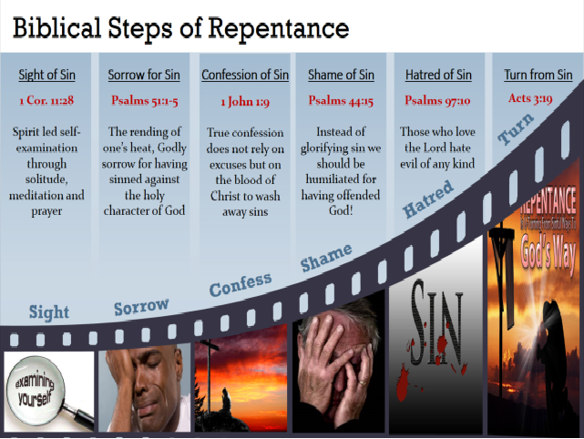

Last week outlined six crucial steps of a Biblical model of repentance. Step one is through solitude, meditation and prayer; examine and identify sin in your life. Step two is to have Godly sorrow for having offended the holy character of God. Step three is to confess to God with a broken heart. Step four is to be absolutely humiliated and ashamed of having broken God’s commands, considered all He has done for you. Step five is to come to hate any word, deed or action that goes against the holiness of God. And the last and most difficult step is to turn from the sin to embrace right living. These steps are incredibly difficult and without the power of the Holy Spirit could not be accomplished. To finish off this exciting series on repentance sermon will outline seven benefits of living a repentant life.

.

**PART 5: SEVEN FRUITS OF LIVING A REPENTANT LIFE**

**John 15:1-4**

Repentance is validated by its fruit. In a world where there are many wolves dressed in sheep’s clothing (Matthew 7:15), it can be very difficult to tell which person has and which one has not been born again. To address this uncertainty Jesus says that we can separate the children of this world from God’s children by examining the fruits of their lives (Matthew 12:33). Those who bear bad fruit are children of the prince of his world (Ephesians 2:2) whereas those who bear good fruit are God’s children. In a similar manner, a person can tell if one is truly repentant or not by examining the fruit or outcomes of their repentance (Matthew 3:8). To tell if one has successfully repented or not one only needs to examine oneself to see if any of the following seven fruits of repentance exists in one’s life.

**FRUIT ONE: CITIZENSHIP IN GOD’S KINGDOM**

 The first fruit of living a repentant life is citizenship in God’s kingdom. While almost all church going people automatically assume they are born again believers, unfortunately this is not the case. Even if you have prophesied in the name of the Lord, driven out demons and performed many miracles; this is not proof of salvation (Matthew 7:21-23). To be saved one must “perform deeds appropriate to repentance” (Acts 26:19-20). Since a good tree bears good fruit and a bad one bad fruit, one cannot have both feet in Satan’s kingdom and expect to bear fruit in God’s! To become a citizen of God’s kingdom requires one to repent of one’s sin and make Jesus Christ the lord of one’s life. Only when one is born again is one enabled to truly bear the good fruits of love, joy, peace, patience, kindness, goodness, faithfulness, gentleness and self-control (Galatians 5:22-23). If one has never experienced these fruits, then one should examine oneself for there is a good chance one is not saved.

**FRUIT TWO: KNOWLEDGE OF TRUTH**

 Only those who are repentant and born again can understand spiritual truths. Jesus spoke in parables so that “though seeing, they do not see; though hearing, they do not hear or understand” (Matthew 13:13). Apostle Paul tells us that “the god of this age has blinded the minds of unbelievers, so that they cannot see the light of the gospel that displays the glory of Christ, who is the image of God” (2 Corinthians 4:4). No matter how much they learn, Paul says a veil of darkness will keep them from ever coming to the knowledge of the truth (2 Timothy 3:7). The solution to removing this veil of darkness is to repent and believe in Jesus Christ (2 Corinthians 3:14-16). Repentance is the only way to know the truth (2 Timothy 2:24-25) concerning God because the seal (2 Corinthians 1:22) of the born-again believer, the Holy Spirit, is the only one who can search, know and reveal the deep things concerning God (1 Corinthians 2:10-14). Genuinely repentant Christians are known by their knowledge of the truth.

**FRUIT THREE: FORGIVENESS OF SINS**

 Repentance for forgiveness of sins should be proclaimed in the name of Jesus Christ to all the nations (Luke 24:45-47). When a person repents, and believes in the atoning sacrifice of Jesus Christ they are forgiven of their sins and are born-again, not of flesh and blood (John 1:13) but of the Spirit of God into His family. Remember the unspeakable joy that you felt when you were born-again? Because there is no sin in God whatsoever, this joyful feeling can only be maintained by living a repentant life style. You might object and say that once born-again the blood of Christ covers all past, present and future sins. While this statement is certainly true in regards to our salvation, it is not true in regards to one’s close personal walk with God. Since God is pure light and there is no darkness in Him at all, the only way to stay closely walking with a holy God is to repent each time one sins. Praise be to God that He is “faithful and just and will forgive our sins and purify us from all unrighteousness” (1 John 1:9).

**FRUIT FOUR: TIMES OF REFRESHMENT**

Everything is in a constant flux of change. Living in a world where truth is in the eye of the beholder means that for many people truth changes from one day to the next. When Christians grow careless about how much the world influences them, they often see moral and spiritual declines in their lives because God is no longer the center of their moral compass. The more we embrace the old self that loves the freedom to sin, the more God demonstrates His displeasure by withdrawing His presence from our very lives. Since we all sin daily (1 John 1:10), the only way to remain close to God then is to repent daily! Job for instance was not considered righteous in God’s sight because he was sinless but due to his practice of repenting each morning for both himself and his family’s sins (Job 1:1-5). Repentance is the mechanism in which we refresh our relationship with the Lord (Acts 3:19) by first asking for forgiveness and then allowing God to renew our minds (Romans 12:2) to love and obey His commands.

**FRUIT FIVE: THE GIFT OF THE HOLY SPIRIT**

 If you are a Christian, then you have received the gift of the Holy Spirit. You have not been baptized by water alone but with the Spirit of God (Mark 1:7-8). It is through the power of the Spirit of truth that we are enabled to obey God’s commands (John 14:15-18). We have all tried to understand and obey God on our own, only to fail time and time again. It is almost like sin is forever crouching at our door (Genesis 4:7) and getting the better of us (Romans 7)! Thankfully, Jesus sent us a Comforter who can reveal and guide us into all truth concerning Him (John 15:26). With the Spirit’s help, the commands that once seemed like a burden (1 John 5:3) or as foolishness (1 Corinthians 1:18) to us are now seen as a source of great joy and the bread of our lives! And when we break these commands, the Spirit of God is of great comfort for He convicts us of our sins so that we might repent and continue to live holy lives (John 16:7-15).

**FRUIT SIX: PERSEVERANCE**

Keeping the great cloud of witnesses ever before us we are to throw off all sin that easily entangles us on the journey. While this race has a glorious finish to it, an inheritance that can never perish, fade, or spoil (1 Peter 1:4); the journey getting there is often fraught with hardships and persecutions. When you joined the kingdom of God, Jesus did not promise you an easy but a difficult life. Jesus promised that since we do not belong to the ways of this world then we can expect unbelievers to hate and persecute all Christians (John 15:18-25). While we are to perceive tribulations as a source of joy because they can lead to increased faith (James 1:1-4), often we succumb to temptations and end up wandering on the broad path of sin. It is only thorough living a repentant life and by keeping our eyes fixed on Jesus, the pioneer and perfecter of our faith, that we are able to return, finish the race and receive crowns of righteousness (2 Timothy 4:8)!

**FRUIT SEVEN: READINESS FOR COMING JUDGMENT**

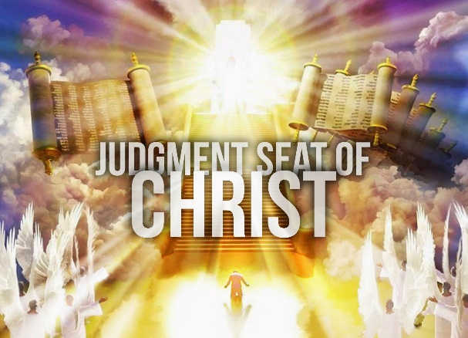 God has appointed a time for every person to die and after that comes some form of judgement (Hebrews 9:27).[1] Both the believer and non-believer face judgment upon their physical death. For the non-believer, this is the kind of judgment that ends in eternal damnation. For the believer, each person gets recompense for the things done in the body whether good or bad (2 Corinthians 5:10). This means that every believer must stand before the tribunal of Christ to “test the quality of each person’s work” here on earth (1 Corinthians 3:13-15). As the righteous judge, we can expect Christ “to reveal the hidden things of darkness” of our innermost thoughts and hold us accountable for them (1 Corinthians 4:4-5). “All unbelief, coveting, self-seeking, pride, greed, envy, and lust that now indwell our works in a hidden way will be exposed.”[2] To have the quality of one’s work on earth judged by a holy God should concern us greatly. Is there anything we as Christians can do to have our works of sin erased? Praise be to God the answer is yes, repent and your sins will be washed as white (Psalms 51:7) as snow, removed from your life as far as the east is from the west (Psalms 103:12)!

**CONCLUSION**

Since we all sin and fall short of God’s glory living a repentant life is the only way for us to maintain a close personal, relationship with a holy God. We learned that repentance must be done God’s way or it will not lead to forgiveness and restoration. For instance, solely focusing on motivators such as sorrow, preservation, penance, reformation, self-deception, selection, and no consequences for sin; often are ineffective because what God truly wants from us is a broken heart! After having gone through the Biblical steps of sight, sorrow, confession, shame, and hatred of sin; one can turn from darkness and embrace righteous living. The benefits of living a repentant life: citizenship in God’s kingdom, knowledge of truth, forgiveness of sins, times of refreshment, God’s presence, perseverance, and readiness for judgment; are truly treasures beyond what any words can express!

1. Richard Own Roberts, The First Word of the Gospel, kindle location 2733.
2. Mark A. Seifrid, [*The Pillar New Testament Commentary: The Second Letter to the Corinthians*](https://ref.ly/logosres/pntc68co2;ref=Bible.2Co5.10;off=2624;ctx=hey_are_in_reality._~All_unbelief,_coveti), ed. D. A. Carson (Grand Rapids, MI; Cambridge, U.K.; England: William B. Eerdmans Publishing Company; Apollos, 2014), 237.