**REPENTANCE SERIES**

Online Sermon: <http://www.mckeesfamily.com/?page_id=3567>

From the moment, God created humanity from the dust of the ground onwards we have been struggling to know and have a relationship with our Creator. You would think the ambassadors of Christ and royal priests that have been sealed by the Spirit of God would have little difficulty knowing, accepting and striving towards fulfilling God’s command to be holy. How I wish that was the case! Like Paul, we often gratify the evil desires of our sinful nature and thus miss the mark of holiness every single day. Sin leaves us distant from a holy God who refuses to be close to those spiritual babies who continue to covet their strongholds of sin. Since there is no sin that the blood of Christ cannot wash away then why do our attempts of confession and repentance seem to be nothing more than an exercise in futility? How can one repent and yet remain a wretched, blind beggar thirsty to know one’s own Creator?

The problem of course is not with God. To those who truly repent He always forgives and cleanses from all unrighteousness. If you draw near to God He will draw near to you. The reason why holiness and closeness to God remain beyond our reach is because we do not know how to repent in a God-fearing manner! This five-part sermon series will begin looking at the God’s command to repent and a discussion on how offensive sin to the character of a holy God. Next, the series will identify some of the myths of what repentance is not so that one can stop wasting one’s time repenting one’s own way. Third, the series will outline the need to embrace the right motives of repentance. Fourth, the series will outline a model of practical steps that will teach one how to repent God’s way. And lastly, this series will finish by outlining the fruits of repentance.

Before I begin I would like to give credit where credit is due. There are four books that I relied heavily on when writing this sermon series. For a full doctrine of repentance, I turned to Richard Owen Roberts “Repentance: The First Word of the Gospel” and Thomas Watson’s “The Doctrine of Repentance.” For everyday issues concerning repentance, I turned to C. John Miller’s book “Repentance: A Daring Call to Real Surrender” and Stephen Baker’s book “Repentance: Gods Marvelous Gift.” While all these workers were an amazing source of information, I primarily relied on commentaries and God’s holy word.

**PART 1: REPENTANCE, SIN AND THE CHARACTER OF GOD**

**Romans 2:4**

Given how hard it is to break the strongholds of sin, one should not be surprised that the very first word of the gospel message is not “love” or “grace” but “repent.” Even though a man dressed in camel’s hair with a palate of locusts and wild honey and the desert for a church building might seem strange to us today, so must be his message “repent for the kingdom of God is near” or Christians everywhere would have already attained holiness! In a culture that no longer believes in absolute truth, right living has been relegated to a sea of ever changing motives and desires. Missing the mark of God’s perfection is no longer seen as a reason to cry out like Paul “what a wretched person I am” but instead as a badge of honor that says I am open minded enough to change and satisfy every whim of my changing culture. So indoctrinated Christians have become in the ways of the world that we have forgotten God’s command to repent and how offensive sin is to the very character of God!

**GOD’S COMMAND TO REPENT**

**Question 1: How important is repentance to God as outlined in both the Old and New Testaments?**

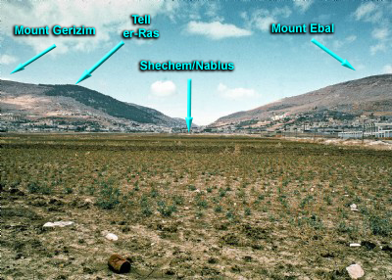 From the introduction of the sinful nature in the book of Genesis onwards humanity has been breaking God’s commands. Repentance in the Old Testament is the mechanism that God gave to His people to be forgiven so that they might not face His wrath but instead His cloeness. Joel told the people of Judah to “rend their hearts” for the “day of the Lord” was coming (2:12-13). The prophet Ezekiel warned the Israelites that that unless they rid themselves of their offenses and get a “new heart and spirit” the wrath of God was coming (18:30-31). Isaiah implored God’s people to seek the Lord while He may be found, call on Him, forsake their wicked ways so that they might enjoy a healthy relationship with God (55:6-7). And what unrepentant person could ever ignore the cries of Jeremiah to repent because God did not want to bring calamity on Jerusalem that would leave her land desolate and deserted (chapter 6). Moses message to Israel sums up God’s view on repentance in the Old Testament best: blessings for those who repent and curses and wrath for those who do not (Deuteronomy 28)!

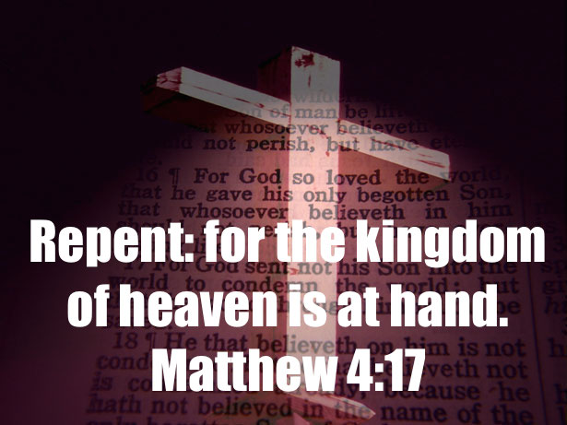In the New Testament, the importance of repentance cannot be over stated. The very first word of the Gospel message was to “repent for the kingdom of God has come near” (Matthew 3:2). We are told in Luke 24 that repentance and forgiveness of sins should be proclaimed in the name of the risen Savior to the entire world (46-47)! What the commands of the Old Testament were powerless to do because they were weakened by the sinful nature, through Christ the law of the Spirit has been given to set people free from the law of sin and death (Romans 8:1-2)! Since this New Covenant fulfills the promise to give humanity a new heart (Ezekiel 36:26, John 3:5-8) that is capable of attaining holiness, we are warned by God that He will no longer overlook our sin (Acts 17:29-31). Like the Old Testament, those who make light of the riches of His kindness, forbearance and patience by hold onto their stubborn, unrepentant hearts are storing up the wrath of God against themselves (Romans 2:4-5). The message of repentance in the New Testament is clear: since all sin is equally offensive to God (James 2:10), all people will be held accountable for the things done in the body, whether good or bad (2 Corinthians 5:10)!

**Question 2: Obviously, repentance is critical to attain holiness. What is sin and why is it so offensive to the character of God?**

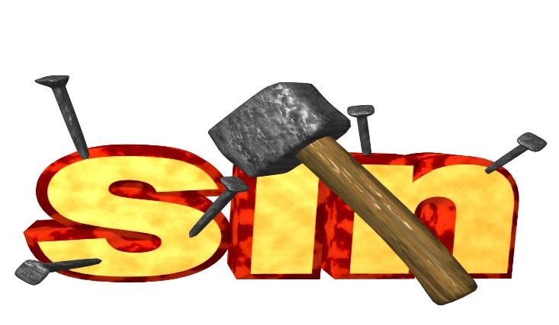 Any thought, word or deed that goes against the will of God as revealed by His Spirit and Word is defined as a sin. Even though this day and age has obscured morality to the extent that the lines between right and wrong can no longer be identified, God alone gets to decide what is right in His sight! While hypocrisy (Matthew 23:1-36), covetousness (Luke 12:15), blasphemy (Matthew 12:22-37), breaking God’s Law (Matthew 15:3-6), lack of faith (Matthew 6:25), anger (Matthew 5:22), immorality (Matthew 5:27-32), pride (Matthew 20:20-28), fruitlessness (John 15:16), and prayerlessness (Luke 18:1-8) are defined as sins general to everyone so is refusing to do the will of God when asked to serve Him (Mark 3:35). When a person misses this mark of righteousness by either intentionally or unintentionally sinning in one’s thoughts, words or deeds; God demands a sacrifice or risk God’s wrath in the form of estrangement from Him (1 John 1:5-10), physical illness or even death (1 Corinthians 11:27-30). God takes sin seriously even if we do not!

**“When our view of God is right, our view of self will be right, and thus our views of sin and salvation can be right also; but if we tolerate a low view of God, we are almost certain to have an excessively high view of ourselves and erroneous views of sin and salvation.”[1]**

**Richard Owen Roberts**

 Knowing this definition of sin means very little to us if we do not have a proper view of who God Himself. We live in an arrogant age that has created God in their own image to make sin an impossibility. Since we cannot fully understand or see a God who is wholly other, we foolishly make Him into an image that is appealing to us, that of ourselves. When we see God’s son Jesus Christ merely as a friend who accepts all of our thoughts, words and deeds without question, the cross becomes nothing more than an instrument of beauty, [2] and God nothing more than a puppet that we command to dance to the evil ways of this world (Matthew 11:17)! Being right in God’s sight has become nothing more than reflectively looking into a mirror only to conclude that our ways are equivalent to the fruits of the Spirit of love, joy, peace, forbearance, kindness, goodness, faithfulness, gentleness and self-control (Galatians 5:22-23)! This misconception of how God sees sins has left many in the church sitting at the Lord’s table craving for a deep spiritual connection with their Creator that forever eludes them![3]

**5This is the message we have heard from him and declare to you: God is light; in him there is no darkness at all. 6If we claim to have fellowship with him and yet walk in the darkness, we lie and do not live out the truth.**

**1 John 1:5-6, NIV**

To satisfy one’s spiritual thirst one must acknowledge that the God of the Bible who is pure light cannot and will not tolerate any kind of sin in His presence.[4] The carnal Christians of this world who believe that having accepted Christ as their Saviour fulfills their duty to a holy God need to be reminded that He who purchased them at a price has every right to demand they honor Him with their thoughts, words and deeds (1 Corinthians 6:19-20). He who was tempted in every way that we are (Hebrews 4:15) and yet did not sin (1 Peter 2:22) has called His own to go beyond the white washed tombs of the Pharisees (Matthew 23:27) and embrace rather than just appear to walk in His footsteps. Those who still love the ways of this world (1 John 2:15) and continue living like the pagans (1 Peter 4:3-5) should heed God’s warning: if He did not spare His own Son (Romans 8:32) what makes us think that He will spare those who remain carnal and in love with the deceitful desires of their own hearts (James 1:13-15)? The message of the Old and New Testaments are clear: God’s righteous wrath will fall on those who choose to embrace any other way of living except that of His own! God is light and there simply will not be any darkness found in Him!

**WHAT REPENTANCE IS AND WHAT IT HAS BECOME**

**Question 3: Since we all sin and miss the mark of holiness does this mean that no one can ever approach a holy God?**

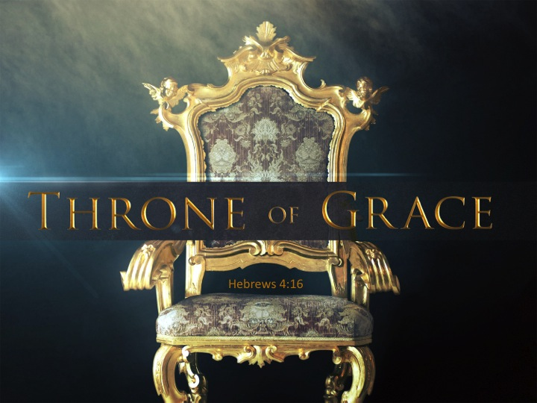 No, for the cross says “no matter what your sins, unlimited mercy is available to those who turn to God through Jesus’ merits.”[5] Those who fall short of the mark of righteousness can be “made holy through the sacrifice of the body of Jesus Christ once and for all” (Hebrews 10:10). While Christ did the hard part, being a sacrifice to appeased God’s wrath, we still have a part to play when it comes to being restored with a holy God. The sacrifice that God expects from us is repentance through a broken heart (Psalms 51:17). We demonstrate our brokenness when we hate the evil we have done (Romans 12:9), confess and turn away from our sins. Once we repent, God promises to forgive and cleanse us from all unrighteousness (1 John 1:9) so that we might boldly approach His throne of grace (Hebrews 4:16). Praise be to God that there is no sin that the blood of Christ cannot cleanse and wash away (1 John 1:7)!

**Problem Defined: If repentance is promised to restore our relationship with a holy God then why do we rarely feel God’s presence?**

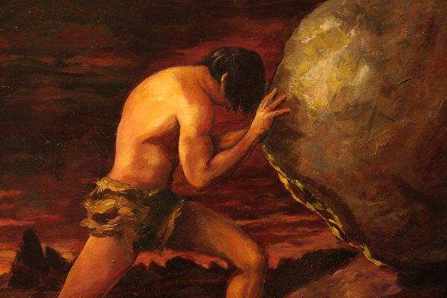 The problem facing today’s Christian is that God’s mechanism to restore our relationship with Him, i.e. repentance, seems to elude our sensibilities! The punishment that the Greek gods did to the king of Ephyra comes to mind. The myth talks about how this king Sisyphus was forced to push an immense boulder up a hill. He would pant and puff for it took him all his strength to move this giant bolder. With sweat dropping down his face Sisyphus would move the boulder one inch at a time until he could see the pinnacle of the hill. O the excitement that was in his eyes for his punishment was almost complete! To his dismay just before that boulder topped the crescent the gods would through the giant boulder to the bottom of the hill and then command Sisyphus to start all over again. According the Greek myth the punishment was that no matter how hard Sisyphus tried he would never get that boulder to the top of the hill and be freed.

Before you think of me as a heretic let me say that I do not believe in Greek gods or their mythology! I merely find the story has a good parallel to the frustration we often feel as Christians when we cannot remove the strongholds of sin in our lives. We come to God repeatedly and repent of our sins and yet remain in a stronghold that has left many of us crying out “who will ever save the wretched person I have become!” How frustrating it is to have boulders of sin pressing down and crushing the life out of us and not knowing how to escape! It is not that God delights in our failures nor does He renege on His promise to forgive those who repent. There is something fundamentally wrong but it is not with God but with us. We simply do not understand how to properly repent in God’s manner so we might have Him remove the sin in our lives!

This is the whole reason for this sermon series. I have many sins in my life just like I am sure you do as well. I am no longer willing to allow sin to reign in my heart and thus keep me from approaching a holy God. I want to see and know my God like Adam, Moses, Elijah, Peter, James and John knew Him. For any Christian to develop a close, personal relationship with a holy God they must first learn what repentance is not which is the topic for next week’s sermon. In the subsequent sermons, I will talk about how to embrace the right motivation and model of God’s repentance so that we can enjoy the fruits of a closer walk with Him!

1. Richard Owen Roberts, Repentance: The First Word of the Gospel, Kindle Location 3875.
2. A. W. Tozer, [*The Radical Cross : Living the Passion of Christ*](https://ref.ly/logosres/radicalcrss;ref=Page.p_3;off=1171;ctx=originally$E2$80$94a_cross._~Its_power_departed_w) (Camp Hill, PA: WingSpread, 2005), 3.
3. Ibid., 8.
4. Richard Owen Roberts, Kindle Location 3885.
5. John Miller, Repentance, Kindle Location 95.