**SIN OR GOD III?**

**Matthew 4:1-11**

Online Sermon: <http://www.mckeesfamily.com/?page_id=3567>

Ever since creation Satan has been tempting humanity to sin against God. When going through the wilderness experiences of aloneness, physical or emotional pain, prepare oneself to be tempted by the Devil. The greater the pain the more likely the Devil will show up and tempt the person to pick the path that leads to self-satisfaction. The first week we learned that Jesus overcame the lust of the flesh by refusing to turn the stones into bread but instead to live by every word that comes from God. Last week we learned that Jesus overcame the pride of life by refusing to cast Himself down from the temple but instead to trust in God in all matters. This week we are going to examine how Jesus overcame the final temptation: the lust of the eyes.

**JESUS’ VICTORIES OVER THE LUST OF THE EYES**

**Again, the devil took Him to a very high mountain and showed Him all the kingdoms of the world and their splendor. “All this I will give you,” he said, “if you will bow down and worship me.” Jesus said to him, “Away from me, Satan! For it is written: ‘Worship the Lord your God, and serve him only.’” Then the devil left Him, and angels came and attended Him.**

**Matthew 4:8-11, NIV**

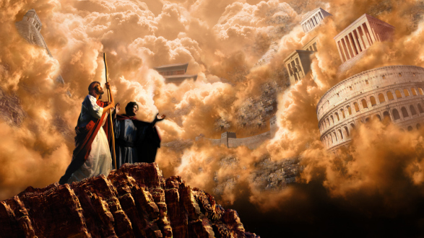 In verse eight we are told that the location of the last temptation is a “very high mountain.” Where this mountain is located is unknown and a subject of great debate. Scholars have suggested the mountain could have either been the one in which Jesus gave His famous Sermon on the Mount of Matthew 5, the one in which He gave His final words to his disciples (28:16)[1] or the mountain of either the vision of Levi or Enoch.[2] Other scholars have argued it was Mount Pisgah (Deuteronomy 3:27; 34:1–4), the one in which Moses viewed the promised land.[3] While it is possible that Satan was tempting Jesus to give into the Jewish expectation that He would establish Israel as a worldwide empire to reign supreme with perfect justice,[4] the lack of parallels[5] between these two events makes this highly unlikely. After all, the Devil showed Jesus the kingdoms of the world whereas Moses was only shown the future land of Israel. Also, the Devil in this passage offers the land to Jesus but for Moses he was shown the land but was told he would never enter it.[6] Most likely the mountaintop temptation was a visionary experience.

 Whether Jesus was physically on that mountain or not, the temptation was real. The rise in altitude from the desert, to the pinnacle of the temple, to the mountaintop; indicates to the reader that this is the climax of Jesus’ wilderness temptation.[7] On the mountain Satan offers Jesus all the kingdoms of this world and their splendor. This is a twofold temptation. First, was the temptation to receive riches. Nothing makes humans fall under Satan’s influence any faster than longing for more and loving covetousness.[8] To be offered the splendor of king and queens, their wealth, pleasure and gaiety, would truly be a temptation to the human side of Christ[9] who had no home (Matthew 8:20) and was starving to death! Since Psalms 2:7-8 states the entire world was Christ’s inheritance, the Devil asks what would be the harm in taking what was rightly His in the first place? Also, why suffer asks the Devil, when the pleasures of this world can easily satisfy Your physical desires?

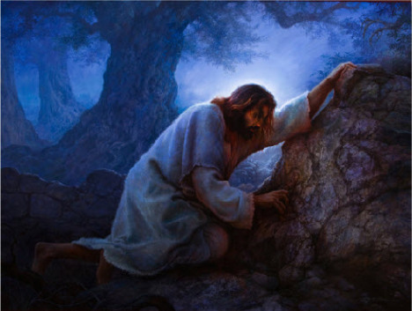Second, this was a temptation to serve Satan rather than God. Jesus is faced with an age-old temptation to act in accordance with the worldly belief that the end justifies the means.[10] The god of this age (2 Corinthians 4:4) and prince of this world (John 12:31), Satan, offered Jesus possession of the earth that was rightful His inheritance without having to obey God and die on the cross! To one who knew that one day soon He would sweat drops of blood before His crucifixion (Luke 22:44), this was a real, inward, spiritual temptation to take an easier path![11] In other words, Satan was saying I will not be like Your unkind Father and leave You starving in this wilderness nor will I request You to go through the agony of the cross.[12] Instead I will offer You Your inheritance now and all that You must do is bow down and worship me. This was Satan’s ultimate goal for the first two temptations as well: to get Jesus to reject God’s will and in doing so Jesus would have served Satan in his kingdom.[13]

**Jesus said to him, Away from me, Satan! For it is written: Worship the Lord your God, and serve Him only. Then the devil left him, and angels came and attended Him.**

**Matthew 4:10-11, NIV**

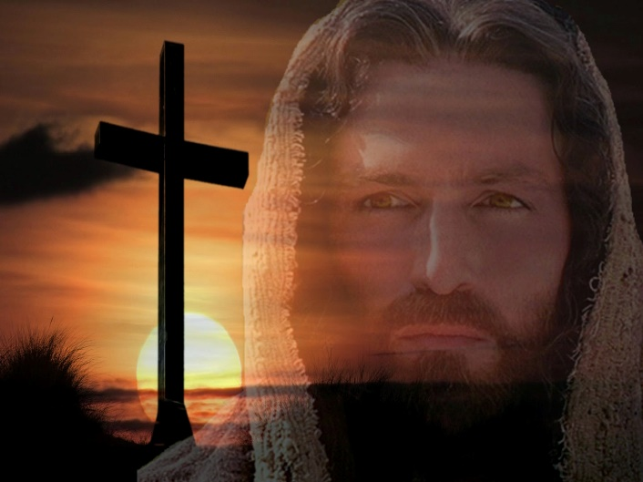 Quoting Deuteronomy 6:13 Jesus reminds Satan that it is the sin of idolatry to serve anyone but God the Father. Even though the three temptations were as hellish as Satan himself,[14] Jesus reminded him that neither the Son of God nor Israel were to sway from their allegiance to God alone (Exodus 23:2-33).[15] How foolish Satan was to offer Jesus Christ the world that was already His to begin with. Jesus who is the author and creator of everything (Colossians 1:16) would one day have His kingdom progressively expand (Matthew 12:25-28)[16] to the point where the Serpent’s head would be crushed forever! The kingdom of this world that was promised to the Son of God (Revelation 11:15; Psalms 110:1-2) would not be obtained by worshipping Satan to receive the fleeting pleasures of a dying world (1 Corinthians 7:31) but only through obeying God’s will and dying on the cross.[17] To demonstrate the Son of God already has authority over Satan, Jesus commanded him to leave and like the unclean spirits he had no choice but to depart.[18] Now that Christ had accomplished God’s will and passed the test, it is appropriate that the angels came and ministered to His needs.[19]

**APPLICATION**

 The first thing that we learn from the final temptation of Christ is the importance of seeking the eternal blessings of God’s kingdom. Satan knows our preoccupation with avoiding human pain while maximizing pleasure. We all know of people who because of life’s circumstances or the product of their own bad choices have gone from having plenty to having so little that they cannot meet the necessities of life. News of wars, earthquakes, downsizing and diseases often instills enough fear into our hearts that hording riches for rainy days seems not only reasonable but also wise. We also know of people of great wealth who flash their possessions around and in doing so invite us to covet their pleasure. While providing for one’s family is certainly not a sin, loving this world (1 John 2:15) and not seeking the kingdom of God first (Matthew 6:33) certainly is! When we keep our focus on eternal, not physical blessings; we show our allegiance is truly to God and not Satan or ourselves.

The second thing that we learn from the final temptation is that the end does not justify the means! Satan offered Jesus the following short cut: worship me and I will give you the rule and the pleasures of this world without having to suffer on the cross. Giving one’s allegiance to God by obeying His will often requires sacrifice and suffering. The more we become like Jesus and let our light shine, the more the world will hate us because they do not want their sin exposed (John 3:20). Also, when serving in God’s kingdom one can expect he who roars like a lion (1 Peter 5:8) to make the righteous path fraught with trials and tribulations! Satan tempts us to compartmentalize our lives. He tempts us to live like this world from Monday to Saturday to obtain riches and then on Sunday justify our weekly sin by offering more of our material wealth to God. The end does not justify the means for God wants us to serve Him and Him alone (Deuteronomy 6:13). Furthermore, true riches that we are to seek are not earthy but heavenly ones (Matthew 6:19)!

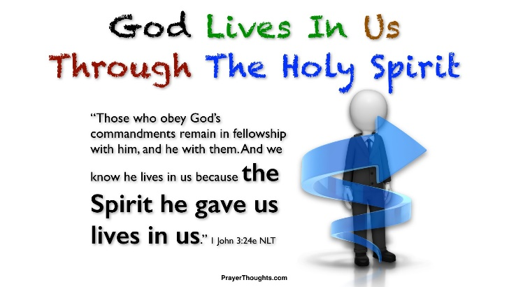The third thing we learn from the final temptation is that Satan has no power over those who do the will of God! The very moment that Jesus said “away from me Satan” was the exact moment he had to leave! When going through temptations do not give the devil a foothold into your heart by becoming angry or feeling your situation is hopeless (Ephesians 4:27), but instead put on the full armor of God (Ephesians 6:11) and resist (James 4:6) the Devil’s attacks by standing firm in the faith (1 Peter 5:6-9) that God will always protect you and provide a means to endure (1 Corinthians 10:13). Remember while you as babies and children of God are no match for the Devil, the Spirit of God who lives inside of you has already defeated the prince of this world!

**CONCLUSION**

Ever since creation Satan has been tempting humanity to sin against God. When going through the wilderness experiences of aloneness, physical or emotional pain, prepare oneself to be tempted by the Devil. In the first temptation of Christ we learn that we can overcome the “lust of the flesh” by refusing to give into our desire for pleasure but instead to live by every word that comes from God. The second temptation teaches us that we can overcame the “pride of life” by refusing to put God to the test but instead to fully trust Him in all matters. The final temptation teaches us that we can overcome the “lust of the eyes” by keeping those eyes focused on God and His kingdom. When faced with temptations put on the armor of God, stand firm in the faith and trust that the Spirit of God will enable you to endure and mature in the faith!

1. Nolland John, “Preface,” in *The Gospel of Matthew: A Commentary on the Greek Text*, New International Greek Testament Commentary (Grand Rapids, MI; Carlisle: W.B. Eerdmans; Paternoster Press, 2005), 166.
2. Craig A. Evans, *The Bible Knowledge Background Commentary: Matthew–Luke*, ed. Craig A. Evans and Craig A. Bubeck, First Edition. (Colorado Springs, CO: David C Cook, 2003), 86.
3. Nolland John, “Preface,” in *The Gospel of Matthew: A Commentary on the Greek Text*, New International Greek Testament Commentary (Grand Rapids, MI; Carlisle: W.B. Eerdmans; Paternoster Press, 2005), 166.
4. Leon Morris, *The Gospel according to Matthew*, The Pillar New Testament Commentary (Grand Rapids, MI; Leicester, England: W.B. Eerdmans; Inter-Varsity Press, 1992), 77.
5. D. A. Carson, “Matthew,” in *The Expositor’s Bible Commentary: Matthew, Mark, Luke*, ed. Frank E. Gaebelein, vol. 8 (Grand Rapids, MI: Zondervan Publishing House, 1984), 114.
6. Craig A. Evans, *The Bible Knowledge Background Commentary: Matthew–Luke*, ed. Craig A. Evans and Craig A. Bubeck, First Edition. (Colorado Springs, CO: David C Cook, 2003), 86.
7. Nolland John, “Preface,” in *The Gospel of Matthew: A Commentary on the Greek Text*, New International Greek Testament Commentary (Grand Rapids, MI; Carlisle: W.B. Eerdmans; Paternoster Press, 2005), 166.
8. John Chrysostom, “Homilies of St. John Chrysostom, Archbishop of Constantinople on the Gospel according to St. Matthew,” in *Saint Chrysostom: Homilies on the Gospel of Saint Matthew*, ed. Philip Schaff, trans. George Prevost and M. B. Riddle, vol. 10, A Select Library of the Nicene and Post-Nicene Fathers of the Christian Church, First Series (New York: Christian Literature Company, 1888), 83.
9. George Whitefield, *Selected Sermons of George Whitefield* (Oak Harbor, WA: Logos Research Systems, Inc., 1999).
10. Robert H. Mounce, *Matthew*, Understanding the Bible Commentary Series (Grand Rapids, MI: Baker Books, 2011), 31.
11. Robert H. Mounce, *Matthew*, Understanding the Bible Commentary Series (Grand Rapids, MI: Baker Books, 2011), 31.
12. George Whitefield, *Selected Sermons of George Whitefield* (Oak Harbor, WA: Logos Research Systems, Inc., 1999).
13. Nolland John, “Preface,” in *The Gospel of Matthew: A Commentary on the Greek Text*, New International Greek Testament Commentary (Grand Rapids, MI; Carlisle: W.B. Eerdmans; Paternoster Press, 2005), 167.
14. George Whitefield, *Selected Sermons of George Whitefield* (Oak Harbor, WA: Logos Research Systems, Inc., 1999).
15. D. A. Carson, “Matthew,” in *The Expositor’s Bible Commentary: Matthew, Mark, Luke*, ed. Frank E. Gaebelein, vol. 8 (Grand Rapids, MI: Zondervan Publishing House, 1984), 114.
16. D. A. Carson, “Matthew,” in *The Expositor’s Bible Commentary: Matthew, Mark, Luke*, ed. Frank E. Gaebelein, vol. 8 (Grand Rapids, MI: Zondervan Publishing House, 1984), 114.
17. James Montgomery Boice, *The Gospel of Matthew* (Grand Rapids, MI: Baker Books, 2001), 58.
18. Craig A. Evans, *The Bible Knowledge Background Commentary: Matthew–Luke*, ed. Craig A. Evans and Craig A. Bubeck, First Edition. (Colorado Springs, CO: David C Cook, 2003), 87.
19. D. A. Carson, “The Gospels and Acts,” in *NIV Zondervan Study Bible: Built on the Truth of Scripture and Centered on the Gospel Message*, ed. D. A. Carson (Grand Rapids, MI: Zondervan, 2015), 1935.