**LIFE IN THE VINE**

**John 15:1-17**

Online Sermon: <http://www.mckeesfamily.com/?page_id=3567>

In John 15:1-17 Jesus Christ tells us that He is the true vine and we are the branches. Even though we are born again with the Spirit of God living inside of us, amongst brothers and sisters who build us up in the faith; staying connected to the vine and living a righteous life is still one of the hardest things a Christian can ever accomplish! Living in a fallen world that glorifies personal pleasure it is easy to compartmentalize our lives to gratify our inward, sinful desires. Christians are not left without hope for the Gardener, God, promises to prune the sin out of our lives and the true Vine, Jesus Christ, promises to give us the fruits of love, joy, peace, forbearance, kindness, goodness and faithfulness to those who abide in Him by obeying His commands. The following sermon is going to begin by reviewing both the warnings and promises to those who chose to stay connected to the vine and then conclude with Jesus’ explanation of how to abide in Him.

**JESUS IS THE VINE**

**“I am the true vine, and my Father is the gardener. He cuts off every branch in me that bears no fruit, while every branch that does bear fruit he prunes so that it will be even more fruitful.  You are already clean because of the word I have spoken to you.  Remain in me, as I also remain in you. No branch can bear fruit by itself; it must remain in the vine. Neither can you bear fruit unless you remain in me.**

**John 15:1-4, NIV**

Jesus begins this parable by stating that He is the true vine. When vines and vineyards are mentioned in parables in the Synoptic Gospels[1] or in the Old Testament, Israel is portrayed as God’s choice vine (Jeremiah 2:21) that consistently lacked any fruit.[2] For example, Israel’s vineyard was described by Isaiah as “bad” (5:4), Jeremiah as “corrupt” (2:21) and Hosea as being “empty” (chapter 10:1-2). Even though God gave Israel the fertile land of Canaan and protected her from her enemies, this light unto the nations failed to shine or bear any fruit. In the 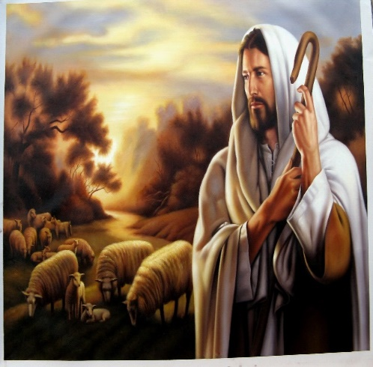last of the “I am” sayings,[3] the true light (John 1:9), true bread (John 6:32) and true tabernacle (Hebrews 8:2), Jesus Christ declared that He alone is the “true vine!”[4] Jesus the sinless, sacrificial lamb in whom God was “well pleased” (Matthew 3:17; 17:5), came to provide us with a new heart (Ezekiel 36:26) so that when we abide in Him we can bear much fruit!

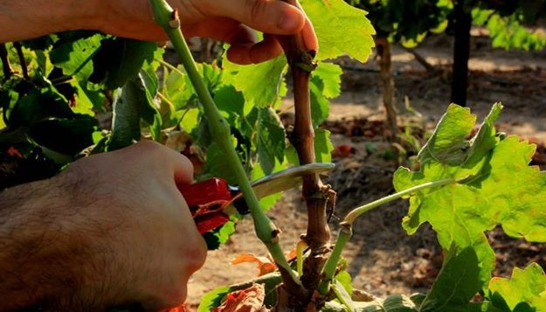 Jesus goes on to say that God the Father is the gardener of the vineyard. His role is to cut and prune the branches. For those branches who like Judas (John 13:1-2) demonstrate that their connection to Jesus is superficial (Matthew 7:22),[5] God will cut them out of the vine. While the cutting of the dead wood from His church[6] is an ongoing process it will be completed at the end times when the tares are collected and burned (Matthew 13:30). For those branches who are born again, God promises to prune them. Dead wood for a believer is worse than fruitlessness, for dead wood can harbor disease and decay.[7] The gardener ensures Christians bear good fruit by removing the sin or dead branches from their lives.[8] Sinful habits must be stripped away, priorities reordered and values changed so that the way a Christian aligns their life to that of the glory of God. [9] While God prefers the removal of sin to be the gentle process of either changing our life circumstances or encouraging us to repent (1 John 1:9), often this pruning process is painful because it involves Him disciplining us (Hebrews 12:4-11). It is out of love and a genuine desire to have the branches share in His holiness that the Father prunes those He calls His own.[10]

**ABIDE IN CHRIST – THE WARNING AND PROMISE**

**“I am the vine; you are the branches. If you remain in me and I in you, you will bear much fruit; apart from me you can do nothing. If you do not remain in me, you are like a branch that is thrown away and withers; such branches are picked up, thrown into the fire and burned. If you remain in me and my words remain in you, ask whatever you wish, and it will be done for you.**

**John 15:5-7, NIV**

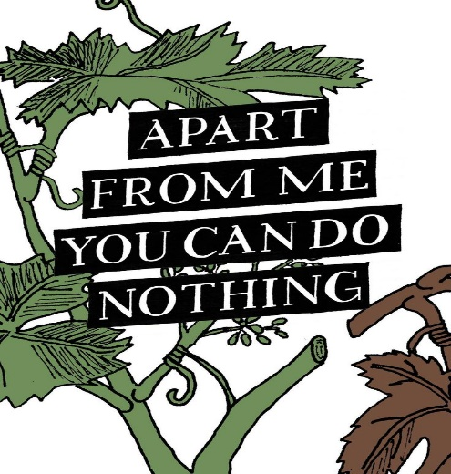 In the second part of the parable of the vineyard Jesus gives to the Christian both a warning and a promise. Discipleship involves more than just being born again it as involves nurturing and maintaining one’s relationship with Jesus Christ by doing exactly what the counterfeit believers refused to do (8:30-59), obey His commands.[11] Since no branch has life in itself [12] because one cannot separate Christ from the Word,[13] the fruits of those Christians who choose to wander on the broad path of sin will be thrown into the fire and burned. This does not mean that one will be separated from the love of God (Romans 8) and lose one’s salvation (John 10:27-29) but merely that one’s attempt to produce good fruit in His kingdom will not happen if one has one foot in Satan’s kingdom.[14] To those Christians who choose to maintain their connection to the vine[15] through obedience and prayer,[16] Jesus promises, for the glory of God, to give them much fruit![17]

 This passage of Scripture explains the frustration that a lot of modern day Christians are experiencing while serving in His kingdom! Who has not desired to obtain the character of Christ? Since we all want to emulate the love, joy, peace, forbearance, kindness, goodness and self-control of Christ in our lives then why do our personalities remain indistinguishable from that of the world? Since so many Christians wholeheartedly serve inside of the church then why is the church not bearing much fruit? The answer to these questions is simple, because we have left the vine to live in accordance with the sin of this world! The promise and cure for our frustration is also simple, remain in the vine through obedience and prayer and you will do miracles greater than Jesus ever did!

**GOD GLORIFIED IN YOU**

**This is to my Father’s glory, that you bear much fruit, showing yourselves to be my disciples. “As the Father has loved me, so have I loved you. Now remain in my love. If you keep my commands, you will remain in my love, just as I have kept my Father’s commands and remain in his love. I have told you this so that my joy may be in you and that your joy may be complete.**

**John 15:8-11, NIV**

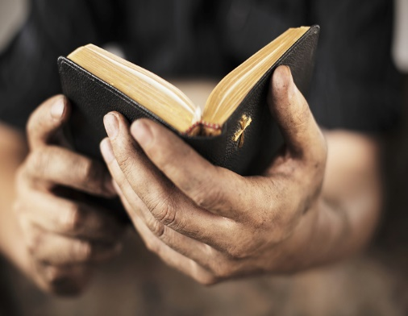Now that Jesus is finished telling us the parable of the vine, the next ten verses are devoted to explaining in more detail two of the results of abiding in Him: obedience and joy.[18] In verse ten Jesus explains what He meant when He said that fruit was contingent on His words abiding inside of the Christian (verse seven). Just like Jesus who remained in the Father’s love by obeying Him (4:34; 5:19-30), we as Christians are to remain in the vine through our love and obedience to Christ.[19] Since “His commands are not burdensome” (1 John 5:3) and His yoke is easy and light (Matt. 11:30),[20] then why is it so hard for the Spirit filled believer to obey? The answer is that we lack the desire and do not believe it is possible to follow His commands! If one continues to love the pleasurable sins of this world one should not expect to effectively serve in His kingdom. Out of love for the sacrificial Lamb of God we must genuinely want to obey Him with all our heart, mind, soul and strength (Matthew 22:37). Like Peter we sin and need constant reassurance[21] that those who draw nearer to God (James 4:8) in reverence and love (John 1 will 5:8) will be empowered by His Spirit to obey.

The result of abiding in Christ by obeying His commands is a harvest of great joy.[22] It is through our obedience that we inherit the same joy that was given to Jesus Christ by God the Father.[23] This is not the same kind of ephemeral, shallow and self-serving kind of joy[24] that this fallen world offers but the kind of joy that is attained, abiding and abounding.[25] This is the kind of joy that is not deterred by suffering and pain or any other life circumstance, but one that is a well-spring of mutual love between our Creator and His friend. The kind of joy that knows that when one’ heart is glad and tongue rejoices (Psalms 16:8-9) in the Lord Jesus Christ, the Prodigal Son will forever be embraced by the Father who makes his/her joy complete! The kind of joy that wakes up in the morning and does not dread the possible outcomes of a day but instead sees it as another opportunity to serve the Shepherd and store more treasures in heaven (Matthew 6:20)! Who would not want to give all they possess to obtain the kind the treasures (Matthew 13:44) that can only be found in His ripe vineyard? How ironic it is that we feel obedience to God’s commands is a source of grief when in fact it is the source of this unspeakable joy!

**CHRIST’S LOVE COMPELS US**

**My command is this: Love each other as I have loved you. Greater love has no one than this: to lay down one’s life for one’s friends. You are my friends if you do what I command. I no longer call you servants, because a servant does not know his master’s business. Instead, I have called you friends, for everything that I learned from my Father I have made known to you. You did not choose me, but I chose you and appointed you so that you might go and bear fruit—fruit that will last—and so that whatever you ask in my name the Father will give you. This is my command: Love each other.**

**John 15:12-17, NIV**

Christ’s love compels us to be obedient to He who bought us at a price. To remain in His love as true disciples requires one to learn how to love as Christ has first loved you.[26] The eternal love that “reached its complete and unsurpassable expression in the death of Jesus Christ,”[27] is to be the motivating force that helps us break the chains of our pleasure seeking wandering. The human autonomy and natural rebellion that we covet can be overcome by 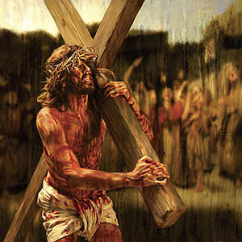embracing His electing grace and the ministry of His Spirit.[28] Following His commands are no longer to be impossible or a burden for those who put their trust in He who conquered death (1 Corinthians 15:4)! Those who have been purchased at a price (1 Corinthians 6:20) honor Christ’s sacrifice through their sincere desire to be obediently attached to the vine. Has not He who paid the price for our sins (John 3:16) earned the right to ask us to obey Him? YES, He certainly has! Those who want to be the disciples of Jesus Christ must learn to deny themselves of the self-seeking pleasures of this world, take up their crosses and follow Him (Matthew 16:24).

Jesus’ love also compels us to love one another. Those who obey His commandments are no longer to be called servants but friends of Christ. Obedience is not what *makes* us His friends but instead is what *characterizes* one as His friend.[29] In the same manner that Christ demonstrated His love for His friends by dying on the cross, we are to love one another. Jesus gave us this command for He knew that church unity depended upon our attitude towards one other.[30] Church unity is dependent on loving, respecting and building each other up in the faith to accomplish our God-given roles. It is precisely when we forget that we are nothing without the vine that disunity reigns as members clamor for positions of power and authority. The members of the body of Christ are no longer to see themselves as servants but partners, chosen (verse 16) to love and support one other as they go about performing the work their Master has shared with them, His friends.[31] Those who accomplish this and stay in the vine are promised to produce fruit that will last for an eternity (verse 16)!

**CONCLUSION**

In the last of the “I am” sayings Jesus tells us that He is the true vine and we are the branches. Even though the Gardener, God, promises to prune us so that we might stay within the vine, He allows us to wander away from the vine to indulge our self-seeking desires. For those who choose to stay in the vine by following His commands they are promised to produce a crop of fruit that lasts for an eternity. For those who choose to leave the vine their effort to obtain fruits are meaningless because without the vine they have no life. They key to staying in the vine is to obey the commands that God has given us. Christ’s love compels us to be obedient to He who purchased us at a price and compels us to love and support one another as we, His friends, serve in the Master’s kingdom.

1. D. A. Carson, *The Gospel according to John*, The Pillar New Testament Commentary (Leicester, England; Grand Rapids, MI: Inter-Varsity Press; W.B. Eerdmans, 1991), 511.
2. James Montgomery Boice, *The Gospel of John: An Expositional Commentary* (Grand Rapids, MI: Baker Books, 2005), 1160.
3. Gary M. Burge, “Gospel of John,” in *John’s Gospel, Hebrews–Revelation*, ed. Craig A. Evans and Craig A. Bubeck, First Edition., The Bible Knowledge Background Commentary (Colorado Springs, CO; Paris, ON; Eastbourne: David C Cook, 2005), 132.
4. James Montgomery Boice, *The Gospel of John: An Expositional Commentary* (Grand Rapids, MI: Baker Books, 2005), 1160.
5. D. A. Carson, “The Gospels and Acts,” in *NIV Zondervan Study Bible: Built on the Truth of Scripture and Centered on the Gospel Message*, ed. D. A. Carson (Grand Rapids, MI: Zondervan, 2015), 2185.
6. Merrill C. Tenney, “John,” in *The Expositor’s Bible Commentary: John and Acts*, ed. Frank E. Gaebelein, vol. 9 (Grand Rapids, MI: Zondervan Publishing House, 1981), 151.
7. Merrill C. Tenney, “John,” in *The Expositor’s Bible Commentary: John and Acts*, ed. Frank E. Gaebelein, vol. 9 (Grand Rapids, MI: Zondervan Publishing House, 1981), 151.
8. D. A. Carson, “The Gospels and Acts,” in *NIV Zondervan Study Bible: Built on the Truth of Scripture and Centered on the Gospel Message*, ed. D. A. Carson (Grand Rapids, MI: Zondervan, 2015), 2185.
9. James Montgomery Boice, *The Gospel of John: An Expositional Commentary* (Grand Rapids, MI: Baker Books, 2005), 1162.
10. D. A. Carson, *The Gospel according to John*, The Pillar New Testament Commentary (Leicester, England; Grand Rapids, MI: Inter-Varsity Press; W.B. Eerdmans, 1991), 514.
11. J. Ramsey Michaels, *John*, Understanding the Bible Commentary Series (Grand Rapids, MI: Baker Books, 2011), 272.
12. D. A. Carson, *The Gospel according to John*, The Pillar New Testament Commentary (Leicester, England; Grand Rapids, MI: Inter-Varsity Press; W.B. Eerdmans, 1991), 516.
13. James Montgomery Boice, *The Gospel of John: An Expositional Commentary* (Grand Rapids, MI: Baker Books, 2005), 1167.
14. James Montgomery Boice, *The Gospel of John: An Expositional Commentary* (Grand Rapids, MI: Baker Books, 2005), 1169.
15. Gary M. Burge, “Gospel of John,” in *John’s Gospel, Hebrews–Revelation*, ed. Craig A. Evans and Craig A. Bubeck, First Edition., The Bible Knowledge Background Commentary (Colorado Springs, CO; Paris, ON; Eastbourne: David C Cook, 2005), 132.
16. Merrill C. Tenney, “John,” in *The Expositor’s Bible Commentary: John and Acts*, ed. Frank E. Gaebelein, vol. 9 (Grand Rapids, MI: Zondervan Publishing House, 1981), 152.
17. James Montgomery Boice, *The Gospel of John: An Expositional Commentary* (Grand Rapids, MI: Baker Books, 2005), 1170.
18. Merrill C. Tenney, “John,” in *The Expositor’s Bible Commentary: John and Acts*, ed. Frank E. Gaebelein, vol. 9 (Grand Rapids, MI: Zondervan Publishing House, 1981), 152.
19. D. A. Carson, “The Gospels and Acts,” in *NIV Zondervan Study Bible: Built on the Truth of Scripture and Centered on the Gospel Message*, ed. D. A. Carson (Grand Rapids, MI: Zondervan, 2015), 2185.
20. James Montgomery Boice, *The Gospel of John: An Expositional Commentary* (Grand Rapids, MI: Baker Books, 2005), 1174.
21. James Montgomery Boice, *The Gospel of John: An Expositional Commentary* (Grand Rapids, MI: Baker Books, 2005), 1175.
22. Merrill C. Tenney, “John,” in *The Expositor’s Bible Commentary: John and Acts*, ed. Frank E. Gaebelein, vol. 9 (Grand Rapids, MI: Zondervan Publishing House, 1981), 152.
23. Gary M. Burge, “Gospel of John,” in *John’s Gospel, Hebrews–Revelation*, ed. Craig A. Evans and Craig A. Bubeck, First Edition., The Bible Knowledge Background Commentary (Colorado Springs, CO; Paris, ON; Eastbourne: David C Cook, 2005), 132.
24. D. A. Carson, “The Gospels and Acts,” in *NIV Zondervan Study Bible: Built on the Truth of Scripture and Centered on the Gospel Message*, ed. D. A. Carson (Grand Rapids, MI: Zondervan, 2015), 2185.
25. James Montgomery Boice, *The Gospel of John: An Expositional Commentary* (Grand Rapids, MI: Baker Books, 2005), 1175.
26. D. A. Carson, *The Gospel according to John*, The Pillar New Testament Commentary (Leicester, England; Grand Rapids, MI: Inter-Varsity Press; W.B. Eerdmans, 1991), 521.
27. D. A. Carson, *The Gospel according to John*, The Pillar New Testament Commentary (Leicester, England; Grand Rapids, MI: Inter-Varsity Press; W.B. Eerdmans, 1991), 521.
28. James Montgomery Boice, *The Gospel of John: An Expositional Commentary* (Grand Rapids, MI: Baker Books, 2005), 1180.
29. D. A. Carson, *The Gospel according to John*, The Pillar New Testament Commentary (Leicester, England; Grand Rapids, MI: Inter-Varsity Press; W.B. Eerdmans, 1991), 522.
30. Merrill C. Tenney, “John,” in *The Expositor’s Bible Commentary: John and Acts*, ed. Frank E. Gaebelein, vol. 9 (Grand Rapids, MI: Zondervan Publishing House, 1981), 153.
31. Merrill C. Tenney, “John,” in *The Expositor’s Bible Commentary: John and Acts*, ed. Frank E. Gaebelein, vol. 9 (Grand Rapids, MI: Zondervan Publishing House, 1981), 153.