**THE WEAK SHAME THE STRONG**

**1 Corinthians 1:26-28**

Online Sermon: <http://www.mckeesfamily.com/?page_id=3567>

Based on worldly standards it is the strong that inherit the earth. Those who have the most power, prestige, money and are the best looking are thought to have the greatest probability of succeeding in this world. In his letter to the church of Corinth Paul states that God chooses to perform miracles through the weak so that His power might be attributed to Him, not to the conduits of His power – human beings. The goal of this sermon is to encourage those of us who are insignificant by worldly standards to join God in serving in His kingdom so that we might see how He graciously performs miracles in and through our lives.

**God chose the lowly things of this world and the despised things—and the things that are not—to nullify the things that are, so that no one may boast before him.**

**1 Corinthians 1:28-29, NIV**

 In his book “Is Bigger Really Better” by Larry Sarver, he begins by stating that this world often glorifies those places and people that are bigger than all others. I created a questionnaire of eight questions to prove Larry’s point. The first four points relate to “big” places and people and the last four questions relate to “small” places and people.

1. What country has the largest population? Answer: China with approximately 1.4 billion people.
2. What is the world’s tallest mountain? Answer: Mount Everest at 8,850 meters above sea level.
3. What type of tree is the tallest? Answer: Redwood can grow 500 to 700 years and the one in Redwood National park is 379 feet tall – higher than the Statue of Liberty!
4. Who is the world’s richest person? Answer: Bill Gates who at age 60 is now worth approximately 87.4 billion dollars
5. Which country has the smallest population? Answer: Vatican City with approximately 832 people.
6. What is the world’s smallest mountain? Answer: Mount Greylock which is 1,064 meters tall or 1/8th the height of Mount Everest
7. What type of tree is the shortest? Answer: Dwarf Willow Tree which is only 4 inches tall
8. Who is the world’s poorest man? Jerome Kerviel who owes SocGen about 6.3 billion dollars

Out of the first four questions most people know the answer because the places/people are “big” based on worldly standards. Out of the last four questions most people do know any of the answers because the places/people are “small” based on worldly standards.

The results of this questionnaire should not be a surprise for the world has told us that those with the biggest house, largest retirement package, the most charisma and best looking are the most likely to succeed in this world. So, strong is this perception that Christians often think it is the church with the most extravagant building, largest budget, best music and speaker/pastor that is most likely to fill the seats. In his letter, Paul tells the church of Corinth that these perceptions are false when it comes to serving in God’s kingdom. If God chose the best based on worldly standards, then any success they might have would be attributed to themselves. As it is God chooses the insignificant so that upon success their light will shine brightly, pointing away from themselves as the source of power to point to God the Father in heaven (Matthew 5:16).

In his book, Larry states that while is usually the “big” places and people that are most successful based on worldly standards, small things can make a difference as well. For example: termites destroy more property than do earthquakes, more fires are caused by matches and cigarettes than volcanoes or lightening and more heartaches and sorrow are caused by little words and deeds of unkindness than any acts of dislike or enmity. If small things in this world can make a difference how much more of a difference can a Spirit filled Christian, make? Matthew 3:1-2 states the following:

**In those days, John, the Baptist came, preaching in the wilderness of Judea and saying, Repent, for the kingdom of heaven has come near.**

**Matthew 3:1-2, NIV**



It was a singular voice of the one calling in the wilderness, John, that said “prepare the way of the Lord, make straight paths for Him” (Isaiah 40:3). It had been over 400 years since God had spoken to the nation of Israel (the prophet Malachi). Over this time, Israel had created their own vision of what the kingdom of God would look like. To them the Messiah was going to come as a warrior, conquer Rome and in doing so elevate Israel to a number one status in the world. It only took one man, who had no worldly status and had sand for a church building, to give Israel what the true kingdom of God looked like. Christ would be raised to the right hand of God (Psalms 110:1) not by destroying Israel’s enemies but instead by being an atonement for all of humanity’s sins by dying on the cross! Let’s take a better look at how Jesus describes His kingdom.

To describe what the kingdom of God looks like Jesus tells two parables. First the *Parable of the Mustard Seed*:

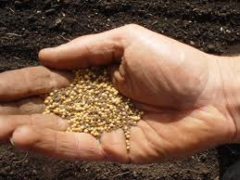

**Then Jesus asked, “What is the kingdom of God like? What shall I compare it to?  It is like a mustard seed, which a man took and planted in his garden. It grew and became a tree, and the birds perched in its branches.**

**Luke 13:18-29, NIV**

In the first century, the mustard seed was the smallest of all seeds. It was about the size of a large piece of dirt! It is hard to believe that from this seed would come a mustard tree that could grow up to 12 feet, large enough for birds to make nests in it! Like the mustard seed, we can start out insignificant by worldly standards but when God chooses us as a vessel there is nothing we cannot do!

The second description of the kingdom of God can be found in the *Parable of the Yeast*:

**Again he asked, “What shall I compare the kingdom of God to?”  It is like yeast that a woman took and mixed into about sixty pounds of flour until it worked all through the dough.**

**Luke 13:20-21, NIV**

Imagine as a boy watching your mother make bread for a large wedding. To take sixty pounds of flour, add water and then mix the yeast evenly throughout the dough would be a daunting task for sure. In this parable, Jesus was saying that while kingdom of God is vast and almost beyond imagination in size it would only take a small amount of light to shine and make a difference in the darkness of this fallen world. The point is not that a mustard seed can grow into a tree or that a small amount of yeast to expand vast amounts of dough, but that the power to do so comes only from God. **God does miracles through ordinary people like you and me!** Let’s look at some of those ordinary people that God chose to do great things inside of His kingdom.

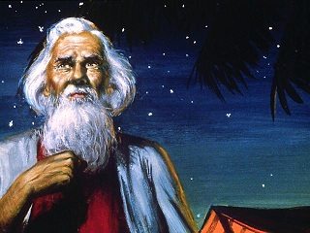 **Abraham**. From a man of a nomadic tribe who is way too old to have children, God promises make a great nation. Abram was an unlikely choice to be the seed of God’s chosen people, after all his family had pagan beliefs (Joshua 24:2). Can you imagine selecting a person who believed in the numerous gods of Canaan as your ambassador? Also, Abram’s family were nomads, not rich or influential. And why would God choose a man whose wife could not have children (Romans 4:19)? How was Abram’s seed to be as numerous as sands on the seashore or stars in the sky (Genesis 22:17) when Sarah’s womb was dead? Abram got rid of his foreign gods. When asked to pack his bags, and go to a foreign land he did so with faith that God would raise his wife’s womb from the dead so that he would have many children (Romans 4:1-3). **From Abram, we learn that God often chooses the weak of this world to demonstrate His power.**

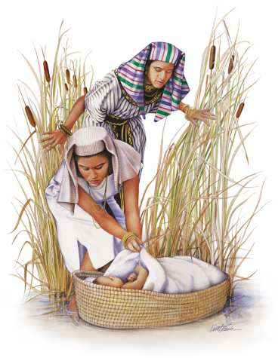 **Moses**. After Joseph and his generation died a new king of Egypt came to power. In seeing the prosperity of the Israelite people the king came to fear that Israel might one day raise up and conquer them. In response to this threat the Egyptian king had Israel enslaved and ordered that all male boys be executed upon birth (Exodus 1). Moses was an unlikely choice to lead God’s nation, after all what could a poor boy born into slavery and scheduled for execution ever accomplish? While floating in the reeds with death imminently on his doorstep, baby Moses is found and saved by Pharaoh’s daughter (Exodus 2:1-8). Even though Moses had vast wealth, power and prestige of being second in command to Pharaoh, he gave it all up the moment God called him. It would be through the son of slaves, Moses, that the ten plagues of Egypt would be announced and through the power of God Israel would be freed. **From Moses, we learn that God can do immeasurably more than we can ask or imagine to accomplish much in His kingdom (Ephesians 3:20-21).**

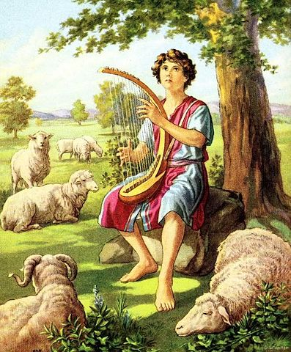**David**. Being the youngest of eight sons of Jesse (1 Samuel 17:12-14) and a shepherd boy makes David an unlikely choice to accomplish great things. Based on worldly standards how could a shepherd boy, the lowest position an all of society, become great? After all, his family was not rich nor were they influential. And yet God chose David to slay Goliath with five smooth stones and a lot of faith (1 Samuel 17). It was also David who God anointed to be the next king of Israel (1 Samuel 16:1-13). David’s life of service was not without difficulties for he was persecuted by king Saul for over 13 years and would spend most of his life subduing Israel’s enemies. Due to his faithful service, it was David who was called a friend of God (Acts 13:22) and it was from David’s line that the Messiah would be born (John 7:42)! **From David, we learn to be ready to serve in a big way and have courage that God can do miracles in your life, even when you are in the midst of a storm!**

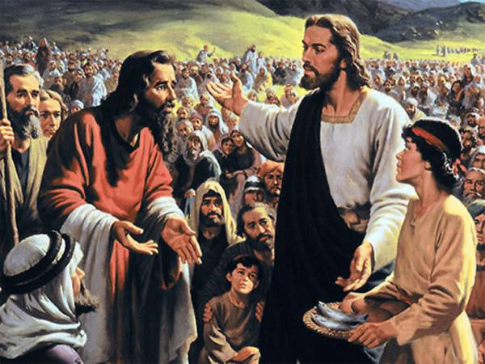 **The boy**. We all know of the story of Jesus feeding the five thousand but have you ever considered the blessing it must have been to be the “boy” in this story? It was late in the afternoon in the town of Bethsaida that the disciples asked Jesus if they should send the people away to the villages to buy food. Instead of following their advice Jesus tells his disciples to “give them something to eat” (Luke 9:13). The disciples scrounge for food and find only a single boy has any: five loaves of bread and two small fish. Like the mustard seed or the yeast in the above parables, Jesus blesses and expands the food to feed well over 5,000 people! Can you imagine what it would have been like to be the boy in this story? To go home and tell your mom or dad that Jesus took the little food you had to feed such a large crowd! **From the boy in this story we learn that a little yeast can go a long way when serving in God’s kingdom.**

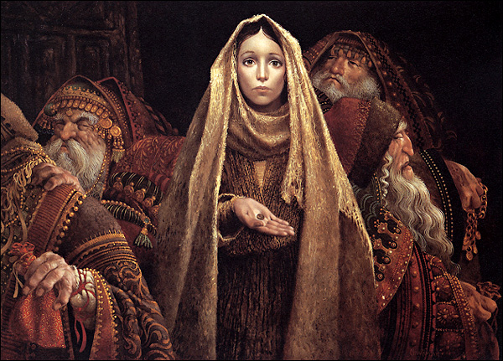 **The widow**. One day Jesus is in the temple and notices the rich putting their gifts into the treasury. As each one threw their heavy coins into the metal box the sound they made announced to everyone their great wealth and supposed generosity. Jesus then notices a widow who comes up and gives a mite – the equivalent of less than one day’s wage. Jesus does not praise the rich, even though they gave substantially more, but instead praises the widow because she gave all she had to live on. If God did not provide soon after her generous giving then she knew she would die! **From the widow, we learn to have faith that when we give all to His kingdom God will bless us beyond measure.**

From these examples, we learn that God truly chooses those of whom the world considers to be the lowest of society to accomplish great things His kingdom. In the first questionnaire, we found that the “largest” things of this world are known while the “smallest” things are forgotten. While this might be true for the short term are the most famous people known for very long? Is it not the insignificant people based on worldly standards that have the most impact on our lives? Like the first questionnaire, the first four points relate to “famous” people.



1. Who were the last five Heisman trophy winners?
2. Who were the last five winners of the Miss America contest?
3. How many people can you list who won the Nobel Peace prize?
4. Who was the academy winner for the best actor in 1982?

Do you know any of these famous people? Most do not because like the riches of this world, human legacy cannot be grounded in the temporal things of life. The second part of the questionnaire outlines the fact that it truly is the “insignificant” that when they serve in God’s kingdom become great and are remembered.

1. **What was the teacher’s name that helped you most in school?**

Billy Sunday’s choir leader, Mr. Rodeheaver, told the following touching story about a boy who sang in his choir. “Joey was not quite bright. He would never leave the tabernacle at night till he could shake my hand. He would stand right next to me until the last man had gone, in order to say good-bye. It was embarrassing at times. One evening a man came forward to speak to me. He said, “I want to thank you for being so kind to Joey. He isn’t quite bright, and has never had anything he enjoyed so much as coming here and singing in the choir. He has worked hard during the day in order to be ready in time to come, too, and it is through him that my wife and my five children have been led to the Lord. His grandfather, seventy-five years old and an infidel all his life, and his grandmother have come tonight, and now the whole family is converted.”[1]

1. **Which friend helped you most with difficult times in your life?**

It had been a dull year in the church where Moffat was converted. The deacons finally said to the old pastor: “We love you, pastor, but don’t you think you had better resign? There hasn’t been a convert this year.” “Yes,” he replied, “it has been a dull year, sadly dull to me. Yet, I remind me that one did come, wee Bobby Moffat. But he is so wee a bairn that I suppose it is not right to count him.” A few years later Bobby came to the pastor and said, “Pastor, do you think that I could ever learn to preach? I feel within me that I ought to. If I could just lead souls to Christ, that would-be happiness to me.” The pastor answered, “Well, Bobby, you might. Who knows? At least you can try!” He did try, and years later when Robert Moffat came back from his wonder-work in Africa, the King of England rose in his presence, and the British Parliament stood as a mark of respect. The humble old preacher, who had but one convert, and who was so discouraged, is dead and forgotten, and yet that was the greatest year’s work he ever did, and few have equaled it![2]

1. **Name a friend who helped you through a difficult time in your life.**

I remember when God first called me to become a pastor. It was a couple of years after my first wife had passed away. Since God had so graciously helped me survive this tragedy I instantly said “YES.” That does not mean that I was not a lot scared of the journey. I knew nothing about the Atlantic Baptist Convention or any of their processes to become ordained. This is where my friend comes into the story. Dr. John Wieler came along side of me and helped me navigate the waters of ordination. He has been with me every step of the way informing and praying over every step I took. May God bless him for his kindness!

1. **Who has had the most impact on your life?**

My mother has had an enormous impact on my life. She taught me about sacrificial love. I remember how she supported me during my studies at university. We had a large family of seven so money was tight. To pay for university I relied heavily on student loans and monies earned from my summer jobs. While this paid for most of my education I still needed money for travel, books and clothes. In additional to taking care of the home my mother took on a second job and worked endless hours so that I might financially survive. From her sacrifice of love, I have learned the value of giving to others as God has given to me!

Out of all these examples I learn that the weak are “significant” because they are the ones often called to serve in God’s kingdom. While those who have the most power, prestige, money and are the best looking might be better known in the short term, it truly is those who serve God with all their hearts that make the most profound impact on other people’s lives. When the seeds or yeast of God’s kingdom are planted in your life never forget there is nothing you cannot accomplish! Remember when you put God first in your life, the weak truly do shame the strong! In conclusion, do not forget:

**One mischievous boy can break up a school. One false alarm can cause a panic.**

**One match can start a conflagration. One false step can cost a life or ruin a character.**

**One broken wheel can ditch a train. One quarrelsome worker can create a strike of ten thousand men.**

One undiplomatic word can provoke a war involving thousands of lives and destruction of millions of dollars in property.

One hasty act of legislation can entail untold hardships.

One wayward daughter can break a mother’s heart.

One lie can destroy a person’s character.

One false witness can send an innocent man to jail.

One vote can decide an election.

**One kind word at the right time may save a person from suicide.**

**One sermon may fire a man’s soul and set the course for his future life.**

**One drink may start a person on the road to alcoholism.**

**One wrong example may lead dozens down the wrong path.**

**One decision for Christ will determine future destiny.**

**One sinner destroyeth much good” (Ecclesiastes 9:18). [3]**

1. Paul Lee Tan, Encyclopedia of 7700 Illustrations: Signs of the Times (Garland, TX: Bible Communications, Inc., 1996).
2. Paul Lee Tan, Encyclopedia of 7700 Illustrations: Signs of the Times (Garland, TX: Bible Communications, Inc., 1996).
3. Paul Lee Tan, Encyclopedia of 7700 Illustrations: Signs of the Times (Garland, TX: Bible Communications, Inc., 1996).