**BEING REMINDED TO DO GOOD**

**TITUS 3:1-8**

Online Sermon: <http://www.mckeesfamily.com/?page_id=3567>

I want you to imagine what it must have been like to establish an early Christian church during a time period when beliefs were as diverse as the stars in the sky. Each time Rome conquered a place they would add the gods of that place to that of their own. They did this to encourage a sense of openness to the belief in many gods so that all people of the empire might be peaceful under one corpus of beliefs. There was a god for all occasions in the Greco-Roman world. If you wanted an abundance of crops, wine, woods or pastures then one would pray either to Demeter, Dionysus, or Pan. If you wanted wisdom you prayed to Athena. If you wanted love you prayed to Eros. And if you were in dire need you prayed to Zeus, the King of all gods. There were so many gods in this time period that the people of Athens erected a statue to an “unknown god” just to be safe that all gods might be honored. To make matters even more difficult the early church was composed of both Jews and Gentile converts to Christianity. Can you imagine how hostile the debates between those stiff necked, lovers of the law must have been with the Gentile dogs that were grafted into the vine? The gulf between those standing on a mountain of laws and those standing on a mountain of grace must have been at times a valley too deep to apprehend!

Paul left Titus on the Island of Crete in order for him to appoint elders in every town and to teach those who “were always considered liars, evil brutes, and lazy gluttons” (Titus 1:12) how to overcome their bad reputation so that they might effectively preach the Gospel message. If the Cretans wanted to be true lights unto the nations and ambassadors of Christ then they must learn to improve community relations by obeying the authorities, by not slandering the people, by being peaceable, considerate and gentle to everyone, especially to those who still believed in multiple gods. Paul reminded the Cretans that it was not that long ago that they too were foolish, disobedient, deceived and enslaved by their sinful passions and pleasures. The Christians of Crete did not earn their salvation by works but received it by the mercy of God. Christ who washed their bondage of sin away and rebirthed and renewed them by the power of the Holy Spirit could do the same for the non Christians of Crete as well. So instead of trying to win over the Cretans by judging, slandering and hating them; they were to do good works so that they might point to God who loved and wanted to redeem them.

**Remember your Identity in Christ**

**Remind the people to be subject to rulers and authorities, to be obedient, to be ready to do whatever is good, to slander no one, to be peaceable and considerate, and always to be gentle toward everyone.**

**Titus 3:1-2, NIV**

Paul begins by telling Titus to “remind the people.” I got thinking about how hard it is to remember certain things in life. The first time I came to this church I was concerned that I would forget people’s names. I remember how impressed I was with the pastor of the Wesleyan church in Moncton. When my first wife passed away the people of my home church felt awkward around me. Since they did not know what to say they would either avoid me altogether or give me some kind of comfort slogan in hopes that it would help. It did not help! To make it easier on them and me I decided to go to a church that did not know my name or life circumstances. I went to the Moncton Wesleyan church and stayed there for a couple of months. I met pastor Buckingham who asked my name once and remembered it week after week. Ten years after having moved on from that church I went back and visited them. To my surprise and delight the pastor still remembered my name! It meant a lot to me because for him to remember me out of the thousands that he would have encountered over the decade, meant in my mind that I mattered to him. I still repeat your names every time I meet you lest I forget and give you the false impression that you may not be important to me when in fact you have become part of my family!

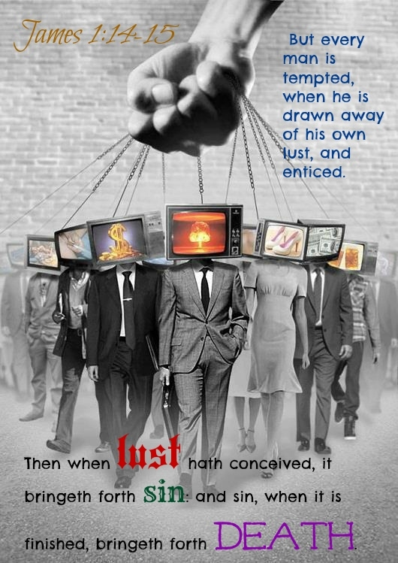While physical names are important to remember how much more important is it to remember our spiritual identity in Christ? When one is in the church singing the worship songs, reading the Bible, praying and having fellowship with like believers; it is easy to keep one’s focus on God. Memory, of God however is truly fickle when living in a fallen world that is constantly enticing us to sin! For good reason Jesus warns us that when we leave the church to go out into the world we must be very careful to not fall in love with their sins (1 John 2:15). The Devil uses the lust of the flesh, lust of the eyes and the pride of life to ensnare and keep believers focused on his kingdom rather than on God’s.

Convincing Christians to disobey God and love the things of this world is only possible when they chose to take their eyes off of Christ. James states that every person has lust inside of their hearts for certain pleasures of this world. For you it might be to have lots of money, for others power, for others sex, for others fame; and the list goes on and on. The Devil knows what you lust for and will provide plenty of opportunities for you to sin and satisfy your desires. The Devil also knows that God is merciful and does not punish Christians each time they sin. If God did then we would never stop being punished! The Devil uses this fact to enslave God’s people. Each time you sin and God chooses to not punish but to show you mercy, the Devil lies and says that fulfilling your lust was a good thing because the only outcome you received was pleasure. The Devil also knows that the more times you give into the temptation the more likely sin will no longer produce feelings of guilt but rather ones of indifference. Left unchecked sin becomes not an activity of temptation but part of your very character. Even when God chooses to punish you for sin the Devil is quick to convince you that your bad circumstances are not punishment but merely a by product of chance.

The more we become like this world the less likely we or the world will see our identity as ambassadors and lights unto the nations! Our witness becomes as best void and at worst hypocritical, one that promotes disobedience to God. When this happens the word “Christian” no longer represents our identity but merely a title that we use without meaning. Remember, being an effective witness to those living in sin is only possible when one keeps one’s heart pure and focused on the object of that witness – Jesus Christ!

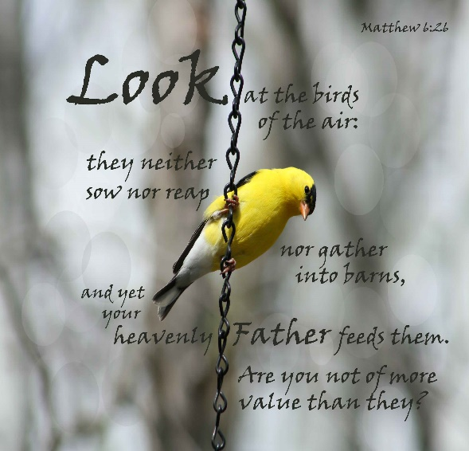Memory, of God is also fickle when living in a fallen world because the Devil is constantly reminding us of the frailty of our human bodies. Scripture describes our bodies as “jars of clay” (2 Corinthians 4:7). Maslow believes that for human beings to be productive five basic needs must be met: physiological, safety, social, esteem and self-fulfillment. Maslow believes human beings are not motivated to satisfy their higher level needs of social, esteem and self-actualization until the basic physiological and safety needs are met. As jars of clay Satan convinces us that our primary motivation is to physically survive. The body needs water, food and shelter or it will die! Satan uses this truth to instill fear into our very lives. The media/world is constantly bombarding us with images of those who have suffered great losses. Who has not seen the devastating effects that losing one’s job, having a house fire, car accident, or debilitating disease can have on a one’s quality of life? Satan uses the fear of death or physical pain to keep Christians focused on the physical rather than the spiritual world. He knows that human beings will do anything to protect their quality of life. Jesus spoke about these fears in Matthew chapter six. He tells us to not worry about our physical life for if God provides for the birds of the air then He certainly will do far more for humanity. While we know this verse to be true the worry for our physical well being keeps us focused on amassing riches so that we might be able to buy back our comfortable life style when tragedies occur. With the love of this world and the fear of physical pain and death in hand, Satan is able to get Christians to drop their focus on God the moment they leave the church to embrace his kingdom as their primary focus. When this happens our witness of the Gospel message becomes null and void!

**Don’t be Drowned out by Sin**

**Illustration**: Lets do a quick illustration to see how sin affects our witness to the world. Ask for a volunteer and give the person a blind fold and a cue card with a single word on it … “GOD.” Have the person blindfolded and instruct them to face the congregation. Instruct the volunteer to repeat this word 3 times in a soft voice to the congregation. Have the volunteer take off the blind fold and ask the congregation to identify the word he/she spoke. Ask for another volunteer and give that person a cue card with a single word on it … “LOVE.” Have the person immersed their whole head in a large basin of water. While he/she is under the water have “LOVE” spoken 3 times. Once the person comes up from the water and dries off, ask the congregation what they heard.

**Meaning**: The blind fold in this illustration represents sin. We have already learned that we all have evil desires in our hearts. If we claim that the love of this world or the frailty of our human bodies has not enticed us to sin, then we make God out to be a liar, for we all have sin present in our lives (1 John 8-10). This sin blinds and keeps us from being effective witnesses for Christ when we refuse to repent but instead indulge in its pleasures. When Christians refuse to indulge in sin but rather focus on Christ, they are able to hear the voice of God who instructs them on how to reach this fallen world as His redeemed child. The basin of water in the second part of the illustration represents the love of this world and the concerns for our physical well being. When the person put his/her whole head in the water it represented how Christians that go outside of the church often allow the love of this world and the concerns for their physical well being drown out their focus on Christ. It is easy to focus in Christ in the church where everyone sings and praises His name, but to do so in the world that has a sea of conflicting values and motivations, is almost impossible. When we do not keep Christ as our central focus, sin overwhelms us and our witness to this world is downed out by our sin.

**The Wrong Way to Present the Gospel Message**

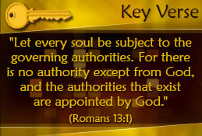Let’s look at why the spoken word in this illustration was soft. In this passage Paul says there is a right and a wrong way to witness to non Christians. The wrong way is to present the Gospel message in a condescending, hateful attitude. We do this in a variety of ways, two of which Paul mentions as being counterproductive to God’s message of love. When we get out into this world it is always tempting to judge and find the leaders of this world corrupt. Who is not saddened and dare I say outraged that Christianity has been reduced from being the center of society to merely being one competing voice of beliefs amongst many! With the passing of each law that forbids displays of our faith in public arenas such as the government, schools and shopping malls; it seems like Christianity has become intolerable to our society. It is so tempting to put on our war paint, to blame and raise up against our leaders in hopes that we might reverse the tides of our pluralistic culture. I put these ashes on my face to represent the war that we sometimes feel must wage against the rulers of this world. Paul warns the Cretans and us as well to not take this route for it will not change our culture but instead will only spark God’s anger towards us! God has appointed our leaders and therefore we must be subject to them as long as they don’t demand us to break God’s laws. Rioting against our leaders is not the way in which Christianity will be restored to the center of our society.

The second warning Paul gives is to not use slander to promote the Gospel message. Last night I stayed late at work to witness to a colleague. This was a challenge for me because while he believes that god exists, he does not believe he can be known. For him, all religions are false and the belief that one group has the truth is absurd! During our discussions I noticed that he found my words offensive because I held to my belief in one God, Jesus is the way, truth and life! This society finds our beliefs narrow and bigoted. They believe in many gods but will not give allegiance to anyone! This way of pluralistic thinking makes sense to this “ME” generation. Holding onto conflicting values that ever change in their sea of meaninglessness, I am not surprised they often hate the narrow path of the Gospel message. In John 15:18 Jesus has told us that being hated by the world for our beliefs is going to happen. It is very tempting to return hatred for hatred. It is tempting to harshly judge the people of this world and demand them to change. Hating people into the kingdom of God will not work because it goes against the core of our beliefs. In Matthew 5:44 Jesus states to love our enemies, to bless and pray for them but no where does He say to hate, ridicule and abuse them. Like Jesus we as His ambassadors are not sent out to condemn the world but to offer them life through Christ!

**Paul’s Suggested Attitude Adjustment**

**At one time we too were foolish, disobedient, deceived and enslaved by all kinds of passions and pleasures. We lived in malice and envy, being hated and hating one another. But when the kindness and love of God our Savior appeared.**

**Titus 3:3-4, NIV**

To reach the lost souls of their world Paul tells the Cretans that they needed a twofold attitude adjustment. First, they needed to remember that at one time they were no better than the corrupt society in which they were trying to reach. If you have ever watched wrestling you know that one week’s perpetrator can be next weeks’ hero! Often we need God to take our disbelief, that the evil people of this world cannot be saved, and smash it into oblivion. To adjust the Cretans attitude, Paul states reminds them that they were just as evil as those they are trying to reach! When you meet people who you are tempted to write off as being too evil to be saved, remember you were at one time just as foolish, deceived and enslaved to your envy and hatred as they currently are. Jesus met you not on the narrow path of righteousness but in the pits of evil. As I put on the mud on my head it reminds me that I was far from perfect when Christ met me and am now only acceptable because of His mercy and gift of salvation.

**He saved us, not because of righteous things we had done, but because of His mercy. He saved us through the washing of rebirth and renewal by the Holy Spirit, whom He poured out on us generously through Jesus Christ our Savior, so that, having been justified by His grace, we might become heirs having the hope of eternal life.**

**Titus 3:5-7, NIV**

This brings me to the second point of Paul’s attitude adjustment. Salvation is a gift that no one can earn! Salvation is not to be seen as an earned position in which we get to yell at the world “look at me and my good works, am I not righteous?” It was not through works but through confession, repentance and belief in the atoning sacrifice of Christ that made you holy. It was Christ, not our works, that broke our slavery to sin and washed our hearts clean. I put my head back into the bucket of water and wash thoroughly to give you an idea of what salvation is like. The ashes and mud on my face and hair that represented sin have been washed away and now I am a new person. As you can see this does not mean I am perfect. There is still some mud in my hair and on my clothes. In God’s eyes He accepts me only because I believe in the atoning sacrifice of His son. Yes, I still have sin in my life but now I am no longer enslaved to that sin. Remember, what God did for you and me as Christians He can and will do for anyone, after all He died once and for all (1 Peter 3:18). Our identity then is to be founded in Christ not in ourselves lest any of us should boast (Ephesians 2:9) or write another off as being unreachable.

**Conclusion: Love them to Reach them**

**This is a trustworthy saying. And I want you to stress these things, so that those who have trusted in God may be careful to devote themselves to doing what is good. These things are excellent and profitable for everyone.**

**Titus 3:8, NIV**

Instead using disobedience and slander to reach the evil people of this world Paul concludes we are to show them the glorious light of the Gospel by doing good deeds. While this world knows hatred, it will not be reached through a hateful attitude. They experience hate all the time and will simply relegate any message wrapped in hate as being one competing voice amongst many, irrelevant and insignificant. If the world is to give up their broad path of pleasure, then you will simply have to offer them something better: God’s love. By removing sins control over your life your words and deeds of love can be clearly seen. It is precisely by doing good deeds that you fulfill God’s command to love Him and one another (Matthew 22:37-40). For Paul, love is the key to showing this world that what you have inside of your heart is the only voice that can save them from the fiery pits of hell. Show them your love by doing good deeds and when they ask why you are being so kind, point them to God the Father in Heaven as the only reason to have hope!