**THRIVING IN BABYLON**

**Part 4: HAVING WISDOM**

Online Sermon: <http://www.mckeesfamily.com/?page_id=3567>

**Source: “Thriving in Babylon: Why Hope, Humility, and Wisdom Matter in a godless Culture” by Larry Osborne**

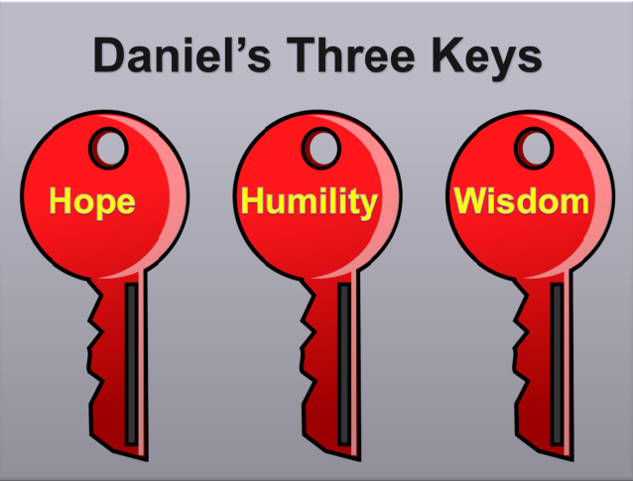Daniel’s counterintuitive “responses to wicked leaders, evil coworkers, and a godless culture” of hope, humility and wisdom; were the keys to his living a holy life for 70 years in Babylon. Today’s sermon will focus on the last key, Daniel’s wisdom. Daniel’s hope gave him courage to live for God in a godless culture, his humility gave him favor in the eyes of his captors, but it was his wisdom to make God-honoring choices that enabled him to thrive in Babylon. Daniel knew if he kept his mind and actions fixed on God’s sovereign plan then nothing would be beyond his reach.

Today’s Christians are often described as being spiritually immature because of a lack of perspective (Kindle, Loc. 1696). The kind of immaturity that comes when one places more value on immediate, rather than long term consequences. For many instant gratification of short term desires always trumps waiting to lay the right foundation to succeed in the long run. For example, 8% of Canadian teens chose to quit school before graduating so that they can make enough money to live “independent” of their parents, knowing full well that this decision will in all probability decrease their income substantially over their lifetime. 29 out of 30 people chose to “hook up” to gratify their sexual desires, knowing full well that this kind of promiscuous activity will have a long-term affect on their ability to have a close relationship with their future mate. How many people speed so that they can get to their appointment faster, knowing full well that one in three fatal accidents are due to breaking the speed limit? While knee-jerk compulsions often lead to short term pleasure they rarely lead to long term happiness!

**Wisdom Focuses on Long-Term Heavenly Treasures**

When Christians choose earthly treasures they can’t keep their heavenly treasures. When Christians lose or judge God’s goodness by today’s problems instead of Good Friday’s sacrifice or respond to sinners with knee-jerk repulsion rather than pursuing the heart of Jesus, they’re stuck in spiritual immaturity. And it breaks God’s heart.

Larry Osborne

Daniel never chose earthly security over heavenly treasures nor did he evaluate God’s goodness in relation to the temporary success of Babylon (Kindle Loc. 1707). Daniel could have compared Babylon’s success despite their evil ways, to his slave position despite his obedience to God, and conclude that God was not just so why serve Him? He could have sought money, fame and power from Nebuchadnezzar but these pleasures would have been short term, after all God was about to destroy Babylon. How it must break God’s heart when we chase after the temporary pleasure while avoiding the glorious riches of our inheritance through Jesus Christ (Ephesians 1:18).

Daniel learned from the cloud of witnesses from Israel’s past the importance of throwing off everything that hinders and the sin that so easily entangles (Hebrews 12:1). For example, from Moses Daniel would have learned that being the second in command of all Egypt was worth throwing away to become a “friend of God” (Exodus 33:11). From a shepherd boy Daniel would have learned that a man after God’s heart (1 Samuel 13:14) could become a king of a great nation. From Josiah Daniel would have learned that a nation who lost its ways can be redeemed and brought back into God’s grace. From Jeremiah Daniel would have learned that even when one stands alone on truth that is unpopular, one never truly stands alone! In each of these cases if the people described had hung onto short term pleasures they would not have become the hero's of faith that they were in the Bible.

**Wisdom is Obedience and Grace**

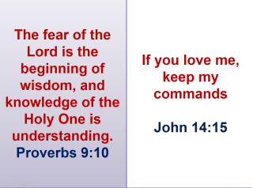To be wise one must first learn to obey God. Only a fool would spit against the wind. Relying on our own abilities to plot a course of happiness for ourselves is truly “spitting in the wind” or foolish because our attempts at controlling the unknown future is truly futile (1 Corinthians 3:19). God’s commands are given to us to teach, rebuke, correct and train us how to live holy lives (2 Timothy 3:16-17). To follow God’s laws, we need to be motivated. The first source of motivation to obey God is fear. Remember, God disciplines those he loves (Hebrews 12:6). Looking back God’s response to evil living: the Flood, Sodom and Gomorrah, The Ten Plagues of Egypt and the destruction of Israel by Babylon; one should not be surprised that Daniel chose to obey God out of fear of being disciplined. The second source of motivation to obey God is love. We love God because He loved us so much that while we were His enemies Christ died for us (Romans 5:10)! Looking back at God’s grace to save Noah and his family, to free Israel from Egyptian bondage, to anoint David a shepherd boy as king and to grant us our very breath; one should not also be surprised that Daniel chose to obey because he loved his sovereign King!

From God’s gracious dealings with this world, Daniel learned that if he wanted to speak truth into the lives of the godless Babylonians he would have to learn what was entangling them in their sin! In response to having had his name changed to Belteshazzar, being castrated, or thrown into the lion’s den, Daniel chose to show grace to his captors by continuing to love and learn more about them. Ever wonder why Daniel, when forced to study astrology or the occult for three years, became so motivated to learn that he graduated at the top of his class? After all, the Bible forbade him to practice astrology or the occult (Deuteronomy 18:9-12). While the Bible clearly states we should not to follow the ways of this world (Romans 12:2), how is learning about the world’s sin make it a sin of our own? Also, how can we expect to convince a non-believer that their beliefs are false when we know nothing of what they believe? It is precisely in knowing the godless content of pagan strongholds that our language is refined to speak truth into a lost heart!

From God’s gracious dealings with this world, Daniel also learned that forbearance and love can win over even the stoniest of all hearts. When the Babylonians chose to ignore Daniel’s spoken appeal to reject their evil ways, his response was to win them over by love. He understood that fierce criticism of godless activities usually only further intensifies existing strongholds of sin. Openly and defiantly mocking this world for its sin will not lead to repentance but harsh criticism of one’s hypocritical, Pharisaic judgments. The world will simply respond by pointing out your sins and dismiss God’s message or give up in defeat when they learn they cannot stop sinning! Daniel learned if he wanted to convince the Babylonians to give up their godless living, he would have to first show them that God loved them enough to free them from their sins. By choosing to obey God rather than the king, Daniel taught the king God’s love in ways that words could never have done so! Would the king have ever called God “the living God” had not Daniel introduced him to God’s might and power in the lion’s den?

**Wisdom is Knowing the Limits of Satan’s Power**

In his book Osborne tells a story of a witch doctor’s spear that is mounted on the wall of his office. On a trip to the Amazon jungle he ran into a witch doctor (Loc 1793). A few hours after sunset the tribal chief and the witch doctor went into a tent to snort some homemade hallucinatory drugs. When they both came out of the tent the witch doctor started a demonic ceremony. Hearing the blood-curdling screams and chants of this witch doctor convinced Osborne that he was truly in the presence of demonic powers. In the morning Osborne traded for the demonic spear that was used in the ceremony. He brought the spear home and mounted it on his office wall. When his friends saw the spear they criticized him for bringing a demon home! In response Osborne argued that he only brought the spear home to remind him that greater is He who is in me than he who is in the world (1 John 4:4). His friends countered his argument by stating he was naïve and had bad theology (Loc 1806). For his friends, they were scared that being close to Satan’s instruments or army would mean that they were inviting Satan into their hearts!

These “scaredy-cat Christians” (Loc 1813) according to Osborne have forgotten that Satan has no power over God’s people who trust and rely on Him! Since the Bible states Satan was a murderer and liar from be beginning (John 8:44), why should we believe Satan when he says that he will get a foothold into our hearts the moment we hang around those who have strongholds of sin? “Evil is not some sort of contagious disease” that is forced upon unsuspecting individuals but rather is a conscious choice (Loc 1814). According to Osborne scaredy-cat Christians can be easily identified because they make two mistakes Daniel that never made. First, they add extra rules to the Bible. While their intent is to promote righteous living, these extra rules often produce pride in one’s appeared holiness and isolation from laying burdens on people that no one could bear. Once legalism takes hold in a Christian’s life, their passion for the rules drowns out their compassion for people (Loc 1828). The human commands of “do not handle, do not taste, do not touch” of legalistic Christians will not scare the godless into repentance but will only further entrench them into the strongholds of their attainable short-term pleasures!

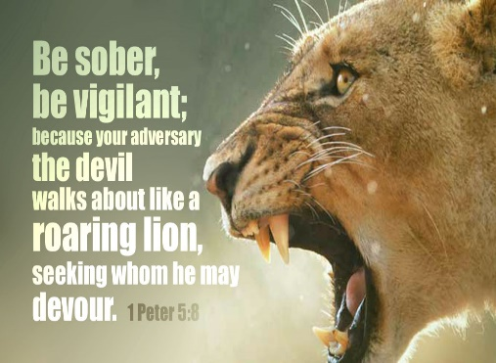The second mistake scaredy-cat Christians make is to flee from anything remotely connected to Satan (Loc 1847). While we should not take the roaring lion who seeks to devour us lightly (1 Peter 5:8), Christians should not panic every time Satan shows up! By submitting to God one can resist the Devil and he will flee from you, not you from him (James 4:7). This is why Daniel was not scared to learn the culture of the Chaldeans. Even though their ways were godless, he was not too scared to show up at special events that honored the occult because he knew God would protect his heart! We as Christians are so scared that we might be influenced by non-Christians that we have chosen to negate Christ’s command to “Go and make disciples of all nations” (Matthew 28:19). If we are to preach the Good News to this dying world, then we simply must first establish genuine friendship with those who practice and are drowning in their evil ways. Never forget “greater is He who is in you than he who is in the world (1 John 4:4)!

**Wisdom is Knowing that God Values Mercy Over Sacrifice**

Earlier we learned in Proverbs 9:10 that to fear God is the beginning of wisdom. While we should fear God’s discipline we should not do so to the extent that we are paralyzed and cannot serve. Perceiving God as an angry God who only looks for ways to nail us to a cross of punishment, negates the sacrifice of Christ who paid the price for our disobedience once and for all (Romans 6:10). When we become a Christian we start out as spiritually immature babies (1 Peter 2:2) who rarely do all the right things that God wants us to do. God does not expect his babies to always get it right for if He did then He would always be disappointed with us. What God expects from us is to always seek wisdom from He (James 1:5) who is the only one who truly knows and lives on the righteous path. When we take the wrong path unintentionally God has given us a mechanism, confession, that enables us to be forgiven (1 John 1:9). In other words, God values mercy over sacrifice (Matthew 9:13). Like Solomon we need to pray for wisdom from God to know how He wants us to serve in His kingdom and to have faith that He will come good on His promise to empower us to achieve His will!

**Wisdom is Knowing the Value of Heavenly Treasures**

**Some faced jeers and flogging, and even chains and imprisonment. They were put to death by stoning; they were sawed in two; they were killed by the sword. They went about in sheepskins and goatskins, destitute, persecuted and mistreated the world was not worthy of them. Hebrews 11:36-38**

Hebrews 11, the Great Hall of Faith, describes the hero's of the Bible who gave their very lives to serve in God’s kingdom. Tracing from Abraham, to Jacob, to Moses, to Joshua the author of Hebrews masterfully outlines their sacrifices as being key to their faithfulness. Gideon, Barak, Samson and Jephthah, David, Samuel and the prophets have all one thing in common: their love of heavenly treasures overruled their love of temporary pleasures! All of these men were commended for their faith even though they did not receive blessings but rather persecution while living on this earth. If these men described if they had hung onto short term pleasures they would not have become the hero's of faith that they were in the Bible.

Reading about hero's like Daniel we can sometimes come to the false conclusion that the good that God promises to do to us will be realized in our lifetime. While we do not always know the eternal results of God’s plan we are called to trust in Him with all our hearts, to not lean on our own understanding but to submit to God so that He will make our paths straight (Proverbs 3:5-6). Remember “God draws straight lines with crooked sticks” (Loc. 1995). It would be foolish to think we being the crooked sticks deserve the credit, but when God’s people stand and let their light shine they can do anything asked by a sovereign God. Daniel lived amongst the mostly ungodly of all nations and yet when his light shined even kings came to acknowledge God’s might and power. Do not buy into the lie that you cannot make a difference in your workplace, community, family or nation because through the power of God you can!

**Conclusion**

Today’s Christians are often described as being spiritually immature because of their lack of long-term perspective (Kindle, Loc. 1696). The kind of immaturity that comes when one places more value on immediate, rather than eternal consequences. What truly mattered to Daniel was not just to survive living in a godless culture but to become wise enough to thrive! Wisdom for Daniel meant obedience to God out of fear and love for Him. To win over the stoniest of Babylonian hearts meant learning the sins that entangled Babylon so that he could speak truth into their lives. While Daniel knew associating with evil people had the inherent risk of being assimilated by evil, he stood firm on his belief that Satan had no power over him because he loved and trusted God. While Daniel knew his spiritual immaturity would lead to many failures that deserved God’s wrath Daniel knew the power of confession and God’s grace would enable him to stay on the path that enabled him to speak truth, even to the kings of godless nations!