**OVERCOMING THE ENEMY**

**1 Samuel 7:1-13**

Online Sermon: <http://www.mckeesfamily.com/?page_id=3567>

We have all faced trials and tribulations in our lifetime that have been extremely painful. James 4:2-4 tells us to consider these trials pure joy because when we respond to trials by staying steadfast in the faith, our perseverance leads to spiritual maturity. We live in a fallen world and as such King Solomon states there is a high probability that, like this world, Christians will also go through difficult times (Ecclesiastes 9:11). Chance is not the only reason why a person might go through tribulations; discipline is the other reason (Hebrews 12:6). When we decide to wander onto the broad path of sin, God disciplines us in order to provoke repentance (Revelation 3:19) so that we might return to His embrace.

When one is faced by one of those gut-wrenching tribulations the first thing one should do is to pray to God for the wisdom (James 1:5) to know what kind of tribulation one is facing: a tribulation by chance that leads to spiritual maturity or a tribulation of discipline that leads to repentance. Today’s sermon is going to focus on the latter: discipline. While God prefers to mercifully get us back on the right path by disciplining us through His word (2 Timothy 3:16); when we refuse to give up our evil ways God will resort to pouring out His righteous wrath upon those He calls His own. This is exactly what happened to Israel in 1 Samuel 4-7.

**Israel’s Journey to a Valley of Sin**

To truly understand this passage in Samuel one needs to place it within its historical perspective. Going all the way back to Abram we find that God’s chosen people started out faithful and obedient. When called to go to an unknown, foreign land Abram chose to faithfully obey God and say YES to His request. Even though God promised to make Abram’s descendants into a great nation, I can only imagine how difficult it must have been for him to tell his family; after all they were not God-fearing people but Chaldeans who believed in multiple gods! To leave his family that were so dear to him to serve a God that was foreign to his people, is the reason why the author of Hebrews included Abram as one of the great hero’s of the faith!

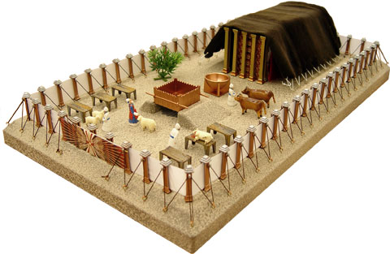 Fast forwarding to Moses’ time, we find the children of Israel wandering in the wilderness in the presence of God. Descendent from Abram, Israel was God’s chosen people and as such He did not ignore their cries while in bondage but instead chose to crush her Egyptian captors with ten fierce plagues. In the wilderness, God choose to enter into a covenant with Israel, one in which they agreed to be a light and example of holiness unto the nations. In return God called them His people and chose to physically dwell in a human made tabernacle in their presence. Can you imagine the honor and privilege of being chosen as God’s light to the nations and having God physically dwell in your presence? No other nation except Israel received those kind of blessings in the Old Testament!

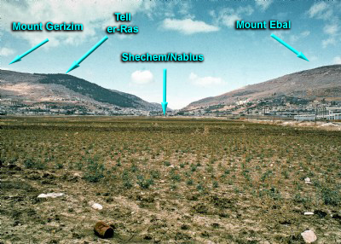 After Moses dies Joshua takes over as Israel’s leader and the children of Israel conquer the Promised Land. After Joshua dies the children of Israel were to remain obedient to God who was to be their king. Even with the blessings of Mount Gerizim and curses of Mount Ebal firmly established in their minds, Israel chose to firmly plant their feet on the path of their own selfish desires. Instead of keeping God at the center of their nation through their obedience to the covenant, Israel chose to do whatever was right in their own sight. In response to their disobedience God rose up unconquerable enemies all throughout the book of Judges to force Israel to repent and once again be brought back into the covenant as a faithful partner.

Fast forwarding to the time of the last judge Samuel, we find Israel is facing once again an unbeatable enemy, the Philistines. Instead of praying to God for wisdom to determine whether or not they were being disciplined by God, Israel decided to fight the Philistines. During the first attack Israel was defeated and lost about 4,000 men (1 Samuel 4:2). The elders decided to bring the ark of the Lord’s covenant into the next battle assuming that God’s mere presence would ensure victory! While the Philistines were initially afraid to be in the presence of the God who defeated Egypt, they chose to fight Israel and ended up slaughtering 30,000 of their soldiers. On that day Israel learned that the presence of God in an ark would not defeat their enemy. To win the war they would have to first invite God into their hearts!

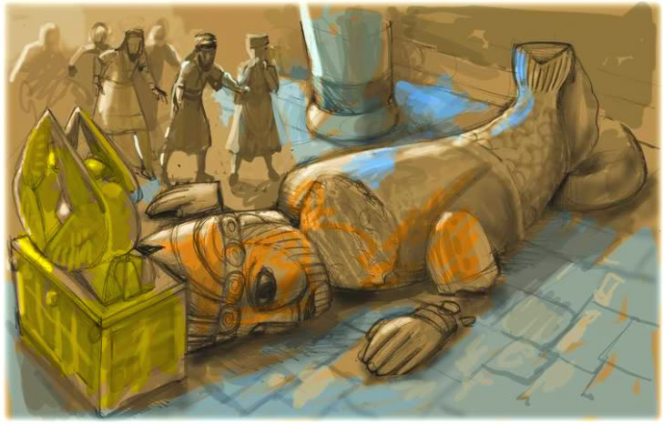Instead of repenting in dust and ashes, Israel chose to turn her back on God and again do what was right in her own sight. The Philistines captured the ark and took it to their temple Dagon (5:2). After having the statue of Dagon fall down before the ark and smashed into pieces and after having devastation and tumors inflicted upon them, the people of Ashdod chose to send a guilt offering of five gold tumors and five gold rats (6:4) along with the ark to Beth Shemesh, an Israelite town. After having many struck dead for having looked into the ark, the people of the town chose to send the ark to a town called Kiriath Jearim (7:1). For 20 years the ark stayed in this town forgotten by the people. God who was to be the center of their society was now on the periphery! As a result, God raised up another Philistine army that was unbeatable!

**Israel’s Warning**

Lest we think to little of Israel and too highly of ourselves, have we not moved God from the center of our lives to the periphery as well? Like Israel, when times are good and full of blessings we often foolishly think that we can manage our happiness. When looking out at our surroundings from a mountaintop of pleasure it is truly hard to see how much we need our Lord, Saviour and king! When we have money in our bank accounts, good health and are popular; these temporal blessings often blind us to our need to be sustained by His loving presence. When we choose to love our blessings more than we love God who gave them to us, we fall from the mountaintop into the depths of our own depravity.

 Willfully sinning against God is the banana peal of this fall. Like Israel, our sin is not a once and for all rejection of God but a gradual surrender of our hearts to the things of this world. Each time we disobey a single command the temporary pleasure that we receive further intensifies the evil desires within our hearts (James 1:14-15). Left unchecked, disobedience leads to sinful habits that will in turn become ingrained into our very character. Once entangled by sin it becomes impossible for us to escape the path of destruction that we are on.

To break this downward spiral of further disobedience we need help from our Creator. The preferred method that God uses too free us from sin is to show us mercy by reminding us of the impending punishment that will happen if we do not repent. Read the warning God gave Israel in Leviticus 26:14-16.

**But if you will not listen to me and carry out all these commands, 15and if you reject my decrees and abhor my laws and fail to carry out all my commands and so violate my covenant, 16then I will do this to you: I will bring on you sudden terror, wasting diseases and fever that will destroy your sight and sap your strength. You will plant seed in vain, because your enemies will eat it.**

God warned Israel that her outright rejection of His commands would lead to some rather serious consequences. In verse 16 Israel is promised that God would remove their blessings and suddenly “terrorize” them if they chose to reject His commandments. I don’t know about you but a God who destroyed the world by a flood, reigned fire down on Sodom and Gomorrah, and issued the Ten Plagues of Egypt; is not a God you want terrorizing you with discipline!

 Instead of responding to God’s warning by repenting, Israel chose to ignore Him. So deep was their depravity that by the time Samuel arrived on the scene the word of the Lord was rarely ever heard (3:1)! Can you imagine living amongst God’s chosen nation and rarely ever hearing a single command from your leaders? Again lets not judge Israel too harshly for when we are in the valleys of sin don’t we as well ignore and break God’s commands as well? Even though we know our obedience is a barometer of our love for God (John 14:15), like Israel we would rather risk His terror than surrender what we love the most, our sin! So we foolishly look at our contemporary times only to state that His word is dated and meant for another time period. It is not just the laws we find offensive but the intent as well. After all, who can live their life without being angry or lusting after another (Matthew 5:22,27)? Out of a sense of obligation to God we might read and maybe even memorize His word but to surrender to it is another matter! You see we have much in common with the Israelites of Samuel’s time.

 The banana peal that keeps us in the valleys of sin is primarily rooted in our complacency. Once sin is fully entrenched into our lives we become like the Israelite people in the time of judges, doing what is right in our own sight (Judges 21:25). Since every Christian has both the Spirit of God and a sinful nature, His children are constantly experiencing an internal war to do both good and evil (Romans 7:1). God’s expectation of His own is that they cry out to Christ who will free them from the evil that ensnares them so that they might use their spiritual gifts to obey God, to build up the body of Christ, and attain the full measure of Christ (Ephesians 4:11-13). Like the Israelite people, our problem with sin is not that victory cannot be obtained but rather that we refuse to cry out! We chose the valleys of our own depravity because we are too complacent and unwilling to give up what we cannot keep to receive what we cannot lose (James 4:7)!

**Israel’s Way Back**

Even though our valleys of complacent sin seem to have no bottom, God always provides a way back to Him. God once again rose up the Philistine army to discipline Israel. They were stronger, more powerful and unbeatable by human means. God disciplines those He loves because He knows that is the only way for His people can get out of the valleys of sin. Complacency in a valley of pleasurable sin will not be given up until one is faced with an enemy/situation that cannot be overpowered by one’s own might. Israel knew that their unbeatable enemy was not a tribulation by chance that leads to spiritual maturity but instead one of discipline that was meant to force them to repent. If Israel chose to remain in the valley of sin, then God would destroy them in that very valley! Since God was the one who raised up this unbeatable army, the Philistines could only be defeated through Israel’s repentance and crying out for mercy from He was about to discipline them!

**Then all the people of Israel turned back to the Lord. 3So Samuel said to all the Israelites, “If you are returning to the Lord with all your hearts, then rid yourselves of the foreign gods and the Ashtoreths and commit yourselves to the Lord and serve him only, and he will deliver you out of the hand of the Philistines.” 4So the Israelites put away their Baals and Ashtoreths, and served the Lord only. (1 Samuel 7:2-4, NIV)**

Israel took four keys steps to get out of their valley of sin. While it is easier to slip on the banana peal of sin and descend into a valley than it is to obey and climb back up the mountain, it is possible! Israel began their journey by first acknowledging that while the valley that they were in was pleasurable to the human senses, it was disobedient and therefore deserving of God’s wrath. This meant turning their backs on the foreign gods that enslaved them sot that they could embrace a life of obedience to serve the Lord only. In other words, they chose to reject the god of self and give back their freedom to choose to God.

**5Then Samuel said, “Assemble all Israel at Mizpah, and I will intercede with the Lord for you.” 6When they had assembled at Mizpah, they drew water and poured it out before the Lord. On that day they fasted and there they confessed, “We have sinned against the Lord.” Now Samuel was serving as leader u of Israel at Mizpah. (1 Samuel 7:5-6, NIV)**

The second step Israel took to climb out of the valley was to confess their sins. All of Israel assembled at Mizpath to fast and pray to God for forgiveness. The whole nation chose to stop everything they were doing and with a single minded devotion they approached a holy God and pleaded to be forgiven. They confessed that the pleasure they got from their sinful actions was no where near as valuable to them as the pleasure they got from serving and being close to their God! Only when we confess our sins is God faithful and just to forgive and purify us from all unrighteousness (1 John 1:9).

**They said to Samuel, “Do not stop crying out to the Lord our God for us, that he may rescue us from the hand of the Philistines.” 9Then Samuel took a suckling lamb and sacrificed it as a whole burnt offering to the Lord. He cried out to the Lord on Israel’s behalf, and the Lord answered him. (1 Samuel 7:8-9, NIV).**

The third step Israel took to climb out of the valley of sin was to cry out to God to remove His hand of discipline. While God says He will forgive and cleanse us from unrighteousness, this does not mean all confessed sins go unpunished. During the time of the judges Israel had demonstrated that their repentance was often short lived and insincere. To convince God they were not going back into their valley of sin the moment the enemy was defeated, Israel needed to understand the depths of both their depravity and God’s mercy to forgo their rightful punishment!

**10While Samuel was sacrificing the burnt offering, the Philistines drew near to engage Israel in battle. But that day the Lord thundered with loud thunder against the Philistines and threw them into such a panic that they were routed before the Israelites. (1 Samuel 7:10, NIV).**

The last step Israel took to climb out of the valley of sin was to believe that God alone had the power to remove their punishment. The Philistines who were reluctant to attack Israel in the presence of the God of the Ten Plagues twenty years earlier, were now bold enough to attack them while they were making a sacrifices to God! This of course was a grave mistake for they soon found out that they could not defeat Israel when God was the Lord of their hearts. Like Israel, if we are to be forgiven and lifted out the valley of sin then we must believe that God can do anything, after all, He who disciplines those He loves prefers to show mercy to those who repent!

**Conclusion**

We have all faced trials and tribulations in our lifetime that have been extremely painful. While tribulations of chance require perseverance to endure, tribulations of discipline require repentance. Those who chose to embrace gratifying their own sinful desires become entangled and slip into a valley that can only be escaped through the power of God. To climb back up the mountain of righteousness one must throw off complacency and embrace a genuine desire to seek and obtain forgiveness through confession. Turn from your evil ways, cry out to God for mercy and pray that He who summoned the enemy might also defeat them!