**THRIVING IN BABYLON**

**Part 2: HAVING HOPE**

Online Sermon: <http://www.mckeesfamily.com/?page_id=3567>

While we usually think of the lion’s den or prophecy when we hear the name “Daniel,” Larry Osborne believes the main theme of the book of Daniel is: “***Thriving in Babylon***.” For Osborne, he sees the book of Daniel as being a template of how to live and thrive in one of the most godless of all cultures. Last week we talked about how people often falsely attribute the past as being the “good old days” and the present as being the evillest of all times. After having taken a history tour over time we concluded that there have been many epochs of time that were worse then that of the present but no time was or will be as evil as that of the time of the Babylonian empire.

**Daniel’s Hope**

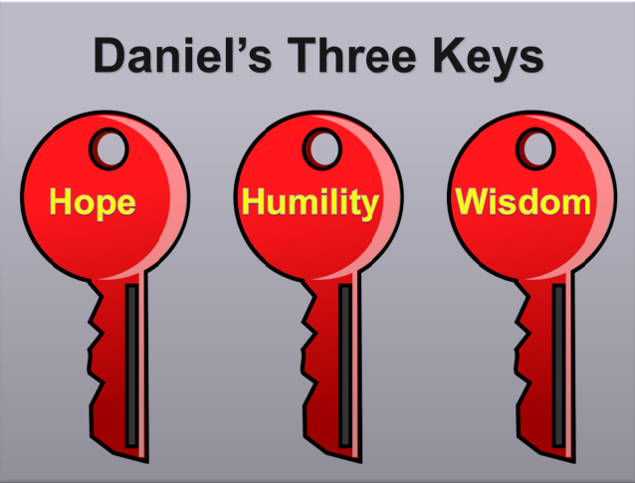Daniel’s counterintuitive “responses to wicked leaders, evil coworkers, and a godless culture” of hope, humility and wisdom; were the keys to his living a holy life for 70 years in Babylon. Today’s sermon will focus on the first key, Daniel’s hope in God.

There can be many definitions of hope that have little if anything to do with this first key. Hope can mean for some “I hope to have a good vacation,” you know the one where buffets fill entire rooms of endless variety as attendants serve your every need. The pool is always like bathwater and the entertainment is the best you have ever seen or heard. For others hope can mean to find their prince charming. You know that special someone who is kind and soft spoken, rich and yet humble. The soul mate who will listen to your every word and whose goal in life is to make you happy every moment of the day. And yet for others hope can mean to overcome all odds and beat the disease that is ravaging their health. This is the hope that the dark days and dreary nights will give way to a new day in which the sun rises on your restored, healthy body.

In each of this cases the world often tells us that going through the mental gymnastics of positive thinking is the key to visualizing your dream and making it become a reality. Daniel had a “deep-seated confidence in God’s character and sovereignty” (Loc. 868). This was the lens in which Daniel chose to view all circumstances in life that happened to him. Looking back at God’s merciful dealings with Israel and looking forward to Jeremiah’s promise that they would only be exiled for 70 years (29:10-14), Daniel knew God would always do good to those who love Him. Like Daniel, the lens in which we are to view our painful tribulations is one in which points to God’s grace. He sent His Son to die for us wretched sinners and will one-day return and take us home to be with Him! This is how Paul says we as Christians are able to say “No to ungodliness and worldly passions, and to live self-controlled, upright and godly lives in this present age” (Titus 2:12, NIV). His grace should be the “organizing principle of our lives, influencing our priorities, moral standards, and even our willingness to be persecuted for His name” (Loc 878). Looking at life through the lens of eternity changes our perspective from seeking temporal to seeking kingdom goals in our lives.

**Hope is Beyond Doubt**

Daniel did not have the kind of hope that is littered with doubt that so many people of this world often experience. Instead, Daniel had the kind of hope that knew beyond any doubt that a sovereign God would always do good by him. This kind of unwavering hope is not acquired overnight. We will all face tribulations in our lives that will throw us into a giant pit of pain and suffering. It is only through experiencing God’s character, power and faithfulness to deliver us from one of these tribulations that our faith begins to grow. Hebrews 11:6 states that if we want to please God we need to believe not only that He exists but that He rewards those who earnestly seek Him.

In Daniel’s case his journey of acquiring steadfast hope began with a simple decision to obey God and stick with his kosher diet no matter what the consequences might be (Loc 902). Daniel and his friends politely asked the chief official if they could eat a diet in accordance with the kosher laws. Even though God caused the official “to show favor and compassion to Daniel” (1:9), he refused their request because of fear that their health would fail and the king would take his head (1:10). At this point Daniel and his friends could have seen their predicament as only having two options: starve to death or break God’s laws. Either choice was very depressing! Firmly believing that a sovereign God would not allow Daniel or his friends to be harmed, he chose to approach their personal guard with a rather unusual request. Daniel asked the guard’s permission for him and his friends to eat only vegetables and water for 10 days. After the ten days if Daniel and his friends were as healthy or healthier than before then the guard would grant them permission to continue their special diet. At the end of the ten days Daniel and his friends were healthier than the other young men who ate the royal food and wine (1:15)! Daniel and his friends were authorized to eat this diet for the entire three years of their training. There are countless examples of people who took a leap of faith not knowing what the outcome would be – after all if one knew the outcome beforehand then it would not be faith!

God often performs miracles to those who place their hope in Him! Daniel and his friends faced a human problem that had no human solution. The king and his company would have never permitted them to practice their kosher laws, especially while they were training in the Babylonian occults. It takes an enormous amount of confidence to trust God when His plans are often unknown. “By faith Abraham, when called to go to a place he would later receive as his inheritance, obeyed and went, even though he did not know where he was going” (Hebrews 11:8). By faith Moses parents hid him for three months and then put him in a basket to float amongst the reeds not knowing if he would survive or not. Let’s look at some of the steps you can take to experience hope amidst adversity just like Daniel and these great men of faith.

**Hope Step 1: With the end Game in Mind you can Persevere any Storm**

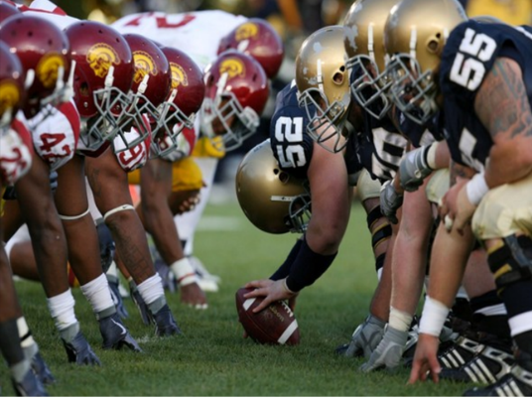Larry Osborne tells a story of an epic battle between USC and Notre Dame in 2005. Entering into the face off USC was riding a 27 game winning streak and were ranked first in the national polls to win. Even after having squandered numerous scoring activities (Loc 955), USC was ahead with only two minutes left in the game. They could see victory in hand! Then Notre Dame marched down the field and scored a touch down to take the lead 31-28. Now it was Notre Dame’s turn to see victory in their hands! With no time left Leinart, helped by a push from Reggie Bush scored from less than one yard out to give USC the win at 34-31.

To be a spectator of that game would have been like riding an emotional roller coaster! One minute Larry’s favorite team, USC, was winning, then loosing and in the final minutes clenching the victory! When Notre Dame got their touchdown with only two minutes left, Larry’s heart sunk and anger filled his soul. Fans are often like that when the other team advances and scores. They get angry and either yell at the TV set or yell out into the field knowing full well that their advice will never be heard nor have any affect on the outcome of the game. In the last minute Larry’s heart leapt for joy when USC scored and quenched the victory.

Larry often goes back and watches this epic game but instead of being angry when Notre Dame scored with two minutes remaining he now relaxes and laughs for he knows the victorious ending. As Christians we know how the game of life ends – spending eternity with Jesus in heaven. Given this is the case then why do we interpret the enemies advances as being unsurmountable? If that was the case, then Jesus would not be sovereign! It is a sad day when God’s own children feel justified in living godless lives out of anger and fear that God will not show up and give them the victory! Going through tribulation is never easy for anyone but knowing that nothing, not demons or even physical death, can separate us from the love of God and glorious eternity He has planned for us (Romans 8:38-39); should sustain our love and joy of God in any circumstance!

**Hope Step 2: With the end Game in Mind you can Thrive in any Storm**

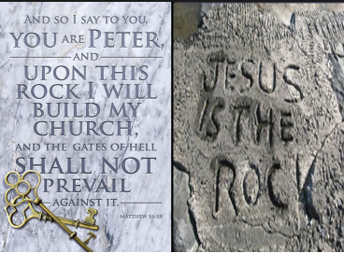

Fear and pessimism of tribulations does not make sense when victory is guaranteed (Loc 996). We all know that the gates of hell itself will not shake the foundation in which the church is built, the risen Christ! But do we know exactly what this verse means? When a person reflects on the meaning of this verse many conclude that it is a promise that no matter how hard the gates of hell hammer us with tribulations, one only needs to hunker down in Jesus’ arms to survive the onslaught (Loc 1032). While this statement is certainly true it does not depict what the gates of hell fully means. Ancient city gates were never used as battering rams but as a defensive method of keeping the enemy from entering into one’s territory. So the gates of hell are also a reference to the ability of the living stones (1 Peter 2:5-8) to accomplish much in God’s kingdom! By keeping eternity with Jesus in clear view and through the power of the Holy Spirit to do more than one can ask or imagine (Ephesians 3:20), nothing will stop a Christian from accomplishing what God has called them to do, not even tribulation.

**Hope Step 3: Garbage in Garbage Out**

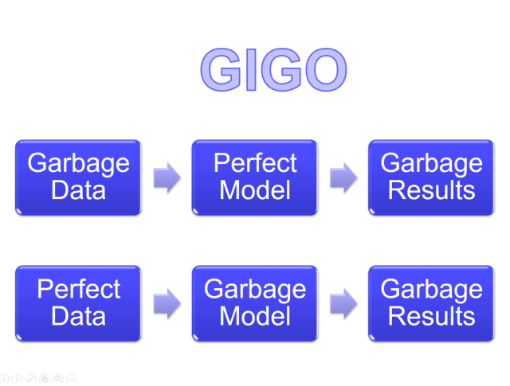During the day I spend most of my time developing programs for the company I work at. I analyze business processes and when I find redundant steps I create a program to remove these steps. After thousands of lines of code and a week later the typical program is ready for the end user. The success of the program is determined by first reviewing how many steps it has eliminated and second by replicating the same results (or better) than that of the original process. I soon learned after a few years of software development two crucial facts when it comes to being successful in my line of work. First, one can have the absolute best software design in the world but if the users refuse to enter the data correctly, the outcome of the business process will als0 be garbage. Second, the users can enter absolutely perfect data but if my program is flawed in its logic, the outcome of the business process will be garbage. Only when both the data input and the software program are both correct will the end results be of value!

The same is true when it comes to serving in God’s kingdom. Satan is a master at bombarding Christians with a never-ending stream of crises de jour to keep them living in the fear of what might happen in the future or to make them believe that their current crises will last forever (Loc 1105). It is no wonder so many Christians have lost hope! Like the users of my programs, allowing Satan input or claim to your emotions concerning either current or future circumstances, is truly putting garbage into God’s perfect, kingdom model. Paul states that during tribulation one needs to focus not on gloom or doom but whatever is noble, right, pure, lovely, admirable or praiseworthy; to maintain hope and happiness in one’s life (Philippians 4:8). Also, standing on Satan’s promise of happiness from fame, power or money that one will supposedly receive for living on the broad path is the equivalent to my users putting in the perfect data when my software design is flawed! To be the ambassador and royal priest God has called you to be one must simply stand firm on God’s promise that no circumstance is beyond His ability to redeem for His good purposes (Romans 8:28-29). After all, Jesus’ crucifixion was the greatest act of injustice and triumph over evil that will ever take place (Loc 1112)!

**Hope Step 4: Watch out for the Hope Killers**

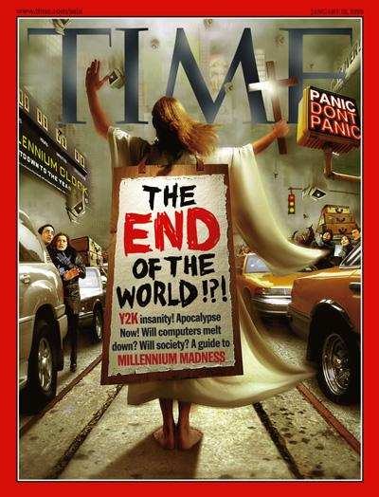I remember in 1999 the crises de jour was the Y2K bug. Data storage used to be very expensive so programmers used two digits to represent the year. When year 2000 approached many felt that computer programs would confuse the “00” of year 2000 for year 1900. There was a massive wave of fear promoted by the media that predicted on January 1, 2000 all sorts of calamities. Many believed that elevators would get stuck, cars would stall, airplanes would crash and nuclear plants would melt down killing millions (Loc 1157). So successful was the media in spreading this fear that many felt the end of the world was upon them so they build underground bunkers. When the millennium year came nothing catastrophic happened! All the critical software programs just kept on working because most of the programs had been redesigned in time to combat this issue! While one might have received a bill in the mail with over a thousand years of interest on it, it was not the end of the world because who would ever be able to enforce and collect it!

Gloom and gloom stories like this teach us the importance of keeping the right focus. It is bad enough to be viewed as foolish for believing in the cross and the power of the empty tomb, but it is even worse to be viewed as a scaredy-cat (Loc. 1202), fearing the unknown future that a sovereign God has in His hands! Even if Y2K had caused all the catastrophes that the media claimed it would God would still be with us and use these events for His glory! Furthermore, God has promised to never give us more than we can handle (1 Corinthians 10:13) and His just in time delivery system provides us the strength we need to not only endure but thrive (Loc 1210). If Daniel’s steadfast hope in a sovereign God helped him endure and thrive in one of the evilest of all cultures, Babylon, what excuse do we have to not survive and thrive in our culture? Surely we have hope for we have God’s spirit living inside of us!

**Conclusion**

Daniel knew Babylon was coming to conquer his people. He also knew that they were a godless people and would enslave him for 70 years. Even though he was castrated, forced to study the occult, given a name that honors demon gods, tossed into a fiery furnace; Daniel remained full of hope because he knew God is sovereign and always in control. Instead of collapsing in terror of our circumstances, like Daniel, Christ’s ambassadors need to stand firm on the cross and empty tomb as being evidence that not even the gates of hell can stop God and His plans!